LAB 11

Nguyễn Thanh Hoài Lộc – SE151250

Open the file cybertapk.apk with jadx-gui-1.4.2.exe

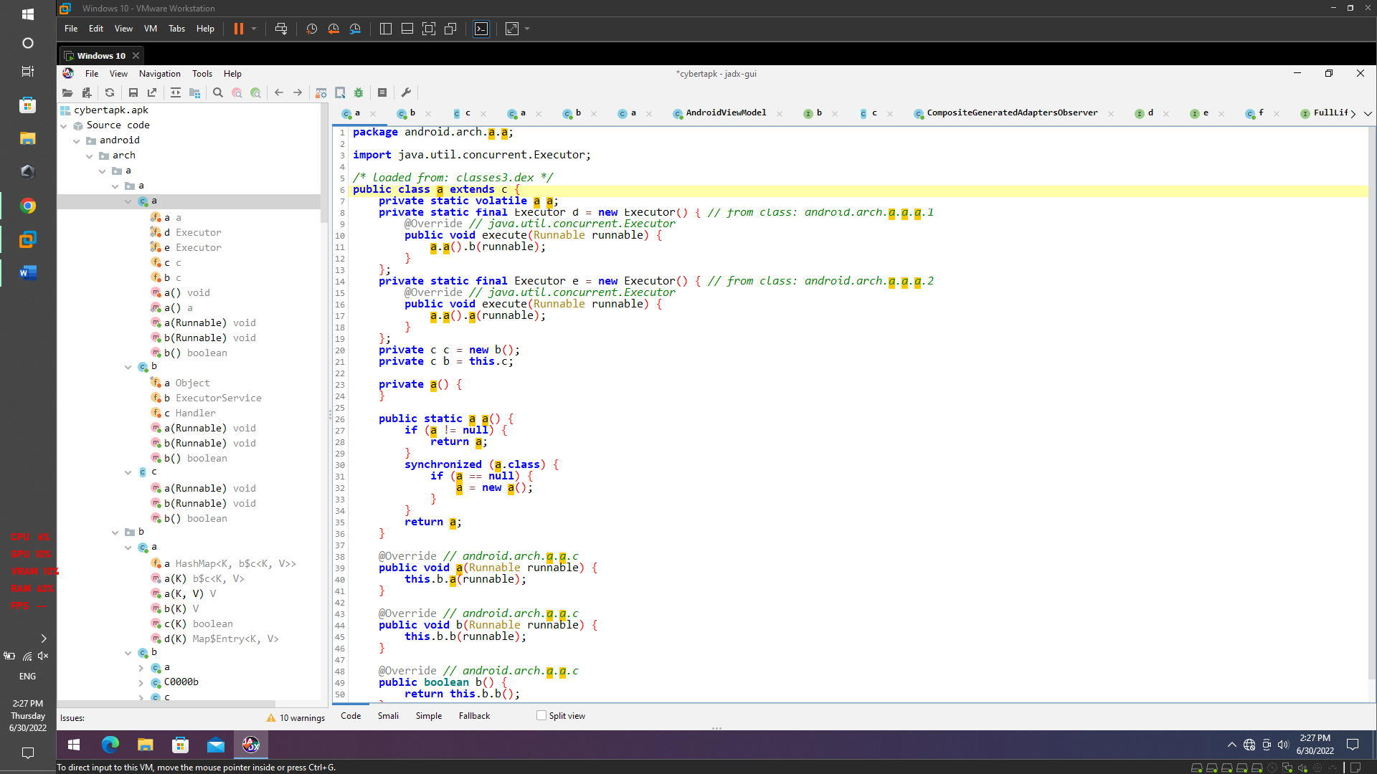

We may now begin studying the decompiled Java code. We can also observe the byte array utilized for padding in class Challenge1.java. This byte array serves as our flag.

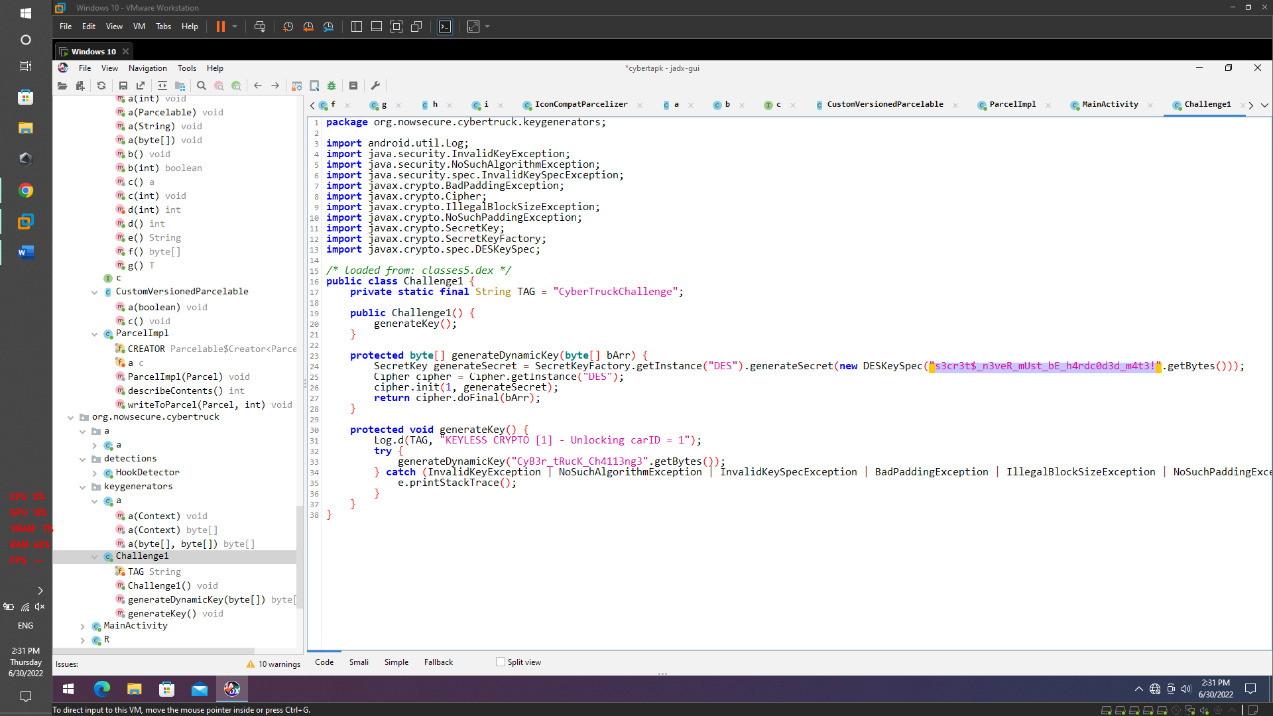

FLAG={s3cr3t$_n3veR_mUst_bE_h4rdc0d3d_m4t3!}

We see in the keygenerators package, we see a class a.java. find the function inputStream = context.getAssets().open("ch2.key"); we are directed to assets folders

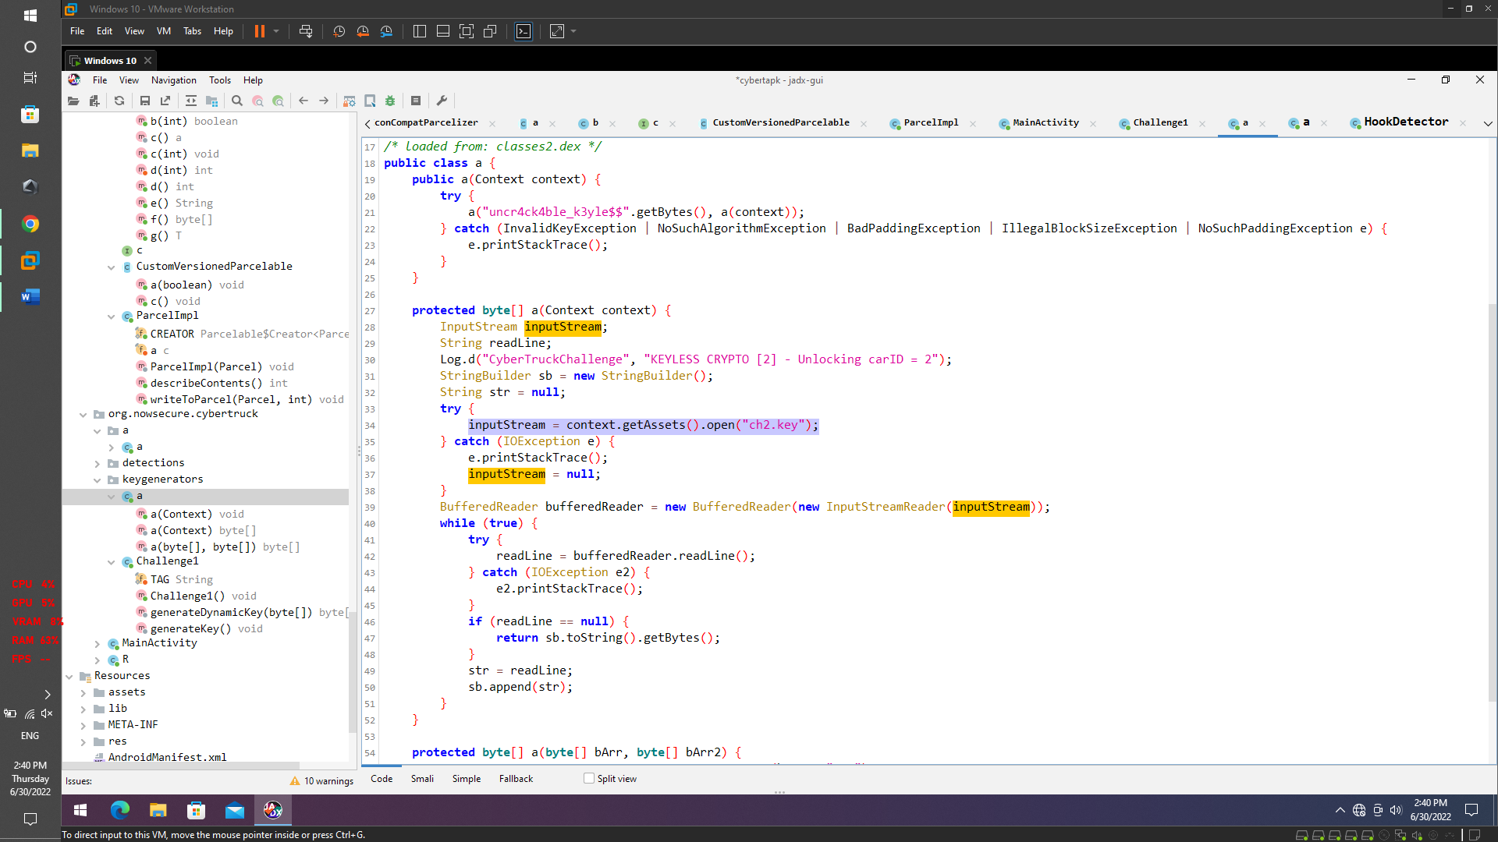

Going to the assets folder we get the flag.

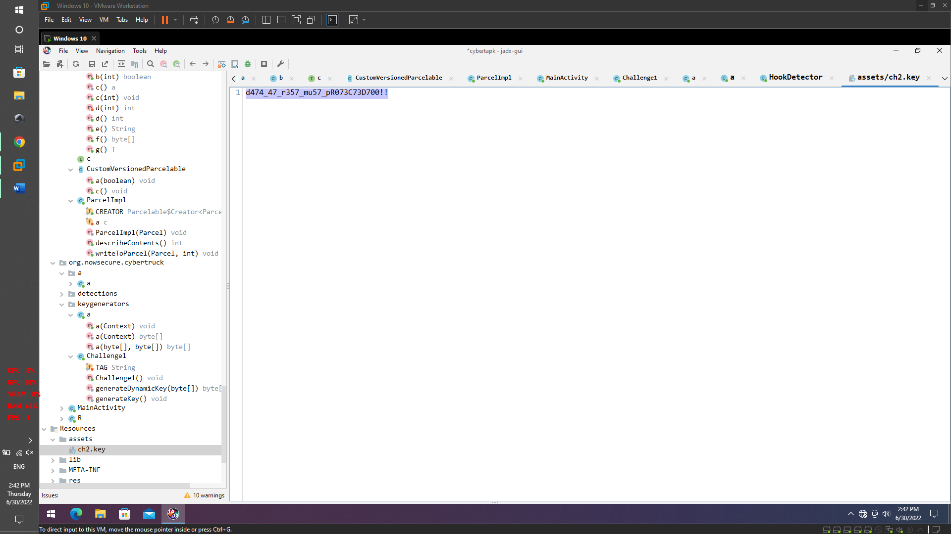

FLAG={d474_47_r357_mu57_pR073C73D700!!}