Lab 8

Nguyễn Thanh Hoài Lộc – SE151250

**insecureApp01.exe**

Run the file ‘insecureApp01.exe’ using cmd. We are asked to enter a password.

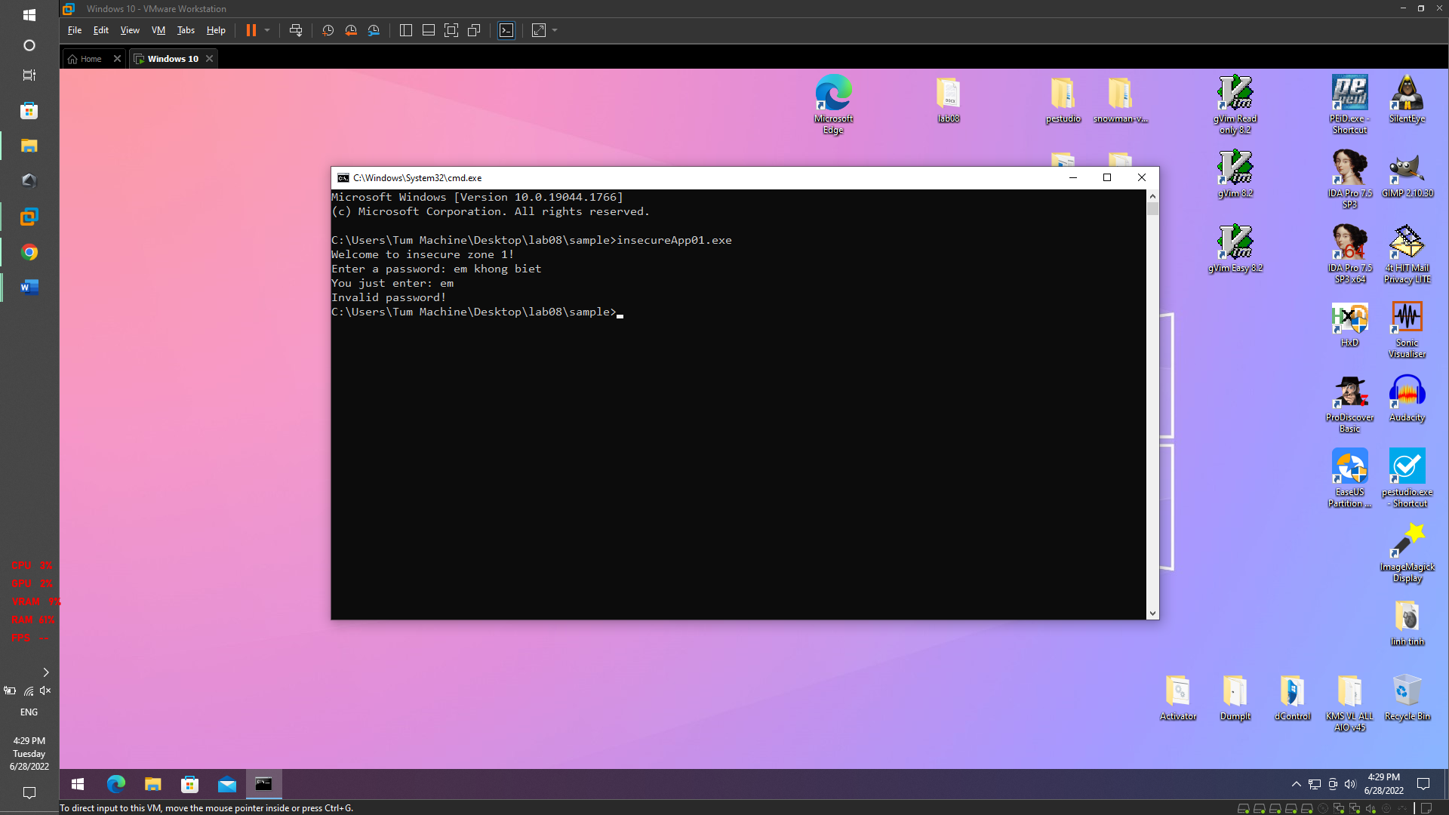

Run file ‘insecureApp01.exe’ on IDA Pro and view. We can see string like ‘Hello’, ‘World’ and ‘!’

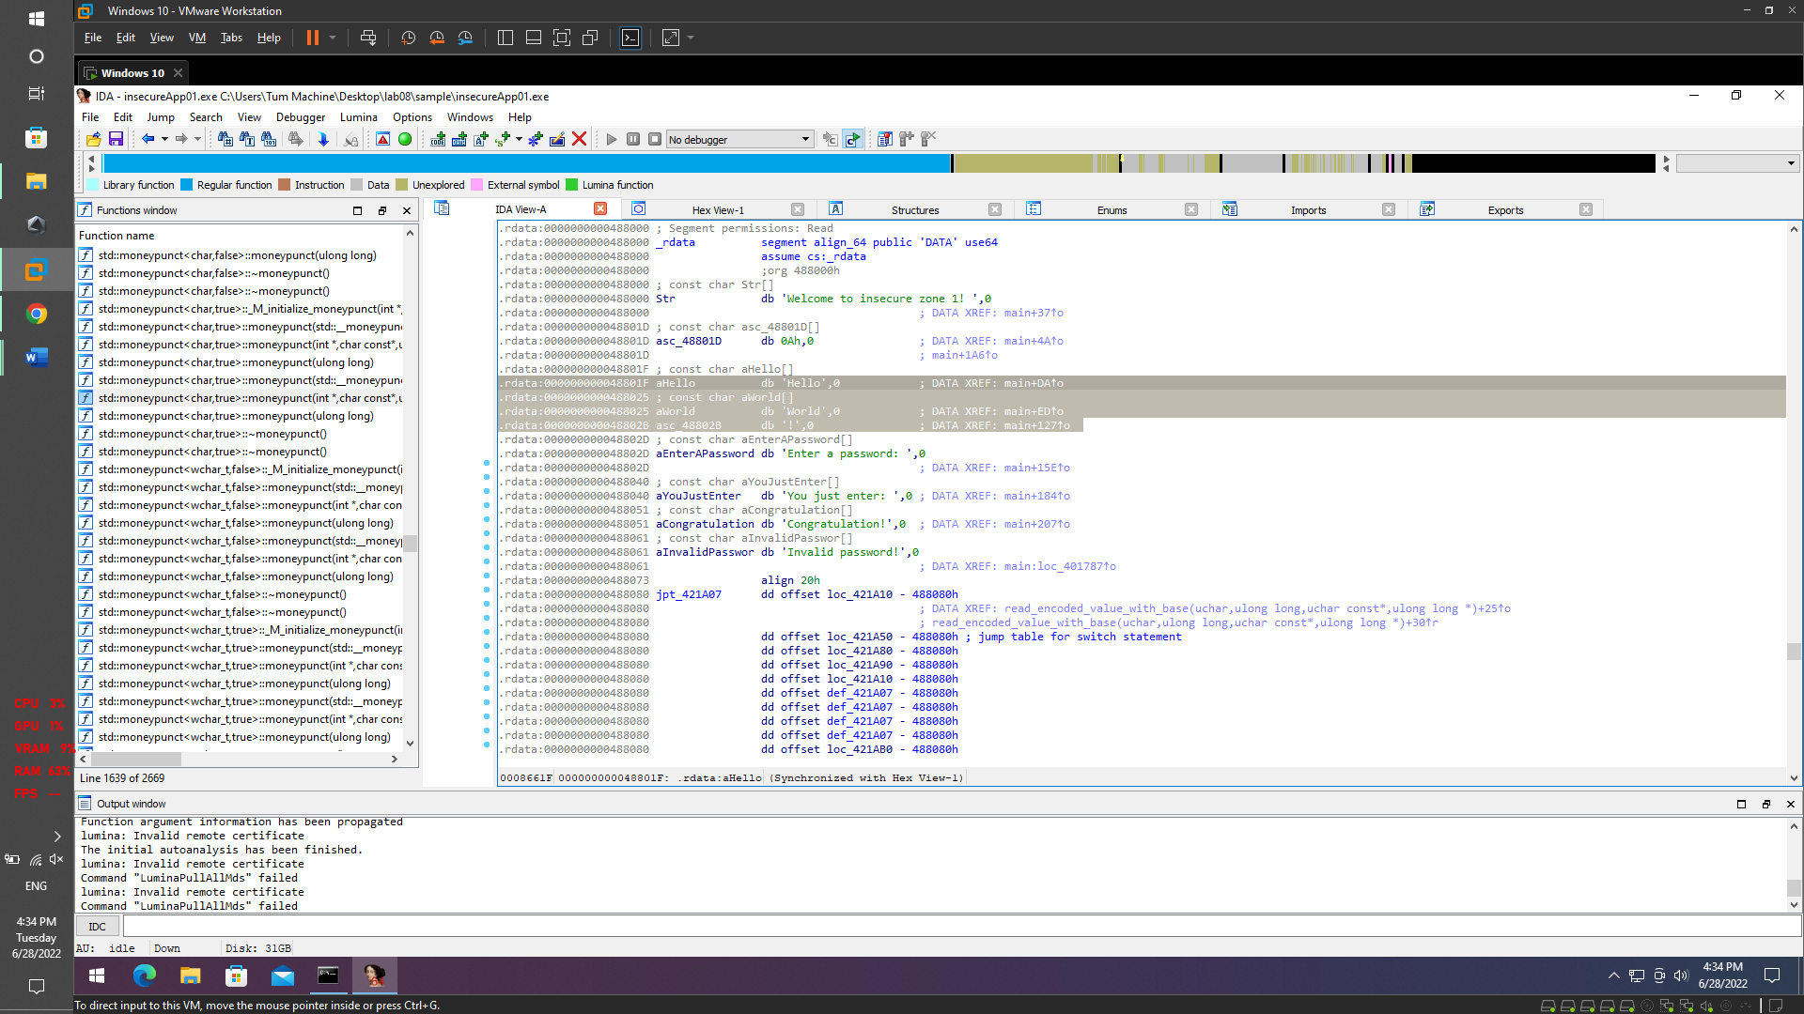

We concatenate the 3 strings 'Hello', 'World' and '!' together and we get the password.

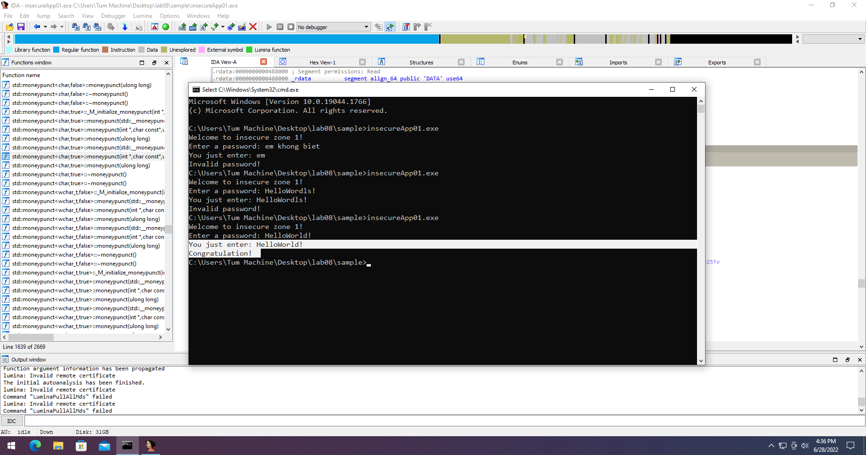

**insecureApp02.exe**

Run the file ‘insecureApp02.exe’ using cmd. We are asked to enter a password.

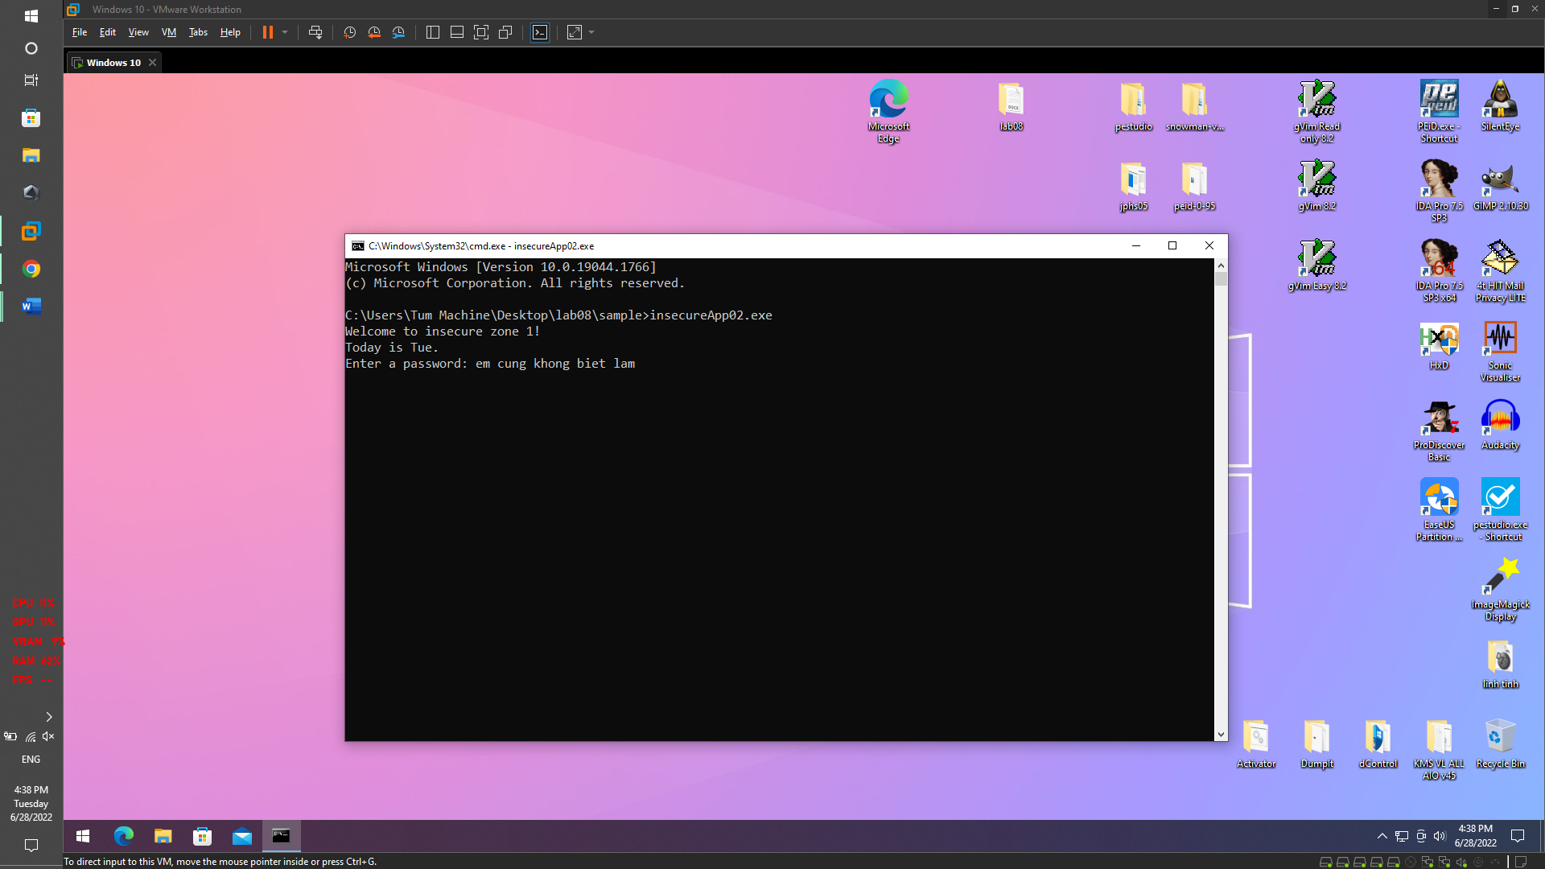

Run file ‘insecureApp01.exe’ on IDA Pro

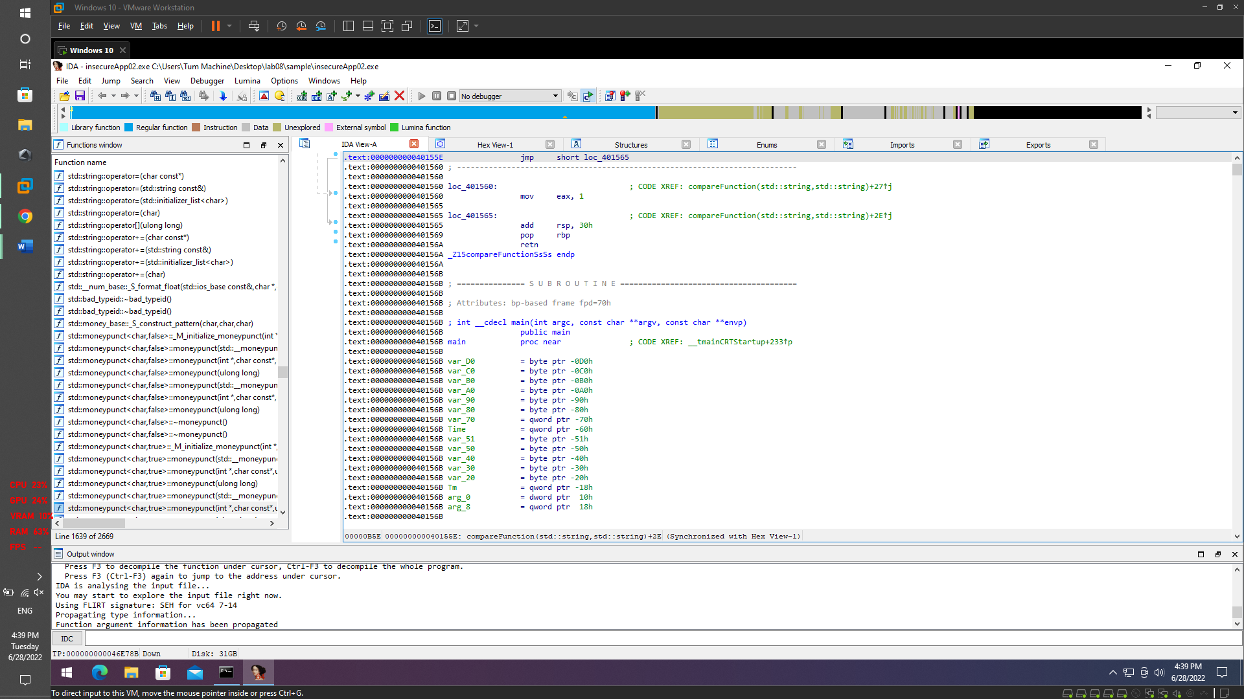

View ‘insecureApp01.exe’ with string flie

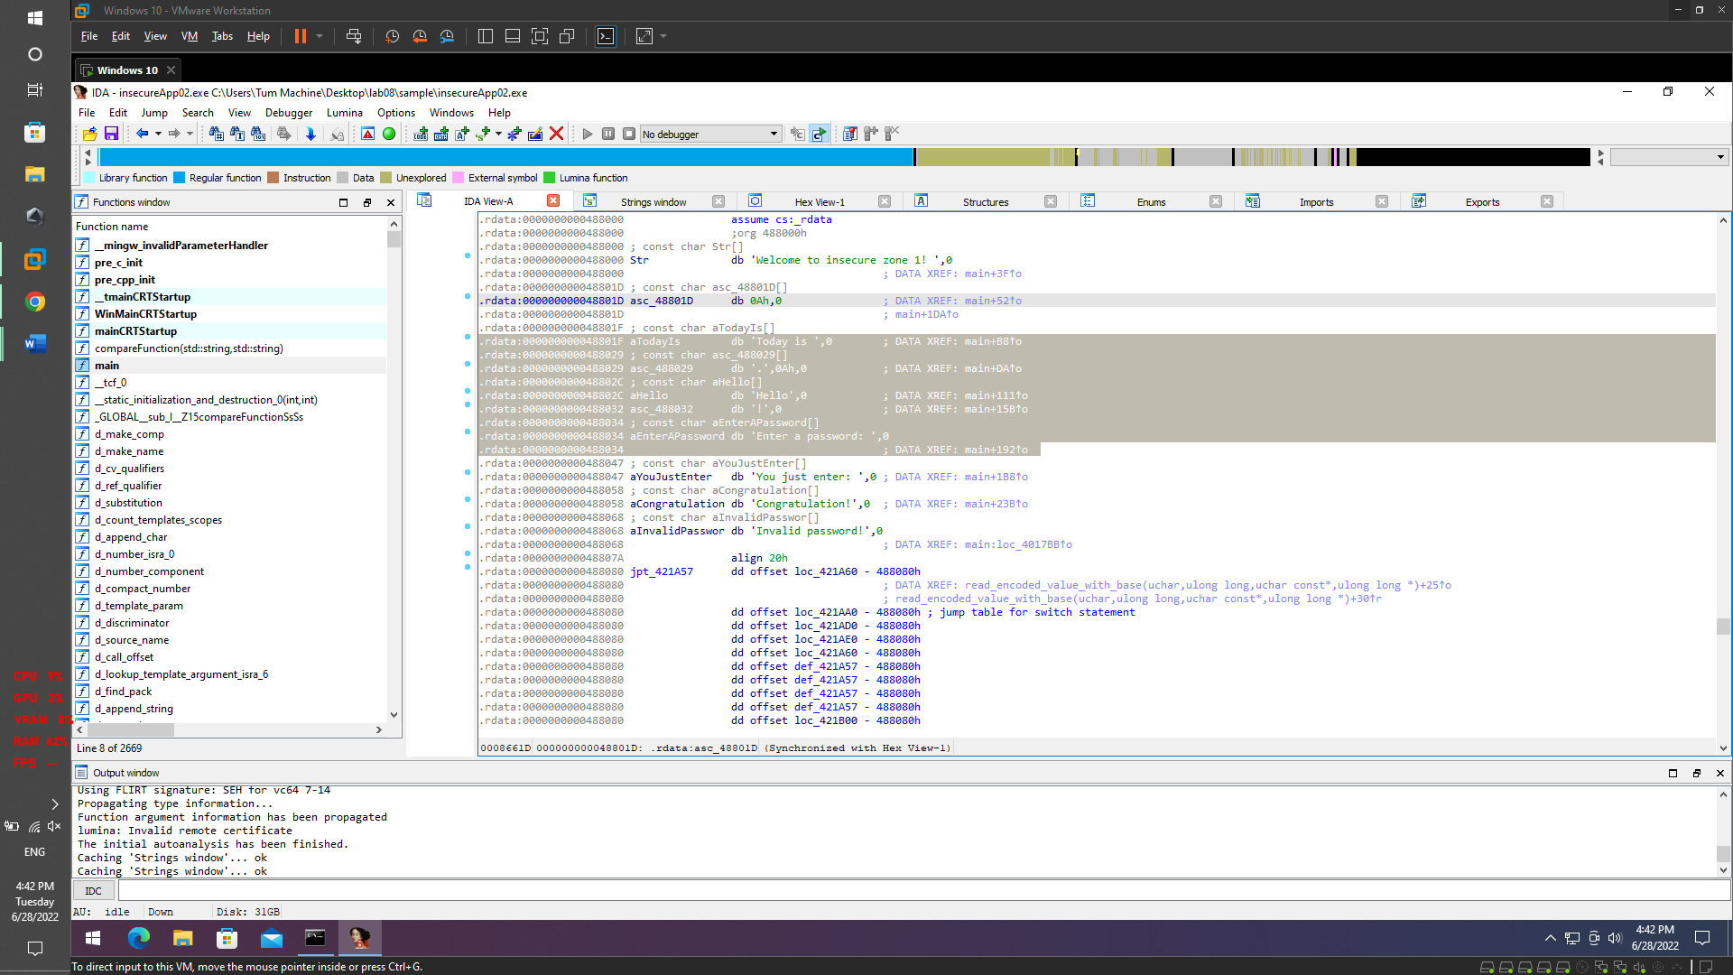

Password change by time

Try ‘Hello’ + ‘time(today)’ + ‘!’

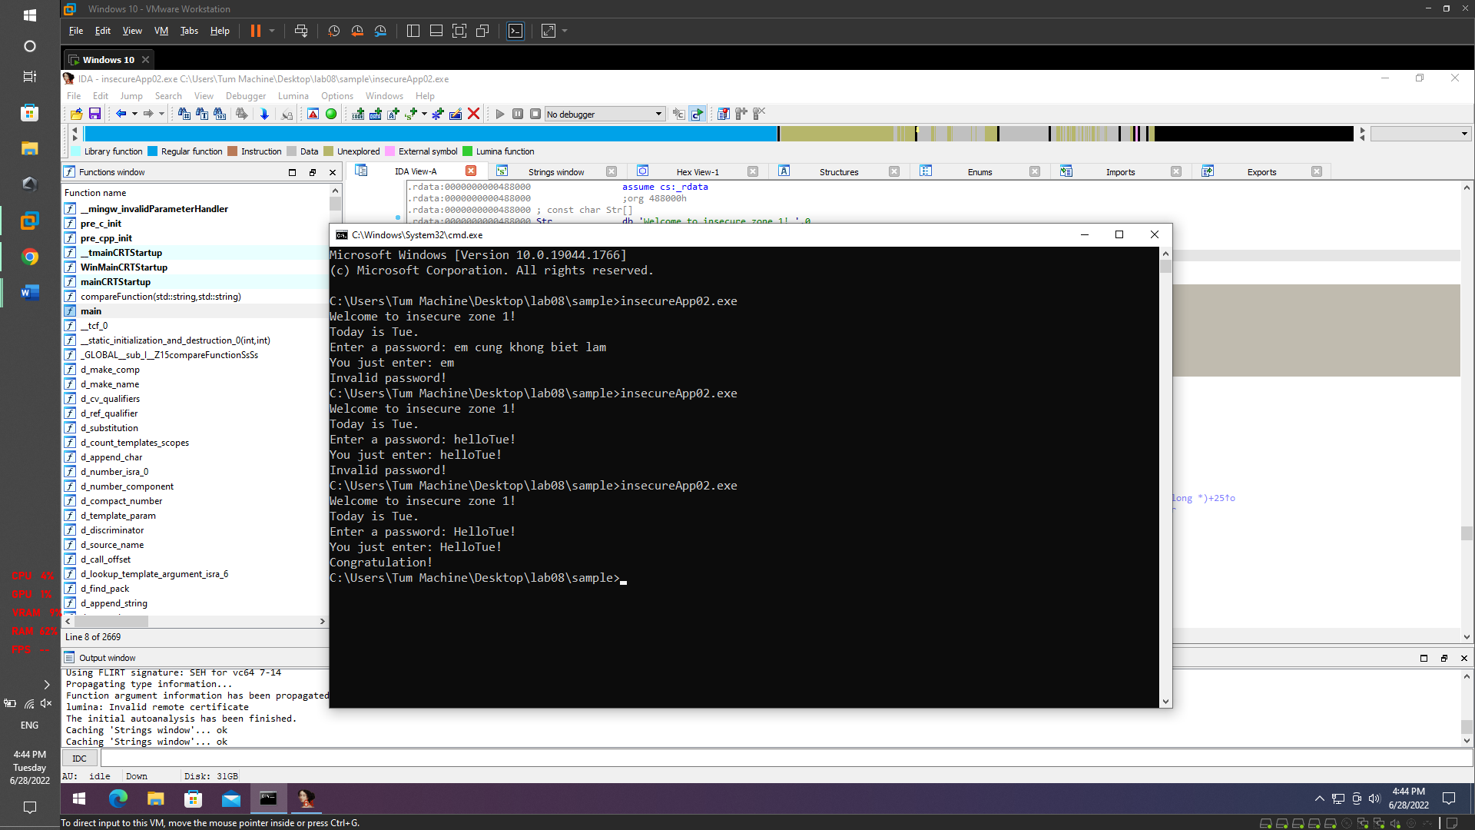

Congratulations!