**MUsic website**

PROJECT MEMBERS

NGUYỄN HOÀI NAM - 1611061851  
CHÂU HOÀNG PHÚC - 1611060633  
TRẦN VĂN THUẬN -1611060844

Tools and Environments for Software Development

OUTLINE

1. OVERVIEW:

Establish a website that allows users to view and listen to music genres and register an account, listen to good sound quality music.

1. ANALYST (2.5 point)
   1. Feature comparision table with competitors

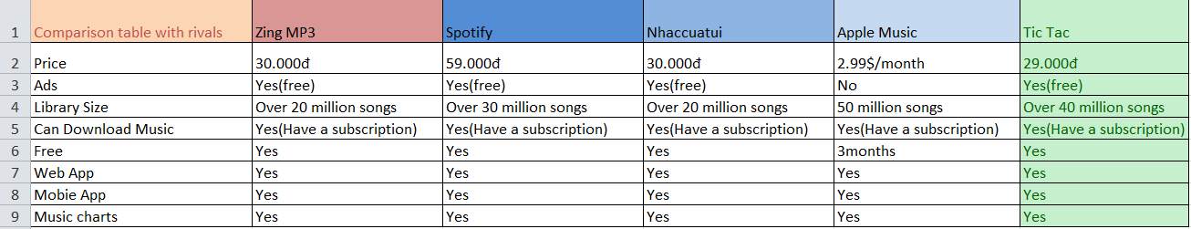

|  |  |  |  |  |  |
| --- | --- | --- | --- | --- | --- |
| **Key partnership** | **Key activities** | **Value Propositions** | | **Customer Relationships(CR)** | Customer Segments |
| Facebook  Youtube  Zalo  Tiktok  Instagram  In which Youtube is our main partner. Thanks to this cooperation, we have a large amount of information from customers. And we get the attention of the customers. | We will develop websites and apps on anroid and ios. In addition, we will post ads about our app and website to community pages. Especially our main youtube partner. | As for solutions and values. Then our solution is to strongly value the value and quality of the products we offer.  For example: the mv quality and sound are good for each song but at a reasonable price. In addition, we overcome the shortcomings when customers comment below the product. | | Personal support  Complete personal support  Self service  Auto service  Community  Building together | Mass market: We will get information from a large number of potential customers because they feel the product can address the general needs of the population.  Niche Market: Based on the specific and unique needs of customers.  Segmented Market: Continuing to segment customers in the main segment by relying on small differences to meet customer needs.  Diversify: flexible service to suit the needs of customers and with the characteristics and needs are not the same. |  |
| **Key resources** | **Channels** |
| Currently our development team still has few personnel so each of us will take two positions.  Technical, project development (ChauHoangPhuc)  Finance, ideas (NguyenHoaiNam)  Project management and customer support (TranVanThuan). | There are two main types of distribution channels:  - Channel owned (But because new development so we develop on channels fb, tiktok, youtube)  - Partner channel (Mostly youtube, facebook, tiktok). |
| **Cost Structure** | | | Revenue Stream | | |
| Fixed Costs  Variable Costs  Economies of Scale  Economies of Scope | | | Sell ​​the goods ownership to customers.  Charge the right to use the product or service.  Customers pay a fee to have exclusive access to the product for a limited period.  Charges for advertisers advertising products on the intermediary channel | | |

b.Business canvas model

1. User story list or Usecase diagram with description

**1. User story list:**

User Story is a simple document about product requirements with a user perspective. Typically, User Story is written by the customer, or the customer representative, however, if there is a collaboration of the Development Team, the group and the customer will have a better understanding of the product.

The User Story format is quite plain and short:

As a *[type of user],* I want *[an action]* so that *[a benefit/a value]*

Great User Stories always fit the criteria in INVEST:

* **I**ndependent – they can be developed in any sequence and changes to one User Story don’t affect the others.
* **N**egotiable – it’s up for the team to decide how to implement them; there is no rigidly fixed workflow.
* **V**aluable – each User Story delivers a detached unit of value to end users.
* **E**stimable – it’s quite easy to guess how much time the development of a User Story will take.
* **S**mall – it should go through the whole cycle (designing, coding, testing) during one sprint.
* **T**estable – there should be clear acceptance criteria to check whether a User Story is implemented appropriately.

We will always update the user story of customers regularly, always upgrade the website so that it is more and more developed, more convenient for customers.

**2. Usecase diagram:**

This Use Case Diagram is a graphic depiction of the interactions among the elements of Music Library Management System. It represents the methodology used in system analysis to identify, clarify, and organize system requirements of Music Library Management System.

The main actors of Music Library Management System in this Use Case Diagram are: Super Admin, System User, Agents, Customers, who perform the different type of use cases such as Manage Music, Manage Album, Manage Album Type, Manage Performaer, Manage Track, Manage Music Library, Manage Singer, Manage Users and Full Music Library Management System Operations.

Major elements of the UML use case diagram of Music Library Management System are shown on the picture below.

The relationships between and among the actors and the use cases of Music Library Management System:

- **Super Admin Entity**: Use cases of Super Admin are Manage Music, Manage Album, Manage Album Type, Manage Performer, Manage Track, Manage Music Library, Manage Singer, Manage Users and Full Music Library Management System Operations.

- **System User Entity**: Use cases of System User are Manage Music, Manage Album, Manage Album Type, Manage Performaer, Manage Track, Manage Music Library, Manage Singer.

- **Agents Entity**: Use cases of Agents are Upload Musics, Create Download Lnks, Manage Tracks, Add Details of Music.

- **Customers Entity**: Use cases of Customers are Search Musics, Download Musics, Play Musics.

**Use Case Diagram of Music Library Management System:**

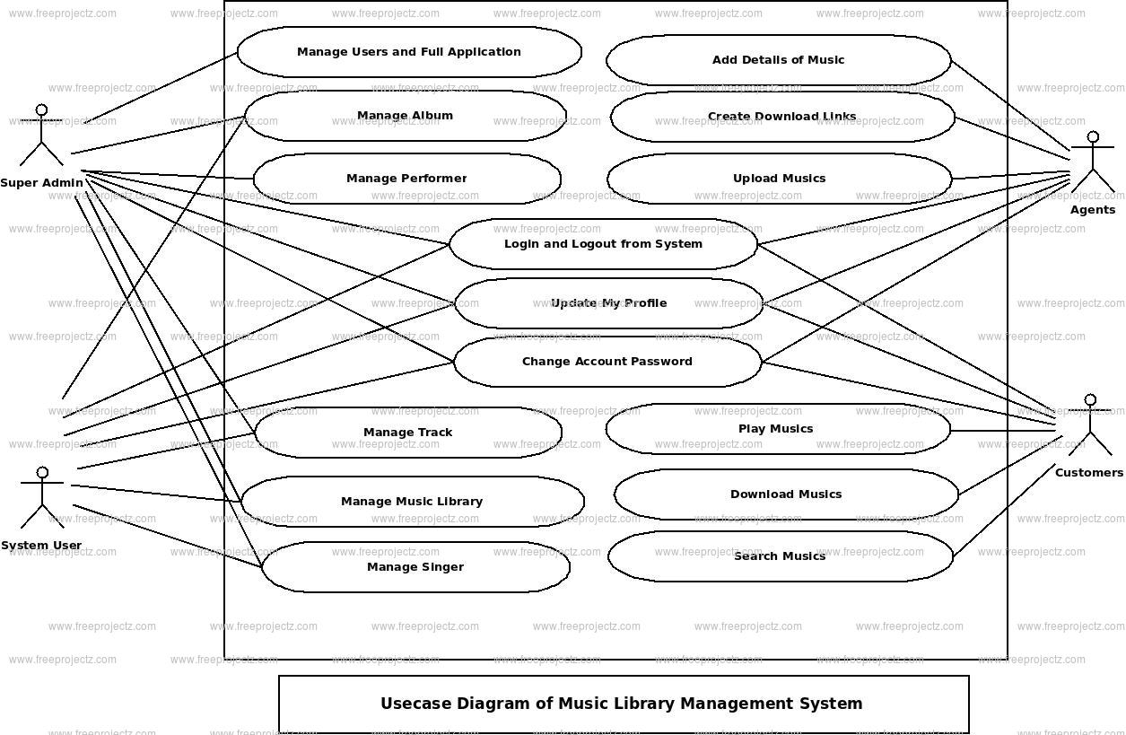

1. DESIGN
   1. Wireframe/prototyp design

Logout Website

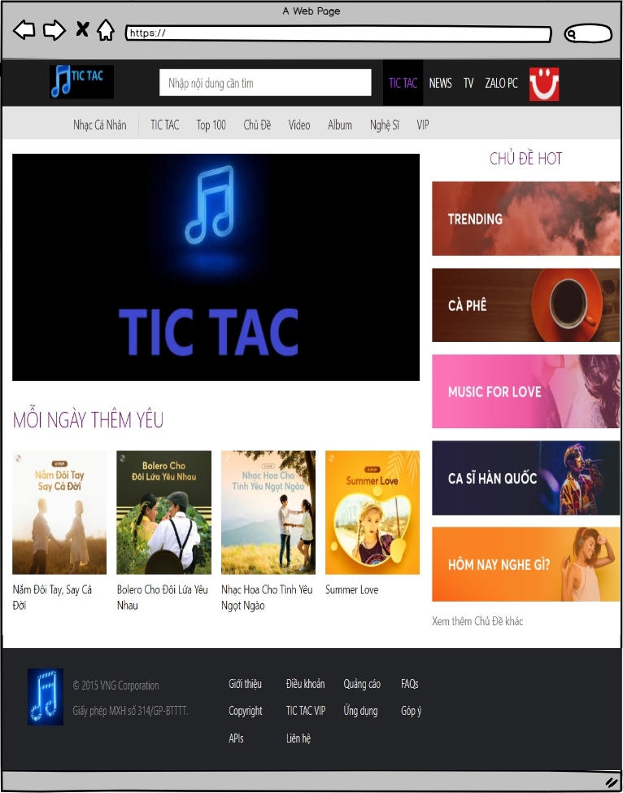

Login Website

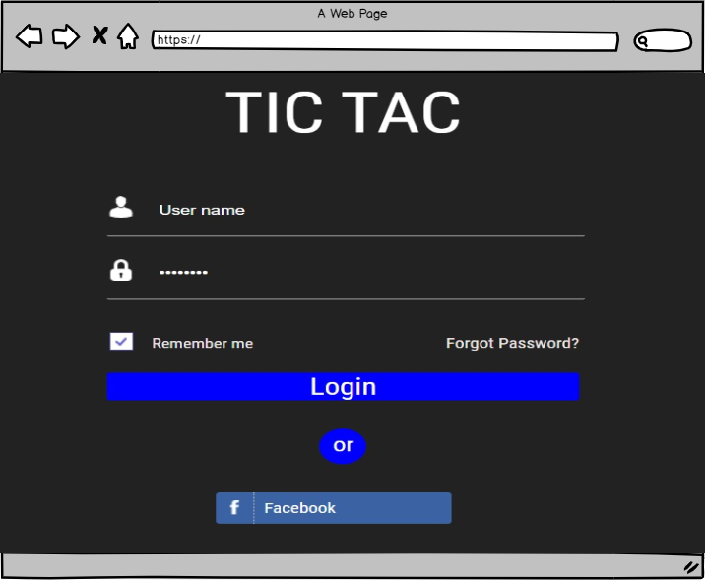 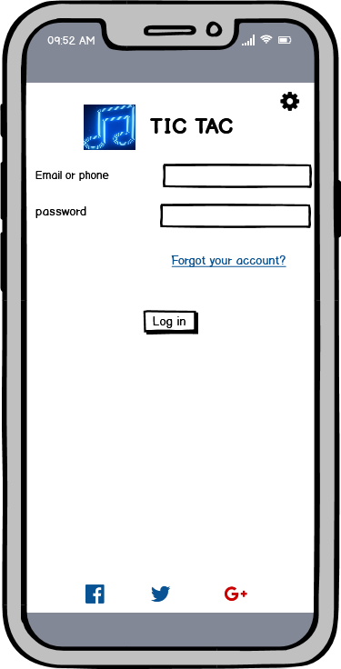

Register Website

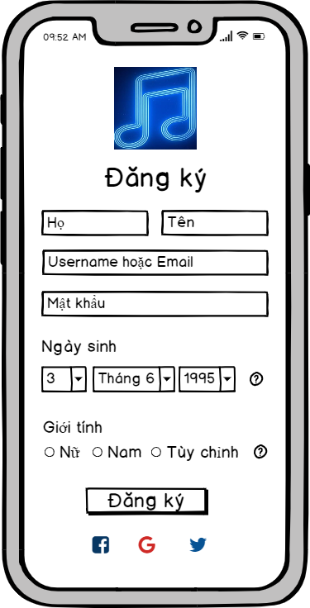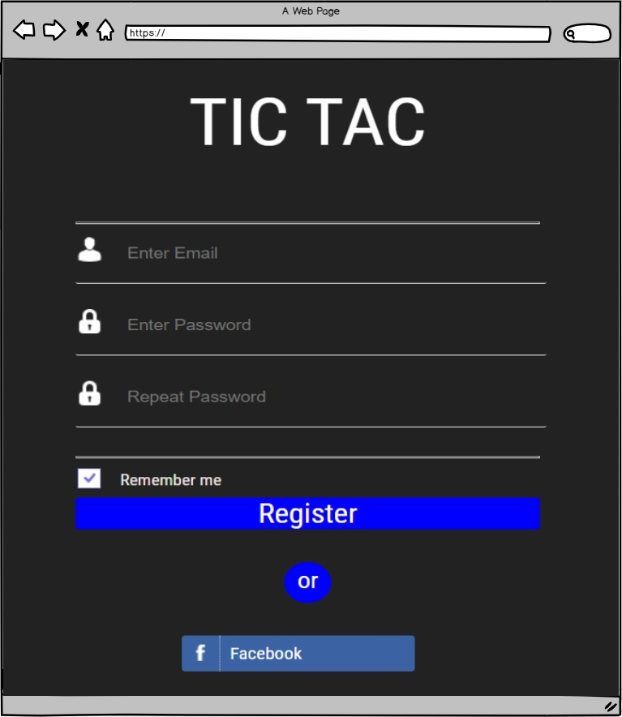

Home Page 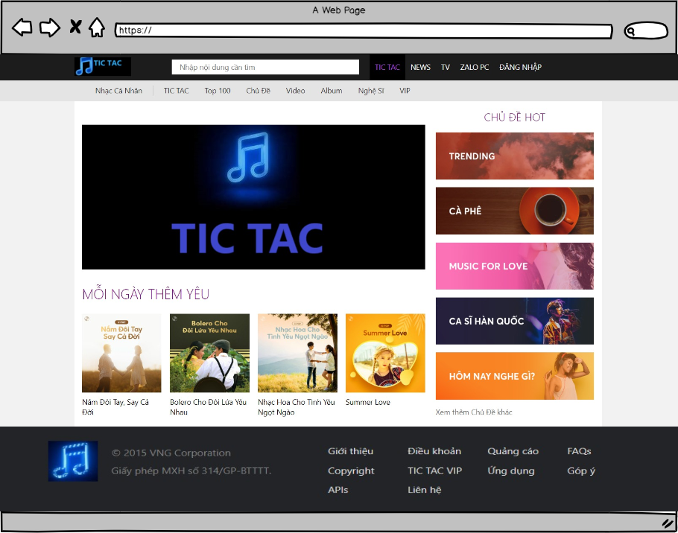

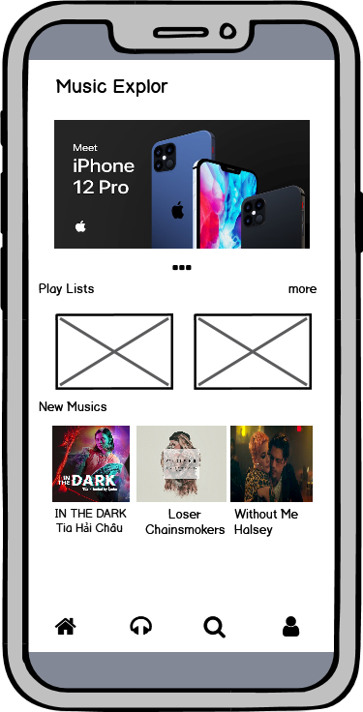

* 1. System context model

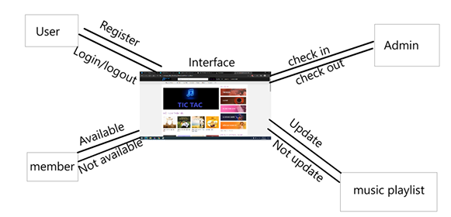

c. Database design

Login database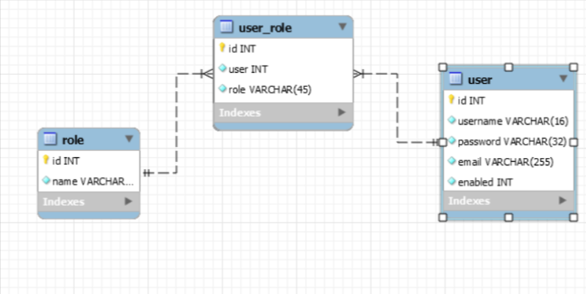

Register database

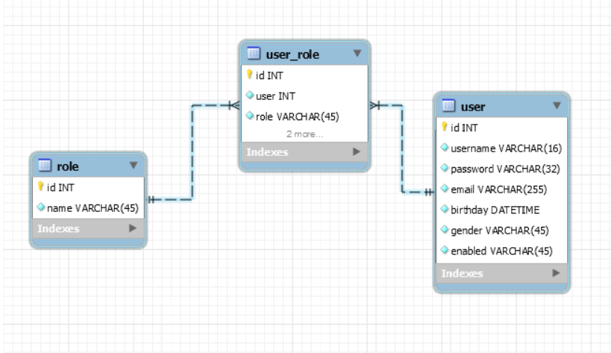

1. state diagram

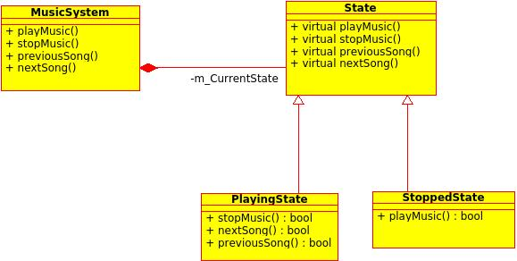

Sequence diagram  
 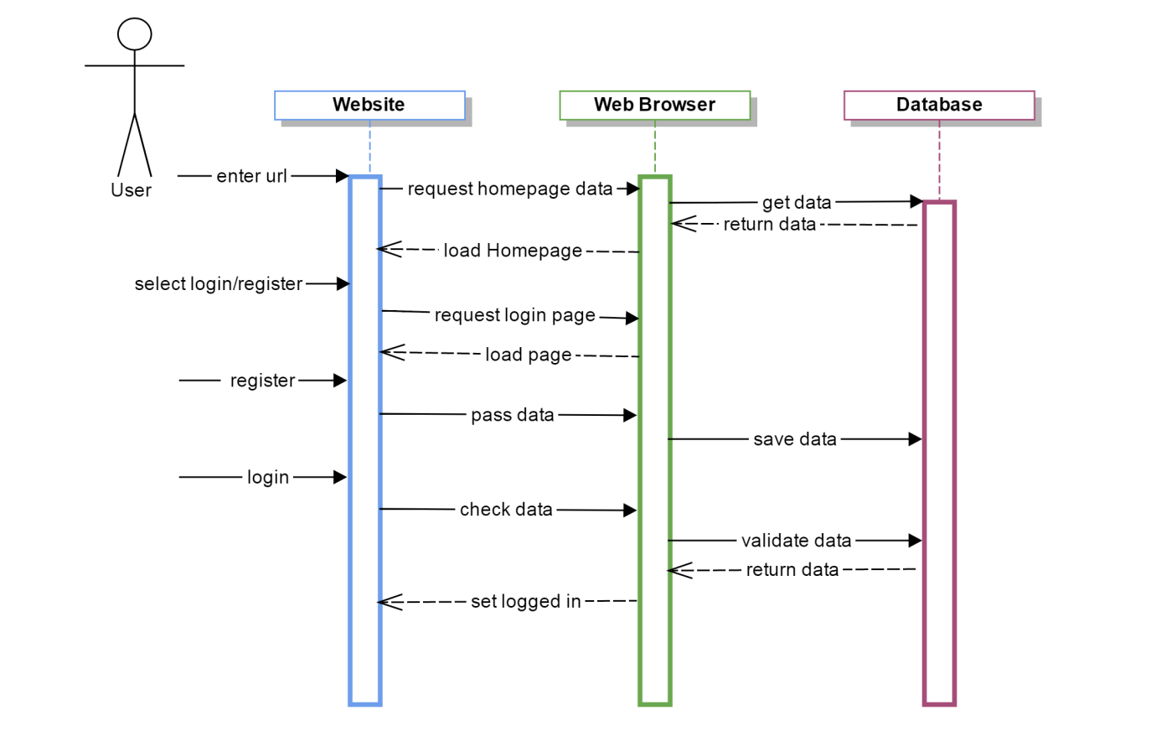

1. DEMO (here is only sample, it depends on your project) (2.5 point)
   1. Homepage
   2. Login/Logout
   3. Register
2. TESTING (2.5 point)
3. TASK LIST
   1. Task list for members

|  |  |  |
| --- | --- | --- |
| No | Working | Name |
| 1 | Outine | Nguyễn Hoài Nam |
| 2 | Feature comparision table with competitors | Nguyễn Hoài Nam |
| 3 | Business canvas model | Châu Hoàng Phúc |
| 4 | User story list or Usecase diagram with description | Trần Văn Thuận |
|  | Database Design | Trần Văn Thuận |
|  | Wireframe/prototyp design | Nguyễn Hoài Nam |
|  | Login | Trần Văn Thuận |
|  | Register | Châu Hoàng Phúc |
|  | Home Page | Nguyễn Hoài Nam |
|  | System context model | Châu Hoàng Phúc |
| 5 | Some flowcharts or state diagram or sequence diagram | Châu Hoàng Phúc |
|  | Demo | Team |
|  | Testing | Team |