# PART 1 – Business & Data Visualization Question

Develop an interactive dashboard that support strategic decision making with Tableau / Power BI.

Please add your answer/analysis together with the dashboard.

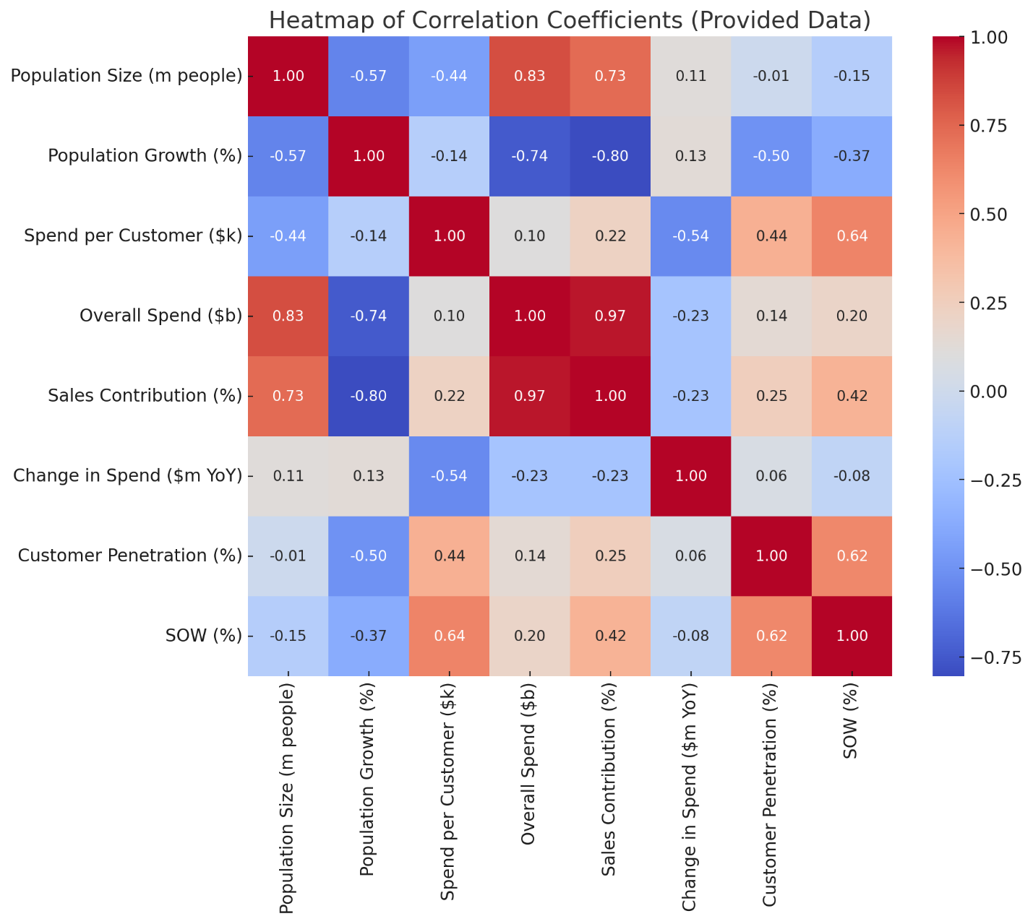

Based on the statistics presented and the correlation heatmap, we will prioritize market segments based on two main objectives:

**Increase Sales:**

We will use the **Sales Distribution** variable to evaluate and consider. It is observed that the greater the Sales contribution to Woolies, the larger the **market size** and the lower the **population growth rate**. Therefore, we should focus on markets with large sizes and low population growth rates. The average size of these markets is 2.5 million people, and the average population growth rate is 7.4%. Hence, the priority for the objective of increasing revenue will be markets with sizes above 2.5 million people and population growth rates below 7.4%. These segments will be: **C, D, F**.

**Increase Market Share:**

We will use the **SOW (Share of Wallet)** variable for evaluation and consideration. It is observed that the larger the SOW of Woolies, the higher the **Spend Per Customer** and **Customer Penetration**. Therefore, we should focus on segments with high customer spending and where Woolies' market penetration is already substantial. The average customer spend in these segments is $2.8k, and the average market penetration rate is 85%. Thus, our priority for increasing market share will be segments with customer spending above $2.8k and market penetration rates above 85%. These segments will be: **A, C**.