Write-up Banh Beo Bi Binh Duong

Đề bài cho 2 file nội dung như sau:

cipher.txt:
QFVI1RbInNB=?5z{W8L{WVB\Z}BAZ5cIZ0|`
seek_here.txt:
qvwqOp=^O`u1HWn4F\p_eJMscFBo0=d;PAzgj5=2L;GQ=:`Fo=Ht^6?cD_B]X]C7K?cdPfRsM;B:SMU^>T8KMrC_HcAGah9s|ax@3I<zvrgnf]e`gplpur0tz7sj?ct`wi@3_[oo1jp:\r4iisy^a\s]zqj`pxvf?r`1t^`xpmmnj]>{wfF:>f59iDAksJ7k?RsfN9Y48}zX>v:iWQ_nOLk\TXfi=zTNAN]VSOko8tYOopJ:Lmhz3fo=[SfVGvft=Ue8qq}ph31Qbt=5uqPx^vbz?Qpc9prQy}E^xJGK}2wzWB\c}IB=qYoa0M_<y7[t90rqi5u7p]\{7`=_bj=z^\sfvkvsrad^v:b=rv3olvp=yk?ovi91ur0vkp@lc}p}3ytcsyzla{zl{@omz0y1kohpoz]bmevo_fclq9@?9ydfdg?wynbpd4xkv=`n_co:1o5a?^kpnyo^ukga3u:tethdo{?qymda}rafg@=yio5i^lwwssllzy8aoc[6u\7^iirfe^ch9k50}jhc2w8ivn`tpbo87w;r{7af_\^pq3l3i7gtl2laqr^\i4hfkmzvc8l?wl`m48besvqjldb;vef}tlzj}s{danr>xe644Cunf3nYA:mpwgDntxyAm3^8]dM[_V[\j2DN:epy1KLV9_dr;BdWOI2wp<`\=ymVF^zntuL=z29_eceB5N0z\5rYZS_q3Q8O^3O[8DucSXek5@@ffFJJnl=OdV4:a0JK@>c`}n?0<`5Y}b;DX:swnx[QW}OIA8>@Df58p>t4JACz{wEOCH^Ss=p]FmKnMI4Fd6DVwotn;^_q}nNn\?HL]6J}2_FinZIxV4@Iq0iuVudr:QZtHbeLD4s0lVTuL9s=KW4p0[=nIk_[:Pwr<h;arnrh\0m\cnezm:ip:i1y?z?3urp5iwfeqi3m]nvptgf8oe:}qz?oc9wt?n7psvzndz_efk_qcibc:p0|td:ilgye4y{oe_=:sbdwxfji3gm=32_ypksvpgle1lqia7s;zvrg^pdbime?cea40|pg5bf|lc}n^gct{bz<fk?c6eoj;moz]grs[?wo_xs1pwtnk<b7j6gzvlokw0:r|ms0z^yj;4`ko38@^z8[a{k<18id]xm8lpnx]:i0kpsc}ok<m|lj]kppzilrr|mbf004p5{_1nyxs:1io|qhqve^epfi`t8r9wq}ggfkj14nukzxi<elzaxmi08qj|`sc0bvisk;[n?8cd1z}m2ag`}`vpseka2to30t0ho;ooq42t8i0=kx<k0zpyh}git`|^9qlfc6g8[[unkmtrdfisn?op=]o\qfz^wf7avckzchbx6^k`umf0m`okzuekd1`>C2QGc\Rc;Xx4`0}heG2iF]L<{}g<a[s0:gukd`;:ihk{@0jquigfwak7k4{wpqq3og@h6duls0rjz]`yfe1=v`qwuc]<rlzt2ov3qo^0e]?vz:qkrhqxooetytnorld@13mnr^y7rdoey1@up0e[d=}zo7k\`?l1r@pxdkygl}yadrrr}ovc9llepl}<m5xx3szyficvbpoud<^4ctmba]e`ph=x4afv9emdjxft\yez]aypkcx1t1}]eorhlzxvoax4>Fwnp?uK7u`t;I>4`\0gw=^:FpO^z\VZp^zmDVDNfDIYnlzi_e\|e^LtgtEiOV=5v6>D1g1x}33rL;S6vOVbRZidPk6;3}Ytbpprc15^nnlY\tIQZY?j}l_LKf4^pMH}C?xDOx3i6}F?LuikMd7:sCH]P0v\`tgWYC;bfOxiiKEskP<<;n2`wl_Ctt4WQrXZubpHlpI8NB5c}0?EcsS9q^?e_|m^puw8?t2qz1MN1r\18o6ELvMF>8L|d[x}Q`_<<rv;krsbiu2r@m67bolqwsr=ynqg|xwy_dleszc]^iw?]8vb5ppkck|z?n3oerq0[n;:f1`ypn]]z8zz`qhcxd?]vo|zsk@r3t|4?6j}cl4`qssdyz=q043}sihnzpuf`=5|ozklchz}}v]hkytphog[vkrbueuurmfd]mqxpd:70t7tzcszxw6pfmmihi15asyohethtw8{gxt?vstk6|hvzbop^;]db\nw;=6k{_{=q7krkmal=x?m7sig8iy=1tf6d6u:h2ljkg2=g0xdpyp`]bz?d`<akw0iku\ixm<lz^z[s0ym4o6<6he_wlvt8gvi]@z6gssvowpqddltasmyqp1iyb?3d_egte44y\2w]a2gjhmfii16w2vagy}[a4oa0?wdeluaii\pupq{3^c_jiru;xqwliaa`?}3wf1krbxj?8yrwmo@fxpg:0a?\yjkuwiojb<<btfkrg]op:flx>Qo6lkF1a1?ji2ElIi^FT_^:Fc;=y2ndL0Vx0aKzl=n6zgF2zCLgU}0fvibt:oNrtfSAtB}xAJEEGfYis^bgra{OnO_^:3pNv_L6QC=UeStt`8^OS`@:nZo{pUtViuiK`E_>S^7a=}SSVzGcc?y4xJTNH3qh\4OQZl_ko3x;qU5_9]Z8b7C@Y]UxC>[3xFsz36g}2AnKwAzqt7vA^<e}^ukncq]ibe`tr4]q3i2xnhdlcnz?m?hn7tfsycu:qtw{s1we<3ydekz53hu2_e<<elp]nlvm46r:eksnuo^yx3e`yrwdzrvv6kia^ri?^7{xo[;mw]d_@ah1d}os@zl4trddsfvk_>oiOOp7Pif0F8tx_eBr62tqTVV=^otsntbY0IYYaS;2}CG?tp:1QW7BL^d0PLoiFfguPdF8[X\QuZ5GS]leADoNVQeEBgcL3w12WlDNI8p@1918{0FDr=Mf^nFmRRnP5b3fkyk4iMVe_kols^VeIlNWl9il_f]N>\emObicO{]OO3FQtwnC\j0l_u8lLYJPq^ZAnMJILaP@lslD0:gmIX4L:X3G30c8Kn_}_8w7QGVIzcRx77AXf8Oa^u=QB1PqPq7I\g4@OU8sOOv\cu4<^gM4n|ZTrJ2?nIOXzov;F^q<nxqnknoc;m`bmsctkzf]`_md|a4m@fejlv86b@fl649artacop4dqru}5nbfc3zpv=ulp\w:dh9q:pomvesnaecticsw\eld@=iesnq2veepfruvn|[187vpifibf6mjo22tg<dtszsraxrd_v{s2csvv@4v<z}bzhnn_|dy_|?9_@ho3irihw5q\<tm`<@0lmbnhli41m4==ijlh>fs8vfOT_UF};52nXdORmz_]br98n|6l8zd{=wa?\VSt_\UDfq`UvAz_[1Fw4YI\70M8sD:CDfQ{uUibxVE3?Pa\7enlkk5adY}qczGpSo_]Lyd}WQJnpznJG]K{d>q|JcsISFP5p7b=qazQfSVoOZJp?aR[8;RpxT7Fr80c8}kbAlG`<mxsff}6?rgu6__a[sep_zr<bbemw9;t:`ot}?_auyf^_sk:sxj]wcy4sbzrkbjhg]adezplleg:sh<zch7>nIWxbcuiu6H[Z7\wnY>bLb8riY:C^fK_:?sD?A<jsfxr>wmr:kQ=LJ7>zeDc@IeLt\^c\Fi6OboYLu9dlCxt]8@4N@@e5sp_ui4c]hr{5kPtj8<h7o?v887\h?v?yb_u^r]csbwrnrm3j_m`a}5mze^{o>Zzmp]PkR:twI}NClIDL`ptyypp}1\xq2DV5]Z_O5oAZhkFQFDv4g7g1qXsnZ6JFZ{ee9xWXQPDfHsLXZy<dotes{zqz`0}s8]fphc?fv3^z_b`qsf}hwt^nv1w^dwfppl1d`c6plwn7qo2=blsnx}yn}ot8jue1}v0ck8w=khn^nw1@a`\0jwnyr0erfkyjvg4lxw1c{kpvzby:=?i5;jo8=uzm`r9?yd:7954^02c]a98wtv?\tr8oiu=?bfuqeaww5^2fcwm:c}crs9tl@zcwwo7vsu6^rpjh}wldowvuzn;j[a:`w5sbc`r>]?BWV8`Dnuu4qzxR;qi5axnp\Ex:x}MT^:Do_5<oq5|ma454mrujm]s`_knnnul}v1vw6yps>bRaL=A2eFrJt1j1}SjRru<imiv5eg=]dpu}iotft0wx9p|uwt?i}n}b5bx38l:f}iy:h8qkrl:u5ow0tapifq`oj3}c\:d<vsno0hbgz:qnlp`e[vigx=di?:no0[lyz[zwecouqe=n3=z02<:4olmf:avzi=9oi]{6]=zz<nv@zzzv=gf0x1q4mnds1bikr}8i=ov8_^fgmkk]yoze9lixqqfo0qz}t`cgrk`n`mr^_n=mbff4ru_n=fuq4wqgo>{cs`QK1_wb@]6qlDZu7n^Q\hoV3coDfn7za14bDDlOMG3pnrlpR0PLvOlzS3Pu4I@3?klm5Qq@m;So8Z|_P[G=ta|z0<o>``2W_CkRt9Ymj?L3QKfMDT:sz_>\IL3<gd@15tp7r8si:qy<cpq3b6bcpxk2fl_f<xupkhf4w]rfj:uom}mwkx`a`lob=qa]vczjcf0_l8xcrfgyr:@w<d:h2o8xr>\^DF9]ppC2qdi7}:0xqYsXsp0WV]t6xYT_nsrV=84[23GI6v:_ru_aFW7DJW8o_3}z0}?_;MeoY\bcs85]kbWa^cmLl:^vnMc@c4edKZ31W7HiiN|s`AdUg}_bKtIfqm7c]8h\kBcPdxT3gLMqnH}MiqpNOdA^4GKVNOzi6^DCKp]KPrb35D^=pjiSh2;1y3sf7NDL@I\|^}uIDMUaGt98lTdO1{`elq4]3W]s40?MjZ5f5`=ZYe5^xe3g6}@rwBmtd98>=nlC}3pX2tDuohCey_^m^`WVetF1n;2jrG=WuXbzaW7]lxmra]ceIoi{`2zew77FVY7uLgnXtNLF?D1gf?Duq1S?Rz1UI;F`B:C2Y]iRp=C0goh5IM>6|VD:=sc}kMCtc@7Va;j=wgy3bMy^4k:b8s7T^444H_PVDH_qnc{_}9kaIn_}7h^s>jEqWBrAfW7GHohOoxA_M^=qMGcK`@p5z;p[Ik|Ft[s2M1PXz|rk8tXlNd0iZiTK>Yi|_b`kRjF\SW9P}i0oZE::xt3JkVr8Xp`]VetIZd^Yges1`g8`Mv_HWAzFYyws`_joT:nE]}vLGm|fmtebHO=]dX8UlEC}E0Zp3Y]}D\=spC}OVzq4DBU5rlKd]<ulplt;ojz0[u:`q1r@sg2z?gz`vo;us7]cnvnfbln`\fmdt1h8tqwb1=dbzv\hvwo08l9xukow^a1i1s}mv97eziybc|ikuwnncj<?euov0`kos8udnhyz1b=_v5k3csxoe\wh6`dtityir=p81iunnmkvhlh}jo?dkk2d=jvkvcf=`4vecw{iipk2o\p3sxr?j5wd|cd1d^wd^cbssn1wyag}3`o4`z6=ys>dLO4}M|GrFI`_w0z]}AE}_c`<vn7;io?i7cwt7jv0^zfatktjlwq41w8ob0\qth[?|lm3mpn=nj^eviqd;i}mv:_br?]q^jjuhihdxq_ftkcdupjr14?`@nf1s4qyazdlw58g9doti8hzuvovpgl|}tv8wkauip_i1tpmhs`>uue]zA8Zu[n_GqIiCk4qmt^KK?vOqYBz]^A3XYrUaUmcQ}|vE`1PFtqv>o`\5HiPoe:e]Smn7X<z?v\naqf0l8zune0sl]f4`:e?6hsv[s<=1x9l;y3dy\k3asi3xsrr}2blkwoymyqolsksv:0oz[jaa>@}Sb47:rt4uRp7Yzcps1zsd[{k3sr`R2}@qLT00`u4o>w3oLLbCM<ocak:4ob^k1rd}3v{dww5q>1SkWYn4p_Dzni0GpzdI7|0@=dg<dh|o?f=sosrdfqb3f:;wdt`ze2=cxnijhi`oaq5ybo=v3v0s<<csec9`igsbl?l=d2un>a0Wo?}}Om4eQbpAkwwc|PjjAQzINrF=OI0alDPpE]rn:8exUxC::_45?E8a_[FUuW6lSt0zUzUY0xeCbR3]sJag>MN7A9U6Q3y@4]w4g^}sVmr0tmY2M=xc`oZIUQ3q_3w;3Zd8PvktHi48Zq>0ap[8oDR3wxI9X=38=cHp?[tK:xPOpokt`jzMvvD=V8kA35l37}FTNoj^W:d`|xrFW^Rio4nt\:ShqN8sG9c3MsqT>`Y7lz3F1`:YC4oZ:OZmMI]Z@oIwx9H3DKQSVbRp`Lcy}RYLeCMDa_3c_P\kFM\gsnH\3f\Y{BA^mGi:__OPiaGa=Fam=8?]pq34qPZKnTSmW4lxArh^ou4rs:ont7KIa3snbbOmc<]zK;]4T_Q128_wrt9:Z2}0_YIpSudE@]fe4A]p8e71cBJ\K6L:d`|6QdkewUCzf<tnsfcusmsloif>Y5se_F2vw^9M@_5fQ@MKwkVF1TQ3T}owF[q3E_;IqvdGkj`^SiYuNmy8qc`?l;n\ifiFk0L>gtMt_t=nx`91=UiFwlG5B36L8cFMcptvgq3AtbsDygaES7cVi>|{{Urn1ckM@>Iyp?q2hURdwzpoz]3]HAAGSi=n12?M9LgbcoO14z|rnv`8CPvSl0LpiSyrBEnO1wW}^UwCitTIGofKO?<4r=Kr>lMYvi5Qo{>Pw4^V:?vEzqHZ92wt:dyW8KCCvZf8wSk;@q}XMRIXBv1B6vBcP_Z`:Q^8eeL^Owp7`[t81LDhCsGs?0DpeP;OWF_0c=]mEx:3ulu7{YD5j`@S[u4aIkO{pOrhW]y9t=VOlJrf:PTI;N4^k5E\xbow_A?FwwSx?}yPV]3CwCQE37YmUZ=`=At3gCluUwre4wX{4dfqluCg7`R23SQqkb82bJ|0u>v}[hI`DMppw}wb{wV`e7YyesyOHPjGYfn`AmelK;0e;O?Zw8LIk0nFm:BVCdoFEHI2xNcSZC8:vy;v3Js{d{2cI;KP\I:[8Q]h;pem1j`MoANnBiQCdgsb

Nhìn qua file “seek_here.txt” có vẻ các kí tự được sinh ra ngẫu nhiên và file “cipher.txt” được mã hóa bởi file “seek_here.txt”
Tên file “seek_here.txt” có thể thấy tác giả yêu cầu seek 1 thứ gì đó trong file kia. Chưa có định hướng cụ thể tìm cái gì nhưng cứ tìm tạm các kí tự trong “cipher.txt”

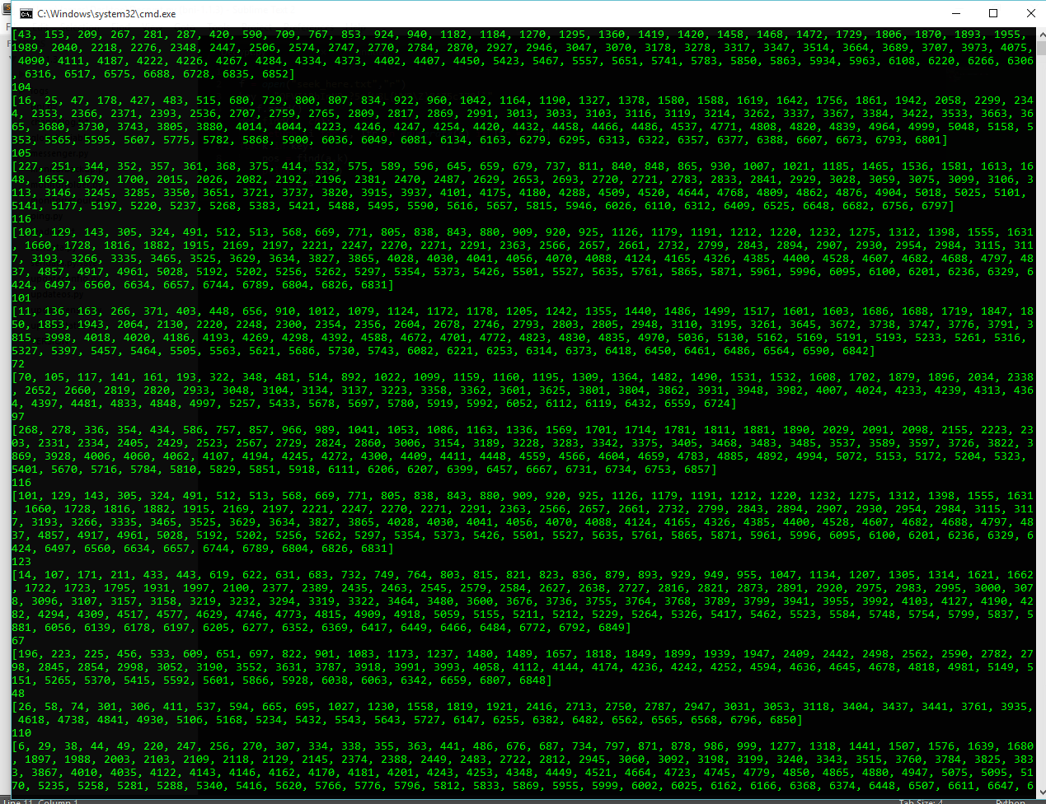

Nhìn vào thông tin về các vị trí không có gì đặc biêt. Nhưng để ý thấy độ lớn các mảng, cũng là tần suất xuất hiện các kí tự là mã ASCII đọc được.Thử tìm lại

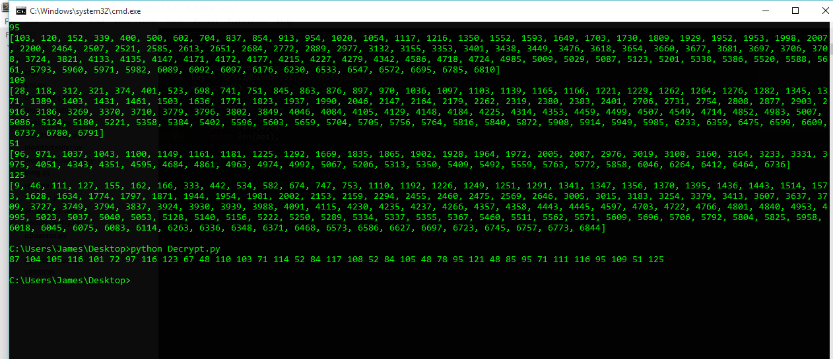

Có thể thấy đây là các mã ASCII. Kết quả thu được
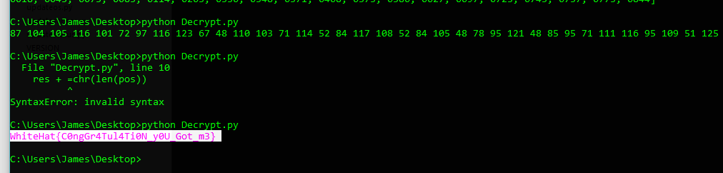

Flag:
WhiteHat{C0ngGr4Tul4Ti0N_y0U_Got_m3}

