**Screenshot 1: MySQL Workbench interface which you have created a database (schema)**

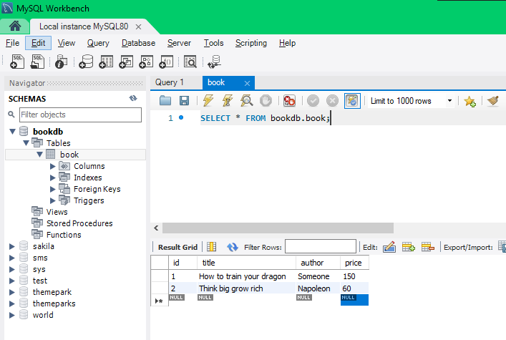

**Screenshot 2: SQL script to create database & tables**

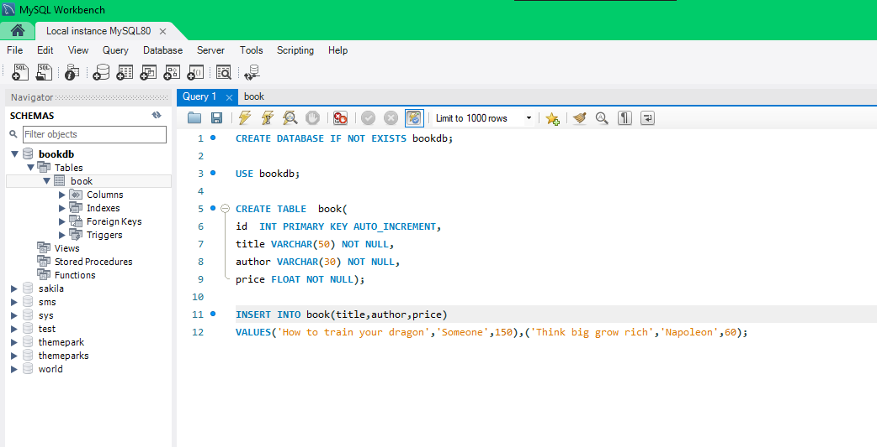

**Screenshot 3: IntelliJ interface which you have created Java project with a Java class to connect to MySQL**

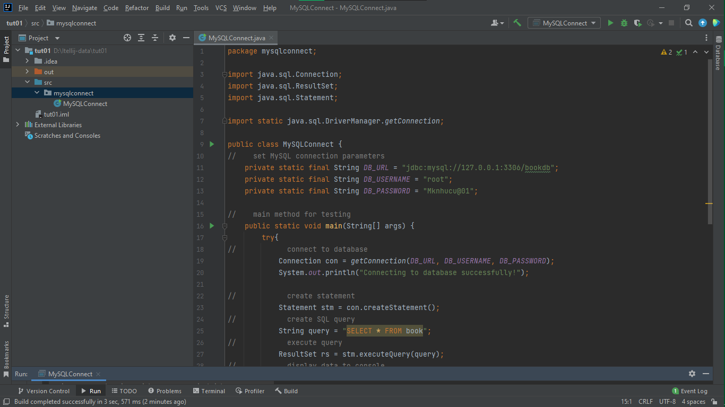

**Screenshot 4: Console output which shows the table data from MySQL**

