 | MINISTRY OF EDUCATION AND TRAINING

FPT UNIVERSITY

Capstone Project Document

Motorbike Accessories Inventory Management

Group 7
Group members | Phạm Minh Hoàng – SE62769 (Leader)  Nguyễn Trường Thịnh – SE61887  Đỗ Trung Hiếu – SE61847  Nguyễn Huy Hoàng – SE62442
Supervisor | Lại Đức Hùng
Ext. Supervisor | N/A
Project Code | RFIM

– Ho Chi Minh City, 13 May, 2019 –

CAPSTONE PROJECT REGISTER

Class: Duration time: from May 13th, 2019 To April 27th, 2019
(*) Profession: <Software Engineer> Specialty: <IS>
(*) Kinds of person make registers: Lecturer Students

1. Register information for supervisor (if have)
 | Full name | Phone | E-Mail | Title
Supervisor 1 | Lại Đức Hùng |  | HungLD5@fe.edu.vn | Mr.
2. Register information for students (if have)
 | Full name | Student code | Phone | E-mail | Role in Group
Student 1 | Phạm Minh Hoàng | SE62769 |  | hoangpmse62769@fpt.edu.vn | Leader
Student 2 | Nguyễn Trường Thịnh | SE61887 |  | thinhntse61887@fpt.edu.vn | Member
Student 3 | Đỗ Trung Hiếu | SE61847 |  | hieudtse61847@fpt.edu.vn | Member
Student 4

3. Register content of Capstone Project
(*) 3.1. Capstone Project name:
English: Motorbike Accessories Inventory Management With RFID (RFIM)
Vietnamese: Quản lý kho phụ tùng xe máy với công nghệ RFID
Abbreviation:
RFIM use RFID technology to organize and manage the inventory of unique assets by enabling users to catalog information and track their location.

(*) 3.2. Main proposal content (including result and product)
- Theory and practice (document):
- Student should apply the software development process and the UML
- Software artifacts include User Requirement, Software Requirement Specification, Architecture Design, Detail Design, System Implementation and Testing Document, Installation Guide, sources code, and deployable software packages
- 3 tiers should be applied
- Program:
- Main functions:
  - Allows curators and owners to track the specific information of every asset in their inventory such as the source, description, storage location and movement, and value.
  - RFID tagging enables the management of collections object information
  - Proximity scanning to physically locate the object amongst the inventory
  - Detailed reporting that shows inventory history and item level details
  - Designed for tablets and handheld for full mobile use
  - User management
    - Add user
    - Edit user
  - Location management
    - Add location
    - Edit location
  - Asset management
    - Add asset
    - Edit asset

  - ………….
- Other products:
4. Other comment (propose all relative thing if have)

Supervisor (If have)  (Sign and full name) | HCM city, date 24/12/2018 …..  On behalf of Registers  (Sign and full name)

Table of Contents

Table of Contents 5
List of Tables 7
List of Figures 8
A. Introduction 9
1. Project Information 9
2. Introduction 9
3. Current Situation 9
4. Problem Definition 9
5. Proposed Solution 10
5.1. Feature Functions 10
5.2. Advantages and Disadvantages 10
6. Functional Requirements 11
7. Role and Responsibility 11
B. Software Project Management Plan 11
1. Problem Definition 11
1.1. Name of this Capstone Project 11
1.2. Problem Abstract 12
1.3. Project Overview 12
2. Project Organization 13
2.1. Software Process Model 13
2.2. Roles and Responsibilities 13
2.3. Tools and Techniques 14
3. Project Management Plan 14
3.1. Software development life cycle 14
3.2. Phase Detail 14
3.3. Meeting Minutes 14
4. Coding Convention 14
C. Software Requirement Specification 15
1. User Requirement Specification 15
2. System Requirement Specification 15
2.1. External Interface Requirement 15
2.2. System Overview Use Case 15
3. Software System Attribute 33
4. Conceptual Diagram 34
D. Software Design Description 34
1. Design Overview 34
2. System Architectural Design 35
2.1. Web Application Architecture Description 35
2.2. Mobile Application Architecture Description 36
3. Component Diagram 36
4. Detail Description 37
4.1. Class Diagram 37
4.2. Class Diagram Explanation 38
4.3. Sequence Diagram 44
4.4. Activity Diagram 46
5. User Interface Design 48
6. Database Design 49
6.1. Entity Relationship Diagram (ERD) 49
6.2. Entity Dictionary 49
7. Algorithms 50
7.1. Find box base on the longest stock in date and closest warehouse’s gate 50
7.2. Convert shelves’ coordinates to matrix algorithm 51
7.3. Dijkstra algorithms 51
E. System Implementation & Testing 51
1. Introduction 51
1.1. Overview 51
1.2. Test Approach: 52
2. Database Relationship Diagram 52
2.1. Physical Diagram 52
2.2. Data Dictionary 53
3. Test Plan 57
3.1. Feature to be tested 57
3.2. Features not to be tested 57
4. System Testing Test Case 57
F. Software User’s Manual 57
G. Appendix 57

List of Tables
Table 1 – Role and Responsibility 11
Table 6 - Role and Responsibilities 14
Table 14 - Conceptual Diagram Data Dictionary 34
Table 15 - Component Dictionary 37
Table 16 - Class Dictionary 38
Table 25- <Class Diagram> Shelf Attributes 39
Table 26- <Class Diagram> Shelf Methods 39
Table 27- <Class Diagram> Floor Attributes 39
Table 28- <Class Diagram>Floor Methods 39
Table 29- <Class Diagram>Cell Attribute 40
Table 30- <Class Diagram>Cell Methods 40
Table 31- <Class Diagram>Package Attributes 40
Table 32- <Class Diagram>Package Methods 40
Table 33- <Class Diagram> Product Attribute 41
Table 34- <Class Diagram> Product Methods 41
Table 37- <Class Diagram>Box Attributes 41
Table 38- <Class Diagram> Box Method 41
Table 41- <Class Diagram>Goods Receipt Attributes 42
Table 42- <Class Diagram>Goods Receipt Methods 42
Table 43- <Class Diagram> Goods Issue Attributes 42
Table 44- <Class Diagram> Goods Issue Methods 42
Table 45- <Class Diagram>Product_Goods Receipt Attributes 43
Table 46- <Class Diagram>Product_Goods Receipt Methods 43
Table 47- <Class Diagram>Product_Goods Issue Attributes 43
Table 48- <Class Diagram>Product_Goods Issue Methods 43
Table 49- <Class Diagram>Stocktake History Attributes 44
Table 50- <Class Diagram>Stocktake History Methods 44
Table 146 - Entity Data Dictionary 50
Table 148 Database Data Ditionary 53
Table 149 Database Data Dictionary 56

List of Figures
Figure 1 - Modified Waterfall - Wicked Problems, Righteous Solutions: A Catalogue of Modern Software Engineering Paradigms [1] 13
Figure 2- Use Case Diagaram 15
Figure 3 - <Warehouse Accountant> Create Goods Receipt 16
Figure 4 - <Warehouse Accountant> Create Goods Issue 18
Figure 5 - <Warehouse Accountant> Update Stocktake Status 20
Figure 6 - <Stock-keeper> Register Cell 22
Figure 7 - <Stock-keeper> Register Package and Box 24
Figure 8 - <Stock-keeper> Stock in Package 26
Figure 9 - <Stock-keeper> Stock out Box 28
Figure 10 - <Stock-keeper> Stocktake Inventory 30
Figure 11 - <Stock-keeper> Transfer Box 32
Figure 12 - Conceptual Diagram 34
Figure 13 - System Architectural Design 35
Figure 14 – Component Diagram 36
Figure 15- Class Diagram 37
Figure 16- <Sequence Diagram> Create Invoice 45
Figure 17- <Sequence Diagram> Update Invoice 45
Figure 18- <Activity Diagram> Register Cell 46
Figure 19- <Activity Diagram> Register Box and Package 46
Figure 20- <Activity Diagram> Stock in 47
Figure 21- <Activity Diagram> Stock Out 47
Figure 22- <Activity Diagram> Stocktake Inventory 48
Figure 23- <Activity Diagram> Transfer Box 48
Figure 24 - Entity Relationship Diagram 49
Figure 25<Algorithm> Optimizing Stock out Product Flowchart 51
Figure 34– Database Diagram 52

A. Introduction

Project Information

- Project name: Motorbike Accessories Inventory Management
- Project Code: RFIM
- Product Type: Website Application, Android Application
- Start Date: May 13th, 2019
- End Date: April 27th, 2019

Introduction

Nowadays, the motorcycle industry has become one of the fastest growing industries. It means that the accessories contained in the inventory are getting larger and larger. Besides, the stock in and stock out processes also occur regularly. Therefore, the need for a method of managing motorbike’s accessories that is precise and quick is necessary. An effective motorbike’s accessories management software not only minimizes the need for manual work, but also increases productivity and reduces the loss of products.
In this document, we would like to introduce a solution that integrates RFID technology into this management software called Motorbike Accessories Inventory Management. This system will help the warehouse managers update as well as manage information of motorbike accessories, goods receipts, good issues, goods receipts, stock-take products easily. This document will also detail our work process in the last 4 months including our perspective on the system, component designs, and detailed core workflow.

Current Situation
Most motorcycle accessory manufacturers and suppliers manage their products by using barcode “archetype” or even traditional excel files and papers.
With traditional excel files and papers, the stock-keeper has to count numerous of motorcycle accessories by his eyes then note those numbers to papers during goods receipt, goods issue or stocktaking process. With barcode archetype, the amount of time spending for counting items is reduced by technology. Stock-keeper will use a barcode scanner to scan instead of counting on his own, then the products’ information will be automatically updated into an inventory management system.
When those previous processes are completed and don’t have any mistakes, stock-keeper will create an excel format file instead of raw paper then transfer it to the accounting department for collating and printing the receipt as the finish step. The receipt has 3 copies: 1 was kept by the stock-keeper, 1 by the accountant and 1 by the deliverer.

Problem Definition

After doing some research, we can see some disadvantages that still exist in current inventory management by using the barcode:
- Time-consuming: Barcode is designed to be scanned once at a time so that when we need to import a bunch of products, we have to spend a lot of time to scan each product.
- Unclear line of sight: Without the clear line of sight, the scanner cannot read the barcode. Sometimes the barcode was pasted in a convex or concave surface that makes the scanner difficult to scan.
- Physical damage: Barcodes are generally printed on paper or plastic, so they are easy to become blur and be torn when they are stored in stock for a long time or contact with dust and humidity. The damaged barcodes cannot be read by the scanner so that the user has to input information by hand.
- Security problem: Barcode can be easily reproduced or forged. Someone can use this problem to make fake products and sell them to the market that affects a lot to the enterprise’s benefit.

Proposed Solution

To solve these problems, our proposed solution is to build a system called “RFIM”. The system supports enterprise organizes and manages the inventory by using RFID technology that helps reduce a lot of time when importing, exporting or inventorying products.

Feature Functions

  - Managing motorbike accessories inventory’s information: product, category, quantity, shelf, etc.
  - Managing receipt and issue process of motorbike accessories, inventory control with stocktaking and transfer product feature
  - Using RFID technology to improve the performance when perform above tasks

Advantages and Disadvantages

The advantages and disadvantages of the proposed solution:
- Advantages:
- Time-saving: The duration when the staff checks the quantity of importing or exporting products can be reduced because RFID tags can be read more than once at the same time.
- Wide range scanning: The RFID reader can be scanned with the range up to 100m.
- Durability: Because the RFID tags are made from durable material so that they are really difficult to be damaged.
- Security: RFID can be saved by using encryption.
- Disadvantages:
- The most disadvantageous of RFID is the investing cost. The RFID implementation’s cost is more expensive than the barcode itself because the price of RFID scanner devices and tags is too high.
- RFID scanners are affected by metal and liquid.
- If multiple tags in the same area respond at the same time, the collision can occur.

Functional Requirements
Function requirements of the system are listed as below:

Admin:
- Manage users
- View current users list
Warehouse Accountant:
- View and manage products
- View and manage categories
- View cells and manage shelves
- View and manage goods receipt and goods issue.
- Create and export pdf reports (issue, receipt, stocktaking…)
- View stocktaking history and update stocktake status
Stock-keeper:
- Transfer products (transfer packages and transfer boxes)
- Stocktake inventory
- Stock in and stock out packages of product’s items with created goods receipt or issue
- Register packages
- Register cells
- Clear RFID tag
- Suggest Boxes

Role and Responsibility

No. | Full Name | Role | Position | Contact
1 | Lại Đức Hùng | Project Manager | Supervisor | hungld5@fe.edu.vn
2 | Phạm Minh Hoàng | Developer | Leader | hoangpmse62769@fpt.edu.vn
3 | Nguyễn Trường Thịnh | Developer | Member | thinhntse61887@fpt.edu.vn
4 | Đỗ Trung Hiếu | Developer | Member | hieudtse61847@fpt.edu.vn
Table 1 – Role and Responsibility

B. Software Project Management Plan

Problem Definition

Name of this Capstone Project
- Official name: Motorbike Accessories Inventory Management With RFID.
- Vietnamese name: Quản lý kho phụ tùng xe máy với công nghệ RFID.
- Abbreviation: RFIM

Problem Abstract
(References to RFIM_200_Page, Section B.1.2, page 17)

Project Overview

The Current Situation
(References to RFIM_200_Page, Section B.1.3.1, page 17)

The Proposed System
(References to RFIM_200_Page, Section B.1.3.2, page 17)

Boundaries of the System

The system can:
- Allow Admin to manage user accounts .
- Allow Warehouse Accountant to manage products, shelves, categories, goods receipts, goods issues, stocktaking history and reports.
- Allow Stock-keeper to register cells, register package and boxes, stock in package, stock out box, stocktaking inventory, transfer products
The system cannot:
- RFID can’t scan multiple tags because of the cheap RFID scanner.
- Due to limitation of technology and funds, RFIM system can only bind RFID tags to product’s boxes, not the product items inside
- The stocktake process report all missing boxes while stocktaking but system doesn’t cover the case that how to handle missing boxes’s case when stocktake process report.
- The system can’t support when warehouse need to decrease shelf’s number of floor or shelf‘s number of cell because it can reduce to effective management.

Future Plans
- The existing systems can only scan one RFID tag at one time. We design our system to scan multiple RFID tags with a wide range.
- We can stick RFID tags to product items for managing effectively.
- We build system to minimize lost of products in warehouse.
- We build this system for medium motorbike companies or stores so it doesn’t support automated system and stock-keepers have to scan the tags manually. We will integrate automated system for managing warehouse.

Development Environment
(References to RFIM_200_Page, Section B.1.3.5, page 19)

Project Organization

Software Process Model

This project is developed using Waterfall model for Software development project. Our team choose Waterfall model because of the following reasons:
- Our team only has 4 members, and this project for medium motorcycle accessories warehouses, no multi-warehouses available.
- For a classic problem “Warehouse management” which most of the requirements were clarified in real life, we decided to choose Modified Waterfall Model
- Modified Waterfall model is easy to progress and maintain, also has lower risk when comparing to the classic Waterfall model.
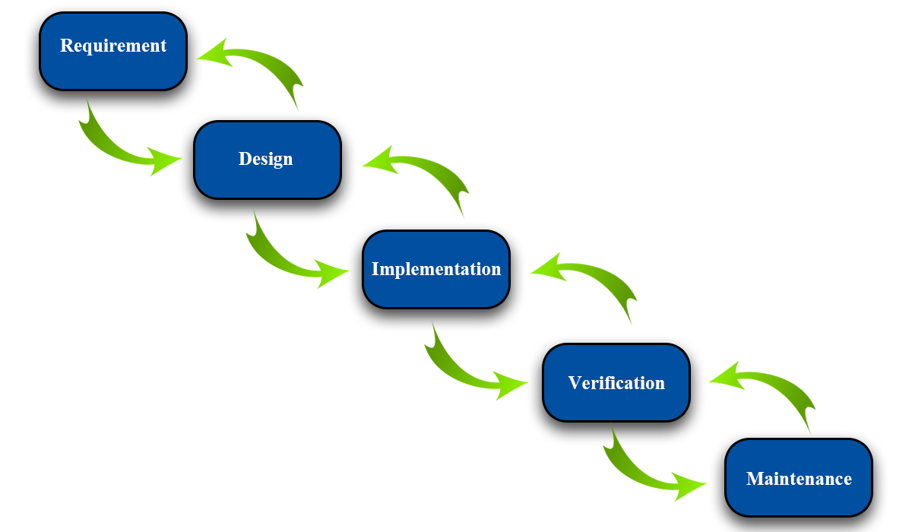
Figure 1 - Modified Waterfall - Wicked Problems, Righteous Solutions: A Catalogue of Modern Software Engineering Paradigms [1]

Roles and Responsibilities
No | Full name | Role in Group | Responsibilities
1 | Lại Đức Hùng | Product Owner | - Specifying user requirements  - Controlling the development process  - Giving out technique and business analysis support
2 | Phạm Minh Hoàng | Team Leader | - Managing process  - Designing database  - Clarifying requirements  - Preparing documents  - Designing GUI  - Creating test plan  - Coding  - Testing  - Arranging Meeting  - Managing Risks
3 | Nguyễn Trường Thịnh | Team Member | - Designing database  - Clarifying requirements  - Preparing documents  - Designing GUI  - Creating test plan  - Coding  - Testing
4 | Đỗ Trung Hiếu | Team Member | - Designing database  - Clarifying requirements  - Preparing documents  - Designing GUI  - Creating test plan  - Coding  - Testing
Table 6 - Role and Responsibilities

Tools and Techniques
(References to RFIM_200_Page, Section B.3.1, page 21)

Project Management Plan

Software development life cycle
(References to RFIM_200_Page, Section B.3.1, page 22)

Phase Detail
(References to RFIM_200_Page, Section B.3.2, page 23)

Meeting Minutes
All meeting documents could be found here:
https://drive.google.com/open?id=1tj0KZxtxWliY2fBINYbQjqLgHpzjM3op (Security: Must be login with fpt university’s email).

Coding Convention
(References to RFIM_200_Page, Section B.4, page 25)

C. Software Requirement Specification

User Requirement Specification
(References to RFIM_200_Page, Section C.1, page 26)

System Requirement Specification

External Interface Requirement
(References to RFIM_200_Page, Section C.2.1, page 27)
Figure 2- Use Case Diagaram

System Overview Use Case
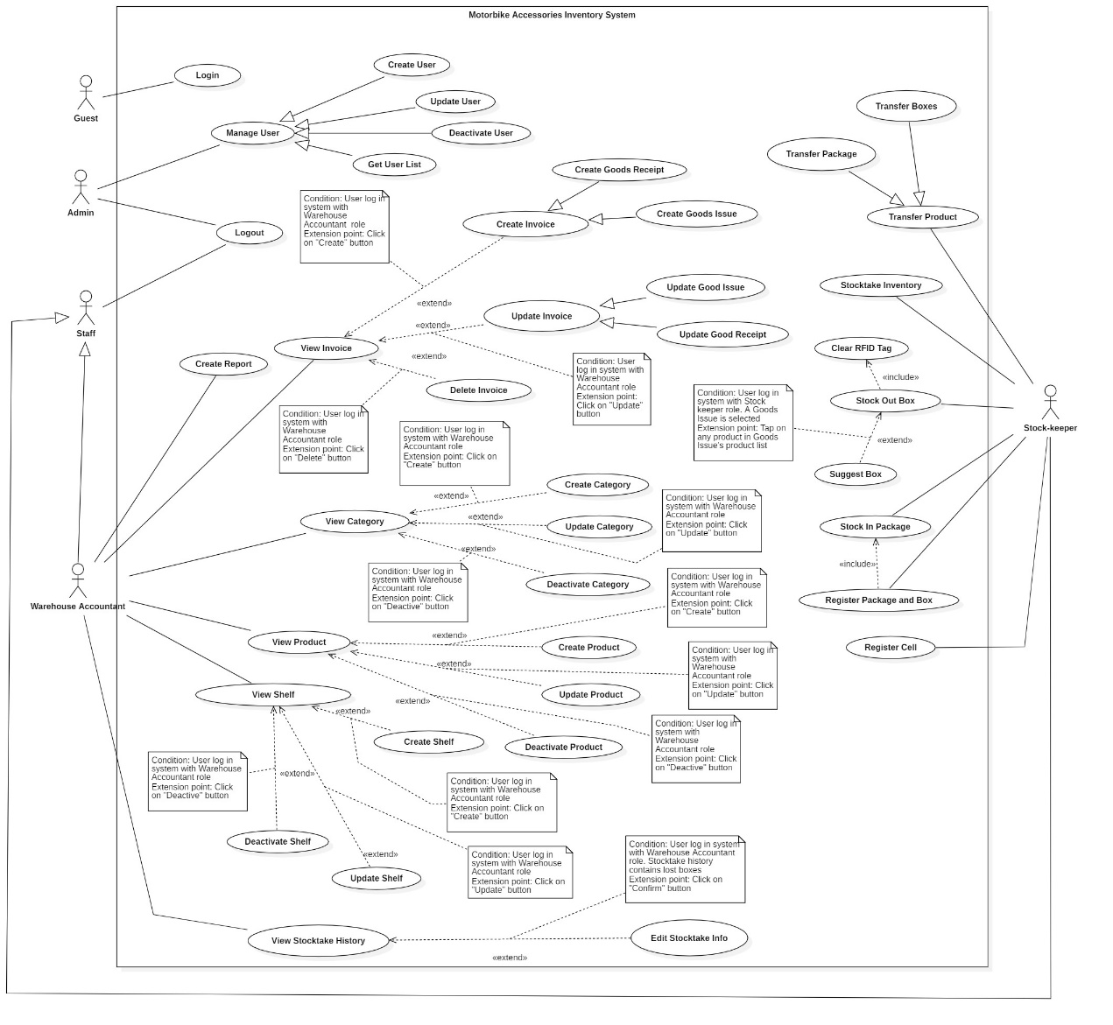

<Warehouse Accountant> Create Goods Receipt
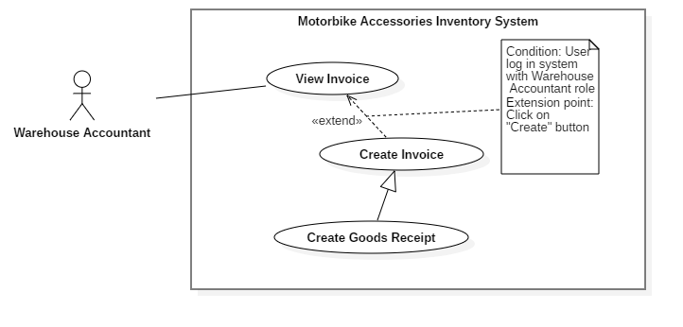
Figure 3 - <Warehouse Accountant> Create Goods Receipt
USE CASE – RFIM_UC_WA_I2
Use Case No. | RFIM_UC_WA_I2 | Use Case Version | 1.0
Use Case Name | Create Goods Receipt
Author | ThinhNT
Date | 26/07/2019 | Priority | Normal
Actor:
- Warehouse Accountant
Summary:
- This use case allows warehouse accountant to create goods receipts.
Goal:
- Warehouse accountant creates goods receipt successfully.
Triggers:
- Warehouse accountant clicks on “Create” button.
Preconditions:
- User must log in the system with Warehouse Accountant role.
Post conditions:
- Success: A new goods receipt will be created.
- Fail: System shows error messages.
Main Success Scenarios:
Step | Actor Action | System Response
1 | Warehouse accountant clicks on “Create” button in “Goods Receipt” screen. | System shows “Create Receipt” screen with following labels, fields:  - Product ID: prefilled, not editable  - Product Name: prefilled, not editable  - Category: prefilled, not editable  - Vendor: prefilled, not editable  - Stock in Quantity: integer, required.
2 | Warehouse accountant clicks on “Choose Product” button in “Add Stock in Product” screen. | “Products List” screen is shown with following attribute of products: Product Id, Product Name, Quantity Per Box, Category, and Vendor.
3 | Warehouse Accountant check single or multiple checkboxes of products and clicks on “Confirm” button. | System shows “Create Receipt” screen with selected products and following labels, fields:  - Product ID: prefilled, not editable  - Product Name: prefilled, not editable  - Category: prefilled, not editable  - Vendor: prefilled, not editable  - Stock in Quantity: integer, required.
4 | Warehouse Accountant fills out “Stock in Quantity” field and clicks on “Finish” button. | System validates inputted data and shows “Goods Receipt” screen  [Exception 1, 2]

Alternative Scenarios: N/A

Exceptions:
No | Actor Action | System Response
1 | Warehouse accountant clicks on “Cancel” button | System shows “Goods Receipt” screen.
2 | Network connection problem. | System shows error message: “Please check your network connection.”

Relationships: Specialized from Create Invoice use case. Create Invoice use case was extended from View Invoice use case.
Business Rules:
- In this system, only Warehouse Accountant can create goods receipts.
- “Stock in Quantity” is the number of boxes for stocking in products, maximum of 9999 boxes per Product per Good Receipt.
- Newly created goods issue will have “Pending” status.
- Goods receipts status will be changed to “Processing” during stock in process and “Done” when stock in process successfully finished.
- Products of Good receipt does not contain deactivated products.
- Goods Receipts Id was define automatically by this format: Configurable Prefix + Creation Date + “-” + Random 4 character code. Ex: RCE221019-A1x0.
- Good Receipt Prefix can be change by using “Edit Receipt Prefix” feature
<Warehouse Accountant> Create Goods Receipt use case specification

<Warehouse Accountant> Create Goods Issue
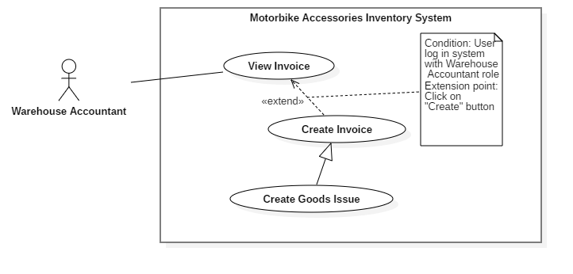
Figure 4 - <Warehouse Accountant> Create Goods Issue
USE CASE – RFIM_UC_WA_I3
Use Case No. | RFIM_UC_ WA_I3 | Use Case Version | 1.0
Use Case Name | Create Goods Issue
Author | ThinhNT
Date | 26/07/2019 | Priority | Normal
Actor:
- Warehouse Accountant
Summary:
- This use case allows warehouse accountant to create goods issue.
Goal:
- Warehouse accountant creates goods issue successfully.
Triggers:
- Warehouse accountant clicks on “Create” button.
Preconditions:
- User must log in the system with Warehouse Accountant role.
Post conditions:
- Success: A new goods issue will be created.
- Fail: System shows error messages.
Main Success Scenarios:
Step | Actor Action | System Response
1 | Warehouse accountant clicks on “Create” button in “Receipts/Issues” screen. | System shows “Create Issue” screen following labels, fields:  - Product ID: prefilled, not editable  - Product Name: prefilled, not editable  - Category: prefilled, not editable  - Vendor: prefilled, not editable  - On-hand Quantity: prefilled, not editable  - Stock out Quantity: integer, required..
2 | Warehouse accountant clicks on “Choose Product” button in “Add Stock out Product” screen. | “Products List” screen is shown with following attribute of products: Product ID, Product Name, Quantity Per Box, Category, Vendor and On-hand Quantity.
3 | Warehouse Accountant check single or multiple checkboxes of products and clicks on “Confirm” button. | System shows “Create Issue” screen with selected products and following labels, fields:  - Product ID: prefilled, not editable  - Product Name: prefilled, not editable  - Category: prefilled, not editable  - Vendor: prefilled, not editable  - On-hand Quantity: prefilled, not editable  - Stock out Quantity: integer, required.
4 | Warehouse Accountant fills out “Stock out Quantity” field and clicks on “Finish” button. | System validates inputted data and shows “Receipts/Issues” screen.  [Exception 1, 2, 3]

Alternative Scenarios: N/A

Exceptions:
No | Actor Action | System Response
1 | Inputted “Stockout Quantity” is greater than “On-hand Quantity” | System shows error message: “Stockout Quantity must greater than 1 and smaller than On-hand Quantity:
2 | Warehouse accountant clicks on “Cancel” button | System shows “Receipts/Issues” screen.
3 | Network connection problem. | System shows error message: “Please check your network connection.”

Relationships: Specialized from Create Invoice use case. Create Invoice use case was extended from View Invoice use case.
Business Rules:
- In this system, only Warehouse Accountant can create goods issue.
- “On-hand Quantity” shows box quantity of that product in stock.
- “Stock out Quantity” is the number of boxes for stocking in products, with the maximum value is equal to “On-hand Quantity”.
- Newly created goods issue will have “Pending” status.
- Goods issue status will be changed to “Done” when stock out process successfully finished.
- Goods Issue Id was define automatically by this format: Configurable Prefix + Creation Date + “-” + Random 4 character code. Ex: ISE221019-A1x0.
- Good Issue Prefix can be change by using “Edit Issue Prefix” feature
<Warehouse Accountant> Create Goods Issue use case specification

<Warehouse Accountant> Update Stocktake Status
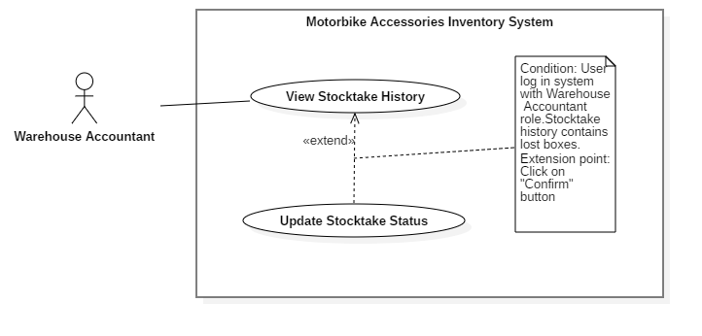
Figure 5 - <Warehouse Accountant> Update Stocktake Status
USE CASE – RFIM_UC_ WA_H2
Use Case No. | RFIM_UC_ WA_H2 | Use Case Version | 2.0
Use Case Name | Update Stocktake Status
Author | ThinhNT
Date | 26/07/2019 | Priority | Normal
Actor:
- Warehouse Accountant
Summary:
- This use case allows Warehouse Accountant to update status of stoktake and status of lost and found boxes after stocktaking.
Goal:
- Warehouse Accountant update stocktake status and lost/found boxes status successfully.
Triggers:
- Warehouse Accountant clicks on “Confirm” button.
Preconditions:
- User must log in the system with Warehouse Accountant role.
- Stocktake History status is “Pending”
Post conditions:
- Success: Stockatake status update successfully. Boxes status update successfully
- Fail: System shows error messages.
Main Success Scenarios:
Step | Actor Action | System Response
1 | Warehouse Accountant clicks on “Confirm” button in “Awaiting Confirm” screen. | Confirmation dialog is shown with the Y/N option: “Are you sure you want to confirm status of this stocktake? This will cause boxes which not found during this stocktake become unacessible unless they was found again by next stocktake.  +Found box:  +Lost box:”
2 | Warehouse Accountant clicks on “Confirm” button. | System shows “Awaiting Confirm” screen.  [Exception 1, 2]

Alternative Scenarios: N/A

Exceptions:
No | Actor Action | System Response
1 | Warehouse Accountant clicks on “Cancel” button. | System shows “Awaiting Confirm” screen.
2 | Network connection problem. | System shows error message: “Please check your network connection.”

Relationships: Extended from View Shelf use case.
Business Rules:
- In this system, only Warehouse Accountant can update stocktake status.
- Boxes which exist in system but doesn’t exist during stocktaking will be set status to “Missing” after Update Stocktake Info.
- Missing boxes can regain “Found” status with another Update Stocktake Status.
- Only stocktake with “Pending” status can be confirm.
- All confirmed Stocktake will be show in “History” screen

<Warehouse Accountant> Update Stocktake Status use case specification

<Stock-keeper> Register Cell
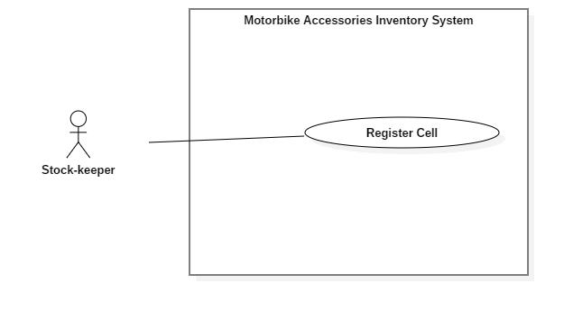
Figure 6 - <Stock-keeper> Register Cell
USE CASE – RFIM_UC_SK1
Use Case No. | RFIM_UC_SK1 | Use Case Version | 2.0
Use Case Name | Register Cell
Author | HoangNH
Date | 26/07/2019 | Priority | Normal
Actor:
- Stock-keeper
Summary:
- This use case allows Stock-keeper register cells with RFID tags.
Goal:
- Stock-keeper registers a cell with RFID tag successfully.
Triggers:
- Stock-keeper taps on “Save” button.
Preconditions:
- User must log in the mobile system with Stock-keeper role.
- The mobile device is connected with a RFID scanner.
Post conditions:
- Success: Cell is linked RFID tag.
- Fail: System shows error messages.
Main Success Scenarios:
Step | Actor Action | System Response
1 | Stock-keeper taps on “Register Cell” feature. | “Register Cell” screen is shown with following labels and fields:  - Shelf: select option, required  - Floor: select option, required  - Cell: select option, required  - Cell RFID: text, automatically inputted when an RFID tag is scanned.
2 | Stock-keeper scans RFID tag and taps on “Save” button. | System validates inputted data and shows message “Register successfully.”  [Exception 1, 2, 3, 4, 5]

Alternative Scenarios: N/A

Exceptions:
No | Actor Action | System Response
1 | Stock-keeper doesn’t scan any Cell RFID tags then taps on “Save” button | System shows error message "Please scan a Cell’s RFID.”
2 | Stock-keeper scans an RFID tags that is already registered with Cell ID | System shows error message "This RFID tag is already registered by another cell.”
3 | Stock-keeper taps on “Cancel” button. | System shows “Home” screen.
4 | Bluetooth connection problem. | System shows error message: “Please check your Bluetooth connection.”
5 | Network connection problem. | System shows error message: “Please check your network connection.”

Relationships: Associated with Stock-keeper actor.
Business Rules:
- In this mobile system, only Stock-keeper can register cells.
- A registered cell can be used to bind packages.
- Each Cell RFID tag can be changed by running “Register Cell” feature once again, but one RFID tag can’t be used to register 2 cells.
<Stock-keeper> Register Cell use case specification

<Stock-keeper> Register Package and Box
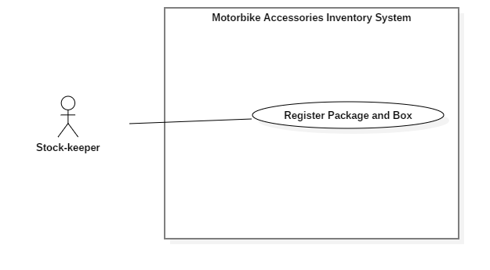
Figure 7 - <Stock-keeper> Register Package and Box
USE CASE – RFIM_UC_SK2
Use Case No. | RFIM_UC_SK1 | Use Case Version | 2.0
Use Case Name | Register Package and Box
Author | HoangPM
Date | 26/07/2019 | Priority | Normal
Actor:
- Stock-keeper
Summary:
- This use case allows Stock-keeper to register packages and boxes.
Goal:
- Stock-keeper register package and box successfully.
Triggers:
- Stock-keeper taps on “Save” button.
Preconditions:
- User must log in the mobile system with Stock-keeper role.
- The mobile device is connected with a RFID scanner.
Post conditions:
- Success: Boxes are successfully registered with a product and a RFID then mapped with a package RFID.
- Fail: System shows error messages.
Main Success Scenarios:
Step | Actor Action | System Response
1 | Stock-keeper taps on “Register Package and Box” button. | “Package Register” screen is shown with following labels and fields:  - Goods Receipt: select option, list Goods Receipt  - Product Name: select option, list Product  - Product Id: automatically show after selecting Product Name  - Package RFID: automatically inputted when an RFID tag is scanned. One tag allowed only  - Boxes RFID: text, automatically inputted when an RFID tag is scanned. Multiple tags are allowed.
2 | - Stock-keeper taps on “Scan” button and uses RFID scanner to scan Package tag.  - Stock-keeper taps on “Scan” button and uses RFID scanner to scan Box tag. | - Package RFIDs are automatically inputted in the field.  - List of Box RFIDs are automatically inputted in the field.
3 | Stock-keeper taps on “Save” button. | System validates inputted data and shows message “Register successfully.”  [Exception 1, 2, 3, 4, 5, 6]

Alternative Scenarios: N/A

Exceptions:
Step | Actor Action | System Response
1 | Stock-keeper doesn’t scan any Package RFID tags then taps on “Save” button. | System shows error message "Please scan a Package’s RFID.”
2 | Stock-keeper doesn’t scan any Box RFID tags then taps on “Save” button. | System shows error message “Please scan Box’s RFID.”
3 | Stock-keeper scan more boxes than required quantity | System shows error message “Enough Product.”
4 | Stock-keeper taps on “Cancel” button. | System shows “Home” screen.
5 | Bluetooth connection problem. | System shows error message: “Please check your Bluetooth connection.”
6 | Network connection problem. | System shows error message: “Please check your network connection.”

Relationships: Associated with Stock-keeper actor.
Business Rules:
- In this system, only Stock-keeper can register packages.
- Stock-keeper can view List Product in Goods Receipt by pressing “Info” icon
- “Registered Quantity” is number of boxes of that product which are registered successfully.
- “Quantity” is number of boxes that the Good Receipt requires.
- When any package is registered successfully, Good Receipt will have “Processing” status. If all packages in Goods Receipt are registered successfully then it will have “Done” status.
- A package can contain many boxes but only have one type of product.
<Stock-keeper> Register Package and Box use case specification

<Stock-keeper> Stock in Package
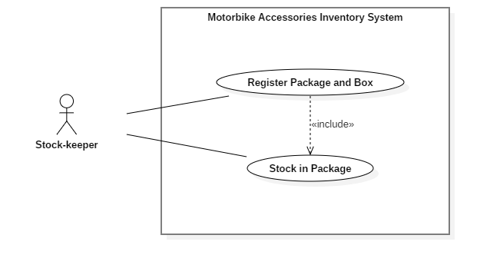
Figure 8 - <Stock-keeper> Stock in Package
USE CASE – RFIM_UC_SK3
Use Case No. | RFIM_UC_SK3 | Use Case Version | 2.0
Use Case Name | Stock in Package
Author | ThinhNT
Date | 26/07/2019 | Priority | Normal
Actor:
- Stock-keeper
Summary:
- This use case allows Stock-keeper to stock in packages.
Goal:
- Stock-keeper stocks in package successfully.
Triggers:
- Stock-keeper taps on “Save” button.
Preconditions:
- User must log in the mobile system with Stock-keeper role.
- Products are registered with RFID tag.
- The mobile device is connected with a RFID scanner.
Post conditions:
- Success: Package is mapped with a Cell RFID tag
- Fail: System shows error messages.
Main Success Scenarios:
Step | Actor Action | System Response
1 | Stock-keeper taps on “Stock In” feature. | “Stock In” screen is shown with following labels and fields:  - Cell RFID: text, automatically inputted when an RFID tag is scanned.  - Cell: text, automatically show after Cell RFID tag is scanned  - Floor: text, automatically show after Cell RFID tag is scanned  - Shelf: text, automatically show after Cell RFID tag scanned  - Package RFID: text, automatically inputted when an RFID tag is scanned.
2 | - Stock-keeper taps on “Scan” button and uses RFID scanner to scan Cell RFID tag.  - Stock-keeper taps on “Scan” button and uses RFID scanner to scan Package RFID tag. | - Cell RFIDs are automatically inputted in the field.  - Package RFIDs are automatically inputted in the field.
3 | Stock-keeper taps on “Save” button. | System validates inputted data and shows message “Stock in successfully.”  [Exception 1, 2, 3, 4, 5, 6]

Alternative Scenarios: N/A

Exceptions:
Step | Actor Action | System Response
1 | Stock-keeper doesn’t scan any Cell RFID tags then taps on “Save” button. | System shows error message "Please scan Cell’s RFID.”
2 | Stock-keeper doesn’t scan any Package RFID tags then taps on “Save” button. | System shows error message "Please scan Package’s RFID.”
3 | Stock-keeper register package into a full cell. | System shows error message "Cell is full. Please register to another cell.”
4 | Stock-keeper taps on “Cancel” button. | System shows “Home” screen.
5 | Bluetooth connection problem. | System shows error message: “Please check your Bluetooth connection.”
6 | Network connection problem. | System shows error message: “Please check your network connection.”

Relationships: Associated with Stock-keeper actor.
Business Rules:
- In this mobile system, only Stock-keeper can stock in packages.
- Unregistered packages cannot be stocked in.
- Each cell only has one package.
- Any further task such as merging packages should be accessed via “Transfer Product” feature.
- Each package can contain many boxes but only have one type of product.
< Stock-keeper > Stock in Package use case specification

<Stock-keeper> Stock out Box
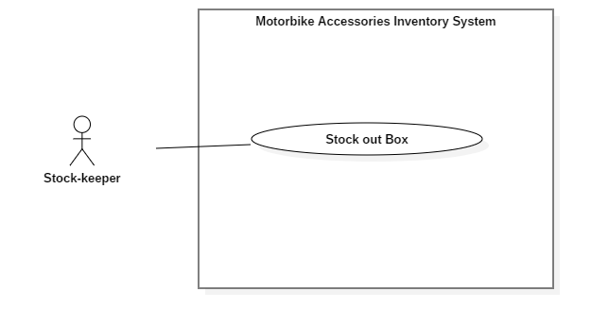
Figure 9 - <Stock-keeper> Stock out Box
USE CASE – RFIM_UC_SK4
Use Case No. | RFIM_UC_SK4 | Use Case Version | 2.0
Use Case Name | Stock out Box
Author | HoangPM
Date | 26/07/2019 | Priority | Normal
Actor:
- Stock-keeper
Summary:
- This use case allows Stock-keeper to stock out boxes.
Goal:
- Stock-keeper stocks out box successfully.
Triggers:
- Stock-keeper taps on “Save” button.
Preconditions:
- User must log in the system with Stock-keeper role.
- Product is stocked in.
- The mobile device is connected with a RFID scanner.
Post conditions:
- Success: Product is stocked out.
- Fail: System shows error messages.
Main Success Scenario:
Step | Actor Action | System Response
1 | Stock-keeper taps on “Stock Out” feature. | “Stock Out” screen is shown with following labels and fields:  - Goods Issue: select option, list Goods Issue  - Box Scanned Information: text, automatically inputted when an RFID tag is scanned
2 | Stock-keeper taps on “Scan” button and uses RFID scanner to scan boxes tag. | Scanner recognizes RFID and fills it to the “Box Scanned Information” field.
3 | Stock-keeper taps on “Save” button. | System shows message “Stock out successfully!”  [Exception 1, 2, 3, 4]

Alternative Scenarios: N/A

Exceptions:
No | Actor Action | System Response
1 | Stock-keeper doesn’t scan any Box RFID tags then taps on “Save” button. | System shows error message "Please scan Box’s RFID.”
2 | Stock-keeper taps on “Cancel” button. | System shows “Home” screen.
3 | Bluetooth connection problem. | System shows error message: “Please check your Bluetooth connection.”
4 | Network connection problem. | System shows error message: “Please check your network connection.”

Relationships: Associated with Stock-keeper actor.
Business Rules:
- In this system only Stock-keeper can stock out boxes.
- Unregistered boxes cannot be stocked out.
- Box Scanned Information contains list of variety product types and its quantity, which are filled by scanning Box RFID tags.
- When all products in Goods Issue are stocked out successfully, Goods Issue will have “Done” status.
- Stock-keeper can scan any box of variety products as long as the invoice contains that product.
<Stock-keeper> Stock out Box use case specification

<Stock-keeper> Stocktake Inventory
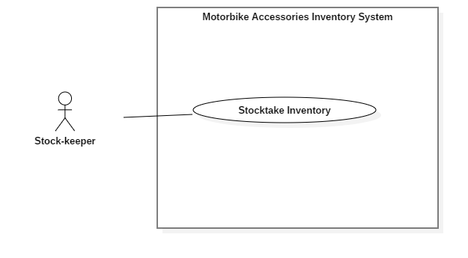
Figure 10 - <Stock-keeper> Stocktake Inventory
USE CASE – RFIM_UC_SK5
Use Case No. | RFIM_UC_SK5 | Use Case Version | 2.0
Use Case Name | Stocktake Inventory
Author | HoangPM
Date | 26/07/2019 | Priority | Normal
Actor:
- Stock-keeper
Summary:
- This use case allows Stock-keeper to stocktake inventory products.
Goal:
- Stock-keeper stocktake inventory product successfully.
Triggers:
- Stock-keeper taps on “Save” button.
Preconditions:
- User must log in the system with Stock-keeper role.
- Product currently has boxes
- The mobile device is connected with a RFID scanner.
Post conditions:
- Success: Product is stocked out.
- Fail: System shows error messages.
Main Success Scenario:
Step | Actor Action | System Response
1 | Stock-keeper taps on “Stocktake Inventory” feature. | “Stocktake Inventory” screen is shown with following labels and fields:  - Product Name: select option, list Product  - Product ID: automatically show after selecting Product Name  - Available Quantity: automatically show after selecting Product Name  - Stocktake Quantity: integer, automatically increase when product’s RFID tag is scanned.
2 | Stock-keeper taps on “Scan Box RFID” button and uses RFID scanner to scan boxes of that products | Scanner recognizes RFID of selected product and increases “Stocktake Quantity”
3 | Stock-keeper taps on “Report” button. | Confirmation dialog is shown with the Y/N option: “Do you want to report?”
4 | Stock-keeper taps on “OK” button. | System shows message “Stocktake successfully!”  [Exception 1, 2, 3]

Alternative Scenarios: N/A

Exceptions:
No | Actor Action | System Response
1 | Stock-keeper taps on “Cancel” button. | System shows “Home” screen.
2 | Bluetooth connection problem. | System shows error message: “Please check your Bluetooth connection.”
3 | Network connection problem. | System shows error message: “Please check your network connection.”

Relationships: Associated with Stock-keeper actor.
Business Rules:
- In this system only Stock-keeper can stocktake inventory products.
- “Available Quantity” is number of box which is archived by RFIM system.
- “Stocktake Quantity” is number of box actually have in warehouse.
- Stocktake Inventory can only stocktake one product at a time.
<Stock-keeper> Stocktake Inventory use case specification

<Stock-keeper> Transfer Box
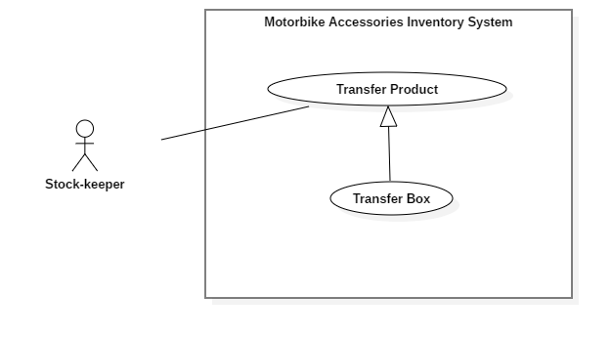
Figure 11 - <Stock-keeper> Transfer Box
USE CASE – RFIM_UC_SK7
Use Case No. | RFIM_UC_SK7 | Use Case Version | 2.0
Use Case Name | Transfer Box
Author | HoangNH
Date | 26/07/2019 | Priority | Normal
Actor:
- Stock-keeper
Summary:
- This use case allows Stock-keeper to transfer product boxes to another package.
Goal:
- Stock-keeper transfer box of product successfully.
Triggers:
- Stock-keeper taps on “Save” button.
Preconditions:
- User must log in the system with Stock-keeper role.
- Product is stocked in.
- The mobile device is connected with a RFID scanner.
Post conditions:
- Success: Boxes of product is transferred to another package successfully.
- Fail: System shows error messages.
Main Success Scenario:
Step | Actor Action | System Response
1 | Stock-keeper taps on “Transfer Product” feature and selects “Transfer Box” tab. | “Transfer Box” screen is shown with following labels and fields:  - Package RFID: text, automatically inputted when package RFID tag is scanned.  - Box RFID: list Boxes, automatically inputted when package RFID tag is scanned.
2 | Stock-keeper taps on “Scan” button and next to Package text field and uses RFID scanner to scan package’s tag. | Package RIFD is automatically inputted in the field.
3 | Stock-keeper taps on “Scan Box RFID” button and uses RFID scanner to scan boxes tag, which have same product as the destination package. | Boxes RFIDs are automatically inputted in the field.
4 | Stock-keeper taps on “Save” button. | System shows message “Transfer successfully!”  [Exception 1, 2, 3, 4, 5]

Alternative Scenarios: N/A

Exceptions:
No | Actor Action | System Response
1 | Stock-keeper doesn’t scan any Package RFID tag then taps on “Save” button. | System shows error message "Please scan Package RFID.”
2 | Stock-keeper doesn’t scan any Box RFID tags then taps on “Save” button. | System shows error message "Please scan Box RFID.”
3 | Stock-keeper taps on “Cancel” button. | System shows “Home” screen.
4 | Bluetooth connection problem. | System shows error message: “Please check your Bluetooth connection.”
5 | Network connection problem. | System shows error message: “Please check your network connection.”

Relationships: Specialized from Transfer Product use case.
Business Rules:
- In this mobile system, only Stock-keeper can transfer boxes to another packages.
- Only Boxes which have identical product with package will be shown on “Box Information”. Others types of boxes will not be scanned
<Stock-keeper> Transfer Box use case specification

Software System Attribute
(References to RFIM_200_Page, Section C.3, page 72)

Conceptual Diagram
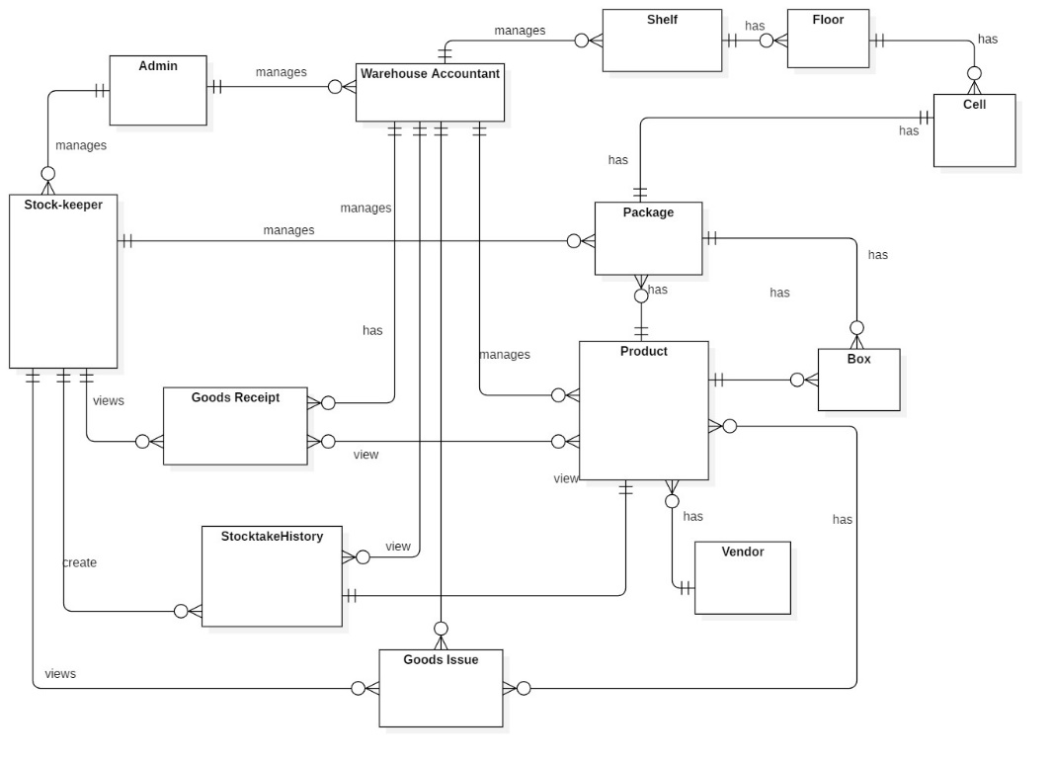
Figure 12 - Conceptual Diagram

ENTITY DATA DICTIONARY: DESCRIBE ALL CONTENT OF ALL ENTITIES
Entity name | Description
Admin | Contains the admin information
Stock-keeper | Contains the stock-keeper information
Warehouse Staff | Contains the warehouse staff information
Package | Contains the package information
Product | Contains the product information
Box | Contains the box information
Shelf | Contains the shelf information
Floor | Contains the floor information
Cell | Contains the cell information
Goods Receipt | Contains the goods receipt information
Goods Issue | Contains the goods issue information
Stocktake History | Contains the stocktake history information
Vendor | Contains the vendor information
Table 14 - Conceptual Diagram Data Dictionary

D. Software Design Description

Design Overview
(References to RFIM_200_Page, Section D.1, page 74)

System Architectural Design
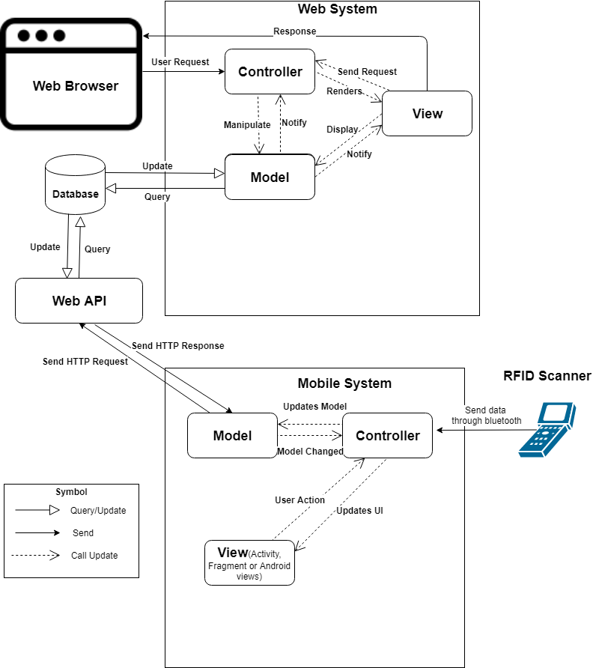
Figure 13 - System Architectural Design

Web Application Architecture Description
In web application, our system is developed with ASP.NET Core MVC architecture. We decide to choose this architect for web application because of following advantages:
- ASP.NET Core is a cross-platform, high-performance, open-source framework for building application.
- Application is built-in dependency injection.
- ASP.NET Core has some technologies like entity framework to connect database.
- Support to develop and run on Windows, macOS, and Linux.
- Support to develop Web API and easily to build Web UI.
- ASP.NET Core is open-source and community-focused.
The MVC pattern (Model-View-Controller) separates application into 3 main components: Model-View-Controller. MVC patter helps you to build application more testable and easier. MVC-based app contains:
- Controller: is a part of application like a handler browser to handle and response user interaction and input. Controller handles route data and call repository’s method to get business data for handling bussines logic. Then select view to render to web browser for user.
- View: is a part of application for displaying the app’s user interface. It get data from model and specifies how that data should be presented. It updates UI when model changes.
- Model: is a part of application for represents the business data. The model classes use validation logic to enforce business data. The model notifies views when it changes and lets view query the model.

Mobile Application Architecture Description
We decided to choose Android and Arduino to implement our system because of the following benefits:
- MVC is a popular architecture which can help device code in to Model, View and Controller.
- We focus on the user who has to work in warehouse and has to move too much. Therefore we choose Android mobile device to develop our system.
- Android is the popular handheld operating system in the word so that user can install easily and use our system. In addition we can develop Android application easily on Window, Mac OS and Linux.
- Compare with React Native and other hybrid framework on mobile, Android is more stable and faster.
- Arduino framework is integrated a lot of modules like RFID scanner, Bluetooth, wifi, etc… which are affordable.
- Bluetooth technology helps transfer data between Android handheld and RFID scanner without using cable.

Component Diagram
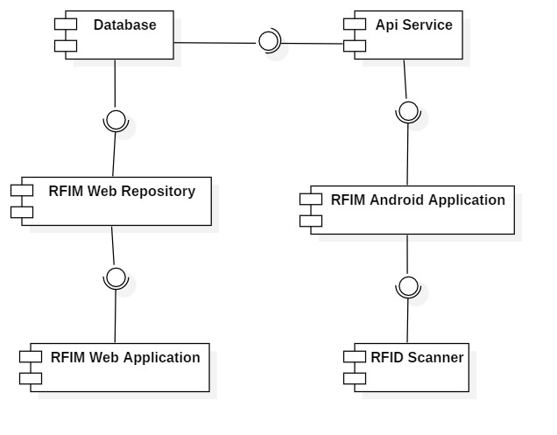

Figure 14 – Component Diagram
COMPONENT DICTIONARY: DESCRIBES COMPONENTS
Component name | Description
RFID Scanner | RFID scanner device
API Service | Provide API for Android application. Interact with Database
RFIM Android Application | Receive data from RFID scanner. Interact with API
RFIM Web Application | Handle business
RFIM Web Repository | Interact with Database
Database | Store data
Table 15 - Component Dictionary

Detail Description

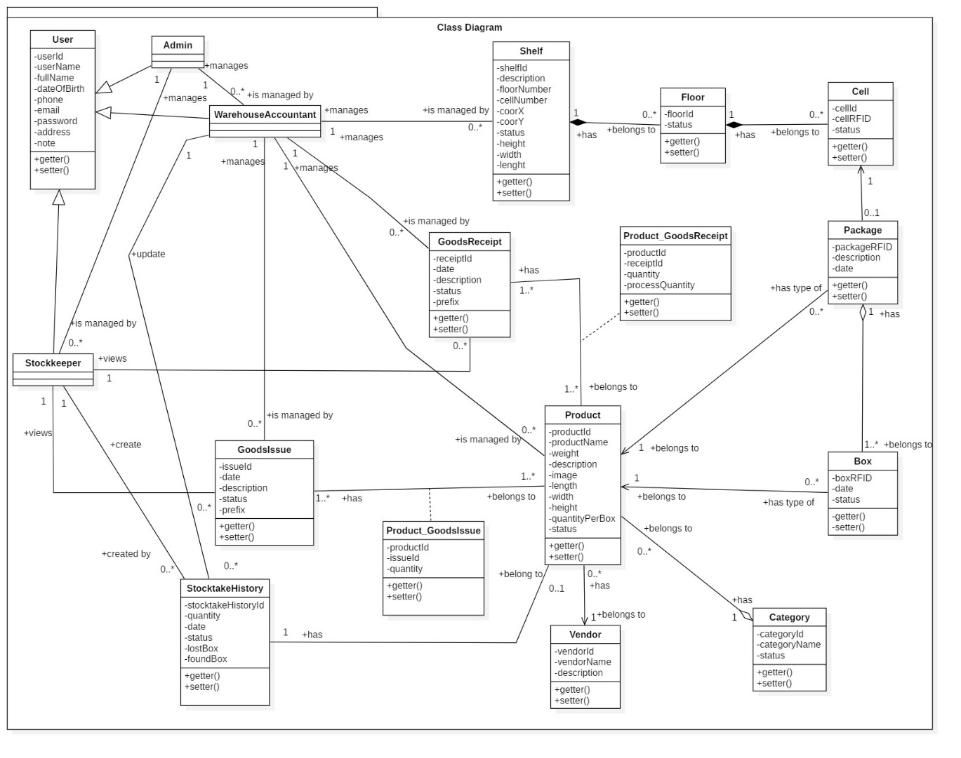
Class Diagram
Figure 15- Class Diagram
CLASS DICTIONARY: DESCRIBE CLASS
Class Name | Mapping column with Conceptual diagram | Description
User | N/A | Not exist in conceptual diagram, but needed in class diagram to contain the user information in general
Admin | Admin | Contains the admin information
Stock-keeper | Stock-keeper | Contains the stock-keeper information
Warehouse Accountant | Warehouse Accountant | Contains the warehouse accountant information
Shelf | Shelf | Contains the shelf information
Floor | Floor | Contains the floor information
Cell | Cell | Contains the cell information
Package | Package | Contains the package information
Product | Product | Contains the product information
Category | N/A | Not exist in conceptual diagram, but needed in class diagram to contain the category information
Box | Box | Contains the box information
Vendor | Vendor | Contains the vendor information
Goods Receipt | Goods Receipt | Contains the goods receipt information
Goods Issue | Goods Issue | Contains the goods issue information
Product _ Goods Receipt | N/A | Not exist in conceptual diagram, but needed in class diagram to contain the attribute to define many to many relationship
Product _ Goods Issue | N/A | Not exist in conceptual diagram, but needed in class diagram to contain the attribute to define many to many relationship
Stocktake History | StocktakeHistory | Contains the stocktake history information
Table 16 - Class Dictionary

Class Diagram Explanation

User
(References to RFIM_200_Page, Section D.4.2.1, page 79)

Admin
(References to RFIM_200_Page, Section D.4.2.2, page 80)

Stock-keeper
(References to RFIM_200_Page, Section D.4.2.3, page 81)

Warehouse Accountant
(References to RFIM_200_Page, Section D.4.2.4, page 81)

Shelf
- Attributes
Attribute | Type | Visibility | Description
shelfId | string | private | Unique identifier of shelf
description | string | private | Description of shelf
floorNumber | integer | private | Number of floor of each shelf
cellNumber | integer | private | Number of cell per floor of each shelf
coorX | integer | private | Coordinate X of shelf, determine by position in horizontal
coorY | integer | private | Coordinate Y of shelf, determine by position in vertical
status | boolean | private | Status of shelf
height | float | private | Height of shelf
width | float | private | Width of shelf
lenght | float | private | Length of shelf
Table 25- <Class Diagram> Shelf Attributes
- Methods
Method | Return Type | Visibility | Description
getter() | attribute type | public | Get shelf attributes
setter() | void | public | Set value of shelf attributes
Table 26- <Class Diagram> Shelf Methods

Floor
- Attributes
Attribute | Type | Visibility | Description
floorId | string | private | Unique identifier of floor
status | boolean | private | Status of floor
Table 27- <Class Diagram> Floor Attributes
- Methods
Method | Return Type | Visibility | Description
getter() | attribute type | public | Get floor attributes
setter() | void | public | Set value of floor attributes
Table 28- <Class Diagram>Floor Methods

Cell
- Attributes
Attribute | Type | Visibility | Description
cellId | string | private | Unique identifier of cell
cellRFID | string | private | RFID bind to cell
status | boolean | private | Status of cell
Table 29- <Class Diagram>Cell Attribute

- Methods
Method | Return Type | Visibility | Description
getter() | attribute type | public | Get cell attributes
setter() | void | public | Set value of cell attributes
Table 30- <Class Diagram>Cell Methods

Package
- Attributes
Attribute | Type | Visibility | Description
packageRFID | string | private | Unique RFID of package
date | date | private | Package creation date
description | string | private | Description of package
Table 31- <Class Diagram>Package Attributes

- Methods
Method | Return Type | Visibility | Description
getter() | attribute type | public | Get package attributes
setter() | void | public | Set value of package attributes
Table 32- <Class Diagram>Package Methods

Product
- Attributes
Attribute | Type | Visibility | Description
productId | string | private | Unique identifier of product
productName | string | private | Name of product
weight | float | private | Weight of product
description | string | private | Description of product
image | string | private | Image of product
length | float | private | Product box length
width | float | private | Product box width
height | float | private | Product box height
quantityPerBox | integer | private | Number of item per product box
status | boolean | private | Product status
Table 33- <Class Diagram> Product Attribute
- Methods
Method | Return Type | Visibility | Description
getter() | attribute type | public | Get product attributes
setter() | void | public | Set value of product attributes
Table 34- <Class Diagram> Product Methods

Category
(References to RFIM_200_Page, Section D.4.2.10, page 84)

Box
- Attributes
Attribute | Type | Visibility | Description
boxRFID | string | private | Unique RFID of box
date | date | private | Box stock in date
status | boolean | private | Status of box
Table 37- <Class Diagram>Box Attributes
- Methods
Method | Return Type | Visibility | Description
getter() | attribute type | public | Get box attributes
setter() | void | public | Set value of box attributes
Table 38- <Class Diagram> Box Method

Vendor
(References to RFIM_200_Page, Section D.4.2.12, page 75)

Goods Receipt
- Attributes
Attribute | Type | Visibility | Description
receiptId | string | private | Unique identifier of goods receipt
date | dateTime | private | Goods receipt creation date
description | string | private | Description of goods receipt
status | int | private | Status of goods receipt
prefix | string | private | Prefix of goods receipt
Table 41- <Class Diagram>Goods Receipt Attributes
- Methods
Method | Return Type | Visibility | Description
getter() | attribute type | public | Get goods receipt attributes
setter() | void | public | Set value of goods receipt attributes
Table 42- <Class Diagram>Goods Receipt Methods

Goods Issue
- Attributes
Attribute | Type | Visibility | Description
issueId | string | private | Unique identifier of goods issue
date | dateTime | private | Date of creating goods issue
description | string | private | Description of goods issue
status | int | private | Status of goods issue
prefix | string | private | Prefix of goods issue
Table 43- <Class Diagram> Goods Issue Attributes
- Methods
Method | Return Type | Visibility | Description
getter() | attribute type | public | Get goods issue attributes
setter() | void | public | Set value of goods issue attributes
Table 44- <Class Diagram> Goods Issue Methods

Product_Goods Receipt
- Attributes
Attribute | Type | Visibility | Description
receiptId | string | private | Unique identifier of goods receipt
productId | string | private | Unique identifier of product
quantity | integer | private | Planning quantity of stock in
processQuantity | integer | private | Current scanned quantity of stock in
Table 45- <Class Diagram>Product_Goods Receipt Attributes
- Methods
Method | Return Type | Visibility | Description
getter() | attribute type | public | Get product_receipt attributes
setter() | void | public | Set value of product_receipt attributes
Table 46- <Class Diagram>Product_Goods Receipt Methods

Product_Goods Issue
- Attributes
Attribute | Type | Visibility | Description
issueId | string | private | Unique identifier of goods issue
productId | string | private | Unique identifier of issue
quantity | integer | private | Planning quantity of stock out
Table 47- <Class Diagram>Product_Goods Issue Attributes
- Methods
Method | Return Type | Visibility | Description
getter() | attribute type | public | Get product_issue attributes
setter() | void | public | Set value of product_issue attributes
Table 48- <Class Diagram>Product_Goods Issue Methods

Stocktake History

- Attributes
Attribute | Type | Visibility | Description
stocktakeHistoryId | int | private | Unique identifier of stocktake history
quantity | string | private | Stocktaked quantity
date | date | private | Date of Stocktake History
status | boolean | private | Status of Stocktake
lostBox | string | private | Boxes that didn’t appear in stocktake process
foundBox | string | private | Lost boxes that was found during stocktake process
Table 49- <Class Diagram>Stocktake History Attributes
- Methods
Method | Return Type | Visibility | Description
getter() | attribute type | public | Get stocktake attributes
setter() | void | public | Set value of stocktake attributes
Table 50- <Class Diagram>Stocktake History Methods

Sequence Diagram

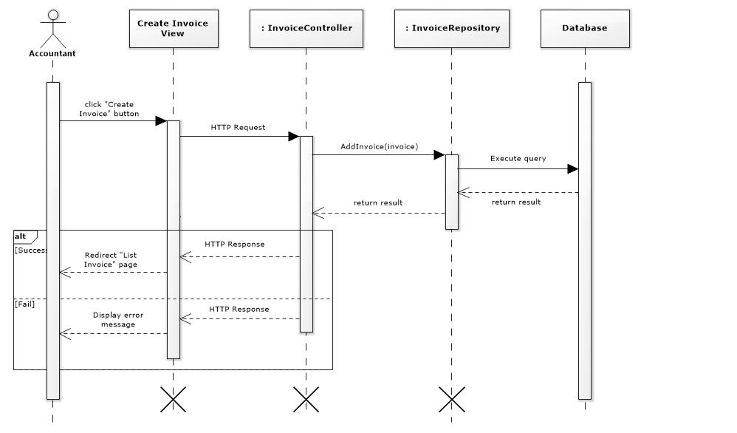
Figure 16- <Sequence Diagram> Create Invoice
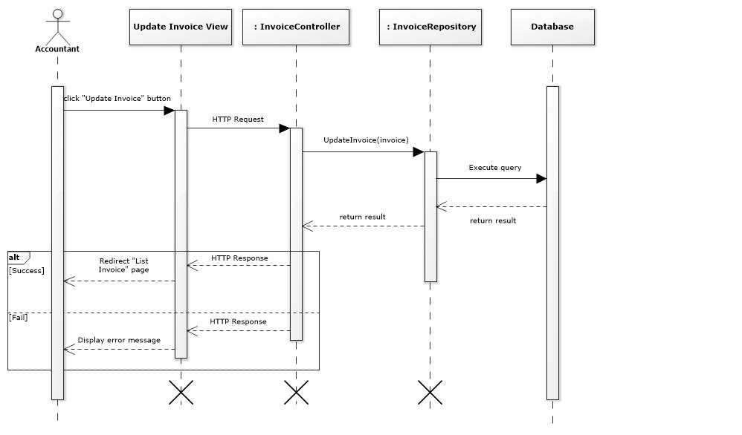
Figure 17- <Sequence Diagram> Update Invoice

Activity Diagram
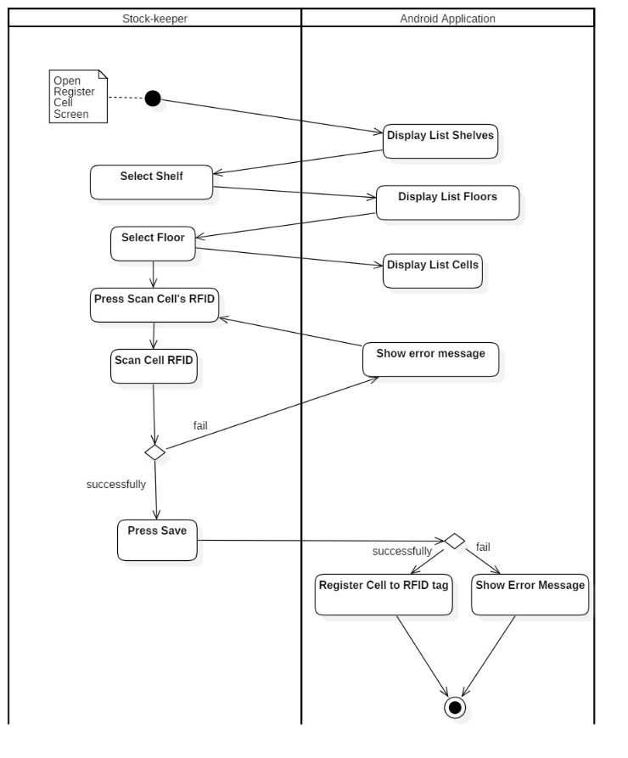
Figure 18- <Activity Diagram> Register Cell

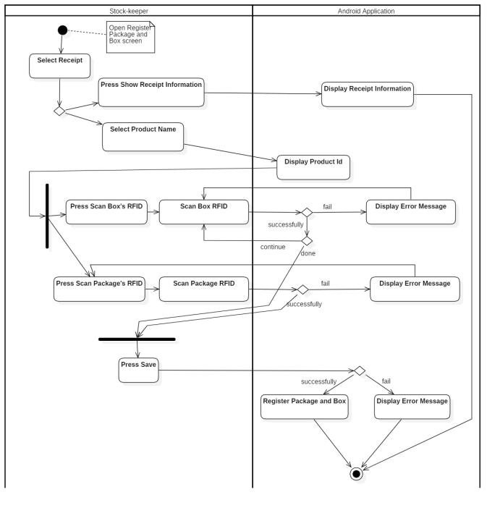
Figure 19- <Activity Diagram> Register Box and Package

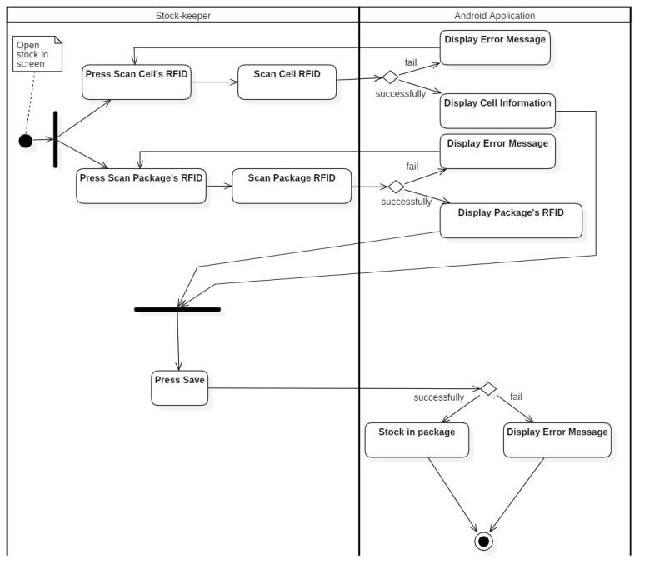
Figure 20- <Activity Diagram> Stock in
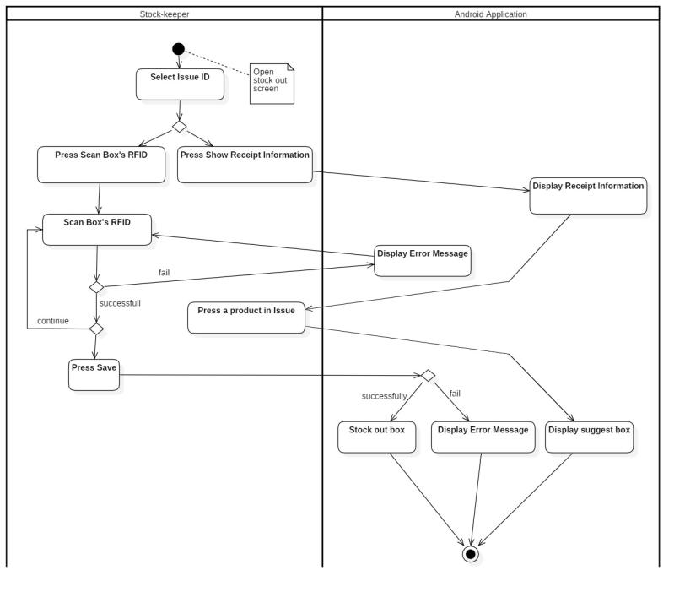
Figure 21- <Activity Diagram> Stock Out
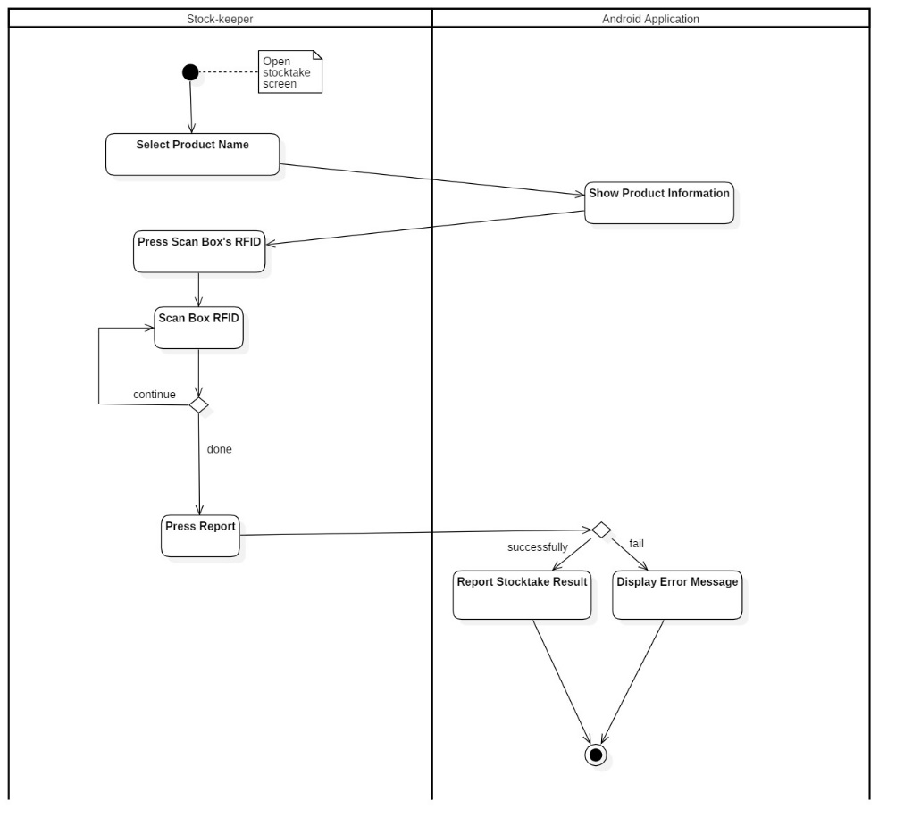
Figure 22- <Activity Diagram> Stocktake Inventory
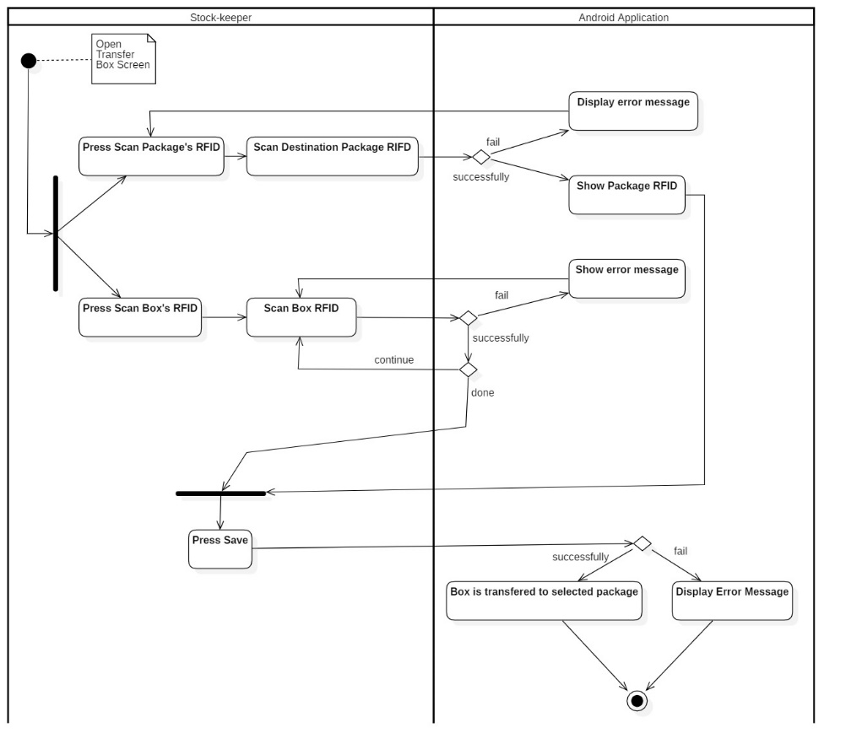
Figure 23- <Activity Diagram> Transfer Box

User Interface Design

(References to RFIM_200_Page, Section D.5, page 102)

Database Design

Entity Relationship Diagram (ERD)
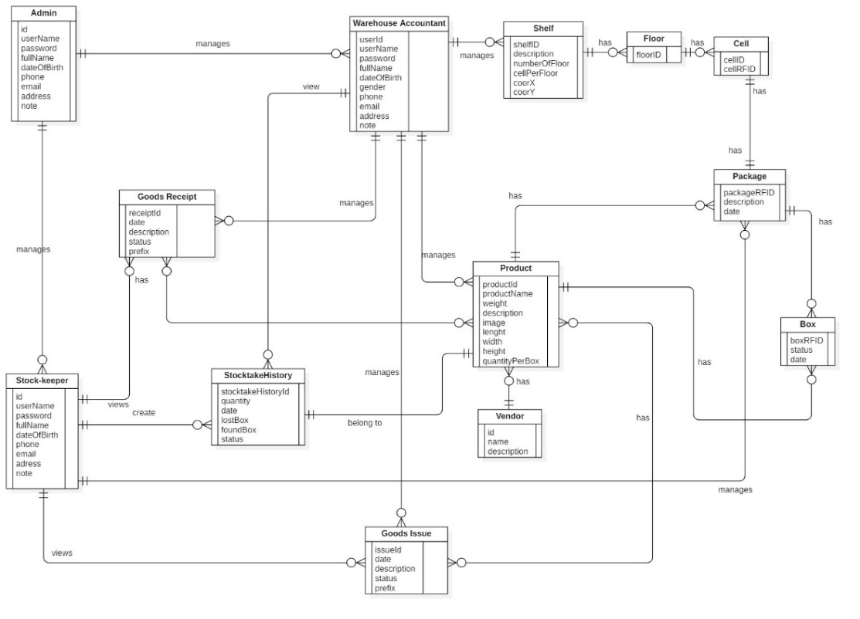
Figure 24 - Entity Relationship Diagram

Entity Dictionary
Entity Data Dictionary: Describe content of all entities
Entity Name | Mapping entity with conceptual diagram | Description
Admin | Admin | Contains information of admin.
Stock-keeper | Stock-keeper | Contains information of stock-keeper.
Warehouse Accountant | Warehouse Accountant | Contains information of warehouse accountant.
GoodsReceipt | GoodsReceipt | Contains information of goods receipt.
GoodsIssue | GoodsIssue | Contains information of goods issue.
Product | Product | Contains information of product.
StocktakeHistory | Stocktake History | Contains information of stocktake history.
Vendor | Vendor | Contains information of vendor.
Shelf | Shelf | Contains information of shelf.
Floor | Floor | Contains information of floor.
Cell | Cell | Contains information of cell.
Package | Package | Contains information of package.
Box | Box | Contains information of box.
Table 146 - Entity Data Dictionary

Algorithms

Find box base on the longest stock in date and closest warehouse’s gate

Definition
This algorithm intended to suggest stock-keeper the suitable box when they need to find box to stock out.

Problem Definition
When stock-keeper get an issue invoice, the stock-keeper do not know where to pick the box to stock out. In addition, a box have longest stock in date need to be stock out first but stock-keeper also do not know about this. This algorithm, provide information that help stock-keeper can choose the closest box and have longest date in warehouse.

Solution
To suggest box information for stock-keeper, we use weighted mean formula to solve this problem:
$$\overline{x}= \frac{\sum_{i=1}^{n}{w_{i}x_{i}}}{\sum_{i=1}^{n}{w_{i}}}= \frac{w_{1}x_{1}+w_{2}x_{2}+…+w_{n}x_{n}}{w_{1}+w_{2}+…+w_{n}}$$
With:
$\overline{x}$: the weighted mean
x: the value of criteria
w: the weighted number

In current problem, we have two criteria need to consider there are:
- The first criteria is the difference days between stock in date and now.
- The second criteria is the distance from source shelf to target shelf. (Because the farther away the distance, the lower priority so that the distance value need to be multiply with -1)
The priority of shelves is based on weighted mean values. The shelf that have larger weighted mean is better.

Example
We have list shelves:
Criteria  Shelf | Days (70%) | Distance (30%)
A | 20 | 10
B | 25 | 8
Shelf C | 20 | 8

Calculate weighted mean values:
$$\overline{x_{A}}=20×0.7+10*0.3*\left(-1\right)=11$$
$$\overline{x_{B}}=25×0.7+8*0.3*\left(-1\right)=15.1$$
$$\overline{x_{C}}=20×0.7+8*0.3*\left(-1\right)=11.6$$
Order weighted mean values descending:
Shelf | Weighted Average Number
B | 15.1
C | 11.6
A | 11

Complexity
In total, the complexity of this algorithm is O(n).

Flowchart
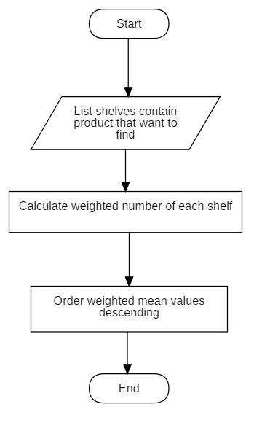
Figure 25<Algorithm> Optimizing Stock out Product Flowchart

Convert shelves’ coordinates to matrix algorithm
(References to RFIM_200_Page, Section D.7.2, page 141)

Dijkstra algorithms
(References to RFIM_200_Page, Section D.7.3, page 143)

E. System Implementation & Testing

Introduction

Overview
(References to RFIM_200_Page, Section E.1.1, page 147)

Test Approach:
(References to RFIM_200_Page, Section E.1.2, page 148)

Database Relationship Diagram

Physical Diagram
Figure 34– Database Diagram

Data Dictionary
Entity Data Dictionary: Describe content of all entities
Entity Name | Mapping table with class diagram | Description
User | User | Contains the information of user.
Role | Role | Contains the information of role.
Invoice | Goods Receipt  Goods Issue | Contains the information of goods receipt and Issue
StocktakeHistory | StocktakeHistory | Contains the information of stocktake history.
Product | Product | Contains the information of product.
Vendor | Vendor | Contains the information of vendor.
Category | Category | Contains the information of category.
Invoice_Product | Product_GoodsReceipt  Product_GoodsIssue | Contains mapping between good receipt/issue and product. Contains info of products in goods receipt/issue
InvoiceType | N/A | Contains the type of goods receipt/issue.
InvoiceStatus | N/A | Contains the status of goods receipt/issue.
Shelf | Shelf | Contains the information of shelf.
Floor | Floor | Contains the information of floor.
Cell | Cell | Contains the information of cell.
Package | Package | Contains information of package.
Box | Box | Contains information of box.
StandardShelfSize | N/A | Contains information of standard shelf size
ConstantTable | N/A | Contains contstant generated from algorithm
Table 148 Database Data Ditionary

Entity Name | Attributes | Description | Domain | Allow Null
User | UserId {PK} | Unique identifier of user | Integer | No
User | UserName | Username of user | String | No
User | FullName | Fullname of user | String | No
User | DateOfBirth | Date of birth of user | Date | No
User | Phone | Phone of user | String | Yes
User | Email | Email of user | String | Yes
User | Password | Password of user | String | No
User | Address | Address of user | String | Yes
User | Note | Note of user | String | Yes
User | RoleId | Role of user | Integer | No
User | Status | Status of user | Boolean | No
Role | RoleId {PK} | Unique identifier of role | Integer | No
Role | RoleName | Role name of role | String | Yes
Invoice | InvoiceId {PK} | Unique identifier of invoice | String | No
Invoice | Date | Date of invoice | Date | No
Invoice | Description | Description of invoice | String | Yes
Invoice | StatusId | Status of invoice | Integer | No
Invoice | UserId | Creator of invoice | Integer | No
Invoice | InvoiceTypeID | Type of invoice | Integer | No
InvoiceStatus | StatusId {PK} | Unique identifier of invoice status | Integer | No
InvoiceStatus | Status | Status name of invoice | String | Yes
InvoiceType | InvoiceTypeId {PK} | Unique identifier of invoice type | Integer | No
InvoiceType | InvoiceTypes | Type name of invoice | String | Yes
InvoiceType | InvoicePrefix | Prefix of invoice type | String | Yes
Stocktake History | StocktakeHistoryId {PK} | Unique identifier of stocktake history | Integer | No
Stocktake History | Quantity | Quantity of box after stocktaking | Integer | No
Stocktake History | Date | Date of stocktake history | Date | Yes
Stocktake History | Status | Status of stocktake history | Boolean | No
Stocktake History | LostBox | Lost box’s RFID after stocktake | String | Yes
Stocktake History | FoundBox | Missing box RFID was found after stocktake | String | Yes
Stocktake History | UserId | Creator of stocktake history | Integer | No
Stocktake History | ProductId | Product Id of stocktake | String | No
Product | ProductId {PK} | Unique identifier of product | String | No
Product | ProductName | Product name of product | String | No
Product | Weight | Weight of product | Float | Yes
Product | Description | Description of product | String | Yes
Product | Image | Image of product | String | Yes
Product | Length | Length of product box | Float | Yes
Product | Width | Width of product box | Float | Yes
Product | Height | Height of product box | Float | Yes
Product | QuantityPerBox | Number of items per product box | Integer | No
Product | CategoryId | Category of product | Integer | No
Product | VendorId | Vendor of product | Integer | No
Product | Status | Status of product | Boolean | No
Vendor | VendorId {PK} | Unique identifier of vendor | Int | No
Vendor | VendorName | Vendor name of vendor. | String | No
Vendor | Description | Description of vendor | String | Yes
Category | CategoryId {PK} | Unique identifier of category | Int | No
Category | CategoryName | Category name of category | String | No
Category | Description | Description of category | String | Yes
Category | Status | Status of category | Boolean | No
Invoice_Product | ProductId | Product Id from product | String | No
Invoice_Product | InvoiceId | Invoice Id from invoice | String | No
Invoice_Product | Quantity | Quantity of box for stock in/out | Integer | No
Invoice_Product | ProcessQuantity | Current scanned box quantity | Integer | Yes
Shelf | ShelfId {PK} | Unique identifier of shelf | String | No
Shelf | Description | Description of shelf | String | Yes
Shelf | FloorNumber | Number of floor | Integer | No
Shelf | CallNumber | Number of cell per floor | Integer | No
Shelf | CoorX | Coordinate X of shelf | Integer | No
Shelf | CoorY | Coordinate Y of shelf | Integer | No
Shelf | Length | Length of shelf | Float | Yes
Shelf | Width | Width of shelf | Float | Yes
Shelf | Height | Height of shelf | Float | Yes
Shelf | Status | Status of shelf | Boolean | Yes
Floor | FloorId {PK} | Unique identifier of floor | String | No
Floor | ShelfId | Shelf Id of floor | String | No
Floor | Status | Status of floor | Boolean | Yes
Cell | CellId {PK} | Unique identifier of cell. | String | No
Cell | FloorId | Floor Id of cell | String | No
Cell | Status | Status of cell | Boolean | Yes
Cell | CellRFID | RFID of cell | String | Yes
Package | PackageRFID {PK} | Unique identifier of package | String | No
Package | Description | Description of package | String | Yes
Package | CellId | Cell Id of package | String | Yes
Package | ProductId | Product Id of package | String | Yes
Package | Date | Creation Date of package | Date | Yes
Box | BoxRFID {PK} | Unique identifier of box. | String | No
Box | PackageRFID | Package RFID of box | String | No
Box | ProductId | Product Id of box | String | No
Box | Date | Date of box | Date | Yes
Box | Status | Status of box | Boolean | Yes
StandardShelfSize | StandardShelfId {PK} | Unique identifier of shelf size | Integer | No
StandardShelfSize | StandardFloor | Standard number of floor | Integer | No
StandardShelfSize | StandardCell | Standard number of cell per floor | Integer | No
ConstantTable | WeightedDate | Weight number of Date in Algorithm | Float | No
ConstantTable | WeightedHeight | Weight number of Height in Algorithm | Float | No
ConstantTable | SourceShelfId | Destination ShelfId of Date in Algorithm | String | No
ConstantTable | ColumnDistance | Distance between two column of shelves | Integer | No
ConstantTable | RowDistance | Distance between two row of shelves | Integer | No
Table 149 Database Data Dictionary

Test Plan

Feature to be tested
- Guest: Login
- Admin: Create User, Update User, Deactivate User
- Stock-keeper: Create Product, Update Product, Deactivate Product, Create Category, Update Category, Deactivate Category, Create Shelf, Update Shelf, Deactivate Shelf, Create Goods Receipt, Update Goods Receipt, Delete Invoice
- Warehouse Staff: Register Cell, Register Package and Box, Stock in Package, Stock out Box, Transfer Package, Transfer Box, Stocktake Inventory

Features not to be tested
Logout, View Product, View Category, View Shelf, View Invoice, Create Report, View Stocktake History, Clear RFID Tag, Edit Stamdard Shelf Size, Edit Invoice Prefix, Update Stocktake Status

System Testing Test Case
(References to RFIM_200_Page, Section E.4, page 154)

F. Software User’s Manual
(References to RFIM_200_Page, Section F, page 177)

G. Appendix

(References to RFIM_200_Page, Section G, page 228)

