 | MINISTRY OF EDUCATION AND TRAINING

FPT UNIVERSITY

Capstone Project Document

Motorbike Accessories Inventory Management

Group 7
Group members | Phạm Minh Hoàng – SE62769 (Leader)  Nguyễn Trường Thịnh – SE61887  Đỗ Trung Hiếu – SE61847  Nguyễn Huy Hoàng – SE62442
Supervisor | Lại Đức Hùng
Ext. Supervisor | N/A
Project Code | RFIM

– Ho Chi Minh City, 13 May, 2019 –

Report 2 – Software Project Management Plan

Table of Contents

Table of Contents 3
B. Software Project Management Plan 4
1. Problem Definition 4
1.1. Name of this Capstone Project 4
1.2. Problem Abstract 4
1.3. Project Overview 4
2. Project Organization 7
2.1. Software Process Model 7
2.2. Roles and Responsibilities 8
2.3. Tools and Techniques 8
3. Project Management Plan 9
3.1. Software development life cycle 9
3.2. Phase Detail 10
3.3. Meeting Minutes 12
4. Coding Convention 12

B. Software Project Management Plan

Problem Definition

Name of this Capstone Project
- Official name: Motorbike Accessories Inventory Management With RFID.
- Vietnamese name: Quản lý kho phụ tùng xe máy với công nghệ RFID.
- Abbreviation: RFIM

Problem Abstract
- Project is concerned about the development of motorbike leading to increasingly difficult accessories management, so we use RFID technology to handle this problem. We call it Motorbike Accessories Inventory Management with RFID (RFIM). RFIM will provide a user-friendly interface and easy-to-use solution to manage motorbike parts.
- Companies use warehouse management system for managing information of products, of users, etc. With the existing systems that use barcode, the can only scan one code at a time, scan in the clear line of sight, and the barcode is easy to become blur and be torn. Therefore, it is hard to manage the correct, authentic information, quantity of motorbike accessories.
- The Motorbike Accessories Inventory Management System will be a useful assistant for every stores, every industry to manage motorbike accessories easily and effectively.

Project Overview

The Current Situation
Below are the problems of the current situation:
• Schedule of team members: team members have different time for studying and working so that it is hard to arrange the available time for the group offline meeting.
• New techniques: team members are all JS students and don’t have much experience to use embedded system. The team needs an amount of time to research and integrate into system.
• Lack of knowledge about warehouse management process: Our team members are students, and no one knows about the warehouse management business’s knowledge. Therefore, the team needs an amount of time to take survey of warehouse management process.
• Lack of budget: The team can’t afford modern and expensive RFID tools, just be able to buy cheap tools for the demonstration.

The Proposed System
According to the technology researches, we found out that RFID is an effective solution to solve motorbike warehouse problems. We build a web application that allows end users manage users, motorbike parts. End users include admin, warehouse accountant. Admin can manage users, permissions. Warehouse accountant can manage products, goods receipts, goods issues, shelves, categories, reports. We also build a mobile application that allows stock-keeper to stock in, stock out, register, and maintain products.
Tasks will be assigned vertically to team members, so that if one member quits, the team will not lack of resources.

Boundaries of the System

The system can:
- Allow Admin to manage user accounts .
- Allow Warehouse Accountant to manage products, shelves, categories, goods receipts, goods issues, stocktaking history and reports.
- Allow Stock-keeper to register cells, register package and boxes, stock in package, stock out box, stocktaking inventory, transfer products
The system cannot:
- RFID can’t scan multiple tags because of the cheap RFID scanner.
- Due to limitation of technology and funds, RFIM system can only bind RFID tags to product’s boxes, not the product items inside
- The stocktake process report all missing boxes while stocktaking but system doesn’t cover the case that how to handle missing boxes’s case when stocktake process report.
- The system can’t support when warehouse need to decrease shelf’s number of floor or shelf‘s number of cell because it can reduce to effective management.

Future Plans
- The existing systems can only scan one RFID tag at one time. We design our system to scan multiple RFID tags with a wide range.
- We can stick RFID tags to product items for managing effectively.
- We build system to minimize lost of products in warehouse.
- We build this system for medium motorbike companies or stores so it doesn’t support automated system and stock-keepers have to scan the tags manually. We will integrate automated system for managing warehouse.

Development Environment

Hardware Requirements
- For server
Hardware | Minimum Requirement | Recommended
Internet Connection | Cable, Wi-Fi (4 Mbps) | Cable, Wi-Fi (8 Mbps or more)
Operation System | XP, Vista, 7, 10, Window Server 2008 | 10, Window server 2008
Computer Processor | Intel® Xeon ® 1.4GHz | Intel® Xeon ® Quad Core (12M Cache, 2.50 GHz)
Computer memory | 4GB RAM | 32 GB RAM or more
Storage space | 1GB | 5GB or more
Table 2 - Hardware requirements for Server
- For PC
PC | Minimum Requirements | Recommended
Internet Connection | Cable, Wi-Fi (4 Mbps) | Cable, Wi-Fi (8 Mbps)
Operating System | Window 7 | Window 7 or more.
Computer Processor | Intel® Core i3 1.4GHz | Intel® Core i5 2.50GHz
Computer Memory | 1GB RAM | 2GB RAM or more
Web Browser | Chromes (v42 or higher) | Chrome latest stable version
Table 3 - Hardware requirements for PC
- For Mobile
Mobile | Minimum Requirements | Recommended
Internet Connection | Wi-Fi (4 Mbps) | Wi-Fi (8 Mbps)
Operating System | Android 6.0 | Android 7.1.1
Mobile Processor | SnapDragon 625 | SnapDragon 625
Mobile Memory | 2GB RAM | 4GB RAM or more
Table 4 - Hardware requirements for Mobile

Software Requirements

Software | Name / Version | Description
Operation System | Window Server 2012 | Operating system and platform for development
Environment | .NET Framework, Java, C, C# | Specification for developing web application
Modeling tool | StarUML | Designing diagram
IDE | Android Studio 3.4.1, Visual Studio 2017, Arduino IDE, IntelliJ 2019.1.3 | Programming tools
DBMS | SQL Server 2017, Amazon Web Services | Creating & managing the database for system
Source control | Git on IDE (Sourcetree) | Controlling the source code
Web browser | Chrome 69 or above | Testing system on browser
Table 5 - Software requirements for PC

Project Organization

Software Process Model

This project is developed using Waterfall model for Software development project. Our team choose Waterfall model because of the following reasons:
- Our team only has 4 members, and this project for medium motorcycle accessories warehouses, no multi-warehouses available.
- For a classic problem “Warehouse management” which most of the requirements were clarified in real life, we decided to choose Modified Waterfall Model
- Modified Waterfall model is easy to progress and maintain, also has lower risk when comparing to the classic Waterfall model.
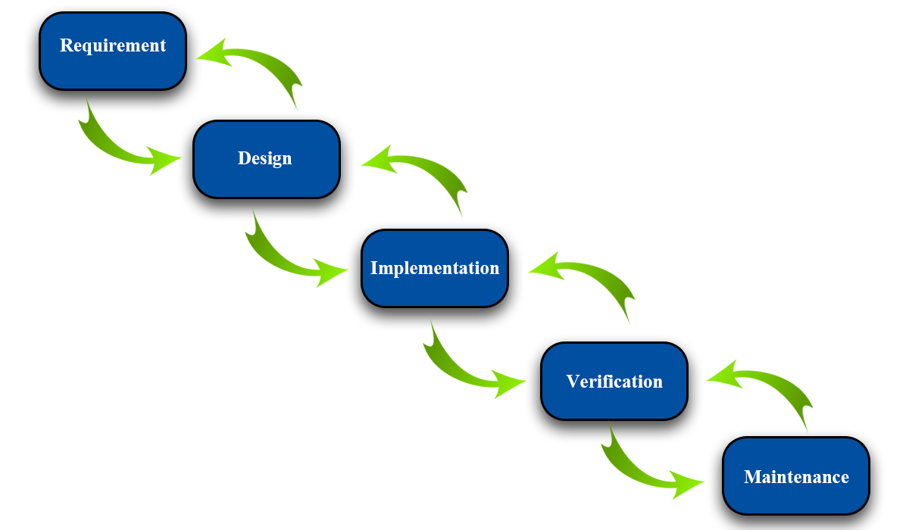
Figure 1 - Modified Waterfall - Wicked Problems, Righteous Solutions: A Catalogue of Modern Software Engineering Paradigms [1]

Roles and Responsibilities
No | Full name | Role in Group | Responsibilities
1 | Lại Đức Hùng | Product Owner | - Specifying user requirements  - Controlling the development process  - Giving out technique and business analysis support
2 | Phạm Minh Hoàng | Team Leader | - Managing process  - Designing database  - Clarifying requirements  - Preparing documents  - Designing GUI  - Creating test plan  - Coding  - Testing  - Arranging Meeting  - Managing Risks
3 | Nguyễn Trường Thịnh | Team Member | - Designing database  - Clarifying requirements  - Preparing documents  - Designing GUI  - Creating test plan  - Coding  - Testing
4 | Đỗ Trung Hiếu | Team Member | - Designing database  - Clarifying requirements  - Preparing documents  - Designing GUI  - Creating test plan  - Coding  - Testing
Table 6 - Role and Responsibilities

Tools and Techniques
Tool/Technique | Name
Front-end | HTML, CSS, JavaScript, jQuery
Back-end | ASP.NET Core 2.1, Entity Framework, Spring Boot , Java
IDE | Android Studio 3.4.1, Visual Studio 2017, Arduino IDE, IntelliJ 2019.1.3
DBMS | SQL Server 2017, Amazon AWS
Source Control | Github, Sourcetree
Modeling tool | StarUML
Table 7 - Tools and Techniques

Project Management Plan

Software development life cycle

Phase | Description | Deliverables | Resource needed | Dependencies and Constrains | Description
Requirement Analysis | Collect and analyze system requirements | Software Requirement Specification | 20 man- days | N/A | - Missing requirement  - Unclear scope project’s scope  - Lack of member share of understanding
System and Software Design | - Design the structure of the system  - Choose Architecture style | Software Design Document | 20 man- days | Depend on requirement after analyzed and system architecture design. | - Lack of experience from real project  - Requirement is too complex and easy to misunderstand
Implementation and Unit Testing | - Implement all system’s function  - Create test plan  - Perform Unit test | Software package and hardware | 50 man- days | Depend on Software Requirement Specification, Software Design Description and Hardware | - Lack of experience and knowledge  - Human mistake  - Hardware error
Integration and System Testing | - Integration test the system  - Alpha test  - Correct bugs  - Beta test | Test case | 20 man- days | Depend on “Implementation” | - Lack of experience  - Missing test case
Operation and Maintenance | Deploy on sever, web and mobile | - Installation guide  - Software User’s Manual | 10 man- days | Depend on “Testing” | - Lack of experience  - Customers do not understand User’s Manual
Table 8 - Software development life cycle

Phase Detail

Phase 1: Requirements Analysis
Task | Description | Author
1. Collect requirements | Research similar application to collect requirement.  Observation real situation. | HoangPM, ThinhNT, HieuDT
2. Identify and clarify main functions | Define main system’s function. | HoangPM, ThinhNT, HieuDT
3. Create System Introduction | Complete Introduction Report. | HoangPM, ThinhNT, HieuDT
4. Software Project  Management Plan | Create Project Management Plan. | HoangPM, ThinhNT, HieuDT
5. Prototype | Build a prototype of proposed system (Website/Mobile). | HoangPM, ThinhNT, HieuDT
6. SRS | Create Software Requirement Specification document. | HoangPM, ThinhNT, HieuDT
Table 9 - Phase 1: Requirements Analysis

Phase 2: Design
Task | Description | Author
1. Database Design | Design database for the RFIM system | HoangPM, ThinhNT, HieuDT
2. Technology research | Study Arduino platform  Study Bluetooth on Mobile Device Technology | HoangPM
3. Design Document | Create software design document | HoangPM, ThinhNT, HieuDT
Table 10 - Phase 2: Design

Phase 3: Implementation
Task | Description | Author
1. RFIM’s functions | Implement function of RFIM system | HoangPM, ThinhNT, HieuDT
2. Front-end web functions | Implement front-end functions on web | ThinhNT, HieuDT
3. Back-end web functions | Implement back-end functions on web | ThinhNT, HieuDT
4. Mobile functions | Implement mobile application | HoangPM
5. RFID Scanner | Assembly RFID Scanner  Implement embedded code for RFID Scanner | HoangPM
6. Unit testing | Write test case and test for web functions | ThinhNT, HieuDT
6. Unit testing | Write test case and testing for mobile functions | HoangPM
Table 11 - Phase 3: Implementation

Phase 4: Testing
Task | Description | Author
1. Integration testing | Write test case and test systems | ThinhNT, HieuDT
2. Acceptance testing | Let customer test real product to ensure the product meet user’s requirements | HoangPM, ThinhNT, HieuDT
Table 12 - Phase 4: Testing

Phase 5: Operation and Maintenance
Task | Description | Author
1. Installation guide | Write installation guide | HoangPM , HieuDT
2. Create User’s Manual | Write user manual | HieuDT, ThinhNT
Table 13 - Phase 5: Maintenance

Meeting Minutes
All meeting documents could be found here:
https://drive.google.com/open?id=1tj0KZxtxWliY2fBINYbQjqLgHpzjM3op (Security: Must be login with fpt university’s email).

Coding Convention
- For C#:
- Naming Conventions:
  - Use pascal case for class and method names.
  - Use camel case for method arguments and local variables.
  - Do not use underscores in identifiers. Except: can prefix private static variables with an underscore.
  - Prefix interfaces with the letter ‘I’.
  - Use noun or noun phrases to name a class.
- Layout Conventions:
  - If continuation lines are not indented automatically, tabs must be set exactly every 4 spaces.
  - Avoid lines longer than 80 characters.
  - Write only one statement per line.
  - Write only one declaration per line.
  - Add at least one blank line between method definitions and property definitions.
- Declaration:
  - Use implicit type ‘var’ for local variable declarations. Except: primitive types (int, string, double, etc) use predefined names.
  - Organize namespaces with a clearly defined structure.
- Commenting Conventions:
  - Place the comment on a separate line.
  - Begin comment text with an uppercase letter and end with a period.
  - Add one space between the comment delimiter (//) and the comment text.
References: C# Coding Conventions [2]
- For Java
- Naming Conventions:
  - Use camel case for method arguments, method name and local variables.
  - Use uppercase with words separated by underscores (“_”) for constant
  - Use all-lowercase for package name
  - Use verbs for method name
  - Use nouns for class name and the first word should be uppercase
- Layout Conventions:
  - If continuation lines are not indented automatically, tabs must be set exactly every 4 spaces.
  - Avoid lines longer than 80 characters.
  - Write only one statement per line.
  - Write only one declaration per line.
  - Add at least one blank line between method definitions and property definitions.
- Declaration:
  - Use one declaration per line.
  - Put declarations only at the begin of the block
  - Do not use space between method name
  - Method are separated by black line
  - Open brace at the same line of method declaration
- Commenting Conventions:
  - Place the comment on a separate line.
  - Begin comment text with an uppercase letter and end with a period.
  - Add one space between the comment delimiter (//) and the comment text.

References: Java Coding Conventions [3]

