 | MINISTRY OF EDUCATION AND TRAINING

FPT UNIVERSITY

Capstone Project Document

Motorbike Accessories Inventory Management

Group 7
Group members | Phạm Minh Hoàng – SE62769 (Leader)  Nguyễn Trường Thịnh – SE61887  Đỗ Trung Hiếu – SE61847  Nguyễn Huy Hoàng – SE62442
Supervisor | Lại Đức Hùng
Ext. Supervisor | N/A
Project Code | RFIM

– Ho Chi Minh City, 13 May, 2019 –

Report 3 – Software Requirement Specification

Table of Contents

Table of Contents 3
C. Software Requirement Specification 4
1. User Requirement Specification 4
1.1. Guest Requirement 4
1.2. Admin Requirement 4
1.3. Warehouse Accountant Requirement 4
1.4. Stock-keeper Requirement 4
2. System Requirement Specification 5
2.1. External Interface Requirement 5
2.2. System Overview Use Case 6
2.3. List of Use Cases 6
3. Software System Attribute 71
3.1. Usability 71
3.2. Reliability 71
3.3. Availability 71
3.4. Security 71
3.5. Maintainability 71
3.6. Portability 71
3.7. Performance 72
4. Conceptual Diagram 72

C. Software Requirement Specification

User Requirement Specification

Guest Requirement
Guest is a person who doesn’t have any access to the system. Guest can only log in the system in order to be able to use all further functions of the system. Guest has the following function:
- Login

Admin Requirement

Admin is a user who works directly with the system and has the rights to manage users’ information existed in the system. Admin can use the following functions:
- Manage Users
- Logout: after finishing all the activities on the system, admin can log out of the system

Warehouse Accountant Requirement

Warehouse Accountant is a user who manages all the information of the products, goods, and accessories appearing in the warehouse, and has the responsibilities of managing the goods receipts, issues and reports. Warehouse Accountant has the following functions:
- View and Manage Products
- View and Manage Category
- View Cells and Manage Shelves
- View and Manage Goods Receipts, Goods Issues
- View Stocktake History and Update Stocktake Status
- Create Reports
- Logout: after finishing all the activities on the system, admin can log out of the system

Stock-keeper Requirement

Stock-keeper is a user who has the responsibilities of works related to using RFID to manage products, packages, boxes. Stock-keeper has the following functions:
- Register Cells
- Register Packages
- Stock in Packages
- Stock out Boxes
- Clear RFID Tags (Automatically)
- Stocktake Inventory
- Transfer Products: transfer by boxes or packages
- Suggest Boxes
- Logout: after finishing all the activities on the system, admin can log out of the system

System Requirement Specification

External Interface Requirement

User Interface

- The general requirement of the GUI is it should be simple, clear, intuitive, and reminiscent.
- The interface design is an iterate process includes: design, sketching, prototyping, user assessment.
- The UI of both of mobile and web application use English language.

Hardware Interface

- PC: connected to Wifi, 4GB of RAM minimum, CPU 1.4GHz.
- Android device: connected to Wifi or LTE, connected to Bluetooth v4.0 or higher, 1GB of RAM minimum, CPU 1.2 GHz.
- RFID Scanner: HC-06 Bluetooth board, Arduino UNO ESP8266

Software Interface
- Web application: work with Chrome browser Firefox (v52 or higher), Chromes (v28 or higher), Internet Explorer (v10 or above) or with any web browsers that support HTML5 & CSS3.
- Mobile application: Android operating system (v6.0 or above).

Communication Protocol

- Use HTTP protocol 1.1 for communication between web system and cloud database.
- Use HTTP protocol 1.1 for communication between mobile application and web server.

System Overview Use Case
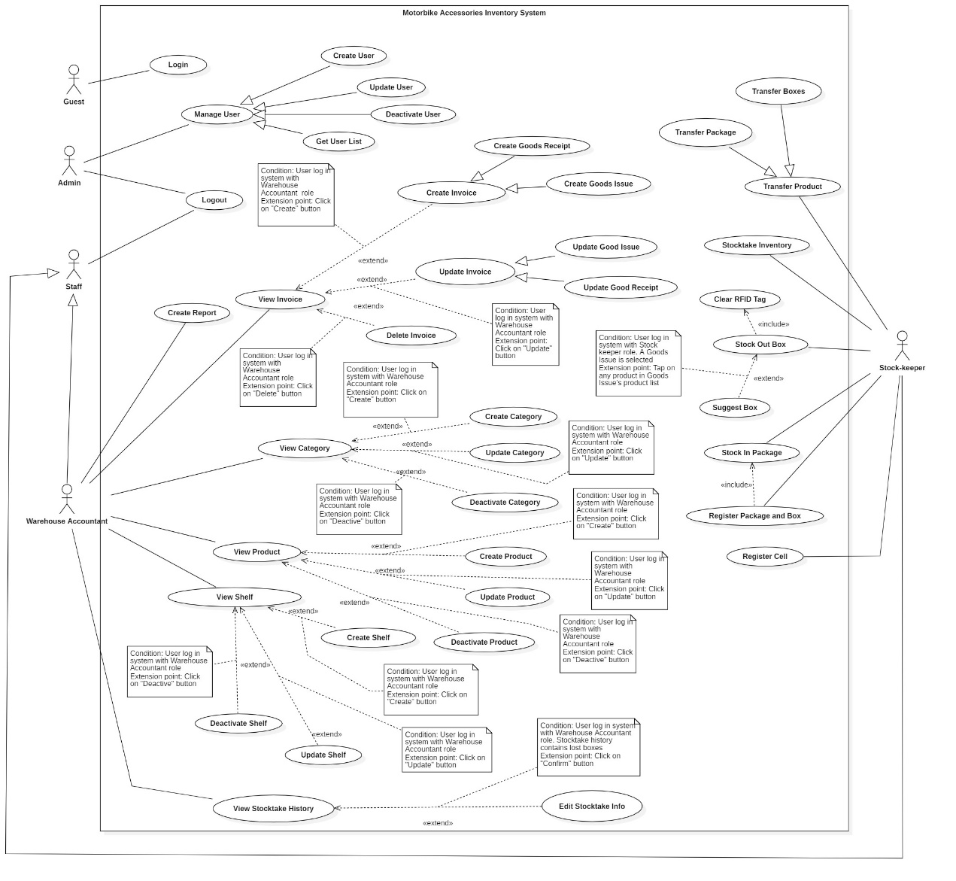
Figure 2 - System Overview Use Case

List of Use Cases

<Guest> Overview Use Case
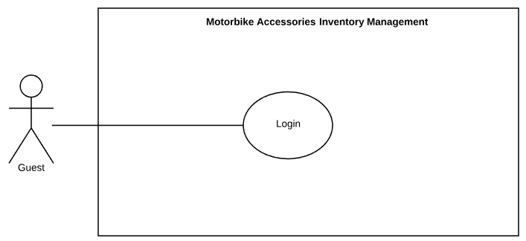
Figure 3 - <Guest> Overview Use Case

<Guest> Login

Figure 4 - <Guest> Login

USE CASE – RFIM_UC_A1
Use Case No. | RFIM_UC_A1 | Use Case Version | 2.0
Use Case Name | Login
Author | ThinhNT
Date | 26/07/2019 | Priority | Normal
Actor:
- Guest
Summary:
- This use case allows guest to log in the system.
Goal:
- Guest logs in the system with authorized role.
Triggers:
- Guest clicks on “Log In” button.
Preconditions: Application successfully launched.
Post conditions:
- Success: Guest is authorized with specific role in the system.
- Fail: System shows error messages.
Main Success Scenarios:
Step | Actor Action | System Response
1 | Guest fills out data fields to “Login” screen. | “Login” screen is shown with following labels and fields:  - Username: text input.  - Password: text input.
2 | Guest clicks on “Log In” button. | System validates inputted data and shows “Home” screen  [Exception 1, 2]

Alternative Scenarios: N/A

Exceptions:
No | Actor Action | System Response
1 | Guest inputs wrong username or password. | System shows error message: “Invalid username or password. Please try again!”
2 | Network problem. | System shows error message: “Fail to log in. Please check your connection”.

Relationships: N/A
Business Rules:
- After logging in to the system, guest will be redirected to specific screen based on his role on the system: Admin or Staff.
- If the role is “Admin”: the system will display the screen for Admin.
- If the role is “Staff”: the system will display the screen for specific Staff role (Warehouse Accountant, Stock-keeper).

<Guest> Login use case specification

<Admin, Staff> Overview Use Case
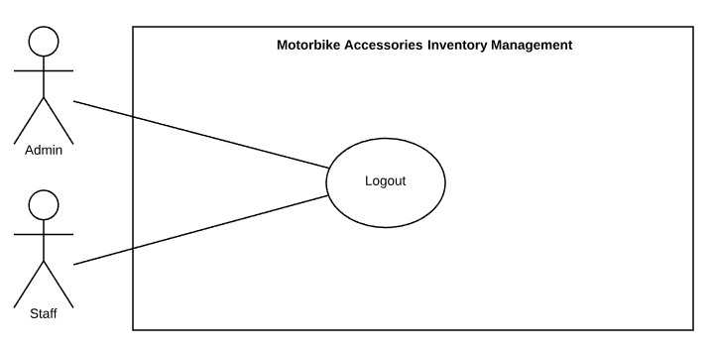
Figure 5 - <Admin, Staff> Overview Use Case

<Admin, Staff> Logout
Figure 6 - <Admin, Staff> Logout

USE CASE – RFIM_UC_A2
Use Case No. | RFIM_UC_A2 | Use Case Version | 2.0
Use Case Name | Logout
Author | ThinhNT
Date | 26/07/2019 | Priority | Normal
Actor:
- Admin, Staff
Summary:
- This use case allows admin/staff to log out of the system.
Goal:
- Admin/Staff logs out of the system successfully.
Triggers:
- Admin/Staff clicks on “Log out” button.
Preconditions:
- User already logged in the system with Admin or Staff role.
Post conditions:
- Success: Admin/Staff logs out of the system successfully.
- Fail: System shows error messages.
Main Success Scenario:
Step | Actor Action | System Response
1 | Admin/Staff clicks on “Log Out” button. | System shows “Login” screen.  [Exception 1]

Alternative Scenarios: N/A

Exceptions:
No | Actor Action | System Response
1 | Network problem. | System shows error message: “Fail to log out. Please check your connection”.

Relationships: N/A
Business Rules:
- In this system, only admin or staff can log out.
- Admin or Staff must log in the system before logging out.

<Admin, Staff> Logout use case specification

<Admin> Overview Use Case
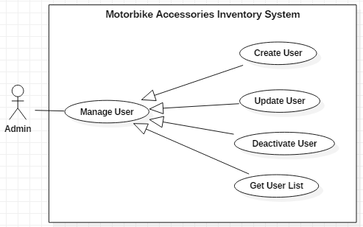
Figure 7 - <Admin> Overview Use Case

<Admin> Create User
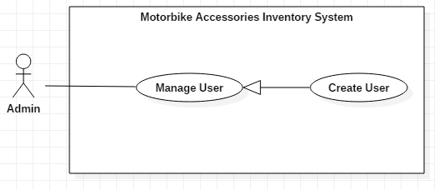
Figure 8 - <Admin> Create User
USE CASE – RFIM_UC_AD1
Use Case No. | RFIM_UC_AD1 | Use Case Version | 2.0
Use Case Name | Create User
Author | ThinhNT
Date | 26/07/2019 | Priority | Normal
Actor:
- Admin
Summary:
- This use case allows admin to create new users.
Goal:
- Admin creates a new user successfully.
Triggers:
- Admin clicks on “Create” button.
Preconditions:
- User must log in the system with Admin role.
Post conditions:
- Success: A new user will be created.
- Fail: System shows error messages.
Main Success Scenarios:
Step | Actor Action | System Response
1 | Admin clicks on “Create” button on “Users” screen. | “Create User” screen is shown with following labels and fields:  - Username: text, required  - Password: text, required  - Role: select option, list Role  - Fullname: text, required.  - Address: text, optional.  - Email: text, required.  - Date of Birth: date, required.  - Phone: integer, 8-11 digits, optional.  - Note: text, optional.
2 | Admin fills out data fields and clicks on “Confirm” button. | System validates inputted data and shows “Users” screen  [Exception 1, 2, 3, 4]

Alternative Scenarios: N/A

Exceptions:
No | Actor Action | System Response
1 | - Username is empty.  - Password is empty.  - Full Name is empty.  - Email is empty.  - Date of birth is not selected. | System shows error message "This field is required.” and highlights the empty fields.
2 | Username already exists. | System show error message “Username already exists!” and highlight the error field.
3 | Admin clicks on “Cancel” button. | System shows “Users” screen.
4 | Network problem. | System shows error message: “Please check your connection.”

Relationships: Specialized from Manage User use case.
Business Rules:
- In this system, there is no registration, only Admin can create new users.
- Users can log in with given Username and Password.
- New user has distinguished functions specified by role.
<Admin> Create User use case specification 1

<Admin> Update User

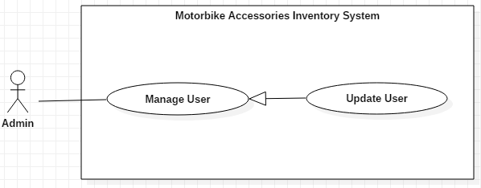
Figure 9 - <Admin> Update User
USE CASE – RFIM_UC_AD2
Use Case No. | RFIM_UC_AD2 | Use Case Version | 2.0
Use Case Name | Update User
Author | ThinhNT
Date | 26/07/2019 | Priority | Normal
Actor:
- Admin
Summary:
- This use case allows admin to update information of users.
Goal:
- Admin updates information of user successfully.
Triggers:
- Admin clicks on “Update” button.
Preconditions:
- User must log in the system with Admin role.
Post conditions:
- Success: Information of user will be updated.
- Fail: System shows error messages.
Main Success Scenarios:
Step | Actor Action | System Response
1 | Admin clicks on “Update” button on “Users” screen. | “Update User” screen is shown with the following labels and fields which have current user’s information:  - Username: text, required.  - Full Name: text, required.  - Password: text, required  - Role: select option, required  - Address: text, optional.  - Email: text, required.  - Date of birth: date, required.  - Phone: integer, 8-11 digits, optional.  - Note: text, optional.
2 | Admin fills out data fields and clicks on “Confirm” button. | System validates inputted data and shows “Users” screen  [Exception 1, 2, 3]

Alternative Scenarios: N/A

Exceptions:
No | Actor Action | System Response
1 | Editing Username already exists. | System show error message “Username already exists!” and highlight the error field
2 | Admin clicks on “Cancel” button. | System shows “Users” screen.
3 | Network problem. | System shows error message: “Please check your connection.”

Relationships: Specialized from Manage User use case.
Business Rules:
- In this system, only Admin can edit user’s information.
- User can login normally with new Username and Password.
- Updated user’s functions can be changed if new role was applied.

<Admin> Update User use case specification

<Admin> Deactivate User
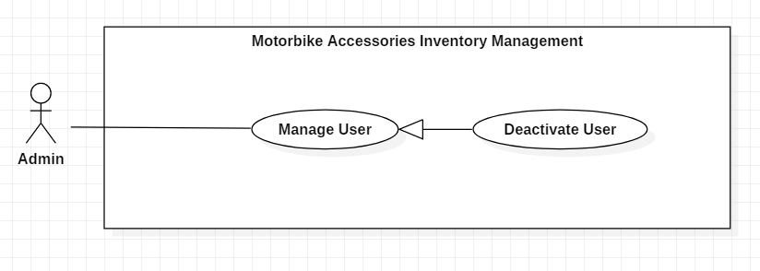
Figure 10 - <Admin> Deactivate User
USE CASE – RFIM_UC_AD3
Use Case No. | RFIM_UC_AD3 | Use Case Version | 2.0
Use Case Name | Deactivate User
Author | ThinhNT
Date | 26/07/2019 | Priority | Normal
Actor:
- Admin
Summary:
- This use case allows admin to deactivate users.
Goal:
- Admin deactivates user successfully.
Triggers:
- Admin clicks on “Deactivate” button.
Preconditions:
- User must log in the system with Admin role.
- User’s status is “Active”.
Post conditions:
- Success: User’s status will be change to “Inactive” and cannot log in the system.
- Fail: System shows error messages.
Main Success Scenarios:
Step | Actor Action | System Response
1 | Admin clicks on “Deactivate” button on “Users” screen. | Confirmation dialog is shown with the Y/N option: “Deactivated user cannot log in to system. Are you sure you want to deactivate?”
2 | Admin clicks on “Yes” button. | System shows “Users” screen.  [Exception 1,2]

Alternative Scenarios: N/A

Exceptions:
Step | Actor Action | System Response
1 | Admin clicks on “Cancel” button. | System shows “Users” screen.
2 | Network problem. | System shows error message “Please check your connection.”

Relationships: Specialized from Manage User use case.
Business Rules:
- In this system, only Admin can deactivate users.
- “Inactive” users cannot log in to system.
- Admin cannot deactivate himself/herself.
- Deactivated users can be “Activate” again by clicking on same button name
- Only “Active” users can be deactivated.

<Admin> Deactivate User use case specification

<Admin> Get User List
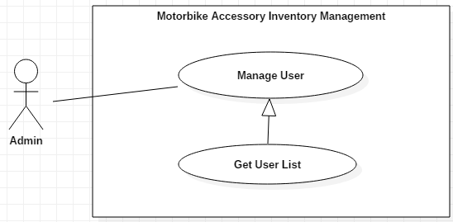
Figure 11 - <Admin> Get User List
USE CASE – RFIM_UC_AD4
Use Case No. | RFIM_UC_AD4 | Use Case Version | 2.0
Use Case Name | Get User List
Author | ThinhNT
Date | 26/07/2019 | Priority | Normal
Actor:
- Admin
Summary:
- This use case allows admin to get list of users.
Goal:
- List of users will be displayed.
Triggers:
- Admin clicks on “Users” button on navigation bar
Preconditions:
- User must log in the system with Admin role.
Post conditions:
- Success: System shows list of users.
- Fail: System shows error messages.
Main Success Scenario:
Step | Actor Action | System Response
1 | Admin clicks on “Users” button on navigation bar. | System shows “User List” screen. [Exception 1, 2]

Alternative Scenarios: N/A

Exceptions:
No | Actor Action | System Response
1 | Users list is empty. | System shows error message "There is no user to show.”
2 | Network problem. | System shows error message: “Please check your connection.”

Relationships: Specialized from Manage User use case.
Business Rules:
- In this system, only Admin can view users list.

<Admin> Get User List use case specification

<Warehouse Accountant> Overview Use Case
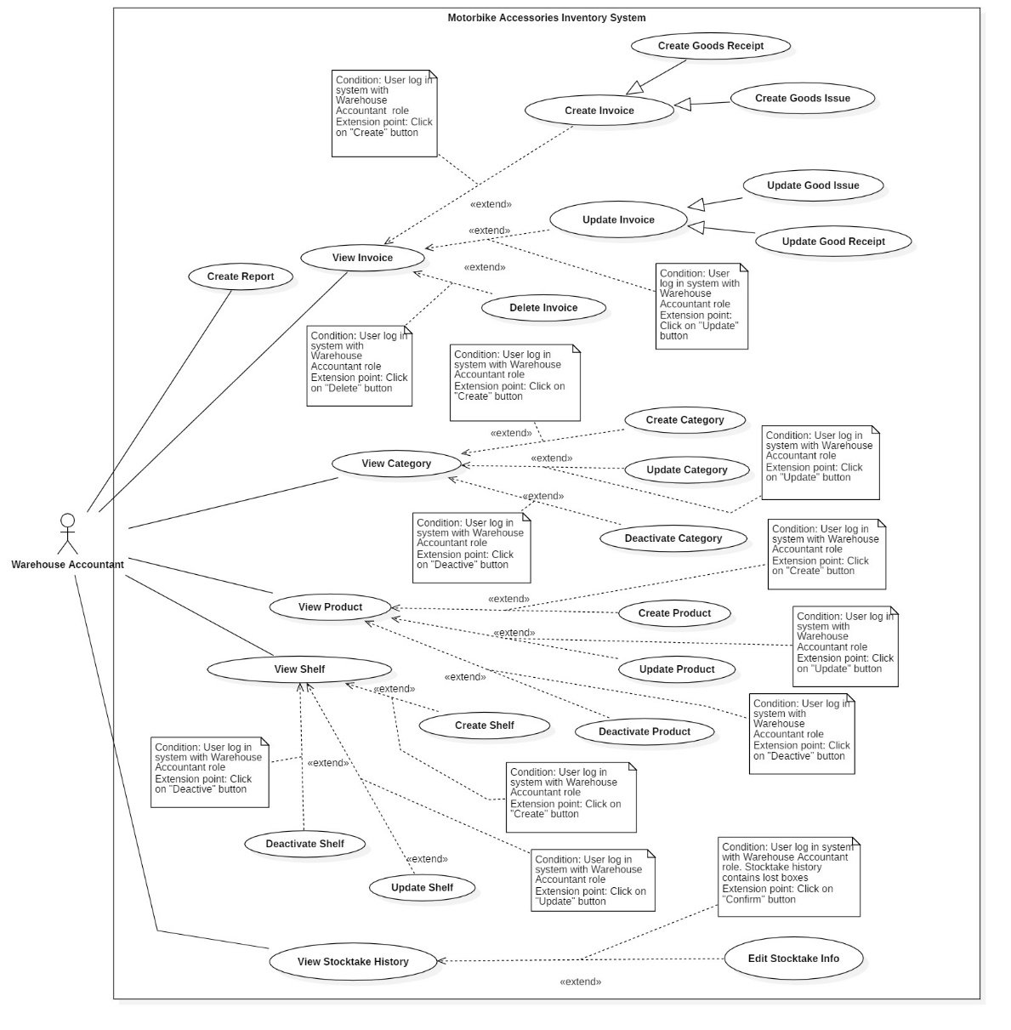
Figure 12 - <Warehouse Accountant> Overview Use Case

<Warehouse Accountant> View Category
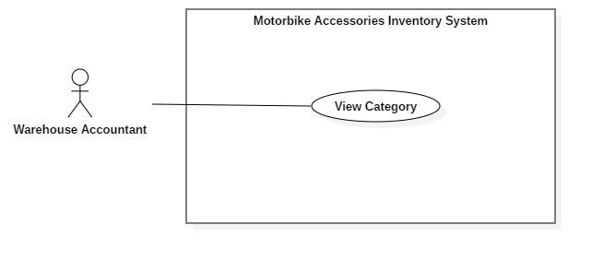
Figure 13 - <Warehouse Accountant> View Category

USE CASE – RFIM_UC_WA_C1
Use Case No. | RFIM_UC_WA-C1 | Use Case Version | 2.0
Use Case Name | View Category
Author | ThinhNT
Date | 26/07/2019 | Priority | Normal
Actor:
- Warehouse Accountant
Summary:
- This use case allows to warehouse accountant view categories’ information.
Goal:
- Warehouse accountant can view category list.
Triggers:
- Warehouse accountant clicks on “Categories” button on navigation bar
Preconditions:
- User must log in the system with Warehouse Accountant role.
Post conditions:
- Success: List of categories will be shown on “Category” screen.
- Fail: System shows error messages.
Main Success Scenario:
Step | Actor Action | System Response
1 | Warehouse accountant clicks on “Categories” button on navigation bar. | System shows “Category List” screen. [Exception 1, 2]

Alternative Scenarios: N/A

Exceptions:
Step | Actor Action | System Response
1 | There is no category in database. | System shows error message “Category is empty. Please add a new category!”
2 | Network problem. | System shows error message: “Please check your connection.”

Relationships: Associated with Warehouse Accountant actor.
Business Rules:
- In this system, only Warehouse Accountant can view category’s information.
- Warehouse Accountant can view list of products belong to each category by click on Category Name

<Warehouse Accountant> View Category use case specification

<Warehouse Accountant> Create Category
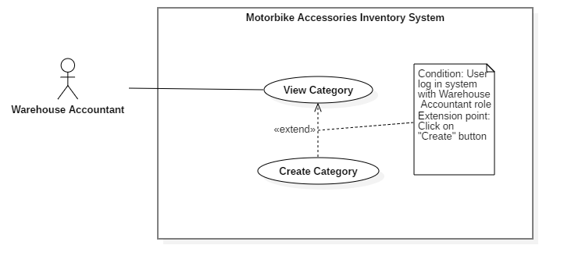
Figure 14 - <Warehouse Accountant> Create Category
USE CASE – RFIM_UC_WA_C2
Use Case No. | RFIM_UC_WA_C2 | Use Case Version | 2.0
Use Case Name | Create Category
Author | ThinhNT
Date | 26/07/2019 | Priority | Normal
Actor:
- Warehouse Accountant
Summary:
- This use case allows Warehouse Accountant to add new categories.
Goal:
- Warehouse Accountant adds new category successfully.
Triggers:
- Warehouse Accountant clicks on “Add” button.
Preconditions:
- User must log in the system with Warehouse Accountant role.
Post conditions:
- Success: A new category will be added to the category list.
- Fail: System shows error messages.
Main Success Scenarios:
Step | Actor Action | System Response
1 | Warehouse Accountant clicks on “Create” button on “Categories” screen. | “Add Category” screen is shown with following labels and fields:  - Category Name: text, required.  - Description: text, optional.
2 | Warehouse Accountant fills out data fields and clicks on “Confirm” button. | System validates inputted data and shows “Categories” screen.  [Exception 1, 2, 3, 4]

Alternative Scenarios: N/A

Exceptions:
Step | Actor Action | System Response
1 | Category Name is empty. | System shows error message "This field is required.” and highlights the empty fields.
2 | Category Name already exists. | System shows error message “Category Name already exists!” and highlights the error field.
3 | Warehouse Accountant clicks on “Cancel” button. | System shows “Categories” screen.
4 | Network problem. | System shows error message: “Please check your connection.”

Relationships: Extended from View Category use case.
Business Rules:
- In this system, only Warehouse Accountant can add new categories.
- A category can have a group of products or no products.
- Category name is a key constraint for searching a group of products.

<Stock-keeper> Create Category use case specification

<Warehouse Accountant> Update Category
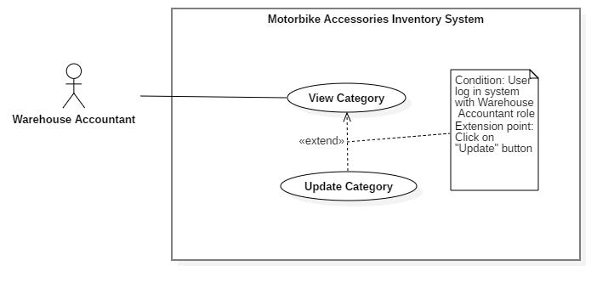
Figure 15 - <Warehouse Accountant> Update Category
USE CASE – RFIM_UC_WA_C3
Use Case No. | RFIM_UC_WA_C3 | Use Case Version | 2.0
Use Case Name | Update Category
Author | ThinhNT
Date | 26/07/2019 | Priority | Normal
Actor:
- Warehouse Accountant
Summary:
- This use case allows Warehouse Accountant to update categories’ information.
Goal:
- Warehouse Accountant updates category’s information successfully.
Triggers:
- Warehouse Accountant clicks on “Update” button.
Preconditions:
- User must log in the system with Warehouse Accountant role.
Post conditions:
- Success: Information of category will be updated to the category list.
- Fail: System shows error messages.
Main Success Scenarios:
Step | Actor Action | System Response
1 | Warehouse Accountant clicks on “Update” button on “Categories” screen. | “Update Category” screen is shown with following labels and fields which currently have category’s information:  - Category Name: text, required.  - Description: text, optional.
2 | Warehouse Accountant fills out data fields and clicks on “Confirm” button. | System validates inputted data and shows “Categories” screen.  [Exception 1, 2, 3]

Alternative Scenarios: N/A

Exceptions:
Step | Actor Action | System Response
1 | Editing Category Name already exists. | System show error message “Category Name already exists!” and highlights the error field.
2 | Warehouse Accountant clicks on “Cancel” button. | System shows “Categories” screen.
3 | Network problem. | System shows error message: “Please check your connection.”

Relationships: Extended from View Category use case.
Business Rules:
- In this system, only Warehouse Accountant can update category’s information.
- A category can have a group of products or no products.
<Warehouse Accountant> Update Category use case specification

<Warehouse Accountant> Deactivate Category
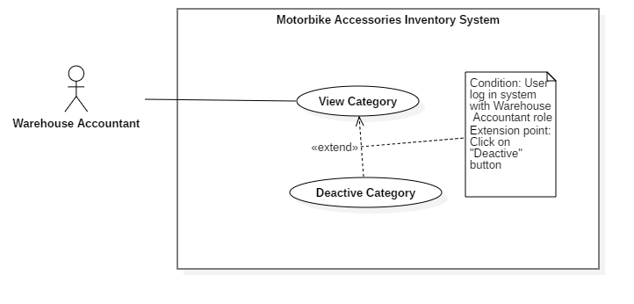
Figure 16 - <Warehouse Accountant> Deactivate Category
USE CASE – RFIM_UC_WA_C4
Use Case No. | RFIM_UC_WA_C4 | Use Case Version | 2.0
Use Case Name | Deactivate Category
Author | ThinhNT
Date | 26/07/2019 | Priority | Normal
Actor:
- Warehouse Accountant
Summary:
- This use case allows Warehouse Accountant to deactivate categories.
Goal:
- Warehouse Accountant deactivates category successfully.
Triggers:
- Warehouse Accountant clicks on “Deactivate” button.
Preconditions:
- User must log in the system with Warehouse Accountant role.
- Category doesn’t contains any products.
- Category’s status is “Active”.
Post conditions:
- Success: Category is deactivated successfully.
- Fail: System shows error messages.
Main Success Scenarios:
Step | Actor Action | System Response
1 | Warehouse Accountant clicks on “Deactivate” button on “Categories” screen. | Confirmation dialog is shown with the Y/N option: “Are you sure to deactivate?”
2 | Warehouse Accountant clicks on “Yes” button. | System shows “Categories” screen  [Exception 1,2,3]

Alternative Scenarios: N/A

Exception:
Step | Actor Action | System Response
1 | Warehouse Accountant clicks on “Cancel” button. | “Categories” screen is shown with list of category.
2 | Category still contains products. | System shows error message: “Current category have active products”.
3 | Network problem. | System shows error message “Please check your connection.”

Relationships: Extended from View Category use case.
Business Rules:
- In this system, only Warehouse Accountant can deactivate categories.
- Category which is still containing active products can’t be deactivated.
- Only “Active” categories can be deactivated.
- Deactivated category won’t be show during create or update product’s info
- A deactivated category can be “Activate” again by clicking on same button name.
<Warehouse Accountant> Deactivate Category use case specification

<Warehouse Accountant> View Product
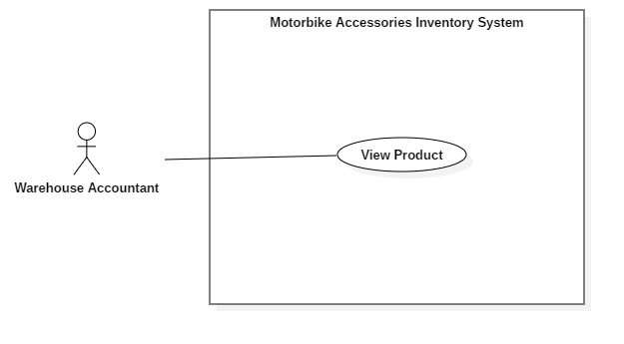
Figure 17 - <Warehouse Accountant> View Product
USE CASE – RFIM_UC_WA_P1
Use Case No. | RFIM_UC_WA_P1 | Use Case Version | 2.0
Use Case Name | View Product
Author | HieuDT
Date | 26/07/2019 | Priority | Normal
Actor:
- Warehouse Accountant
Summary:
- This use case allows Warehouse Accountant to view products’ information.
Goal:
- Warehouse Accountant can view product list.
Triggers:
- Warehouse Accountant clicks on “Products” button on navigation bar.
Preconditions:
- User must log in the system with Warehouse Accountant role.
Post conditions:
- Success: List of categories will be shown on “Products” screen.
- Fail: System shows error messages.
Main Success Scenario:
Step | Actor Action | System Response
1 | Warehouse Accountant clicks on “Products” button on navigation bar. | System shows “Product List” screen. [Exception 1, 2]

Alternative Scenario: N/A

Exception:
Step | Actor Action | System Response
1 | There is no product in database. | System shows error message “Product is empty. Please add a new product!”
2 | Network problem. | System shows error message: “Please check your connection.”

Relationships: Associated with Warehouse Accountant actor.
Business Rules:
- In this system, only Warehouse Accountant can view product’s information.
- Warehouse Accountant can view Package RFID, Box RFID, Stock-in Date and Quantity belonging to that product in “Product Detail” screen.
- Product’s boxes with “Missing” status won’t be show in “Product Detail” total quantity.
<Warehouse Accountant> View Product use case specification

<Warehouse Accountant> Create Product
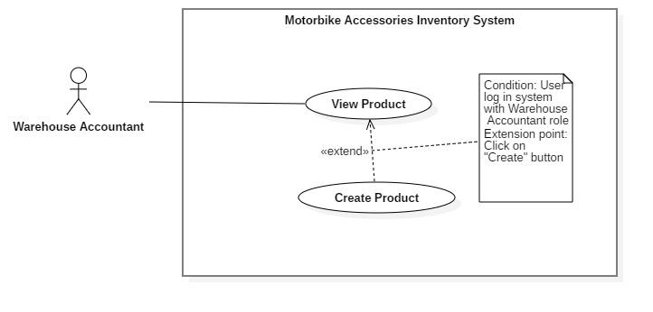
Figure 18 - <Warehouse Accountant> Create Product
USE CASE – RFIM_UC_WA_P2
Use Case No. | RFIM_UC_WA_P2 | Use Case Version | 2.0
Use Case Name | Create Product
Author | HieuDT
Date | 26/07/2019 | Priority | Normal
Actor:
- Warehouse Accountant
Summary:
- This use case allows Warehouse Accountant to create new products.
Goal:
- Warehouse Accountant creates new products successfully.
Triggers:
- Warehouse Accountant clicks on “Create” button.
Preconditions:
- User must log in the system with Warehouse Accountant role.
Post conditions:
- Success: New product is created successfully.
- Fail: System shows error messages.
Main Success Scenarios:
Step | Actor Action | System Response
1 | Warehouse Accountant clicks on “Create” button on “Products” screen. | “Add Product” screen is shown with following labels and fields:  - Product ID: text, required  - Product Name: text, required  - Category: select option, list Category  - Length (cm): float, optional  - Width (cm): float, optional  - Height (cm): float, optional  - Quantity per Box: integer, required  - Vendor: select option, list Vendor  - Weight (g): double, optional  - Image: text, optional  - Description: text, optional
2 | Warehouse Accountant fills out data fields and clicks on “Confirm” button.  [Alternative 1, 2] | System validates inputted data and shows “Products” screen.  [Exception 1, 2, 3, 4]

Alternative Scenarios:
Step | Actor Action | System Response
1 | Warehouse Accountant clicks on “Import” button on “Products” screen. | “Import Product” screen is shown with following labels and fields:  - Upload file: file chooser, required.
2 | Warehouse Accountant chooses file and clicks on “Confirm” button. | System validates the uploaded file whether it contains the same fields with sample file and adds list of products, then shows “Products” screen.  [Exception 4, 5, 6, 7]

Exceptions:
No | Actor Action | System Response
1 | - Product ID is empty  - Product Name is empty  - Quantity per Box is empty | System shows error message "This field is required.” and highlights the empty fields.
2 | Product Id already exists. | System show error message “Product ID already exists!” and highlights the error field.
3 | Warehouse Accountant clicks on “Cancel” button. | System shows “Products” screen.
4 | Network connection problem. | System shows error message: “Please check your connection.”
5 | File is not chosen. | System shows error message “Please choose a file.”
6 | File extension is not .xls or .xlsx. | System shows error message “Please choose any file with .xls or .xlsx extension.”
7 | Uploaded file’s fields are not as same as the fields of “Sample File” | System shows error message “File has wrong format. Please check “Sample File” format.”

Relationships: Extended from View Product use case.
Business Rules:
- In this system, only Warehouse Accountant can create new products.
- Product ID will be generated automatically with RFIM prefix and number which is ascending.
- Each product must belong to one category and one vendor.
- One box only has one type of product, but can contain many items of that product. This rule also applies with packages.
- “Import Products” feature requires Excel data file (.xls, .xlsx) that must follow the format of “Sample File”.
- Quantity per Box determines how many items that product has in one box.
- Length, Width and Height are the 3 dimensions of each product’s box.
<Warehouse Accountant> Create Product use case specification

<Warehouse Accountant> Update Product
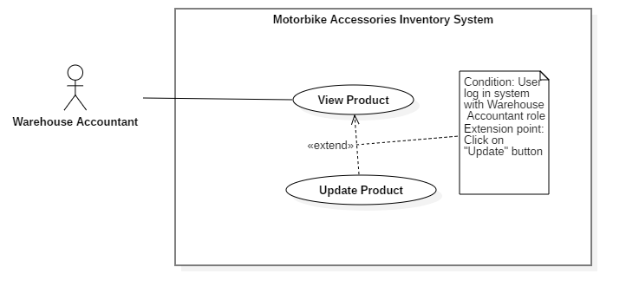
Figure 19 - <Warehouse Accountant> Update Product
USE CASE – RFIM_UC_WA_P3
Use Case No. | RFIM_UC_WA_P3 | Use Case Version | 2.0
Use Case Name | Update Product
Author | HieuDT
Date | 26/07/2019 | Priority | Normal
Actor:
- Warehouse Accountant
Summary:
- This use case allows Warehouse Accountant to update products’ information.
Goal:
- Warehouse Accountant updates information of products successfully.
Triggers:
- Warehouse Accountant clicks on “Update” button.
Preconditions:
- User must log in the system with Warehouse Accountant role.
Post conditions:
- Success: Information of products will be updated.
- Fail: System shows error messages.
Main Success Scenarios:
Step | Actor Action | System Response
1 | Warehouse Accountant clicks on “Update” button on “Products” screen. | “Update Product” screen is shown with following labels and fields which have current product’s information:  - Product ID: prefilled, not editable  - Product Name: text, required  - Category: select option, list Category  - Length (cm): float, optional  - Width (cm): float, optional  - Height (cm): float, optional  - Quantity per Box: integer, required  - Vendor: select option, list Vendor  - Weight (g): double, optional  - Image: text, optional  - Description: text, optional
2 | Warehouse Accountant fills out data fields and clicks on “Confirm” button.  [Alternative 1, 2] | System validates inputted data and shows “Products” screen.  [Exception 1, 2, 3]

Alternative Scenarios:
No | Actor Action | System Response
1 | Warehouse Accountant clicks on “Update” button in “Product Details” screen. | “Update Product” screen is shown with following labels and fields which have current product’s information:  - Product ID: fixed  - Product Name: text, required  - Category: select option, list Category  - Length (cm): float, optional  - Width (cm): float, optional  - Height (cm): float, optional  - Quantity per Box: integer, required  - Vendor: select option, list Vendor  - Weight (g): double, optional  - Image: text, optional  - Description: text, optional
2 | Warehouse Accountant fills out data fields and clicks on “Confirm” button. | System validates inputted data and updates product’s information then shows “Products” screen.  [Exception 1, 2, 3]

Exceptions:
No | Actor Action | System Response
1 | Editing Product Name already exists | System shows error message “Product Name already exists!”
2 | Warehouse Accountant clicks on “Cancel” button | System shows “Products” screen.
3 | Network connection problem. | System shows error message: “Please check your connection”.

Relationships: Extended from View Product use case.
Business Rules:
- In this system, only Warehouse Accountant can update prodcuts’ information.
- Product ID is fixed and can’t be updated.
- Each product must belong to one category and one vendor.
- One box only has one type of product, but can contain many items of that product. This rule also applies with packages.
- Quantity per Box determines how many items that product has in one box.
- Length, Width and Height are the 3 dimensions of each product’s box.
<Warehouse Accountant> Update Product use case specification

<Warehouse Accountant> Deactivate Product
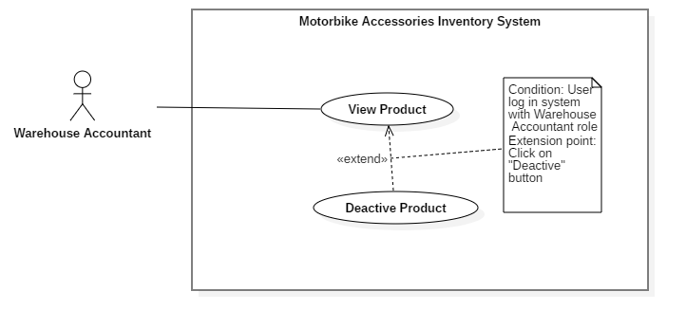
Figure 20 - <Warehouse Accountant> Deactivate Product
USE CASE – RFIM_UC_WA_P4
Use Case No. | RFIM_UC_WA_P4 | Use Case Version | 2.0
Use Case Name | Deactivate Product
Author | HieuDT
Date | 26/07/2019 | Priority | Normal
Actor:
- Warehouse Accountant
Summary:
- This use case allows Warehouse Accountant to deactivate products.
Goal:
- Warehouse Accountant deactivates selected products successfully.
Triggers:
- Warehouse Accountant clicks on “Deactivate” button.
Preconditions:
- User must log in the system with Warehouse Accountant role.
Post conditions:
- Success: Selected products will be deactivated.
- Fail: System shows error messages.
Main Success Scenarios:
Step | Actor Action | System Response
1 | Warehouse Accountant clicks on “Deactivate” button on “Products” screen.  [Alternative 1] | Confirmation dialog is shown with the Y/N option: “You’re about to deactivate a product. Are you sure?”
2 | Warehouse Accountant clicks on “Confirm” button. | System shows “Products” screen.  [Exception 1, 2, 3]

Alternative Scenarios: N/A

Exceptions:
No | Actor Action | System Response
1 | Deactivated produt have package | System shows error message:”Please remove all package belong to this product before deactivate”
2 | Warehouse Accountant clicks on “Cancel” button | System shows “Product List” screen.
3 | Network connection problem. | System shows error message: “Please check your network connection.”

Relationships: Extended from View Product use case.
Business Rules:
- In this system, only Warehouse Accountant can deactivate products.
- Products which were deactivated won’t be removed from the database.
- Deactivated products won’t be shown when creating Goods Receipt Invoice.
- Deactivated product can be “Activate” again by clicking on same button name.
- Products which have packages can’t not be deactivated
<Warehouse Accountant> Deactivate Product use case specification

<Warehouse Accountant> View Shelf
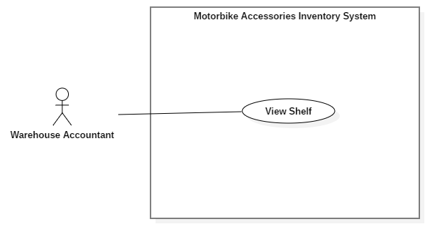
Figure 21 - <Warehouse Accountant> View Shelf
USE CASE – RFIM_UC_WA_S1
Use Case No. | RFIM_UC_WA_S1 | Use Case Version | 2.0
Use Case Name | View Shelf
Author | ThinhNT
Date | 26/07/2019 | Priority | Normal
Actor:
- Warehouse Accountant
Summary:
- This use case allows Warehouse Accountant to view shelves’ information.
Goal:
- Warehouse Accountant can view shelf list.
Triggers:
- Warehouse Accountant clicks on “Shelves” button on navigation bar.
Preconditions:
- User must log in the system with Warehouse Accountant role.
Post conditions:
- Success: List of categories will be shown on “Shelves” screen.
- Fail: System shows error messages.
Main Success Scenario:
Step | Actor Action | System Response
1 | Warehouse Accountant clicks on “Shelves” button on navigation bar. | System shows “Shelf List” screen. [Exception 1, 2]

Alternative Scenarios: N/A

Exceptions:
Step | Actor Action | System Response
1 | There is no shelf in the database. | System shows error message “Shelf is empty. Please add a new shelf!”
2 | Network problem. | System shows error message: “Please check your connection.”

Relationships: Associated with Warehouse Accountant actor.
Business Rules:
- In this system, only Warehouse Accountant can view shelf’s information.
- Each shelf contains floors and cells. User can check the list of those floors and cells by clicking on “Details” button. “Shelf Detail” screen also shows Cell’s status whether it is empty or not.
- Total empty cell of a Shelf can be shown in “Shelf List” screen

<Warehouse Accountant> View Shelf use case specification

<Warehouse Accountant> Create Shelf
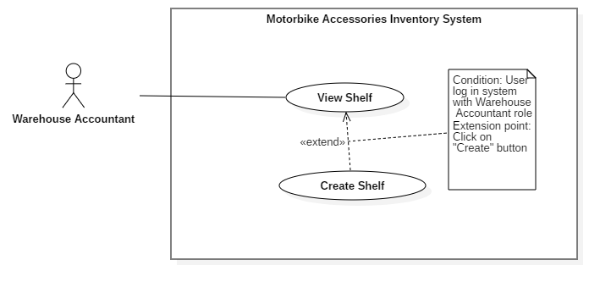
Figure 22 - <Warehouse Accountant> Create Shelf
USE CASE – RFIM_UC_WA_S2
Use Case No. | RFIM_UC_WA_S2 | Use Case Version | 2.0
Use Case Name | Create Shelf
Author | ThinhNT
Date | 26/07/2019 | Priority | Normal
Actor:
- Warehouse Accountant
Summary:
- This use case allows Warehouse Accountant to create shelves.
Goal:
- Warehouse Accountant creates shelf successfully.
Triggers:
- Warehouse Accountant clicks on “Create” button.
Preconditions:
- User must log in the system with Warehouse Accountant role.
Post conditions:
- Success: A new shelf with cells will be created.
- Fail: System shows error messages.
Main Success Scenarios:
Step | Actor Action | System Response
1 | Warehouse Accountant clicks on “Create” button in “Shelves” screen. | “Add Shelf” screen is shown with following labels and fields:  - Shelf ID: text, required  - Description: text, optional  - Number of Floor: integer, required  - Number of Cell: integer, required  - Cell Height (cm): float, optional  - Cell Width (cm): float, optional  - Cell Length (cm): float, optional  - Coordinate X: integer, required  - Coordinate Y: integer, required
2 | Warehouse Accountant fills out data fields and clicks on “Confirm” button. | System validates inputted data and shows “Shelves” screen.  [Exception 1, 2, 3, 4]

Alternative Scenarios: N/A

Exceptions:
No | Actor Action | System Response
1 | - Shelf ID is empty  - Coordinate X is empty  - Coordinate Y is empty | System shows error message "This field is required.” and highlights the empty fields.
2 | Shelf ID already exists. | System shows error message “Shelf ID already exists!” and highlights the error field.
3 | Warehouse Accountant clicks on “Cancel” button. | System shows “Shelves” screen.
4 | Network connection problem. | System shows error message: “Please check your network connection.”

Relationships: Extended from View Shelf use case.
Business Rules:
- In this system, only Warehouse Accountant can create shelves.
- Created shelves can be registered with a specified RFID tag.
- “Number of Floor” field shows the number of floors that shelf has. This warehouse uses Selective Pallet Racking Systems which commonly has most maximum height is 5 floors because the forklift can’t bypass that height limit.
- “Number of Cell” field shows the number of cells in each floor of that shelf. Number of Cell is a fixed number which is determined by the first created shelf. All shelves inside the warehouse must have the same number of cells per floor for easy maintenance, stocking in and stocking out process.
- “Cell Width”, “Cell Length” and “Cell Height” are the 3 dimension of Cell size to let stock-keeper know when Cell is full.
- “Number of Floor” and “Number of Cell” fields are prefilled by configurable value from “Standard Cell Size”.
- Coordinate X is position of that cell in horizontal, Coordinate Y is position of that cell in vertical (ex: CoorX = 1, Coor Y = 1 => Shelf is the closest to the warehouse door)
- Cell code will be created automatically with the following format: Shelf Code-Floor-Cell. (ex: A-4-5 means Shelf A - 4th floor of that shelf - 5th cell of that floor)
<Stock-keeper> Create Shelf use case specification

<Warehouse Accountant> Update Shelf
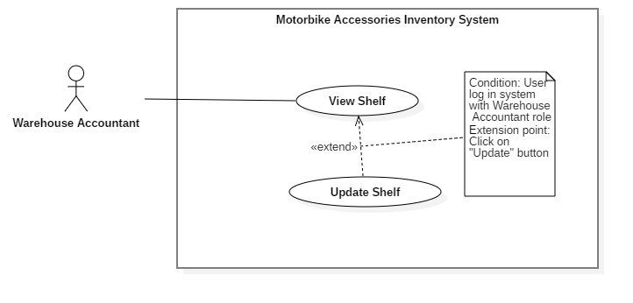
Figure 23 - <Warehouse Accountant> Update Shelf
USE CASE – RFIM_UC_WA_S3
Use Case No. | RFIM_UC_WA_S3 | Use Case Version | 2.0
Use Case Name | Update Shelf
Author | ThinhNT
Date | 26/07/2019 | Priority | Normal
Actor:
- Warehouse Accountant
Summary:
- This use case allows Warehouse Accountant to update shelves’ information.
Goal:
- Warehouse Accountant updates the information of shelf successfully.
Triggers:
- Warehouse Accountant clicks on “Update” button.
Preconditions:
- User must log in the system with Warehouse Accountant role.
Post conditions:
- Success: Selected shelf’s information will be successfully updated.
- Fail: System shows error messages.
Main Success Scenarios:
Step | Actor Action | System Response
1 | Warehouse Accountant clicks on “Update” button in “Shelves” screen. | “Update Shelf” screen is shown with following labels and fields which have current shelf information:  - Shelf ID: text, required  - Description: text, optional  - Number of Floor: integer, required  - Number of Cell: integer, required  - Cell Height (cm): float, required  - Cell Width (cm): float, required  - Cell Length (cm): float, required  - Coordinate X: integer, required  - Coordinate Y: integer, required
2 | Warehouse Accountant fills out data fields and clicks on “Confirm” button. | System validates inputted data and shows “Shelves” screen  [Exception 1, 2, 3, 4]

Alternative Scenarios: N/A

Exceptions:
No | Actor Action | System Response
1 | Editing Shelf Code already exists. | System show error message “Shelf Code already exists!” and highlight the error field.
2 | New editing Number of Floor/Number of Cell is lower than current ones. | System shows message “Number of Floor and Number of Cell can’t be decrease.”
3 | Warehouse Accountant clicks on “Cancel” button. | System shows “Shelves” screen.
4 | Network connection problem. | System shows error message: “Please check your network connection.”

Relationships: Specialized from Manage Shelf use case.
Business Rules:
- In this system, only Warehouse Accountant can update shelves’ information.
- “Number of Floors” field shows the number of floors that shelf has. This warehouse uses Selective Pallet Racking Systems which commonly has most maximum height is 5 floors because the forklift can’t bypass that height limit.
- “Number of Cell” field shows the number of cells in each floor of that shelf. Number of Cell is a fixed number which is determined by the first created shelf. All shelves inside the warehouse must have the same number of cells per floor for easy maintenance, stocking in and stocking out process.
- “Number of Floor” and “Number of Cell” are were prefilled by configurable value from “Standard Cell Size”.
- “Cell Width”, “Cell Length” and “Cell Height” are the 3 dimension of Cell size to let stock-keeper know when Cell is full.
- Coordinate X is position of that cell in horizontal, Coordinate is position of that cell in vertical
- For the shelf that still has remained packages, only Shelf Code and Description, Coordinate X and Coordinate Y information can be changed. In order to be able to change any other attributes, all boxes belonging to that shelf must be removed.
<Warehouse Accountant> Update Shelf use case specification

<Warehouse Accountant> Deactivate Shelf
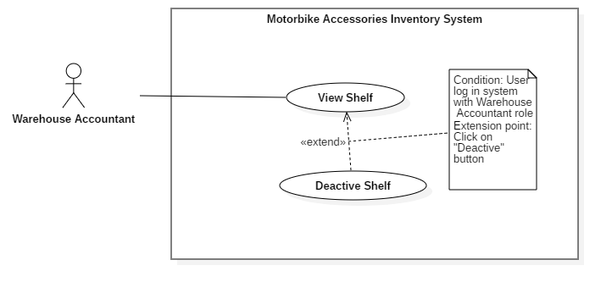
Figure 24 - <Warehouse Accountant> Deactivate Shelf
USE CASE – RFIM_UC_WA_S4
Use Case No. | RFIM_UC_WA_S4 | Use Case Version | 2.0
Use Case Name | Deactivate Shelf
Author | ThinhNT
Date | 26/07/2019 | Priority | Normal
Actor:
- Warehouse Accountant
Summary:
- This use case allows Warehouse Accountant to delete shelves.
Goal:
- Warehouse Accountant deletes shelf successfully.
Triggers:
- Warehouse Accountant clicks on “Deactive” button.
Preconditions:
- User must log in the system with Warehouse Accountant role.
Post conditions:
- Success: Selected shelf will be deleted from the current Shelf List.
- Fail: System shows error messages.
Main Success Scenarios:
Step | Actor Action | System Response
1 | Warehouse Accountant clicks on “Deactivate” button in “Shelves” screen. | Confirmation dialog is shown with the Y/N option: “You’re about to deactivate a shelf. Are you sure?”
2 | Warehouse Accountant clicks on “Confirm” button. | System validates whether the current shelf contains packages and shows “Shelves” screen.  [Exception 1, 2, 3]

Alternative Scenarios: N/A

Exceptions:
No | Actor Action | System Response
1 | Shelf currently contains packages. | System shows error message “The current shelf has one or more packages inside its cell. Please remove all packages and try again.”
2 | Warehouse Accountant clicks on “Cancel” button. | System shows “Shelves” screen.
3 | Network connection problem. | System shows error message: “Please check your network connection.”

Relationships: Extended from View Shelf use case.
Business Rules:
- In this system, only Warehouse Accountant can deactivate selected shelves.
- All remained packages must be removed from the shelf before that shelf is being deactivated.
- Deactivated shelf can be “Activate” again by click on same button name

<Warehouse Accountant> Deactivate Shelf use case specification

<Warehouse Accountant> View Invoice
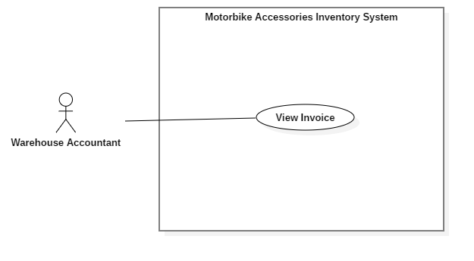
Figure 25 - <Warehouse Accountant> View Invoice
USE CASE – RFIM_UC_WA_I1
Use Case No. | RFIM_UC_WA_I1 | Use Case Version | 2.0
Use Case Name | View Invoice
Author | ThinhNT
Date | 26/07/2019 | Priority | Normal
Actor:
- Warehouse Accountant
Summary:
- This use case allows warehouse accountant to view invoice information.
Goal:
- Warehouse accountant can view invoice list.
Triggers:
- Warehouse accountant clicks on “Goods Receipt”, “Goods Issue” or “History” button on navigation bar
Preconditions:
- User must log in the system with Warehouse Accountant role.
Post conditions:
- Success: List of invoice will be shown on “Goods Receipt”, “Goods Issue” or “History” screen base on which user choose
- Fail: System shows error messages.
Main Success Scenarios:
Step | Actor Action | System Response
1 | - Warehouse accountant clicks on “Goods Receipt” button on navigation bar  - Warehouse accountant clicks on “Goods Issue” button on navigation bar  - Warehouse accountant clicks on “History” button on navigation bar | - System shows “Goods Receipt” screen  - System shows “Goods Issue” screen.  - System shows “History” screen.  [Exception 1, 2]

Alternative Scenarios: N/A

Exceptions:
Step | Actor Action | System Response
1 | There is no goods receipt or goods issue in the database. | System shows error message “Invoice is empty!”
2 | Network connection problem. | System shows error message: “Please check your network connection.”

Relationships: Associated with Warehouse Accountant actor.
Business Rules:
- In this system, only Warehouse Accountant can view invoice’s information.
- “Goods Receipts” screen show pending and processing goods receipt which can be delete and edit
- “Goods Issues” screen show pending issue, which can also does same tasks above.
- “History” screen show both goods issue and receipt which are already done
<Warehouse Accountant> View Invoice use case specification

<Warehouse Accountant> Create Goods Receipt
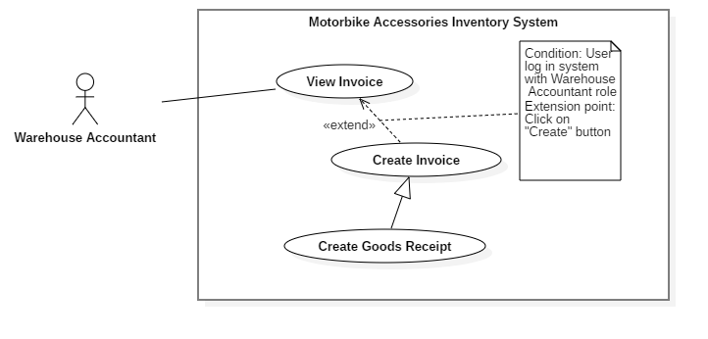
Figure 26 - <Warehouse Accountant> Create Goods Receipt
USE CASE – RFIM_UC_WA_I2
Use Case No. | RFIM_UC_WA_I2 | Use Case Version | 1.0
Use Case Name | Create Goods Receipt
Author | ThinhNT
Date | 26/07/2019 | Priority | Normal
Actor:
- Warehouse Accountant
Summary:
- This use case allows warehouse accountant to create goods receipts.
Goal:
- Warehouse accountant creates goods receipt successfully.
Triggers:
- Warehouse accountant clicks on “Create” button.
Preconditions:
- User must log in the system with Warehouse Accountant role.
Post conditions:
- Success: A new goods receipt will be created.
- Fail: System shows error messages.
Main Success Scenarios:
Step | Actor Action | System Response
1 | Warehouse accountant clicks on “Create” button in “Goods Receipt” screen. | System shows “Create Receipt” screen with following labels, fields:  - Product ID: prefilled, not editable  - Product Name: prefilled, not editable  - Category: prefilled, not editable  - Vendor: prefilled, not editable  - Stock in Quantity: integer, required.
2 | Warehouse accountant clicks on “Choose Product” button in “Add Stock in Product” screen. | “Products List” screen is shown with following attribute of products: Product Id, Product Name, Quantity Per Box, Category, and Vendor.
3 | Warehouse Accountant check single or multiple checkboxes of products and clicks on “Confirm” button. | System shows “Create Receipt” screen with selected products and following labels, fields:  - Product ID: prefilled, not editable  - Product Name: prefilled, not editable  - Category: prefilled, not editable  - Vendor: prefilled, not editable  - Stock in Quantity: integer, required.
4 | Warehouse Accountant fills out “Stock in Quantity” field and clicks on “Finish” button. | System validates inputted data and shows “Goods Receipt” screen  [Exception 1, 2]

Alternative Scenarios: N/A

Exceptions:
No | Actor Action | System Response
1 | Warehouse accountant clicks on “Cancel” button | System shows “Goods Receipt” screen.
2 | Network connection problem. | System shows error message: “Please check your network connection.”

Relationships: Specialized from Create Invoice use case. Create Invoice use case was extended from View Invoice use case.
Business Rules:
- In this system, only Warehouse Accountant can create goods receipts.
- “Stock in Quantity” is the number of boxes for stocking in products, maximum of 9999 boxes per Product per Good Receipt.
- Newly created goods issue will have “Pending” status.
- Goods receipts status will be changed to “Processing” during stock in process and “Done” when stock in process successfully finished.
- Products of Good receipt does not contain deactivated products.
- Goods Receipts Id was define automatically by this format: Configurable Prefix + Creation Date + “-” + Random 4 character code. Ex: RCE221019-A1x0.
- Good Receipt Prefix can be change by using “Edit Receipt Prefix” feature
<Warehouse Accountant> Create Goods Receipt use case specification

<Warehouse Accountant> Create Goods Issue
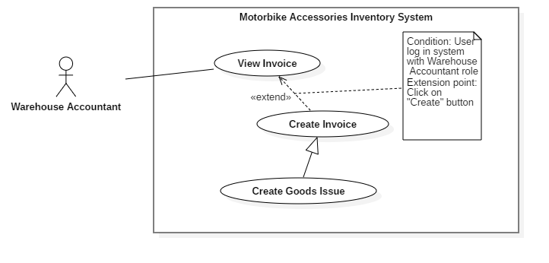
Figure 27 - <Warehouse Accountant> Create Goods Issue
USE CASE – RFIM_UC_WA_I3
Use Case No. | RFIM_UC_ WA_I3 | Use Case Version | 1.0
Use Case Name | Create Goods Issue
Author | ThinhNT
Date | 26/07/2019 | Priority | Normal
Actor:
- Warehouse Accountant
Summary:
- This use case allows warehouse accountant to create goods issue.
Goal:
- Warehouse accountant creates goods issue successfully.
Triggers:
- Warehouse accountant clicks on “Create” button.
Preconditions:
- User must log in the system with Warehouse Accountant role.
Post conditions:
- Success: A new goods issue will be created.
- Fail: System shows error messages.
Main Success Scenarios:
Step | Actor Action | System Response
1 | Warehouse accountant clicks on “Create” button in “Receipts/Issues” screen. | System shows “Create Issue” screen following labels, fields:  - Product ID: prefilled, not editable  - Product Name: prefilled, not editable  - Category: prefilled, not editable  - Vendor: prefilled, not editable  - On-hand Quantity: prefilled, not editable  - Stock out Quantity: integer, required..
2 | Warehouse accountant clicks on “Choose Product” button in “Add Stock out Product” screen. | “Products List” screen is shown with following attribute of products: Product ID, Product Name, Quantity Per Box, Category, Vendor and On-hand Quantity.
3 | Warehouse Accountant check single or multiple checkboxes of products and clicks on “Confirm” button. | System shows “Create Issue” screen with selected products and following labels, fields:  - Product ID: prefilled, not editable  - Product Name: prefilled, not editable  - Category: prefilled, not editable  - Vendor: prefilled, not editable  - On-hand Quantity: prefilled, not editable  - Stock out Quantity: integer, required.
4 | Warehouse Accountant fills out “Stock out Quantity” field and clicks on “Finish” button. | System validates inputted data and shows “Receipts/Issues” screen.  [Exception 1, 2, 3]

Alternative Scenarios: N/A

Exceptions:
No | Actor Action | System Response
1 | Inputted “Stockout Quantity” is greater than “On-hand Quantity” | System shows error message: “Stockout Quantity must greater than 1 and smaller than On-hand Quantity:
2 | Warehouse accountant clicks on “Cancel” button | System shows “Receipts/Issues” screen.
3 | Network connection problem. | System shows error message: “Please check your network connection.”

Relationships: Specialized from Create Invoice use case. Create Invoice use case was extended from View Invoice use case.
Business Rules:
- In this system, only Warehouse Accountant can create goods issue.
- “On-hand Quantity” shows box quantity of that product in stock.
- “Stock out Quantity” is the number of boxes for stocking in products, with the maximum value is equal to “On-hand Quantity”.
- Newly created goods issue will have “Pending” status.
- Goods issue status will be changed to “Done” when stock out process successfully finished.
- Goods Issue Id was define automatically by this format: Configurable Prefix + Creation Date + “-” + Random 4 character code. Ex: ISE221019-A1x0.
- Good Issue Prefix can be change by using “Edit Issue Prefix” feature
<Warehouse Accountant> Create Goods Issue use case specification

<Warehouse Accountant> Update Goods Receipt
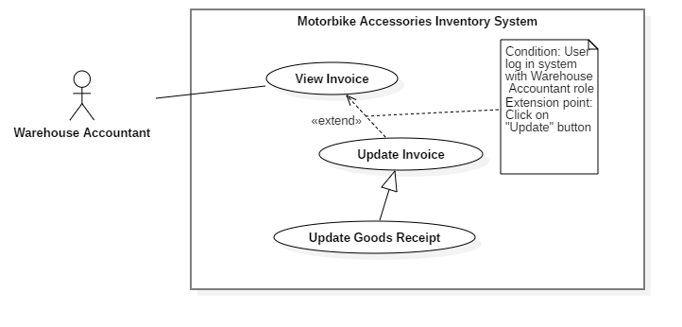
Figure 28 - <Warehouse Accountant> Update Goods Receipt
USE CASE – RFIM_UC_ WA_I4
Use Case No. | RFIM_UC_ WA_I4 | Use Case Version | 1.0
Use Case Name | Update Goods Receipt
Author | ThinhNT
Date | 26/07/2019 | Priority | Normal
Actor:
- Warehouse Accountant
Summary:
- This use case allows warehouse accountant to update goods receipts.
Goal:
- Warehouse accountant update goods receipt successfully.
Triggers:
- Warehouse accountant clicks on “Update” button.
Preconditions:
- User must log in the system with Warehouse Accountant role.
- Goods Receipt’s status is “Pending”.
Post conditions:
- Selected good receipt information will be successfully updated.
- Fail: System shows error messages.
Main Success Scenarios:
Step | Actor Action | System Response
1 | Warehouse accountant clicks on “Update” button in “Goods Receipt” screen. | System shows “Update Stock in Product” screen with products and following labels, fields:  - Product ID: prefilled, not editable  - Product Name: prefilled, not editable  - Category: prefilled, not editable  - Vendor: prefilled, not editable  - Stock in Quantity: integer, required.
2 | Warehouse accountant clicks on “Choose Product” button in “Update Stock in Product” screen. | “Products List” screen is shown with following attribute of products: Product ID, Product Name, Quantity Per Box, Category, and Vendor.
3 | Warehouse Accountant check single or multiple checkboxes and clicks on “Confirm” button. | System shows “Update Stock in Product” screen with new selected products and following labels, fields:  - Product ID: prefilled, not editable  - Product Name: prefilled, not editable  - Category: prefilled, not editable  - Vendor: prefilled, not editable  - Stock in Quantity: integer, required.
4 | Warehouse Accountant fills out “Stock in Quantity” field and clicks on “Finish” button. | System validates inputted data and shows “Goods Receipt” screen  [Exception 1, 2]

Alternative Scenarios: N/A

Exceptions:
No | Actor Action | System Response
1 | Warehouse accountant clicks on “Cancel” button | System shows “Goods Receipt” screen.
2 | Network connection problem. | System shows error message: “Please check your network connection.”

Relationships: Specialized from Update Invoice use case. Update Invoice use case was extended from View Invoice use case.
Business Rules:
- In this system, only Warehouse Accountant can update goods receipts.
- “Stock in Quantity” is the number of boxes for stocking in products, maximum of 9999 boxes per Product per Good Receipt.
- Goods receipts status will be changed to “Processing” during stock in process and “Done” when stock in process successfully finished.
- Only Goods receipts with “Pending” status can be edited. Any further processes will cause the change of the status of the goods receipt and make the goods receipt not editable.
- Products of Good receipt does not contain deactivated products.
<Warehouse Accountant> Update Goods Receipt use case specification

<Warehouse Accountant> Update Goods Issue
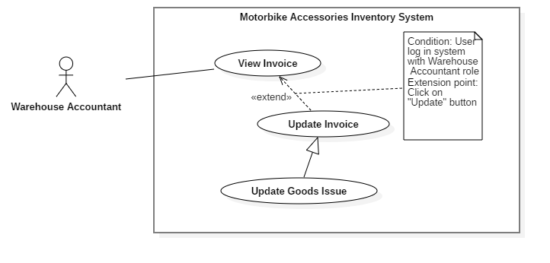
Figure 29 - <Warehouse Accountant> Update Goods Issue
USE CASE – RFIM_UC_ WA_I5
Use Case No. | RFIM_UC_ WA_I5 | Use Case Version | 1.0
Use Case Name | Update Goods Issue
Author | ThinhNT
Date | 26/07/2019 | Priority | Normal
Actor:
- Warehouse Accountant
Summary:
- This use case allows warehouse accountant to update goods issues
Goal:
- Warehouse accountant update goods issues successfully.
Triggers:
- Warehouse accountant clicks on “Update” button.
Preconditions:
- User must log in the system with Warehouse Accountant role.
- Goods Issue’s status is “Pending”.
Post conditions:
- Selected good issue information will be successfully updated.
- Fail: System shows error messages.
Main Success Scenarios:
Step | Actor Action | System Response
1 | Warehouse accountant clicks on “Update” button in “Goods Issues” screen. | System shows “Update Stock out Product” screen with products and following labels, fields:  - Product ID: prefilled, not editable  - Product Name: prefilled, not editable  - Category: prefilled, not editable  - Vendor: prefilled, not editable  - On-hand Quantity: prefilled, not editable  - Stock in Quantity: integer, required.
2 | Warehouse accountant clicks on “Choose Product” button in “Update Stock out Product” screen. | “Products List” screen is shown with following attribute of products: Product ID, Product Name, Quantity Per Box, Category, Vendor and On-hand Quantity.
3 | Warehouse Accountant check single or multiple checkboxes of products and clicks on “Confirm” button. | System shows “Update Stock out Product” screen with new selected products and following labels, fields:  - Product ID: prefilled, not editable  - Product Name: prefilled, not editable  - Category: prefilled, not editable  - Vendor: prefilled, not editable  - On-hand Quantity: prefilled, not editable  - Stock in Quantity: integer, required.
4 | Warehouse Accountant fills out “Stock out Quantity” field and clicks on “Finish” button. | System validates inputted data and shows “Goods Issues” screen  [Exception 1, 2]

Alternative Scenarios: N/A

Exceptions:
No | Actor Action | System Response
1 | Warehouse accountant clicks on “Cancel” button | System shows “Goods Issues” screen.
2 | Network connection problem. | System shows error message: “Please check your network connection.”

Relationships: Specialized from Update Invoice use case. Update Invoice use case was extended from View Invoice use case.
Business Rules:
- In this system, only Warehouse Accountant can update goods issue.
- “On-hand Quantity” shows box quantity of that product in stock.
- “Stock out Quantity” is the number of boxes for stocking in products, with the maximum value is equal to “On-hand Quantity”.
- Goods issue status will be changed to “Done” when stock out process successfully finished.
- Only Goods issues with “Pending” status can be edited. Any further processes will cause the change of the status of the goods receipt and make the goods receipt not editable.
<Warehouse Accountant> Update Goods Issue use case specification

<Warehouse Accountant> Delete Invoice
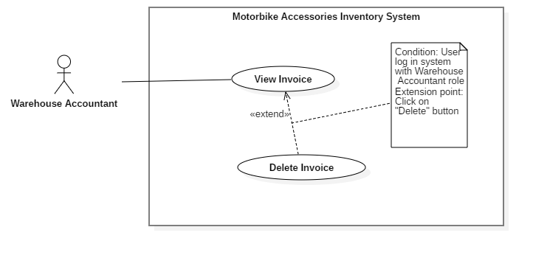
Figure 30 - <Warehouse Accountant> Delete Invoice
USE CASE – RFIM_UC_ WA_I5
Use Case No. | RFIM_UC_ WA_I5 | Use Case Version | 1.0
Use Case Name | Delete Invoice
Author | ThinhNT
Date | 26/07/2019 | Priority | Normal
Actor:
- Warehouse Accountant
Summary:
- This use case allows warehouse accountant to delete invoices.
Goal:
- Warehouse accountant deletes invoice successfully.
Triggers:
- Warehouse accountant clicks on “Delete” button.
Preconditions:
- User must log in the system with Warehouse Accountant role.
- Invoice’s status is “Pending”.
Post conditions:
- Success: Selected invoice will be deactivated
- Fail: System shows error messages.
Main Success Scenarios:
Step | Actor Action | System Response
1 | Warehouse Accountant clicks on “Delete” button on “Goods Receipt” or “Goods Issue” screen. | Confirmation dialog is shown with the Y/N option: “You’re about to delete an invoice. Are you sure?”
2 | Warehouse Accountant clicks on “Confirm” button. | System validates invoice status then shows “Goods Receipt” or “Goods Issue” screen.  [Exception 1, 2, 3]

Alternative Scenarios: N/A

Exceptions:
Step | Actor Action | System Response
1 | Invoice status is not “Pending”. | System shows error message: “Only invoice with ‘Pending’ status can be deleted.”
2 | Warehouse Accountant clicks on “Cancel” button. | System shows “Receipts/Issues” screen.
3 | Network connection problem. | System shows error message: “Please check your network connection.”

Relationships: Extended from View Invoice use case.
Business Rules:
- In this system, only Warehouse Accountant can delete invoices.
- Only Goods invoice with “Pending” status can be deleted.
- After deleted an invoice, user will be return to “Goods Receipt” or “Goods Issue” screen base on invoice type which user have just deleted
<Warehouse Accountant> Delete Invoice use case specification

<Warehouse Accountant> Create Report
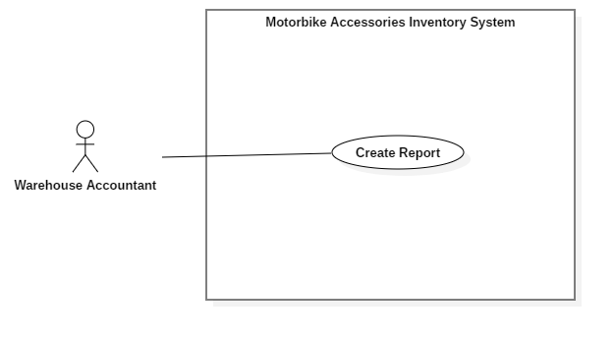
Figure 31 - <Warehouse Accountant> Create Report
USE CASE – RFIM_UC_ WA_I6
Use Case No. | RFIM_UC_ WA_I6 | Use Case Version | 2.0
Use Case Name | Create Report
Author | ThinhNT
Date | 26/07/2019 | Priority | Normal
Actor:
- Warehouse Accountant
Summary:
- This use case allows warehouse accountant to create a report file with pdf extension.
Goal:
- Warehouse accountant create report successfully.
Triggers:
- Warehouse accountant clicks on “Reports” button.
Preconditions:
- User must log in the system with Warehouse Accountant role.
Post conditions:
- Success: A report will be created.
- Fail: System shows error messages.
Main Success Scenarios:
Step | Actor Action | System Response
1 | Warehouse Accountant clicks on a report type button in “Reports” screen. | A specific report will be shown based on the report type that is chosen by Warehouse accountant.  [Exception 1]

Alternative Scenarios: N/A

Exception:
No | Actor Action | System Response
1 | Network connection problem. | System shows error message: “Please check your network connection.”

Relationships: Associated with Warehouse Accountant actor.
Business Rules:
- In this system, only Warehouse Accountant can create reports.
- There are 6 types of report can be chosen.
- Goods Receipt, Goods Issue report helps Stock-keeper know what invoice they should progress.
- Vendor, Category report helps Warehouse Accountant fill the excel file for “Import” feature.
- Product report shows list of Products and Cells containing that Product.
<Warehouse Accountant> Create Report

<Warehouse Accountant> View Stocktake History
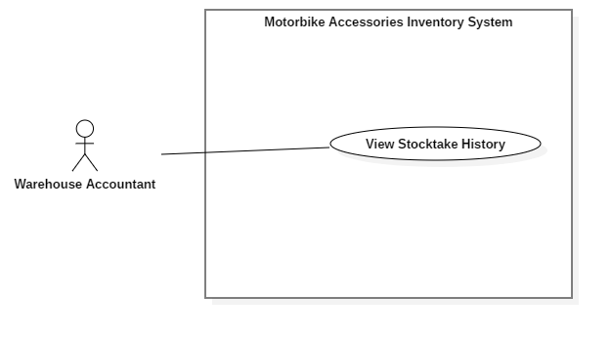
Figure 32 - <Warehouse Accountant> View Stocktake History
USE CASE – RFIM_UC_ WA_H1
Use Case No. | RFIM_UC_ WA_H1 | Use Case Version | 2.0
Use Case Name | View Stocktake History
Author | ThinhNT
Date | 26/07/2019 | Priority | Normal
Actor:
- Warehouse Accountant
Summary:
- This use case allows warehouse accountant to stocktake history information.
Goal:
- Warehouse accountant can view stocktake history issues list.
Triggers:
- Warehouse accountant clicks on “Awaiting Confirm” button on navigation bar
- Warehouse accountant clicks on “History” button on navigation bar
Preconditions:
- User must log in the system with Warehouse Accountant role.
Post conditions:
- Success: List of stocktake history will be shown on “Awaiting Confirm” or “History” screen.
- Fail: System shows error messages.
Main Success Scenarios:
Step | Actor Action | System Response
1 | - Stock-keeper clicks on “Awaiting Confirm” button on navigation bar.  - Stock-keeper clicks on “History” button on navigation bar. | - System shows “Awaiting Confirm” screen.  - System shows “History” screen.  [Exception 1, 2]

Alternative Scenarios: N/A

Exceptions:
Step | Actor Action | System Response
1 | There is no stocktake history in the database. | System shows error message “Goods receipt or issue is empty!”
2 | Network connection problem. | System shows error message: “Please check your network connection.”

Relationships: Associated with Warehouse Accountant actor.
Business Rules:
- In this system, only Warehouse Accountant can view stocktake history information.
<Warehouse Accountant> View Stocktake History use case specification

<Warehouse Accountant> Update Stocktake Status
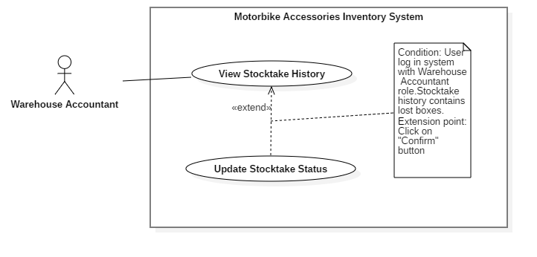
Figure 33 - <Warehouse Accountant> Update Stocktake Status
USE CASE – RFIM_UC_ WA_H2
Use Case No. | RFIM_UC_ WA_H2 | Use Case Version | 2.0
Use Case Name | Update Stocktake Status
Author | ThinhNT
Date | 26/07/2019 | Priority | Normal
Actor:
- Warehouse Accountant
Summary:
- This use case allows Warehouse Accountant to update status of stoktake and status of lost and found boxes after stocktaking.
Goal:
- Warehouse Accountant update stocktake status and lost/found boxes status successfully.
Triggers:
- Warehouse Accountant clicks on “Confirm” button.
Preconditions:
- User must log in the system with Warehouse Accountant role.
- Stocktake History status is “Pending”
Post conditions:
- Success: Stockatake status update successfully. Boxes status update successfully
- Fail: System shows error messages.
Main Success Scenarios:
Step | Actor Action | System Response
1 | Warehouse Accountant clicks on “Confirm” button in “Awaiting Confirm” screen. | Confirmation dialog is shown with the Y/N option: “Are you sure you want to confirm status of this stocktake? This will cause boxes which not found during this stocktake become unacessible unless they was found again by next stocktake.  +Found box:  +Lost box:”
2 | Warehouse Accountant clicks on “Confirm” button. | System shows “Awaiting Confirm” screen.  [Exception 1, 2]

Alternative Scenarios: N/A

Exceptions:
No | Actor Action | System Response
1 | Warehouse Accountant clicks on “Cancel” button. | System shows “Awaiting Confirm” screen.
2 | Network connection problem. | System shows error message: “Please check your network connection.”

Relationships: Extended from View Shelf use case.
Business Rules:
- In this system, only Warehouse Accountant can update stocktake status.
- Boxes which exist in system but doesn’t exist during stocktaking will be set status to “Missing” after Update Stocktake Info.
- Missing boxes can regain “Found” status with another Update Stocktake Status.
- Only stocktake with “Pending” status can be confirm.
- All confirmed Stocktake will be show in “History” screen

<Warehouse Accountant> Update Stocktake Status use case specification

<Stock-keeper> Overview Use Case
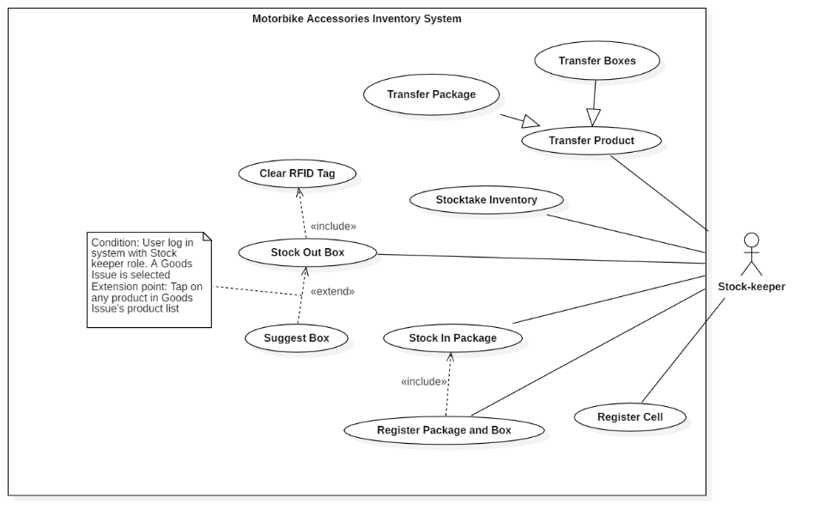
Figure 34 - <Stock-keeper> Overview Use Case

<Stock-keeper> Register Cell
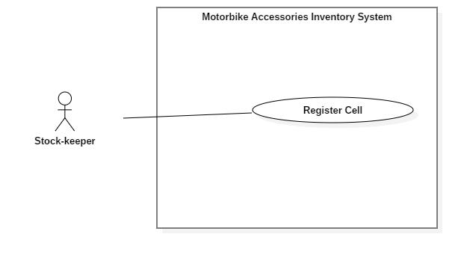
Figure 35 - <Stock-keeper> Register Cell
USE CASE – RFIM_UC_SK1
Use Case No. | RFIM_UC_SK1 | Use Case Version | 2.0
Use Case Name | Register Cell
Author | HoangNH
Date | 26/07/2019 | Priority | Normal
Actor:
- Stock-keeper
Summary:
- This use case allows Stock-keeper register cells with RFID tags.
Goal:
- Stock-keeper registers a cell with RFID tag successfully.
Triggers:
- Stock-keeper taps on “Save” button.
Preconditions:
- User must log in the mobile system with Stock-keeper role.
- The mobile device is connected with a RFID scanner.
Post conditions:
- Success: Cell is linked RFID tag.
- Fail: System shows error messages.
Main Success Scenarios:
Step | Actor Action | System Response
1 | Stock-keeper taps on “Register Cell” feature. | “Register Cell” screen is shown with following labels and fields:  - Shelf: select option, required  - Floor: select option, required  - Cell: select option, required  - Cell RFID: text, automatically inputted when an RFID tag is scanned.
2 | Stock-keeper scans RFID tag and taps on “Save” button. | System validates inputted data and shows message “Register successfully.”  [Exception 1, 2, 3, 4, 5]

Alternative Scenarios: N/A

Exceptions:
No | Actor Action | System Response
1 | Stock-keeper doesn’t scan any Cell RFID tags then taps on “Save” button | System shows error message "Please scan a Cell’s RFID.”
2 | Stock-keeper scans an RFID tags that is already registered with Cell ID | System shows error message "This RFID tag is already registered by another cell.”
3 | Stock-keeper taps on “Cancel” button. | System shows “Home” screen.
4 | Bluetooth connection problem. | System shows error message: “Please check your Bluetooth connection.”
5 | Network connection problem. | System shows error message: “Please check your network connection.”

Relationships: Associated with Stock-keeper actor.
Business Rules:
- In this mobile system, only Stock-keeper can register cells.
- A registered cell can be used to bind packages.
- Each Cell RFID tag can be changed by running “Register Cell” feature once again, but one RFID tag can’t be used to register 2 cells.
<Stock-keeper> Register Cell use case specification

<Stock-keeper> Register Package and Box
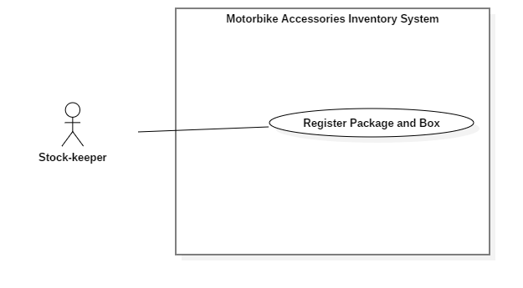
Figure 36 - <Stock-keeper> Register Package and Box
USE CASE – RFIM_UC_SK2
Use Case No. | RFIM_UC_SK1 | Use Case Version | 2.0
Use Case Name | Register Package and Box
Author | HoangPM
Date | 26/07/2019 | Priority | Normal
Actor:
- Stock-keeper
Summary:
- This use case allows Stock-keeper to register packages and boxes.
Goal:
- Stock-keeper register package and box successfully.
Triggers:
- Stock-keeper taps on “Save” button.
Preconditions:
- User must log in the mobile system with Stock-keeper role.
- The mobile device is connected with a RFID scanner.
Post conditions:
- Success: Boxes are successfully registered with a product and a RFID then mapped with a package RFID.
- Fail: System shows error messages.
Main Success Scenarios:
Step | Actor Action | System Response
1 | Stock-keeper taps on “Register Package and Box” button. | “Package Register” screen is shown with following labels and fields:  - Goods Receipt: select option, list Goods Receipt  - Product Name: select option, list Product  - Product Id: automatically show after selecting Product Name  - Package RFID: automatically inputted when an RFID tag is scanned. One tag allowed only  - Boxes RFID: text, automatically inputted when an RFID tag is scanned. Multiple tags are allowed.
2 | - Stock-keeper taps on “Scan” button and uses RFID scanner to scan Package tag.  - Stock-keeper taps on “Scan” button and uses RFID scanner to scan Box tag. | - Package RFIDs are automatically inputted in the field.  - List of Box RFIDs are automatically inputted in the field.
3 | Stock-keeper taps on “Save” button. | System validates inputted data and shows message “Register successfully.”  [Exception 1, 2, 3, 4, 5, 6]

Alternative Scenarios: N/A

Exceptions:
Step | Actor Action | System Response
1 | Stock-keeper doesn’t scan any Package RFID tags then taps on “Save” button. | System shows error message "Please scan a Package’s RFID.”
2 | Stock-keeper doesn’t scan any Box RFID tags then taps on “Save” button. | System shows error message “Please scan Box’s RFID.”
3 | Stock-keeper scan more boxes than required quantity | System shows error message “Enough Product.”
4 | Stock-keeper taps on “Cancel” button. | System shows “Home” screen.
5 | Bluetooth connection problem. | System shows error message: “Please check your Bluetooth connection.”
6 | Network connection problem. | System shows error message: “Please check your network connection.”

Relationships: Associated with Stock-keeper actor.
Business Rules:
- In this system, only Stock-keeper can register packages.
- Stock-keeper can view List Product in Goods Receipt by pressing “Info” icon
- “Registered Quantity” is number of boxes of that product which are registered successfully.
- “Quantity” is number of boxes that the Good Receipt requires.
- When any package is registered successfully, Good Receipt will have “Processing” status. If all packages in Goods Receipt are registered successfully then it will have “Done” status.
- A package can contain many boxes but only have one type of product.
<Stock-keeper> Register Package and Box use case specification

<Stock-keeper> Stock in Package
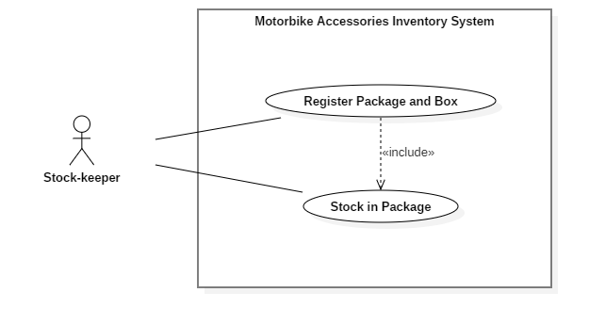
Figure 37 - <Stock-keeper> Stock in Package
USE CASE – RFIM_UC_SK3
Use Case No. | RFIM_UC_SK3 | Use Case Version | 2.0
Use Case Name | Stock in Package
Author | ThinhNT
Date | 26/07/2019 | Priority | Normal
Actor:
- Stock-keeper
Summary:
- This use case allows Stock-keeper to stock in packages.
Goal:
- Stock-keeper stocks in package successfully.
Triggers:
- Stock-keeper taps on “Save” button.
Preconditions:
- User must log in the mobile system with Stock-keeper role.
- Products are registered with RFID tag.
- The mobile device is connected with a RFID scanner.
Post conditions:
- Success: Package is mapped with a Cell RFID tag
- Fail: System shows error messages.
Main Success Scenarios:
Step | Actor Action | System Response
1 | Stock-keeper taps on “Stock In” feature. | “Stock In” screen is shown with following labels and fields:  - Cell RFID: text, automatically inputted when an RFID tag is scanned.  - Cell: text, automatically show after Cell RFID tag is scanned  - Floor: text, automatically show after Cell RFID tag is scanned  - Shelf: text, automatically show after Cell RFID tag scanned  - Package RFID: text, automatically inputted when an RFID tag is scanned.
2 | - Stock-keeper taps on “Scan” button and uses RFID scanner to scan Cell RFID tag.  - Stock-keeper taps on “Scan” button and uses RFID scanner to scan Package RFID tag. | - Cell RFIDs are automatically inputted in the field.  - Package RFIDs are automatically inputted in the field.
3 | Stock-keeper taps on “Save” button. | System validates inputted data and shows message “Stock in successfully.”  [Exception 1, 2, 3, 4, 5, 6]

Alternative Scenarios: N/A

Exceptions:
Step | Actor Action | System Response
1 | Stock-keeper doesn’t scan any Cell RFID tags then taps on “Save” button. | System shows error message "Please scan Cell’s RFID.”
2 | Stock-keeper doesn’t scan any Package RFID tags then taps on “Save” button. | System shows error message "Please scan Package’s RFID.”
3 | Stock-keeper register package into a full cell. | System shows error message "Cell is full. Please register to another cell.”
4 | Stock-keeper taps on “Cancel” button. | System shows “Home” screen.
5 | Bluetooth connection problem. | System shows error message: “Please check your Bluetooth connection.”
6 | Network connection problem. | System shows error message: “Please check your network connection.”

Relationships: Associated with Stock-keeper actor.
Business Rules:
- In this mobile system, only Stock-keeper can stock in packages.
- Unregistered packages cannot be stocked in.
- Each cell only has one package.
- Any further task such as merging packages should be accessed via “Transfer Product” feature.
- Each package can contain many boxes but only have one type of product.
< Stock-keeper > Stock in Package use case specification

<Stock-keeper> Stock out Box
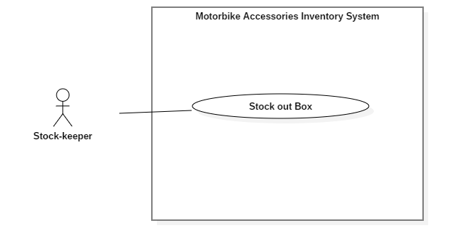
Figure 38 - <Stock-keeper> Stock out Box
USE CASE – RFIM_UC_SK4
Use Case No. | RFIM_UC_SK4 | Use Case Version | 2.0
Use Case Name | Stock out Box
Author | HoangPM
Date | 26/07/2019 | Priority | Normal
Actor:
- Stock-keeper
Summary:
- This use case allows Stock-keeper to stock out boxes.
Goal:
- Stock-keeper stocks out box successfully.
Triggers:
- Stock-keeper taps on “Save” button.
Preconditions:
- User must log in the system with Stock-keeper role.
- Product is stocked in.
- The mobile device is connected with a RFID scanner.
Post conditions:
- Success: Product is stocked out.
- Fail: System shows error messages.
Main Success Scenario:
Step | Actor Action | System Response
1 | Stock-keeper taps on “Stock Out” feature. | “Stock Out” screen is shown with following labels and fields:  - Goods Issue: select option, list Goods Issue  - Box Scanned Information: text, automatically inputted when an RFID tag is scanned
2 | Stock-keeper taps on “Scan” button and uses RFID scanner to scan boxes tag. | Scanner recognizes RFID and fills it to the “Box Scanned Information” field.
3 | Stock-keeper taps on “Save” button. | System shows message “Stock out successfully!”  [Exception 1, 2, 3, 4]

Alternative Scenarios: N/A

Exceptions:
No | Actor Action | System Response
1 | Stock-keeper doesn’t scan any Box RFID tags then taps on “Save” button. | System shows error message "Please scan Box’s RFID.”
2 | Stock-keeper taps on “Cancel” button. | System shows “Home” screen.
3 | Bluetooth connection problem. | System shows error message: “Please check your Bluetooth connection.”
4 | Network connection problem. | System shows error message: “Please check your network connection.”

Relationships: Associated with Stock-keeper actor.
Business Rules:
- In this system only Stock-keeper can stock out boxes.
- Unregistered boxes cannot be stocked out.
- Box Scanned Information contains list of variety product types and its quantity, which are filled by scanning Box RFID tags.
- When all products in Goods Issue are stocked out successfully, Goods Issue will have “Done” status.
- Stock-keeper can scan any box of variety products as long as the invoice contains that product.
<Stock-keeper> Stock out Box use case specification

<Stock-keeper> Stocktake Inventory
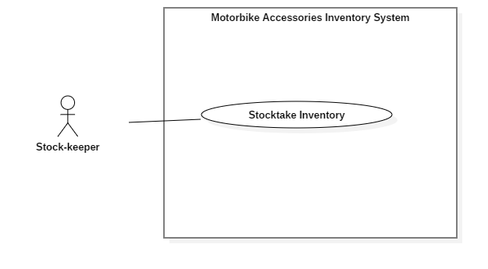
Figure 39 - <Stock-keeper> Stocktake Inventory
USE CASE – RFIM_UC_SK5
Use Case No. | RFIM_UC_SK5 | Use Case Version | 2.0
Use Case Name | Stocktake Inventory
Author | HoangPM
Date | 26/07/2019 | Priority | Normal
Actor:
- Stock-keeper
Summary:
- This use case allows Stock-keeper to stocktake inventory products.
Goal:
- Stock-keeper stocktake inventory product successfully.
Triggers:
- Stock-keeper taps on “Save” button.
Preconditions:
- User must log in the system with Stock-keeper role.
- Product currently has boxes
- The mobile device is connected with a RFID scanner.
Post conditions:
- Success: Product is stocked out.
- Fail: System shows error messages.
Main Success Scenario:
Step | Actor Action | System Response
1 | Stock-keeper taps on “Stocktake Inventory” feature. | “Stocktake Inventory” screen is shown with following labels and fields:  - Product Name: select option, list Product  - Product ID: automatically show after selecting Product Name  - Available Quantity: automatically show after selecting Product Name  - Stocktake Quantity: integer, automatically increase when product’s RFID tag is scanned.
2 | Stock-keeper taps on “Scan Box RFID” button and uses RFID scanner to scan boxes of that products | Scanner recognizes RFID of selected product and increases “Stocktake Quantity”
3 | Stock-keeper taps on “Report” button. | Confirmation dialog is shown with the Y/N option: “Do you want to report?”
4 | Stock-keeper taps on “OK” button. | System shows message “Stocktake successfully!”  [Exception 1, 2, 3]

Alternative Scenarios: N/A

Exceptions:
No | Actor Action | System Response
1 | Stock-keeper taps on “Cancel” button. | System shows “Home” screen.
2 | Bluetooth connection problem. | System shows error message: “Please check your Bluetooth connection.”
3 | Network connection problem. | System shows error message: “Please check your network connection.”

Relationships: Associated with Stock-keeper actor.
Business Rules:
- In this system only Stock-keeper can stocktake inventory products.
- “Available Quantity” is number of box which is archived by RFIM system.
- “Stocktake Quantity” is number of box actually have in warehouse.
- Stocktake Inventory can only stocktake one product at a time.
<Stock-keeper> Stocktake Inventory use case specification

<Stock-keeper> Suggest Box
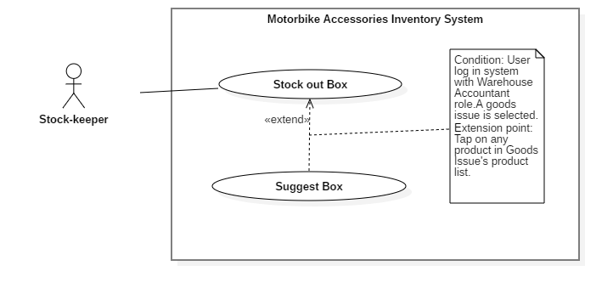
Figure 40 - <Stock-keeper> Suggest Box
USE CASE – RFIM_UC_SK6
Use Case No. | RFIM_UC_SK6 | Use Case Version | 2.0
Use Case Name | Suggest Box
Author | ThinhNT
Date | 26/07/2019 | Priority | Normal
Actor:
- Stock-keeper
Summary:
- This use case show stock-keeper longest-lasting boxes and where to find them
Triggers:
- Stock-keeper tap on any product in “Goods Issue Info” screen
Preconditions:
- User must log in the mobile system with role Stock-keeper.
Post conditions:
- Success: List longest-lasting boxes was suggested
- Fail: “Suggest Box” screen show nothing
Main Success Scenario:
Step | Actor Action | System Response
1 | Stock-keeper taps on “Goods Issue Info” button on “Good Issue” screen | “Goods Issue Info” screen is shown with list of products.
2 | Stock-keeper taps on any product on “Good Issue” screen | “Suggest Box” screen is shown with list of shelves contains that product.
3 | Stock-keeper taps on any shelf on “Suggest Box” screen | System show “List of Cell” contains boxes that satisfied both distance and lasting time
Alternative Scenarios: N/A
Exceptions:
No | Actor Action | System Response
1 | Network problem. | System shows error message: “Please check your connection.”
2 | Bluetooth problem. | System shows error message: “Please check your Bluetooth connection.”

Relationships: Associated with Stock-keeper actor.
Business Rules:
- If there is no box of that product, “Suggest Box” feature will leave an empty field.
- “Suggest Box” feature list best options to stock out, making warehouse management much more effective
<Stock-keeper> Suggest Box use case specification

<Stock-keeper> Transfer Box
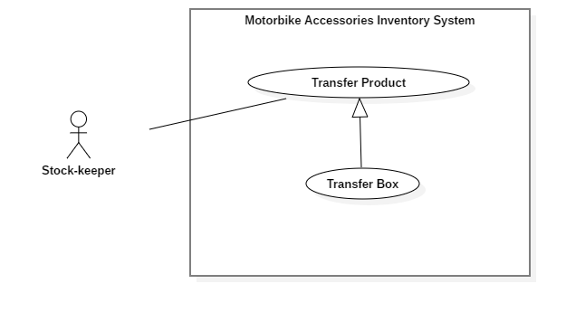
Figure 41 - <Stock-keeper> Transfer Box
USE CASE – RFIM_UC_SK7
Use Case No. | RFIM_UC_SK7 | Use Case Version | 2.0
Use Case Name | Transfer Box
Author | HoangNH
Date | 26/07/2019 | Priority | Normal
Actor:
- Stock-keeper
Summary:
- This use case allows Stock-keeper to transfer product boxes to another package.
Goal:
- Stock-keeper transfer box of product successfully.
Triggers:
- Stock-keeper taps on “Save” button.
Preconditions:
- User must log in the system with Stock-keeper role.
- Product is stocked in.
- The mobile device is connected with a RFID scanner.
Post conditions:
- Success: Boxes of product is transferred to another package successfully.
- Fail: System shows error messages.
Main Success Scenario:
Step | Actor Action | System Response
1 | Stock-keeper taps on “Transfer Product” feature and selects “Transfer Box” tab. | “Transfer Box” screen is shown with following labels and fields:  - Package RFID: text, automatically inputted when package RFID tag is scanned.  - Box RFID: list Boxes, automatically inputted when package RFID tag is scanned.
2 | Stock-keeper taps on “Scan” button and next to Package text field and uses RFID scanner to scan package’s tag. | Package RIFD is automatically inputted in the field.
3 | Stock-keeper taps on “Scan Box RFID” button and uses RFID scanner to scan boxes tag, which have same product as the destination package. | Boxes RFIDs are automatically inputted in the field.
4 | Stock-keeper taps on “Save” button. | System shows message “Transfer successfully!”  [Exception 1, 2, 3, 4, 5]

Alternative Scenarios: N/A

Exceptions:
No | Actor Action | System Response
1 | Stock-keeper doesn’t scan any Package RFID tag then taps on “Save” button. | System shows error message "Please scan Package RFID.”
2 | Stock-keeper doesn’t scan any Box RFID tags then taps on “Save” button. | System shows error message "Please scan Box RFID.”
3 | Stock-keeper taps on “Cancel” button. | System shows “Home” screen.
4 | Bluetooth connection problem. | System shows error message: “Please check your Bluetooth connection.”
5 | Network connection problem. | System shows error message: “Please check your network connection.”

Relationships: Specialized from Transfer Product use case.
Business Rules:
- In this mobile system, only Stock-keeper can transfer boxes to another packages.
- Only Boxes which have identical product with package will be shown on “Box Information”. Others types of boxes will not be scanned
<Stock-keeper> Transfer Box use case specification

<Stock-keeper> Transfer Package
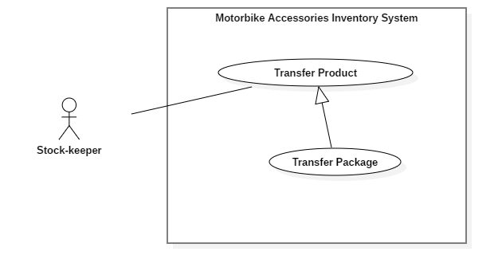
Figure 42 - <Stock-keeper> Transfer Package
USE CASE – RFIM_UC_SK8
Use Case No. | RFIM_UC_SK8 | Use Case Version | 2.0
Use Case Name | Transfer Package
Author | HoangNH
Date | 26/07/2019 | Priority | Normal
Actor:
- Stock-keeper
Summary:
- This use case allows Stock-keeper to transfer product packages to another cell.
Goal:
- Stock-keeper transfer packages successfully.
Triggers:
- Stock-keeper taps on “Save” button.
Preconditions:
- User must log in the system with Stock-keeper role.
- Product is stocked in.
- The mobile device is connected with a RFID scanner.
Post conditions:
- Success: Product package is transferred to another cell successfully.
- Fail: System shows error messages.
Main Success Scenario:
Step | Actor Action | System Response
1 | Stock-keeper taps on “Transfer Product” feature and selects “Transfer Package” tab. | “Transfer Package” screen is shown with following labels and fields:  - Cell RFID: text, automatically inputted when an RFID tag is scanned.  - Cell: text, automatically inputted after Cell RFID tag is scanned.  - Floor: text, automatically inputted when an RFID tag is scanned.  - Shelf: text, automatically inputted when an RFID tag is scanned.  - Package: RFID of Package, text, automatically inputted when an RFID tag is scanned.
2 | Stock-keeper taps on “Scan” button next to Cell RFID text field and uses RFID scanner to scan cell’s tag. | Cell RIFD is automatically inputted in the field, followed by the position of the cell, floor, shelf associated with it.
3 | Stock-keeper taps on “Scan” button next to Package text field and uses RFID scanner to scan package’s tag. | Package RIFD is automatically inputted in the field
3 | Stock-keeper taps on “Save” button. | System shows message “Transfer successfully!”  [Exception 1, 2, 3, 4, 5, 6]

Alternative Scenarios: N/A

Exceptions:
No | Actor Action | System Response
1 | Stock-keeper doesn’t scan any Cell RFID tags then taps on “Save” button. | System shows error message "Please scan Cell RFID tags.”
2 | Stock-keeper doesn’t scan any Package RFID tags then taps on “Save” button. | System shows error message "Please scan Package RFID tags.”
3 | Stock-keeper taps on “Cancel” button. | System shows “Home” screen.
4 | Stock-keeper scan Cell that already contains package | System shows error message: “Cell is full.”
5 | Bluetooth connection problem. | System shows error message: “Please check your Bluetooth connection.”
6 | Network connection problem. | System shows error message: “Please check your network connection.”

Relationships: Associated with Stock-keeper actor.
Business Rules:
- In this mobile system, only Stock-keeper can transfer packages.
- Unregistered packages cannot be transferred.
<Stock-keeper> Transfer Package use case specification

<Stock-keeper> Clear RFID Tag
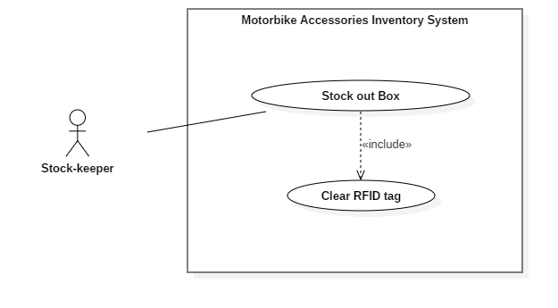
Figure 43 - <Stock-keeper> Clear RFID Tag
USE CASE – RFIM_UC_SK9
Use Case No. | RFIM_UC_SK9 | Use Case Version | 2.0
Use Case Name | Clear RFID Tag
Author | HoangPM
Date | 26/07/2019 | Priority | Normal
Actor:
- Stock-keeper
Summary:
- This use case allows system automatically clear RFID tag.
Goal:
- RFID tag successfully unbind from boxes and package for reusing purpose.
Triggers:
- Boxes: Stock out successfully.
- Packages: Automatically cleared when contains no box.
Preconditions:
- User must log in the mobile system with role Stock-keeper.
Post conditions:
- Success: RFID Tag will be cleared successfully.
- Fail: System shows error messages.
Main Success Scenario:
Step | Actor Action | System Response
1 | Stock-keeper taps on “Save” Button on Stock out screen | System automatically clear RFID tag of boxes

Alternative Scenarios: N/A
Exceptions: N/A

Relationships: Included by Stock out Box usecase
Business Rules:
- Clear RFID Tag automatically trigger when stock out boxes successfully (Clear boxes RFIDs) or when package contains no box (Clear package RFID)
<Stock-keeper> Clear RFID Tag use case specification

Software System Attribute

Usability
- The authorized users should need at least 2 days of training to be capable of using the system effectively and productively.
- The texts, labels must be all in English.
- The content of the description can be written in Vietnamese.

Reliability
- Exception rate is at minimum 1% over all working time
- The RFID tag always contains and transfer correct information of the accessory it is attached to - to the server whenever the scanner detects the tag successfully to do the further works.

Availability
Server available 24/7 including holidays with minimun downtime 1-2 days each 3 months for maintainance

Security
- Privacy: Each role of the user has a specific permission to interact with the system. The system always checks the authorization and authentication before doing further work.

Maintainability
- The system is divided into separated modules.
- The code is easy to maintain and upgrade.
- Require schedule maintainance every 6 month

Portability
- Admin, customers and guests can use application on Google Chrome version 42 or above.
- Warehouse Staff can use mobile application on Android devices that support Android 6.0 or later.

Performance
Requests from web application are responded in less than 5 seconds at 4 Mbps bandwidth speed and 1GHz processing speed of CPU.

Conceptual Diagram
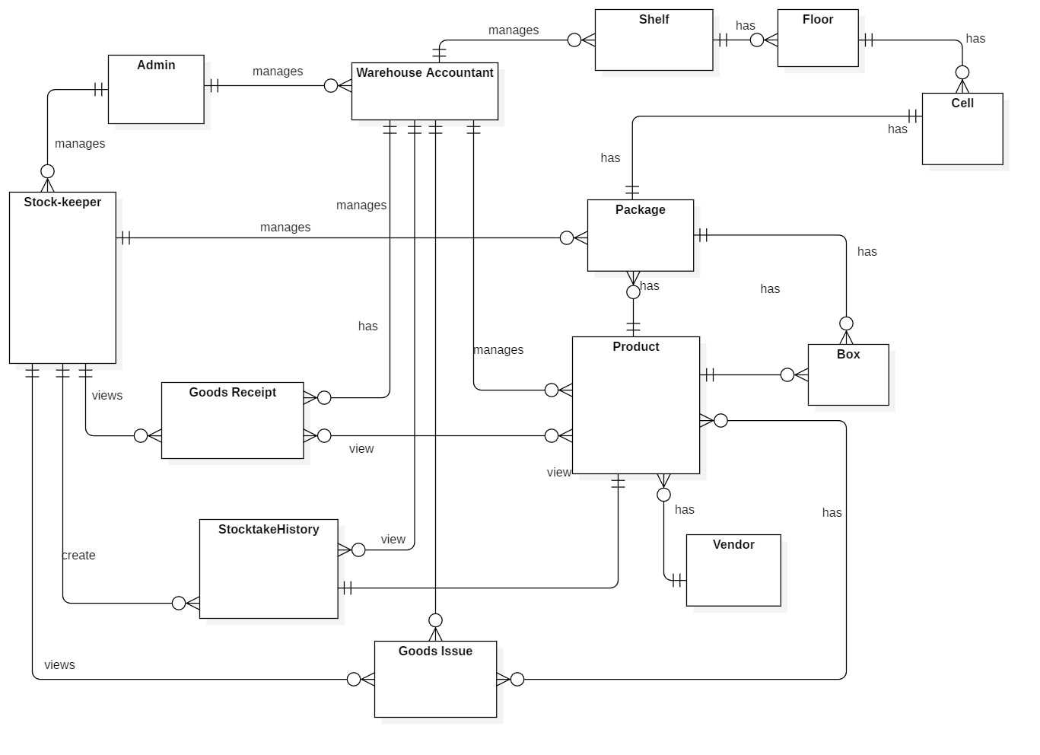
Figure 44 - Conceptual Diagram

ENTITY DATA DICTIONARY: DESCRIBE ALL CONTENT OF ALL ENTITIES
Entity name | Description
Admin | Contains the admin information
Stock-keeper | Contains the stock-keeper information
Warehouse Staff | Contains the warehouse staff information
Package | Contains the package information
Product | Contains the product information
Box | Contains the box information
Shelf | Contains the shelf information
Floor | Contains the floor information
Cell | Contains the cell information
Goods Receipt | Contains the goods receipt information
Goods Issue | Contains the goods issue information
Stocktake History | Contains the stocktake history information
Vendor | Contains the vendor information
Table 14 - Conceptual Diagram Data Dictionary

