

International School

**Software Testing**

*CMU-SE 303 KIS*

**DATABASE DESIGN DOCUMENT**

*Version: 2.0*

*Date: 18/09/2021*

**CHECK IT NOW WEBSITE**

**Submitted by:**

Mlo, H’ Na Ri

Hung, Le Van

Phong, Bui Duy

Trung, Le Thanh

Hoang, Nguyen Duc

**Approved by**

**Proposal Review Panel Representative:**

Name Signature Date

**Software Testing - Mentor:**

Name Signature Date

MSc Trinh, Tran Thi Thuy

# Project Information

|  |  |  |  |
| --- | --- | --- | --- |
| **Project acronym** | CiN | | |
| **Project Title** | Check it Now - Task Management website | | |
| **Start Date** | 01 Sep 2021 | **End Date** | 20 Dec 2021 |
| **Lead Institution** | International School, Duy Tan University | | |
| **Project Mentor** | MSc Trinh, Tran Thi Thuy  Email: thuytrinh85@gmail.com  Tel: 0795898823 | | |
| **Scrum master / Project Leader & contact details** | Mlo, H’ Na Ri  Email: narimlo2001@gmail.com  Tel: +84 886 912 935 | | |
| **Partner Organization** | Phong, Bui Duy  Email: buiduyphong921@gmail.com  Tel: +84 906 547 932 | | |
| **Project Web URL** |  | | |
| **Team members** | Name | Email | Tel |
|  | Hung, Le Van | 88levanhung@gmail.com | +84 823 474 409 |
| Mlo, H’ Na Ri | narimlo2001@gmail.com | +84 886 912 935 |
| Phong, Bui Duy | [buiduyphong921@gmail.com](mailto:nguyenxuandung711@gmail.com) | +84 906 547 932 |
| Trung, Le Thanh | thanhtrung20022001@gmail.com | +84 378 339 279 |
|  | Hoang, Nguyen Duc | hoang922001@gmail.com | +84 778 727 300 |

|  |  |  |  |
| --- | --- | --- | --- |
| **DOCUMENT NAME** | | | |
| **Document Title** | Database Design Document | | |
| **Author(s)** | Team 3 | | |
| **Role** | Team members | | |
| **Date** | 18 – Sep – 2021 | **File name:** | Database_Design_v2.0 |
| **URL** |  | | |

|  |  |  |  |
| --- | --- | --- | --- |
| **REVISION HISTORY** | | | |
| **Version** | **Person** | **Date** | **Description** |
| **1.0** | Phong Bui Duy, Hoang Nguyen Duc | 12 – Sep – 2021 | Draft |
| **2.0** | Phong Bui Duy, Hoang Nguyen Duc | 18 – Sep – 2021 | Update |

**Contents**

Project Information 1

1. Introduction 4

1.1. Purpose 4

1.2. Goal 4

1.3. Scope 4

1.4. Data storage platforms 4

1.5. Definition, Acronyms and Abbreviations 5

2. Database Design 5

2.1. Table Overview 5

2.2. Entity Relationship Diagram 5

2.3. Table Relationship Diagram 6

2.4. Details 6

2.4.1. Users 6

2.4.2. Tasks 7

# Introduction

## Purpose

Place information system’s database design document describes structure of database and file structure of system. Database Design document will introduce all attribute the System that will help developer and tester base on this design to implement and test.

## Goal

To create database tables most accurate.

## Scope

This Database Design Document provides the basic for “Check it Now” Database design.

It describes both logical and physical definition, non-functional issues, and the database interfaces; storage aspects are defined in the physical database design sections.

The tables performance considerations requirements. The following topics are covered in this document:

* Assumptions and decisions on database design.
* Entity-mapping.
* Table column definitions.
* Primary, unique and foreign key definitions.
* Column and row level validation rules (check constraints).
* Rule for populating specific columns (sequences, derivations, demoralized (column)).
* Interfaces and dependencies with other components.

During design, these initial definitions are enhanced to support the functionality described in the functional specification/ user stories and defined in the primary and supporting modules of the application high level design.

## Data storage platforms

Data of system is stored in MySQL database.

In MySQL, data structure is stored as tables that the database objects that behave as containers for the data, in which the data will be logically organized in rows and columns format.

## Definition, Acronyms and Abbreviations

|  |  |  |
| --- | --- | --- |
| **Abbreviations** | **Description** | **Comment** |
| PK/FK | Primary/ Foreign Key | Use to indicate a file is a Primary or Foreign key in a table |
| ERD | Entity Relationship Diagram | Show the relationship between entities in the system |
| UNI | Unique | Ensure all values going to store into the column will be unique |

# Database Design

### Table Overview

|  |  |  |
| --- | --- | --- |
| **No.** | **Table name** | **Short Description** |
| 1 | Users | This table contains information about user. |
| 2 | Tasks | This table contains information about task. |

### Entity Relationship Diagram

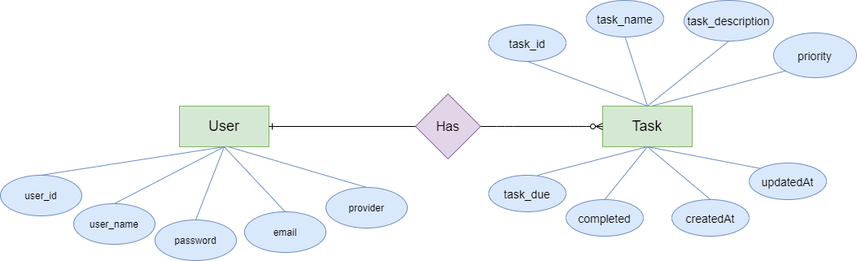

***Figure 1: Entity Relationship Diagram***

### Table Relationship Diagram

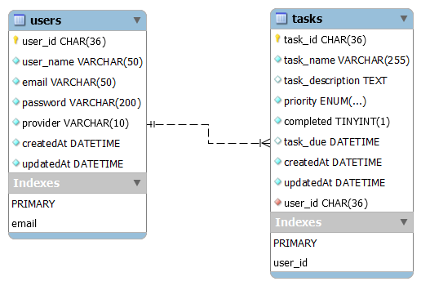

***Figure 2: Table Relationship Diagram***

### Details

#### Users

|  |  |  |  |  |  |
| --- | --- | --- | --- | --- | --- |
| **Attributes** | **Datatype** | **Null** | **Key** | **Default** | **Extra** |
| user_id | CHAR (36) | No | PK |  |  |
| user_name | VARCHAR (50) | No |  |  |  |
| email | VARCHAR (50) | No | UNI |  |  |
| password | VARCHAR (200) | No |  |  |  |
| provider | VARCHAR (10) | No |  | system |  |

#### Tasks

|  |  |  |  |  |  |
| --- | --- | --- | --- | --- | --- |
| **Attributes** | **Datatype** | **Null** | **Key** | **Default** | **Extra** |
| task_id | CHAR (36) | No | PK |  |  |
| task_name | VARCHAR (255) | No |  |  |  |
| task_description | TEXT | Yes |  |  |  |
| priority | ENUM(‘low’, ‘medium’, ‘high’) | No |  | low |  |
| task_due | DATETIME | Yes |  | now() + interval 1 day |  |
| user_id | CHAR (36) | No | FK |  |  |
| completed | TINYINT(1) | No |  | 0 |  |
| createdAt | DATETIME | No |  |  |  |
| updatedAt | DATETIME | No |  |  |  |