FinAgent
Investment Analysis Report
AI-Powered Financial Data Pipeline

Assets Analysed: AAPL | MSFT | NVDA | GOOGL
Generated: 2026-05-09 11:54
AI Provider: Groq — llama-3.3-70b-versatile
Data Source: Yahoo Finance (yfinance)

This report is generated for academic purposes only and does not constitute financial advice. All analysis is based on historical data.

Asset Summary Statistics
Key price and risk metrics for all tracked assets over the past 12 months.
Ticker | Company | Price | 52w High | 52w Low | Period Ret | Ann. Vol | Sharpe | Trend
AAPL | Apple Inc. | $293.32 | $293.32 | $194.68 | +48.39% | 23.37% | 1.82 | ↑ Above MA30
MSFT | Microsoft Corporation | $415.12 | $539.83 | $356.77 | -4.66% | 23.68% | -0.08 | ↑ Above MA30
NVDA | NVIDIA Corporation | $215.20 | $216.61 | $116.62 | +84.53% | 34.27% | 1.97 | ↑ Above MA30
GOOGL | Alphabet Inc. | $400.80 | $400.80 | $152.22 | +163.30% | 28.99% | 3.51 | ↑ Above MA30

Data Visualisations
All charts are generated from cleaned historical data. Moving averages and Bollinger Bands use 7-day, 30-day, and 20-day windows respectively.
Chart 1 — Price Trend & Volume
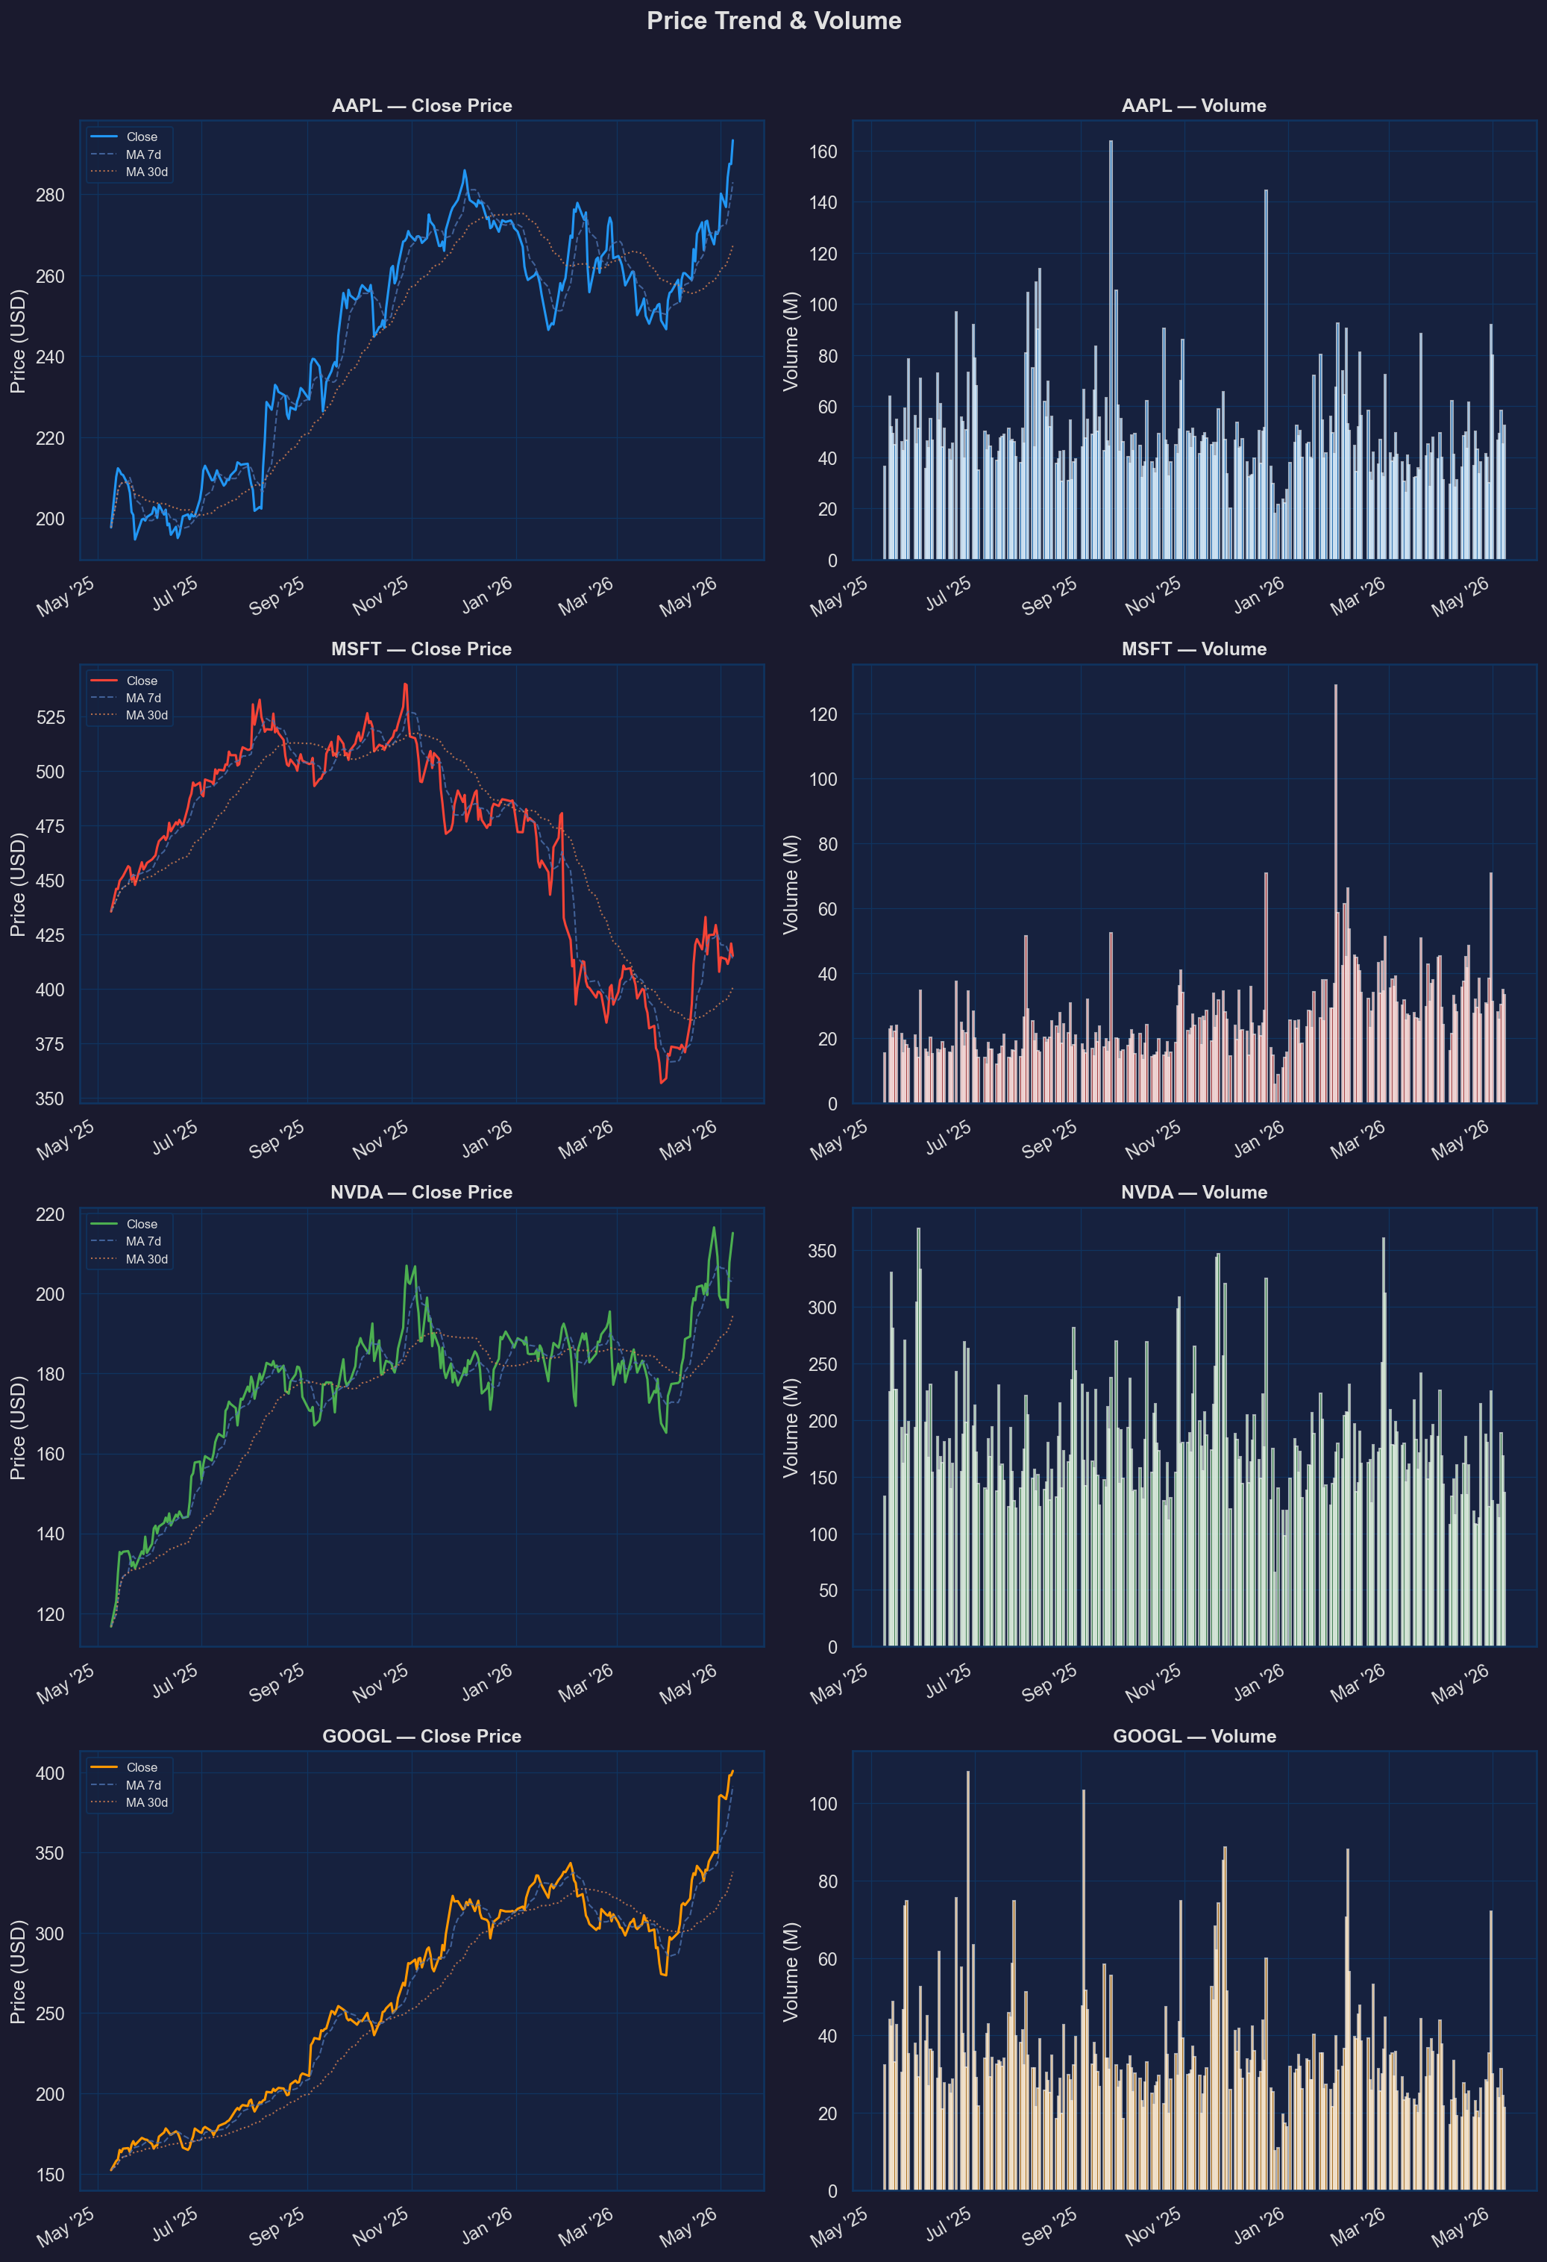
Close price with 7-day and 30-day moving averages alongside daily trading volume.
Chart 2 — Daily Return Correlation Heatmap
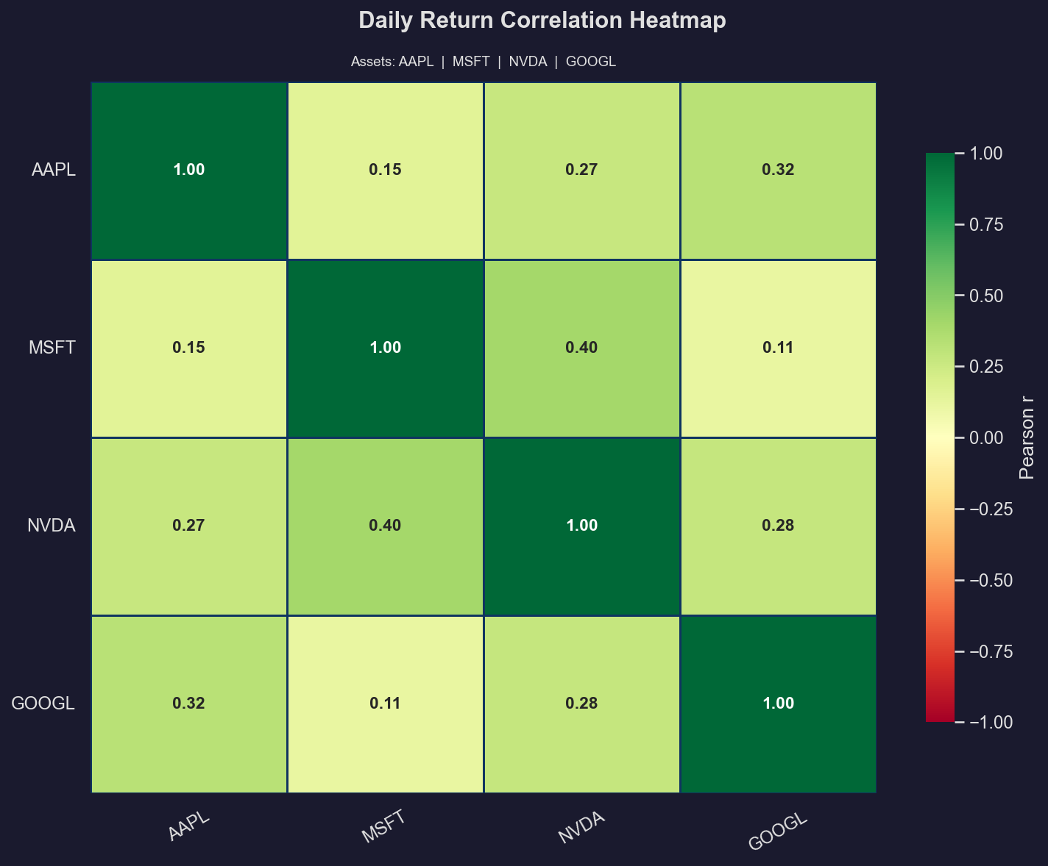
Pearson correlation coefficients between daily returns. Values near +1 indicate assets move together; near 0 indicates independence.
Chart 3 — Return Distribution (Histogram + KDE)
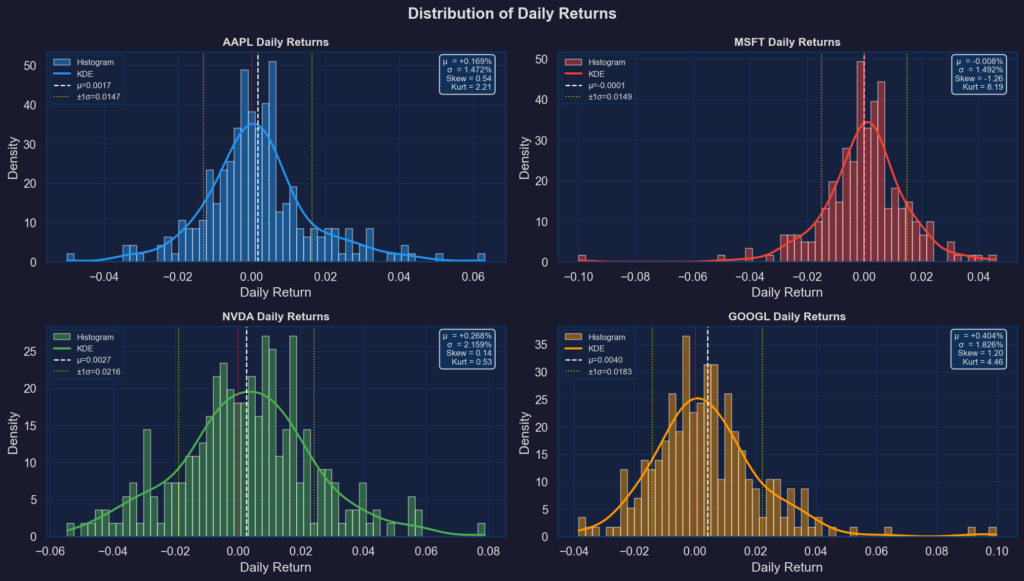
Histogram and KDE of daily returns with mean (dashed) and ±1σ (dotted) markers. Skew and kurtosis values indicate tail risk.
Chart 4 — Rolling Statistics & Bollinger Bands
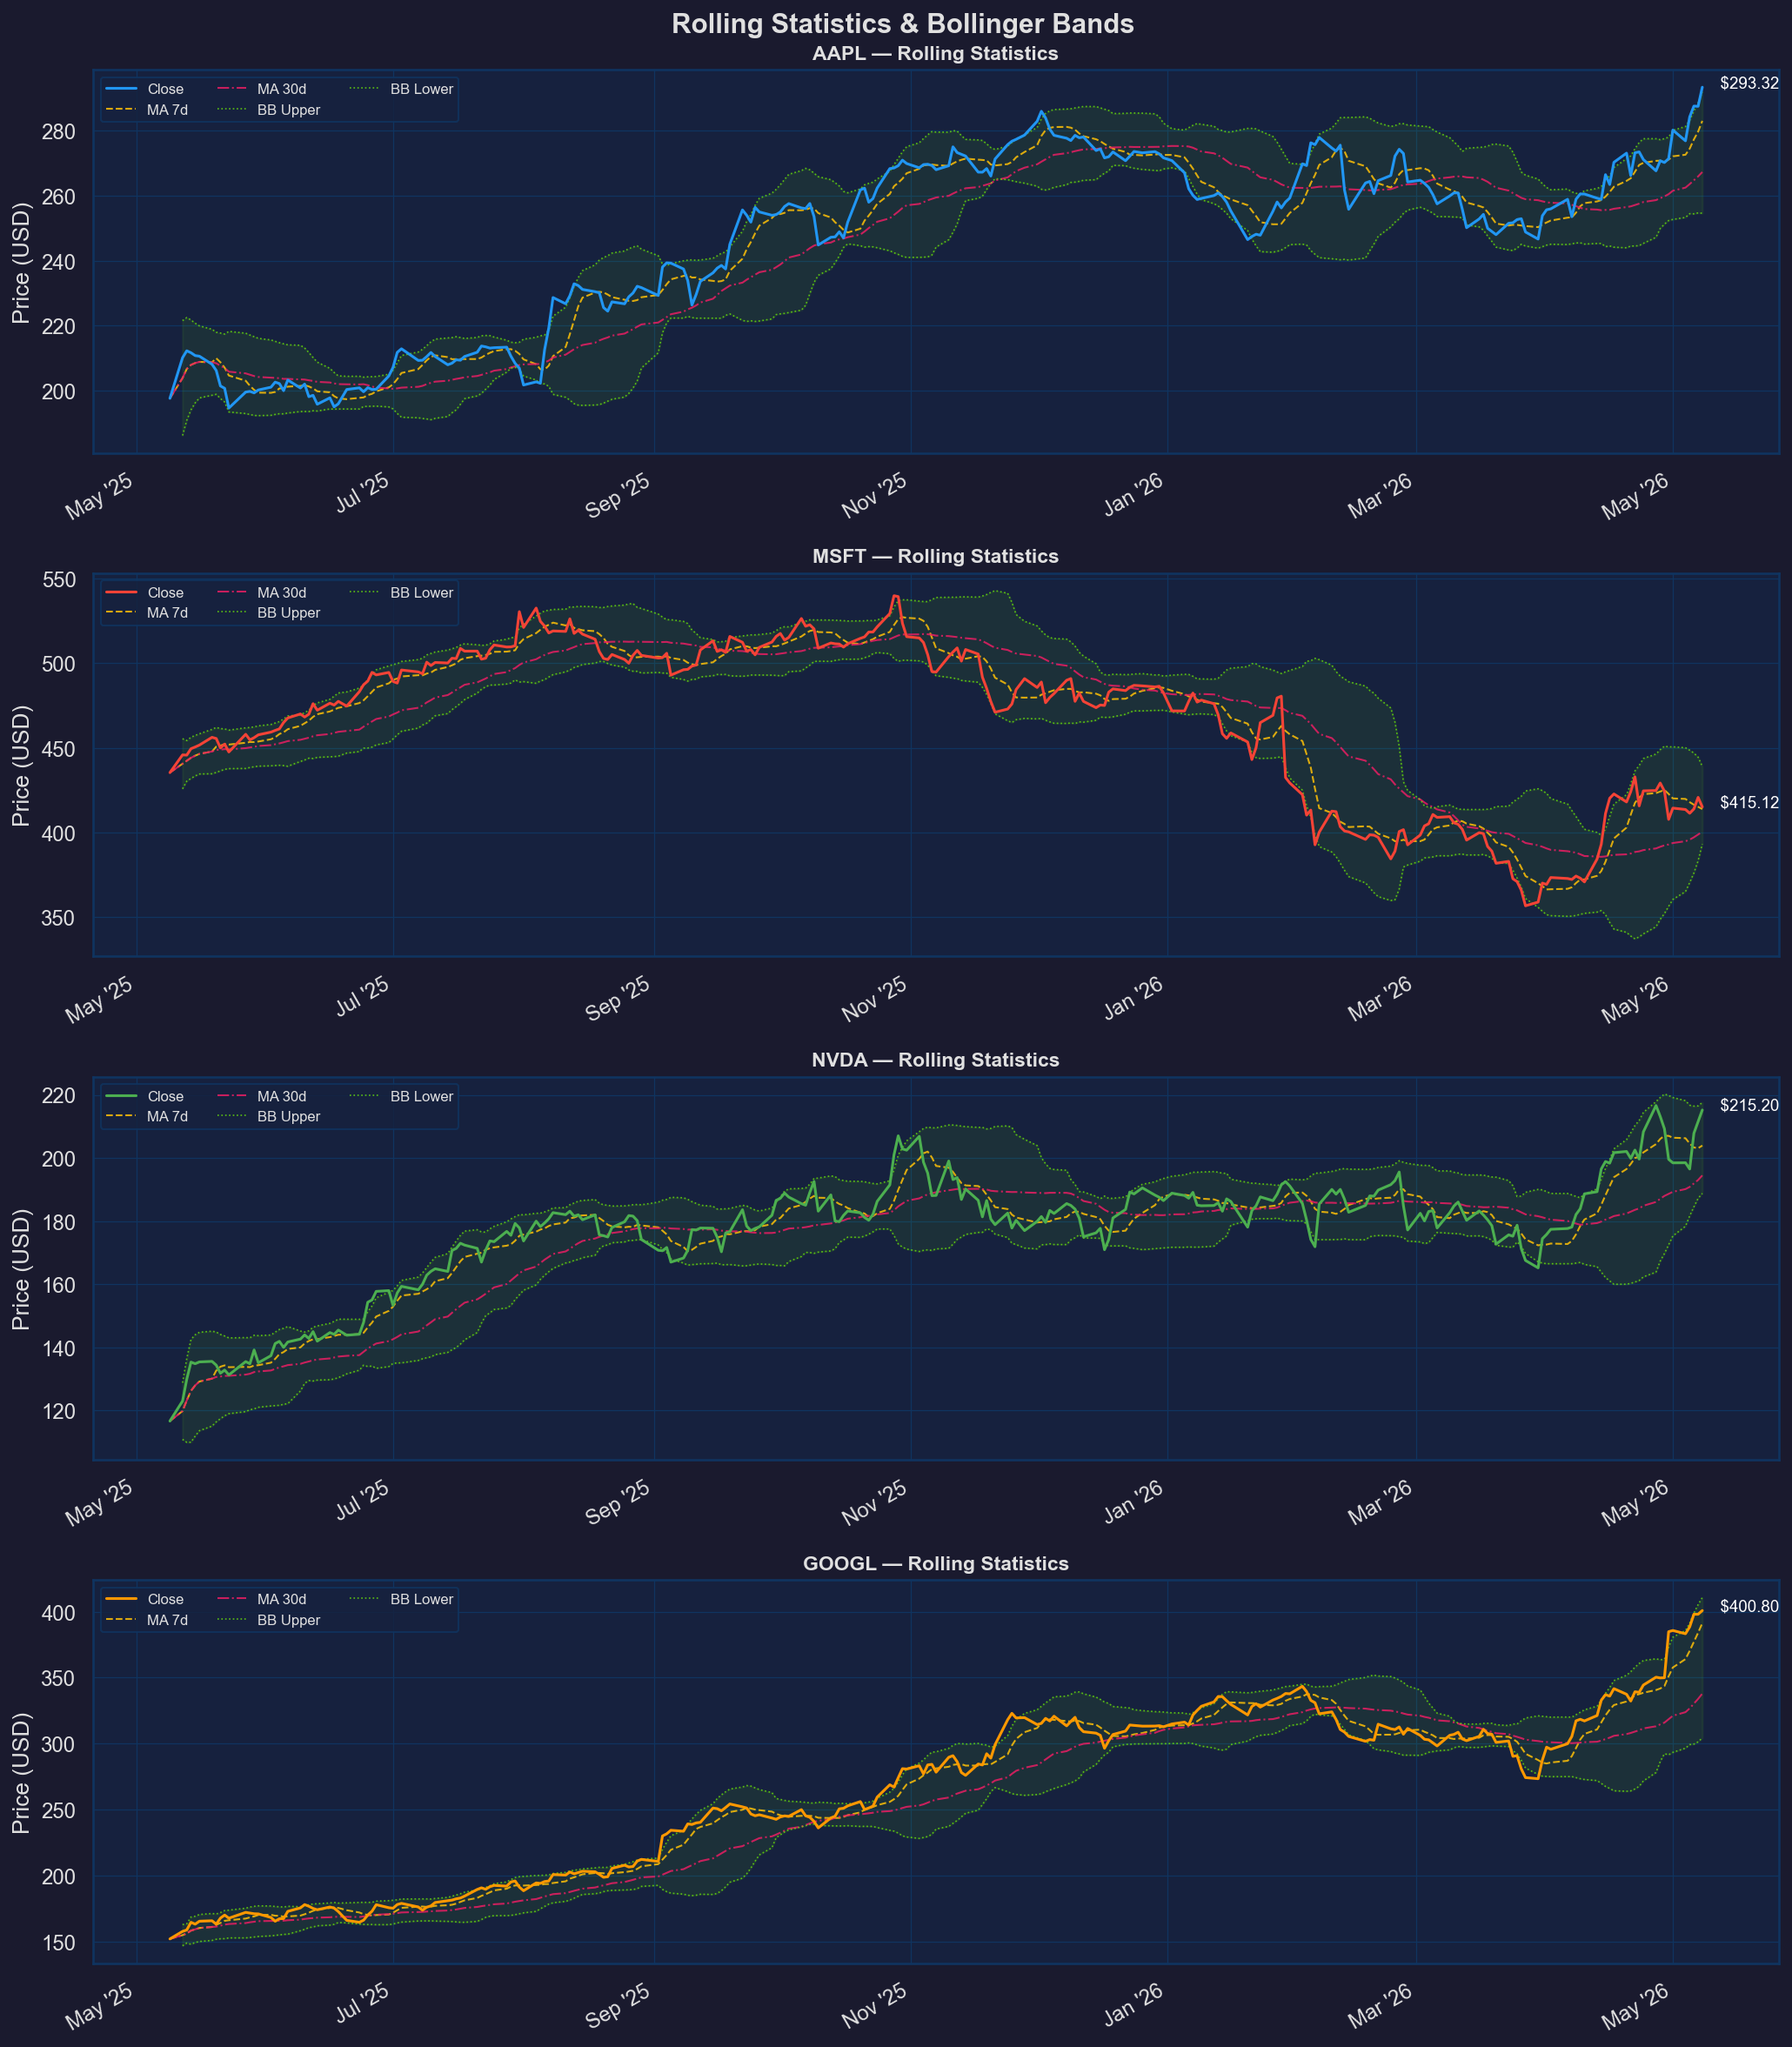
Close price overlaid with MA7, MA30, and Bollinger Bands (20-day, ±2σ). Price touching the upper band may signal overbought conditions.
Chart 5 — Cumulative Returns Comparison (Bonus)
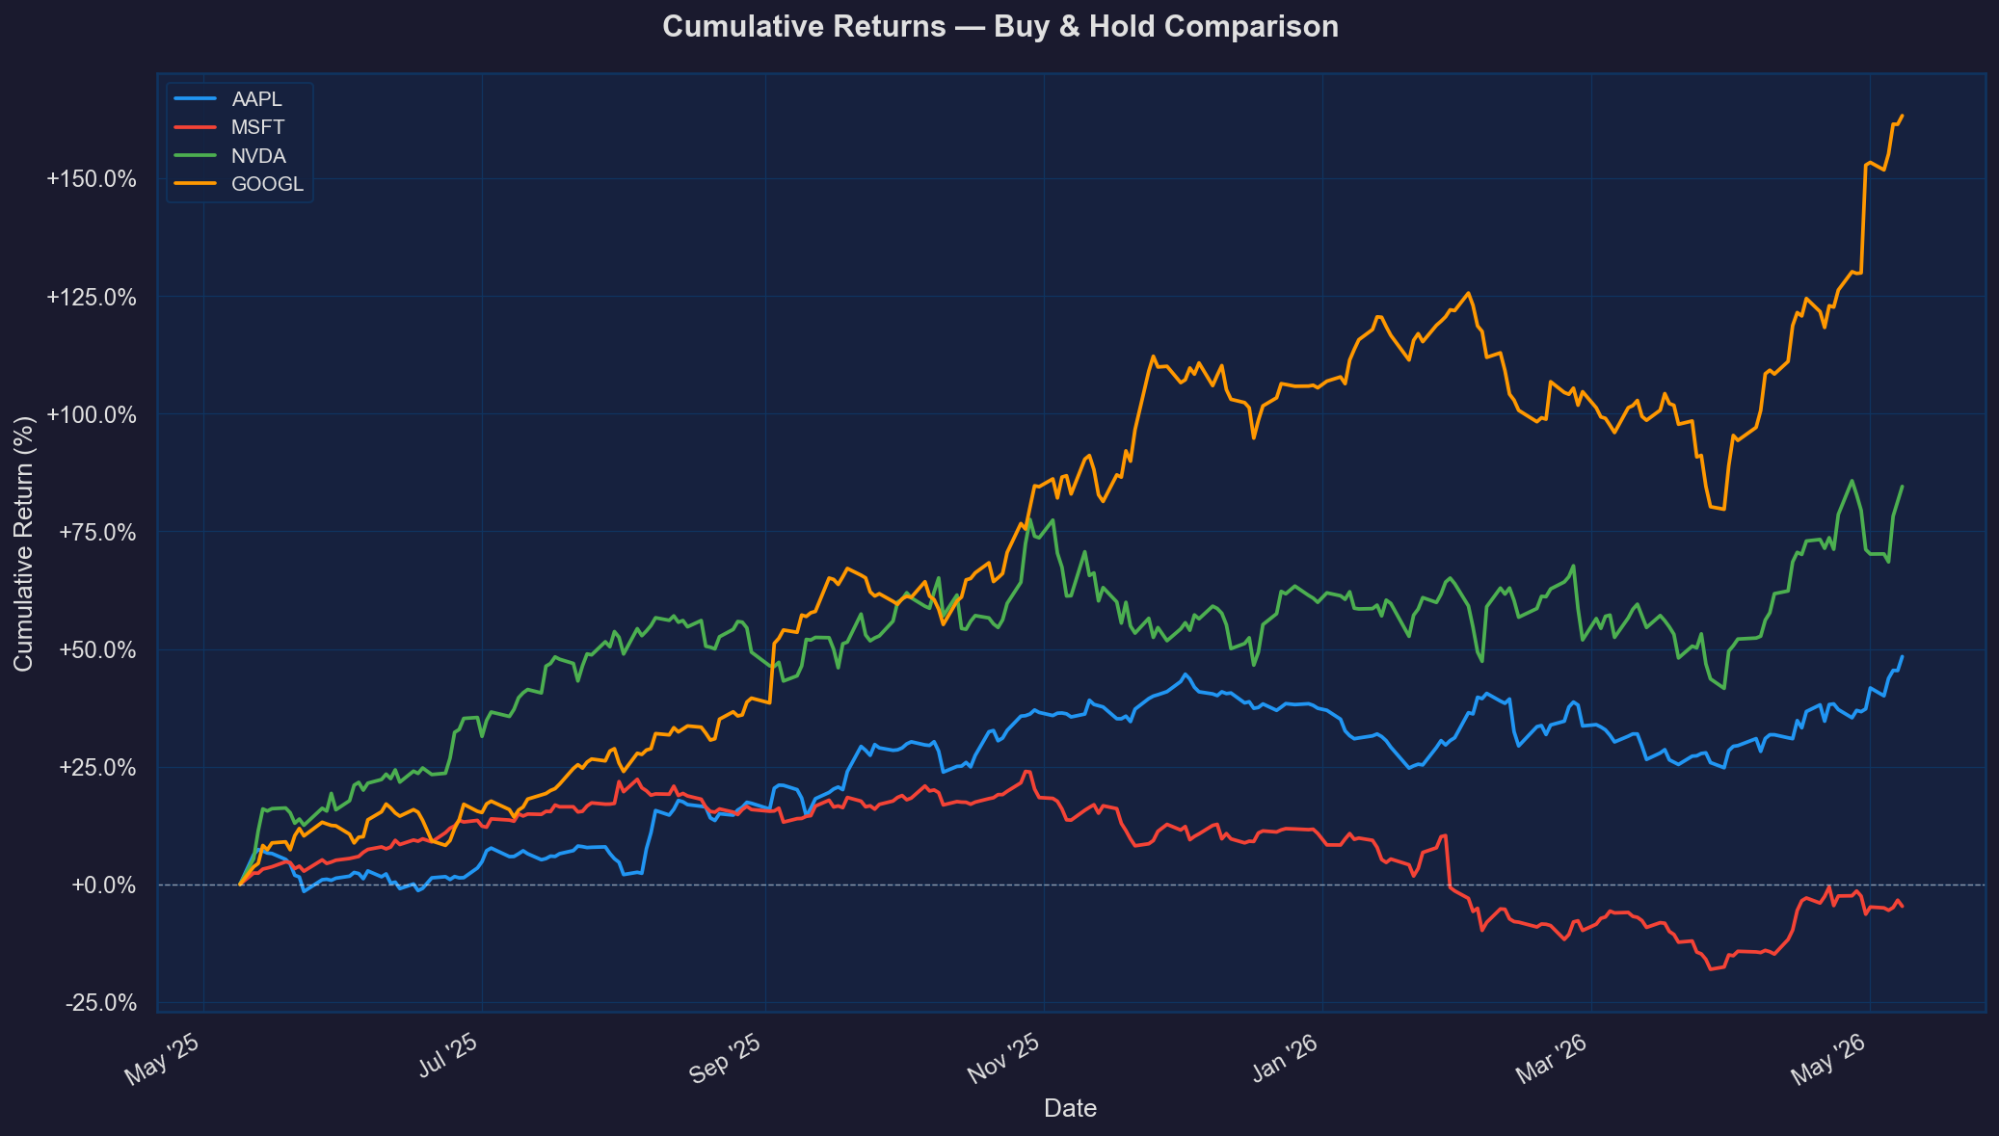
Normalised buy-and-hold cumulative return from the start of the analysis period. Allows direct performance comparison across assets.

1. Company Overview
Apple Inc. (AAPL)
Apple's core business model revolves around designing, manufacturing, and marketing consumer electronics, with key revenue segments including iPhones, Macs, iPads, wearables, and accessories. As a dominant player in the technology industry, Apple maintains a strong market position. Recent strategic developments include a preliminary chip-making agreement with Intel, which could enhance Apple's supply chain and reduce dependence on external manufacturers.

Microsoft Corporation (MSFT)
Microsoft's core business model focuses on developing and supporting software, services, devices, and solutions. The company operates through several segments, including Productivity and Business Processes, with key revenue streams from Microsoft 365 commercial and enterprise mobility. As a challenger in the AI-driven landscape, Microsoft aims to strengthen its position through strategic partnerships and investments. Recent news highlights include the announcement of layoffs by Cloudflare and Coinbase, which might impact Microsoft's own AI-driven initiatives.

NVIDIA Corporation (NVDA)
NVIDIA operates as a data center scale AI infrastructure company, with its core business model centered around providing accelerated computing and networking platforms, AI solutions, and automotive platforms. As a dominant player in the semiconductor industry, NVIDIA maintains a strong market position. Recent strategic developments include a massive multi-year partnership with Corning, which could drive growth in NVIDIA's optical specialist segment.

Alphabet Inc. (GOOGL)
Alphabet's core business model encompasses various products and platforms, including ads, Android, Chrome, devices, and Google Cloud. The company operates through several segments, with key revenue streams from Google Services and Google Cloud. As a dominant player in the internet content and information industry, Alphabet maintains a strong market position. Recent news highlights include the strengthening of Google Cloud's outlook, which led to a price target increase by Mizuho.

2. Trend & Price Analysis
Apple Inc. (AAPL)
The current price of $293.32 is 0.0% away from the 52-week high and 50.6% away from the 52-week low. With a period return of +48.39% and a cumulative return of +48.39%, AAPL ranks second among its peers. The MA7 ($282.97) is above the MA30 ($267.24), indicating a bullish trend direction and momentum signal. The best single-day move was +6.31%, while the worst was -5.00%, indicating moderate event risk.

Microsoft Corporation (MSFT)
The current price of $415.12 is -23.2% away from the 52-week high and 16.5% away from the 52-week low. With a period return of -4.66% and a cumulative return of -4.66%, MSFT ranks last among its peers. The MA7 ($413.87) is above the MA30 ($400.50), indicating a bullish trend direction and momentum signal. The best single-day move was +4.61%, while the worst was -9.99%, indicating higher event risk.

NVIDIA Corporation (NVDA)
The current price of $215.20 is -0.7% away from the 52-week high and 84.6% away from the 52-week low. With a period return of +84.53% and a cumulative return of +84.53%, NVDA ranks first among its peers. The MA7 ($203.93) is above the MA30 ($194.47), indicating a bullish trend direction and momentum signal. The best single-day move was +7.87%, while the worst was -5.46%, indicating moderate event risk.

Alphabet Inc. (GOOGL)
The current price of $400.80 is 0.0% away from the 52-week high and 163.1% away from the 52-week low. With a period return of +163.30% and a cumulative return of +163.30%, GOOGL ranks first among its peers in terms of cumulative return. The MA7 ($391.29) is above the MA30 ($337.92), indicating a bullish trend direction and momentum signal. The best single-day move was +9.96%, while the worst was -3.85%, indicating lower event risk.

3. Return Distribution & Risk-Adjusted Performance
Apple Inc. (AAPL)
The mean daily return is +0.1687%, which annualizes to +43.1%. The skewness of 0.540 indicates a slightly skewed distribution toward gains. The kurtosis of 2.210 suggests a relatively normal distribution with moderate fat-tail risk. The Sharpe ratio of 1.819 indicates strong risk-adjusted performance.

Microsoft Corporation (MSFT)
The mean daily return is -0.0078%, which annualizes to -2.0%. The skewness of -1.257 indicates a skewed distribution toward losses. The kurtosis of 8.187 suggests a leptokurtic distribution with high fat-tail risk. The Sharpe ratio of -0.083 indicates weak risk-adjusted performance.

NVIDIA Corporation (NVDA)
The mean daily return is +0.2685%, which annualizes to +69.2%. The skewness of 0.140 indicates a relatively symmetrical distribution. The kurtosis of 0.526 suggests a platykurtic distribution with low fat-tail risk. The Sharpe ratio of 1.974 indicates strong risk-adjusted performance.

Alphabet Inc. (GOOGL)
The mean daily return is +0.4043%, which annualizes to +104.3%. The skewness of 1.203 indicates a skewed distribution toward gains. The kurtosis of 4.462 suggests a leptokurtic distribution with moderate fat-tail risk. The Sharpe ratio of 3.514 indicates exceptional risk-adjusted performance.

4. Risk Commentary
Ranking the assets by annualized volatility, we have:
- NVDA (34.27%)
- GOOGL (28.99%)
- AAPL (23.37%)
- MSFT (23.68%)

Comparing 30-day rolling volatility to annualized volatility, we see that near-term risk is expanding for NVDA and GOOGL, while contracting for AAPL and MSFT.

Macro factors:
- Gold's +41.52% period change and high annualized volatility (27.1%) may indicate inflationary pressures.
- Oil's +56.37% period change and high annualized volatility (49.5%) may indicate supply chain disruptions.
- The USD/EUR's +4.28% period change and moderate annualized volatility (6.8%) may indicate currency fluctuations.

The correlation structure suggests that a multi-asset portfolio would benefit from diversification, as the pairwise correlations are relatively low (range: +0.110 to +0.404).

5. News Sentiment & Narrative Analysis
Apple Inc. (AAPL)
The overall sentiment is bullish, driven by the preliminary chip-making agreement with Intel. The most market-moving headline is the Intel-Apple chip deal, which could positively impact Apple's stock price. Forward-looking catalysts include the potential for increased supply chain efficiency and reduced dependence on external manufacturers.

Microsoft Corporation (MSFT)
The overall sentiment is mixed, with news about layoffs and AI-driven initiatives. The most market-moving headline is the announcement of layoffs by Cloudflare and Coinbase, which might impact Microsoft's own AI-driven initiatives. Forward-looking catalysts include the potential for increased investment in AI-driven technologies.

NVIDIA Corporation (NVDA)
The overall sentiment is bullish, driven by the massive multi-year partnership with Corning. The most market-moving headline is the partnership announcement, which could drive growth in NVIDIA's optical specialist segment. Forward-looking catalysts include the potential for increased adoption of AI-driven technologies.

Alphabet Inc. (GOOGL)
The overall sentiment is bullish, driven by the strengthening of Google Cloud's outlook. The most market-moving headline is the price target increase by Mizuho, which could positively impact Alphabet's stock price. Forward-looking catalysts include the potential for increased investment in cloud computing and AI-driven technologies.

6. Cross-Asset Comparison
Ranking the assets by risk-adjusted return (Sharpe ratio), we have:
- GOOGL (3.514)
- NVDA (1.974)
- AAPL (1.819)
- MSFT (-0.083)

The most diversified pair is AAPL and MSFT, with a correlation of +0.151.

Valuation comparison:
- P/E: NVDA (43.8) is the richest, while MSFT (24.8) is the cheapest.
- P/B: AAPL (40.40) is the richest, while MSFT (7.44) is the cheapest.
- Beta: NVDA (2.24) is the most volatile, while AAPL (1.06) is the least volatile.

7. Investment Perspective & Key Metrics to Watch
The most attractive asset is Alphabet Inc. (GOOGL), given its exceptional risk-adjusted performance, strong market position, and bullish sentiment. The key metric to watch for GOOGL is the continued growth of Google Cloud, which could drive further upside in the stock price.

The most risky asset is Microsoft Corporation (MSFT), given its weak risk-adjusted performance, high fat-tail risk, and mixed sentiment. The key metric to watch for MSFT is the impact of layoffs and AI-driven initiatives on its bottom line, which could negatively impact the stock price.

If an investor could only pick two assets, we recommend GOOGL and NVDA, given their strong risk-adjusted performance, bullish sentiment, and growth potential in the AI-driven landscape. Key metrics to watch include the continued growth of Google Cloud and the adoption of AI-driven technologies in the semiconductor industry.

