5. https://www.figma.com/community/plugin/1016243269511956141

figma -> React native

6. Not free  
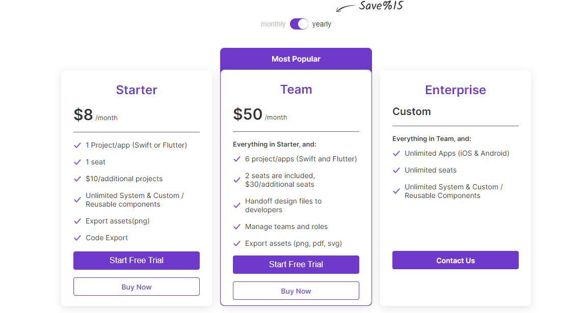

Nhận thấy dhiwise tách component khá tốt