 | FPT ACADEMY INTERNATIONAL  FPT – APTECH COMPUTER EDUCATION

Center Name: ACE-HCMC-2-FPT.
Address: 590 Cach Mang Thang 8 Street, District 3, Ho Chi Minh City, Vietnam.



Decos Store
Manager System

Design Document

Faculty: |  | Ms. Le Mong Thuy
Batch No: |  | T1.2109.M1
Group No: |  | 2
Students: |  | Fullname | Roll No.
 | 1. | Nguyễn Hoàng Minh | Student1287968
 | 2. | Lê Thanh Sang | Student1334010
 | 3. | Nguyễn Phạm Thị Cẩm Tú | Student1335967
 | 4. | Đặng Quốc Thái | Student1339031
 | 5. | Lê Thị Minh Anh | Student1333965

June, 2022

Mục Lục

Table of Contents
June, 2022 0
REVIEW 1 2
REVIEW 2 3
Group Leader Faculty 16
REVIEW 3 16
Group Leader Faculty 27

REVIEW 1
I. Introduction:
- - In an increasingly developed society, advanced technology partly meets the indispensable needs of our country's current sales management. Faced with that situation, our team has developed sales management software, specifically the software "Business management of apparel for stores" to help business owners manage products, employees, and customers. staff as well as take care of customers in a better way.
- With our software, business owners can easily assess the number of products available at the store. Business owners will have full control over employees, customers, goods and products. Staff will quickly advise on choosing clothes for customers to help save maximum time. In addition, the software is integrated with the invoice directly on the application, bringing optimization and professionalization not only for the seller but also for the buyer.
II. Situation
- - So that business owners can manage employees without necessarily being at the store. Business owners will be able to track sales staff information, number of products sold, revenue through the software.
- - Business owners easily manage employees with items to add, edit and block employees (If that employee violates the terms seriously).
- - When the customer comes to the store, the staff will advise to choose the right product and then add it to the cart after issuing the invoice, the customer will pay and save customer information including name and phone number.

III. Solution:

- Store management system (SMS) is a centralized system that allows business owners to manage employees, retrieve and process information related to products, goods and store invoices. .

- From the store, the customer through the staff can place an order into the system and can retrieve product information when needed.

- This information will be managed by the business owner for checking sales revenue.

- After each successful transaction, customer information will be stored in the system for customer care. Business owners can log into the system to clearly check the output of products

. System Functions:
- Login, Logout: Allows store managers and staff to access the store's storage system. Managers and employees are authorized to correspond to different functions of the software.
- Store information about fashion store.
- Store staff information.

- Store customer information.
IV. User roles:
1. All users:
- Login/Logout.
-Change Password.
-View, change profile.
2. Admin:
- View, add, edit, delete, lock staff information.
- View Revenue.
3. Staff:
- Management Bo Suu Tap (Category): View, add, edit, delete Category.
- Management Products: View, add, edit, delete Products.
- Just View & Edit Orders.
- Management customer: View, add, edit, lock customer information.
- Management News: View, add, edit, delete News.
- View, add, edit, delete Promotion.
- Management Image: Home Pages (Image slide).
4. Customer:
- Visitors can search products by price, bo suu tap of product
- Visitors can see products’ introduction before buying
- Registered visitors can add to cart, check out, view order history,
- Register, Login by Google Facebook, Logout.
- View promotion.

V.Limited:
Updating…

VI. Function:
- Login function:
User
Login
Error
notification.
Manager or Staff
Customer
Check information
True
False

- Password change function:
Change
Error notification
Check infomation
True
False
Insert old password/ new password/confirm password.
Update database
- Staff Function
Staff
News
View
Add
Edit
Delete
Database
Order
Products
View
Search
Add
Edit
Delete
Customer
View
Edit
Confirm
View
Edit
Categories
View
Add
Edit
Delete
Slide Image
View
Add
Edit
Delete
- Manager Function
Manager
Database
Staff
Revenue
View
View
Add
Edit

VII.Hardware/Software Requirements
- Hardware
- A minimum computer system that will help you access all the tools in the courses is a Core I3 or better
- 1GB of RAM or better
- HDD 5G free space available or better
- Software
- Operating system: Windows 7 (or higher if possible)
- Visual Studio Code
- MySQL
- Xampp
- Composer
- Task Sheet:
Project Ref. No: 1 |  | Project Title:  Decos Store Management | Date of Preparation of Activity Plan
Sr. No. | Task |  | Actual Start Date | Actual Days | Team Member Names | Status
01 | Introduce |  | 25 June, 2022 | 5 | All Members | Completed
02 | Situation
03 | Solution
04 | System Function
05 | User Roles
07 | Function Diagram
08 | Harfware/ Software Requirement
09 | Task Sheet

 | Prepare By: Group 2 | Approved By: Faculty
Date: | Team Leader  Nguyen Hoang Minh | Ms. Le Mong Thuy

REVIEW 2

USE CASE
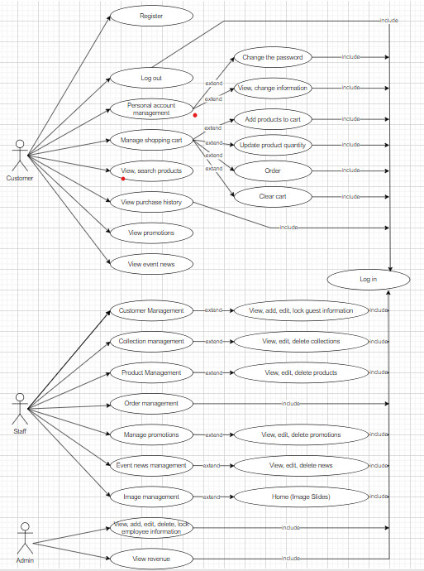

2. DATA FLOW DIAGRAM (DFD)
LEVEL 0
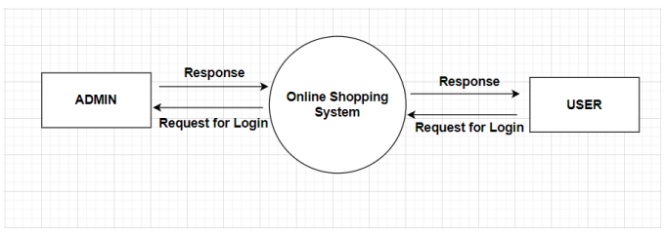

ADMINSIDE LEVEL 1
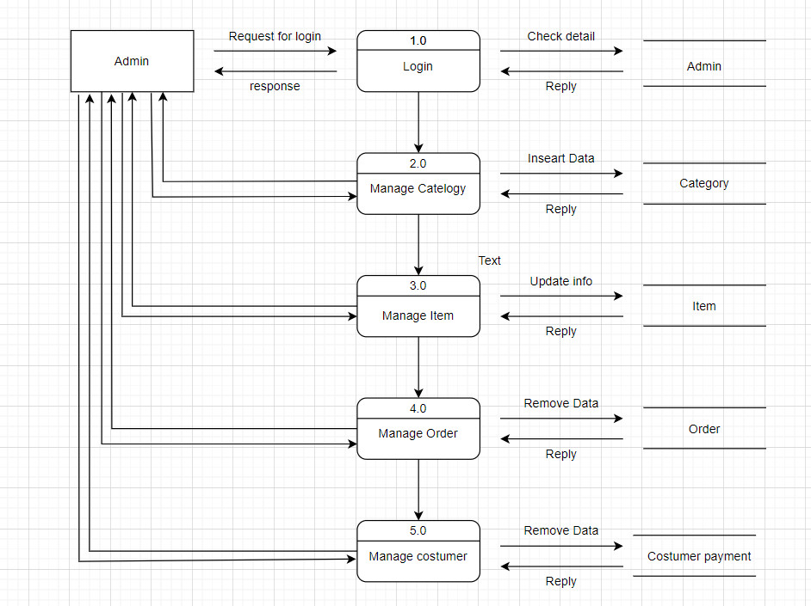
ADMINSIDE LEVEL 2
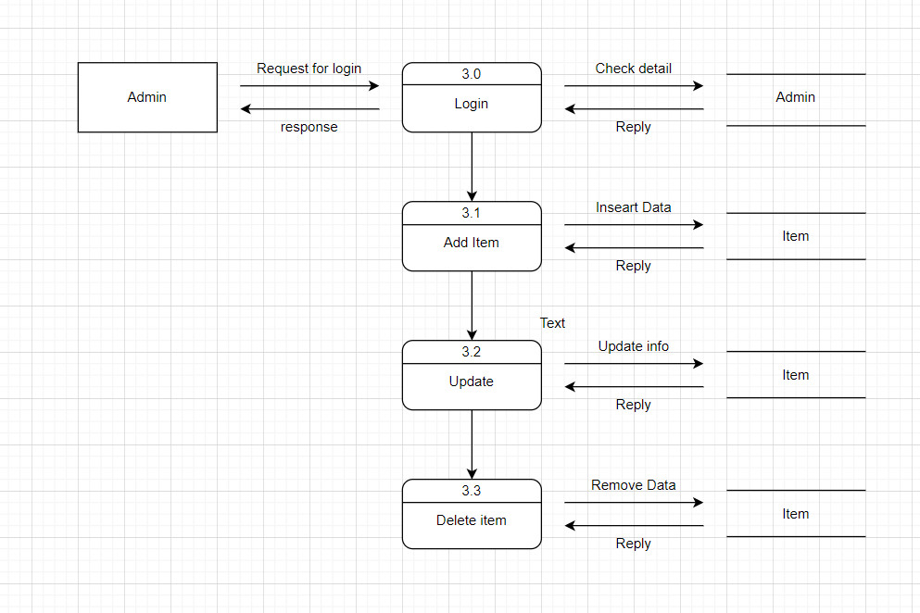
ADMINSIDE LEVEL 3
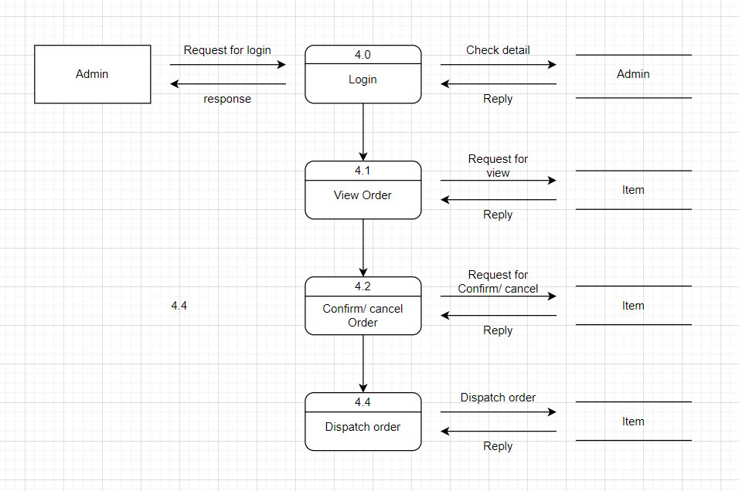
USERSIDE LEVEL 1
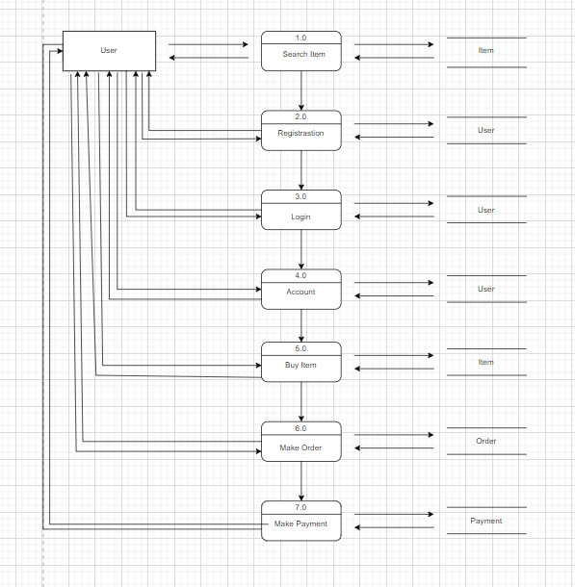

USERSIDE LEVEL 2
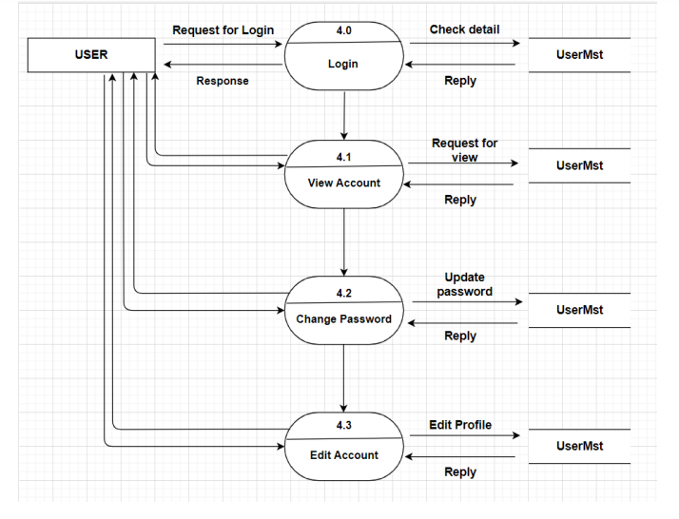
USERSIDE LEVEL 3
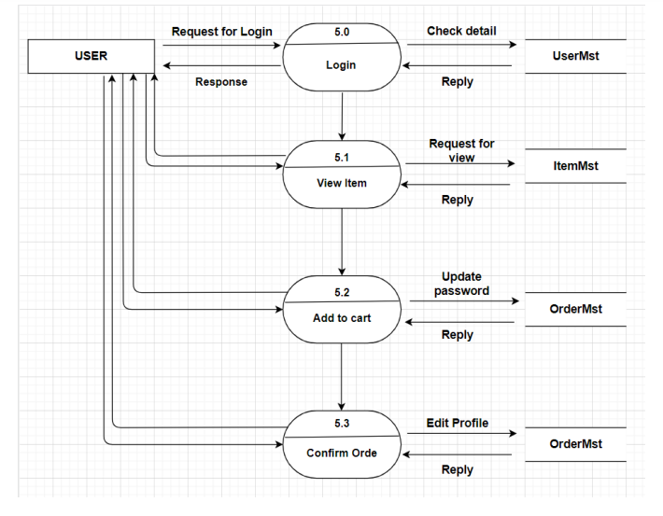

ENTITY AND PROPERTIES
nguoi_dung
Column Name | Data Type | Description
ID_THE_LOAI | int | Auto_increment, primary key
PHAN_QUYEN | varchar | Admin, staff or customer login rights
HO_TEN | varchar | Name of user
EMAIL | varchar | Email of user
MAT_KHAU | varchar | Password used to login
DIEN_THOAI | varchar | Phone used for communication
HINH_ANH | varchar | Image of user
DIA_CHI | varchar | address used for delivery
TRANG_THAI | varchar | Blocked or active
NGAY_TAO | datetime | the date the user was created
NGAY_CAP_NHAT | datetime | the date the user was updated

the_loai
Column Name | Data Type | Description
ID_THE_LOAI | int | Auto_increment, primary key
TEN_TL | varchar | Name of category
MO_TA | varchar | Description of category
HINH_ANH_TL | varchar | Image of category
TRANG_THAI | varchar | Show or hide
NGAY_TAO | datetime | the date the category was created
NGAY_CAP_NHAT | datetime | the date the category was updated

san_pham
Column Name | Data Type | Description
ID_SAN_PHAM | int | Auto_increment, primary key
ID_THE_LOAI | int | Foregin key of table ‘the_loai’
MO_TA | varchar | Description of product
MO_TA_NGAN | varchar | Sort description of product
TEN_SP | varchar | Name of product
GIA | varchar | Price of product
HINH_ANH | varchar | Image of product
DAC_SAC | boolean | Featured or not featured
MOI | boolean | New or old product
TRANG_THAI | varchar | in stock or out of stock
NGAY_TAO | datetime | the date the product was created
NGAY_CAP_NHAT | datetime | the date the product was updated

tin_tuc
Column Name | Data Type | Description
ID_TIN_TUC | int | Auto_increment, primary key
ID_THE_LOAI | int | Foregin key of table ‘the_loai’
TIEU_DE | varchar | Name of news
NOI_DUNG | text | Description of news
TRANG_THAI | varchar | Show or hide
NGAY_TAO | datetime | the date the news was created
NGAY_CAP_NHAT | datetime | the date the news was updated

hinh_anh_slide
Column Name | Data Type | Description
ID_SLIDE | int | Auto_increment, primary key
HINH_ANH | varchar | Image of slide
NGAY_TAO | datetime | the date the image of slide was created
NGAY_CAP_NHAT | datetime | the date the image of slide was updated

hinh_anh_san_pham
Column Name | Data Type | Description
ID_HINH_ANH | int | Auto_increment, primary key
ID_SAN_PHAM | varchar | Foregin key of table ‘san_pham’
HINH_ANH | varchar | Images of product
NGAY_TAO | datetime | the date the images of product was created
NGAY_CAP_NHAT | datetime | the date the images of product was updated

don_hang
Column Name | Data Type | Description
ID_DON_HANG | int | Auto_increment, primary key
ID_NGUOI_DUNG | int | Foregin key of table ‘nguoi_dung’
TEN_NGUOI_NHAN | varchar | Name of customer
DIA_CHI_GIAO | varchar | Address of customer
DIEN_THOAI_NGUOI_NHAN | varchar | Phone of customer
PHUONG_THUC_THANH_TOAN | varchar | payment method of the order
PHI_VAN_CHUYEN | float | shipping cost of the order
GHI_CHU | text | Note of customer
TONG_CONG | float | Total money
TRANG_THAI | varchar | delivering or delivered
NGAY_TAO | datetime | the date the order was created
NGAY_CAP_NHAT | datetime | the date the order was updated

chi_tiet_don_hang
Column Name | Data Type | Description
ID_CHI_TIET_DON_HANG | int | Auto_increment, primary key
ID_DON_HANG | int | Foregin key of table ‘don_hang’
ID_SAN_PHAM | int | Foregin key of table ‘san_pham’
SO_LUONG | int | Quantity of product
TONG_CONG | float | Total price
NGAY_TAO | datetime | the date the details of order was created
NGAY_CAP_NHAT | datetime | the date the details of order was updated

Review 2 - Task Sheet
Project Ref. No.: Project title: Decos Store |  | Activity Plan Prepared by: Thuy |  | Date of Preparation of Activity Plan
Sr.No. | Task | Start Date | End Date | Actual day | Member’s Name | status
1 | Use-Case | 4 July 2022 | 10 July 2022 | 6 | All Memeber | Complete
2 | Data Flow Diagram
3 | Entity Properties

Group Leader Faculty

Ms. Le Mong Thuy Nguyen Hoang Minh

REVIEW 3
      - SITE MAP

CUSTOMER’S SITE MAP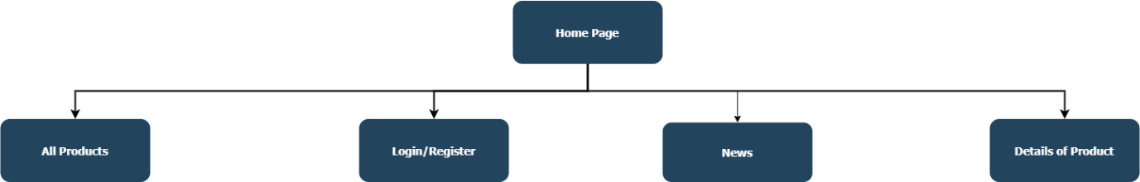

STAFF’S SITE MAP
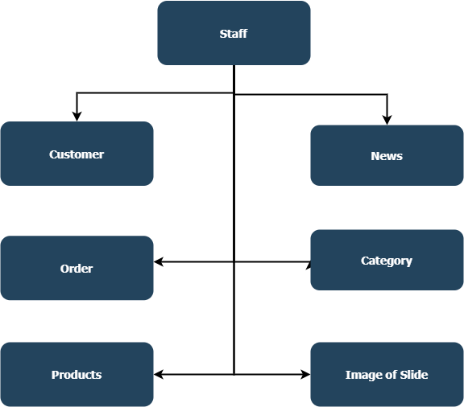

ADMIN’S SITE MAP
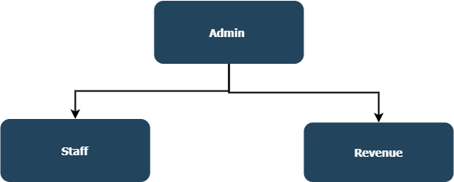

2.DECOS STORE SCREENSHOT
CUSTOMER PAGE
HOME PAGE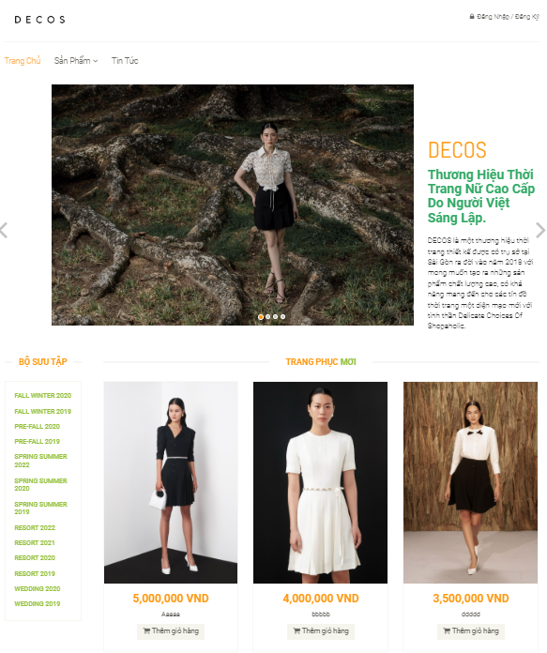
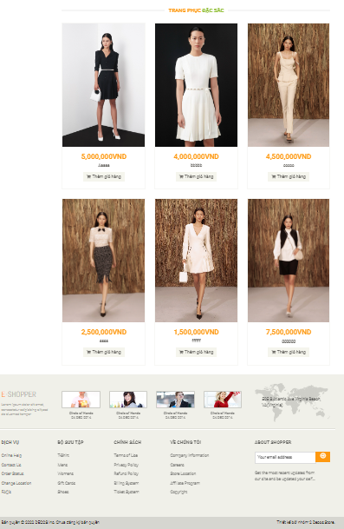
LOGIN / REGISTER PAGE
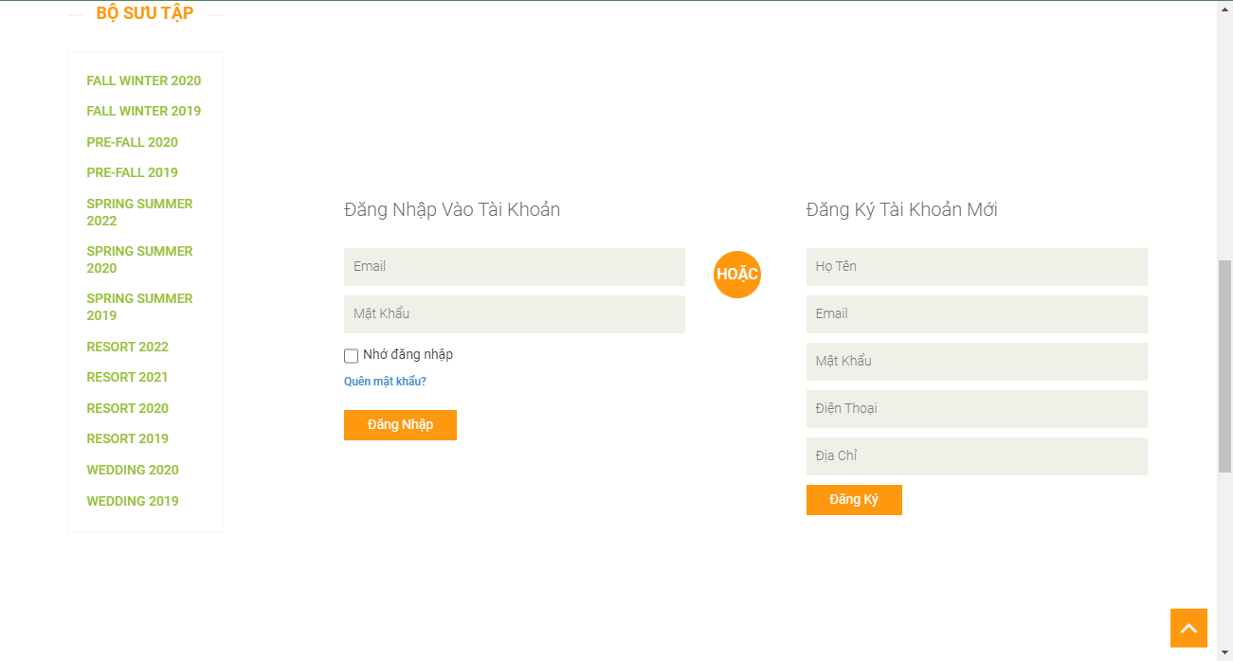
PROFILE PAGE

CHANGE PROFILE PAGE

PRODUCT PAGE
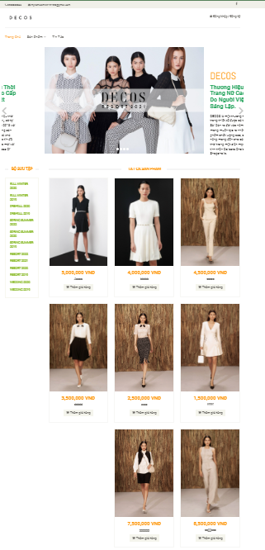

PRODUCT DETAILS PAGE
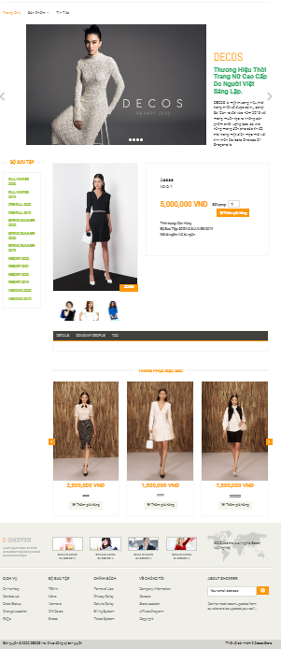
ORDER PAGE
ORDER HISTORY PAGE
CHANGE PASSWORD PAGE
NEWS PAGE
NEWS DETAILS PAGE
CART & CHECK-OUT PAGE
FORGET PASSWORD PAGE

STAFF PAGE
MANAGEMENT PROFILE PAGE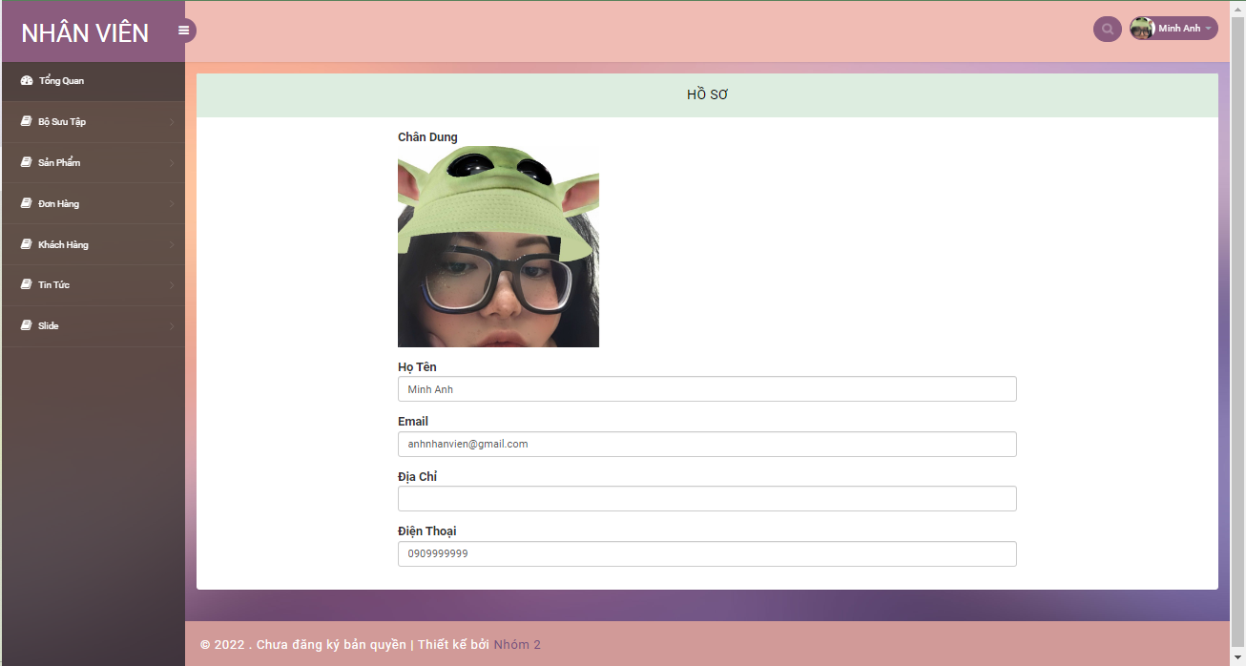
MANAGEMENT CUSTOMER PAGE
MANAGEMENT PRODUCT PAGE
MANAGEMENT ORDER PAGE
MANAGEMENT CATEGORY PAGE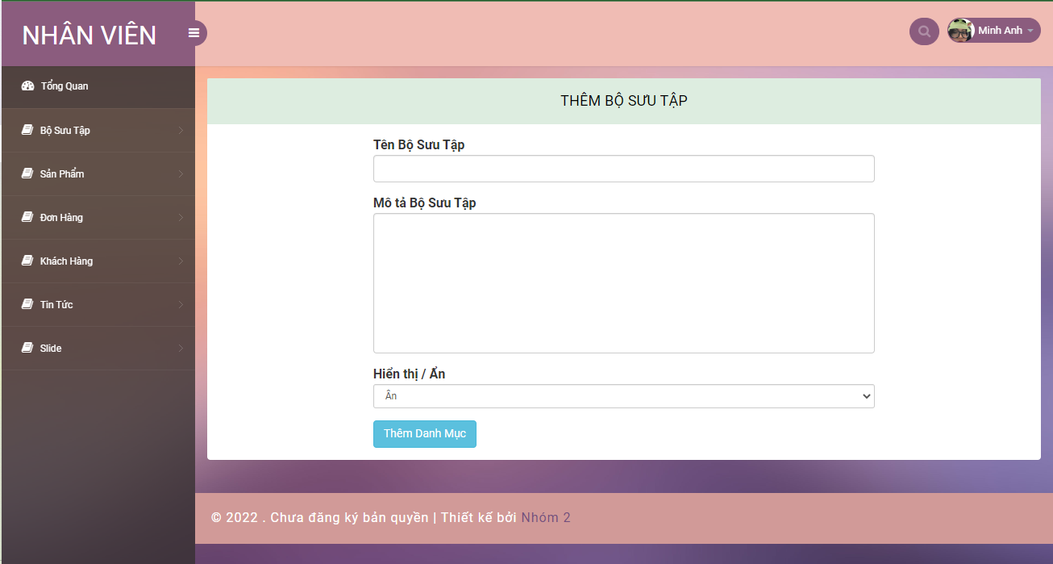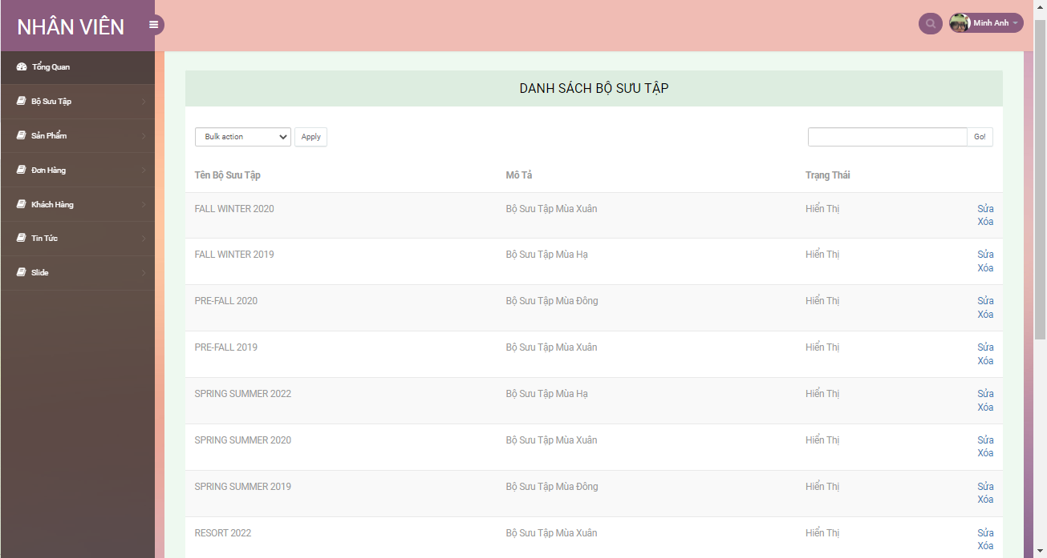

ADMIN PAGE
CHANGE PASSWORD PAGE

MANAGEMENT PROFILE PAGE
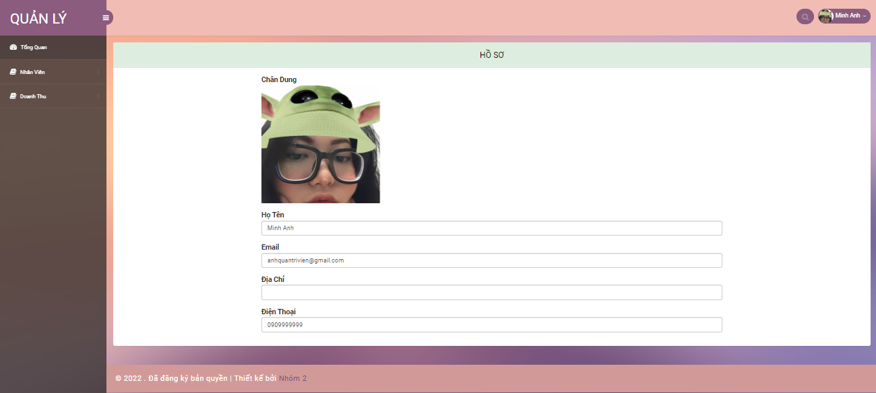
MANAGEMENT STAFF PAGE
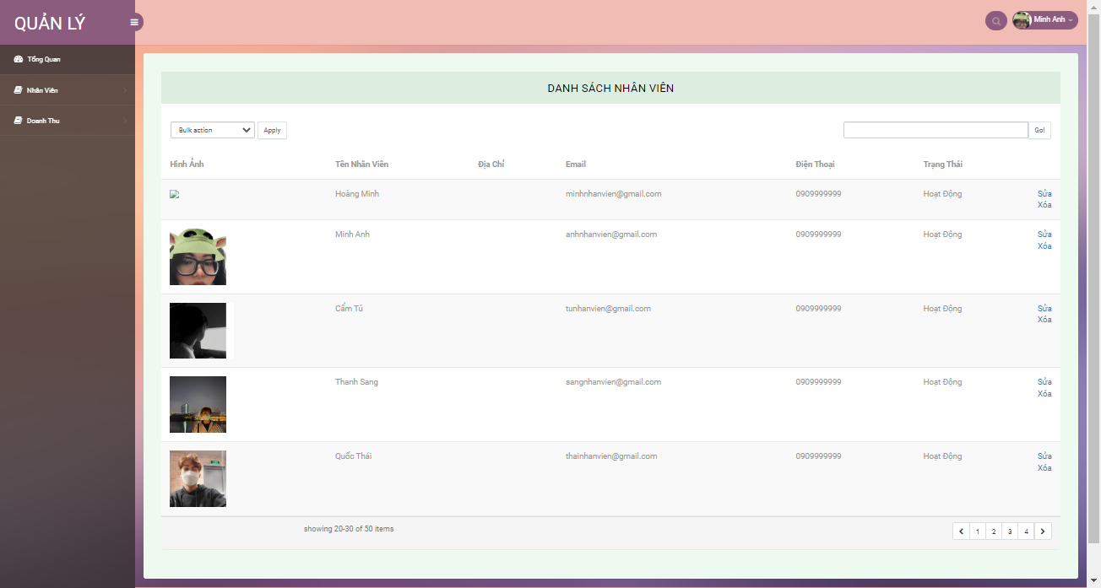

Review 3 - Task Sheet
Project Ref. No.: Project title: Decos Store |  | Activity Plan Prepared by: Thuy |  | Date of Preparation of Activity Plan
Sr.No. | Task | Start Date | End Date | Actual day | Member’s Name | status
1 | All Customer Page | 11 July 2022 | 16 July 2022 | 5 | All Memeber | Complete
2 | All Admin Page
3 | All Staff Page

Group Leader Faculty

Nguyen Hoang Minh Ms. Le Mong Thuy

