

**CAPSTONE PROJECT REPORT**

**Report 3 – Software Requirement Specification**

– Da Nang, October 2023–

**Table of Contents**

**I. Record of Changes 4**

**II. Software Requirement Specification 5**

1. Product Overview 5

2. User Requirements 6

2.1 Actors 6

2.2 Use Cases 7

2.2.1 Diagram(s) 7

2.2.2 Descriptions 8

2.2.3 Use case details 10

01: Sign Up 10

02: Sign In 14

03: Edit Profile 17

04: Create Group 22

05: Update Group 25

06. Delete Group 28

07. Create Post 30

08. Delete Post 31

09. View Post 32

10. Search Group 32

11. Search Post 33

12. Edit Post 34

13. View Hot Post 35

14. Report Post 36

15. Comment 37

16. Edit Comment 38

17. Delete Comment 39

18. Report Comment 40

19. Like Post/Comment 41

20. Upload Document 42

21. Download Document 44

22. Rate Document 45

23. Edit Document 46

24. Delete Document 47

25. View Document 48

26. Join In Group 49

27. Exit Group 50

28. Buy Coins 50

29.Donate Coins 52

30. Exchange Coins To Money 53

30. Like Post/Comment 54

31. Kick Member Out 56

32. View All Accounts 57

33. Delete Accounts 57

34. Lock/Open Accounts 59

35. View Report 62

36. Accept/Reject Document 63

37. View All Groups 64

38. Notify Group 65

39. Delete Group 66

40. View Charts 67

41. Do Survey 68

3. Functional Requirements 70

3.1 System Functional Overview 70

3.1.1 Screens Flow 70

3.1.2 Screen Descriptions 70

3.1.3 Screen Authorization 73

3.1.4 Non-Screen Functions 76

3.1.5 Entity Relationship Diagram 76

4. Non-Functional Requirements 79

4.1 External Interfaces 80

4.2 Quality Attributes 80

5. Requirement Appendix 81

5.1 Business Rules 81

5.2 Common Requirements 81

5.3 Application Messages List 82

5.4 Other Requirements… 82

# I. Record of Changes

| **Date** | **A* M, D** | **In charge** | **Change Description** |
| --- | --- | --- | --- |
| 20/8/2023 | M | Java spring spring boot version | Change spring boot version from 3.2.0 to 3.0.11 |
| 10/9/2023 | M | Upload Image | Change from upload image using spring boot storage to use CLOUDinary |
| 20/9/2023 | A | Use Case Exchange coins | Add use case exchange coins to money |
|  |  |  |  |
|  |  |  |  |
|  |  |  |  |

*A - Added M - Modified D - Deleted

# II. Software Requirement Specification

## 1. Product Overview

Camp-Scholar is an academic exchange platform that provides an online environment exclusively for the academic community. This platform allows users to:

- Exchange academic information: Users can post articles to share academic knowledge or ask questions about academic issues they are interested in.

- Search for academic information: If you need to search for specific information or academic documents, you can access the website to search for information or previous discussions.

- Engage in academic discussions: The platform provides a space for discussing academic issues and exchanging opinions with the community.

- Buy and sell academic materials: Users can buy and sell academic materials on this platform using the website's own currency unit. Money can be deposited into accounts or exchanged between users.

The main goal of the project is to create a diverse academic environment and support the Vietnamese language, promoting the sharing and development of knowledge within the academic community. Camp-Scholar is committed to providing an effective and user-friendly platform for anyone interested in the academic field.

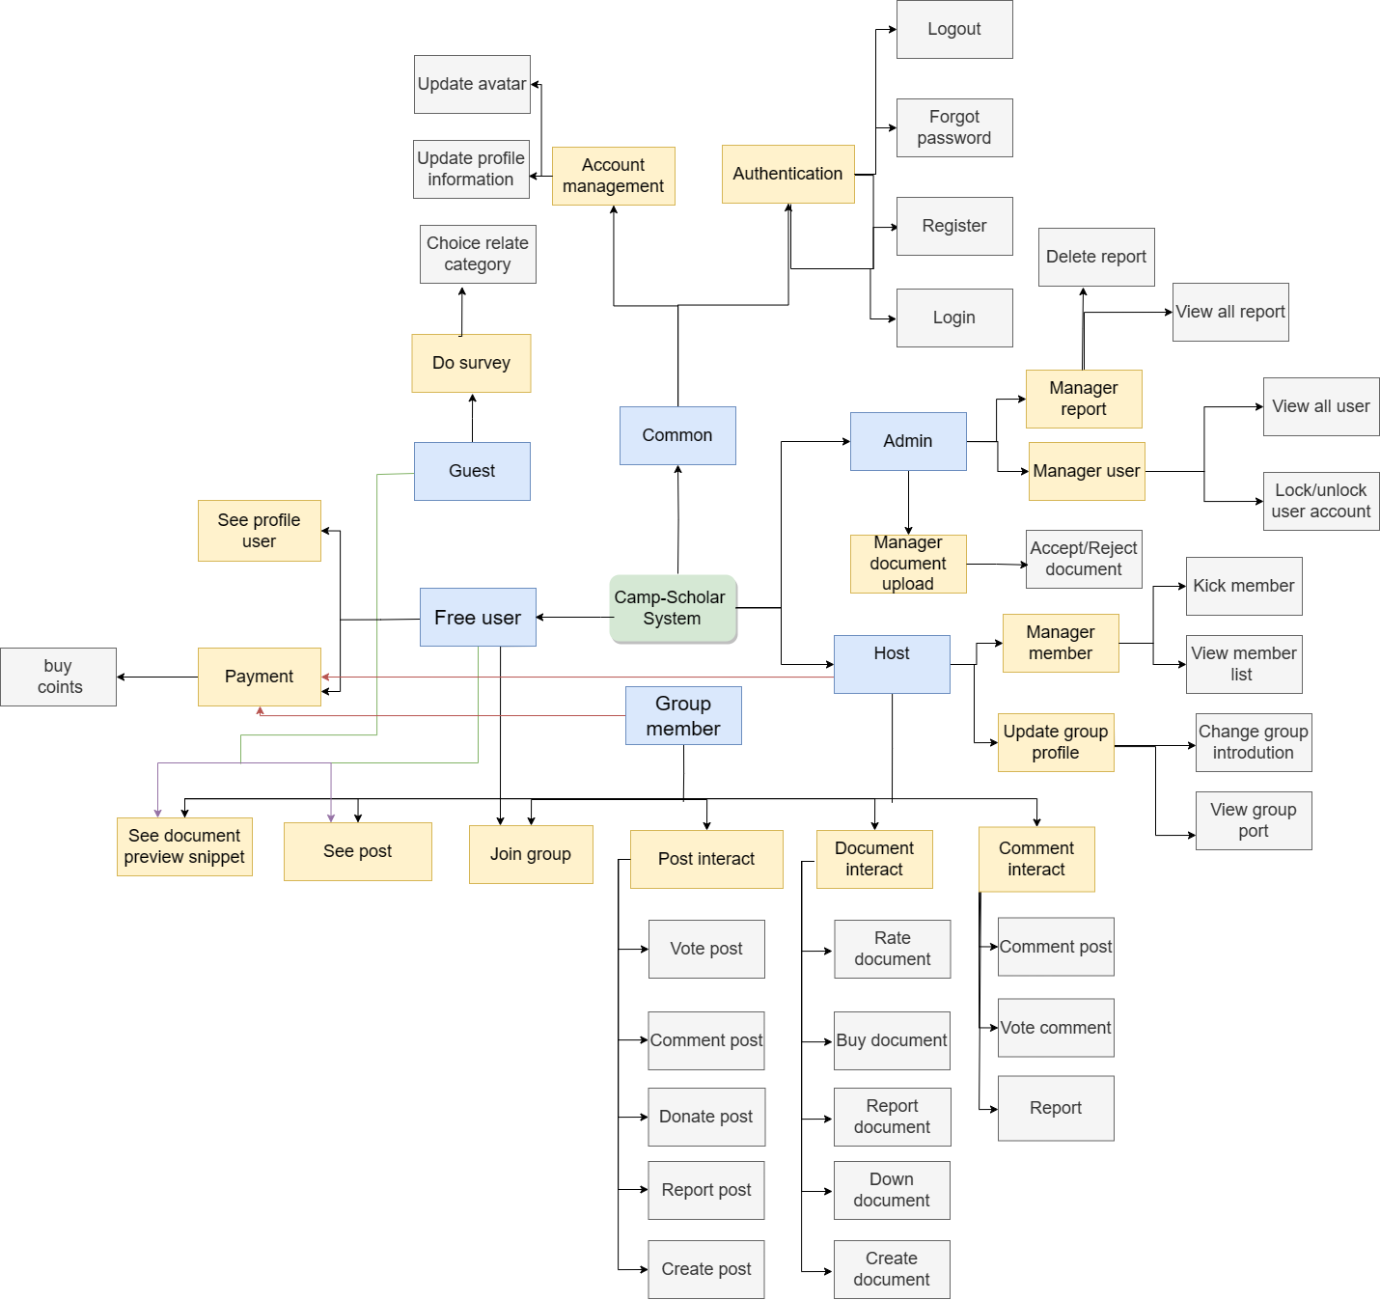

[View full](https://drive.google.com/file/d/1-szs9VJHKPdsmOYCmMHaKY4v41SFqyf2/view?usp=sharing)

## 2. User Requirements

### 2.1 Actors

| **#** | **Actor** | **Description** |
| --- | --- | --- |
| 1 | Student, Worker | Those who need to find a place where they can post questions and answers or discuss, find extra exercises to practise, read academic articles to improve their knowledge, and buy and sell cheap academic materials. |
| 2 | Expert | Those who post their academic reports, documents to reach many readers and earn extra income. |
| 3 | Group Host | Those who create a group and manage the members and activities of that group. |
| 4 | System Admin | Those who manage groups, manage users, manage reports on bad, toxic, and inappropriate content to improve the community better. |

### 2.2 Use Cases

#### 2.2.1 Diagram(s)

**2.2.1.1 Use Case for Admin**

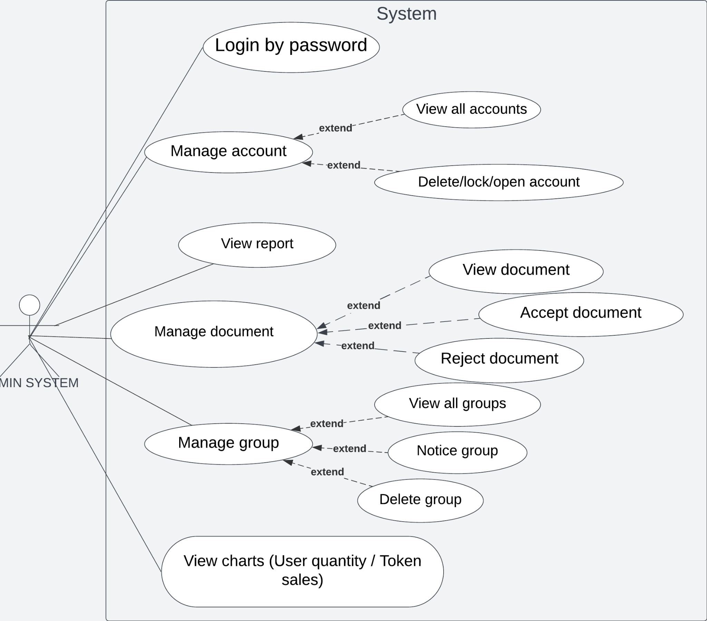

**2.2.1.2 Use Case for User**

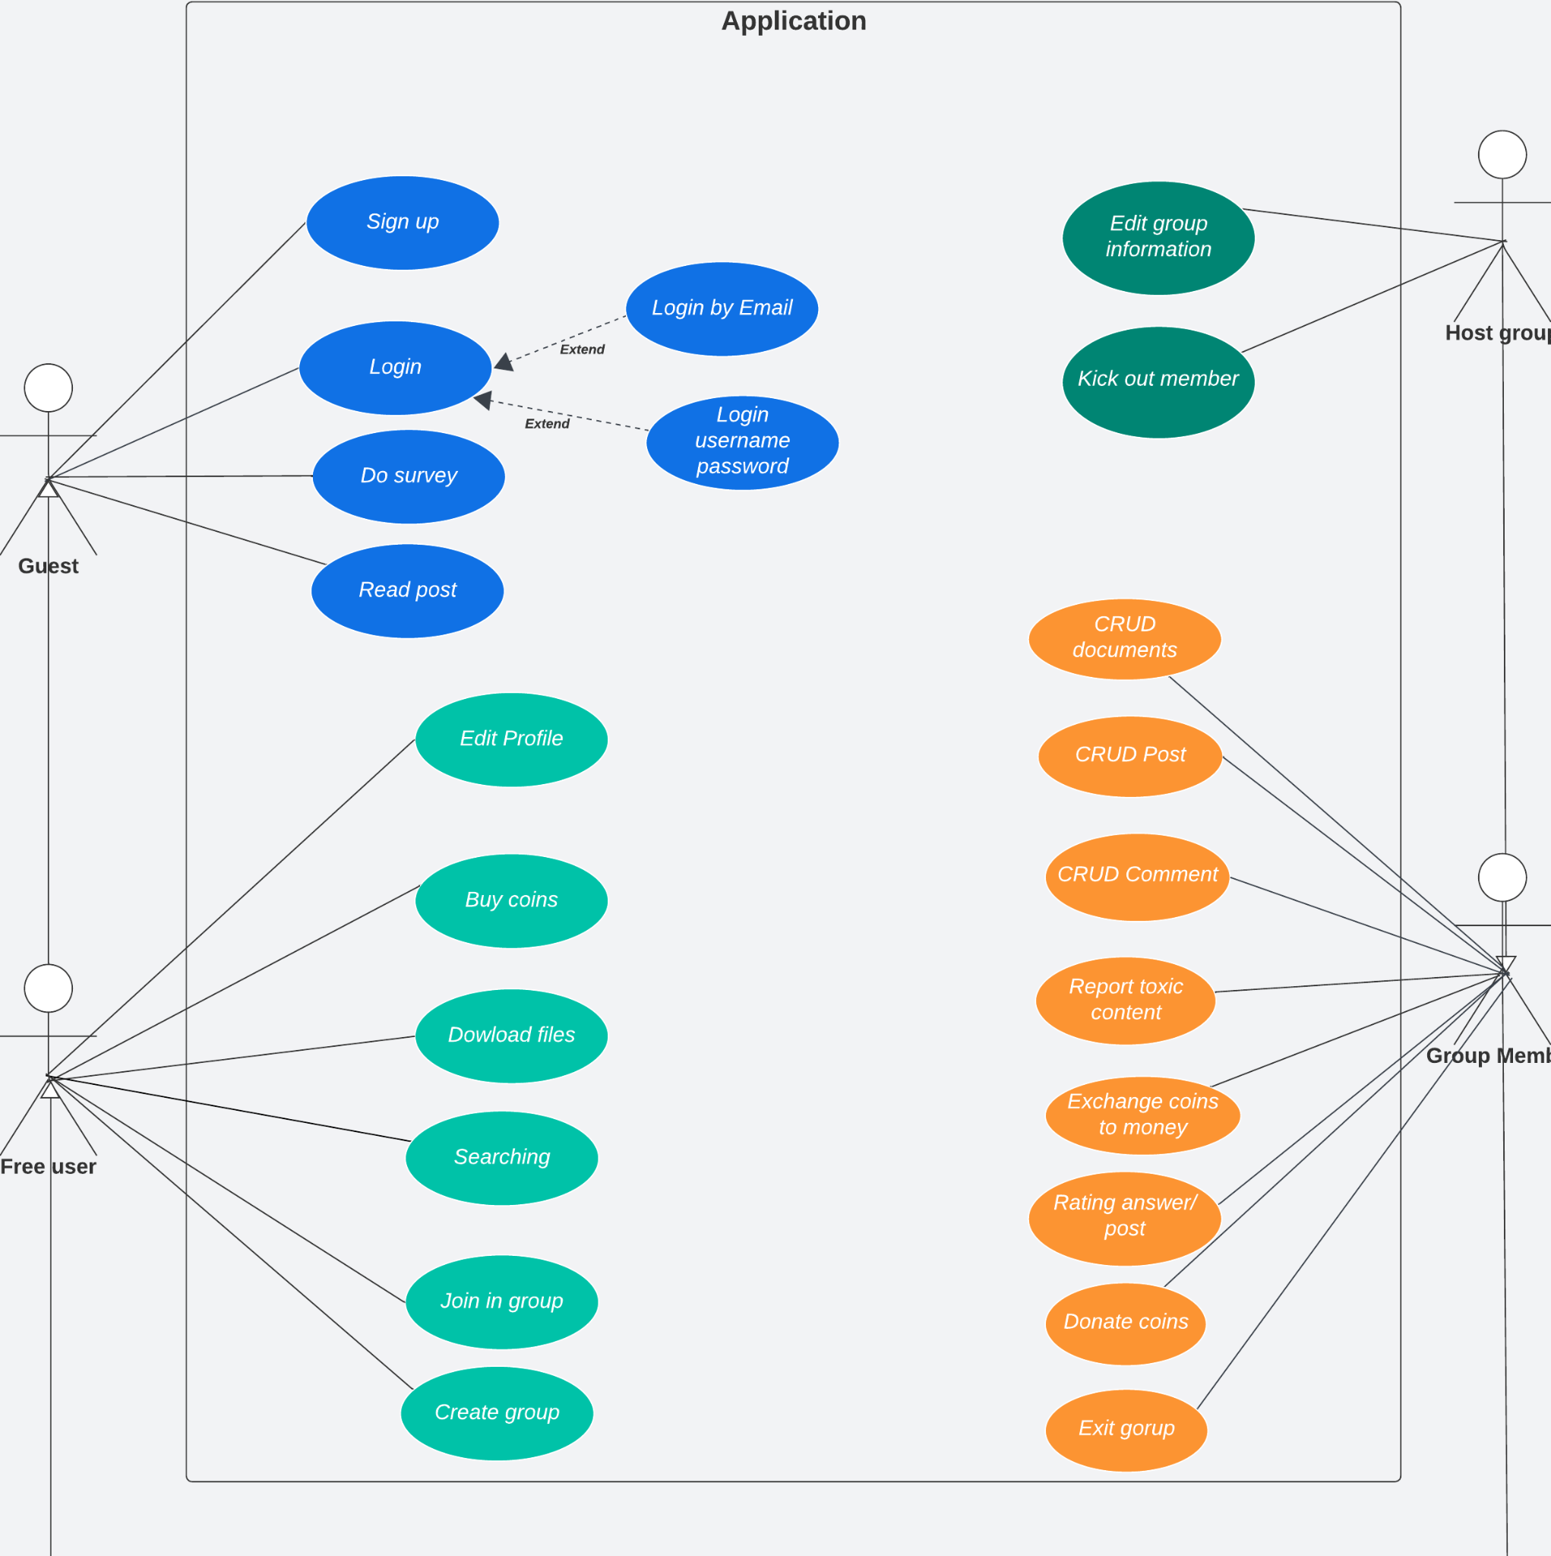

#### 2.2.2 Descriptions

| **ID** | **Use Case** | **Actors** | **Use Case Description** |
| --- | --- | --- | --- |
| UC-01 | Sign Up | User | The feature allows user to sign up the system |
| UC-02 | Sign In | User/Admin | The feature allows user to login the system |
| UC-03 | Edit Profile | User | The feature allows user to change their avatar, username, password, phone number |
| UC-04 | Create Group | User | The feature allows user to create groups |
| UC-05 | Update Group | Host | The feature allows host to update their groups |
| UC-06 | Delete Group (By Host) | Admin | The feature allows admin to delete groups |
| UC-07 | Create Post | User | The feature allows user to create new posts |
| UC-08 | Delete Post | User | The feature allows user to delete their posts |
| UC-09 | View Post | User | The feature allows user to view any posts |
| UC-10 | Search Group | User | The feature allows user to search groups |
| UC-11 | Search Post | User | The feature allows user to search posts by title |
| UC-12 | Edit Post | User | The feature allows user to edit their posts |
| UC-13 | View Hot Post | User | The feature allows user to see all hot posts which have the most comments, and upvotes. |
| UC-14 | Report Post | User | The feature allows user to report any posts |
| UC-15 | Comment | User | The feature allows user to comment posts |
| UC-16 | Edit Comment | User | The feature allows user to edit their comments |
| UC-17 | Delete Comment | User | The feature allows user to delete their comments |
| UC-18 | Report Comment | User | The feature allows user to report any comments |
| UC-19 | Like Post/Comment | User | The feature allows user to like or dislike posts/comments |
| UC-20 | Upload Document | User | The feature allows user to upload their documents onto groups |
| UC-21 | Download Document | User | The feature allows user to download documents |
| UC-22 | Rate Document | User | The feature allows user to rate documents |
| UC-23 | Edit Document | User | The feature allows user to edit their documents’ information |
| UC-24 | Delete Document | User | The feature allows user to delete their document |
| UC-25 | View Document | User | The feature allows user to view any documents |
| UC-26 | Join In Group | User | The feature allows user join in any groups |
| UC-27 | Exit Group | User | The feature allows user exit groups |
| UC-28 | Buy Coins | User | The feature allows user buy coins |
| UC-29 | Donate Coins | User | The feature allows user donate their coins to others |
| UC-30 | Exchange Coins To Money | User | The feature allows user to exchange their coins to money |
| UC-31 | Kick Member Out | Host | The feature allows host to kick members in their own groups out |
| UC-32 | View All Accounts | Admin | The feature allows admin to view the details of all accounts |
| UC-33 | Delete Accounts | Admin | The feature allows admin to delete accounts |
| UC-34 | Lock/Open Accounts | Admin | The feature allows admin to lock or open accounts |
| UC-35 | View Report | Admin | The feature allows admin to view all reports sent to them |
| UC-36 | Accept/Reject Document | Admin | The feature allows admin to accept or reject documents before releasing |
| UC-37 | View All Groups | Admin | The feature allows admin to view the details of all groups |
| UC-38 | Notify Group | Admin | The feature allows admin to notify groups |
| UC-39 | Delete Group (By Admin) | Admin | The feature allows admin to delete groups |
| UC-40 | View Charts | Admin | The feature allows admin to view charts about community’s activities |
| UC-41 | Do Survey | User | The feature allows user to choose their interesting category from a survey popup. |

#### 2.2.3 Use case details

##### 01: Sign Up

| **ID and Name** | **UC-01: Sign Up** | | |
| --- | --- | --- | --- |
| **Created By:** | KhoaNVD | **Date Created:** | 30/9/2023 |
| **Primary Actor** | Guest | **Secondary Actors:** | N/A |
| **Priority:** | High | **Frequency of Use:** | Usually |
| **Trigger:** | The user wants to create new account in the Camp Scholars web app | | |
| **Description:** | This feature allows actor to create new account | | |
| **Preconditions:** | User must have authorised email | | |
| **Post-conditions:** | Success: Redirect to sign in window  Fail: The system shows error message corresponding to error code | | |
| **Normal Flow:** | | **Step** | **Actor Action** | **System Response** | | --- | --- | --- | | 1 | In the home page, user clicks “Sign up” | System show a form with these fields:  - Email: A string input must follow the email regex (abc@xxx.yyy)  - Username: A string input is not empty and duplicate  - Password: A string input is not empty and at least 8 characters  - Confirm password: A string is identical with password  - A button “Sign up with google” (Optional) | | 2 | User inputs email, username, password, confirm password |  | | 3 | User clicks “Next” | System sends to that registered mail an OTP code, then shows a new window with a new field - OTP code input that has 6 characters | | 4 | User input OTP code |  | | 5 | User clicks “Sign up” | System checks if OTP code is correct. If correct, the system redirects the user to the sign in window. | | | |
| **Alternative Flow** | | **Step** | **Actor Action** | **System Response** | | --- | --- | --- | | 1 | In the home page, user clicks “Sign up” | System show a form with these fields:  - Email: A string input must follow the email regex (abc@xxx.yyy)  - Username: A string input is not empty and duplicate  - Password: A string input is not empty and at least 8 characters  - Confirm password: A string is identical with password  - A button “Sign up with google” (Optional) | | 2 | User clicks “Sign up with google” button | System requires user to input google account | | 3 | User clicks “Sign up” | If the google account is correct, the system redirects the user to the home page. | | | |
| **Exceptions:** | | **No** | **Cause** | **System Response** | | --- | --- | --- | | 1 | At least one input field doesn’t match the constraint | System shows a warning error corresponding to the fail constraint. | | 2 | Email does not exist | System shows an warning error : “Email does not exist” | | 3 | OTP code is expired | System shows an warning error: “OTP is expired” | | 4 | OTP code is not correct | System shows an warning error: “Incorrect OTP” | | | |
| **Business Rules:** | - OTP code consists of 6 positive numbers and is valid in 10 minute.  - If users input incorrect OTP 5 times, their email/phone will be locked in 10 minutes. | | |
| **Assumptions:** | - User’s internet connection is available | | |

##### 02: Sign In

| **ID and Name** | **UC-02: Sign In** | | |
| --- | --- | --- | --- |
| **Created By:** | KhoaNVD | **Date Created:** | 30/9/2023 |
| **Primary Actor** | User | **Secondary Actors:** | N/A |
| **Priority:** | High | **Frequency of Use:** | Usually |
| **Trigger:** | The user wants to sign in to the Camp Scholars web app | | |
| **Description:** | This feature allows user to sign in | | |
| **Preconditions:** | The user must have an account before or authorised email | | |
| **Post-conditions:** | Success: Redirect to home page  Fail: The system shows error message corresponding to error code | | |
| **Normal Flow:** | | **Step** | **Actor Action** | **System Response** | | --- | --- | --- | | 1 | In the home page, user clicks “Sign in” | System show a form with these fields:  - Username  - Password  - A button “Sign in with google” (Optional) | | 2 | User inputs username and password |  | | 3 | User clicks “Sign in” | System checks if the account is correct. If correct, the system redirects the user to the home page. | | | |
| **Alternative Flow** | | **Step** | **Actor Action** | **System Response** | | --- | --- | --- | | 1 | In the home page, user clicks “Sign in” | System show a form with these fields:  - Username  - Password  - A button “Sign in with google” (Optional) | | 2 | User clicks “Sign in with google” button | System requires user to input google account | | 3 | User clicks “Sign in” | If the google account is correct, the system redirects the user to the home page. | | | |
| **Exceptions:** | | **No** | **Cause** | **System Response** | | --- | --- | --- | | 1 | Username or password is incorrect | System shows an warning error : “Username or password is incorrect” | | | |
| **Business Rules:** | - If users input incorrect username or password 5 times, they must wait 10 minutes for the next try. | | |
| **Assumptions:** | - User’s internet connection is available | | |

##### 03: Edit Profile

| **ID and Name** | **UC-03: Edit Profile** | | |
| --- | --- | --- | --- |
| **Created By:** | HungVV | **Date Created:** | 30/09/2023 |
| **Primary Actor** | User | **Secondary Actors:** | N/A |
| **Priority:** | High | **Frequency of Use:** | Often |
| **Trigger:** | The user wants to edit their profile in the Camp Scholars web app | | |
| **Description:** | This feature allows the user to change their password, email. Add their phone information | | |
| **Preconditions:** | The user must have an account before | | |
| **Post-conditions:** | Success: System show the successful notification | | |
| **Normal Flow:** | | **Step** | **Actor Action** | **System Response** | | --- | --- | --- | | 1 | In the home page, user clicks profile section | System redirects user to the profile page showing:  - Avatar  - Username  - Email (Can not change)  - Coins  - Level  - Activity Point  - Phone number (Adding if empty)  - “Change password” button | | 2 | User clicks the “edit” button of the field they want to change (avatar, username, phone) | Profile shows “save” button | | 3 | User input new username and then clicks “Save” | System checks if the username is unique. If unique, the system show successful notification | | | |
| **Alternative Flow** | 1. **Change avatar**  | **Step** | **Actor Action** | **System Response** | | --- | --- | --- | | 1 | In the profile page, user clicks “edit avatar” | The profile page shows a window to the user selects their image | | 2 | The user add new avatar and then clicks “Save” | System shows successful notification |  1. **Change phone**  | **Step** | **Actor Action** | **System Response** | | --- | --- | --- | | 1 | In the profile page, user clicks “edit phone” | The profile page enables the user to input their new phone number | | 2 | The user input their new phone number and then clicks “Save” | System sends to that new phone an OTP code, then shows a new window with a new field - OTP code input that has 6 characters | | 3 | User input OTP code |  | | 4 | User clicks “Save” | System checks if OTP code is correct. If correct, the system shows successful notification. |  1. **Change password**  | **Step** | **Actor Action** | **System Response** | | --- | --- | --- | | 1 | In the profile page, the user clicks “change password” | The profile page shows new form including:   * Old password: A string input to authenticate user * Password: A string input is not empty and at least 8 characters * Confirm password: A string is identical with password | | 2 | The user input password and confirm password and then clicks “Save” | System checks if 2 fields are identical. If identical, the system shows successful notification. | | | |
| **Exceptions:** | | **No** | **Cause** | **System Response** | | --- | --- | --- | | 1 | OTP code is expired | System shows an warning error: “OTP is expired” | | 2 | OTP code is not correct | System shows an warning error: “Incorrect OTP” | | 3 | Avatar image is not correct file format | System shows an warning error: “Image incorrect format” | | | |
| **Business Rules:** | - All input information must be correct before you can click create group | | |
| **Assumptions:** | - User’s internet connection is available | | |

##### 04: Create Group

| **ID and Name** | **UC-04: Create Group** | | |
| --- | --- | --- | --- |
| **Created By:** | AnTDH | **Date Created:** | 27/9/2023 |
| **Primary Actor** | User | **Secondary Actors:** | N/A |
| **Priority:** | High | **Frequency of Use:** | Usually |
| **Trigger:** | The user wants to create group in the Camp Scholars web app | | |
| **Description:** | This feature allows user to create a group | | |
| **Preconditions:** | * User must have an account before. * User must have activity points >= 2000 to operate | | |
| **Post-conditions:** | Success: Redirect to group page  Fail: The system shows error message corresponding to error code | | |
| **Normal Flow:** | | **Step** | **Actor Action** | **System Response** | | --- | --- | --- | | 1 | In the home page, user clicks “Create Group” | System show a form with these fields:  - Name:  - Description:  - Category:  - Hash Tag:  - Avatar image:  - Cover image: | | 2 |  | System checks condition input | | 3.a | User clicks “Create Group” | System checks condition input. If  correct, create new group  and redirect to group page | | | |
| **Alternative Flow:** | | **Step** | **Actor Action** | **System Response** | | --- | --- | --- | | 3.b | User clicks “Cancel” | System redirect to home page | | | |
| **Exceptions:** | | **No** | **Cause** | **System Response** | | --- | --- | --- | | 1 | At least one input field  doesn’t match the  constraint | System shows an warning error  corresponding to the fail  constraint. | | 2 | Category is not correct | System shows an warning error : “Category is not valid” | | 3 | Hashtags do not comply with regulations | System shows an warning error: “Hashtags is not valid” | | 4 | Avatar image is not correct file format | System shows an warning error: “Image incorrect format” | | 5 | Cover image is not correct file format | System shows an warning error: “Image incorrect format” | | | |
| **Business Rules:** | Constraints:  - All input information must be correct before you can click create group | | |
| **Assumptions:** | - User’s internet connection is available | | |

##### 05: Update Group

| **ID and Name** | **UC-05: Update Group** | | |
| --- | --- | --- | --- |
| **Created By:** | AnTDH | **Date Created:** | 27/9/2023 |
| **Primary Actor** | Host | **Secondary Actors:** | N/A |
| **Priority:** | High | **Frequency of Use:** | Usually |
| **Trigger:** | The user wants to update information about group | | |
| **Description:** | This feature allows user to update information about group | | |
| **Preconditions:** | * The user must have an account before. * User must be the Host of that group. | | |
| **Post-conditions:** | Success: Redirect to group page  Fail: The system shows error message corresponding to error code | | |
| **Normal Flow:** | | **Step** | **Actor Action** | **System Response** | | --- | --- | --- | | 1 | In the group page, user clicks “Update Group” | System show a form with these fields:  - Name:  - Description:  - Category:  - Hash Tag:  - Avatar image:  - Cover image: | | 2 | User inputs name, description,category,hashtag, avatar image, cover image |  | | 3.a | User clicks “Update Group” | System checks condition input. If  correct, create new group  and redirect to group page | | | |
| **Alternative Flow:** | | **Step** | **Actor Action** | **System Response** | | --- | --- | --- | | 3.b | User clicks “Cancel” | System redirect to group page | | | |
| **Exceptions:** | | **No** | **Cause** | **System Response** | | --- | --- | --- | | 1 | At least one input field doesn’t match the constraint | System shows an warning error  corresponding to the fail  constraint. | | 2 | Category is not correct | System shows an warning error : “Category is not valid” | | 3 | Hash tags do not comply with regulations | System shows an warning error: “Hash tags is not valid” | | 4 | Avatar image is not correct file format | System shows an warning error: “Image incorrect format” | | 5 | Cover image is not correct file format | System shows an warning error: “Image incorrect format” | | | |
| **Business Rules:** | Constraints:  - All input information must be correct before you can click create group | | |
| **Assumptions:** | - User’s internet connection is available | | |

##### 06. Delete Group

| **ID and Name** | **UC-06: Delete Group** | | |
| --- | --- | --- | --- |
| **Created By:** | AnTDH | **Date Created:** | 27/9/2023 |
| **Primary Actor** | Group Host | **Secondary Actors:** | N/A |
| **Priority:** | Normal | **Frequency of Use:** | Often |
| **Trigger:** | The group host wants to delete their groups. | | |
| **Description:** | This feature allows the group host to delete their groups. | | |
| **Preconditions:** | * The user must have an account before. * User must be the Host of that group. | | |
| **Post-conditions:** | Success: System displays a successful message and redirects the host to the previous page. | | |
| **Normal Flow:** | | **Step** | **Actor Action** | **System Response** | | --- | --- | --- | | 1 | In the list group column, the host clicks the garbage icon on the right of the group they want to delete. | System displays the alert to check the host's decision with 2 buttons “Yes” and “No” | | 2 | User clicks “Yes” | System shows a message that says “Delete group success!” ,removes this group and redirects the host to the previous page. | | | |
| **Alternative Flow** | N/A | | |
| **Exceptions:** | N/A | | |
| **Business Rules:** | N/A | | |
| **Assumptions:** | - User’s internet connection is available | | |

##### 07. Create Post

| **Id and Name:** | **UC-07: Create posts in group** | | |
| --- | --- | --- | --- |
| **Created By:** | TaiNL | **Date Created:** | 27/9/2023 |
| **Primary Actor:** | User | **Secondary Actors:** | N/A |
| **Priority:** | High | **Frequency of Use:** | Usually |
| **Trigger:** | The user wants to make a post inside the group. | | |
| **Description:** | This feature allows the user who has created an account to make a post about the problem or questions which they want to know. | | |
| **Preconditions:** | The user needs to have an account, and users have already joined the group. | | |
| **Post-conditions:** | Success: Redirect to the group with their post.  Fail: The system shows error message corresponding to error code | | |
| **Normal Flow:** | | Step | Actor Action | System Response | | --- | --- | --- | | 1 | In the group page user click on button “Make Post” | System shows a form with these fields:  -Content: a text input  - Add image: a file input with type .png, .jpg, .gif, .bmp. | | 2 | User input the content or add picture(Optional) for their post |  | | 3 | The user click “Post” | System checks the validation. If correct, create a new post and redirect users to group with their post. | | | |
| **Alternative Flow:** | N/A | | |
| **Exceptions:** | | No | Cause | System Response | | --- | --- | --- | | 1 | At least one file does not follow the type of file which is supported. | System shows an error message corresponding to the fail constraint. | | 2 | The file is in correct support type but with the size bigger than 5 MB | System shows an error message corresponding to the fail constraint. | | | |
| **Business Rules:** | BR-05, BR-06, BR-12 | | |
| **Assumptions:** | - User’s internet connection is available | | |

##### 08. Delete Post

| **Id and Name:** | **UC-08: Delete posts in group** | | |
| --- | --- | --- | --- |
| **Created By:** | TaiNL | **Date Created:** | 27/9/2023 |
| **Primary Actor:** | User | **Secondary Actors:** | N/A |
| **Priority:** | Normal | **Frequency of Use:** | Usually |
| **Trigger:** | The user wants to delete their post inside the group. | | |
| **Description:** | This feature allows the user who had created an account to delete their post after making it. | | |
| **Preconditions:** | The user need to have an account, and users have already joined a group and have at least one post. They can delete their post only. | | |
| **Post-conditions:** | Success: Message “Delete Successfully” and Redirect to the group. | | |
| **Normal Flow:** | | Step | Actor Action | System Response | | --- | --- | --- | | 1 | In the group page user click the arrow icon on the top right of their post | System shows a list with these fields:   * Edit Post * Delete Post | | 2 | User click on delete post | System shows a message: ”Do you want to delete ?” with 2 option button:   * Delete * Cancel | | 3 | The user click “Delete” | The System delete their post. | | 4 | The user click “Cancel” | The System hides the window and message. | | | |
| **Alternative Flow:** | N/A | | |
| **Exceptions:** |  | | |
| **Business Rules:** | BR-12 | | |
| **Assumptions:** | - User’s internet connection is available | | |

##### 09. View Post

| **Id and Name:** | **UC-08: View posts in group** | | |
| --- | --- | --- | --- |
| **Created By:** | TaiNL | **Date Created:** | 27/9/2023 |
| **Primary Actor:** | User | **Secondary Actors:** | N/A |
| **Priority:** | High | **Frequency of Use:** | Usually |
| **Trigger:** | The user wants to view post made by others inside group. | | |
| **Description:** | The user can see all posts inside the group. | | |
| **Preconditions:** | Users need to have an account. | | |
| **Post-conditions:** | Success: Redirect to the group with posts. | | |
| **Normal Flow:** | | Step | Actor Action | System Response | | --- | --- | --- | | 1 | User clicks on the droplist which is on the top left of the website. | System shows a list of group which they had joined | | 2 | User click on the group which they want to see the post inside | System redirects user to the group they choose and allows them to see all the posts inside. | | | |
| **Alternative Flow:** | N/A | | |
| **Exceptions:** | | No | Cause | System Response | | --- | --- | --- | | 1 | No post in group, postlist empty. | System shows an error message.  “Group empty post” | | | |
| **Business Rules:** | N/A | | |
| **Assumptions:** | - User’s internet connection is available | | |

##### 

##### 10. Search Group

| **Id and Name:** | **UC-09: Search groups** | | |
| --- | --- | --- | --- |
| **Created By:** | TaiNL | **Date Created:** | 27/9/2023 |
| **Primary Actor:** | User | **Secondary Actors:** | Guest |
| **Priority:** | High | **Frequency of Use:** | Usually |
| **Trigger:** | People want to find groups base on group name | | |
| **Description:** | The user can see the list of group contain what the had input in the group name | | |
| **Preconditions:** | N/A | | |
| **Post-conditions:** | Success: Redirect to the list of group  Failed: Show message “Not found” | | |
| **Normal Flow:** | | Step | Actor Action | System Response | | --- | --- | --- | | 1 | Click on the search box | System shows the text cursor. | | 2 | User input what they want to find | System redirects the user to the result page. | | | |
| **Alternative Flow:** | N/A | | |
| **Exceptions:** | | No | Cause | System Response | | --- | --- | --- | | 1 | No group name contains what people search. | System shows an error message.  “Not found” | | | |
| **Business Rules:** | N/A | | |
| **Assumptions:** | - User’s internet connection is available | | |

##### 11. Search Post

##### 

| **Id and Name:** | **UC-11: Search posts** | | |
| --- | --- | --- | --- |
| **Created By:** | TaiNL | **Date Created:** | 27/9/2023 |
| **Primary Actor:** | User | **Secondary Actors:** | Guest |
| **Priority:** | High | **Frequency of Use:** | Usually |
| **Trigger:** | People want to find post base on post titles | | |
| **Description:** | The user can see the list of post contain what the had input in the titles. | | |
| **Preconditions:** | N/A | | |
| **Post-conditions:** | Success: Redirect to the list of posts.  Failed: Show message “Not found” | | |
| **Normal Flow:** | | Step | Actor Action | System Response | | --- | --- | --- | | 1 | Click on the search box | System shows the text cursor. | | 2 | User input what they want to find | System redirects the user to the result page. | | | |
| **Alternative Flow:** | N/A | | |
| **Exceptions:** | | No | Cause | System Response | | --- | --- | --- | | 1 | No post titles contain what people search. | System shows an error message.  “Not found” | | | |
| **Business Rules:** | N/A | | |
| **Assumptions:** | - User’s internet connection is available | | |

##### 12. Edit Post

| **Id and Name:** | **UC-11: Edit posts in group** | | |
| --- | --- | --- | --- |
| **Created By:** | TaiNL | **Date Created:** | 27/9/2023 |
| **Primary Actor:** | User | **Secondary Actors:** | N/A |
| **Priority:** | High | **Frequency of Use:** | Usually |
| **Trigger:** | The user wants to edit their post inside the group. | | |
| **Description:** | This feature allows the user who has created an account to edit their post after making it. | | |
| **Preconditions:** | The user needs to have an account, and users have already joined a group and have at least one post. They can edit their posts only. | | |
| **Post-conditions:** | Success: Redirect to the group with their post after edit.  Fail: The system shows error message corresponding to error code | | |
| **Normal Flow:** | | Step | Actor Action | System Response | | --- | --- | --- | | 1 | In the group page user click the arrow icon on the top right of their post | System shows a list with these fields:   * Edit post * Delete Post | | 2 | User click on edit post | System allows user change this post’s content | | 3 | The user click “Done” | System creates a new version of this post and redirects users to the group page they are standing | | | |
| **Alternative Flow:** | N/A | | |
| **Exceptions:** | | No | Cause | System Response | | --- | --- | --- | | 1 | At least one file does not follow the type of file which is supported. | System shows an error message corresponding to the fail constraint. | | 2 | The file is in correct support type but with the size bigger than 5 MB | System shows an error message corresponding to the fail constraint. | | | |
| **Business Rules:** | BR-12 | | |
| **Assumptions:** | - User’s internet connection is available | | |

##### 13. View Hot Post

| **Id and Name:** | **UC-12: View Hot Post** | | |
| --- | --- | --- | --- |
| **Created By:** | TaiNL | **Date Created:** | 27/9/2023 |
| **Primary Actor:** | User | **Secondary Actors:** | Guest |
| **Priority:** | Normal | **Frequency of Use:** | Usually |
| **Trigger:** | People want to view the hot post inside groups. | | |
| **Description:** | The user can see all hot posts which have the most comments, and upvote. | | |
| **Preconditions:** | N/A | | |
| **Post-conditions:** | Success: Redirect to the hot post page and showing result. | | |
| **Normal Flow:** | | Step | Actor Action | System Response | | --- | --- | --- | | 1 | Click on the hot post tab on the landing page. | System shows a list of post which have the most comments and upvotes. | | | |
| **Alternative Flow:** | N/A | | |
| **Exceptions:** | | No | Cause | System Response | | --- | --- | --- | | 1 | No post on the website, Post list empty. | System shows an error message.  “empty post” | | | |
| **Business Rules:** | N/A | | |
| **Assumptions:** | - User’s internet connection is available | | |

## 

##### 14. Report Post

| **Id and Name:** | **UC-13: Report posts** | | |
| --- | --- | --- | --- |
| **Created By:** | KhoaNVD | **Date Created:** | 03/10/2023 |
|  |  |  |  |
| **Primary Actor:** | User | **Secondary Actors:** | N/A |
| **Priority:** | Normal | **Frequency of Use:** | Often |
| **Trigger:** | People want to report posts with negative contents. | | |
| **Description:** | The feature allows user to report any posts with negative contents. | | |
| **Preconditions:** | The user needs to have an account, and users have already joined a group. | | |
| **Post-conditions:** | Success: Redirect to the group page which user is standing | | |
| **Normal Flow:** | | Step | Actor Action | System Response | | --- | --- | --- | | 1 | Click “Report” on the top-right of the post | System shows a form with list report types and checkboxes lies beside each one:   * Báo cáo vi phạm bản quyền * Báo cáo spam hoặc quảng cáo không đúng chỗ * Báo cáo lạm dụng hoặc vi phạm quy tắc ứng xử * Báo cáo nội dung không phù hợp với chủ đề nhóm * Báo cáo vi phạm quy tắc về thông tin cá nhân * Báo cáo vi phạm ngôn ngữ và nội dung không đúng đắn | | 2 | User selects the checkbox corresponding to post content and then click “Next” | System show a text field to input report description | | 3 | User input report description then click “Submit” | System shows successful notification and redirects user to the group page they are standing | | | |
| **Alternative Flow:** | N/A | | |
| **Exceptions:** | | No | Cause | System Response | | --- | --- | --- | | 1 | User write description over 250 characters | System shows an error message.  “Description must not exceed 250 characters” | | | |
| **Business Rules:** | All description are restricted to 250 characters | | |
| **Assumptions:** | - User’s internet connection is available | | |

##### 

##### 15. Comment

| **Id and Name:** | **UC-15: Comment under posts** | | |
| --- | --- | --- | --- |
| **Created By:** | KhoaNVD | **Date Created:** | 03/10/2023 |
| **Primary Actor:** | User | **Secondary Actors:** | N/A |
| **Priority:** | High | **Frequency of Use:** | Usually |
| **Trigger:** | People want to discuss with others under the post | | |
| **Description:** | The user can comment under the post | | |
| **Preconditions:** | The user needs to have an account, and users have already joined a group. | | |
| **Post-conditions:** | Success: Redirect to the comment space of the post which user is standing | | |
| **Normal Flow:** | | Step | Actor Action | System Response | | --- | --- | --- | | 1 | Click on “Comment” button under the post user want to discuss | System will show a text field in the comment space of the post | | 2 | User write comment on the text field and then enter | System redirects user to new comment they created | | | |
| **Alternative Flow:** | N/A | | |
| **Exceptions:** | N/A | | |
| **Business Rules:** | N/A | | |
| **Assumptions:** | - User’s internet connection is available | | |

##### 

##### 16. Edit Comment

| **Id and Name:** | **UC-16: Edit comments** | | |
| --- | --- | --- | --- |
| **Created By:** | KhoaNVD | **Date Created:** | 03/10/2023 |
| **Primary Actor:** | User | **Secondary Actors:** | N/A |
| **Priority:** | Normal | **Frequency of Use:** | Often |
| **Trigger:** | User want to change the comment they created | | |
| **Description:** | The feature allows user to edit their comments | | |
| **Preconditions:** | The user needs to have an account, and users have already joined a group and have at least one comment. They can edit their comments only. | | |
| **Post-conditions:** | Success: Redirect to the comment space and show the new comment in it. | | |
| **Normal Flow:** | | Step | Actor Action | System Response | | --- | --- | --- | | 1 | In the comment space user click the arrow icon on the right of their comment | System shows a list with these fields:   * Edit comment * Delete comment | | 2 | User click on edit comment | System allows user change this comment’s content | | 3 | The user click “Done” | System creates a new version of this comment and redirects users to the comment they changed | | | |
| **Alternative Flow:** | N/A | | |
| **Exceptions:** | N/A | | |
| **Business Rules:** | N/A | | |
| **Assumptions:** | - User’s internet connection is available | | |

##### 

##### 17. Delete Comment

| **Id and Name:** | **UC-17: Delete comments** | | |
| --- | --- | --- | --- |
| **Created By:** | KhoaNVD | **Date Created:** | 03/10/2023 |
| **Primary Actor:** | User | **Secondary Actors:** | N/A |
| **Priority:** | Normal | **Frequency of Use:** | Often |
| **Trigger:** | User want to delete the comment they created | | |
| **Description:** | The feature allows user to delete their comments | | |
| **Preconditions:** | The user needs to have an account, and users have already joined a group and have at least one comment. They can delete their comments only. | | |
| **Post-conditions:** | Success: Redirect user to the comment space they are standing | | |
| **Normal Flow:** | | Step | Actor Action | System Response | | --- | --- | --- | | 1 | In the comment space user click the arrow icon on the right of their comment | System shows a list with these fields:   * Edit comment * Delete comment | | 2 | User click on delete comment | System deletes the comment and redirects users to the comment space they are standing | | | |
| **Alternative Flow:** | N/A | | |
| **Exceptions:** | N/A | | |
| **Business Rules:** | N/A | | |
| **Assumptions:** | - User’s internet connection is available | | |

##### 

##### 18. Report Comment

| **Id and Name:** | **UC-18: Report comments** | | |
| --- | --- | --- | --- |
| **Created By:** | KhoaNVD | **Date Created:** | 03/10/2023 |
| **Primary Actor:** | User | **Secondary Actors:** | N/A |
| **Priority:** | Normal | **Frequency of Use:** | Often |
| **Trigger:** | People want to report comments with negative contents. | | |
| **Description:** | The feature allows user to report any comments with negative contents. | | |
| **Preconditions:** | The user needs to have an account, and users have already joined a group. | | |
| **Post-conditions:** | Success: Redirect to the group page which user is standing | | |
| **Normal Flow:** | | Step | Actor Action | System Response | | --- | --- | --- | | 1 | Click “Report” on the right of the comment | System shows a form with list report types and checkboxes lies beside each one:   * Báo cáo vi phạm bản quyền * Báo cáo spam hoặc quảng cáo không đúng chỗ * Báo cáo lạm dụng hoặc vi phạm quy tắc ứng xử * Báo cáo nội dung không phù hợp với chủ đề bai viet * Báo cáo vi phạm quy tắc về thông tin cá nhân * Báo cáo vi phạm ngôn ngữ và nội dung không đúng đắn | | 2 | User selects the checkbox corresponding to comment content and then click “Next” | System show a text field to input report description | | 3 | User input report description then click “Submit” | System shows successful notification and redirects user to the group page they are standing | | | |
| **Alternative Flow:** | N/A | | |
| **Exceptions:** | | No | Cause | System Response | | --- | --- | --- | | 1 | User write description over 250 characters | System shows an error message.  “Description must not exceed 250 characters” | | | |
| **Business Rules:** | All description are restricted to 250 characters | | |
| **Assumptions:** | - User’s internet connection is available | | |

##### 19. Like Post/Comment

| **Id and Name:** | **UC-19: Like posts or comments** | | |
| --- | --- | --- | --- |
| **Created By:** | KhoaNVD | **Date Created:** | 01/10/2023 |
| **Primary Actor:** | User | **Secondary Actors:** | N/A |
| **Priority:** | Normal | **Frequency of Use:** | Often |
| **Trigger:** | People want to like or dislike posts or comments they want to rate. | | |
| **Description:** | The feature allows user to like or dislike posts/comments | | |
| **Preconditions:** | The user needs to have an account, and users have already joined a group. | | |
| **Post-conditions:** | Success: Redirect user to the post or comment space they are standing | | |
| **Normal Flow:** | | Step | Actor Action | System Response | | --- | --- | --- | | 1 | At the post or comment space user want to rate, they click the “up arrow” symbol at the left of the post or comment | System shows that the total like of the post or comment increases 1 unit. | | | |
| **Alternative Flow:** | | Step | Actor Action | System Response | | --- | --- | --- | | 1 | At the post or comment space user want to rate, they click the “down arrow” symbol at the left of the post or comment | System shows that the total like of the post or comment decreases 1 unit. | | | |
| **Exceptions:** | N/A | | |
| **Business Rules:** | If user continuously like/dislike 2 times on 1 post/comment, the total like made by that user will return 0 | | |
| **Assumptions:** | - User’s internet connection is available | | |

##### 20. Upload Document

| **Id and Name:** | **UC-20: Upload document** | | |
| --- | --- | --- | --- |
| **Created By:** | HungVV | **Date Created:** | 01/10/2023 |
| **Primary Actor:** | User | **Secondary Actors:** | N/A |
| **Priority:** | High | **Frequency of Use:** | Usually |
| **Trigger:** | Users want to sell their document | | |
| **Description:** | This feature allow user to upload a document, set price and add more information about it. | | |
| **Preconditions:** | | Actors must sign in as “User”.  Actors must be a member of a group  Actors should be in a group view | | --- | | | |
| **Post-conditions:** | Success: System save document and add status is not approved then return document page | | |
| **Normal Flow:** | | Step | Actor Action | System Response | | --- | --- | --- | | 1 | In group view, clicks on “Document” button | System redirects user to group’s documents page | | 2 | Clicks on “Add your document” in the right top of the page | The page shows a form include:   * Upload document: the upload file must belong to these format: doc, pdf, txt, xlsx, docx; and not be empty * Name: a string >= 8 chars and does not contains special chars * Descrpition: not null string * Cost: a natural number implies the numbers of coins that user want to be earned with each purchase. | | 3 | User input data then clicks “Upload” | System save document and send it to waiting list that the admins can consider and approve documents. | | | |
| **Alternative Flow:** | N/A | | |
| **Exceptions:** | | No | Cause | System Response | | --- | --- | --- | | 1 | The file is too large | System shows an error message.  “The file is too large” | | 2 | Incorrect format file | System shows an error message.  “Your file must be in doc, pdf, txt, xlsx, docx” | | | |
| **Business Rules:** | - All input information must be correct before you can click create group | | |
| **Assumptions:** | - User’s internet connection is available | | |

##### 21. Download Document

| **Id and Name:** | **UC-21: Download document** | | |
| --- | --- | --- | --- |
| **Created By:** | HungVV | **Date Created:** | 01/10/2023 |
| **Primary Actor:** | User | **Secondary Actors:** | N/A |
| **Priority:** | High | **Frequency of Use:** | Usually |
| **Trigger:** | Users want to download the documents. | | |
| **Description:** | This feature allow user buy a document by coins and download it. | | |
| **Preconditions:** | Actors must sign in as “User”.  Actor should be viewing the documents in group’s document page or document home page  Actor coins >= document’s cost | | |
| **Post-conditions:** | Success: Save file to user’s device and return . | | |
| **Normal Flow:** | | Step | Actor Action | System Response | | --- | --- | --- | | 1 | Clicks on a document to select. | Current page shows a window include document information and “Buy” button | | 2 | Actor checks the costs by him/herself and click on “Buy” button | System save the bills and show document in user’s document list | | | |
| **Alternative Flow:** | | Step | Actor Action | System Response | | --- | --- | --- | | 1 | In home page, clicks “My documents” button | System redirects to User’s document page | | 2 | Pays attention to “Purchased documents” and select document in list then clicks on. | Shows download window to choose destination folder and save on device | | | |
| **Exceptions:** | | No | Cause | System Response | | --- | --- | --- | | 1 | User’s coins is not enough. | System shows an error message.  “Lack of coins” | | | |
| **Business Rules:** | N/A | | |
| **Assumptions:** | - User’s internet connection is available | | |

##### 22. Rate Document

| **Id and Name:** | **UC-22: Rate Document** | | |
| --- | --- | --- | --- |
| **Created By:** | HoangVH | **Date Created:** | 01/10/2023 |
| **Primary Actor:** | User | **Secondary Actors:** | N/A |
| **Priority:** | Normal | **Frequency of Use:** | Regularly |
| **Trigger:** | User wants to rate a document they have purchased. | | |
| **Description:** | Users can rate the document they build. | | |
| **Preconditions:** | N/A | | |
| **Post-conditions:** | Success: Show current vote of user  Error : Throw exception | | |
| **Normal Flow:** | | Step | Actor Action | System Response | | --- | --- | --- | | 1 | Click document user have purchased in history build | Show the document page preview of document | | 2 | On the document page, the user selects the star corresponding to the document and submit in rating bar | Show the current status rating bar of user for the document | | | |
| **Alternative Flow:** | | Step | Actor Action | System Response | | --- | --- | --- | | 1.b | Search document in search bar | System shows list document relate search key | | 1.c | Select documents that the user has previously paid for | Show the document page preview of document | | | |
| **Exceptions:** | | No | Cause | System Response | | --- | --- | --- | | 1 | User not login to website | Hide rating bar ( only show status rating bar ) | | 2 | User not purchased document | Hide rating bar ( only show status rating bar ) | | | |
| **Business Rules:** | Actors must sign in as “User”.  Actors should buy this document. | | |
| **Assumptions:** | - User’s internet connection is available | | |

##### 23. Edit Document

| **Id and Name:** | **UC-23: Edit document** | | |
| --- | --- | --- | --- |
| **Created By:** | HungVV | **Date Created:** | 01/10/2023 |
| **Primary Actor:** | User | **Secondary Actors:** | N/A |
| **Priority:** | High | **Frequency of Use:** | Often |
| **Trigger:** | Users want to edit their created document | | |
| **Description:** | This feature allow user to change the document’s name, description and cost | | |
| **Preconditions:** | Actors must sign in as “User”.  Actors has created at least one document.  Actor should be in user’s document page | | |
| **Post-conditions:** | Success: System update data. | | |
| **Normal Flow:** | | Step | Actor Action | System Response | | --- | --- | --- | | 1 | User pays attention to “Documents for sale” and select the document in the list then clicks on. | Current page shows a window allow user edit name, description, cost, “Save” and “Delete ”button | | 2 | User edits then clicks on “Save” button | Systems save document | | | |
| **Alternative Flow:** | N/A | | |
| **Exceptions:** | N/A | | |
| **Business Rules:** | * Name: a string >=8 chars and doesn’t contain special chars * Description: not null string * Cost: natural number * Document Resourses can not be changed | | |
| **Assumptions:** | - User’s internet connection is available | | |

##### 24. Delete Document

| **Id and Name:** | **UC-24: Delete Document** | | |
| --- | --- | --- | --- |
| **Created By:** | HungVV | **Date Created:** | 01/10/2023 |
| **Primary Actor:** | User | **Secondary Actors:** | N/A |
| **Priority:** | High | **Frequency of Use:** | Often |
| **Trigger:** | People want to delete their created document. | | |
| **Description:** | This feature allows user select document from their created document list and delete it. | | |
| **Preconditions:** | Actors must sign in as “User”.  User has created at least one document.  Usershould be in user’s document page | | |
| **Post-conditions:** | Success: Shows result in user’s document page and delete document in database. | | |
| **Normal Flow:** | | Step | Actor Action | System Response | | --- | --- | --- | | 1 | User pays attention to “Documents for sale” and select the document in the list then clicks on. | Current page shows a window allow user edit name, description, cost, “Save” and “Delete ”button | | 2 | Clicks “Delete ”button | Shows smaller window contains string “Do you definitely want to delete this document?” and 2 choices button “Yes”, “No” | | 3 | Clicks “Yes” | Deletes documents in database in storage and shows result in User’s document page | | | |
| **Alternative Flow:** | N/A | | |
| **Exceptions:** | N/A | | |
| **Business Rules:** | N/A | | |
| **Assumptions:** | - User’s internet connection is available | | |

##### 25. View Document

| **Id and Name:** | **UC-25: View Document** | | |
| --- | --- | --- | --- |
| **Created By:** | HungVV | **Date Created:** | 01/10/2023 |
| **Primary Actor:** | User | **Secondary Actors:** | N/A |
| **Priority:** | High | **Frequency of Use:** | Usually |
| **Trigger:** | The Actors want to view the documents. | | |
| **Description:** | This feature allow user to view approved document list, and get information of each document | | |
| **Preconditions:** | N/A | | |
| **Post-conditions:** | Success: Shows window contains document information | | |
| **Normal Flow:** | | Step | Actor Action | System Response | | --- | --- | --- | | 1 | In landing page/home page, clicks on “Document” button | System redirects to document page shows list of approved documents.  The site is paginated 12 documents per page. | | 2 | Clicks on each document name to selects | Current page shows window contains information and “Buy” button | | | |
| **Alternative Flow:** | | Step | Actor Action | System Response | | --- | --- | --- | | 1 | Signed in User can goes to a group page and clicks on “Document” button of that page | System redirect to group documents page that shows the list of document created by group member | | | |
| **Exceptions:** | | No | Cause | System Response | | --- | --- | --- | | 1 | Guest clicks “Buy” button | System shows an error message.  “You are not have authority” | | | |
| **Business Rules:** | - Guest must sign up to buy document | | |
| **Assumptions:** | - User’s internet connection is available | | |

##### 26. Join In Group

| **Id and Name:** | **UC-26: Join In Group** | | |
| --- | --- | --- | --- |
| **Created By:** | AnTDH | **Date Created:** | 05/10/2023 |
| **Primary Actor:** | User | **Secondary Actors:** | N/A |
| **Priority:** | Normal | **Frequency of Use:** | Often |
| **Trigger:** | People want to join in groups. | | |
| **Description:** | This feature allows user to create a group | | |
| **Preconditions:** | User must log in to Camp Scholars | | |
| **Post-conditions:** | Success: Redirect to group page | | |
| **Normal Flow:** | | Step | Actor Action | System Response | | --- | --- | --- | | 1 | In the group page, user clicks “Join Group” | System redirect to group page | | | |
| **Alternative Flow:** | N/A | | |
| **Exceptions:** | N/A | | |
| **Business Rules:** | N/A | | |
| **Assumptions:** | - User’s internet connection is available | | |

##### 27. Exit Group

| **Id and Name:** | **UC-27: Exit Group** | | |
| --- | --- | --- | --- |
| **Created By:** | AnTDH | **Date Created:** | 05/10/2023 |
| **Primary Actor:** | User | **Secondary Actors:** | N/A |
| **Priority:** | Normal | **Frequency of Use:** | Often |
| **Trigger:** | The user wants to exit group | | |
| **Description:** | This feature allows user to delete group | | |
| **Preconditions:** | User must log in to Camp Scholars | | |
| **Post-conditions:** | Success: Redirect to home page | | |
| **Normal Flow:** | | Step | Actor Action | System Response | | --- | --- | --- | | 1 | In the group page, user clicks “Join Group” | System redirect to group page | | | |
| **Alternative Flow:** | N/A | | |
| **Exceptions:** | N/A | | |
| **Business Rules:** | - The group host can’t exit | | |
| **Assumptions:** | - User’s internet connection is available | | |

##### 28. Buy Coins

| **Id and Name:** | **UC-28: Buy coin** | | |
| --- | --- | --- | --- |
| **Created By:** | TaiNL | **Date Created:** | 05/10/2023 |
| **Primary Actor:** | User | **Secondary Actors:** | N/A |
| **Priority:** | High | **Frequency of Use:** | Often |
| **Trigger:** | User want to by coins which help them pay for document, donate.. | | |
| **Description:** | The user can pay to buy coins, with 1 USD they can get 20 coins | | |
| **Preconditions:** | N/A | | |
| **Post-conditions:** | Success: Redirect to the new page and showing success result, add coins they had bought to their account  Failed: Redirect to the new page and showing failed result. | | |
| **Normal Flow:** | | Step | Actor Action | System Response | | --- | --- | --- | | 1 | Click on their name on the top right of screen. | System shows a list of features   * Profile * Buy Coins * Exchange Coins | | 2 | Click on Buy Coins | System will redirect user to new page which showing:  Method: Paypal  Currency: USD  Description: Input Text  Coins: input number >20  Amount: Result number | | 3 | User enter the number of coins they want to buy | System will calculate on change the amount for the coins which user request | | 4 | User click “Pay with paypal“button | System will redirect user to the paypal login and showing:   * Enter the paypal email * Enter the paypal password | | 5 | User Enter paypal email and password and click “login” | System will redirect users to the new page and show their invoice.  and list of card and paypal wallet | | 6 | User choice card or wallet and click “Continue to Review Order” | The system will process the payment and redirect user to the result page | | | |
| **Alternative Flow:** | N/A | | |
| **Exceptions:** | | No | Cause | System Response | | --- | --- | --- | | 1 | The payment not success cause by paypal or bank account problem | System shows an error message.  in the new page ”payment Error” | | | |
| **Business Rules:** | BR13, BR-14 | | |
| **Assumptions:** | - User’s internet connection is available | | |

##### 

##### 29.Donate Coins

| **Id and Name:** | **UC-29: Donate Coins** | | |
| --- | --- | --- | --- |
| **Created By:** | TaiNL | **Date Created:** | 01/10/2023 |
| **Primary Actor:** | User | **Secondary Actors:** | N/A |
| **Priority:** | Normal | **Frequency of Use:** | Often |
| **Trigger:** | People want to donate coins for the owner of post | | |
| **Description:** | The user can donate their coins for the owner of the post which they are interested in. | | |
| **Preconditions:** | N/A | | |
| **Post-conditions:** | Success: Subtract the user coin and add it to the owner's post. | | |
| **Normal Flow:** | | Step | Actor Action | System Response | | --- | --- | --- | | 1 | Click donate icon on the bottom right of post | System shows a window where the donated coins which is the input number. | | 2 | User input number of coin they want to donate | System will check the donate coin fewer than all the coins they have. | | 3 | User click Donate | System shows the result message. | | | |
| **Alternative Flow:** | N/A | | |
| **Exceptions:** | | No | Cause | System Response | | --- | --- | --- | | 1 | input not integer number | System shows an error message.  “Please input an integer number” | | 2 | input the number of coins for donate larger than which they have | System shows an error message.  “Not Enough Coin, try again” | | | |
| **Business Rules:** | BR-11, BR12 | | |
| **Assumptions:** | - User’s internet connection is available | | |

##### 30. Exchange Coins To Money

| **Id and Name:** | **UC-31: Exchange Coins To Money** | | |
| --- | --- | --- | --- |
| **Created By:** | TaiNL | **Date Created:** | 01/10/2023 |
| **Primary Actor:** | User | **Secondary Actors:** | N/A |
| **Priority:** | Normal | **Frequency of Use:** | Often |
| **Trigger:** | People want Exchange their coins to money. | | |
| **Description:** | When the user have too much coins from selling document or getting donation, they can exchange their coins back to money, money will be send to their paypal account. | | |
| **Preconditions:** | N/A | | |
| **Post-conditions:** | Success: Get accepted message from admin, and subtract the coins which they had exchanged.  Failed: Get rejected message from admin. | | |
| **Normal Flow:** | | Step | Actor Action | System Response | | --- | --- | --- | | 1 | Click on their name on the top right of screen. | System shows a list of features   * Profile * Buy Coins * Exchange Coins | | 2 | User click on exchange coin | System will redirect user to the new page and showing:   * Exchange coins number: input number * Amount: on change result | | 3 | User input number of coin they want to exchange and click “Done” button | * System will send the request exchange to the admin to make a process and decision. * Redirect user to their request list with exchange status. | | | |
| **Alternative Flow:** | N/A | | |
| **Exceptions:** | N/A | | |
| **Business Rules:** | BR-11, BR-13, BR15 | | |
| **Assumptions:** | - User’s internet connection is available | | |

##### 30. Like Post/Comment

| **Id and Name:** | **UC-18: Like posts or comments** | | |
| --- | --- | --- | --- |
| **Created By:** | KhoaNVD | **Date Created:** | 01/10/2023 |
| **Primary Actor:** | User | **Secondary Actors:** | N/A |
| **Priority:** | Normal | **Frequency of Use:** | Often |
| **Trigger:** | People want to view the hot post inside groups. | | |
| **Description:** | The user can see all hot posts which have the most comments, and upvote. | | |
| **Preconditions:** | N/A | | |
| **Post-conditions:** | Success: Redirect to the hot post page and showing result. | | |
| **Normal Flow:** | | Step | Actor Action | System Response | | --- | --- | --- | | 1 | Click on the hot post tab on the landing page. | System shows a list of post which have the most comments and upvotes. | | | |
| **Alternative Flow:** | N/A | | |
| **Exceptions:** | | No | Cause | System Response | | --- | --- | --- | | 1 | No post on the website, Post list empty. | System shows an error message.  “empty post” | | | |
| **Business Rules:** | N/A | | |
| **Assumptions:** | - User’s internet connection is available | | |

##### 

##### 31. Kick Member Out

| **Id and Name:** | **UC-31: Kick Member Out** | | |
| --- | --- | --- | --- |
| **Created By:** | AnTDH | **Date Created:** | 05/10/2023 |
| **Primary Actor:** | Host | **Secondary Actors:** | N/A |
| **Priority:** | Normal | **Frequency of Use:** | Often |
| **Trigger:** | Host want to kick out toxic members. | | |
| **Description:** | This feature allows host to kick members out | | |
| **Preconditions:** | User must login to their account as “Host” role  Host of the group | | |
| **Post-conditions:** | Success: Redirect list user of group page | | |
| **Normal Flow:** | | Step | Actor Action | System Response | | --- | --- | --- | | 1 | In the list user of group page, host, clicks on the member | System shows a list with these fields:   - Kick out   * Cancel | | 2.a | Host clicks “Kick out” | System shows a message that says “Kick out success!” and redirect list user of group page | | | |
| **Alternative Flow:** | | Step | Actor Action | System Response | | --- | --- | --- | | 2.b | Host clicks “Cancel” | System redirect the list user of group page | | | |
| **Exceptions:** | N/A | | |
| **Business Rules:** | N/A | | |
| **Assumptions:** | - Host’s internet connection is available | | |

##### 32. View All Accounts

| **Id and Name:** | **UC-32: View All Accounts** | | |
| --- | --- | --- | --- |
| **Created By:** | AnTDH | **Date Created:** | 05/10/2023 |
| **Primary Actor:** | Admin | **Secondary Actors:** | N/A |
| **Priority:** | High | **Frequency of Use:** | Usually |
| **Trigger:** | Admin wants to view accounts’ details | | |
| **Description:** | The feature allows admin to view the details of all accounts | | |
| **Preconditions:** | User must login to their account as “admin” role | | |
| **Post-conditions:** | Success: System redirects admin to the Account Detail page. | | |
| **Normal Flow:** | | Step | Actor Action | System Response | | --- | --- | --- | | 1 | In the home page clicks on “Accounts” | System redirect to the list accounts page includes:   * “Select” button of the top right * A list of all accounts | | 2 | Admin clicks on 1 account | System redirects the admin to the Account Detail page includes:   * User’s profile * User’s posts * User’s groups | | | |
| **Alternative Flow:** | N/A | | |
| **Exceptions:** | N/A | | |
| **Business Rules:** | N/A | | |
| **Assumptions:** | - Admin’s internet connection is available | | |

##### 33. Delete Accounts

| **Id and Name:** | **UC-33: Delete accounts** | | |
| --- | --- | --- | --- |
| **Created By:** | KhoaNVD | **Date Created:** | 05/10/2023 |
| **Primary Actor:** | Admin | **Secondary Actors:** | N/A |
| **Priority:** | Normal | **Frequency of Use:** | Often |
| **Trigger:** | Admin wants to delete the user's account permanently. | | |
| **Description:** | The feature allows admin to delete accounts | | |
| **Preconditions:** | Admin must login to their account as “admin” role | | |
| **Post-conditions:** | Success: System displays a message “Delete successfully!” and redirects admin to the list accounts page | | |
| **Normal Flow:** | | Step | Actor Action | System Response | | --- | --- | --- | | 1 | In the list accounts page, the admin clicks the arrow icon on the right of the account they want to delete. | System shows a list with these fields:   * Delete account * Lock account (or Open account) | | 2 | Admin clicks “Delete account” | System displays the alert to check the admin's decision with 2 buttons “Yes” and “No” | | 3 | Admin click “Yes” | System displays a message “Delete successfully!” and redirects admin to the list accounts page | | | |
| **Alternative Flow:** | 1. Admin clicks “No”  | Step | Actor Action | System Response | | --- | --- | --- | | 1 | In the list accounts page, the admin clicks the arrow icon on the right of the group they want to notify. | System shows a list with these fields:   * Delete account * Lock account (or Open account) | | 2 | Admin clicks “Delete account” | System displays the alert to check the admin's decision with 2 buttons “Yes” and “No” | | 3 | Admin click “No” | System return admin back to the previous page. |  1. Admin clicks “Select” button  | Step | Actor Action | System Response | | --- | --- | --- | | 1 | In the list accounts page, the admin clicks ”Select” button | System shows checkboxes on the right of groups and 2 icons:   * Lock icon * Open icon * Delete icon | | 2 | Admin clicks on checkboxes of the accounts they want to delete and then click the “Delete” icon. | System displays the alert to check the admin's decision with 2 buttons “Yes” and “No” | | 3 | Admin click “Yes” | System displays a message “Delete successfully!” and redirects admin to the list accounts page | | | |
| **Exceptions:** | N/A | | |
| **Business Rules:** | N/A | | |
| **Assumptions:** | - Admin’s internet connection is available | | |

##### 34. Lock/Open Accounts

| **Id and Name:** | **UC-34: Like posts or comments** | | |
| --- | --- | --- | --- |
| **Created By:** | KhoaNVD | **Date Created:** | 05/10/2023 |
| **Primary Actor:** | Admin | **Secondary Actors:** | N/A |
| **Priority:** | Normal | **Frequency of Use:** | Often |
| **Trigger:** | Admin wants to lock or open user’s account | | |
| **Description:** | The feature allows admin to lock user to restrict them by bad behaviours or open them to continue participating in the activities. | | |
| **Preconditions:** | * Admin must login to their account as “admin” role * The account must: * be locked before to open it * not be locked before to lock it | | |
| **Post-conditions:** | * Lock account -> Success: System displays a message “Lock successfully!” and redirects admin to the list account page * Open account -> Success: System displays a message “Open successfully!” and redirects admin to the list account page | | |
| **Normal Flow:** | 1. Lock account ->  | Step | Actor Action | System Response | | --- | --- | --- | | 1 | In the list accounts page, the admin clicks the arrow icon on the right of the account they want to lock.. | System shows a list with these fields:   * Delete account * Lock account | | 2 | Admin clicks “Lock account” | System displays the alert to check the admin's decision with 2 buttons “Yes” and “No” | | 3 | Admin click “Yes” | System displays a message “Lock successfully!” and redirects admin to the list accounts page |  1. Open account ->  | Step | Actor Action | System Response | | --- | --- | --- | | 1 | In the list accounts page, the admin clicks the arrow icon on the right of the account they want to open. | System shows a list with these fields:   * Delete account * Open account | | 2 | Admin clicks “Open account” | System displays the alert to check the admin's decision with 2 buttons “Yes” and “No” | | 3 | Admin click “Yes” | System displays a message “Open successfully!” and redirects admin to the list accounts page | | | |
| **Alternative Flow:** | 1. Lock account -> click “No”  | Step | Actor Action | System Response | | --- | --- | --- | | 1 | In the list accounts page, the admin focuses on the account they want to delete. Then the admin clicks the arrow icon on the right of that account | System shows a list with these fields:   * Delete account * Lock account | | 2 | Admin clicks “Lock account” | System displays the alert to check the admin's decision with 2 buttons “Yes” and “No” | | 3 | Admin click “No” | System return admin back to the previous page. |  1. Open account -> click “No”  | Step | Actor Action | System Response | | --- | --- | --- | | 1 | In the list accounts page, the admin focuses on the account they want to delete. Then the admin clicks the arrow icon on the right of that account | System shows a list with these fields:   * Delete account * Open account | | 2 | Admin clicks “Open account” | System displays the alert to check the admin's decision with 2 buttons “Yes” and “No” | | 3 | Admin click “No” | System return admin back to the previous page. |  1. Click “Select” button  | Step | Actor Action | System Response | | --- | --- | --- | | 1 | In the list groups page, the admin clicks ”Select” button | System shows checkboxes on the right of groups and 2 icons:   * Lock icon * Open icon * Delete icon | | 2 | Admin clicks on checkboxes of the accounts they want to delete and then click the “Lock” icon. | System displays the alert to check the admin's decision with 2 buttons “Yes” and “No” | | 3 | Admin click “Yes” | System displays a message “Lock successfully!” and redirects admin to the list accounts page | | | |
| **Exceptions:** | 1. Lock account ->  | No | Cause | System Response | | --- | --- | --- | | 1 | The account is locked before | System shows an error message.  “Account is already locked” |  1. Open account ->  | No | Cause | System Response | | --- | --- | --- | | 1 | The account is not locked yet | System shows an error message.  “Account is not locked yet” | | | |
| **Business Rules:** | N/A | | |
| **Assumptions:** | - Admin’s internet connection is available | | |

##### 35. View Report

| **Id and Name:** | **UC-35: Like posts or comments** | | |
| --- | --- | --- | --- |
| **Created By:** | KhoaNVD | **Date Created:** | 05/10/2023 |
| **Primary Actor:** | User | **Secondary Actors:** | N/A |
| **Priority:** | Normal | **Frequency of Use:** | Often |
| **Trigger:** | Admin want to view all reports sent to them | | |
| **Description:** | The feature allows the admin to view all reports in order to manage the quality of the community | | |
| **Preconditions:** | Admin must login to their account as “admin” role | | |
| **Post-conditions:** | Success: System redirects the admin to the post/comment reported | | |
| **Normal Flow:** | | Step | Actor Action | System Response | | --- | --- | --- | | 1 | In the home page, the admin clicks “Reports” on the navigation bar. | System redirects the admin to the list reports page | | 2 | Admin clicks on 1 report | System ticks that report “checked” and redirects the admin to the post/comment reported | | | |
| **Alternative Flow:** | N/A | | |
| **Exceptions:** | | No | Cause | System Response | | --- | --- | --- | | 1 | Post/comment is deleted before the admin check | System shows an error message.  “Post is deleted” (or “Comment is deleted”) | | | |
| **Business Rules:** | N/A | | |
| **Assumptions:** | - Admin’s internet connection is available | | |

##### 

##### 36. Accept/Reject Document

| **Id and Name:** | **UC-36: Like posts or comments** | | |
| --- | --- | --- | --- |
| **Created By:** | KhoaNVD | **Date Created:** | 01/10/2023 |
| **Primary Actor:** | User | **Secondary Actors:** | N/A |
| **Priority:** | Normal | **Frequency of Use:** | Often |
| **Trigger:** | People want to view the hot post inside groups. | | |
| **Description:** | The user can see all hot posts which have the most comments, and upvote. | | |
| **Preconditions:** | N/A | | |
| **Post-conditions:** | Success: Redirect to the hot post page and showing result. | | |
| **Normal Flow:** | | Step | Actor Action | System Response | | --- | --- | --- | | 1 | Click on the hot post tab on the landing page. | System shows a list of post which have the most comments and upvotes. | | | |
| **Alternative Flow:** | N/A | | |
| **Exceptions:** | | No | Cause | System Response | | --- | --- | --- | | 1 | No post on the website, Post list empty. | System shows an error message.  “empty post” | | | |
| **Business Rules:** | N/A | | |
| **Assumptions:** | - Admin’s internet connection is available | | |

##### 37. View All Groups

| **Id and Name:** | **UC-37: View all groups** | | |
| --- | --- | --- | --- |
| **Created By:** | KhoaNVD | **Date Created:** | 07/10/2023 |
| **Primary Actor:** | Admin | **Secondary Actors:** | N/A |
| **Priority:** | High | **Frequency of Use:** | Usually |
| **Trigger:** | Admin wants to view groups’ details. | | |
| **Description:** | The feature allows admin to view the details of all groups. | | |
| **Preconditions:** | Admin must login to their account as “admin” role | | |
| **Post-conditions:** | Success: System redirects admin to the Group Detail page. | | |
| **Normal Flow:** | | Step | Actor Action | System Response | | --- | --- | --- | | 1 | In the home page clicks on “Groups” | System redirect to the list groups page includes:   * “Select” button of the top right * A list of all groups | | 2 | Admin clicks on 1 group | System redirects the admin to the Group Detail page includes:   * Group’s information * Group’s post | | | |
| **Alternative Flow:** | N/A | | |
| **Exceptions:** | N/A | | |
| **Business Rules:** | N/A | | |
| **Assumptions:** | - Admin’s internet connection is available | | |

##### 38. Notify Group

| **Id and Name:** | **UC-38: Like posts or comments** | | |
| --- | --- | --- | --- |
| **Created By:** | KhoaNVD | **Date Created:** | 07/10/2023 |
| **Primary Actor:** | Admin | **Secondary Actors:** | N/A |
| **Priority:** | Normal | **Frequency of Use:** | Often |
| **Trigger:** | Admin wants to interact with the group host about that group’s situation. | | |
| **Description:** | The feature allows admin to send notifications to groups. | | |
| **Preconditions:** | Admin must login to their account as “admin” role | | |
| **Post-conditions:** | Success: System redirects admin to the List Groups page. | | |
| **Normal Flow:** | | Step | Actor Action | System Response | | --- | --- | --- | | 1 | In the list groups page, the admin clicks the arrow icon on the right of the group they want to notify. | System shows a list with these fields:   * Delete group * Notify group | | 2 | Admin clicks “Notify group” | System displays the input form include 2 text fields:   * Title * Content   and a “Send” button | | 3 | Admin input notification content then click “Send” | System displays a message “Sent successfully!” and redirects admin to the list accounts page | | | |
| **Alternative Flow:** | | Step | Actor Action | System Response | | --- | --- | --- | | 1 | In the list groups page, the admin clicks ”Select” button | System shows checkboxes on the right of groups and 2 icons:   * Notify icon * Delete icon | | 2 | Admin clicks on checkboxes of the groups they want to notify and then click the “Notify” icon. | System displays the input form include 2 text fields:   * Title * Content   and a “Send” button | | 3 | Admin input notification content then click “Send” | System displays a message “Sent successfully!” and redirects admin to the list accounts page | | | |
| **Exceptions:** | N/A | | |
| **Business Rules:** | N/A | | |
| **Assumptions:** | - Admin’s internet connection is available | | |

##### 

##### 39. Delete Group

| **Id and Name:** | **UC-39: Delete groups** | | |
| --- | --- | --- | --- |
| **Created By:** | KhoaNVD | **Date Created:** | 08/10/2023 |
| **Primary Actor:** | Admin | **Secondary Actors:** | N/A |
| **Priority:** | Normal | **Frequency of Use:** | Often |
| **Trigger:** | Admin wants to delete groups in community | | |
| **Description:** | The feature allows admin to delete groups. | | |
| **Preconditions:** | Admin must login to their account as “admin” role | | |
| **Post-conditions:** | Success: System displays a successful message and redirects the admin to the List Groups page. | | |
| **Normal Flow:** | | Step | Actor Action | System Response | | --- | --- | --- | | 1 | In the list groups page, the admin clicks the arrow icon on the right of the group they want to notify. | System shows a list with these fields:   * Delete group * Notify group | | 2 | Admin clicks “Delete group” | System displays the alert to check the admin's decision with 2 buttons “Yes” and “No” | | 3 | Admin click “Yes” | System displays a message “Delete successfully!” and redirects admin to the list group page | | | |
| **Alternative Flow:** | 1. Click “No”  | Step | Actor Action | System Response | | --- | --- | --- | | 1 | In the list groups page, the admin clicks the arrow icon on the right of the group they want to notify. | System shows a list with these fields:   * Delete group * Notify group | | 2 | Admin clicks “Delete group” | System displays the alert to check the admin's decision with 2 buttons “Yes” and “No” | | 3 | Admin click “No” | System return admin back to the previous page. |  1. Click “Select”  | Step | Actor Action | System Response | | --- | --- | --- | | 1 | In the list groups page, the admin clicks ”Select” button | System shows checkboxes on the right of groups and 2 icons:   * Notify icon * Delete icon | | 2 | Admin clicks on checkboxes of the groups they want to notify and then click the “Delete” icon. | System displays the alert to check the admin's decision with 2 buttons “Yes” and “No” | | 3 | Admin click “Yes” | System displays a message “Delete successfully!” and redirects admin to the list group page | | | |
| **Exceptions:** | N/A | | |
| **Business Rules:** | N/A | | |
| **Assumptions:** | - Admin’s internet connection is available | | |

##### 40. View Charts

| **Id and Name:** | **UC-40: Like posts or comments** | | |
| --- | --- | --- | --- |
| **Created By:** | KhoaNVD | **Date Created:** | 01/10/2023 |
| **Primary Actor:** | User | **Secondary Actors:** | N/A |
| **Priority:** | Normal | **Frequency of Use:** | Often |
| **Trigger:** | People want to view the hot post inside groups. | | |
| **Description:** | The user can see all hot posts which have the most comments, and upvote. | | |
| **Preconditions:** | N/A | | |
| **Post-conditions:** | Success: Redirect to the hot post page and showing result. | | |
| **Normal Flow:** | | Step | Actor Action | System Response | | --- | --- | --- | | 1 | Click on the hot post tab on the landing page. | System shows a list of post which have the most comments and upvotes. | | | |
| **Alternative Flow:** | N/A | | |
| **Exceptions:** | | No | Cause | System Response | | --- | --- | --- | | 1 | No post on the website, Post list empty. | System shows an error message.  “empty post” | | | |
| **Business Rules:** | N/A | | |
| **Assumptions:** | - Admin’s internet connection is available | | |

##### 41. Do Survey

| **Id and Name:** | **UC-41: Do Survey** | | |
| --- | --- | --- | --- |
| **Created By:** | HoangVH | **Date Created:** | 01/10/2023 |
| **Primary Actor:** | User | **Secondary Actors:** | N/A |
| **Priority:** | High | **Frequency of Use:** | Single use only |
| **Trigger:** | The user has access to the website. | | |
| **Description:** | The user can choose their interesting category from a survey popup. The system saves their choices and it helps user see their wish post feed. | | |
| **Preconditions:** | Browser supports cookies and should be enabled. Cookies storage not save before survey | | |
| **Post-conditions:** | Success: Message thanks user and close popup | | |
| **Normal Flow:** | | Step | Actor Action | System Response | | --- | --- | --- | | 1 | User access to a website. | System shows a survey popup with some default cate and search bar. | | 2 | User choose at least the category they want in the default category. | Storage it into a cookie and popup toast message “Thanks you” with 2s before close popup. | | | |
| **Alternative Flow:** | | Step | Actor Action | System Response | | --- | --- | --- | | 2.b | User search new category in search bar | System shows list category searching relate with user search key-word | | 2.c | User choice at least category they want from category searching box | Storage it into a cookie and popup toast message “Thanks you” with 2s before close popup. | | | |
| **Exceptions:** | | No | Cause | System Response | | --- | --- | --- | | 1 | Survey in cookie exits | Don’t show popup to survey user | | | |
| **Business Rules:** | - Browser support cookie or enable cookie | | |
| **Assumptions:** | - Admin’s internet connection is available | | |

## 3. Functional Requirements

### 3.1 System Functional Overview

#### 3.1.1 Screens Flow

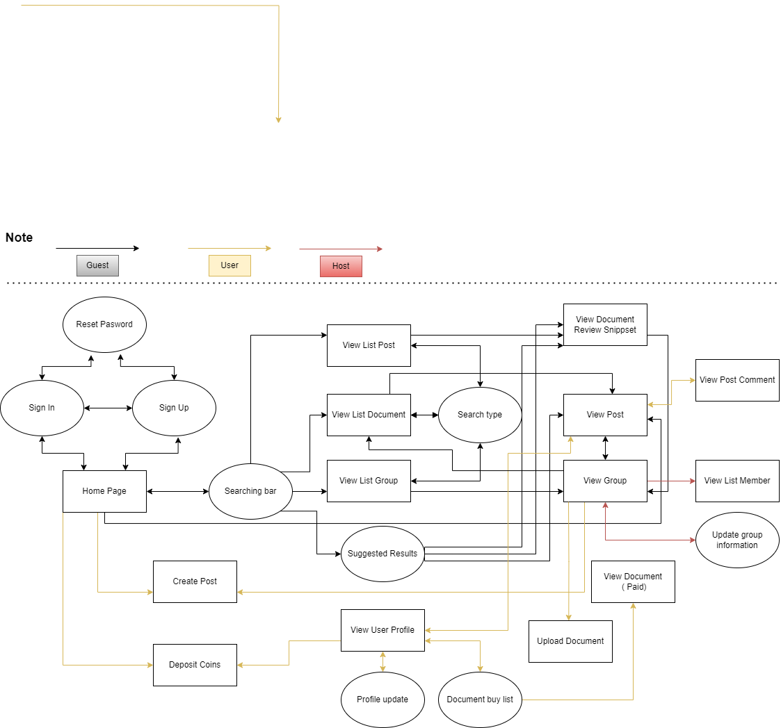

[*View full*](https://drive.google.com/file/d/1JvREVDZsplj5HAvTjqOFvD7CUbKAwHO0/view?usp=sharing)

#### 3.1.2 Screen Descriptions

| **#** | **Feature** | **Screen** | **Description** |
| --- | --- | --- | --- |
| 1 | View All Hot Post | Landing Page | The guest can see all the hot posts inside all groups, but they can’t see the comments. |
| 2 | Login | Login | The user login to their account. |
| 3 | Register | Signup | The guest created an account. |
| 4 | Reset Password | Reset Password | User forgot the password and they want to reset to make a new password. |
| 5 | View Profile | User Profile | The user wants to view their profile. |
| 6 | Edit Username | Edit Profile | The user wants to change their username. |
| 7 | Edit Phone | Edit Profile | The user wants to change or add their Phone. |
| 8 | Edit Avatar | Edit Profile | The user wants to change or add their Avatar. |
| 9 | Change Password | Edit Profile | The user wants to change their password. |
| 10 | View All Post | Home Page | The user can see all the posts available. |
| 11 | Create Group | Home Page | The User who has enough 2000 activity points can create a group. |
| 12 | Edit Group Avatar | Group Page | The host of the group can change the group avatar. |
| 13 | Edit Group Background | Group Page | The host of the group can change the group background. |
| 14 | Edit Group Description | Group Page | The host of the group can change the group description. |
| 15 | View your group list | Home Page | The user can see all the groups that they have joined in the drop list. |
| 16 | View Hot Post By Group | Group Page | The user can see all the hot posts of each group. |
| 17 | Comment | Group Page, Home Page | The user can make a comment on the post which they care about. |
| 18 | Edit comment | Group Page, Home Page | The user can edit their comment. |
| 19 | Delete comment | Group Page, Home Page | The user can delete their comment. |
| 20 | View Comment | Group Page, Home Page | The user can view all comments. |
| 21 | Like/ Dislike post | Group Page, Home Page | The user can like or dislike the post. |
| 22 | Like/ Dislike Comment | Group Page, Home Page | The user can like the comment. |
| 23 | Create Post | Group Page | The user can make a post inside the group which they had joined. |
| 24 | Edit Post | Group Page, Home Page | The user can edit their post, edit content, add or remove pictures. |
| 25 | Delete Post | Group Page, Home Page | The user can delete their post. |
| 26 | Search Post | Landing Page, Group Page, Home Page |  |
| 27 | Report Post | Group Page, Home Page | The user can report the post not following the rule of the website or group to the admin . |
| 28 | Report Comment | Group Page, Home Page | The user can report the comment not following the rule of the website or group to the admin. |
| 29 | Buy Coins | Payment | The user can use their own money to buy coins which are needed for paying documents. |
| 30 | Donate coins | Group Page, Home Page | The user can donate coins for someone, who have good sharing  on post. |
| 31 | Exchange coins to money | Home page | The user can exchange their coins back to money |
| 32 | View all accounts | Admin home page | Admin can view accounts’ details |
| 33 | Delete accounts | List accounts page | Admin can delete the user's account permanently. |
| 34 | Lock/Open accounts | List accounts page | Admin can lock/open the user’s account temporarily. |
| 35 | View all reports | Admin home page | Admin can view reports’ details |
| 36 | View document to approve | Admin home page | Admin can view documents before approving them. |
| 37 | Accept/Reject document | List documents page | Admin can accept documents to release to the community or reject them. |
| 38 | View all groups | Admin home page | Admin can view groups’ details |
| 39 | Notify groups | List groups page | Admin can send notification to groups. |
| 40 | Delete groups | List groups page | Admin can delete groups permanently. |
| 41 | View User quantity/Coin sales charts | Admin home page | Admin can view community statistics about user quantity and coin sales. |

#### 3.1.3 Screen Authorization

| **Screen** | **User** | **Group Host** | **Group Member** | **Admin** | **Guest** |
| --- | --- | --- | --- | --- | --- |
| **<<Landing Page>>** |  |  |  |  | X |
| View All Hot Post |  |  |  |  | X |
| **<<Login>>** | X | X | X | X | X |
| Login | X | X | X | X | X |
| **<<Register>>** | X | X | X |  | X |
| Register | X | X | X |  | X |
| **<<** **Reset Password >>** | X | X | X |  |  |
| Reset Password | X | X | X |  |  |
| **<<Edit Profile>>** | X | X | X |  |  |
| Edit Username | X | X | X |  |  |
| Edit Avatar | X | X | X |  |  |
| Edit Phone | X | X | X |  |  |
| Change Password | X | X | X |  |  |
| **<<User Profile>>** | X | X | X |  |  |
| View Profile | X | X | X |  |  |
| **<< Home Page>>** | X | X | X |  |  |
| View All Post | X | X | X |  |  |
| Create Group | X | X | X |  |  |
| View your group list | X | X | X |  |  |
| Comment |  | X | X |  |  |
| Edit comment |  | X | X |  |  |
| Delete comment |  | X | X |  |  |
| View Comment |  | X | X |  |  |
| Like/ Dislike post | X | X | X |  |  |
| Like/ Dislike Comment | X | X | X |  |  |
| Edit Post |  | X | X |  |  |
| Delete Post |  | X | X |  |  |
| Search Post | X | X | X |  |  |
| Report Post | X | X | X |  |  |
| Report Comment | X | X | X |  |  |
| Buy Coins | X | X | X |  |  |
| Donate coins | X | X | X |  |  |
| Exchange coins to money | X | X | X |  |  |
| **<< Group Page >>** |  | X | X |  |  |
| Edit Group Avatar |  | X |  |  |  |
| Edit Group Background |  | X |  |  |  |
| Edit Group Description |  | X |  |  |  |
| View Hot Post By Group |  | X | X |  |  |
| Create Post |  | X | X |  |  |
| View all accounts |  |  |  | X |  |
| Delete accounts |  |  |  | X |  |
| Lock/Open accounts |  |  |  | X |  |
| View all reports |  |  |  | X |  |
| View document to approve |  |  |  | X |  |
| Accept/Reject document |  |  |  | X |  |
| View all groups |  |  |  | X |  |
| Notify groups |  |  |  | X |  |
| Delete groups |  |  |  | X |  |
| View User quantity/Coin sales charts |  |  |  | X |  |

#### 3.1.4 Non-Screen Functions

| **#** | **Feature** | **System Function** | **Description** |
| --- | --- | --- | --- |
| 1 | Get Activity Points | Add Activity Points | Add points that are needed for upgrading the user's level when the user does specific activities. |
| 2 | Verify Email | Send Verify Key | Send a key to input email to verify the user every time the user wants to reset password. |
| 3 | Get Coins | Do Transaction | Get coins from the user transfering money to give to the recipient. |

#### 3.1.5 Entity Relationship Diagram

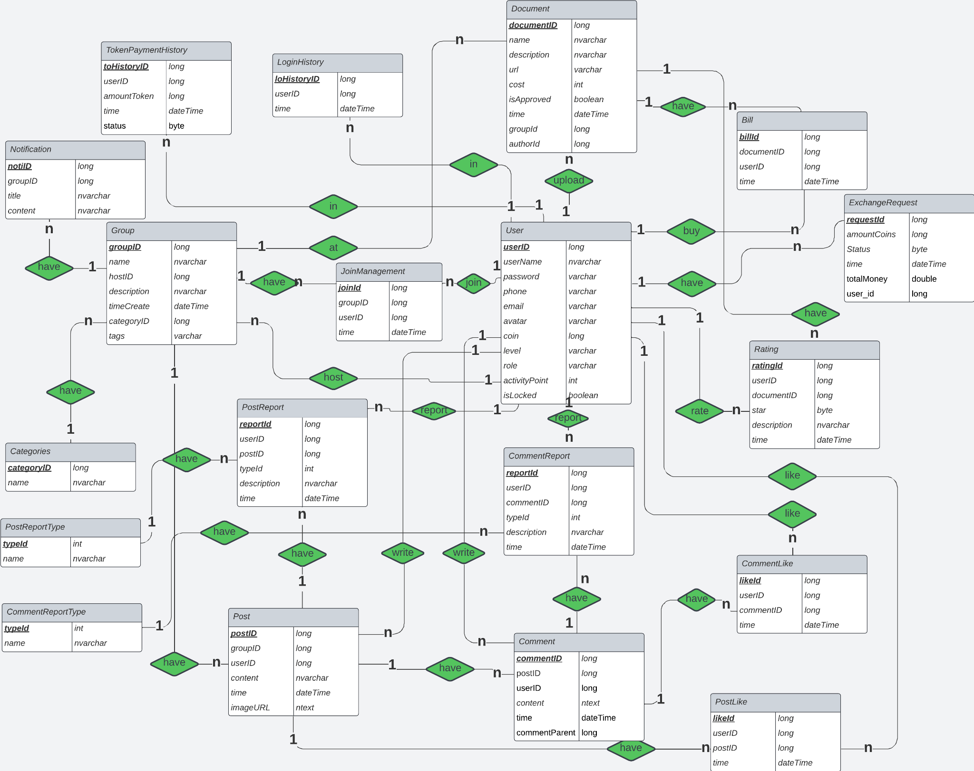

**Entities Description**

| **#** | **Entity** | **Description** |
| --- | --- | --- |
| 1 | User | Define 3 types of user in Camp Scholars system, store information about a user |
| 2 | Group | Users can create Group Each group information including Categories, JoinManagement and consists of many Post |
| 3 | Categories | Categories belong to each Group, represents categories or genres of the group |
| 4 | JoinManagement | JoinManagement belong to each Group, including users and join time |
| 5 | Post | Posts belong to each Group, including content and many Comment |
| 6 | PostLike | PostLikes belong to each Post,users can like posts interesting |
| 7 | PostReport | Users can report invalid posts |
| 8 | PostReportType | PostReportType belong to each PostReport, including the name of the reports type |
| 9 | Comment | Comments belong to each Post, including content |
| 10 | CommentLike | CommentLikes belong to each Post,users can like comments interesting |
| 11 | CommentReport | Users can report invalid comments |
| 12 | CommentReportType | CommentReportType belong to each CommentReport, including the name of the reports type |
| 13 | Document | Users can buy or upload documents for sell on the system |
| 14 | Bill | Bills belong to each Document,Bills to confirm the users has paid token for the document |
| 15 | Rating | Rating belong to each Document, to review the quality of document |
| 16 | TokenPaymentHistory | Stores user transaction history |
| 17 | LoginHistory | Stores user login logs including login time |
| 18 | Notification | Stores all notification admin sent to groups. |
| 19 | ExchangeRequest | Stores information of the coin transactions. |

## 4. Non-Functional Requirements

### 4.1 External Interfaces

* All text, messages should be written in Vietnamese
* The academic website should have a user-friendly interface accessible via web browsers.
* It should support various web browsers, including Chrome, Firefox, Safari, and Edge.

### 4.2 Quality Attributes

***4.2.1 Usability***

* The academic website should have an intuitive and easy-to-navigate design.
* Users, both guest and member, should be able to become productive within 15 minutes of using the website.
* Measurable task times:
  + User registration: < 2 minutes
  + Search for academic articles: < 10 seconds
  + Upload research papers, academic documents: < 5 minutes

***4.2.2 Reliability***

* Availability: The website should be available 99.9% of the time (excluding scheduled maintenance).
* Mean Time Between Failures (MTBF): The system should have an MTBF of at least 10,000 hours.
* Mean Time To Repair (MTTR): In the event of a failure, the system should be restored within 2 hours.
* Accuracy: The website should provide precise and accurate academic information and data, meeting industry standards for data accuracy.
* Maximum Bugs or Defect Rate: The website should have a maximum bug rate of 1 bug per 1,000 lines of code (1 bug/KLOC).
* Bugs or Defect Rate: Categorised as minor, significant, and critical bugs, with critical bugs defined as those that result in a complete loss of data or a significant disruption of core functionality.

***4.2.3 Performance***

* Response time for a transaction:
  + Average response time for searching academic articles: < 2 seconds
  + Maximum response time for submitting research papers: < 10 seconds
* Throughput: The system should support a minimum of 50 concurrent users and handle at least 10 transactions per second during peak usage.
* Capacity: The website should accommodate a minimum of 100 registered users and store at least 500 academic data.

## 5. Requirement Appendix

### 5.1 Business Rules

| **ID** | **Rule Definition** |
| --- | --- |
| BR-01 | OTP code consists of 6 positive numbers and is valid in 1 minute. |
| BR-02 | If users input incorrect OTP 5 times, their email/phone will be locked in 10 minutes. |
| BR-03 | If users input incorrect username or password 5 times, they must wait 10 minutes for the next try. |
| BR-04 | All descriptions are restricted to 250 characters. |
| BR-05 | Image type must be png, jpg, gif, bmp. |
| BR-06 | Image <= 5MB. |
| BR-07 | If user continuously like/dislike 2 times on 1 post/comment, the total like made by that user will return 0 |
| BR-08 | Network transmissions that involve financial information or personally identifiable information require 256-bit encryption. |
| BR-09 | Only regular employees can register for payroll deduction for any company purchase. |
| BR-10 | An employee can register for payroll deduction payment of cafeteria meals if no more than 40 percent of his gross pay is currently being deducted for other reasons. |
| BR-11 | Coins in wallet > Coin use |
| BR-12 | User must be a member of group |
| BR-13 | Paypal account still working |
| BR-14 | Buy coins price: 1 USD = 20 coins |
| BR-15 | Exchange coins price: 30 coins = 1 USD |
| BR-16 | Login to system |

### 5.2 Common Requirements

### 5.3 Application Messages List

| **#** | **Message code** | **Message Type** | **Context** | **Content** |
| --- | --- | --- | --- | --- |
| 1 | MSG01 | In line | There is not any search result | *No search results.* |
| 2 | MSG02 | In red, under the text box | Input-required fields are empty | *The * field is required.* |
| 3 | MSG03 | Toast message | Updating asset(s) information successfully | *Update asset(s) successfully.* |
| 4 | MSG04 | Toast message | Adding new asset successfully | *Add assets successfully.* |
| 5 | MSG05 | Toast message | Confirming email of asset hand-over is sent successfully | *A confirmation email has been sent to {email_address}.* |
| 6 | MSG06 | Toast message | Resetting asset information successfully | *Return asset(s) successfully.* |
| 7 | MSG07 | Toast message | Deleting asset information successfully | *Delete asset(s) successfully.* |
| 8 | MSG08 | In red, under the text box | Input value length > max length | *Exceed max length of {max_length}.* |
| 9 | MSG09 | In line | Username or password is not correct when clicking sign-in | *Incorrect username or password. Please check again.* |