Link github: <https://github.com/hoangan26022003/D05K13_hoangan/tree/main/BT>

BT1

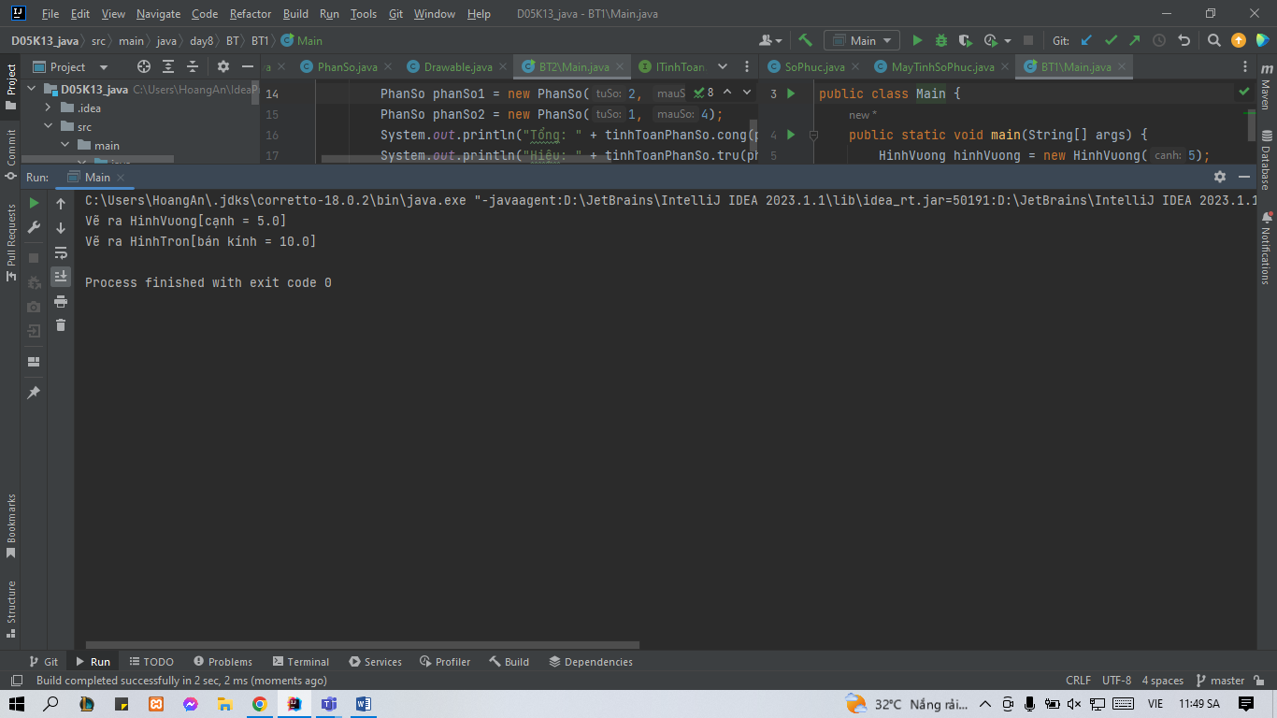

BT2

