Library Management System
Requirement Specification and Design Document
Group 05 – Stage 1 (Analysis and Requirements) and Stage 2 (Design)

0. Introduction
Purpose. The Library Management System (LMS) automates the daily operations of a library: managing the catalogue of books, registering readers, lending and returning books, handling reservations, calculating fines and producing reports.
Scope. The system is a desktop/web application used inside one library. It replaces paper cards and spreadsheets, reduces errors in lending records and gives the librarian a quick view of which books are available, borrowed or overdue.
Actors.
Actor | Description
Guest | Visitor who has not logged in. Searches the catalogue and logs in.
Reader | Library member. Does everything a Guest can; also views own loans, reserves and renews books.
Librarian | Manages books, readers, loans, returns, reservations and fines.
Administrator | A Librarian with extra rights: inherits every Librarian function and also manages staff accounts, system parameters (loan period, fine rate) and the audit log.
System | Automatic actor: daily overdue scan, reservation and card expiry, audit logging.
Email Service | External service that delivers reminders and notices to readers.

Requirement IDs use the format FR-<ACTOR>-<NN> (GST, RDR, LIB, ADM, SYS; USR = every logged-in user) and NFR-<CATEGORY>-<NN>. Tables in Sections 3–7 have a “Related FR” column for traceability.

1. Functional Requirements

1.1 All logged-in users
- FR-USR-01 The system shall allow users to log out and change their password.
- FR-USR-02 The system shall restrict each function according to the user’s role. An Administrator has all Librarian permissions in addition to the administrator functions.

1.2 Guest
- FR-GST-01 Any user shall search books by title, author, ISBN, category, publisher or year. The result shall show the number of available copies and the shelf location.
- FR-GST-02 The system shall allow staff and readers to log in with a username and password, and shall show an error if the credentials are wrong or the account is locked.

1.3 Reader
- FR-RDR-01 A reader shall view personal information, current loans, loan history, reservations and fines.
- FR-RDR-02 A reader shall reserve a title whose copies are all borrowed.
- FR-RDR-03 A reader shall cancel his or her own reservation.
- FR-RDR-04 A reader shall renew a loan (maximum 2 times) if the loan is not overdue and the title is not reserved by another reader.

1.4 Librarian
- FR-LIB-01 The Librarian shall add a new book title with: ISBN, title, author(s), publisher, publication year, category, language, number of pages and description.
- FR-LIB-02 The Librarian shall add, update and remove physical copies of a title (each copy has a barcode, shelf location, price and status: Available, Borrowed, Reserved, Lost, Damaged).
- FR-LIB-03 The Librarian shall edit or delete book information (deletion is refused if the book has active loans).
- FR-LIB-04 The Librarian shall manage lists of categories, authors and publishers.
- FR-LIB-05 The Librarian shall register a new reader with: full name, date of birth, address, phone, email, reader type (Student, Teacher, Other) and membership expiry date. The system shall issue a unique reader card number.
- FR-LIB-06 The Librarian shall update, renew, suspend or delete a reader record.
- FR-LIB-07 The Librarian shall create a loan by scanning/entering the reader card number and the copy barcode(s).
- FR-LIB-08 The system shall refuse a loan if the reader’s card is expired or suspended, the reader has reached the maximum number of books (default 5), the reader has unpaid fines or overdue books, or the copy is not available.
- FR-LIB-09 The system shall automatically set the due date (default 14 days from the loan date); the Librarian can print a loan slip.
- FR-LIB-10 The Librarian shall record the return of a copy and its condition (Good, Damaged, Lost); the system updates the copy status and calculates any fine. For a damaged or lost copy the Librarian enters the compensation amount.
- FR-LIB-11 The Librarian shall search, renew, reserve and cancel reservations on behalf of a reader.
- FR-LIB-12 The Librarian shall record fine payments and print a receipt.
- FR-LIB-13 The Librarian shall list all overdue loans and send reminders by email.

1.5 Administrator
- FR-ADM-01 The Administrator shall create, update, lock/unlock and delete staff accounts and assign roles.
- FR-ADM-02 The Administrator shall configure library parameters: loan days, maximum books, maximum renewals, fine per day, reservation pickup days.
- FR-ADM-03 The system shall produce reports: books borrowed per period, most borrowed titles, overdue list, active readers, fine revenue and current inventory (Administrator and Librarian).
- FR-ADM-04 Reports shall be exportable to PDF or Excel.
- FR-ADM-05 The Administrator shall view the audit log (user, action, record, time).

1.6 System (automatic)
- FR-SYS-01 Once a day the system shall set loans past their due date to Overdue and calculate the late fine (default 2,000 VND per day per book).
- FR-SYS-02 When a returned copy matches a waiting reservation, the system shall mark the copy as Reserved and notify the first reader in the queue by email.
- FR-SYS-03 A reservation not collected within 3 days shall expire and the copy goes to the next reader in the queue or back to Available.
- FR-SYS-04 The system shall set a reader card to Expired when its expiry date has passed.
- FR-SYS-05 The system shall log every create, update and delete action and every loan and return with user and timestamp.

2. Non-Functional Requirements
ID | Category | Requirement
NFR-PER-01 | Performance | Search results within 2 seconds for a catalogue of up to 100,000 titles; loan and return within 3 seconds.
NFR-PER-02 | Capacity | At least 50 concurrent users and 20,000 registered readers.
NFR-SEC-01 | Security | Passwords stored hashed (e.g. bcrypt); role-based access control (an Administrator has all Librarian permissions); protection against SQL injection and XSS; sessions expire after 30 minutes of inactivity; a reader sees only his or her own data.
NFR-REL-01 | Reliability | Availability of at least 99% during opening hours; transactions are atomic, so a loan is never half-recorded, and one copy cannot be lent to two readers at once.
NFR-REL-02 | Backup | Automatic daily database backup; recovery within 2 hours.
NFR-USA-01 | Usability | A new librarian can perform a loan after at most 30 minutes of training; Vietnamese and English interface; consistent layout and clear error messages.
NFR-MNT-01 | Maintainability | Layered architecture with separated modules; documented code; unit-test coverage of the business layer of at least 70%; parameters changeable without redeploying.
NFR-COM-01 | Portability | Runs on Windows, Linux and macOS and on current Chrome, Edge and Firefox (if web-based).
NFR-AUD-01 | Auditability | All create/update/delete actions and every loan/return are logged with user and timestamp.
NFR-DAT-01 | Data integrity | Referential integrity enforced by the database; unique ISBN, barcode and reader card number.
NFR-COM-02 | Compatibility | Barcode scanner input as keyboard emulation; reports exportable to PDF and Excel.

3. Data Flow Diagram (DFD)

3.1 Level 0 – Context Diagram
External entities: Guest, Reader, Librarian, Administrator, Email Service. Single process: 0 – Library Management System.
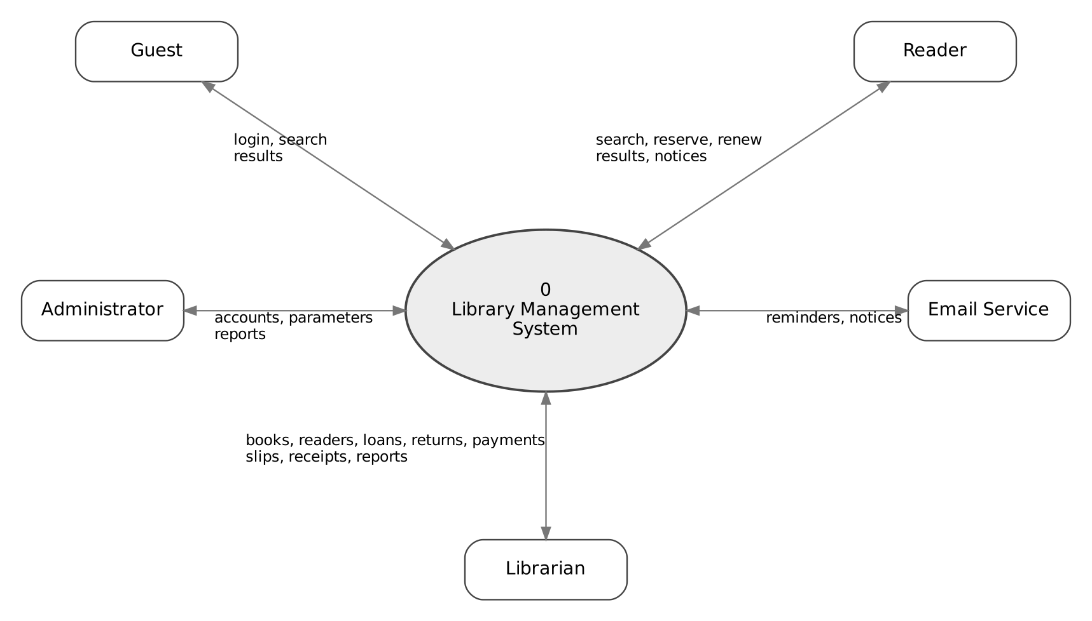
Figure 1. DFD level 0 – every data flow that crosses the system boundary.
From | Data flow | To | Related FR
Guest / Reader | Login, search criteria, reservation and renewal requests | System | FR-GST-01/02, FR-RDR-02 to 04
Librarian | Book, reader, loan/return data, fine payments, report requests | System | FR-LIB-01 to 13
Administrator | Staff accounts, parameters, report requests | System | FR-ADM-01 to 05
System | Search results, account data, loan slips, receipts, reports | Guest / Reader / Librarian / Administrator | FR-RDR-01, FR-LIB-09/12, FR-ADM-03
System | Reminders and pickup notices | Email Service | FR-LIB-13, FR-SYS-02

3.2 Level 1 DFD
Processes: 1.0 Authenticate and Manage Accounts, 2.0 Manage Books, 3.0 Manage Readers, 4.0 Search Catalogue, 5.0 Process Loan/Return, 6.0 Manage Reservations, 7.0 Manage Fines, 8.0 Generate Reports, 9.0 Configure Parameters. Data stores: D1 Accounts, D2 Books and Copies, D3 Readers, D4 Loans, D5 Reservations, D6 Fines, D7 System Parameters (the audit log is written by every process and is omitted from the figure).
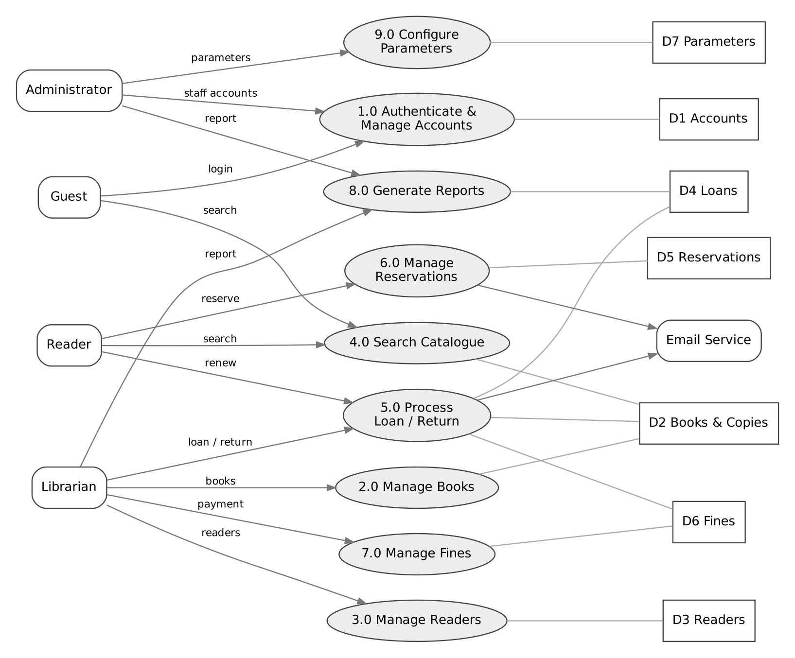
Figure 2. DFD level 1. Plain lines show data-store access.
Process | Inputs | Outputs | Stores | Related FR
1.0 Authenticate and Manage Accounts | Credentials, account data | Login result, role | D1 | FR-GST-02, FR-USR-01/02, FR-ADM-01
2.0 Manage Books | Book/copy data | Updated catalogue | D2 | FR-LIB-01 to 04
3.0 Manage Readers | Reader data | Reader card | D1, D3 | FR-LIB-05/06, FR-SYS-04
4.0 Search Catalogue | Search criteria | Result list with availability | D2, D4 | FR-GST-01
5.0 Process Loan/Return | Card no., barcode, renewal request | Loan slip, return confirmation, fine data | D2, D3, D4, D6, D7 | FR-LIB-07 to 11, 13, FR-RDR-04, FR-SYS-01
6.0 Manage Reservations | Reserve/cancel request, returned copy | Confirmation, pickup notice | D2, D3, D5 | FR-RDR-02/03, FR-SYS-02/03
7.0 Manage Fines | Fine data, payment | Receipt | D3, D6 | FR-LIB-10, FR-LIB-12
8.0 Generate Reports | Report type, period | Report | D2, D3, D4, D6 | FR-ADM-03/04
9.0 Configure Parameters | Parameters | Updated parameters | D7 | FR-ADM-02

3.3 Level 2 – Process 5.0 Process Loan/Return
- 5.1 Validate reader (card status, fines, limit) – reads D3, D4, D6.
- 5.2 Validate copy (availability) – reads D2.
- 5.3 Record loan and compute due date – writes D4, updates D2; reads D7.
- 5.4 Record return and compute fine – updates D4, D2; writes D6.
- 5.5 Renew loan – updates D4; checks D5.
- 5.6 Detect overdue loans (daily) – updates D4; writes D6.
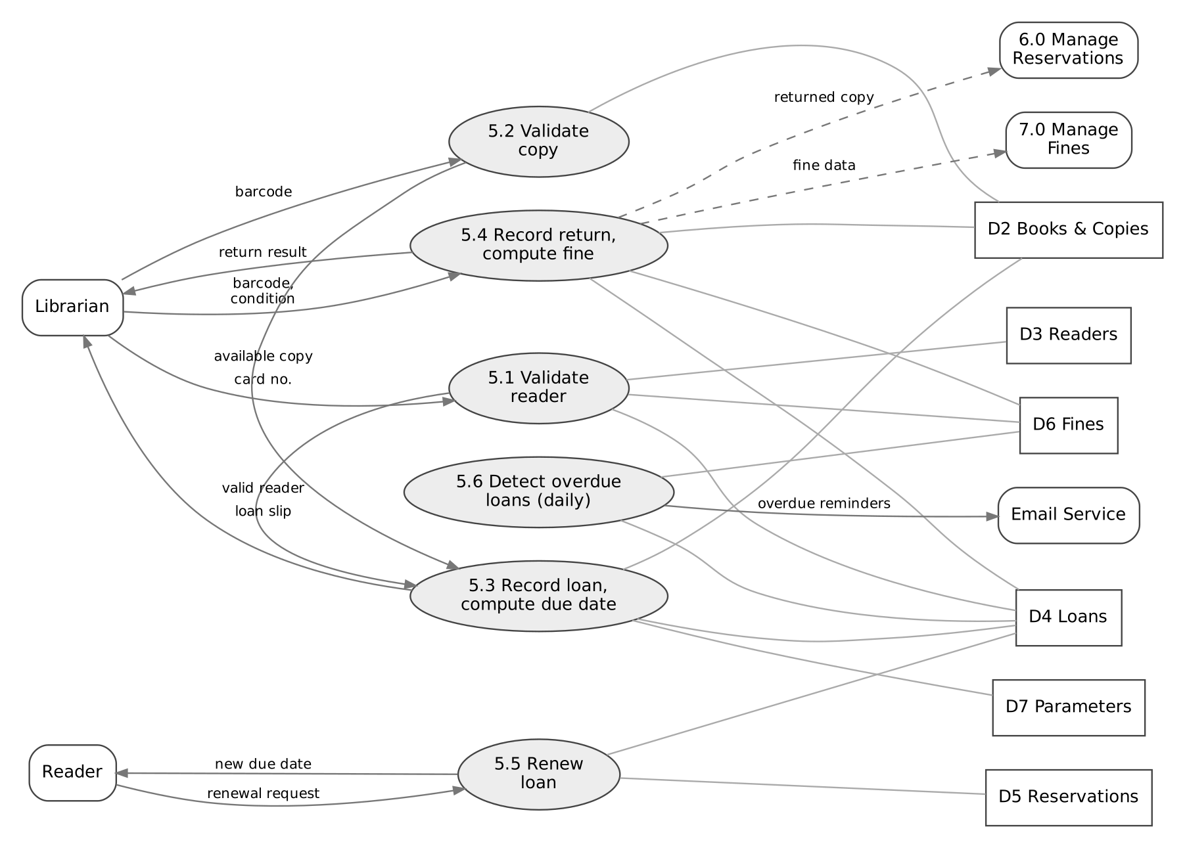
Figure 3. DFD level 2 – process 5.0 Process Loan/Return. Dashed arrows go to other processes (6.0, 7.0); plain lines show data-store access.

4. Use Case Diagram

4.1 Use case list
ID | Use case | Actors | Related FR
UC01 | Log in | Guest, all roles | FR-GST-02
UC02 | Log out / change password | Reader, Librarian, Administrator | FR-USR-01
UC03 | Search books | Guest, Reader, Librarian | FR-GST-01
UC04 | View my account | Reader | FR-RDR-01
UC05 | Reserve book | Reader, Librarian | FR-RDR-02, FR-LIB-11
UC06 | Cancel reservation | Reader, Librarian | FR-RDR-03, FR-LIB-11
UC07 | Renew loan | Reader, Librarian | FR-RDR-04, FR-LIB-11
UC08 | Manage books and copies | Librarian | FR-LIB-01 to 03
UC09 | Manage categories, authors, publishers | Librarian | FR-LIB-04
UC10 | Manage readers | Librarian | FR-LIB-05/06
UC11 | Borrow book | Librarian | FR-LIB-07 to 09
UC12 | Return book | Librarian | FR-LIB-10
UC13 | Manage fines and payments | Librarian | FR-LIB-12
UC14 | Send overdue reminders | Librarian, System | FR-LIB-13
UC15 | Generate reports | Librarian, Administrator | FR-ADM-03/04
UC16 | Manage staff accounts | Administrator | FR-ADM-01
UC17 | Configure parameters | Administrator | FR-ADM-02
UC18 | View audit log | Administrator | FR-ADM-05
UC19 | Process overdue loans (daily) | System | FR-SYS-01
UC20 | Expire reservations and cards (daily) | System | FR-SYS-03/04

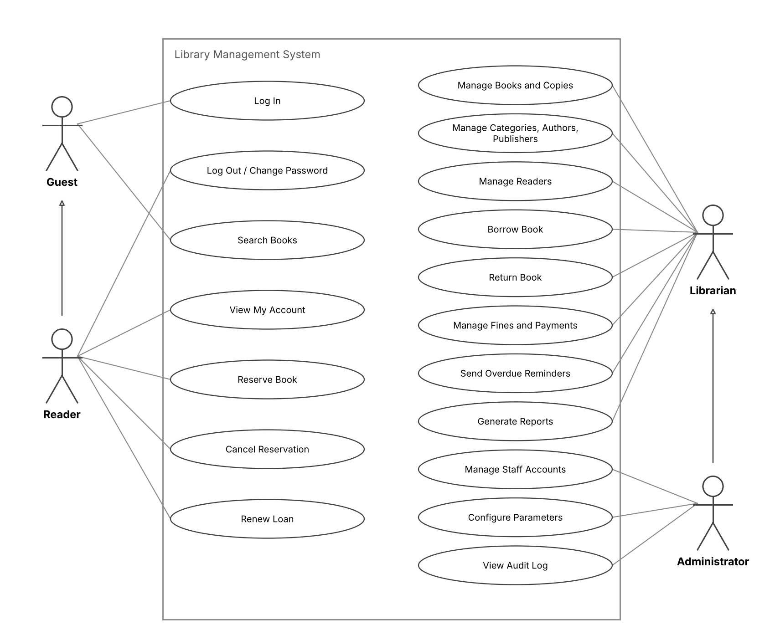
Figure 4. Use case diagram. The two functions run by the System (process overdue loans, expire reservations and cards) are listed in the table only. Librarians can also search, reserve, cancel a reservation and renew a loan on behalf of readers; every user logs in first. Administrator inherits from Librarian, so all Librarian use cases also apply to the Administrator.
Relationships. UC05, UC07 and UC11 include Validate reader; UC05 and UC11 include Check book availability; UC12 is extended by Calculate fine when the book is late, lost or damaged; Reader is a specialisation of Guest, and Administrator is a specialisation of Librarian.

4.2 UC03 Search Books
Item | Description
Actor | Guest, Reader, Librarian
Precondition | None (public function).
Main flow | 1. User enters a keyword and optional filters. 2. System searches title, author and ISBN. 3. System shows the result list with available copies and shelf location. 4. User opens a title to see its details.
Alternative flows | 2a. No result: system shows “No book found”. 3a. All copies borrowed and user is a Reader or Librarian: a Reserve button is shown (UC05).

4.3 UC11 Borrow Book
Item | Description
Actor | Librarian (Reader participates)
Precondition | Librarian is logged in; reader has a valid card.
Main flow | 1. Librarian enters the reader card number. 2. System displays reader information and current loans. 3. Librarian scans the copy barcode. 4. System checks the rules (FR-LIB-08). 5. System creates the loan record with due date and sets the copy status to Borrowed. 6. Steps 3–5 repeat for each book. 7. System prints the loan slip.
Alternative flows | 4a. Reader expired/suspended/has fines → system shows the reason and rejects the loan. 4b. Copy not available → system suggests reservation. 4c. Limit reached → system rejects the loan.
Postcondition | Loan records saved; copy status updated.

4.4 UC12 Return Book
Item | Description
Actor | Librarian
Precondition | The copy is currently borrowed.
Main flow | 1. Librarian scans the copy barcode. 2. System finds the active loan. 3. System compares the return date with the due date and calculates the fine if late. 4. Librarian confirms the book condition. 5. System sets the loan to Returned, the copy to Available (or Reserved if a reservation exists) and notifies the next reader in the queue.
Alternative flows | 3a. Book damaged/lost → Librarian enters the compensation amount.
Postcondition | Loan closed; fine record created if applicable.

5. Class Diagram
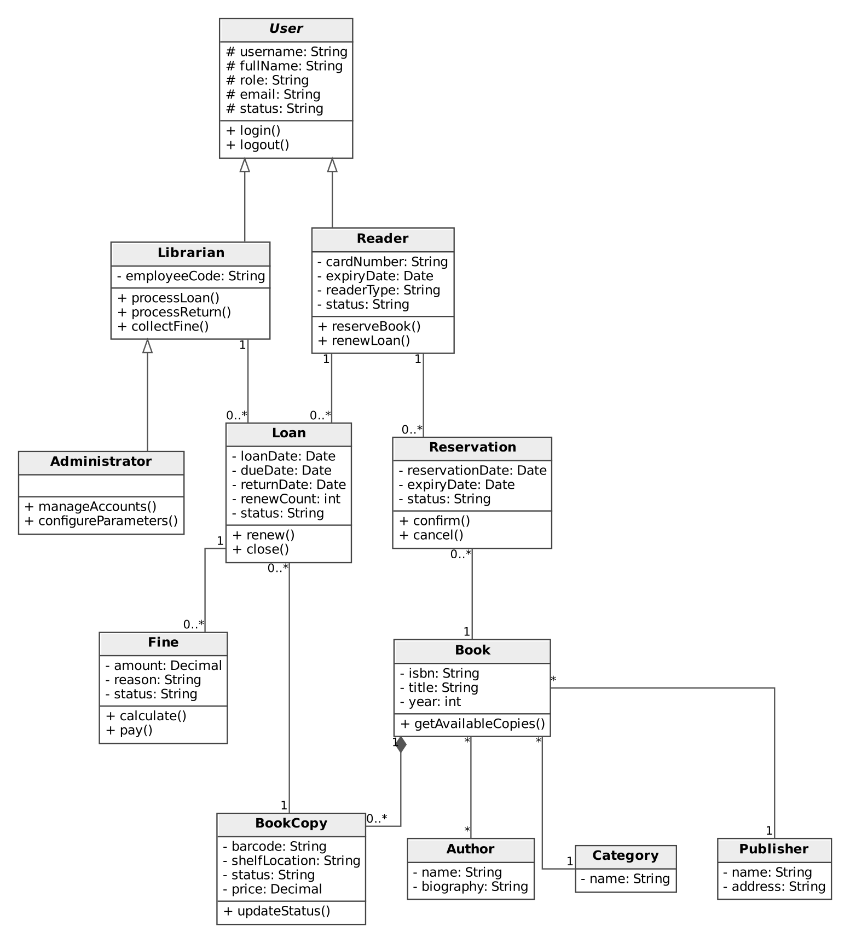
Figure 5. Class diagram – main classes and associations. Visibility: + public, - private, # protected. Notification, Setting and AuditLog are omitted from the figure.
Class | Attributes | Main methods | Related FR
User (abstract) | userId, username, passwordHash, fullName, email, role, status | login(), logout(), changePassword() | FR-GST-02, FR-USR-01
Administrator (extends Librarian) | – (inherits employeeCode) | manageAccounts(), configureParameters(), viewAuditLog(); inherits all Librarian methods | FR-ADM-01/02/05
Librarian | employeeCode | manageBooks(), manageReaders(), processLoan(), processReturn(), collectFine() | FR-LIB-01 to 13
Reader | cardNumber, dateOfBirth, address, phone, readerType, expiryDate, status | searchBook(), reserveBook(), renewLoan(), viewHistory() | FR-RDR-01 to 04
Book | bookId, isbn, title, publicationYear, language, pages, description | addCopy(), getAvailableCopies() | FR-GST-01, FR-LIB-01/03
BookCopy | copyId, barcode, shelfLocation, status, price | updateStatus() | FR-LIB-02
Author, Category, Publisher | id, name (+ biography / description / address) | – | FR-LIB-04
Loan | loanId, loanDate, dueDate, returnDate, returnCondition, renewCount, status | calculateDueDate(), renew(), close() | FR-LIB-07 to 10, FR-RDR-04
Reservation | reservationId, reservationDate, expiryDate, status | confirm(), cancel(), expire() | FR-RDR-02/03, FR-SYS-02/03
Fine | fineId, amount, reason, issuedDate, paidDate, receiptNo, status | calculate(), pay() | FR-LIB-10/12, FR-SYS-01
Notification | notificationId, type, channel, message, status, sentAt | send() | FR-LIB-13, FR-SYS-02
Setting | key, value | get(), set() | FR-ADM-02
AuditLog | logId, action, entity, timestamp | write() | FR-SYS-05, FR-ADM-05

Visibility. Attributes are private (-), so they are accessed only through the methods of the class; the attributes of User are protected (#) so that Librarian, Administrator and Reader can use them; all methods are public (+).

Relationships
- Librarian and Reader inherit from User; Administrator inherits from Librarian, so an Administrator can do everything a Librarian can do (and is also a User).
- Book 1 — 1..* BookCopy (composition); Book * — * Author; Book * — 1 Category; Book * — 1 Publisher.
- Reader 1 — 0..* Loan; BookCopy 1 — 0..* Loan; Librarian 1 — 0..* Loan (issued by).
- Reader 1 — 0..* Reservation; Book 1 — 0..* Reservation; Loan 1 — 0..* Fine (the reader of a fine is found through its loan).

6. Data Model
DBMS: relational (MySQL / PostgreSQL / SQL Server), 14 tables in third normal form. PK = primary key, FK = foreign key. The full column list with types and constraints is in the attached file schema.sql.
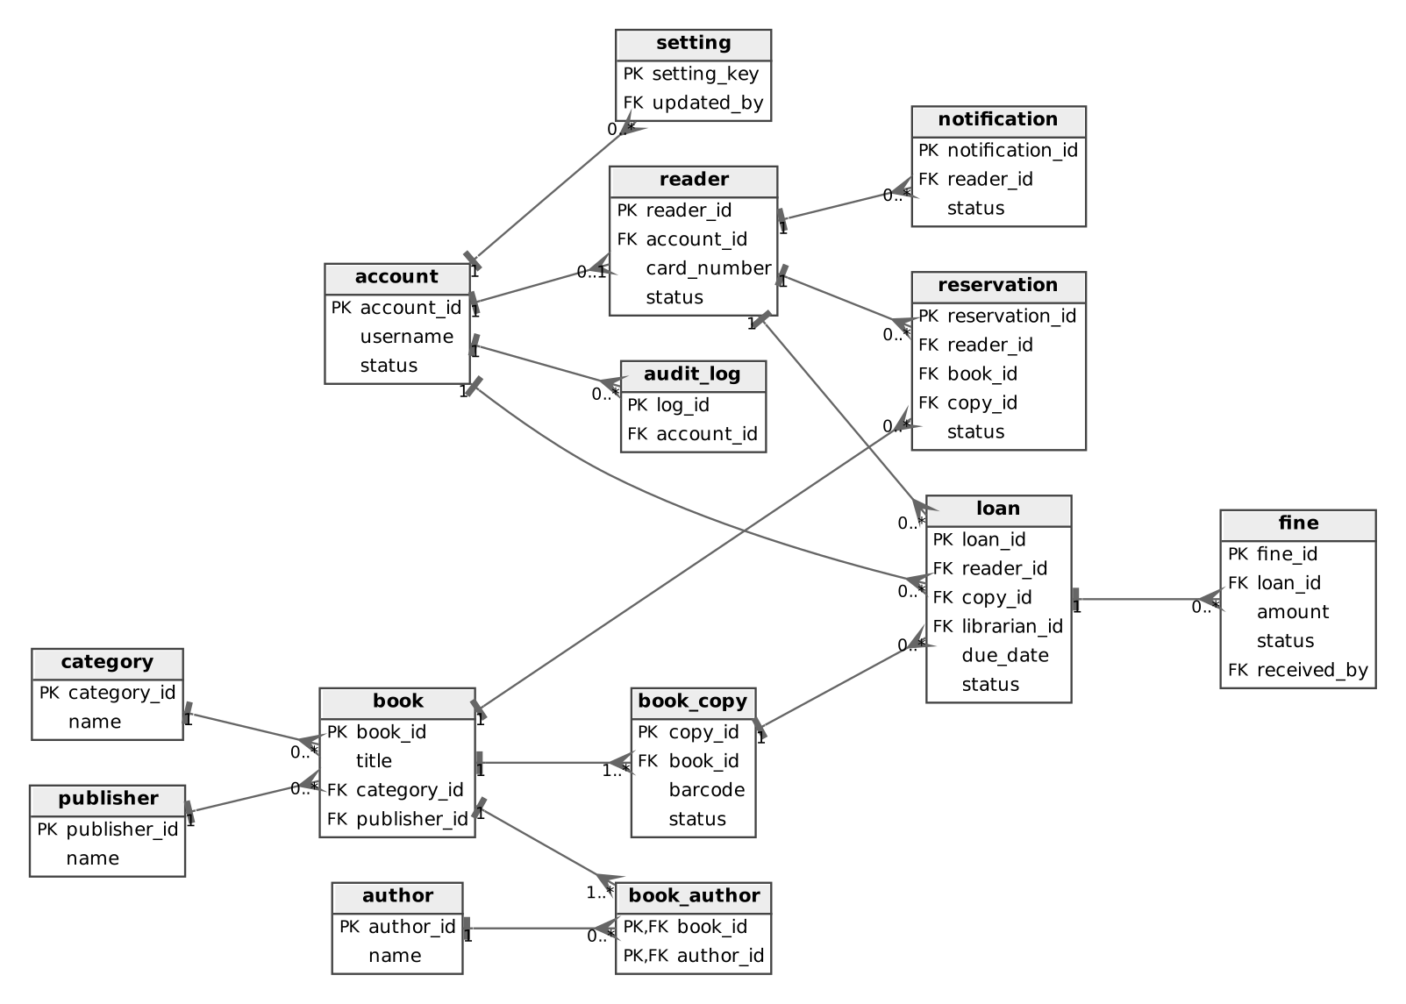
Figure 6. Entity-relationship diagram (key columns only).
Table | Main columns | Notes
account | account_id PK, username, password_hash, full_name, email, role, status | Login accounts of all roles (READER, LIBRARIAN, ADMIN; ADMIN inherits all LIBRARIAN permissions); status ACTIVE, LOCKED
reader | reader_id PK, account_id FK, card_number, reader_type, issue_date, expiry_date, status | One-to-one with a READER account; status ACTIVE, SUSPENDED, EXPIRED
category, publisher, author | id PK, name (+ description / address / biography) | Catalogue lists
book | book_id PK, isbn, title, publication_year, language, pages, category_id FK, publisher_id FK | Bibliographic record
book_author | book_id FK, author_id FK (composite PK) | Many-to-many link
book_copy | copy_id PK, book_id FK, barcode, shelf_location, price, status | AVAILABLE, BORROWED, RESERVED, LOST, DAMAGED
loan | loan_id PK, reader_id FK, copy_id FK, librarian_id FK, loan_date, due_date, return_date, return_condition, renew_count, status | BORROWED, RETURNED, OVERDUE
reservation | reservation_id PK, reader_id FK, book_id FK, copy_id FK (held copy), reservation_date, expiry_date, status | WAITING, READY, FULFILLED, CANCELLED, EXPIRED
fine | fine_id PK, loan_id FK, amount, reason, issued_date, paid_date, receipt_no, status | LATE, LOST, DAMAGED; UNPAID, PAID
notification | notification_id PK, reader_id FK, type, channel, message, status, sent_at | Emails sent to readers
setting | setting_key PK, setting_value, updated_by FK | LOAN_DAYS=14, MAX_BOOKS=5, MAX_RENEWALS=2, FINE_PER_DAY=2000, HOLD_DAYS=3
audit_log | log_id PK, account_id FK, action, entity, entity_id, created_at | Who did what and when

7. Interface Design Description
General principles. The interface follows the Figma design of the group (https://www.figma.com/design/XWDUsmtiwzL9fWwKjcFpmQ/Untitled?node-id=0-1&m=dev&t=XlaxkVLI6GOGNmZv-1). Every screen has a top bar with the library name, the branch, the current user with role and a Logout button, a left menu that depends on the role, a breadcrumb and a page title. Staff and administrators work in the “Workspace”; readers use the “Reader portal”, which has only two menu items (Book search, My account). Status is shown with coloured labels (for example Active, Suspended, Expired, On loan, Overdue). Tables have sorting and paging. Required fields are marked with *. A language selector is on the login screen. Because Administrator inherits from Librarian, an Administrator can also open the Librarian screens (S02 to S09); the Figma menu of the Administrator shows only the administrator-specific items to keep it short.
No. | Screen | Users | Main components | Related FR
S01 | Login | All | Username, password, error message, Forgot password link, Login button, language selector | FR-GST-02
S02 | Dashboard | Librarian, Administrator | Cards (books borrowed today, overdue books, new readers, unpaid fines), Borrow and Return shortcuts, recent loans, service-desk figures, weekly circulation chart, overdue alert | FR-LIB-13, FR-ADM-03
S03 | Book search | Reader, Librarian | Search box, filters (category, author, publication year), result table with availability and shelf, Reserve / View hold button, My reservations button | FR-GST-01, FR-RDR-02
S04 | Book management | Librarian | Book list with search, Edit book form, physical copies table (barcode, shelf, status), Add book and Add copy buttons | FR-LIB-01 to 03
S05 | Reader management | Librarian | Reader list with search and status, Edit reader form, Renew card and Suspend card buttons, current borrowing, Add reader | FR-LIB-05, FR-LIB-06
S06 | Borrow book | Librarian | 3-step progress, reader card field and reader panel, barcode field, selected copies, loan summary with eligibility message, Cancel / Print slip / Confirm checkout | FR-LIB-07 to 09
S07 | Return book | Librarian | Barcode field, loan details, condition and return location, staff notes, fine calculation, Confirm return | FR-LIB-10
S08 | Reservations | Librarian | Counters, reservation queue with filters, Notify and Cancel actions, selected hold, reader notification | FR-LIB-11, FR-SYS-02, FR-SYS-03
S09 | Fines | Librarian | Unpaid fines list with search and filter, selected fine, Record payment (method, cash received, change), receipt preview | FR-LIB-12
S10 | Reports | Administrator, Librarian | Report type, date range, branch, Generate report, summary cards, chart, daily table, Export PDF and Export Excel | FR-ADM-03, FR-ADM-04
S11 | Account management and settings | Administrator | Staff accounts table, role assignment and account status, lending parameters form, Add staff account | FR-ADM-01, FR-ADM-02
S12 | My account | Reader | Profile and Edit profile, borrowing allowance, overdue alert, current loans with Renew, reservations with Cancel, fines, borrowing history | FR-RDR-01, FR-RDR-03, FR-RDR-04

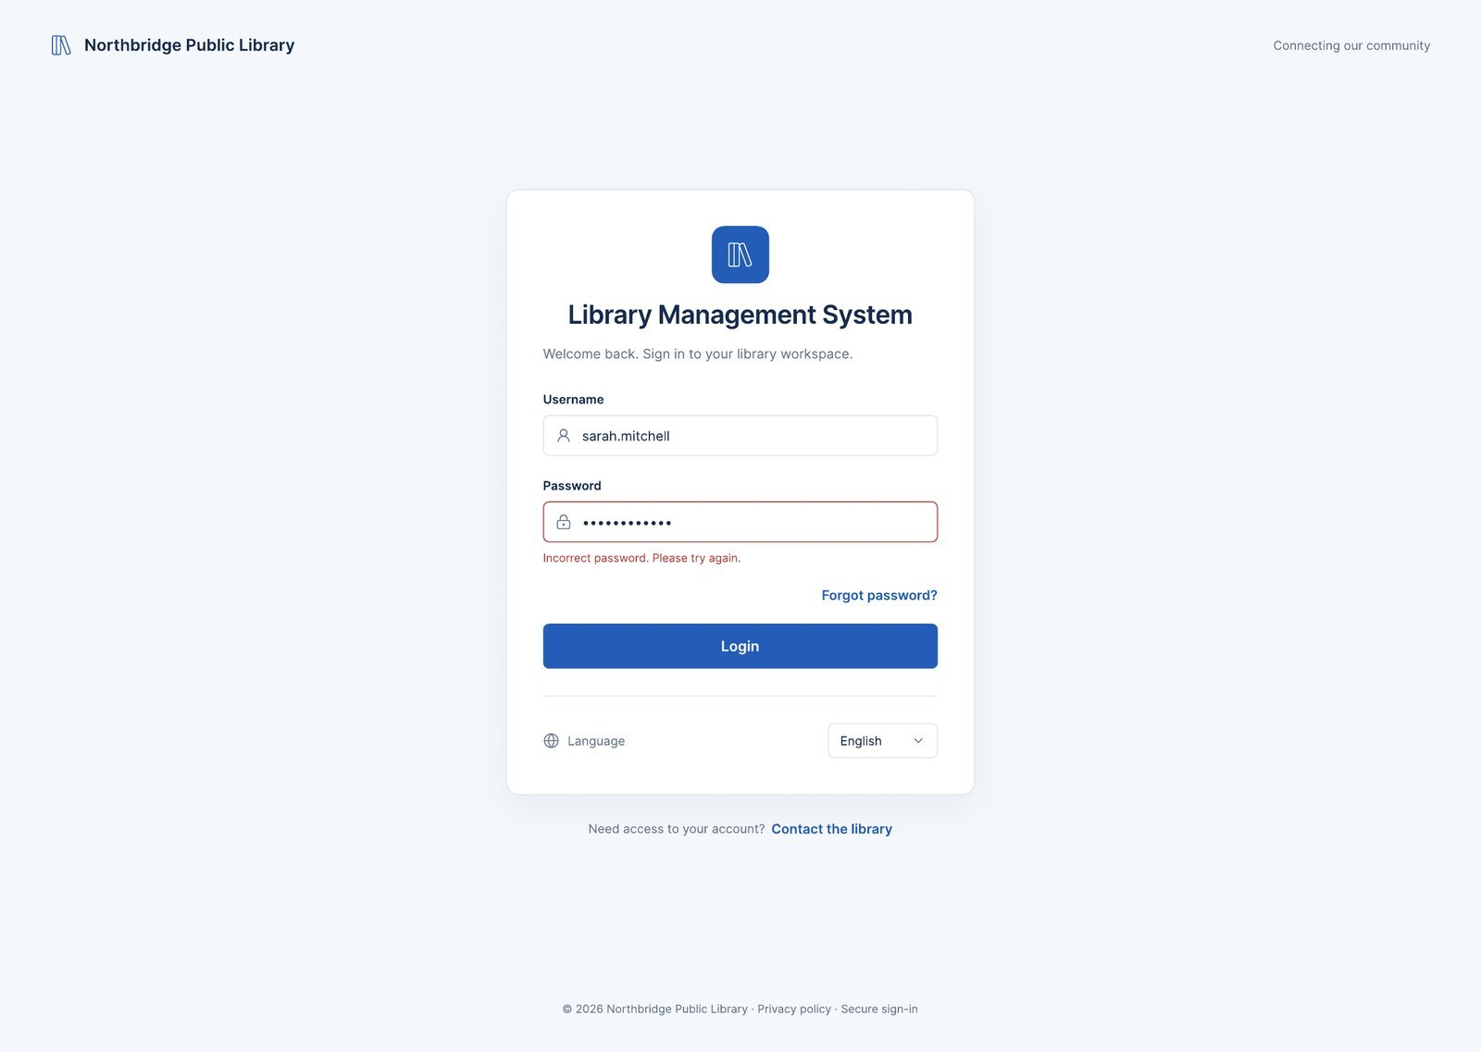
Figure 7. S01 Login.
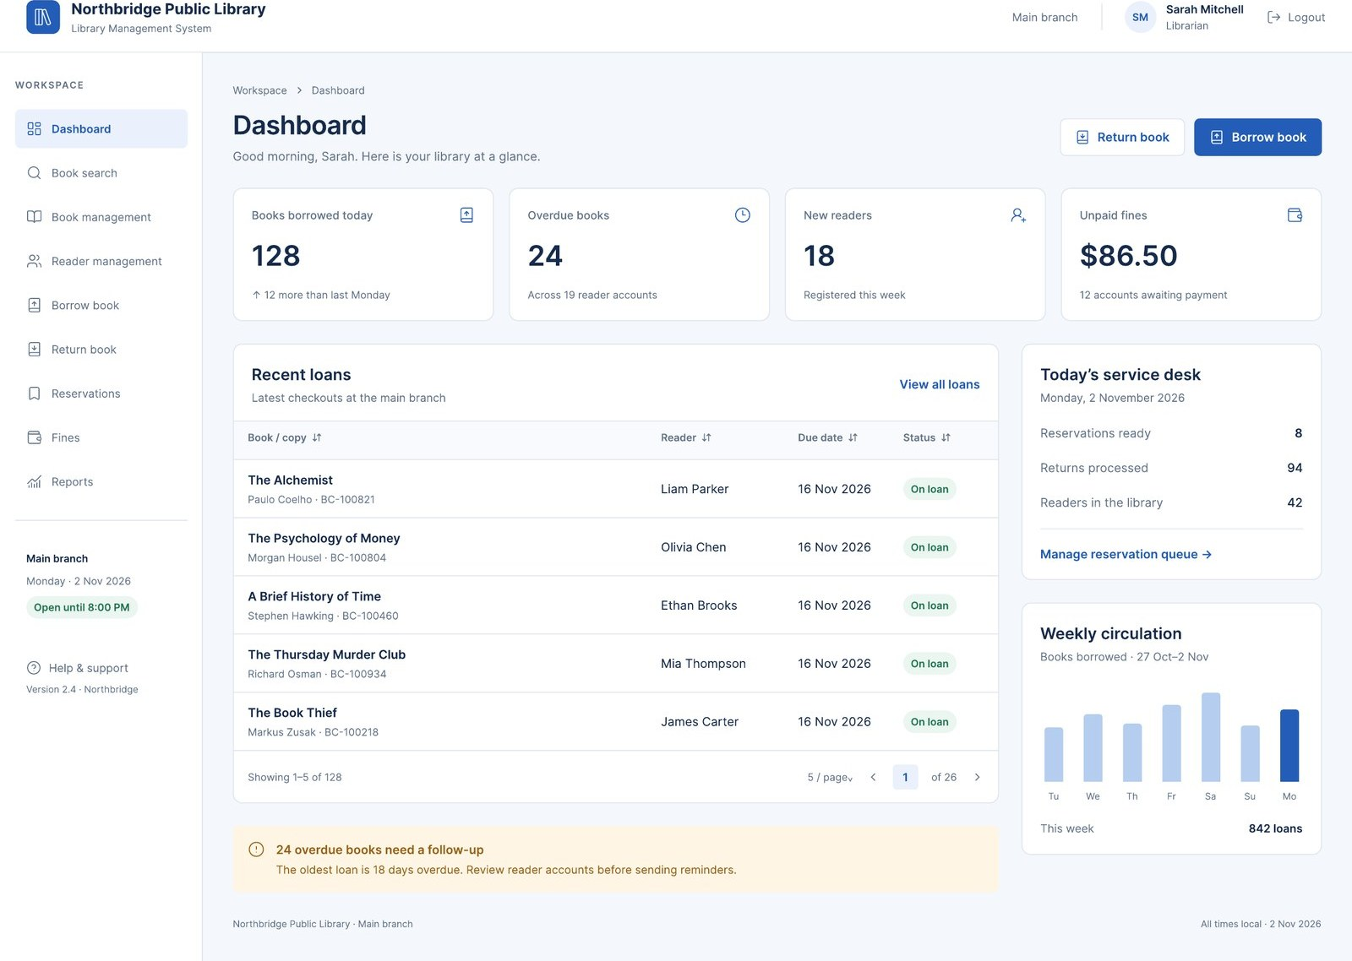
Figure 8. S02 Dashboard (Librarian).
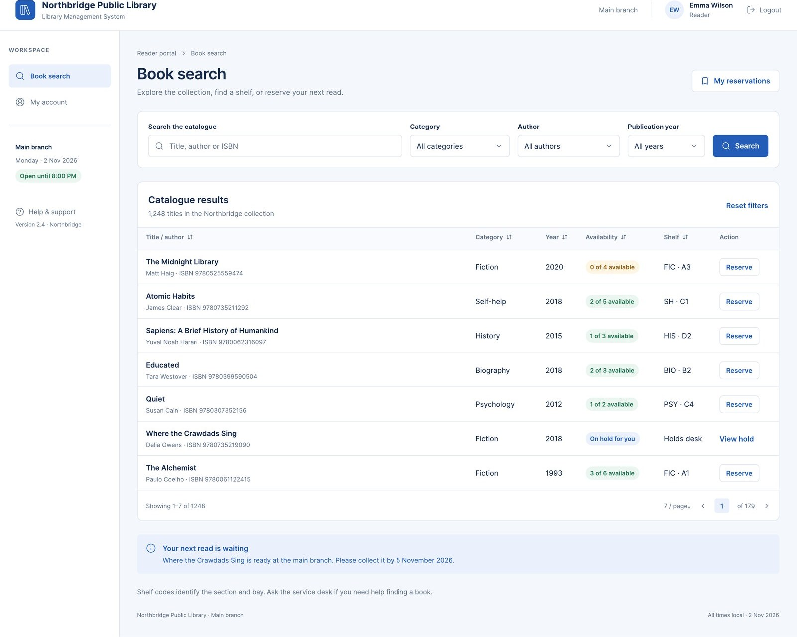
Figure 9. S03 Book search (Reader).
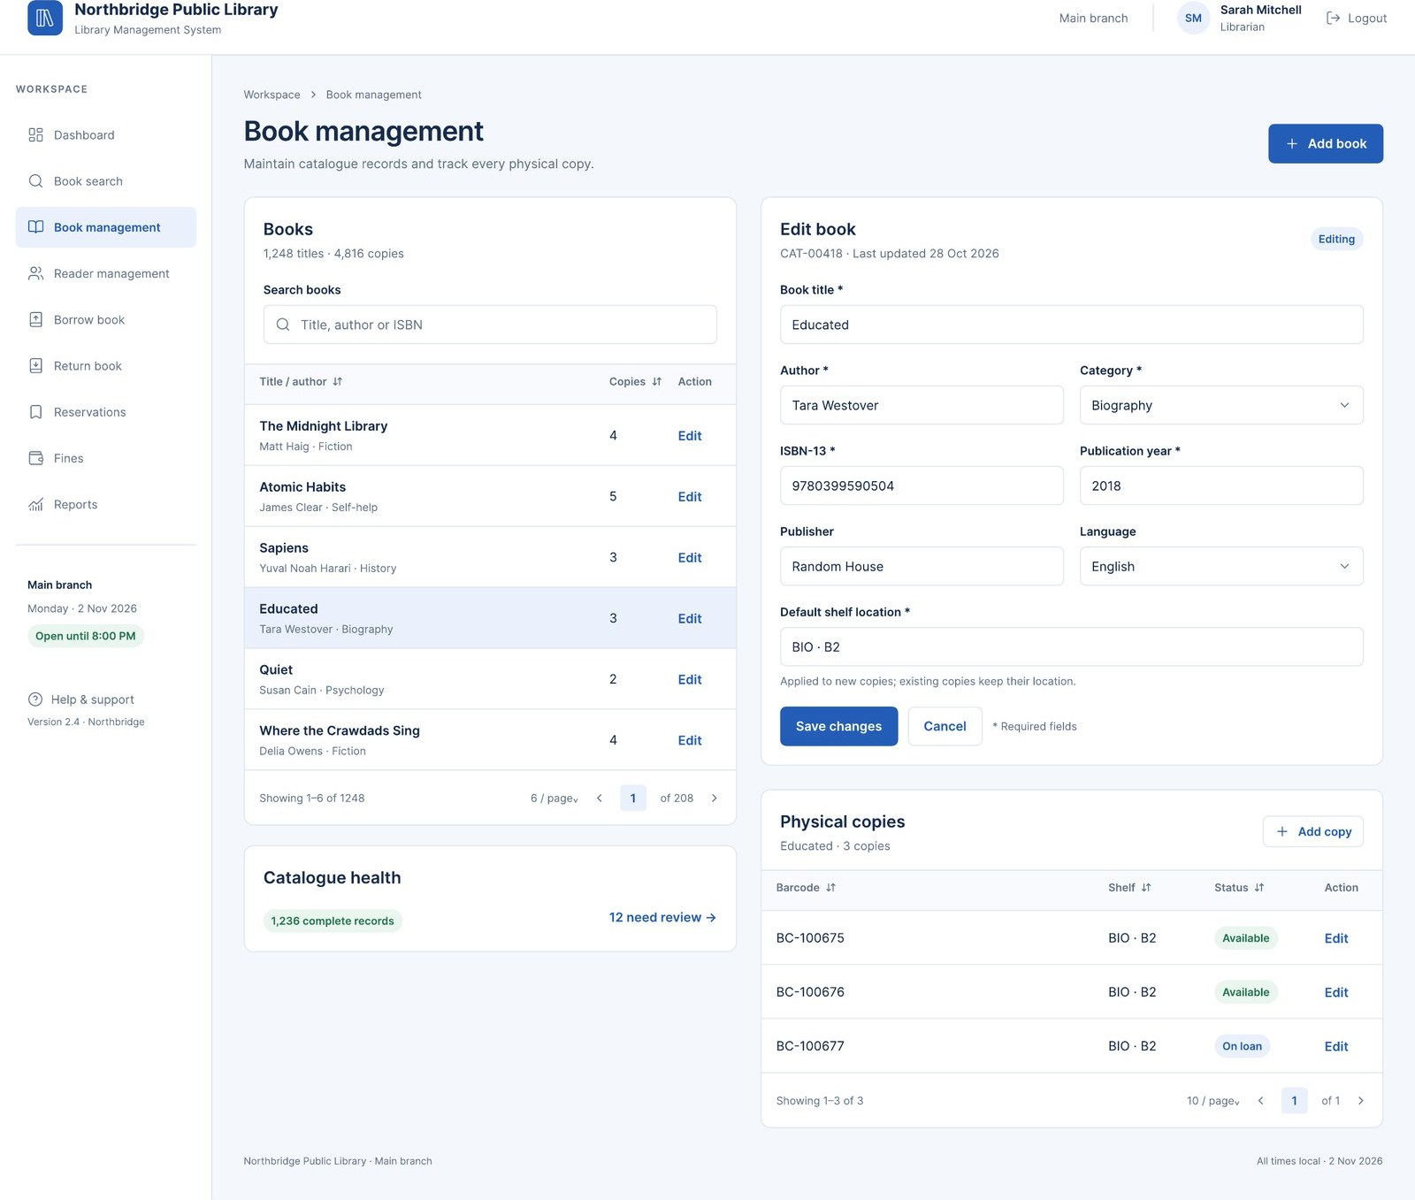
Figure 10. S04 Book management.
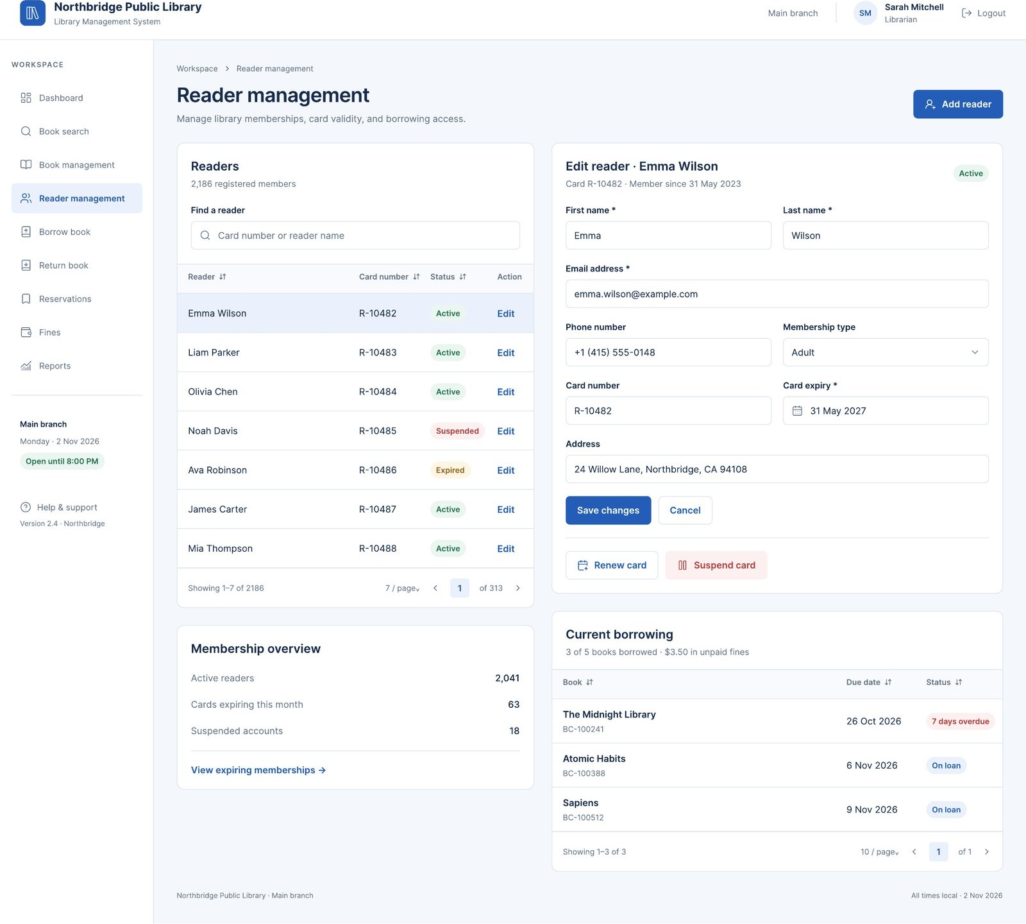
Figure 11. S05 Reader management.
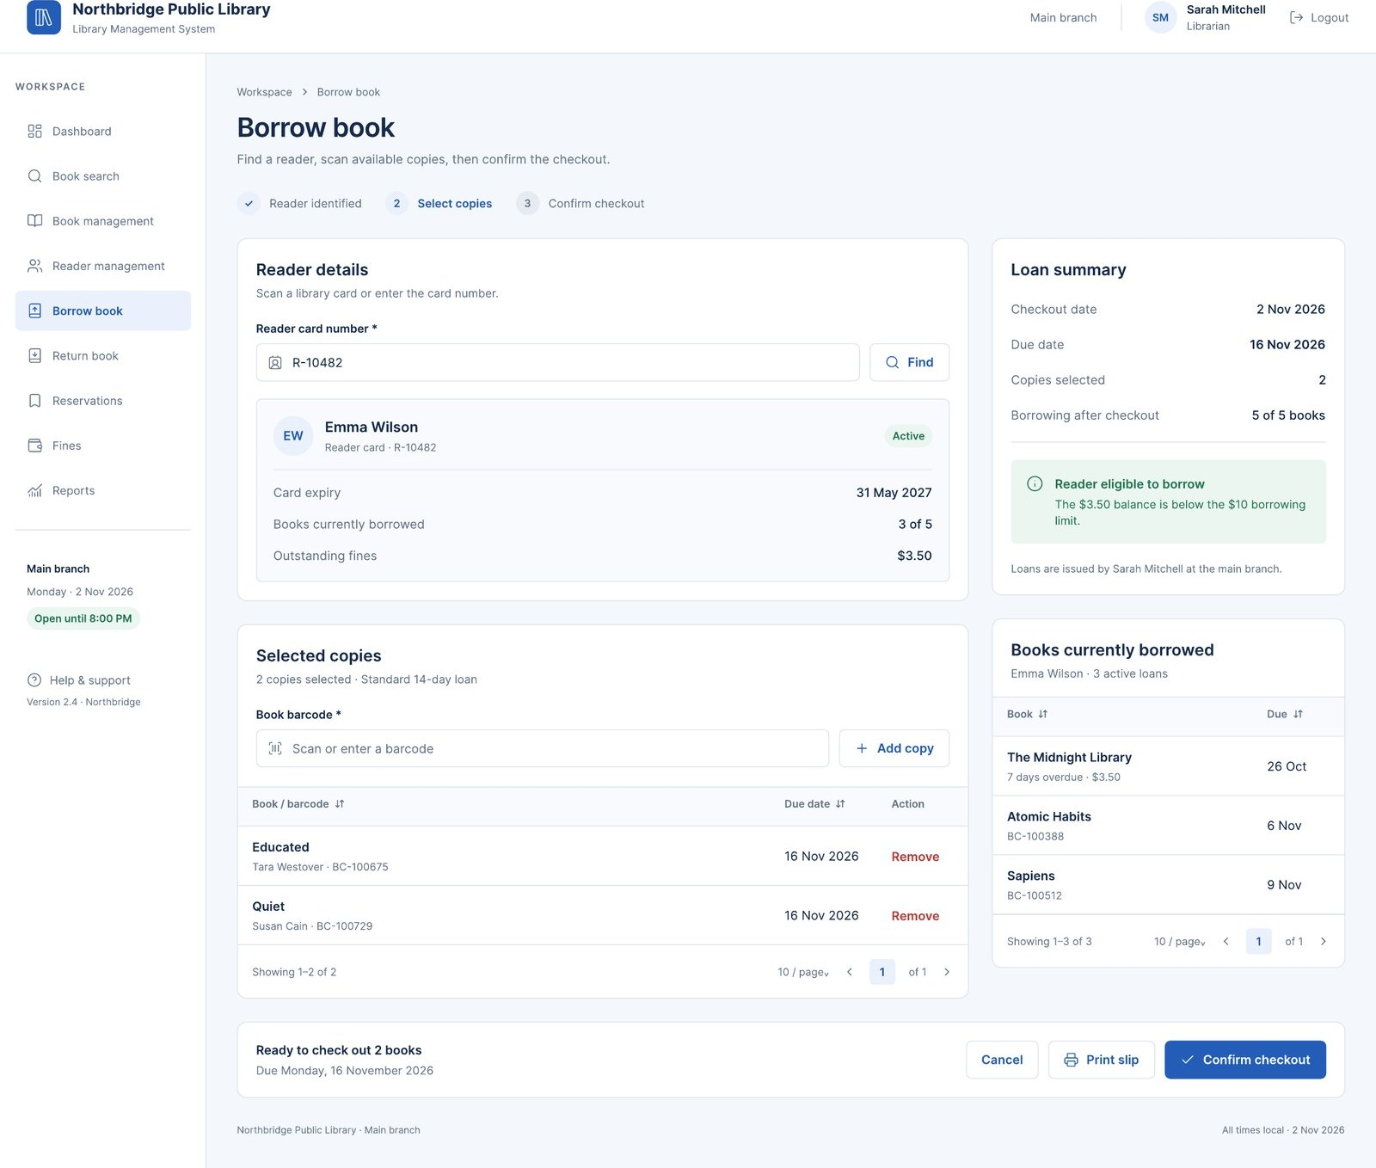
Figure 12. S06 Borrow book.
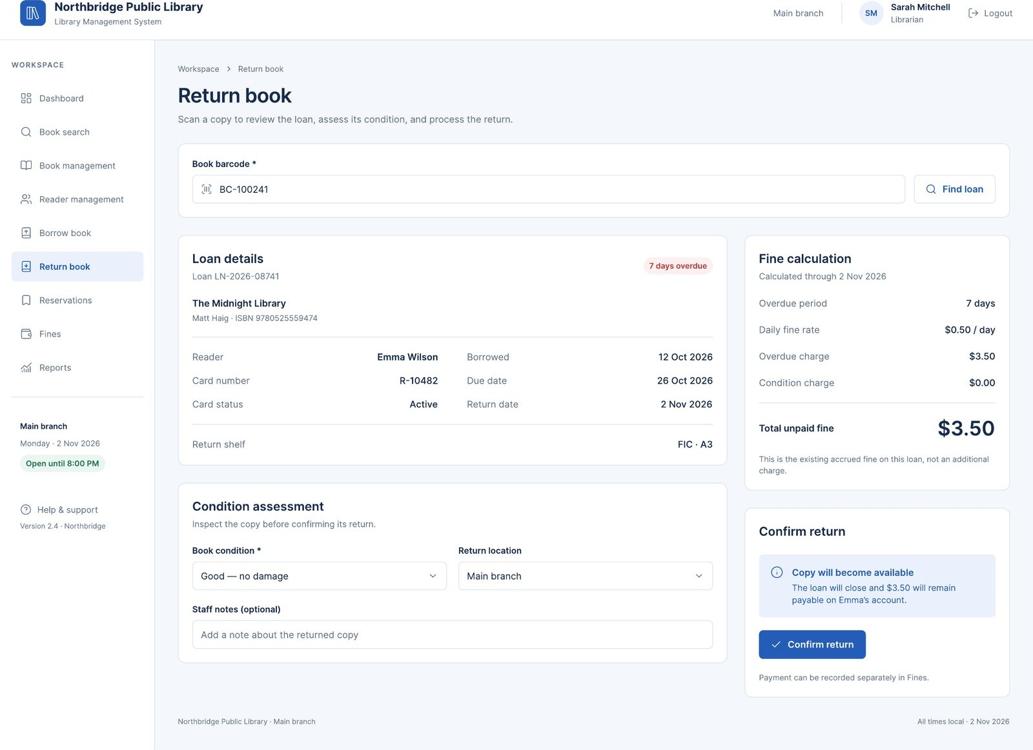
Figure 13. S07 Return book.
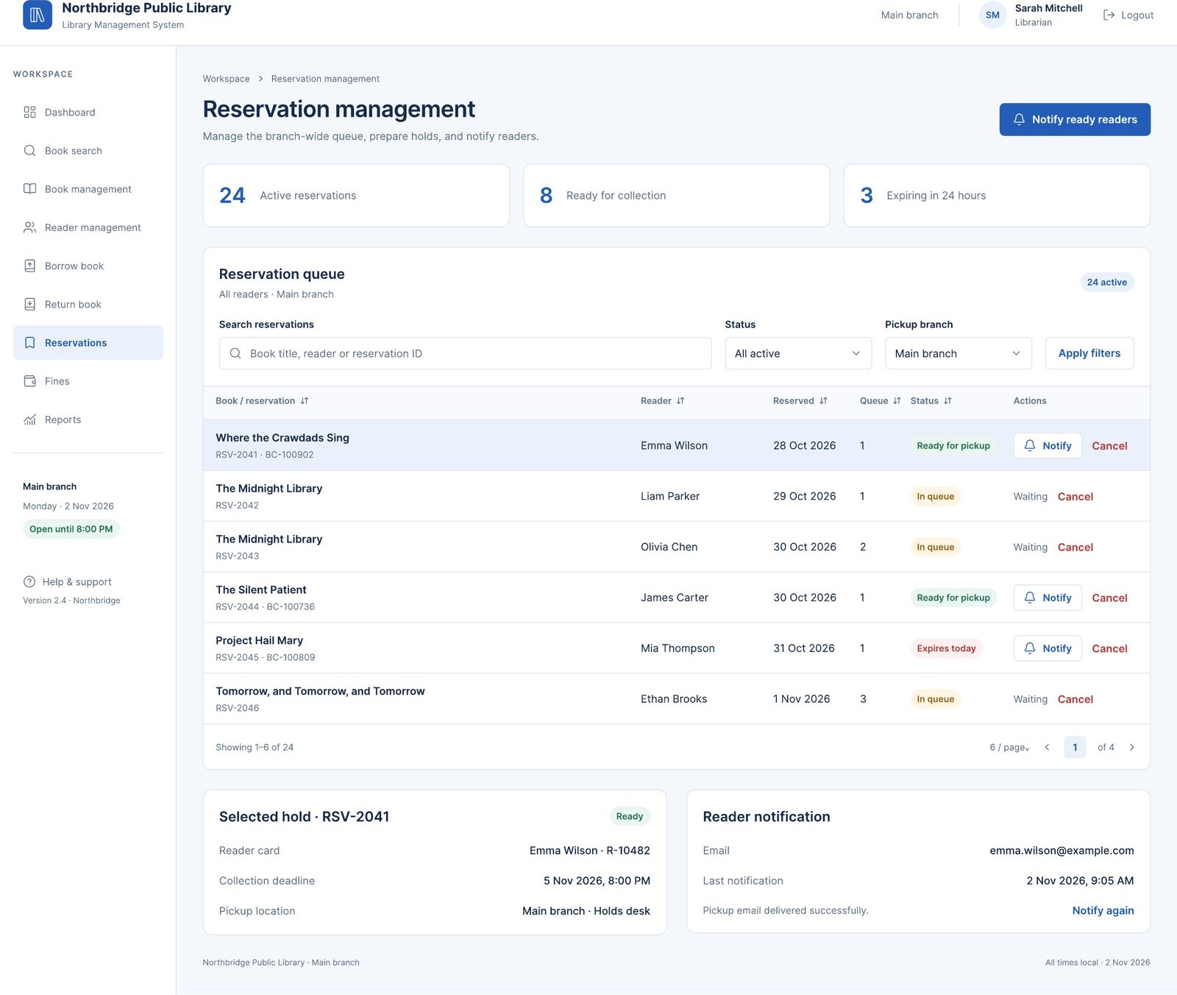
Figure 14. S08 Reservation management.
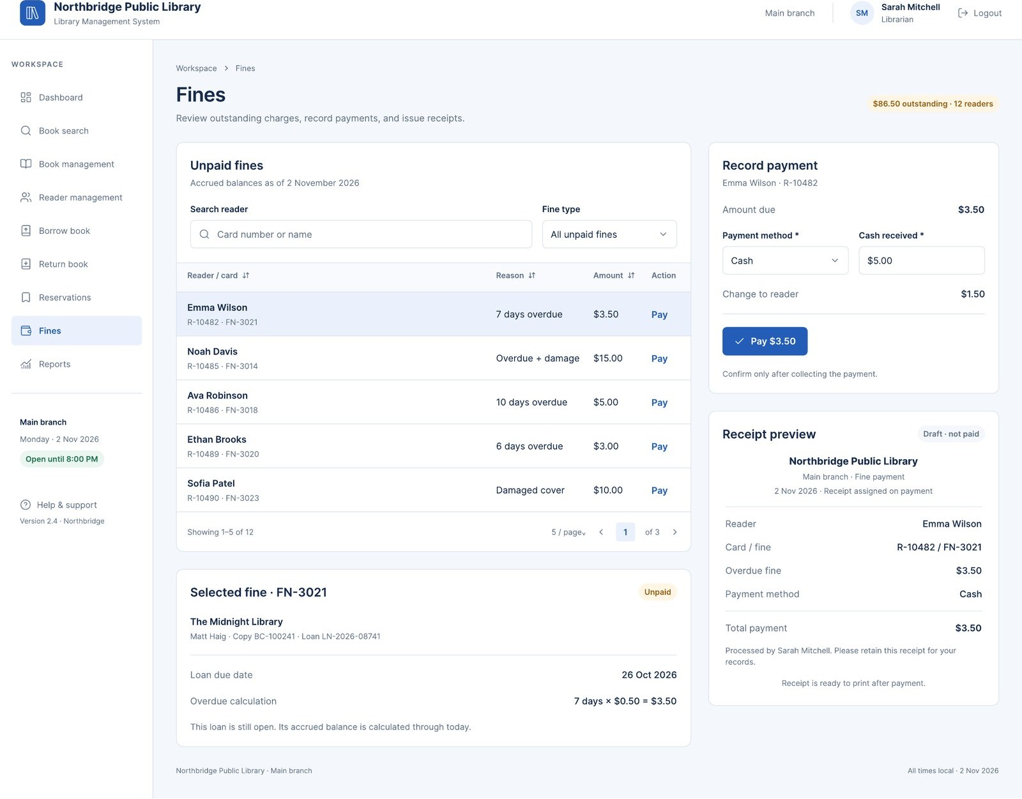
Figure 15. S09 Fines.
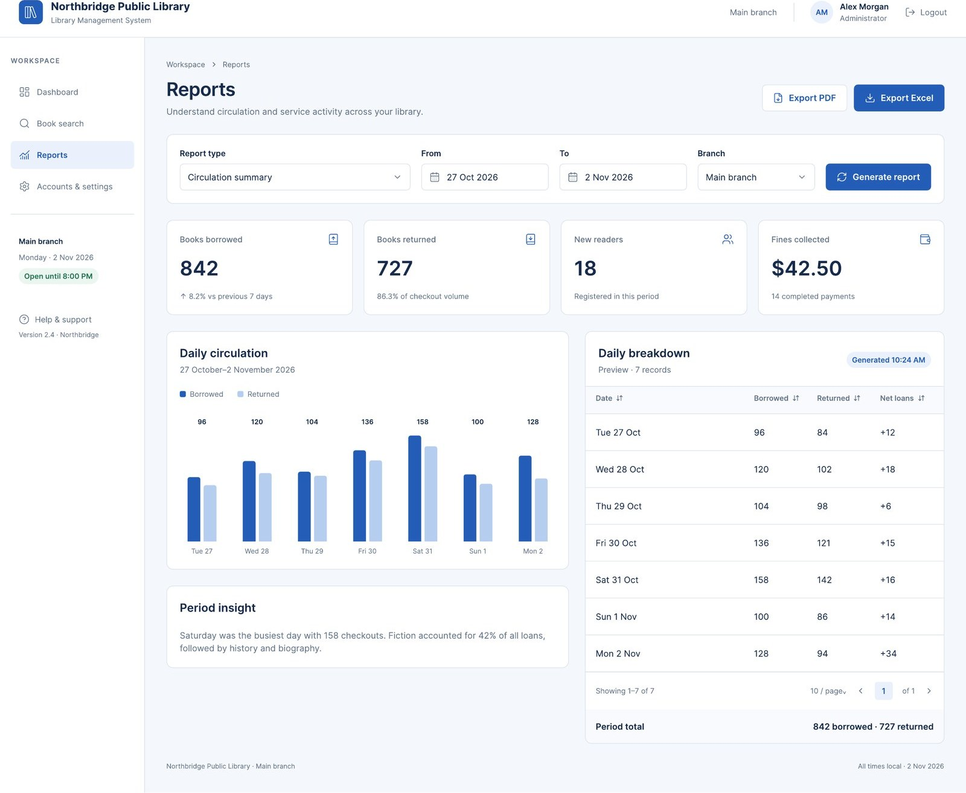
Figure 16. S10 Reports (Administrator).
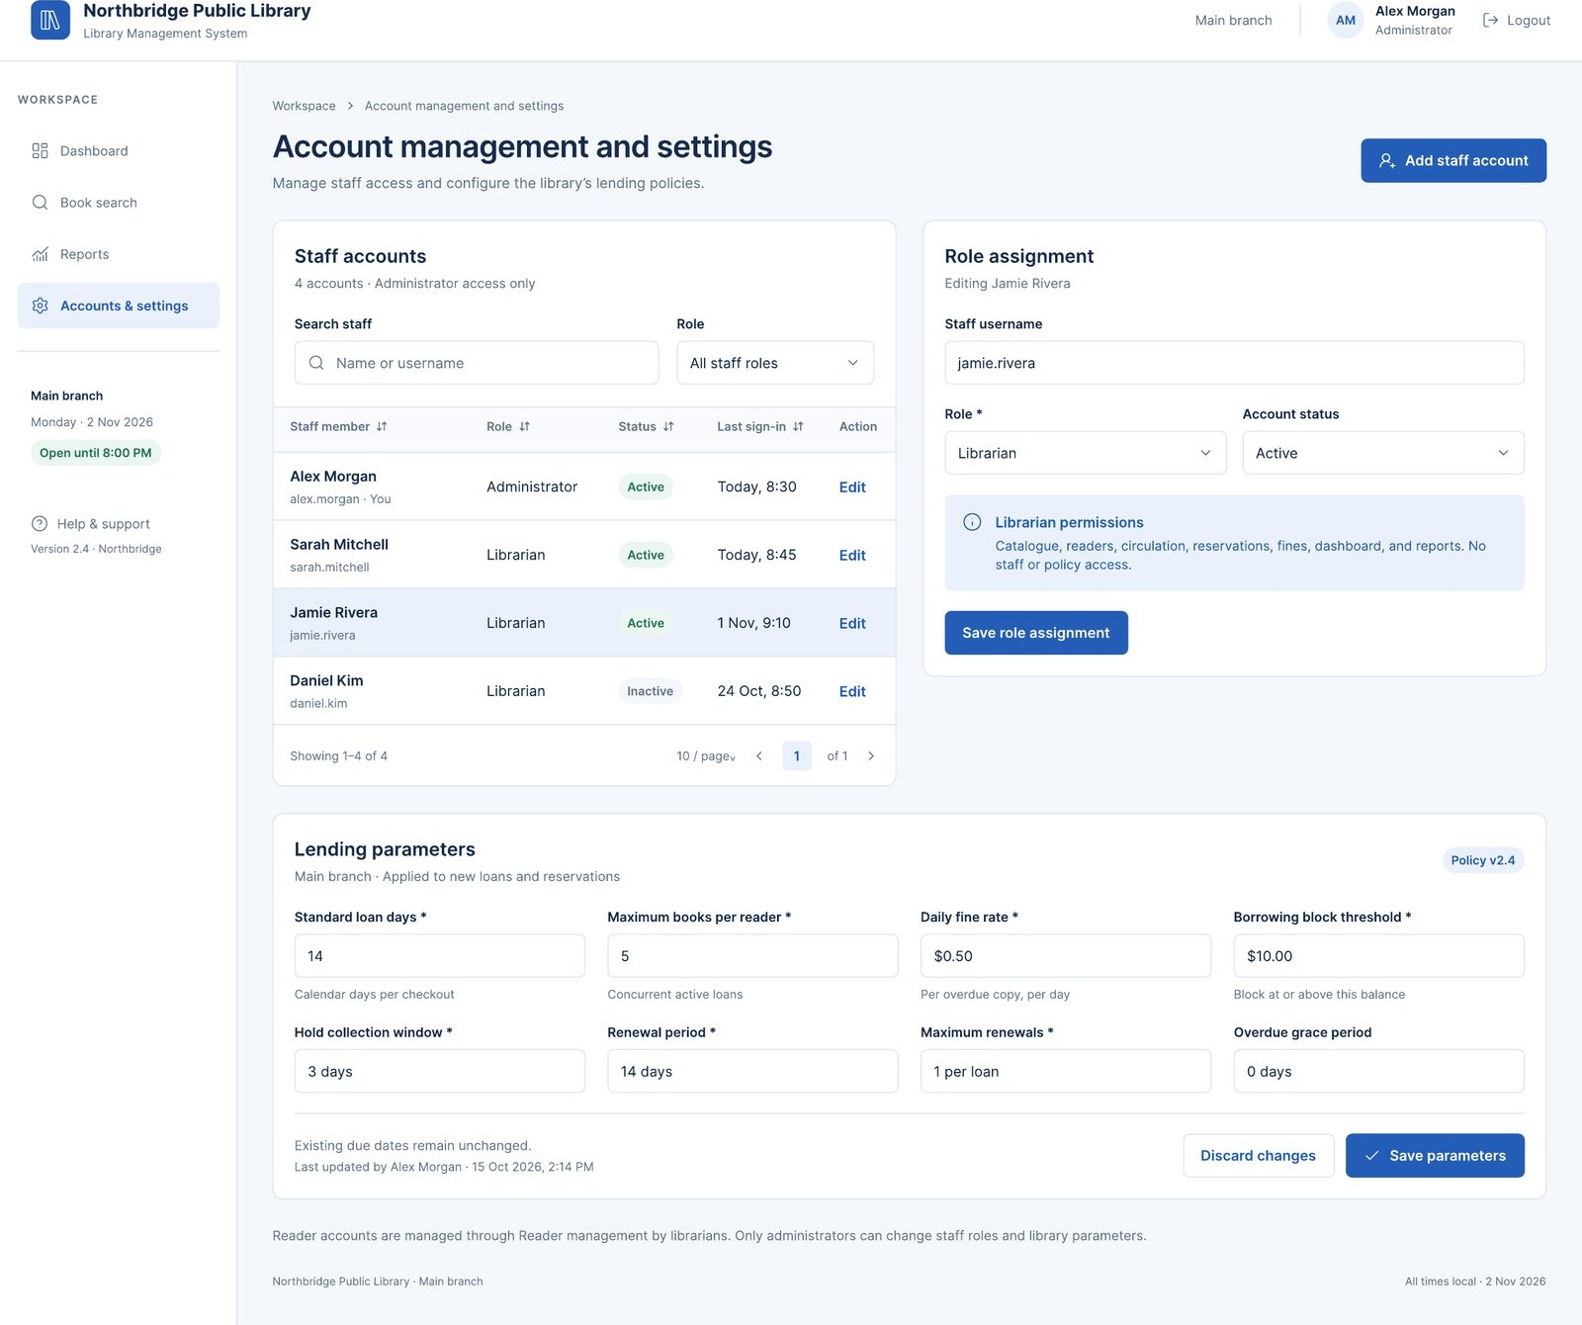
Figure 17. S11 Account management and settings (Administrator).
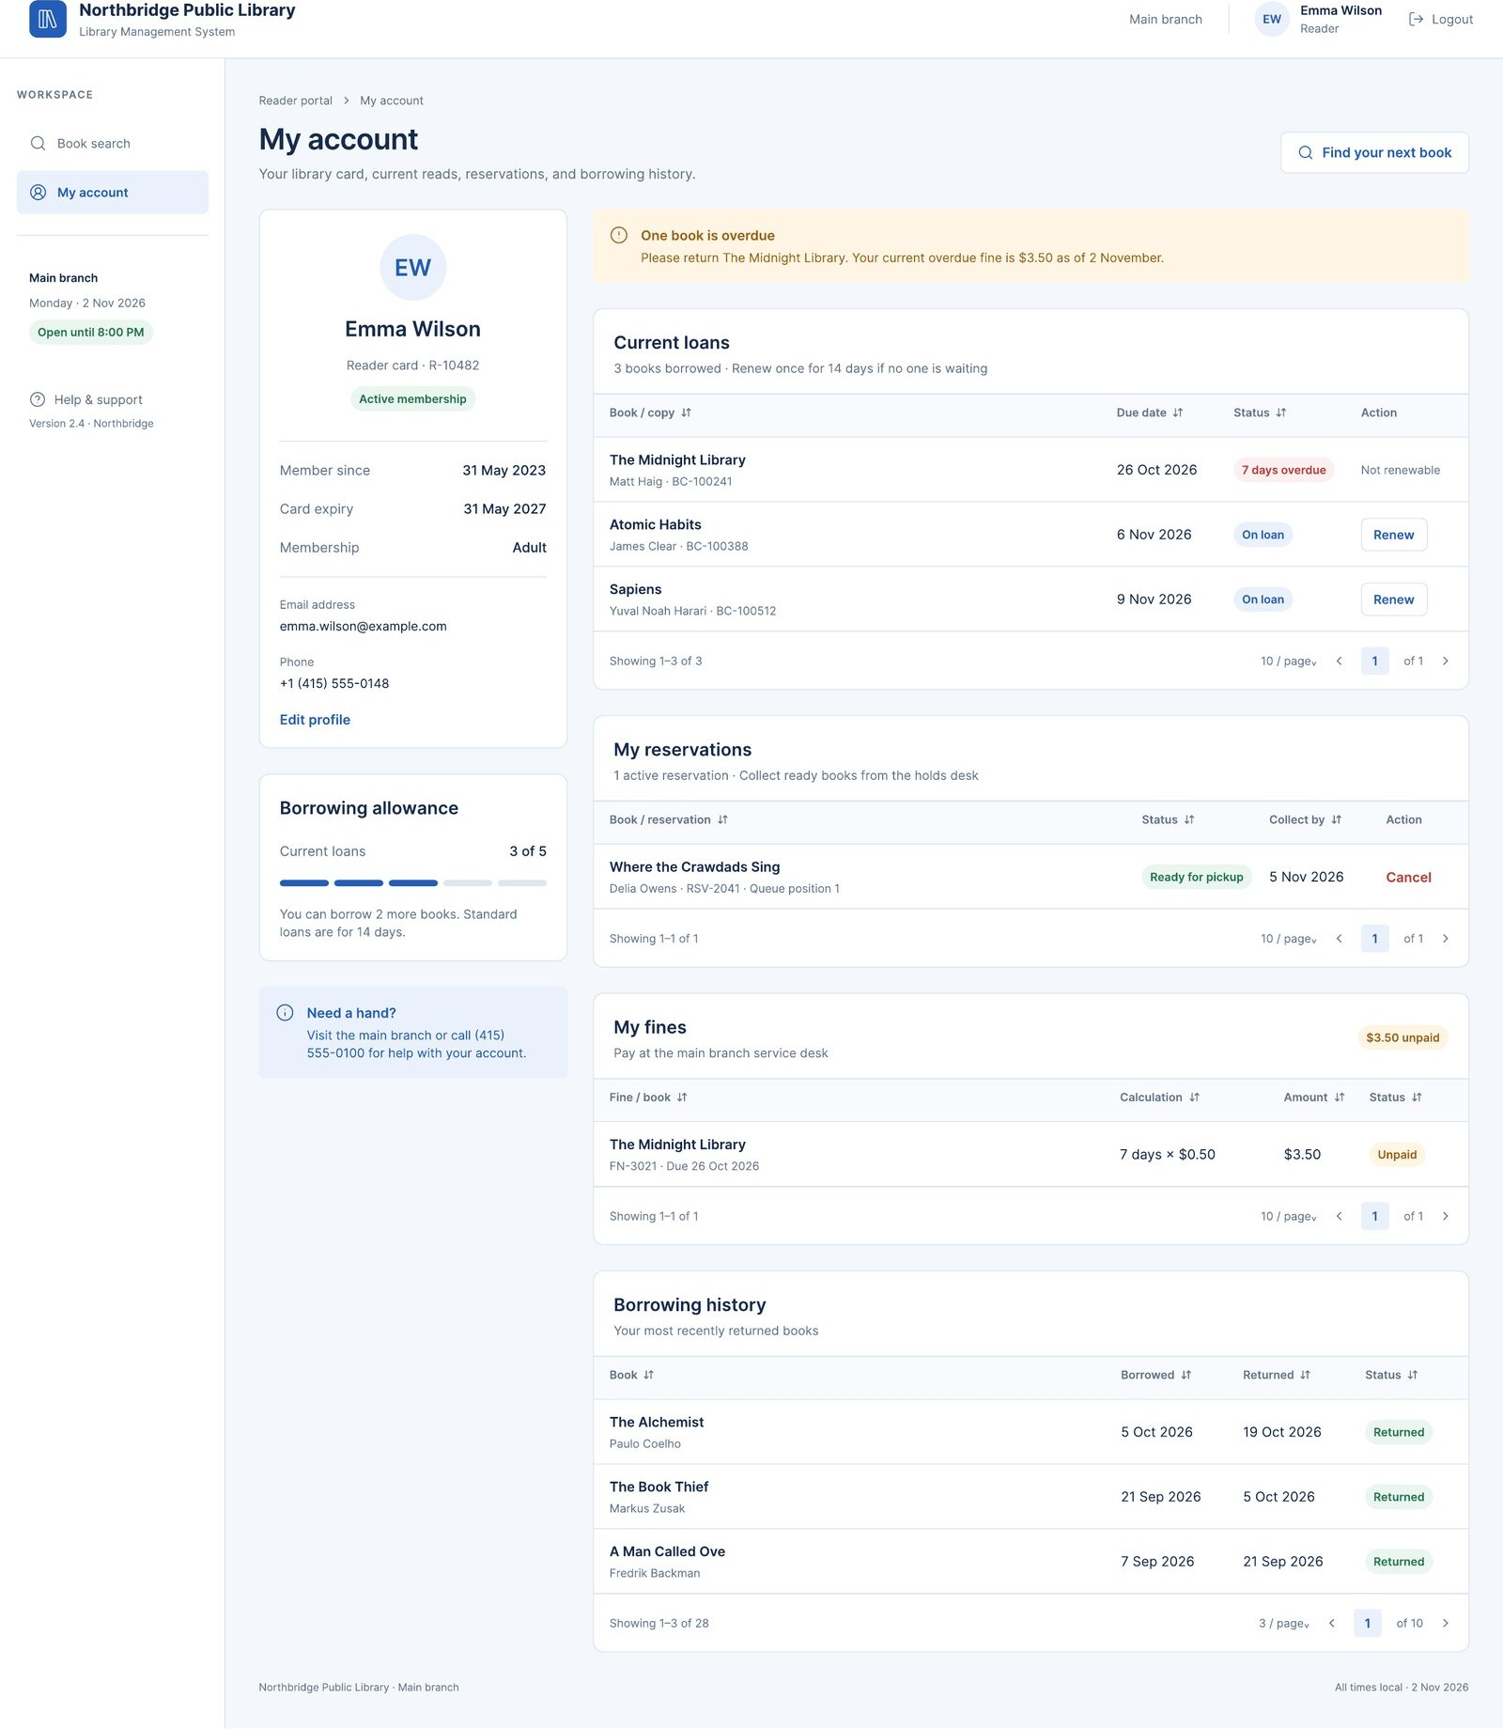
Figure 18. S12 My account (Reader).

Appendix – Software Architecture (Stage 2)
Three-tier layered architecture with the MVC pattern in the presentation tier.
Layer | Responsibility | Examples
Presentation (View + Controller) | Screens, input validation, calling services | LoginController, BorrowController, BookController
Business logic (Service / Model) | Loan limits, fine calculation, reservation queue | LoanService, BookService, ReaderService, FineService, ReservationService
Data access | CRUD through Repository/DAO | BookRepository, LoanRepository, ReaderRepository
Database | Persistent storage | MySQL / PostgreSQL

Patterns: MVC (separates interface from logic); Repository/DAO (isolates SQL); Singleton (Setting manager, connection pool); Strategy (fine calculation); Observer (notify readers when a reserved book is available); Factory (creates the User subclass at login).
Access control: the permission check accepts the role ADMIN wherever the role LIBRARIAN is required, which implements the inheritance Administrator → Librarian.
Borrow flow: BorrowView → BorrowController.handleBorrow() → LoanService.createLoan() (checks rules, reads Setting) → LoanRepository.save() and BookCopyRepository.updateStatus() in one transaction → result to the view.

