LAB 7: EVENT-DRIVEN ARCHITECTURE (EDA) & INTEGRATION
Applied to VIETCHILL Hotel Booking System

OVERVIEW

This lab introduces the Event-Driven Architecture (EDA) pattern applied to the VIETCHILL Hotel Booking system, focusing on asynchronous communication between microservices. We will use a message broker to decouple the Booking Service (Producer) from the Notification Service (Consumer). Specifically, when a hotel administrator confirms a guest's booking, a BookingConfirmedEvent is published to RabbitMQ. The Notification Service then picks it up and simulates sending a confirmation email to the guest — without the Booking Service needing to wait for that email to be delivered.

OBJECTIVES

1. Understand the concepts of Producers, Consumers, and Message Brokers in the context of a hotel booking system.
2. Install and configure a local RabbitMQ message broker using Docker.
3. Implement the Booking Service as the event Producer, publishing BookingConfirmedEvent and BookingCancelledEvent messages.
4. Implement the Notification Service as the event Consumer, processing events and simulating email delivery to guests.
5. Demonstrate the decoupled, non-blocking nature of the two services.

TECHNOLOGY & TOOL INSTALLATION

Tool | Purpose / Setup
RabbitMQ | The Message Broker that holds and routes booking events. Run via Docker: docker run -d --hostname rabbitmq-host --name rabbitmq -p 5672:5672 -p 15672:15672 rabbitmq:3-management
Python 3.x | Core programming language. Ensure Python 3 is installed.
Pika | Python client library for connecting to RabbitMQ. Run: pip install pika
Two Separate Terminals | One terminal for the Booking Service (Producer) and one for the Notification Service (Consumer) running concurrently.

ARCHITECTURE OVERVIEW

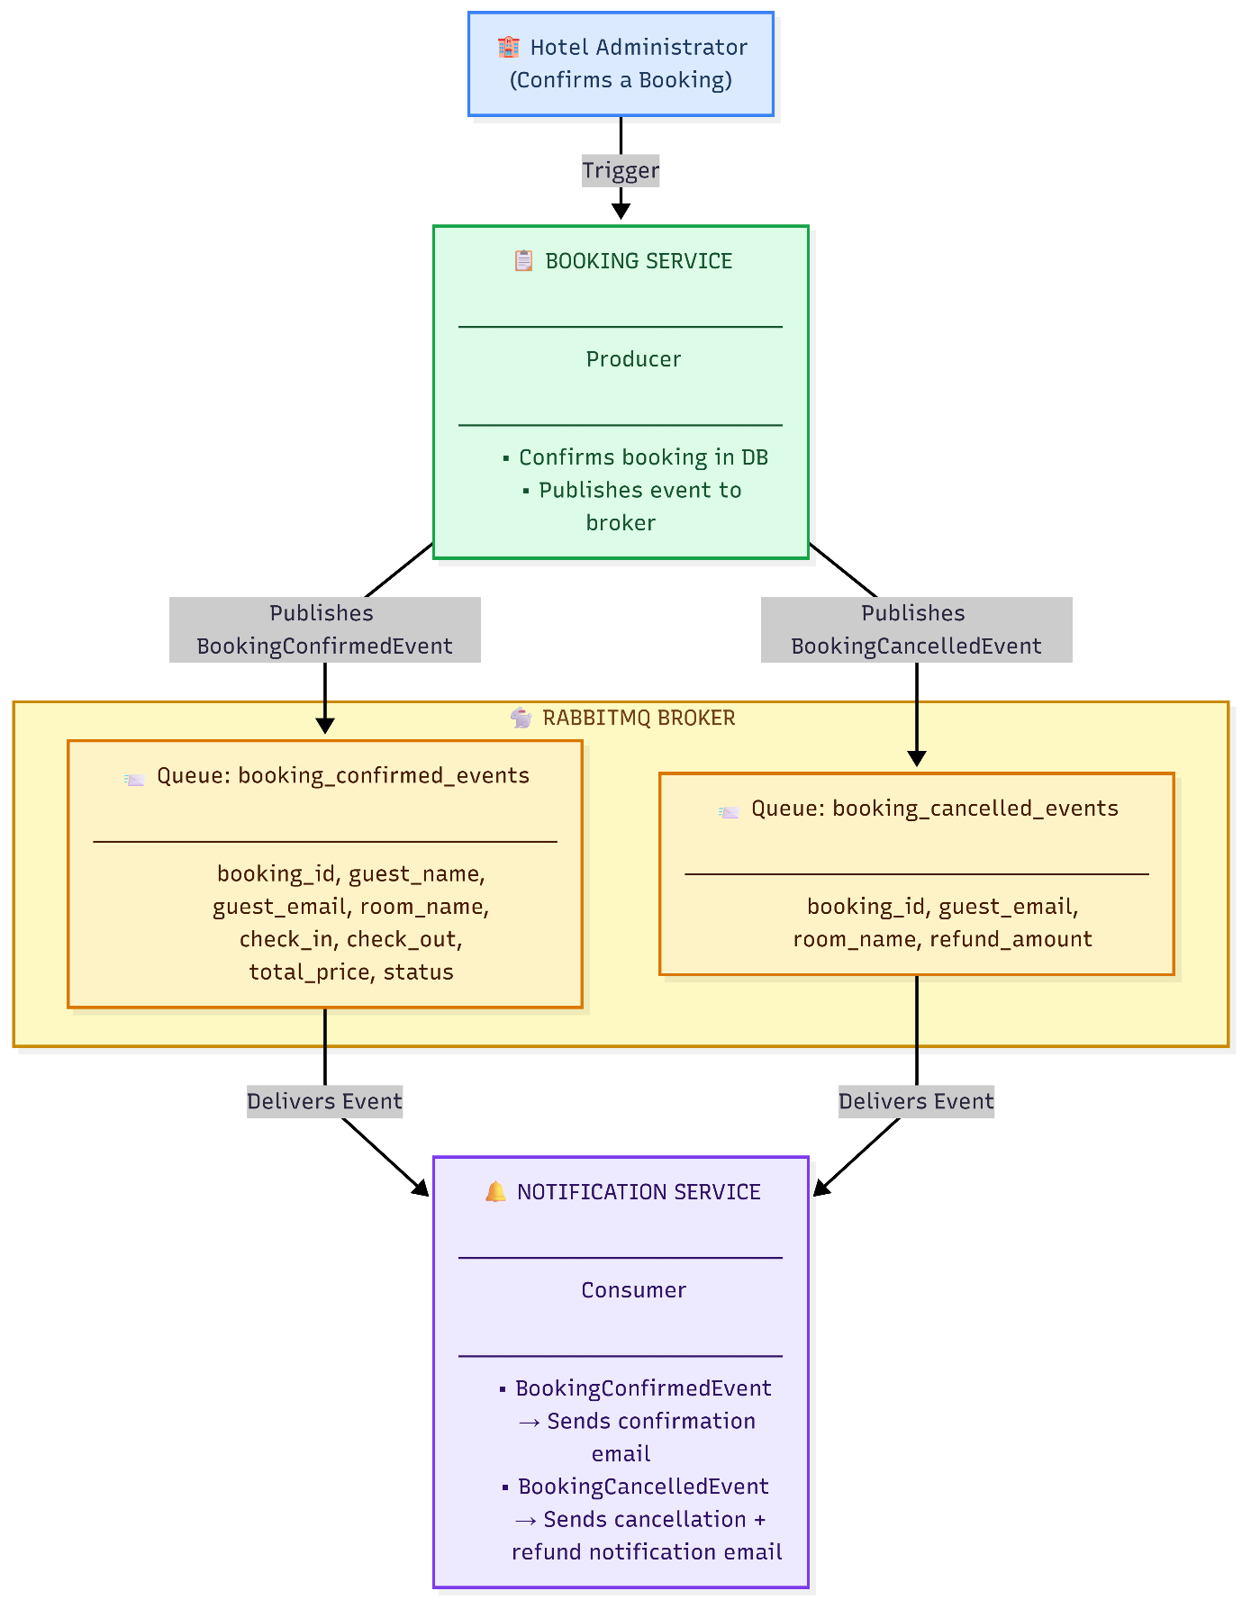

KEY PRINCIPLE: The Booking Service publishes the event and immediately continues. It does NOT wait for the email to be sent. If the Notification Service is offline, messages safely queue in RabbitMQ until it comes back online.

EVENT TYPES:
BookingConfirmedEvent → Queue: booking_confirmed_events
BookingCancelledEvent → Queue: booking_cancelled_events

════════════════════════════════════════════════════════════════
ACTIVITY PRACTICE 1: SETUP AND BROKER CONNECTION
════════════════════════════════════════════════════════════════

Goal: Ensure RabbitMQ is running and set up the project structure with the shared configuration.
STEP 1 – Start RabbitMQ
Run the following Docker command to start RabbitMQ with the management plugin enabled:
docker run -d --hostname rabbitmq-host --name rabbitmq -p 5672:5672 -p 15672:15672 rabbitmq:3-management
Verify RabbitMQ is running by opening the management console in your browser at http://localhost:15672 and logging in with the default credentials (username: guest, password: guest). You should see the RabbitMQ dashboard with no queues yet.

STEP 2 – Create Project Structure

mkdir vietchill_eda
cd vietchill_eda
python -m venv venv
source venv/bin/activate # Windows: venv\Scripts\activate
pip install pika
touch booking_service_producer.py
touch notification_service_consumer.py
STEP 3 – Define Shared Configuration

Add the following configuration block to the top of both Python files. This defines the connection details and queue names used throughout the lab.

Configuration (Add to both files):

RABBITMQ_HOST = 'localhost'

# Queue for confirmed booking events (admin approves a booking)
QUEUE_CONFIRMED = 'booking_confirmed_events'

# Queue for cancelled booking events (guest or admin cancels)
QUEUE_CANCELLED = 'booking_cancelled_events'

════════════════════════════════════════════════════════════════
ACTIVITY PRACTICE 2: BOOKING SERVICE (EVENT PRODUCER)
════════════════════════════════════════════════════════════════

Goal: Simulate the Booking Service confirming and cancelling bookings, then publishing the corresponding events to the appropriate RabbitMQ queues.

STEP 1 – Implement the Producer Logic
The Producer connects to RabbitMQ, declares both queues to ensure they exist, then publishes JSON event messages. It simulates two types of hotel operations: a booking confirmation (when admin approves a guest's reservation) and a booking cancellation (when a guest or admin cancels).
File: booking_service_producer.py

import pika
import json
import time

RABBITMQ_HOST = 'localhost'
QUEUE_CONFIRMED = 'booking_confirmed_events'
QUEUE_CANCELLED = 'booking_cancelled_events'

# ============================================================
# HELPER: Establish connection and declare both queues
# ============================================================

def get_channel():
"""Creates a RabbitMQ connection and returns a ready-to-use channel."""
connection = pika.BlockingConnection(
pika.ConnectionParameters(host=RABBITMQ_HOST)
)
channel = connection.channel()
channel.queue_declare(queue=QUEUE_CONFIRMED)
channel.queue_declare(queue=QUEUE_CANCELLED)
return connection, channel

# ============================================================
# PRODUCER: Publish a BookingConfirmedEvent
# Triggered when: Admin approves a pending booking
# ============================================================

def publish_booking_confirmed(booking_data):
"""Publishes a BookingConfirmedEvent to the booking_confirmed_events queue."""
try:
connection, channel = get_channel()

event = {
"event_type": "BookingConfirmedEvent",
"booking_id": booking_data["booking_id"],
"guest_name": booking_data["guest_name"],
"guest_email": booking_data["guest_email"],
"room_name": booking_data["room_name"],
"check_in": booking_data["check_in"],
"check_out": booking_data["check_out"],
"total_price": booking_data["total_price"],
"status": "booked",
"timestamp": time.time()
}

channel.basic_publish(
exchange='',
routing_key=QUEUE_CONFIRMED,
body=json.dumps(event)
)

print(f" [x] Booking Service published BookingConfirmedEvent "
f"→ Booking ID: {booking_data['booking_id']} "
f"| Guest: {booking_data['guest_name']}")
connection.close()

except pika.exceptions.AMQPConnectionError as e:
print(f" [!] Connection Error: Could not connect to RabbitMQ. Is it running? {e}")

# ============================================================
# PRODUCER: Publish a BookingCancelledEvent
# Triggered when: Guest or admin cancels a confirmed booking
# ============================================================

def publish_booking_cancelled(booking_data):
"""Publishes a BookingCancelledEvent to the booking_cancelled_events queue."""
try:
connection, channel = get_channel()

event = {
"event_type": "BookingCancelledEvent",
"booking_id": booking_data["booking_id"],
"guest_name": booking_data["guest_name"],
"guest_email": booking_data["guest_email"],
"room_name": booking_data["room_name"],
"refund_amount": booking_data["total_price"],
"status": "cancelled",
"timestamp": time.time()
}

channel.basic_publish(
exchange='',
routing_key=QUEUE_CANCELLED,
body=json.dumps(event)
)

print(f" [x] Booking Service published BookingCancelledEvent "
f"→ Booking ID: {booking_data['booking_id']} "
f"| Refund: {booking_data['total_price']:,} VND")
connection.close()

except pika.exceptions.AMQPConnectionError as e:
print(f" [!] Connection Error: Could not connect to RabbitMQ. Is it running? {e}")

# ============================================================
# MAIN: Simulate hotel booking operations
# ============================================================

if __name__ == '__main__':
print("=" * 55)
print(" VIETCHILL Booking Service (Producer) starting...")
print("=" * 55)

# Simulate 3 bookings being confirmed by admin
confirmed_bookings = [
{
"booking_id": "BK-001",
"guest_name": "Nguyen Van A",
"guest_email": "nguyenvana@email.com",
"room_name": "Deluxe King Room",
"check_in": "2025-08-10",
"check_out": "2025-08-13",
"total_price": 3600000
},
{
"booking_id": "BK-002",
"guest_name": "Tran Thi B",
"guest_email": "tranthib@email.com",
"room_name": "Superior Twin Room",
"check_in": "2025-08-15",
"check_out": "2025-08-17",
"total_price": 1800000
},
{
"booking_id": "BK-003",
"guest_name": "Le Van C",
"guest_email": "levanc@email.com",
"room_name": "Suite Ocean View",
"check_in": "2025-08-20",
"check_out": "2025-08-25",
"total_price": 17500000
}
]

print("\n--- Admin is confirming bookings ---")
for booking in confirmed_bookings:
publish_booking_confirmed(booking)
time.sleep(1)

# Simulate 1 cancellation
print("\n--- Guest is cancelling a booking ---")
cancelled_booking = {
"booking_id": "BK-002",
"guest_name": "Tran Thi B",
"guest_email": "tranthib@email.com",
"room_name": "Superior Twin Room",
"total_price": 1800000
}
publish_booking_cancelled(cancelled_booking)

print("\n [✔] All events published. Booking Service is done.")
print(" Notification Service will process them asynchronously.")

════════════════════════════════════════════════════════════════
ACTIVITY PRACTICE 3: NOTIFICATION SERVICE (EVENT CONSUMER)
════════════════════════════════════════════════════════════════

Goal: Implement the Notification Service. It listens continuously on both queues and processes each event by simulating the sending of an appropriate email to the guest.

STEP 1 – Implement the Consumer Logic

The Consumer connects to RabbitMQ, registers separate callback functions for each queue, and enters a continuous listening loop. Each callback simulates the email delivery logic appropriate to the event type.

File: notification_service_consumer.py

import pika
import json
import time

RABBITMQ_HOST = 'localhost'
QUEUE_CONFIRMED = 'booking_confirmed_events'
QUEUE_CANCELLED = 'booking_cancelled_events'

# ============================================================
# CALLBACK: Handle BookingConfirmedEvent
# ============================================================

def on_booking_confirmed(ch, method, properties, body):
"""Processes a confirmed booking event and simulates sending a confirmation email."""
try:
event = json.loads(body)

print("\n ─────────────────────────────────────────")
print(f" [→] Received: BookingConfirmedEvent")
print(f" Booking ID : {event.get('booking_id')}")
print(f" Guest : {event.get('guest_name')}")
print(f" Room : {event.get('room_name')}")
print(f" Check-in : {event.get('check_in')}")
print(f" Check-out : {event.get('check_out')}")
print(f" Total : {event.get('total_price'):,} VND")

# Simulate email processing time
print(f" [~] Sending confirmation email to {event.get('guest_email')}...")
time.sleep(1)

print(f" [✔] EMAIL SENT: Booking confirmation for {event.get('guest_name')} "
f"→ {event.get('guest_email')}")
print(f" Subject: Your reservation at VIETCHILL is confirmed!")
print(" ─────────────────────────────────────────")

# Acknowledge the message: tells RabbitMQ it was processed successfully
ch.basic_ack(delivery_tag=method.delivery_tag)

except json.JSONDecodeError:
print(f" [!] Error decoding message: {body}")
ch.basic_reject(delivery_tag=method.delivery_tag, requeue=False)

# ============================================================
# CALLBACK: Handle BookingCancelledEvent
# ============================================================

def on_booking_cancelled(ch, method, properties, body):
"""Processes a cancellation event and simulates sending a refund notification email."""
try:
event = json.loads(body)

print("\n ─────────────────────────────────────────")
print(f" [→] Received: BookingCancelledEvent")
print(f" Booking ID : {event.get('booking_id')}")
print(f" Guest : {event.get('guest_name')}")
print(f" Room : {event.get('room_name')}")
print(f" Refund Amount : {event.get('refund_amount'):,} VND")

# Simulate refund notification email
print(f" [~] Sending cancellation + refund email to {event.get('guest_email')}...")
time.sleep(1)

print(f" [✔] EMAIL SENT: Cancellation notice for {event.get('guest_name')} "
f"→ {event.get('guest_email')}")
print(f" Subject: Your VIETCHILL booking has been cancelled. "
f"Refund of {event.get('refund_amount'):,} VND is being processed.")
print(" ─────────────────────────────────────────")

ch.basic_ack(delivery_tag=method.delivery_tag)

except json.JSONDecodeError:
print(f" [!] Error decoding message: {body}")
ch.basic_reject(delivery_tag=method.delivery_tag, requeue=False)

# ============================================================
# MAIN: Start listening on both queues
# ============================================================

if __name__ == '__main__':
try:
print("=" * 55)
print(" VIETCHILL Notification Service (Consumer)")
print(" Connecting to RabbitMQ...")
print("=" * 55)

connection = pika.BlockingConnection(
pika.ConnectionParameters(host=RABBITMQ_HOST)
)
channel = connection.channel()

# Declare both queues (idempotent)
channel.queue_declare(queue=QUEUE_CONFIRMED)
channel.queue_declare(queue=QUEUE_CANCELLED)

# Prefetch limit: process one message at a time
channel.basic_qos(prefetch_count=1)

# Register callbacks for each queue
channel.basic_consume(
queue=QUEUE_CONFIRMED,
on_message_callback=on_booking_confirmed
)
channel.basic_consume(
queue=QUEUE_CANCELLED,
on_message_callback=on_booking_cancelled
)

print("\n [*] Waiting for booking events from VIETCHILL...")
print(" Listening on queues:")
print(f" - {QUEUE_CONFIRMED}")
print(f" - {QUEUE_CANCELLED}")
print(" Press CTRL+C to stop.\n")

channel.start_consuming()

except pika.exceptions.AMQPConnectionError as e:
print(f" [!] Connection Error: Could not connect to RabbitMQ. Is it running? {e}")
except KeyboardInterrupt:
print("\n [*] Notification Service shutting down gracefully.")

COMPLETE FILE STRUCTURE

vietchill_eda/
├── venv/
├── booking_service_producer.py ← Publishes booking events
└── notification_service_consumer.py ← Processes events, sends emails

════════════════════════════════════════════════════════════════
ACTIVITY PRACTICE 4: TESTING ASYNCHRONOUS DECOUPLING
════════════════════════════════════════════════════════════════

Goal: Observe how the Booking Service and Notification Service operate independently, with the message broker acting as the buffer between them.

PREREQUISITES

Ensure RabbitMQ is running:

docker ps | grep rabbitmq

If not running, start it again:

docker start rabbitmq

TEST 1 – Normal Flow (Both Services Running)

Step 1: Start the Notification Service (Consumer) in Terminal 1:

cd vietchill_eda
source venv/bin/activate
python notification_service_consumer.py

Expected output in Terminal 1:

VIETCHILL Notification Service (Consumer)
Connecting to RabbitMQ...
[*] Waiting for booking events from VIETCHILL...
Listening on queues:
- booking_confirmed_events
- booking_cancelled_events
Press CTRL+C to stop.

Step 2: Run the Booking Service (Producer) in Terminal 2:

cd vietchill_eda
source venv/bin/activate
python booking_service_producer.py

Expected output in Terminal 2 (Producer):

VIETCHILL Booking Service (Producer) starting...
--- Admin is confirming bookings ---
[x] Booking Service published BookingConfirmedEvent → Booking ID: BK-001 | Guest: Nguyen Van A
[x] Booking Service published BookingConfirmedEvent → Booking ID: BK-002 | Guest: Tran Thi B
[x] Booking Service published BookingConfirmedEvent → Booking ID: BK-003 | Guest: Le Van C
--- Guest is cancelling a booking ---
[x] Booking Service published BookingCancelledEvent → Booking ID: BK-002 | Refund: 1,800,000 VND
[✔] All events published. Booking Service is done.
Notification Service will process them asynchronously.

Expected output in Terminal 1 (Consumer) — events processed one by one:

[→] Received: BookingConfirmedEvent
Booking ID : BK-001
Guest : Nguyen Van A
Room : Deluxe King Room
Check-in : 2025-08-10
Check-out : 2025-08-13
Total : 3,600,000 VND
[~] Sending confirmation email to nguyenvana@email.com...
[✔] EMAIL SENT: Booking confirmation for Nguyen Van A → nguyenvana@email.com
Subject: Your reservation at VIETCHILL is confirmed!

[→] Received: BookingConfirmedEvent
Booking ID : BK-002 ...

[→] Received: BookingCancelledEvent
Booking ID : BK-002
Refund Amount : 1,800,000 VND
[✔] EMAIL SENT: Cancellation notice for Tran Thi B → tranthib@email.com

Key observation: The Producer finished publishing all 4 events almost instantly. The Consumer processed them one by one with a 1-second delay each. The Booking Service was NOT blocked waiting for emails to be sent.

TEST 2 – Resilience Test (Consumer Offline)

This test demonstrates that the Booking Service continues to operate even when the Notification Service is completely offline, and that no events are lost.

Step 1: Stop the Notification Service in Terminal 1 (press CTRL+C).

Step 2: Run the Producer again in Terminal 2:

python booking_service_producer.py

Observation: The Producer runs and publishes all 4 events successfully, even though the Consumer is not running. The events are safely stored in the RabbitMQ queues.

Step 3: Verify the queued messages by opening the RabbitMQ Management Console at http://localhost:15672. Navigate to Queues and you will see the booking_confirmed_events and booking_cancelled_events queues now contain unprocessed messages.

Step 4: Restart the Notification Service in Terminal 1:

python notification_service_consumer.py

Observation: The Consumer immediately begins processing all queued messages that accumulated while it was offline. No events were lost.

Key observation: This demonstrates fault tolerance. In a real hotel system, even if the email server is down for maintenance, no booking confirmations are lost. They queue up and are delivered as soon as the service recovers.

TEST 3 – RabbitMQ Management Dashboard Verification

While both services are running, open http://localhost:15672 in your browser and observe:

- Under Queues, you can see booking_confirmed_events and booking_cancelled_events.
- The message rate graphs show messages being published and consumed in real time.
- The Ready column shows unprocessed messages.
- The Unacked column shows messages currently being processed by the Consumer.

This provides a visual confirmation that the message broker is correctly routing events between the two decoupled services.

SUMMARY OF TEST RESULTS

TC | Scenario | Expected Observation
1 | Both services running — confirm 3 bookings and 1 cancellation | Producer publishes instantly; Consumer processes with 1s delay
2 | Consumer offline — Producer publishes events | Events queued in RabbitMQ; Producer completes successfully
3 | Consumer comes back online after being offline | All queued events processed immediately; zero events lost
4 | RabbitMQ Dashboard verification | Queues, message rates, and ready/unacked counts visible

CONCLUSION

This lab demonstrated that the VIETCHILL Booking Service is fully decoupled from the Notification Service through the Event-Driven Architecture pattern. The Booking Service publishes events to RabbitMQ and immediately continues — it does not wait for emails to be sent. The Notification Service consumes and processes events independently at its own pace. If the Notification Service goes offline, the Booking Service continues to operate normally and all events are safely queued until the consumer recovers, ensuring reliability and non-blocking operation across the entire VIETCHILL hotel booking microservices system.

