KSE Software JSC
Project Plan

V0.1

Prepared by: Group 2

Student Number | Student Name
103487172 | Phan Nhật Minh
103488036 | Nguyễn Việt Trung
103806560 | Phan Ngọc Hải
104061221 | Bùi Việt Hoàng
103809802 | Hoàng Minh Đức

Contact: Bui Viet Hoang - hoangbvswh00508@fpt.edu.vn

Date: 19/09/2024
REVISION HISTORY

Version | Date Released | Comments/Changes
1.0 | 19/09/2024 | All Planning Steps

1 EXECUTIVE SUMMARY 4
2 BACKGROUND 4
3 OBJECTIVES 4
4 SCOPE 4
5 OUT OF SCOPE 4
6 CONSTRAINTS AND DEPENDENCIES 4
7 ASSUMPTIONS 4
8 RISKS 4
9 DELIVERABLES 5
10 ISSUES 5
11 PROJECT TEAM STRUCTURE 5
11.1 Roles and Responsibilities 5
12 PROJECT SIGNOFF 6
13 APPENDIX A – GANTT CHART 7

List of Figures

Figure 1: Risks and Assumptions
Figure 2: SBE Sales Project Team Structure.
Figure 3.1: Gantt Chart
Figure 3.2: Gantt Chart

Executive Summary
This project aims to provide a website for office rentals that allows a super admin to login and manage other subordinate admins. The role management function enables the super admin to oversee, create accounts for subordinate or equal-level admins, and grant them access to data based on their respective roles. For subordinate admin accounts to be legitimized and authorized to access data corresponding to their roles, a user verification step is required, where they must use their email to retrieve an OTP code for system authentication. From this point, authorized accounts can send messages between admins and receive internal information through the messaging function. Instant notifications such as alerts can be sent to all users within the website. Finally, users can edit their profile information.

Background
KSE Software JSC is a very well-known company in the software development and IT services market. The company faces challenges due to the lack of secure user authentication, a role-based system, and a notification system which may lead to many vulnerabilities and challenges. To fix these issues, the project aims to develop an office renting website with a friendly user interface using HTML, CSS, and JavaScript. This platform allows administrators to log in with a super admin account and utilize role management functions within the Matrix Roles system.
Additionally, it offers functionalities for creating accounts to expand management scope and messaging and notification systems. Using these methods, the project makes sure to align with KSE Software JSC to innovate and operate efficiently, ensuring that admins can manage sensitive information and protect the company's internal data. Therefore increasing confidence and satisfaction from clients and stakeholders. Dependencies in third-party services such as email verification and external API are acknowledged, along with a focus on time and resource management effectively to provide a website without errors and bugs. Potential risks that can be encountered such as network issues or limited resources will be mitigated through detailed planning with involved parties.

Objectives
- Create a user-friendly interface for login.
- Ensure the platform is responsive and accessible.
- Optimize for quick response times and lower downtime.
- Provide features for the super admin to manage other admins’ roles.
- Provide user authentication functionality through OTP.
- Provide an instant notification system.
- Provide a messaging system

Scope
- Allow admins to log in to an account with the provided super admin account.
- All admin accounts can only be granted by authorized personnel. And the roles management system can only be operated by a super admin account.
- Have Role-based access control.
- The company's internal notification system operates and is directly utilized on the website interface, requiring user authentication to access the content of incoming messages. It includes notifications about access permissions, data updates, and task requests based on specific roles.
- Allow notifications to be sent instantly and users can send and receive messages in real-time

Out of Scope
- Accessibility: The website will not have an accessibility system for people with disabilities.
- An in-depth customer support system such as a chatbot will not be implemented.
- Support for multiple languages

Constraints and Dependencies
Constraints:

- The system relies on third-party systems such as email verification which may affect performance if the system runs into issues.
- The project requires efficient time management which can potentially limit the ability for improvement.
- The project may need to spend more time and resources to have a bug-free and high-quality website.

Dependencies:

- Dependence on third-party services such as Email for account verification.
- Integration with external APIs for functionalities such as notifications, and user authentication.
- Dependence on specific development tools, libraries, and frameworks.
- Dependence on testing and quality assurance processes to ensure a bug-free and high-quality product.

Assumptions
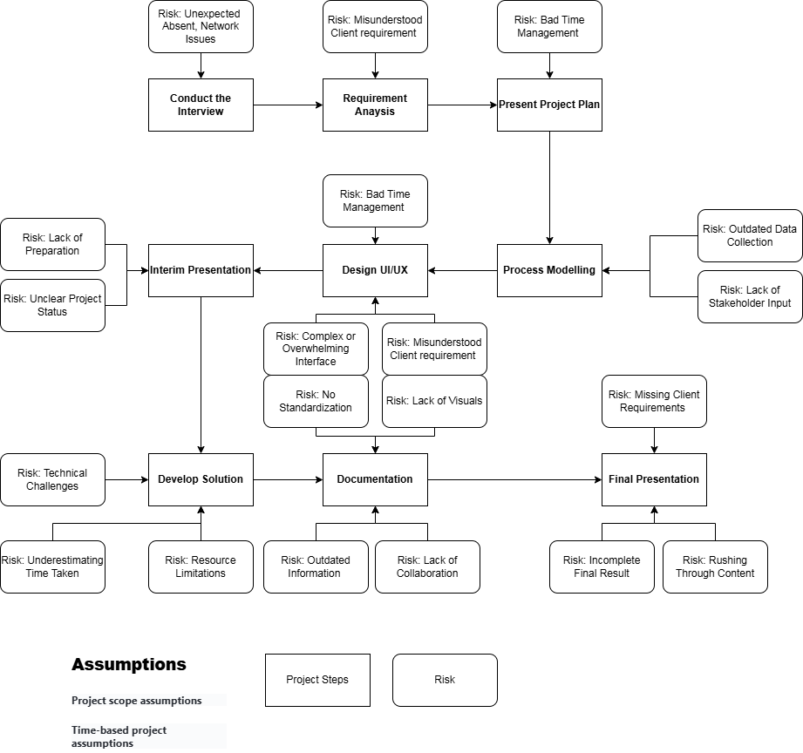
Figure 1: Risks and Assumptions

Risks
Each phase of the project carries different risks; this is a matter of risk management. With a spirit of learning, we have considered various potential risks at different levels on the Assumptions chart.

However, here is a summary of the key risks we have specifically considered;

- Network Issues
- Misunderstood Client Requirement
- Bad Time Management
- Outdated Data Collection
- Overwhelming Interface
- Resource Limitations
- Lack of Collaboration

Deliverables
- A website with a login interface for the super admin, including login functionality and user authentication via email
- A dashboard interface after login with navigation buttons to the main project features
- A website interface to list and manage other admin users
- A notification system allows notifications to be sent to all users
- A messaging system allows users to send and receive messages
- A website with a user profile interface and a function to update user information
- An OTP verification system to verify accounts

Issues
The issues we anticipate before starting the project are:
- Lack of Collaboration: Our team is a group of individuals unfamiliar with each other and who have never worked together before, so disagreements are inevitable, which may hinder the workflow.
- Overwhelming Interface: Since this is a real project with an actual business, completing it requires us to possess the knowledge to handle the functions requested by the client. This could be a challenge, and we may need to gauge our capabilities carefully to negotiate with the client for tasks that match our skill levels.
- Bad Time Management: We have three months for this course, and from taking on tasks to delivering the project to the client, we have less than three months to complete everything. Therefore, time management is the biggest challenge we face.

Project team Structure
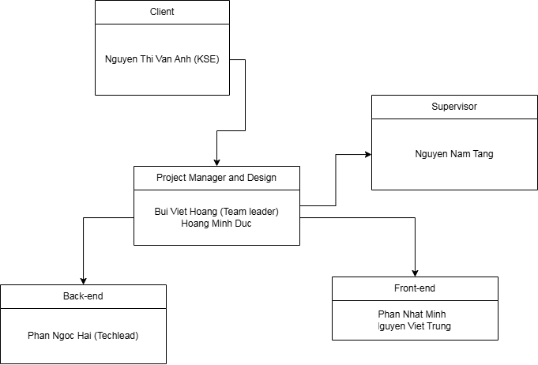
Figure 2: SBE Sales Project Team Structure
  - Roles and Responsibilities
Member: Bui Viet Hoang, Hoang Minh Duc
Roles: Project Manager, Documentation and Design
Responsibilities: Their task is to gather work-related information from team members, including tasks, project execution methods, draft diagrams, and user interface designs. They analyze project requirements and document them, assess risks, and evaluate the likelihood of success, ensuring that progress aligns with the project plan. The project manager plays a crucial role in bridging project progress with the client and making necessary adjustments to ensure the project meets the client's requirements.
Member: Nguyen Viet Trung, Phan Nhat Minh
Roles: Front-end
Responsibilities: The work of a front-end developer may include tasks such as creating website interfaces that align with the design, ensuring usability, and implementing functionalities that meet project requirements. Front-end developers and back-end developers have a close, complementary relationship, working together to ensure smooth functionality. They use tools like HTML, JavaScript, and CSS to design website interfaces and optimize the user experience.
Member: Phan Ngoc Hai
Roles: Back-end
Responsibilities: Lastly, the work of the back-end developer involves building the website's system, including APIs, and implementing functionalities as required by the business. They create databases to store user login information and ensure the logical structure of each functional design, such as account creation, OTP authentication, roles management systems, notification,n and messaging systems. As mentioned above, front-end and back-end development are closely interconnected and support each other to ensure efficiency and seamless responsiveness for each website function.

Project Sign Off

The signatures of the people below document approval of the formal Project Plan. The Project Manager is empowered by this charter to proceed with the project as outlined in this document.

For and on behalf of INSERT CLIENT NAME:

Signed: Van Anh, Date:20/11/2024
( Nguyen Thi Van Anh, KSE Software JSC )

For and on behalf of the Project Team:

Signed: Hoang, Date: 20/11/2024
( Bui Viet Hoang, Project Manager )

For and on behalf of Swinburne University of Technology:

Signed: Tang, Date: 20/11/2024
( Nguyen Nam Tang, Project Supervisor )

Appendix A – Gantt Chart
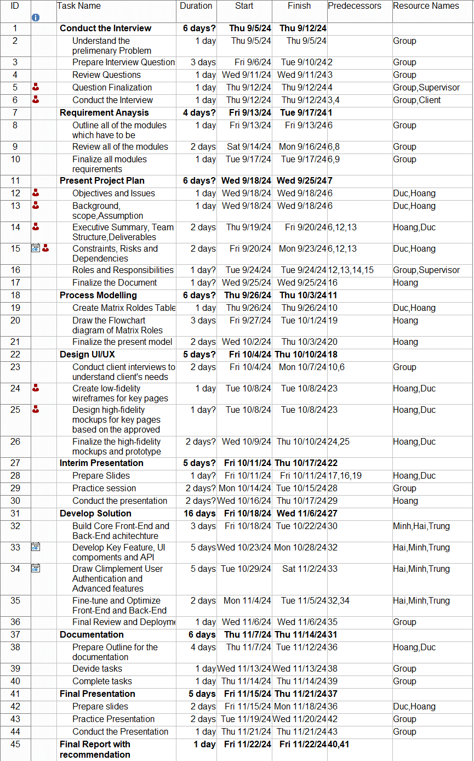
Figure 3.1: Gantt Chart
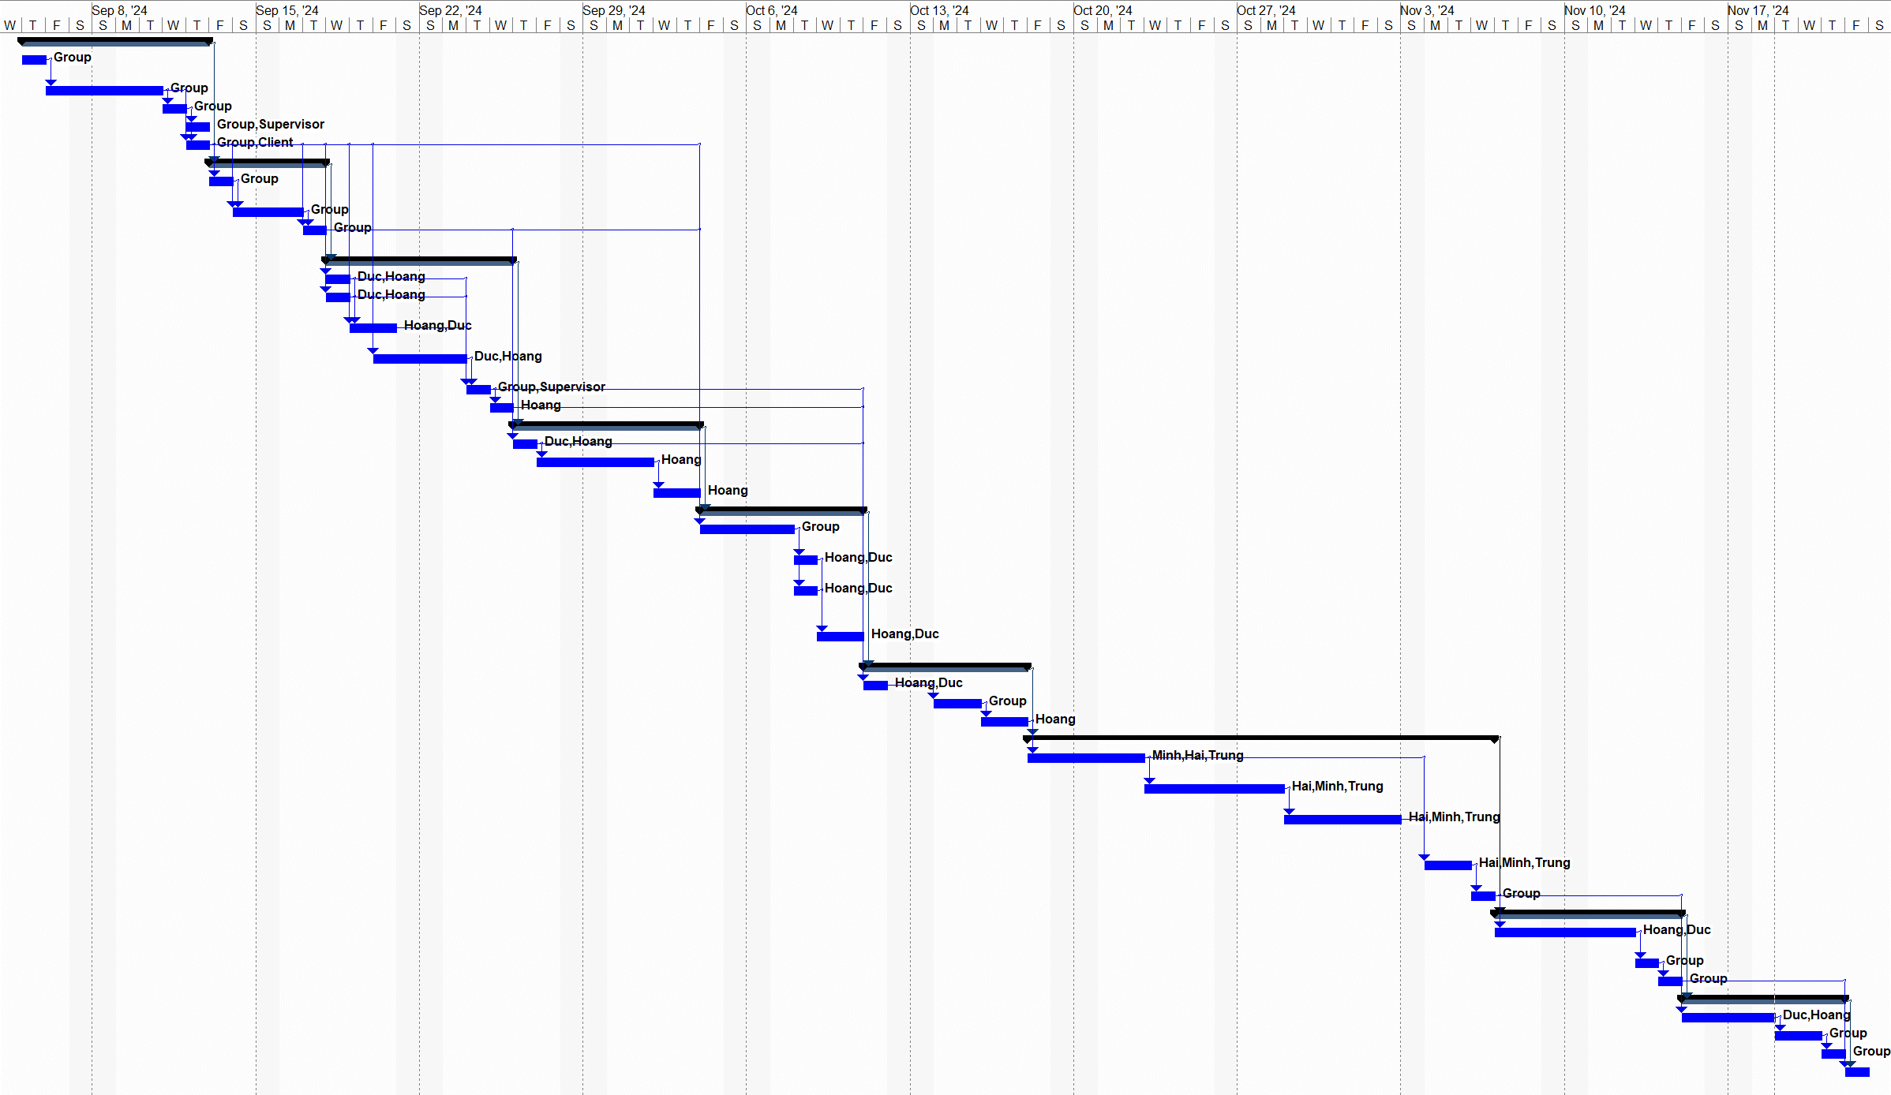
Figure 3.2: Gantt Chart

