**NODEJS**

1. ***Node.js Modules***
   1. Modules in Node js are a way of encapsulating code in a separate logical unit
   2. There are many readymade modules available in the market which can be used within Node js. Such as:
      1. **Express framework** – Express is a minimal and flexible Node js web application framework that provides a robust set of features for the web and[Mobile](https://www.guru99.com/mobile-testing.html)applications.
      2. **Socket.io** - Socket.IO enables real-time bidirectional event-based communication. This module is good for creation of chatting based applications.
      3. **Jade**- Jade is a high-performance template engine and implemented with[JavaScript](https://www.guru99.com/interactive-javascript-tutorials.html)for node and browsers.
      4. **MongoDB** - The[MongoDB](https://www.guru99.com/mongodb-tutorials.html)Node.js driver is the officially supported node.js driver for MongoDB.
      5. **Restify** - restify is a lightweight framework, similar to express for building REST APIs
      6. **Bluebird**- Bluebird is a fully featured promise library with focus on innovative features and performance
2. **Creating NPM modules**
   1. Node.js has the ability to create custom modules and allows you to include those custom modules in your Node.js application.
   2. The "exports" keyword is used to ensure that the functionality defined in this file can actually be accessed by other files.
3. **Express Module**
   1. Express.js is a Node js web application server framework, which is specifically designed for building single-page, multi-page, and hybrid web applications, It has become the standard server framework for node.js. Express is the backend part of something known as the MEAN stack.
   2. The MEAN is a free and open-source[JavaScript](https://www.guru99.com/interactive-javascript-tutorials.html)software stack for building dynamic web sites and web applications which has the following components:
      1. **MongoDB** - The standard NoSQL database
      2. **Express.js** - The default web applications framework
      3. **Angular.js** - The JavaScript MVC framework used for web applications
      4. **Node.js** - Framework used for scalable server-side and networking applications.
   3. The Express.js framework makes it very easy to develop an application which can be used to handle multiple types of requests like the GET, PUT, and POST and DELETE requests.

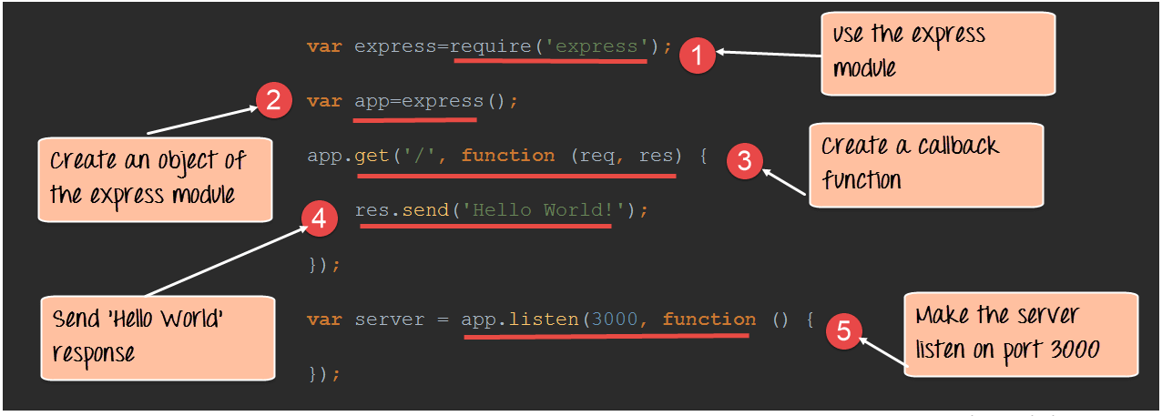

1. **Routes**
   1. Routing refers for determining the way in which an application responds to a client request to a particular endpoint.
   2. The general syntax for a route is



***Where in:***

1) app is an instance of the express module

2) METHOD is an HTTP request method (GET, POST, PUT or DELETE)

3) PATH is a path on the server.

4) HANDLER is the function executed when the route is matched.

1. **Node.js MongoDB**