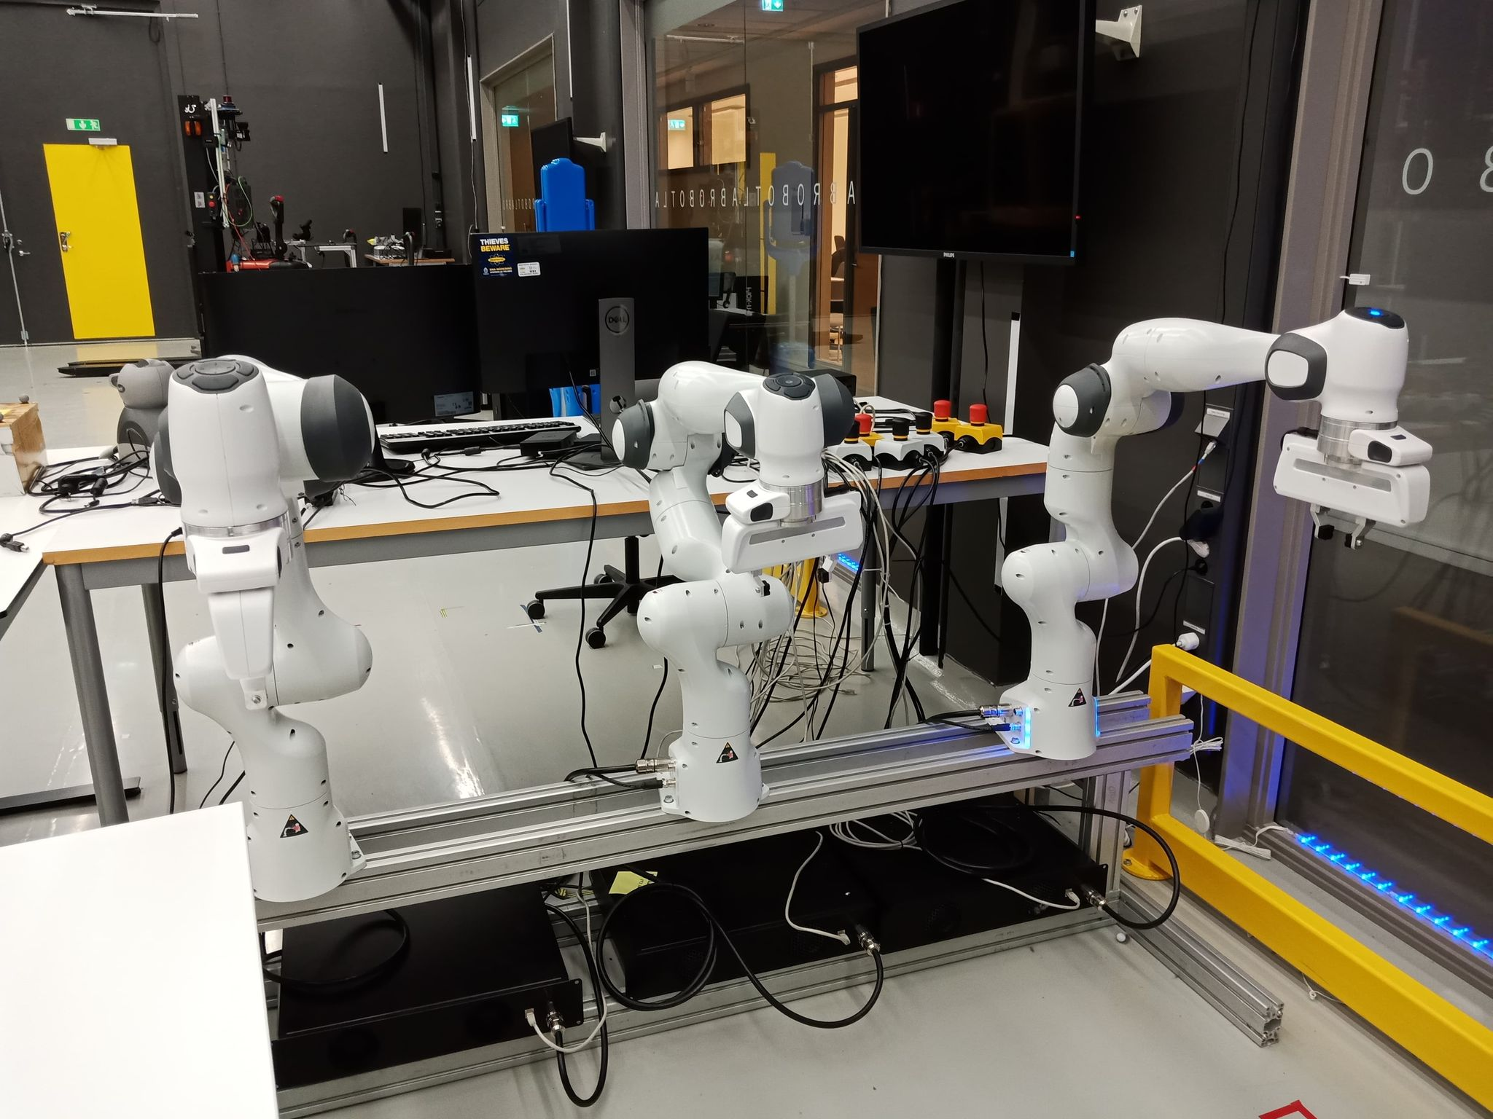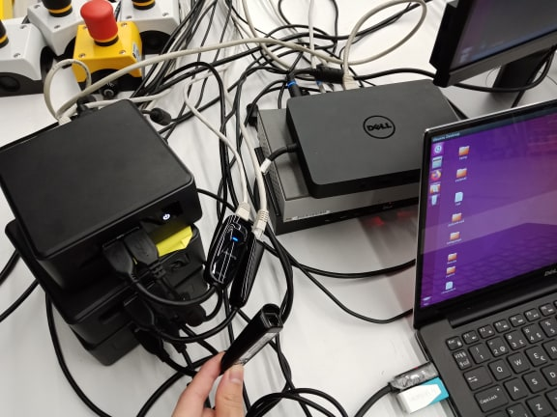
Fig 1. Wired Connection

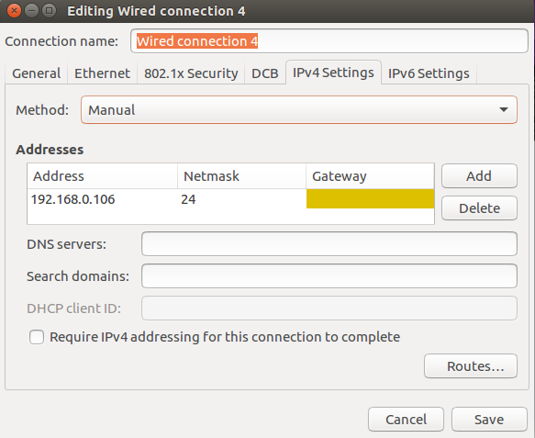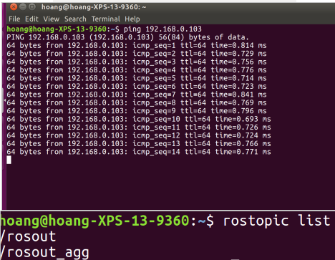
Fig 2. Set IP and Check Connection

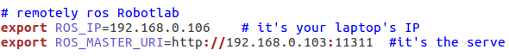
Fig 3. Change .bashrc file in the laptop

$ catkin_make -DFranka_DIR=/home/frankanuc03/libfranka/build
$ roslaunch franka_tminplan joint_point_to_point_motion_my.launch
$ roslaunch franka_example_controllers model_example_controller_with_gripper.launch robot_ip:=172.16.0.103

