PE_FER202_TRIALTEST
Subject: FER202
Duration: 85 minutes

INSTRUCTIONS
Please read the instructions carefully before doing the questions.
- You are Not allowed to use any device to share data with others.
- You must use IDE as Visual Studio Code, for your development tools.
- The data for this application must be gotten from students.json file and must to store at the mockapi.io tool, the endpoint must be added your environment variables to the .env file.

Create a new React application using Vite + React. Named after your-roll-number.
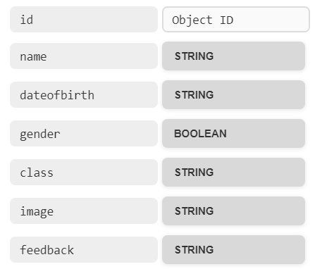
Task 1. Create a new resource and supply data for your application.
- (0.25 mark) Create a new resource named studentManagement in mockapi.io and declare a Schema.
- (0.25 mark) Edit/replace data for studentManagement resource. Copy the content of students.json file.
Task 2.
- (1.0 mark) Create a Navbar for navigating all the routes in your application. Including: Home, Dashboard, Contact. (install react-router-dom or react-router library)


- (2 marks) At home route, display all the students in data which order name ascending. Each Student must contain some information such as: Id, Name, DateOfBirth, Gender, Class, Image. When you click the detail button or Id, the view switches to detail route.

- (1.5 marks) At detail route, display all the information of student: Id, Name, DateOfBirth, Gender, Class, Image and Feedback . Design and arrange this component as good as possible. This route path will match requests to: /student/:id
Task 3.
- (1.0 mark) At management route, it displays the list of students by table. Each row must contain the links or icons for CRUD actions. This route path will match requests to: /management
- (1.5 marks) Create a add route with the requirements:
- This route path will match request to: /addStudent or use the modal component from management route.
- Create a form and validate all data.
- All fields are required.
- Name must more than 2 words
- Image must be a URL
- Gender is True (Male) or False (Female)
- DateOfBirth is a Birthday of Student
- Feedback is an option control
- (1.0 mark) At management route implement the delete action.
With delete function, you must confirm before implementing. After deleting successful, showing a notice (modal, alert, toast…) and the list of students will render the new list.
- (1.5 marks) Implement the update action. With the update function, the same validation requirements as the add function.
-The end of test-

