


UNIVERSITY OF TRANSPORTS HO CHI MINH CITY INSTITUTE OF INFORMATION TECHNOLOGY AND ELECTRICAL - ELECTRONIC ENGINEERING

SPECIFICATION OF RESTAURANT ORDER MANAGEMENT SYSTEM PROJECT
Course: Công nghệ phần mềm
Class: 012012210506
Group: 03

LECTURER: TRẦN THỊ MỸ TIÊN

Ho Chi Minh city, month 11 year 2025
GROUP MEMBERS
STT | TÊN | STUDENT ID | ROLE
1 | Nguyễn Tuấn An | 079206030887 | Member
2 | Dương Gia Bảo | 079206027561 | Member
3 | Phạm Hải Đăng | 079206020761 | Leader
4 | Lê Phúc Thọ | 079206036366 | Member
5 | Huỳnh Gia Huy | 079206018609 | Member

CHANGELOG
Date | Version | Content
27/12/2025 | 1.0.0 | Building Document
30/12/2025 | 1.0.1 | Update use case
31/12/2025 | 1.0.2 | Update use case requirement
1/1/2026 | 1.0.3 | Update class diagram
2/1/2026 | 1.0.4 | Update class to database and it’s spectification
3/1/2026 | 1.0.5 | Update dfd diagram level 0-1 and it’s spectification
3/1/2026 | 1.0.6 | Update user interface spectification

FIRST WORD
First and foremost, we would like to express our deepest gratitude to our lecturer, Ms. Trần Thị Mỹ Tiên, for her invaluable guidance, constant encouragement, and dedicated support throughout the development of this Restaurant Order Management System project. Her insightful feedback and expertise in Software Engineering have been instrumental in helping us refine our requirements and perfect the system's logic. This project would not have reached its current form without her mentorship. We are extremely grateful to Ms. Trần Thị Mỹ Tiên for providing us with the opportunity to work on this project and for guiding us through every stage of the software development life cycle. Her clear instructions and practical advice have greatly enhanced our understanding of system analysis and design. We truly appreciate the time and effort she invested in helping our group succeed. Our group would like to extend our sincere thanks to Ms. Trần Thị Mỹ Tiên for her professional guidance during the Course: 'Công nghệ phần mềm'. Thanks to her lectures and detailed reviews on our use cases, class diagrams, and database specifications, we have gained a comprehensive view of how a real-world restaurant management system operates.

I.FUNCTIONAL REQUIREMENTS
The restaurant order management system need to include these basic functions:
-View menu(Customer):
- Customer can view a list of dishes provided by the restaurant. The list of dishes can be displayed by dish type(main dish, side dish, dessert).
- For every dish, the system displays basic information include: Name of dish, dish_id, price and dish status(available or out of stock)
- Customer can view menu without login.
-Login(Staff):
- Staff can log in the system with staff_id as username and password provided by the restaurant.
- The system shall authenticate login credentials before granting access and only authenticated staff are allowed to access system functions.
- Access rights shall be granted based on staff roles(Waiter, Kitchen Staff, Cashier, Manager).
-View Order(Staff):
- Staff members can view existing orders in the system and the system will display order detail(order_id,table number,ordered item, quantities,notes) and order status.
-Create order(Waiter):
- The waiter can create a new order and each order shall contain an unique order ID,table number, creation time, list of ordered item and quantities of it, and order status. The waiter will have to input the table number, ordered item and quantities of it, and notes if customer want to add or remove dish ingredients. Other attributes will be created automatically by system.

-Manage order(Waiter):
- The waiter can view an existing order and choose to add OrderItem to order or remove OrderItem from order or Update OrderItem quantities.
- The system shall update the order details accordingly after each modification.
- The waiter can view existing order and choose to delete it if the customer want to cancel it.
- The system shall update the order status to canceled after it had been removed.
- After the customer had done placed order,the waiter can send a completed order to the kitchen.
- The system shall forward the order details to kitchen staff for preparation.
- Once the customer finished their dishes, Waiter can update the order to “COMPLETED” status.
-Update order status(Kitchen staff):
- Kitchen staff can only view order that has status “PENDING”, they can update status of an order(preaparing, ready) by viewing a list of existing order which sent by the waiters. Each order shall display the order_id, ordered item and their quantities.
- When an order item is marked as "PREPARING", the system shall automatically deduct the corresponding ingredient quantities from the inventory.
- Whenever the order is marked as “Ready”, the system shall store the updated status into database and update inventory information and make them available to relevant staff.

-Process payment(Cashier):
- The cashier can only view order that order status is ”Completed” and the system will display order detail and total bill.
- The system shall automatically calculate the total bill based on ordered item and quantities and it will generate a payment automatically with payment detail(payment_id, amout of order_item, payment_method,payment_time, and status).Then the cashier can process payment for order. The system will ask if the cashier confirm the payment, if no then it will return to the current order screen.
- After the order has been paid, the system shall update the order status to “Paid”.
- The system shall allow the Cashier to generate a preview invoice (PENDING status) for customer review.
- The system shall allow the Cashier to export the finalized invoice to a text file (.txt) upon successful payment confirmation.
- The system shall update the payment status of an invoice to "PAID" and the order status to "COMPLETED" simultaneously.
- The system shall provide a refund function to revert a paid invoice status to "REFUNDED" in case of errors.
-View sales report(manager):
- Manager will have to input the range of date, then the system will return the sum all of order that has “PAID” status in those range.
-Manage menu(manager):
- Manager can view a detail menu and add new dish to menu
- Manager can remove existing dish from menu
- Manager can update new information to a dish from menu, include set price, new name.
- The system shall allow the Manager to define ingredient requirements for each menu item (linking MenuItem to InventoryItem).
- The system shall allow the Manager to update or remove ingredient quantities and serving sizes for specific dishes.
- The system shall automatically deduct inventory levels based on the pre-defined requirements in InventoryItemMenu when an order is marked as "PREPARING".
-Manage staff:
The system shall allow the Manager to create, update, and remove staff accounts including ID, Name, Password, Phone, and Role.
The system shall restrict access to Staff Management functions to users with the 'Manager' role only.

II.NON FUNCTIONAL REQUIREMENTS
Usability
Restaurant staff should be able to use all the system functions after four hours of training. After this training, the average number of errors made by experienced users shall not exceed three per 5 minutes of system use.
The system shall display the menu in a clear and readable format, including dish name, price, and description. Every customer must not order wrong dish more than 2 dishes.
Reliability
During normal operation, the system shall not generate more than 1 system error per 5 hours of use.
The system shall correctly process and store all orders without data loss.
The system shall only accept inputs that match the displayed functional options. In case of an invalid entry, the system shall notify the user and maintain the current state instead of terminating or resetting the session
Supportability
The system shall allow administrators to update menu and prices without modifying the system source code.
Performance
The system shall be capable of storing and managing up to 10,000 customer records and 50,000 order transactions without any significant decrease in processing speed.
The system shall process and display menu search results or order filtering in less than 0.5 seconds.
Maintainability
The system shall be developed using a modular architecture (Object-Oriented Programming). Each function such as Menu Management, Order Processing, and Inventory Control must be handled by separate classes to ensure that changes in one module do not adversely affect others.

Compatibility
The system is compatible with Microsoft Windows 10 and 11. It also be capable of running on Linux environments (such as Ubuntu) through standard C++ compilers (GCC/G++)
The source code must be compliant with the ISO C++11 standard (or higher) to ensure it can be compiled without errors using popular IDEs such as Visual Studio
The application requires a minimum of 512 MB of available RAM to handle internal data structures and database caching, though 2 GB is recommended for optimal multi-tasking. At least 50 MB of free disk space for the executable file and local database storage. And the cpu should be able to run at least 1.0Ghz.

Security
Only manager can access to management functions.
Password must be hiding while staff is inputting and staff password are encrypted before being stored.
Design Constraints
The app should be run in console environment, implemented by C++ with compiler GCC 17++ or higher version, database mysql. OS window 11.

IV. DATA FLOW DIAGRAM
4.1 Diagram
Level 0:
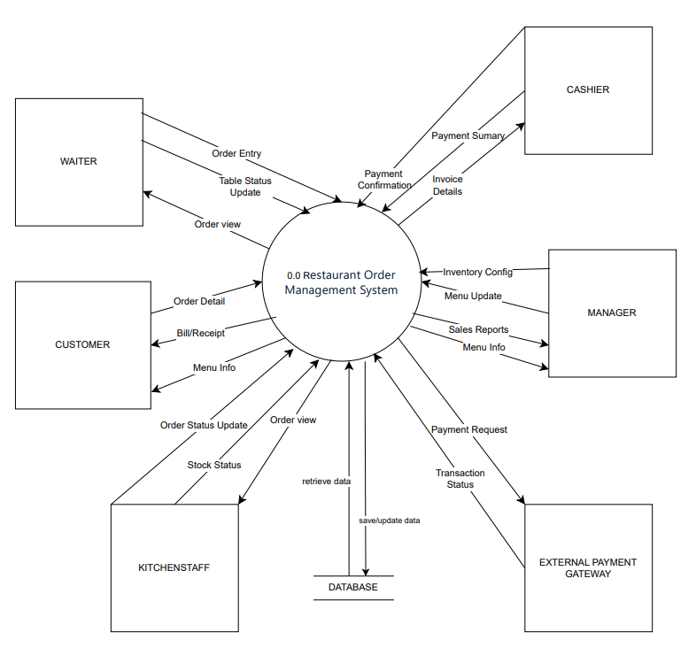

Level 1:
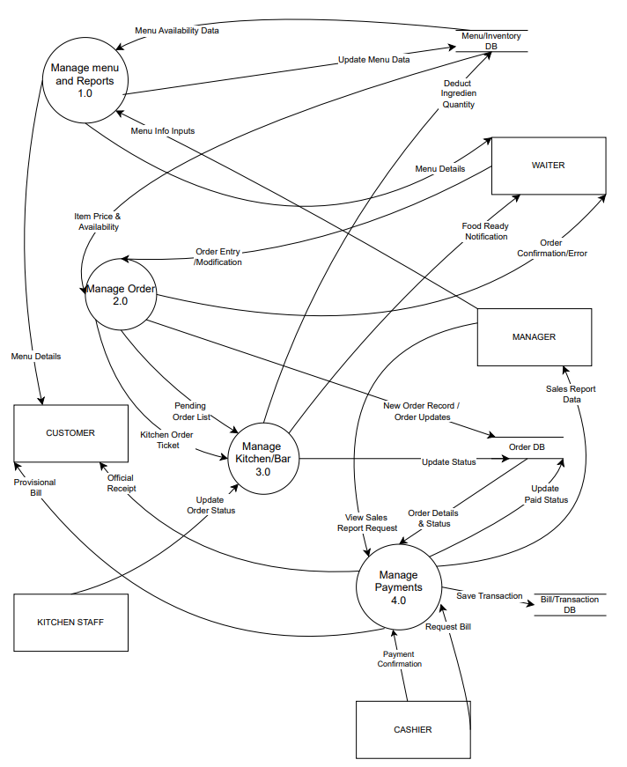
4.2 DFD spectification
DFD LV0 specification (Context diagram)
External Entities:
- MANAGER: Manages the menu, employees, inventory and views sales reports
- WAITER: update, view table status, receives order requests from CUSTOMER
- CUSTOMER: View menu, Order through WAITER, receives bills, makes payments.
- KITCHENSTAFF:Receives dishes order requests and updates dishes status.
- CASHIER: Processes, confirms payments and create receipts.
- EXTERNAL PAYMENT GATEWAY: Handles credit card payment.

Data Stores:
- Several Database will come up in Level 1 DFD Diagram: retrieve data, save/update data

DFD LEVEL 1 SPECTIFICATION:
1. External Entities
The external objects that interact with the system:
- Manager: Manages the menu and views sales reports.
- Waiter: Receives order requests from customers, creates, and updates orders.
- Kitchen Staff: Receives preparation requests and updates dish status.
- Cashier: Processes payments and issues receipts.
- Customer: Views the menu, receives bills, and makes payments.
- External Payment Gateway: Handles card/online payment processing.
2. Data Stores
Where the system stores data:
-D1 - Menu/Inventory DB: Stores information on dishes, prices, categories, and inventory ingredient quantities.
-D2 - Order DB: Stores information on orders, order details, and order status.
-D3 - Bill/Transaction DB: Stores transaction history, payment bills, and revenue data.
3. Detailed Process Descriptions
The system is decomposed into 4 main processes handling data as follows:
Process 1.0: Manage Menu and Reports
Description: This process allows the management of dish information updates, provides menu data to customers/staff, and aggregates sales reports.
-Inputs:
+Menu Info Inputs: New dish information, price changes, or edits from the Manager.
+Menu Availability Data: Data regarding dish availability from D1 Menu/Inventory DB.
-Processing:
+Add/Edit/Delete dishes in the D1 data store.
+Retrieve the list of dishes for display.
+Aggregate sales data for reporting.
-Outputs:
+Update Menu Data: Updates information into D1 Menu/Inventory DB.
+Menu Details: Displays the list of dishes for the Customer and Waiter.
+Sales Report Data: Sends sales report data to the Manager (Retrieved from transaction data).
Process 2.0: Manage Order
Description: The core process handling ordering, price checking, and creating orders to be sent to the kitchen.
-Inputs:
+Order Entry/Modification: Requests to create new or modify existing orders from the Waiter.
+Item Price & Availability: Dish price and status information from D1 Menu/Inventory DB.
-Processing:
+Check dish availability (in stock/out of stock).
+Calculate the provisional value of ordered items.
+Record the new order into the system.
-Outputs:
+New Order Record/Updates: Saves order information into D2 Order DB.
+OrderConfirmation/Error: Returns the order result (success/error) to the Waiter.
+Kitchen Order Ticket: Sends the order ticket to Process 3.0 (Manage Kitchen) for preparation.
+Pending Order List: Sends the list of items needing preparation to Process 3.0.
Process 3.0: Manage Kitchen/Bar
Description: This process assists the kitchen department in tracking items to be prepared, updating cooking status, and deducting inventory.
-Inputs:
+Kitchen Order Ticket / Pending Order List: List of items to be prepared from Process 2.0.
+Update Order Status: Kitchen Staff updates the status (Preparing -> Ready).
-Processing:
+Track the status of each item.
+When an item is completed ("Ready"), the system automatically deducts the corresponding ingredients.
-Outputs:
+Update Status: Updates order status in D2 Order DB.
+Deduct Ingredient Quantity: Updates and reduces ingredient quantities in D1 Menu/Inventory DB.
+Food Ready Notification: Sends a notification that the food is ready to the Waiter to serve the customer.
Process 4.0: Manage Payments
Description: Handles billing calculation, bill printing, and recording financial transactions.
-Inputs:
+Request Bill: Payment request from the Cashier.
+Payment Info: Payment information (cash/card) from the Customer.
+Order Details & Status: Retrieves order information to be paid from D2 Order DB.
+Transaction Status: Payment result confirmation from the External Payment Gateway.
-Processing:
+Calculate the total bill amount.
+Process transactions via the payment gateway (if not using cash).
+Record revenue.
-Outputs:
+Provisional Bill: Temporary bill sent to the Customer for review.
+Official Receipt: Official receipt sent to the Customer after payment.
+Transaction Request: Sends a debit request to the External Payment Gateway.
+Save Transaction: Saves transaction history into D3 Bill/Transaction DB.
+Update Paid Status: Updates the status to "Paid" in D2 Order DB.

V.USE CASE DIAGRAM
1. Diagram
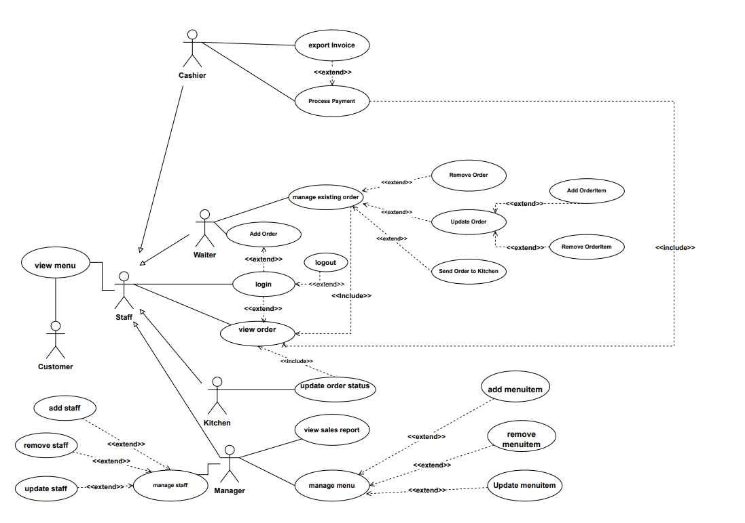
5.1 List of actor
STT | Actor | Meaning
1 | Staff | Employee working in restaurant
2 | Cashier | staff that process payment for customer
3 | Waiter | staff that serve customer
4 | Kitchen | staff that cook food
5 | Manager | Manager who manage the restaurant
6 | Customer | Those who have dish at restaurant

5.2 List of use case
STT | Use case
1 | view order
2 | login
3 | add order
4 | manage existing order
5 | remove order
12 | update order
7 | send order to kitchen
8 | add orderitem
9 | remove orderitem
10 | export Invoice
11 | process payment
6 | update order status
13 | view sales report
14 | manage menu
15 | add menuitem
16 | remove menuitem
17 | update menuitem
18 | view menu
19 | Logout
20 | Add staff
21 | Remove staff
22 | Update staff
23 | Manage staff

5.3 Use-case view order
3.1. Summary
This use case allows staff members (Waiter, Kitchen Staff, Cashier, Manager) to view a list of existing orders in the system and access specific order details, including ordered items, quantities, notes, and order status .
3.2. Flow of Events
3.2.1. Basic Flow The use case begins when a staff member successfully logs into the system and selects the "View Orders" function.
- The system displays a list of current orders with summary information: Order ID, Table Number, Creation Time, and Order Status .
- The staff member can filter the order list by status (e.g., Kitchen Staff filters for "Pending/Preparing", Cashier filters for "Completed") .
- The system updates the list according to the selected filter.
- The staff member selects a specific order to view details.
- The system displays the detailed information of that order:
  - General Info: Order ID, table number, time, status, and general notes.
  - Order Items: Name of dishes, quantities, unit price, and specific notes for each item .
  - Subtotal/Total amount.
3.2.2. Alternative Flows
- 2a. No orders found: If no orders match the filter criteria, the system displays "No matching orders found."
3.3. Special Requirements
- The system must update order status in real-time to ensure synchronization between departments (Kitchen, Waiter, Cashier).
- Only authenticated staff members are granted access to this function.
3.4. Pre-conditions
- The staff member is logged in with a valid role.
- There is at least one order existing in the database.
3.5. Post-conditions
- System data remains unchanged.
3.6. Extension Points
- Login: staff has to login to use this function, once logged in, they don’t have to login again.

5.4 Use-case login
4.1. Summary
This use case allows staff members (Waiter, Kitchen Staff, Cashier, Manager) to access the system by providing their credentials (staff_id and password). The system authenticates the user and grants access rights based on their specific role.
4.2. Flow of Events
4.2.1. Basic Flow The use case begins when a staff member opens the application.
- The system displays the login screen requesting a staff_id and password.
- The user enters their unique staff_id and password.
- The system validates the credentials against the Staff DB (D4).
- The system identifies the user's role (Waiter, Kitchen Staff, Cashier, or Manager).
- The system grants access and redirects the user to the main dashboard corresponding to their role's permissions.
4.2.2. Alternative Flows
- 3a. Invalid Credentials: If the staff_id or password is incorrect:
  - The system displays an error message: "Invalid username or password."
  - The user is returned to the login screen to try again.
4.3. Special Requirements
None
4.4. Pre-conditions
- The staff member has a valid account created in the system by the Manager.
4.5. Post-conditions
- If successful, the user can use system functions.
- The system tracks which user is performing actions (e.g., which Waiter created an Order).
4.6. Extension Points
- Logout: Once logged in, the user can choose to log out to terminate the session.

5.5 Use-case add order
5.1. Summary
This use case allows a Waiter to create a new order for a table. The waiter inputs the table number and enter OrderItem id and customer name if it is a potentional customer. The system automatically records the order details, calculates initial values, and prepares the order for the kitchen.
5.2. Flow of Events
5.2.1. Basic Flow The use case begins when a Waiter selects the "Create New Order" function.
- The system generates a unique Order ID, records the Creation Time, sets the status to "CREATED", and saves the data to the Order DB (D2).
- The system displays a blank order form and the current menu (from Menu DB).
- Then the system will call the manage order function
- The Waiter enters the Table Number.
- The waiter enters the customer name.
- The Waiter selects a MenuItem and specifies the Quantity.
- The Waiter adds a Note for the dish if the customer has special requests (e.g., "no spicy").
- The system creates an OrderItem linked to the selected MenuItem and calculates the sub-price .
- Steps 3-5 are repeated until all dishes are added to the order.
5.2.2. Alternative Flows
- 3a. Item Out of Stock: If the selected MenuItem has is_available = false:
  - The system displays a warning: "This item is currently out of stock."
  - The Waiter must select a different item or inform the customer.
- 7a. Cancel Order Creation: The Waiter can choose to cancel the process at any time before confirmation. No data is saved to the database.
5.3. Special Requirements
- The Order ID must be unique and generated automatically by the system.
5.4. Pre-conditions
- The Waiter is logged into the system.
- The requested table is currently available.
5.5. Post-conditions
- A new order is successfully stored in the Order DB.
- The status of the order is set to "CREATED".
- The Kitchen Staff can now view this order in their pending list.
5.6. Extension Points
- Login: staff has to be logged in to use this function, once logged in they don’t have to log in again.

5.6 Use-case manage existing order
6.1. Summary
This use case allows a Waiter to modify an active order. This includes adding new items, removing existing items, updating item quantities, or canceling the entire order if requested by the customer .
6.2. Flow of Events
6.2.1. Basic Flow The use case begins when a Waiter selects an existing order from the "View Orders" screen.
- The system displays the current details of the selected order, including the list of OrderItems .
- The Waiter chooses one of the following actions:
  - Add Item: The Waiter selects additional MenuItems and quantities. The system creates new OrderItem records.
  - Update Quantity: The Waiter modifies the quantity of an existing OrderItem.
  - Remove Item: The Waiter deletes a specific OrderItem from the order.
- After each modification, the system recalculates the subtotal and updates the Order DB (D2).
- The Waiter selects "Update Kitchen" to send the modifications.
- The system sends an updated Kitchen Order Ticket to the Chef.
6.2.2. Alternative Flows
- 2a. Cancel Order: 1. The Waiter selects the "Cancel Order" option. 2. The system prompts for confirmation. 3. Upon confirmation, the system updates the order status to "CANCELED" in the Order DB.
- 4a. Order Already Prepared: If the Kitchen Staff has already marked an item as "Ready", the system prevents the Waiter from removing or modifying that specific item.
6.3. Special Requirements
- Status updates must be reflected immediately on the Kitchen Staff's display.
6.4. Pre-conditions
- The Waiter is logged in.
- The order status is not "Paid" or "Canceled" or “COMPLETED” (only active orders can be managed).
6.5. Post-conditions
- The order details are updated in the database.
- The Kitchen Staff receives notification of changes.
6.6. Extension Points
- Remove order: waiter can remove an order then it will update order status to “CANCELED”.
- Update order: the waiter can add orderitem and remove orderitem.
- Send order to kitchen: once the customer has done ordering, the waiter will use this function and order status will set to “PENDING”.
5.7 Use-case remove order
7.1. Summary
This use case allows a Waiter to cancel an existing order if a customer requests to stop their meal or if the order was created by mistake. The system updates the order status and notifies relevant departments to stop service.
7.2. Flow of Events
7.2.1. Basic Flow The use case begins when a Waiter selects an active order from the "View Orders" screen.
- The Waiter selects the "Cancel Order" option.
- The system prompts the Waiter to provide a reason for cancellation (optional) and asks for confirmation.
- The Waiter confirms the cancellation.
- The system updates the status of the Order to "CANCELED" in the Order DB (D2).
- The system sends a cancellation notification to the Kitchen Staff to stop preparation (if the order was in "Pending" or "Preparing" status).
- The system releases the table associated with the order, making it available for new customers.
- The system displays a confirmation message: "Order [ID] has been successfully canceled."
7.2.2. Alternative Flows
- 3b. Waiter Aborts: If the Waiter selects "No" at the confirmation prompt, the system returns to the order detail screen without making any changes.
7.3. Special Requirements
- Once an order is canceled, it cannot be reopened. A new order must be created if the customer changes their mind.
7.4. Pre-conditions
- The Waiter is logged in.
- The order is currently in an active state (Created, Pending, or Preparing).
7.5. Post-conditions
- The order status is updated to "CANCELED".
- The Kitchen Staff no longer sees the order in their active preparation list.
7.6. Extension Points
none

5.8 Use-case update order status
8.1. Summary
This use case allows the Kitchen Staff to update the preparation progress of an order. When an order is marked as "Ready", the system automatically deducts the required ingredients from the inventory.
8.2. Flow of Events
8.2.1. Basic Flow The use case begins when a Kitchen Staff member views the list of pending orders.
- The system displays a list of orders sent by Waiters that are in "Pending" or "Preparing" status.
- The Kitchen Staff selects a specific order to view the list of items and quantities.
- The Kitchen Staff selects the "Preparing" status when they start cooking. The system updates the status in Order DB (D2).
- Once the dishes are finished, the Kitchen Staff selects the "Ready" status.
- The system performs the following automatic actions:
  - Updates the order status to "READY" in the Order DB (D2).
  - Inventory Deduction: Identifies the ingredients for each item in the order and subtracts the corresponding quantities from the Menu/Inventory DB (D1).
8.2.2. Alternative Flows
- 4a. Item Unavailable: If the Kitchen Staff discovers an ingredient is missing after starting:
  - The Waiter uses the Manage Order use case to remove or replace the item.
8.3. Special Requirements
- The inventory deduction logic must be precise based on the recipes defined in the system.
8.4. Pre-conditions
- The Kitchen Staff is logged in.
- An order has been sent to the kitchen by a Waiter (Status: "Pending").
8.5. Post-conditions
- The order status is updated to “PREPARING” or "READY".
- Inventory levels are updated (decreased) in the database.
8.6. Extension Points
None
5.9 Use-case send order to kitchen
9.1. Summary
This use case allows a Waiter to finalize a customer's order and transmit the details to the Kitchen Staff for preparation. This action officially moves the order from the "Created" phase to the "Pending" phase in the kitchen queue.
9.2. Flow of Events
9.2.1. Basic Flow The use case begins when a Waiter completes adding items to a new or existing order.
- The Waiter selects the "Send to Kitchen" option on the order management screen.
- The system updates the status of the Order to "PENDING" (or "Sent to Kitchen") in the Order DB (D2).
- The system displays a confirmation to the Waiter: "Order sent to kitchen successfully."
9.2.2. Alternative Flows
None
9.3. Special Requirements
None
9.4. Pre-conditions
- The Waiter is logged in.
- An order has been created and is currently in the "Created" state.
9.5. Post-conditions
- The order status is updated in the database.
- The order appears on the Kitchen Staff’s "Pending Orders" list.
9.6. Extension Points
None

5.10 Use-case add order item
10.1. Summary
This use case allows a Waiter to add a specific dish (MenuItem) to an existing or new order. The system creates a link between the order and the menu, capturing the quantity and any specific customer preferences for that item.
10.2. Flow of Events
10.2.1. Basic Flow The use case begins when the Waiter is within an Order interface and selects "Add Dish".
- The system displays the list of available MenuItems categorized by type (main dish, side dish, dessert).
- The Waiter searches for or selects a MenuItem from the list.
- The Waiter enters the Quantity (e.g., 2).
- The Waiter enters a Note if the customer has a special request (e.g., "extra sauce", "no onions").
- The system validates the item's availability (is_available == true).
- The system creates a new OrderItem record with a unique order_item_id.
- The system captures the current price from the MenuItem and calculates the total for this item (price * quantity).
- The system attaches this OrderItem to the current Order.
- The system updates the provisional total of the order.
10.2.2. Alternative Flows
- 5a. Item Out of Stock: If the item is marked as unavailable:
  - The system displays a message: "Sorry, this dish is currently out of stock."
  - The Waiter is prompted to select another item.
- 3a. Invalid Quantity: If the Waiter enters a non-numeric or negative value:
  - The system displays an error and requests a valid quantity.
10.3. Special Requirements
- The system must allow multiple OrderItems for the same MenuItem if they have different notes (e.g., one "Phở - No onions" and one "Phở - Extra beef").
10.4. Pre-conditions
- An Order has already been initialized (has an Order ID).
- The Waiter is logged in.
10.5. Post-conditions
- A new OrderItem is saved in the database and linked to the Order.
- The Order's total amount is updated.
10.6. Extension Point
None

5.11 Use-case remove order item
11.1. Summary
This use case allows a Waiter to remove a specific item (OrderItem) from an existing order, usually because the customer changed their mind or the item was added by mistake. The system updates the order details and recalculates the total.
11.2. Flow of Events
11.2.1. Basic Flow The use case begins when the Waiter is viewing the details of an active order.
- The system displays the list of OrderItems currently attached to the order.
- The Waiter selects the specific OrderItem they wish to remove.
- The Waiter selects the "Remove" or "Delete" option.
- The system prompts for confirmation: "Are you sure you want to remove [Dish Name] from this order?"
- The Waiter confirms the action.
- The system deletes the OrderItem record from the Order DB (D2).
- The system automatically recalculates the total price of the Order.
- The system displays a confirmation message and updates the order view.
11.2.2. Alternative Flows
- 4a. Waiter Cancels: If the Waiter chooses "No" at the confirmation prompt, the item is not removed, and the system returns to the order detail screen.
11.3. Special Requirements
None
11.4. Pre-conditions
- The Waiter is logged in.
- An active order is selected.
11.5. Post-conditions
- The OrderItem is removed from the order.
- The Order's total price is updated in the database.
11.6. Extension Point
None

5.12 Use-case export Invoice
12.1. Summary
This use case allows a Cashier or Waiter to generate and export a txt file for the customer. The bill summarizes all ordered items, their prices, and the total amount due, providing the customer with a document to review before payment.
12.2. Flow of Events
12.2.1. Basic Flow The use case begins when the customer requests the bill for their table.
- The Cashier selects the "Print Bill" function after payment
- The system retrieves the active Order and all associated OrderItems from the Order DB (D2).
- The system calculates the Total Price by summing the prices of all items (applying any discounts or taxes if applicable).
- The system generates a Provisional Bill layout including:
  - Restaurant Name and Address.
  - Order ID, Table Number, and Date/Time.
  - Detailed list of items (Name, Quantity, Unit Price, Subtotal).
  - Final Total Amount.
- The system export text .txt file.
12.2.2. Alternative Flows
None
12.3. Special Requirements
None
12.4. Pre-conditions
- The Cashier is logged in.
- The order is processing payment.
12.5. Post-conditions
- A txt file is saved in folder.
12.6. Extension Points
None

5.13 Use-case process payment
13.1. Summary
This use case allows a Cashier to process the payment for an order that has been completed. The system calculates the final amount, handles different payment methods, updates the order status to "Paid", and records the transaction for financial reporting.
13.2. Flow of Events
13.2.1. Basic Flow The use case begins when the Cashier selects an order for payment (in "Completed").
- The system displays the order details and the Total Bill calculated from the OrderItems.
- The system generates a Payment record with a unique payment_id and sets the initial status to "Pending".
- The Cashier processes the payment.
- Upon successful transaction:
  - The system updates the Payment Status to "Paid".
  - The system updates the Order Status to "Paid" in the Order DB (D2).
  - The system records the transaction details into the Invoice DB (D3).
13.2.2. Alternative Flows
- 3a. Refund Request: If the customer requests a refund after paying:
  - The Cashier selects the "Refund" option.
  - The system updates the Payment Status to "Refunded" and logs the reason.
13.3. Special Requirements
- Total sales data must be updated immediately to ensure the Manager sees accurate real-time reports.
13.4. Pre-conditions
- The Cashier is logged in.
- The order status is “completed” which is set by waiter.
13.5. Post-conditions
- The order is officially closed and marked as "Paid".
13.6. Extension Point
- Export Invoice: Once the payment is completed, the system will ask if cashier want to export a txt file.
5.14 Use-case update order
14.1. Summary
This use case allows a Waiter to modify the general information of an existing order, such as changing the table number or updating general order notes, to ensure the order details remain accurate throughout the customer's dining experience.
14.2. Flow of Events
14.2.1. Basic Flow The use case begins when a Waiter selects an active order from the "View Orders" screen.
- The Waiter selects the "Update order" option.
- The system displays the current editable fields of the order (e.g., Table Number, General Note).
- The Waiter performs one or more of the following:
  - Update General Note: Adds or modifies instructions that apply to the whole order (e.g., "Customer has a peanut allergy").
  - Update orderitem quantity: Increase or decrease an OrderItem
- The Waiter selects "Save Changes".
- The system updates the Order record in the Order DB (D2).
- The system displays a confirmation: "Order information updated successfully."
14.2.2. Alternative Flows
None
14.3. Special Requirements
None
14.4. Pre-conditions
- The Waiter is logged in.
- The order status is not "Paid" or "Canceled" or “Completed”.
14.5. Post-conditions
- The order's general attributes are updated in the database.
- The changes are reflected in the views of the Kitchen Staff and Cashier.
14.6. Extension Point
- Add OrderItem: staff can add orderitem to order
- Remove OrderItem:staff can remove an orderitem from order

5.15 Use-case view sales report
15.1. Summary
This use case allows the Manager to view and analyze sales data. The system aggregates transaction records to generate reports based on specific time periods (daily, weekly, monthly) or product categories.
15.2. Flow of Events
15.2.1. Basic Flow
The use case begins when the Manager logs into the system and selects the "Reports" or "Sales Analytics" module.
- The system displays a dashboard with default summary statistics (e.g., Today's total revenue).
15.2.2. Alternative Flows
None
15.3. Special Requirements
- Reports must be accurate and reflect all successfully completed payments (Status: "Paid").
15.4. Pre-conditions
- The Manager is logged into the system.
15.5. Post-conditions
None
15.6. Extension Points
None

5.16 Use-case manage menu
16.1. Summary
This use case allows the Manager to maintain the restaurant's menu. It includes adding new dishes, updating existing dish information (name, price, availability), or removing dishes that are no longer served.
16.2. Flow of Events
16.2.1. Basic Flow The use case begins when the Manager selects the "Manage Menu" function from the dashboard.
- The system displays the current list of all MenuItems stored in the Menu/Inventory DB (D1).
- The Manager chooses one of the following actions:
  - Add New Item: The Manager enters the name, price, category, and initial availability.
  - Edit Item: The Manager selects an existing item and updates its details (e.g., changing the price or toggling is_available).
  - Delete Item: The Manager selects an item to remove from the menu.
- The system validates the input data (e.g., price must be a positive number).
- The system updates the MenuItem records in the Menu/Inventory DB (D1).
- The system displays a confirmation message: "Menu updated successfully."
- The updated menu is immediately reflected on the Waiter's order screen.
16.2.2. Alternative Flows
None
16.3. Special Requirements
None
16.4. Pre-conditions
- The Manager is logged in.
16.5. Post-conditions
- The MenuItem data is successfully modified in the database.
- The new menu information is available for Waiters to use in the Create Order use case.
16.6. Extension Point
- Add menuitem: the manager can add menuitem into menu
- Remove menuitem: the manager can remove menuitem from menu
- Update menuitem: the manager can update basic information from a menuitem.

5.17 Use-case add menu item
17.1. Summary
This use case allows the Manager to expand the restaurant's offerings by adding a new dish or drink to the digital menu. The system captures the item's details and makes it immediately available for Waiters to order.
17.2. Flow of Events
17.2.1. Basic Flow The use case begins when the Manager is in the "Manage Menu" interface and selects the "Add New Item" button.
- The system displays a form with fields: Item Name, Price, Category, Description, and Status (Available/Unavailable).
- The Manager enters the Name of the new dish (e.g., "Grilled Salmon").
- The Manager enters the Price (e.g., 250,000 VND).
- The Manager selects a Category (e.g., Main Course, Drink, Dessert).
- The Manager enter it receipt
- The system validates the input data:
  - Check if the Name field is empty.
  - Check if the Price is a positive number.
  - Check if the Item Name already exists in the Menu DB (D1).
- The system generates a new unique item_id.
- The system saves the new MenuItem record into the Menu/Inventory DB (D1).
- The system displays a success message: "New item added successfully."
17.2.2. Alternative Flows
- 7a. Invalid Input: If any validation fails:
  - The system displays an error message (e.g., "Price must be greater than zero").
17.3. Special Requirements
None
17.4. Pre-conditions
- The Manager is logged into the system.
- The Manager has navigated to the "Manage Menu" section.
17.5. Post-conditions
- A new MenuItem object is created in the database.
- The new item is ready to be used in the Create Order use case.
17.6. Extension Point
None

5.18 Use-case remove menuitem
18.1. Summary
This use case allows the Manager to remove a dish or drink from the restaurant's active menu. This is typically done when a dish is permanently discontinued.
18.2. Flow of Events
18.2.1. Basic Flow The use case begins when the Manager is in the "Manage Menu" interface.
- The Manager browses or searches for the MenuItem they wish to remove.
- The Manager selects the "Remove" or "Delete" option for that specific item.
- The system prompts for confirmation: "Are you sure you want to permanently remove [Dish Name] from the menu?"
- The Manager confirms the action.
- The system updates the Menu/Inventory DB (D1):
  - Hard Delete: The record is removed from the database (only if it has never been ordered).
- The system displays a success message: "Item removed from menu successfully."
18.2.2. Alternative Flows
- 5a. Manager Cancels: If the Manager selects "No" at the confirmation prompt, the item remains in the menu.
18.3. Special Requirements
- Data Integrity: The system must not delete an item that is linked to past Invoices (Sales history), as this would cause errors in financial reports. In such cases, "Soft Delete" or disabling the item is mandatory.
18.4. Pre-conditions
- The Manager is logged in.
- The Manager has navigated to the "Manage Menu" section.
18.5. Post-conditions
- The MenuItem is no longer visible to Waiters during the Create Order process.
- The database is updated to reflect the removal.
18.6. Extension Point
None

5.19 Use-case update menu item
19.1. Summary
This use case allows the Manager to modify the details of an existing dish or drink in the menu. This is commonly used for price adjustments, correcting typos in names/descriptions.
19.2. Flow of Events
19.2.1. Basic Flow The use case begins when the Manager is in the "Manage Menu" interface.
- The Manager selects a specific MenuItem from the list to edit.
- The system displays the current information of the item in an editable form (Name, Price, Category, Description, Availability).
- The Manager modifies one or more fields:
  - Update Price: Changes the cost of the item.
  - Edit Details: Updates the name or description.
- The system validates the new data (e.g., ensuring the price is still a valid positive number).
- The system updates the MenuItem record in the Menu/Inventory DB (D1).
- The system displays a success message: "Item updated successfully."
19.2.2. Alternative Flows
- 5a. Invalid Input: If the Manager enters an invalid price (e.g., text or negative number):
  - The system displays an error and prevents saving until the data is corrected.
19.3. Special Requirements
None
19.4. Pre-conditions
- The Manager is logged in.
- The Manager has navigated to the "Manage Menu" section.
19.5. Post-conditions
- The modified details are saved in the database.
19.6. Extension Point
None
5.20. Use-case view menu
20.1. Summary
This use case allows a Customer to browse the restaurant's menu. Customers can view dish names, descriptions, prices, and availability status to decide what they would like to order.
20.2. Flow of Events
20.2.1. Basic Flow The use case begins when a Customer accesses the digital menu (e.g., by scanning a QR code at the table or opening the tablet provided).
- The system retrieves the full list of active categories and items from the Menu DB (D1).
- The system displays the categories (e.g., Appetizers, Main Courses, Drinks).
- The Customer selects a category or scrolls through the menu.
- The system displays the MenuItem details:
  - Name of the dish.
  - Price.
  - Description/Ingredients (if available).
  - Image of the dish.
- The Customer can filter items or search for a specific dish by name.
- The system displays the real-time availability:
  - If is_available == false, the item is shown as "Out of Stock" or grayed out.
20.2.2. Alternative Flows
- 4a. No Items in Category: If a category is empty, the system does not display that category to the customer.
20.3. Special Requirements
- Read-Only Access: Customers must not be able to modify any prices or item details.
20.4. Pre-conditions
None
20.5. Post-conditions
None
20.6 Extension Point
None

5.20 Use-case logout
20.1. Summary
This use case allows a staff member to securely terminate their current session in the system. It ensures that no unauthorized person can access the system functions using the previous user's credentials after they have finished their shift or left the workstation.
20.2. Flow of Events
20.2.1. Basic Flow The use case begins when a staff member selects the "Logout" option from the system dashboard.
- The system prompts the user for confirmation: "Are you sure you want to log out?"
- The user confirms the logout action.
- The system terminates the current session and clears any temporary session data.
- The system redirects the user back to the Login Screen.
20.2.2. Alternative Flows
2a. User Aborts: If the user selects "Cancel" at the confirmation prompt, the system returns to the previous dashboard, and the session remains active.
20.3. Special Requirements
None
20.4. Pre-conditions
The staff member is currently logged into the system.
20.5. Post-conditions
Return to login screen.
20.6. Extension Points
None

5.21 Use-case add staff
21.1. Summary
This use case allows the Manager to register a new employee into the system. It involves creating a unique account with a designated role (Waiter, Cashier, Kitchen Staff, or Manager) and login credentials.
21.2. Flow of Events
21.2.1. Basic Flow The use case begins when the Manager selects the "Manage Staff" function and chooses "Add New Staff".
- The system displays a blank staff registration form.
- The Manager enters the following details: Staff ID (unique username), Staff Name, Password, Phone Number, and selects a Role.
- The system validates the input data (e.g., checks if Staff ID already exists, validates phone format).
- The Manager confirms the creation.
- The system saves the new record to the Staff DB (D4).
- The system displays a confirmation message: "Staff member added successfully."
21.2.2. Alternative Flows
3a. Duplicate Staff ID: If the entered Staff ID already exists in the database: The system displays an error: "This Staff ID is already taken." The Manager is prompted to enter a different ID.
21.3. Special Requirements
None
21.4. Pre-conditions
The user is logged in as a Manager.
21.5. Post-conditions
- A new staff record is successfully stored in the database.
- The new employee can now log in using their credentials.
21.6. Extension Points
None

5.22 Use-case remove staff
22.1. Summary
This use case allows the Manager to delete a staff member's account from the system, typically when an employee leaves the restaurant. This revokes all their access rights to the management system.
22.2. Flow of Events
22.2.1. Basic Flow The use case begins when the Manager selects a staff member from the staff list.
- The Manager selects the "Remove Staff" option.
- The system displays the staff details and asks for confirmation: "Are you sure you want to delete this account? This action cannot be undone."
- The Manager confirms the deletion.
- The system removes the record from the Staff DB (D4).
- The system displays a confirmation message: "Staff account [ID] has been removed."
22.2.2. Alternative Flows
3a. Manager Aborts: If the Manager selects "No" at the confirmation prompt, the account is not deleted.
3b. Self-Deletion Prevention: If a Manager tries to delete their own currently active account, the system prevents the action and displays: "You cannot delete your own account."
22.3. Special Requirements
None
22.4. Pre-conditions
The user is logged in as a Manager.
22.5. Post-conditions
The staff record is deleted from the Staff DB.
22.6. Extension Points
None.

5.23 Use-case update staff
23.1. Summary
This use case allows the Manager to modify the information of an existing staff member, such as updating their phone number, changing their password, or promoting/reassigning their role.
23.2. Flow of Events
23.2.1. Basic Flow The use case begins when the Manager selects a staff member from the "Manage Staff" screen.
- The Manager selects the "Edit Staff" or "Update Staff" option.
- The system displays the current information of the staff member in an editable form.
- The Manager modifies the necessary fields (Name, Phone, Password, or Role).
- The Manager selects "Save Changes".
- The system validates the new data and updates the record in the Staff DB (D4).
- The system displays a success message: "Staff information updated successfully."
23.2.2. Alternative Flows
4a. Invalid Data: If any field (like phone number) contains invalid characters: display “wrong format, input again”.
23.3. Special Requirements
Changing a staff member's role should immediately affect their permissions upon their next login.
23.4. Pre-conditions
- The user is logged in as a Manager.
- The staff account exists in the database.
23.5. Post-conditions
The updated information is stored in the Staff DB.
23.6. Extension Points
None.

5.24 Use-case manage staff
24.1. Summary
This use case allows the Manager to oversee the entire list of employees within the system. The Manager can view all staff records, search for specific individuals, and access administrative functions such as adding, updating, or removing staff accounts.
24.2. Flow of Events 24.2.1. Basic Flow The use case begins when the Manager successfully logs into the system and selects the "Manage Staff" function from the menu screen.
- The system retrieves data from the Staff DB (D4) and displays a comprehensive list of all current employees.
- The list displays essential information for each member: Staff ID, Staff Name, Phone Number, and Role.
- The Manager can select a specific staff member from the list to view their full profile or initiate changes.
- The Manager chooses one of the following sub-functions:
  - Add Staff: (Refer to Use Case 5.21)
  - Update Staff: (Refer to Use Case 5.23)
  - Remove Staff: (Refer to Use Case 5.22)
- Upon completion of any sub-function, the system refreshes the displayed list and saves all changes to the database.
24.2.2. Alternative Flows
- 2a. Search Staff: The Manager enters a name or Staff ID into the search bar. The system filters and displays only the records matching the keywords. If no results are found, the system displays: "No staff found."
- 4a. Cancel Action: The Manager can exit the management screen at any time by selecting the "Back" button. The system returns to the dashboard without saving any unconfirmed changes.
24.3. Special Requirements
- The staff list must support pagination or scrolling if the number of employees is large.
- Sensitive actions, such as removing a staff member or resetting a password, must require a final confirmation step.
24.4. Pre-conditions
- The user must be logged in with a valid Manager role.
24.5. Post-conditions
- All personnel changes (additions, modifications, or deletions) are synchronized and updated in the Staff DB.
- Staff access permissions are updated immediately based on the modified records.
24.6. Extension Points
- Add Staff: Triggered when the Manager chooses to register a new employee.
- Update Staff: Triggered when the Manager needs to modify an existing employee's details.
- Remove Staff: Triggered when the Manager decides to delete a staff account from the system.

III. CLASS DIAGRAM
3.1 Diagram
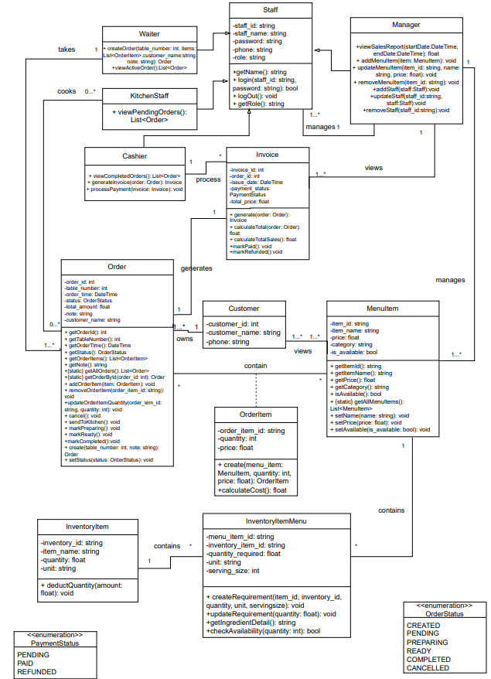

3.2 Database
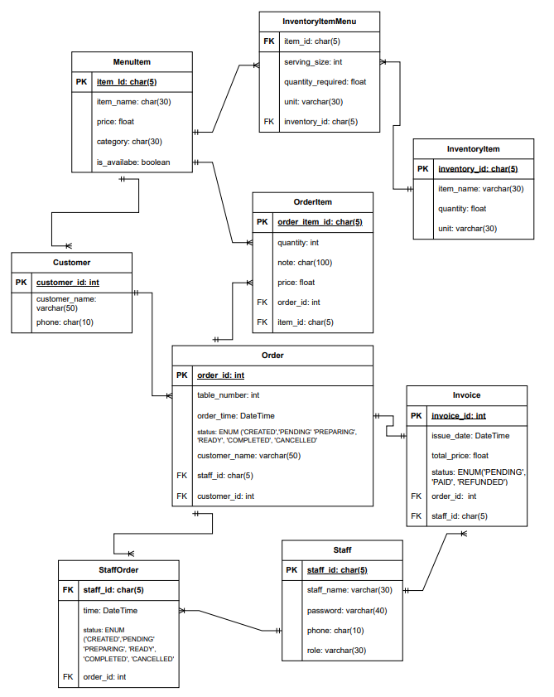

3.3 Class Requirement
Staff:
Parent class(staff) stores basic information of employees and their roles. Child class(Waiter, Cashier, KitchenStaff,Manager) has different functions based on their role.
Attributes:
- staff_id (string): An Unique ID use to distinguish each employees. Use for login username.
- staff_name (string): employee name.
- password(string): a password that provided by the restaurant manager which employee used to access the system.
- phone(string): basic information
- role(string): used to give employees access to functions based on their role.
Method:
- login(staff_id,password):bool : use to know if employees input correct username,password. Will return true and let employees access the system, else they can’t access system and will have to input username and password again.
- logOut():void: end the current session.
- getRole():void: return staff role.
- getName():string: return staff name.

Waiter:
A child class from parent(staff), use for create order and modify it.
Attributes: inherit from staff
Method:
- createOrder(table_number:int, items: List<OrderItem>, note: string):Order : waiter will have to input table_number and note(default is “”) and the customer name. And the input List<OrderItem> so waiter could add dish to order when order was created.
- viewActiveOrder(): List<Order>: return a list of order which status is not “COMPLETED”

KitchenStaff
A child class from parent(staff), can only view order which status is “PENDING” and set order status.
Attributes: inherit from staff
Method:
- viewPendingOrders(): List<Order>: return a List of order and only view order which status is “PENDING”.
Cashier
A child class from parent(staff), can only view order which status is “COMPLETED” and process payment.
Attributes: inherit from staff
Method:
- viewCompletedOrder(): List<Order>: return a List of order and only view “COMPLETED” order.
- generateInvoice(order: Order): Invoice:Takes a specific Order object and initializes a corresponding Invoice.The system automatically maps data from the order (such as OrderItem list, total_amount, and customer_name) into the invoice. It assigns a unique invoice_id and the current timestamp as the issue_date. Then return an Invoice object for customer review.
- processPayment(invoice: Invoice): void: Confirms the final financial transaction for a specific invoice.Once payment is received, this method updates the invoice's payment_status to PAID. It also records the staff_id of the cashier who handled the transaction for sales reporting and accountability.
Manager
A child class from parent(staff), view sale report and manage menu.
Attributes: inherit from staff
Method:
- viewSalesReport(startDate: DateTime, endDate: DateTime): float: Calculates and returns the total revenue generated within a specific timeframe.The system filters all Invoice records with a PAID status between the startDate and endDate, then sums their total_price values.
- addMenuItem(item: MenuItem): void: Adds a new dish or drink to the restaurant's official menu. Creates a new record in the MenuItem table with details such as name, price, and category.
- updateMenuItem(item_id: string, name: string, price: float): void: Modifies the information of an existing menu item.
- removeMenuItem(item_id: string): void:Deletes a specific item from the menu.
- addStaff(staff: Staff): void: Registers a new employee into the system.
- updateStaff(staff_id: string, staff: Staff): void:Updates the personal information or system Role of an existing employee.
- removeStaff(staff_id: string): void:Removes an employee's account from the system.
Order
A class that stores all order basic information and one order include one or many OrderItem.
Attributes:
- order_id(int): Unique ID which will be generated automatically by the database.
- table_number(int): input by Waiter.
- order_time(DateTime): generated automatically by system at the time order is created.
- status(OrderStatus): an ENUM with status “CREATED”, “PENDING”, “PREPAREING”, “READY”,”COMPLETED”, “CANCELLED”.
- total_amount(float): the total price of order which customer has to paid.
- note(string): input by Waiter, default is “” if there is no input.
- customer_name(string): input by Waiter, must be input else error.
Method:
- getOrderId(): int: return order_id.
- getTableNumber(): int: return the order table_number.
- getOrderTime(): DateTime: return the time that order was created
- getStatus(): OrderStatus: return order current status.
- getOrderItems(): List<OrderItem>: return the list of OrderItem.
- getNote(): string: return the note.
- {static} getAllOrders(): List<Order>: return all the order currently in database without created order object.
- {static} getOrderById(order_id: int): Order: return the order with it order_id, without created order object.
- addOrderItem(item: OrderItem): void: add OrderItem to Order.
- removeOrderItem(order_item_id: string): void: remove OrderItem from Order.
- updateOrderItemQuantity(order_iem_id: string, quantity: int): void: change OrderItem quantity from Order.
- cancel(): void: set order status to “CANCELLED”.
- sendToKitchen(): void: set order status to “PENDING”.
- markPreparing(): void: set order status to “PREPAREING”.
- markReady(): void: set order status to “READY”.
- markCompleted():void: set order status to “COMPLETED”.
- create(table_number: int, note: string): Order: return an order with table_number and note is inputted by Waiter.
- setStatus(status: OrderStatus): void: set order status.
InventoryItem
A class that stores all ingredients to know that if it is possible to make a dish(OrderItem).
Attributes:
- inventory_id(string): Unique ID to distinguish each ingredient
- item_name(string): ingredient name
- quantity(float): how much an ingredient that restaurant have.
- unit(string): kg, gam,..
Method:deductQuantity(amount: float): void: when an order status is set to “PREPARING”, system will call this function automatically.

Customer
A class that save customer basic information
Attributes:
- customer_id(int): Unique ID which is created automatically by the system.
- customer_name(string): customer name.
- phone(string): customer phone.
Method: none because customer can only view menu which method is at MenuItem. This class is for loyalty customer only. However, customer can still can view menu through static method viewMenu() at MenuItem class.
Invoice
A class used to represent the formal billing document provided to the customer.
Attributes:
- invoice_id (int): Unique ID generated automatically by the database.
- issue_date (DateTime): The date and time when the invoice is generated.
- total_price (float): The final amount from the associated Order that the customer has to pay.
- payment_status(Paymentstatus):Current state of the payment (PENDING, PAID, REFUNDED).
Methods:
- generate(order: Order): Invoice: Creates a new invoice instance based on the provided Order object.
- calculateTotal(order: Order): float: Calculates the sum of all item costs within a specific order.It iterates through the List<OrderItem> and return the final numeric value for total_price.
- calculateTotalSales(): float: A static or utility function used to aggregate the total revenue from all invoices in the system.It sums the total_price of all invoices that have a payment_status of 'PAID'.
- markPaid(): void: Updates the invoice's status to confirm that payment has been successfully received.
- markRefunded(): void:Processes a reversal of the payment.Updates the payment_status to REFUNDED. This is typically used in cases of customer complaints or billing errors after a payment was already processed.
MenuItem
A class that represents a dish or drink available in the restaurant's menu.
Attributes:
- item_id (string): Unique ID to distinguish each menu item.
- item_name (string): Name of the dish or drink.
- price (float): The current selling price of the item.
- category (string): The category of the item (Main dish, Side dish Drink,…).
- is_available (bool): A flag to indicate if the item is currently available for ordering.
Methods:
- getItemId(): string: Returns the item_id.
- getItemName(): string: Returns the item_name.
- getPrice(): float: Returns the current price.
- getCategory(): string: Returns the category.
- isAvailable(): bool: Returns the is_available status.
- {static} getAllMenuItems(): List<MenuItem>: Returns a list of all items in the menu from the database without created MenuItem object.
- setName(name: string): void: Updates the item's name.
- setPrice(price: float): void: Updates the item's price.
- setAvailable(isAvailable: bool): void: Updates the item's availability status.
OrderItem
A class that represents a specific entry within an Order, linking a MenuItem to a quantity.
Attributes:
- menu_item_id (string): The ID of the MenuItem being ordered.
- quantity (int): The number of portions ordered for this item.
- price (float): The price of the item at the time it was ordered (snapshot price).
Methods:
- create(menuItem: MenuItem, quantity: int, price: float): OrderItem: Returns a new OrderItem object with the specified details.
- calculateCost():float: return the price of orderitem (return quantity*price).
InventoryItemMenu
A class that defines the ingredients and proportions required to prepare a specific MenuItem.
Attributes:
- menu_item_id (string): Foreign key linking to the specific dish.
- inventory_item_id (string): Foreign key linking to the specific ingredient in stock.
- quantity_required (float): The exact amount of the ingredient needed.
- unit (string): The measurement unit (e.g., grams, ml, pieces).
- serving_size (int): The portion size this requirement applies to.
Methods:
- createRequirement(item_id, inventory_id, quantity, unit, servingsize): void: Establishes a new link between a menu item and an ingredient.Records how much of a specific inventory item is needed to create a dish. This is typically used when the Manager adds a new recipe to the system.
- updateRequirement(quantity: float): void:Modifies the existing amount of an ingredient required for a dish.
- getIngredientDetail(): string:Retrieves a formatted string containing the ingredient name and the required quantity.
- checkAvailability(quantity: int): bool:Checks if the current stock in InventoryItem is sufficient to fulfill a specific number of orders.The system multiplies quantity_required by the requested quantity and compares it with the available stock in the inventory.Returns True if there is enough stock to prepare the requested amount, otherwise returns False.
VI.USER INTERFACE
6.1 Login screen
==================================================
SON TUNG ATM RESTAURANT
==================================================
1. Customer
2. Staff
3. Exit
--------------------------------------------------
Please enter your Choice: 2

Staff ID: ST001
Password: ************
--------------------------------------------------
If success:
Welcome, [Staff Name]! Role: [Waiter/Manager/Chef/Cashier]
Else:
Wrong password or ID, please enter again.

6.2 Menu screen
---------------------------------------------------------------------------
MENU
---------------------------------------------------------------------------
ID Item Name Price (VND) Category Available
---------------------------------------------------------------------------
M01 Beefsteak 250,000 Main dish Yes
M02 Pasta 120,000 Main dish Yes
M03 Salmon 300,000 Side dish No
M04 Red Wine 150,000 Drink Yes
---------------------------------------------------------------------------
[0] Logout [1] view only main dish [2] view only drink
[3] view only side dish
---------------------------------------------------------------------------

6.3 Waiter
==================================================
CURRENT ORDERS LIST
==================================================
Order ID Table Number Status Note
---------------------------------------------------------------------------
530 05 READY None
502 02 PENDING None
508 01 CREATED None
---------------------------------------------------------------------------
[N] New Order [V] View Detail (Input ID) [0] Logout
==================================================
Choice: V
Enter Order ID to view: 502

==================================================
ORDER DETAIL - ID: #502
==================================================
Table: 02 Time: 2026-01-03 14:20 Staff: [Your Name]
Status: PENDING
---------------------------------------------------------------------------
Item Name Quantity Price (VND) Subtotal
---------------------------------------------------------------------------
Beefsteak 2 250,000 500,000
Pasta 1 120,000 120,000
Red Wine 1 150,000 150,000
---------------------------------------------------------------------------
TOTAL AMOUNT: 770,000 VND
---------------------------------------------------------------------------
[V] view menu [S] Send to Kitchen [C] Completed [U] Update order [B] Back
==================================================
Choice: U
[A]Add order item R] Remove orderitem [U] Update Note [Q]Quantity modify [B] Back
If order status is “READY” , the waiter can’t modify it. If customer ask for more food, waiter have to add new order.
If add new order
--- CREATE NEW ORDER ---
Enter Table Number: 05
Enter customer name: son tung
Note(optional):
------------------------
System: Creating Order... Success! Order ID: #512.

==================================================
ORDER DETAIL - ID: #512
==================================================
Table: 05 Status: CREATED
---------------------------------------------------------------------------
Item Name Quantity Price Subtotal
---------------------------------------------------------------------------
---------------------------------------------------------------------------
[V] view menu [S] Send to Kitchen [C] Completed [U] Update order [B] Back
==================================================
Choice: U
[A]Add order item R] Remove orderitem [U] Update Note [Q]Quantity modify [B] Back
Choice: A
Enter Item ID (e.g., M01): M01
Enter Quantity: 2
Success! Added 2 x Beefsteak.
Remove item will need input is an OrderItemId and will ask if waiter actually want to delete it. And so does quantity.
Send to kitchen will set order status to PENDING and KitchenStaff will see it.

6.4 KitchenStaff
==================================================
CURRENT ORDERS LIST
==================================================
Order ID Table Number Status Note
---------------------------------------------------------------------------
502 02 PENDING None
---------------------------------------------------------------------------
[V] View Detail (Input ID) [0] Logout
==================================================
Choice: V
Enter Order ID: 502
==================================================
ORDER DETAIL - ID: #502
==================================================
Table: 02 Time: 2026-01-03 14:20 Staff: [Your Name]
Status: PENDING
---------------------------------------------------------------------------
Item Name Quantity Price (VND) Subtotal
---------------------------------------------------------------------------
Beefsteak 2 250,000 500,000
Pasta 1 120,000 120,000
Red Wine 1 150,000 150,000
---------------------------------------------------------------------------
TOTAL AMOUNT: 770,000 VND
---------------------------------------------------------------------------
[A] Set Preparing [S] Set Ready [B] Back
==================================================
Choice: A
Order has been set to Preparing
Returning to order list….

6.5 Cashier
==================================================
CURRENT ORDERS LIST
==================================================
Order ID Table Number Status Note
---------------------------------------------------------------------------
505 10 COMPLETED No chilli in beef
---------------------------------------------------------------------------
[V] View Detail (Input ID) [0] Logout
==================================================
Choice: V
Enter Order ID: 505
==================================================
ORDER DETAIL - ID: #505
==================================================
Table: 10 Time: 2026-01-03 14:20 Staff: [Your Name]
Status: COMPLETED
---------------------------------------------------------------------------
Item Name Quantity Price (VND) Subtotal
---------------------------------------------------------------------------
Beefsteak 2 250,000 500,000
Pasta 1 120,000 120,000
Red Wine 1 150,000 150,000
---------------------------------------------------------------------------
TOTAL AMOUNT: 770,000 VND
---------------------------------------------------------------------------
[P] Process payment [B] Back
choice: P
Amount received: 800000 (cashier input)
Change: 30000
Confirm? (y/n): y
Order has been paid, order status has been set to PAID
Do you want to print bill(y/n) ? y
Bill is being print as file txt
Returning to order list…

6.6 Manager
==================================================
MENU MANAGEMENT
==================================================
ID Item Name Price (VND) Category Available
---------------------------------------------------------------------------
M01 Beefsteak 250,000 Main dish Yes
M02 Pasta 120,000 Main dish Yes
M03 Salmon 300,000 Side dish No
M04 Red Wine 150,000 Drink Yes
---------------------------------------------------------------------------
[A] Add New Dish [E] Edit Dish [R] Remove Dish
[S] Staff management [0]Log out
==================================================
Choice: A
--- ADD NEW DISH ---
Enter ID (e.g., M05): M05
Enter Name: Caesar Salad
Enter Price: 85000
Enter Category: Appetizer
Is Available? (1: Yes, 0: No): 1

[System]: Dish "Caesar Salad" has been added successfully!
[System]: WARNING: No inventory requirement found for this dish. Created a new one ? (y/n): y
--- CREATE REQUIREMENT FOR: Caesar Salad ---
Enter Serving Size: 1
Ingredient ID & Amount (Example: I01 0.2): I01 0.2
Ingredient ID & Amount ( I01 0.2): I05 0.05
Press [0] to confirm. [System]: Requirement created! Requirement has been successfully added to M05
Returning to menu management…
Edit dish is the same as add new dish
When remove dish, manager has to input menuitem id and the system will request confirmation, if yes then the dish will be deleted else nothing happen.
==================================================
SALES REPORT SETUP
==================================================
[1] Date Range
[0] Back
--------------------------------------------------
Choice: 1
Date start (YYYY-MM-DD): 2026-01-01
Date end (YYYY-MM-DD): 2026-01-03

--- SALES REPORT ---
-----------------------------------
REPORT FROM 2026-01-01 TO 2026-01-03
-----------------------------------
Total Orders: 120
Total Revenue: 45,000,000 VND
-----------------------------------
[0] Back to Menu
==================================================
STAFF MANAGEMENT
==================================================
ID Name Phone Role
--------------------------------------------------
S01 Nguyen Van A 0901234567 Manager
S02 Tran Thi B 0907654321 Waiter
S03 Le Van C 0908889999 Cashier
S04 Pham Gia D 0901112222 Kitchen
--------------------------------------------------
[A] Add Staff [U] Update Staff [R] Remove Staff
[B] Back to Menu Management
==================================================
Choice:

