ĐẠI HỌC BÁCH KHOA HÀ NỘI

TRƯỜNG CÔNG NGHỆ THÔNG TIN VÀ TRUYỀN THÔNG

BÁO CÁO THỰC HÀNH

**IT3103-744528-2024.1**

BÀI THỰC HÀNH 05

Họ và tên sv: Đặng Huy Hoàng Lớp: **K67-Việt Nhật 06**

GVHD: Lê Thị Hoa TA: Đặng Mạnh Cường

Hà Nội 12/2024

BÁO CÁO THỰC HÀNH LAB 5 LẬP TRÌNH HƯỚNG ĐỐI TƯỢNG

Contents

1. Swing components 5

1.1 AWTAccumulator 5

1.2 SwingAccumulator 6

2 Organizing Swing components with Layout Managers 8

2.1 Code 8

2.2 Demo 11

3 Create a graphical user interface for AIMS with Swing 12

3.1 Create class StoreScreen 12

3.2 Create class MediaStore 14

3.3 Demo 16

4 JavaFX API 20

4.1 Create class Painter 20

4.2 Create Painter.fxml 20

4.3 Create class PainterController 21

5 View Cart Screen 25

5.1 Create cart.fxml 25

5.2 Create class CartScreen 26

5.3 Create class CartScreenController 27

5.4 Demo 28

6 Updating buttons based on selected item in TableView – ChangeListener 28

6.1 Edit class CartScreenController 28

6.2 Demo 29

7 Deleting a media 30

7.1 Code 30

7.2 Demo 31

8 Complete the Aims GUI application 32

Figure 1.1: Source code of AWTAccumulator 4

Figure 1.2: Demo of AWTAccumulator 5

Figure 1.3: Source code of SwingAccumulator 5

Figure 1.4: Demo of SwingAccumulator 6

Figure 2.1: Source code of NumberGrid 1 6

Figure 2.2: Source code of NumberGrid 2 7

Figure 2.3: Demo buttons 0-9 8

Figure 2.4: Demo DEL button 8

Figure 2.5: Demo C button 8

Figure 3.1: Class StoreScreen 1 9

Figure 3.2: Class StoreScreen 2 10

Figure 3.3: Class StoreScreen 3 10

Figure 3.4: Class StoreScreen 4 11

Figure 3.5: Class StoreScreen 5 11

Figure 3.6: Class StoreScreen 6 12

Figure 3.7: Class MediaStore 1 13

Figure 3.8: Class MediaStore 2 13

Figure 3.9: Class MediaStore 3 14

Figure 3.10: StoreScreen 14

Figure 3.11 Demo Add to cart button 15

Figure 3.12 Demo Play button 15

Figure 3.13 Demo View cart button 15

Figure 4.1: Class Painter 16

Figure 4.2: Painter.fxml 1 16

Figure 4.3: Painter.fxml 2 17

Figure 4.4: PainterController 17

Figure 4.5: Use Pen 18

Figure 4.6: Use Eraser 18

Figure 4.7: Clear button 18

Figure 5.1: Cart.fxml 1 19

Figure 5.2: Cart.fxml 2 19

Figure 5.3: Cart.fxml 3 20

Figure 5.4: CartScreen class 20

Figure 5.5: CartScreenController 1 21

Figure 5.6: CartScreenController 2 21

Figure 5.7: Demo CartScreen 22

Figure 6.1: CartScreenController 1 22

Figure 6.2: CartScreenController 2 23

Figure 6.3: Demo media playable 23

Figure 6.4: Demo media unplayable 24

Figure 7.1: btnRemovePressed Method 24

Figure 7.2: button Remove 25

Figure 7.3: button Remove 25

Figure 8.1: Store before add book 26

Figure 8.2: Add book 26

Figure 8.3: Store after add book 27

Figure 8.4: Add CD 27

Figure 8.5: Store after add CD 28

Figure 8.6 Add DVD 28

Figure 8.7: Store after add DVD 29

Figure 8.8: Cart 29

# Swing components

## AWTAccumulator

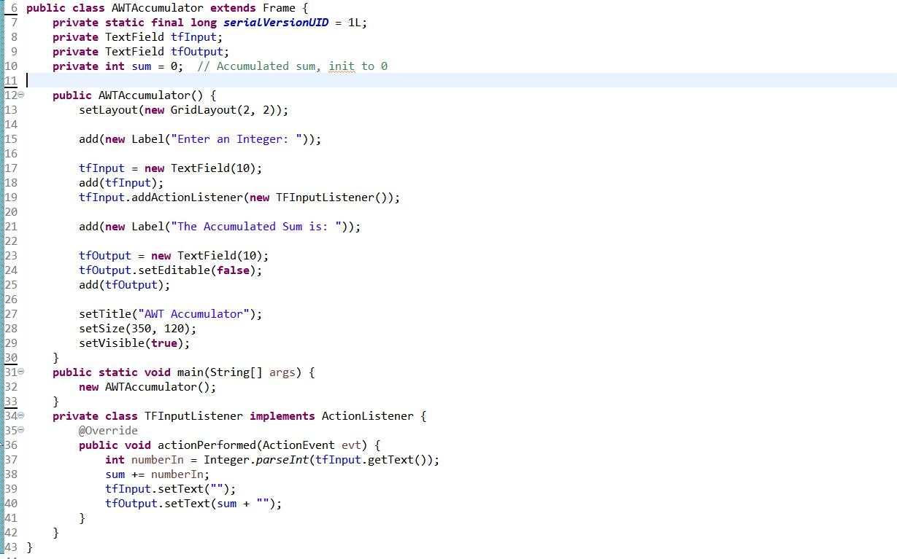

*Figure 1.1: Source code of AWTAccumulator*

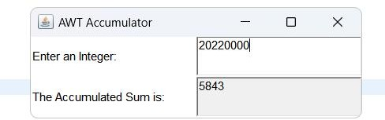

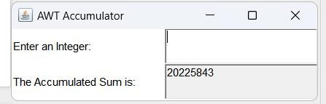

## SwingAccumulator

*Figure 1.2: Demo of AWTAccumulator*

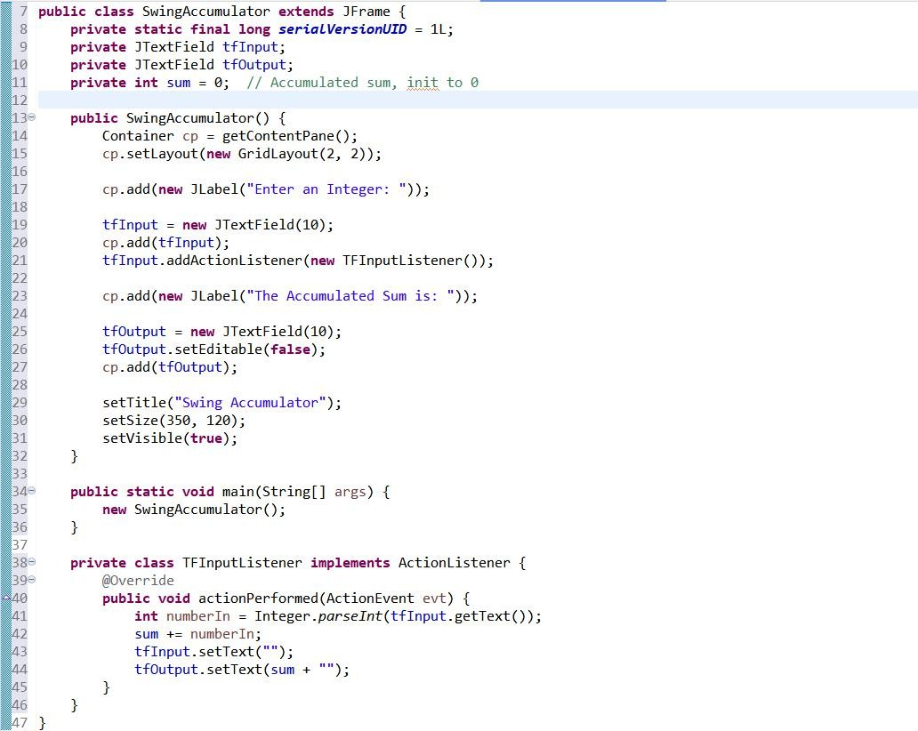

*Figure 1.3: Source code of SwingAccumulator*

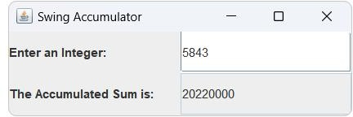

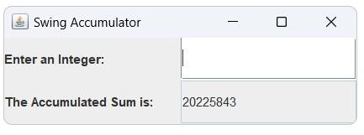

*Figure 1.4: Demo of SwingAccumulator*

# Organizing Swing components with Layout Managers

## Code

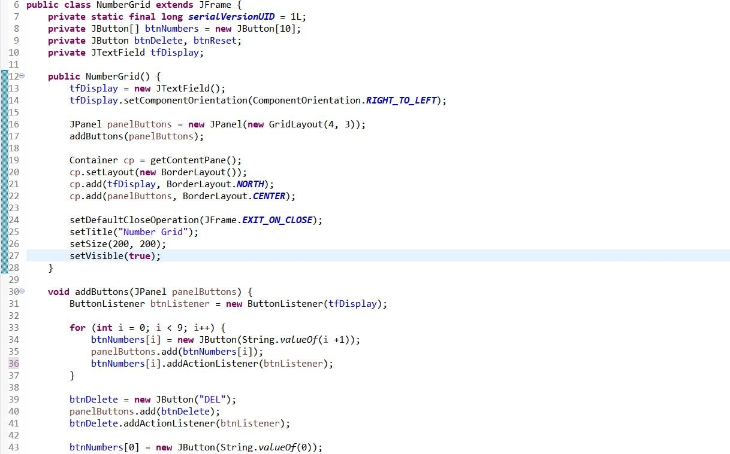

*Figure 2.1: Source code of NumberGrid 1*

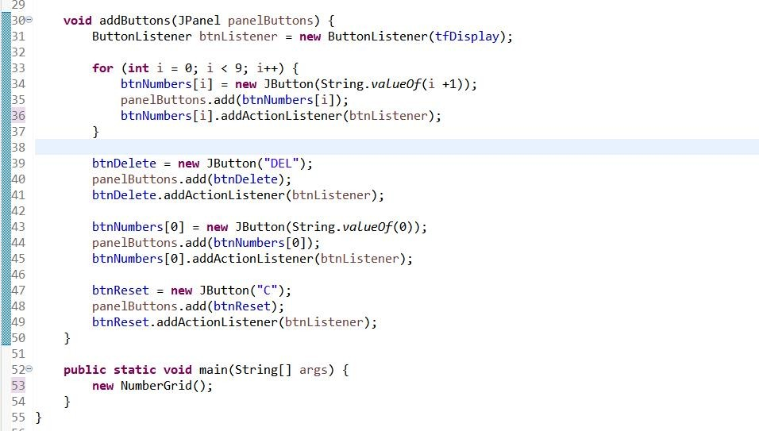

*Figure 2.2: Source code of NumberGrid 2*

## Demo

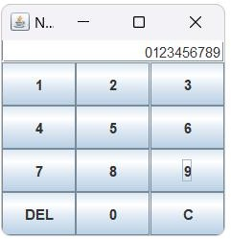

*Figure 2.3: Demo buttons 0-9*

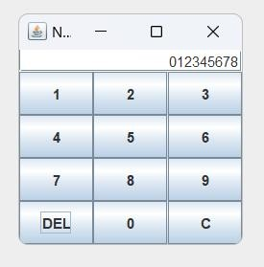

*Figure 2.4: Demo DEL button*

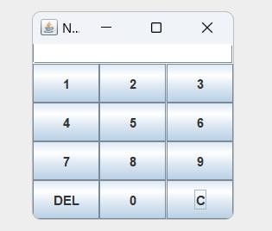

*Figure 2.5: Demo C button*

# Create a graphical user interface for AIMS with Swing

## Create class StoreScreen

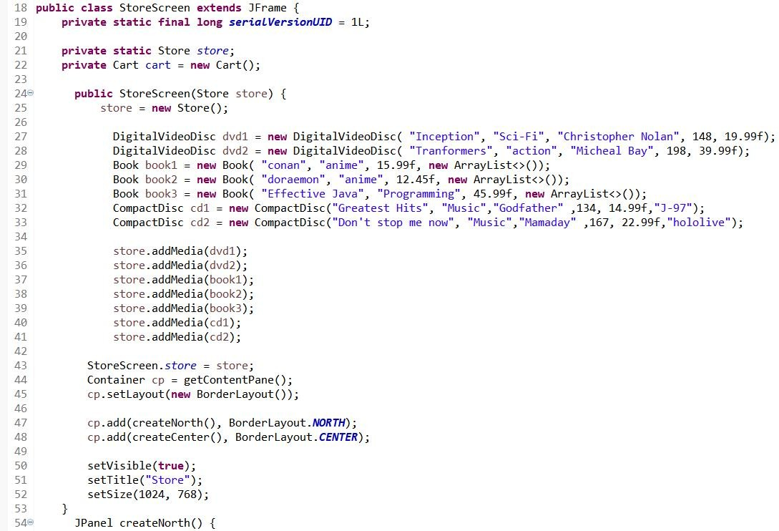

*Figure 3.1: Class StoreScreen 1*

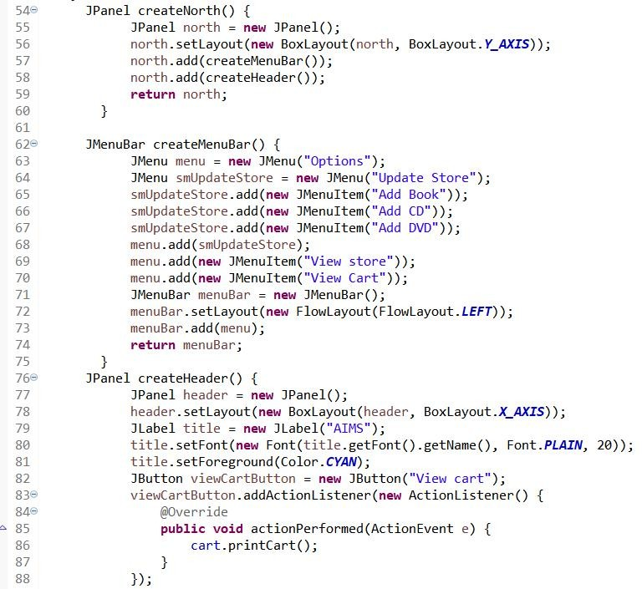

*Figure 3.2: Class StoreScreen 2*

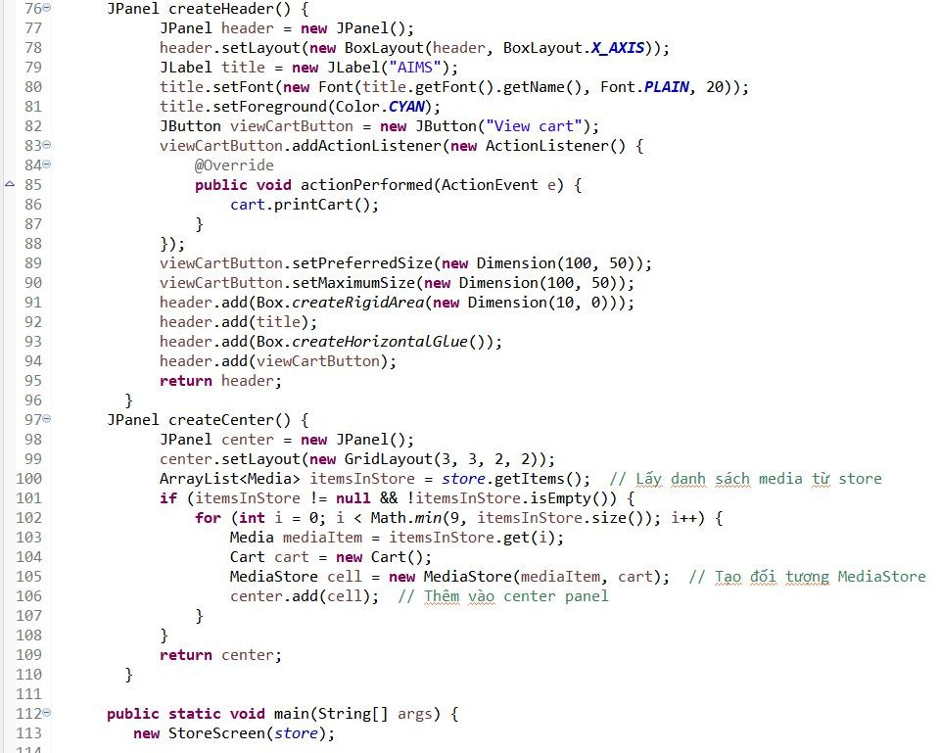

*Figure 3.3: Class StoreScreen* *3*

## Create class MediaStore

*Figure 3.7: Class MediaStore 1*

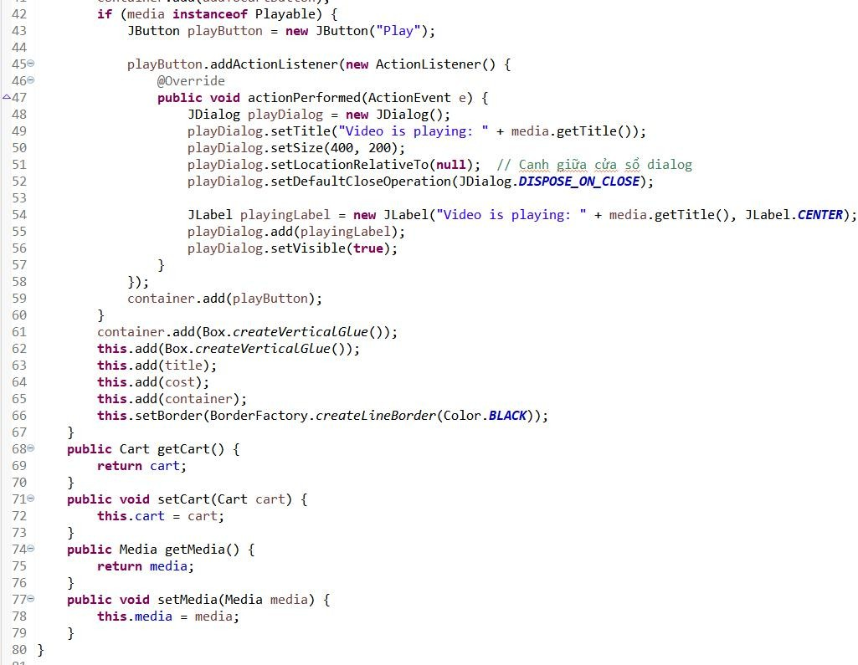

*Figure 3.8: Class MediaStore 2*

## Demo

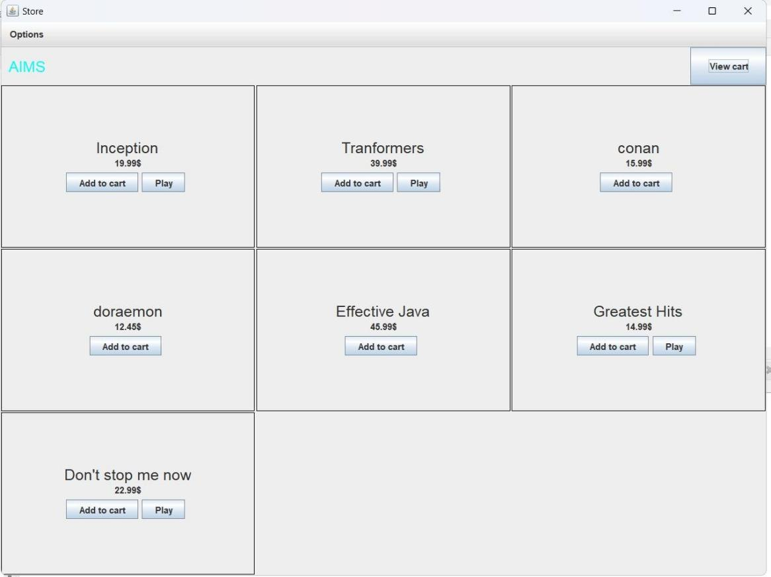

*Figure 3.10: StoreScreen*

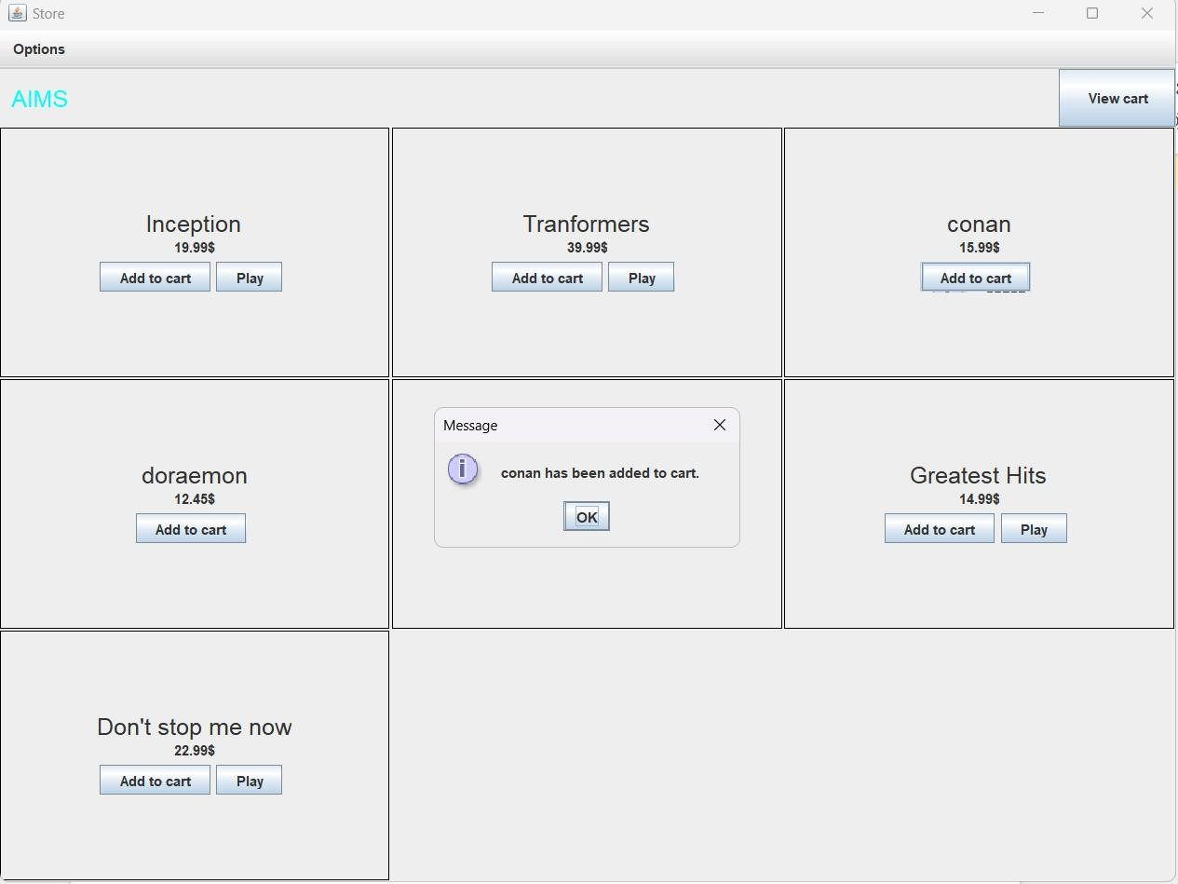

*Figure 3.11 Demo Add to cart button*

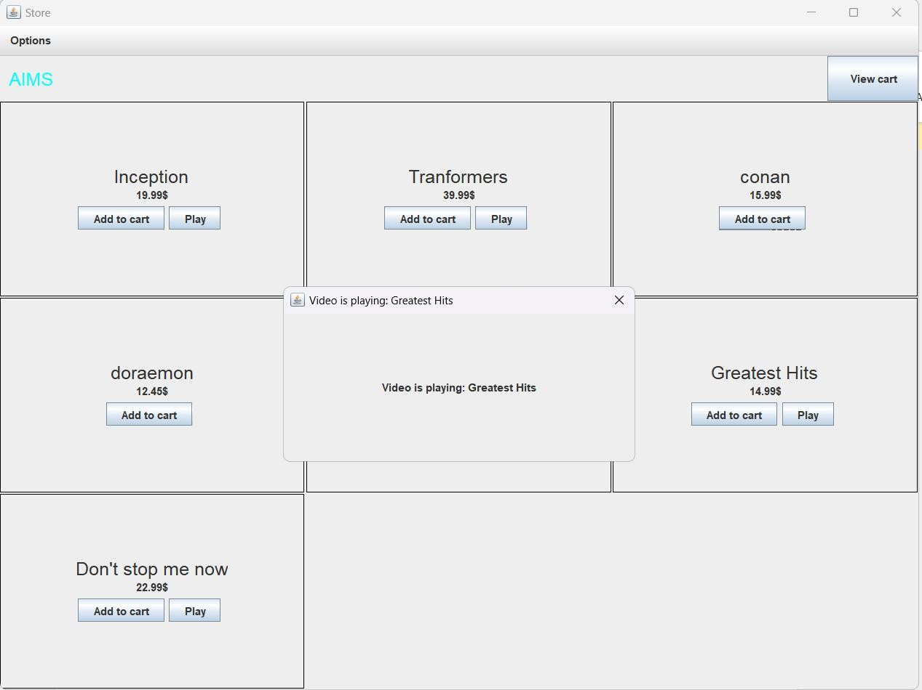

*Figure 3.12 Demo Play button*

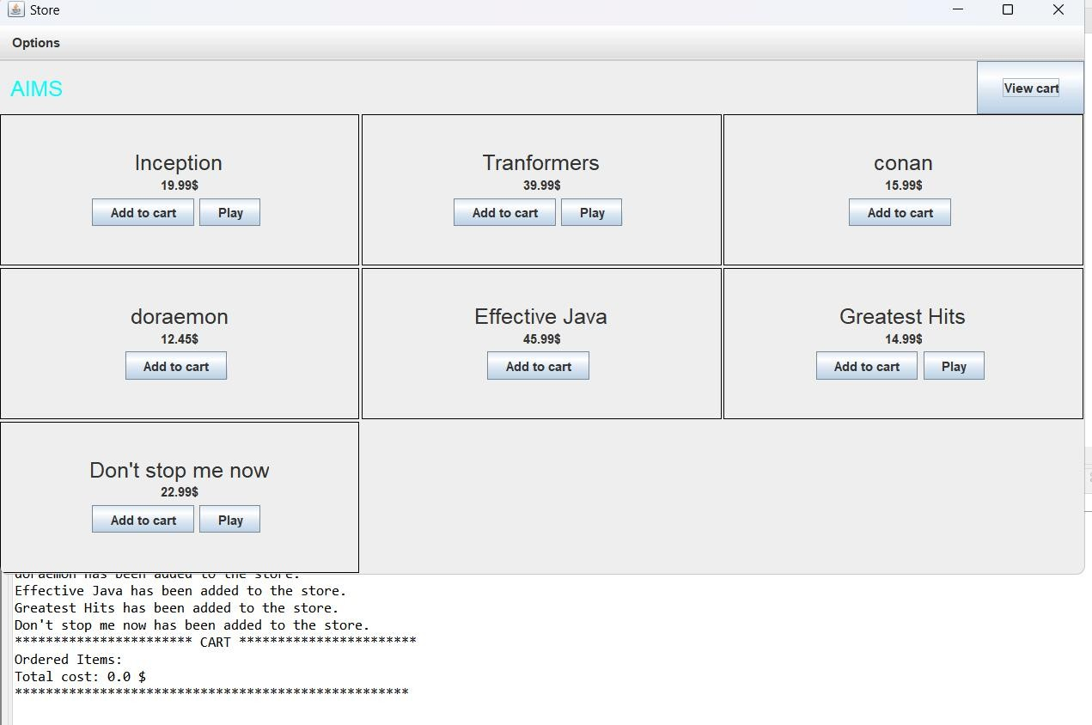

*Figure 3.13 Demo View cart button*

# JavaFX API

## Create class Painter

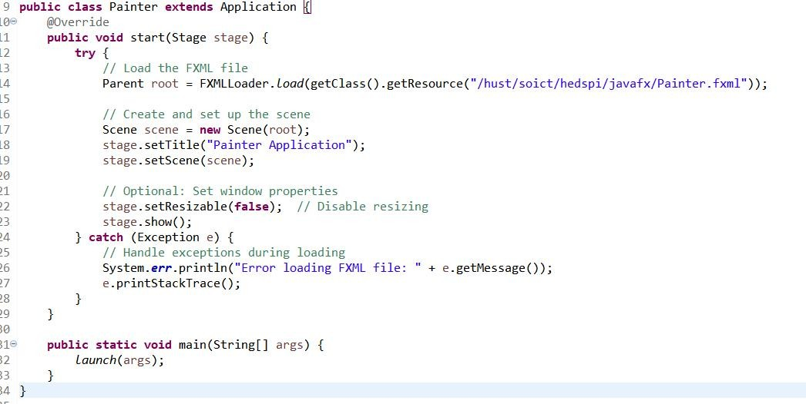

## Create Painter.fxml

*Figure 4.1: Class Painter*

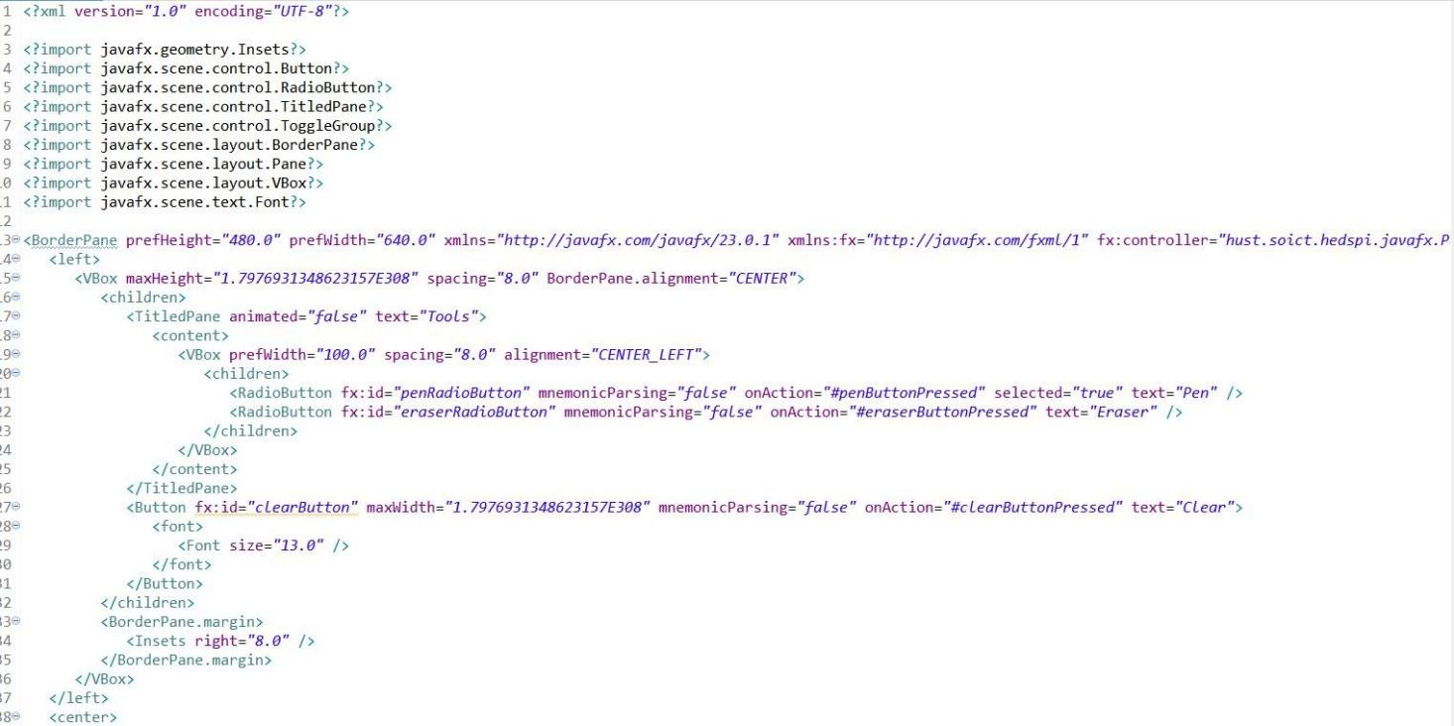

*Figure 4.2: Painter.fxml 1*

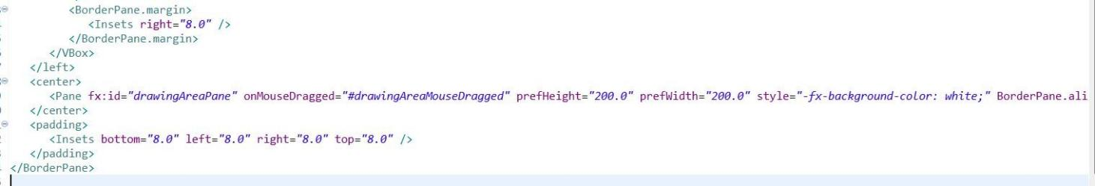

## Create class PainterController

*Figure 4.3: Painter.fxml 2*

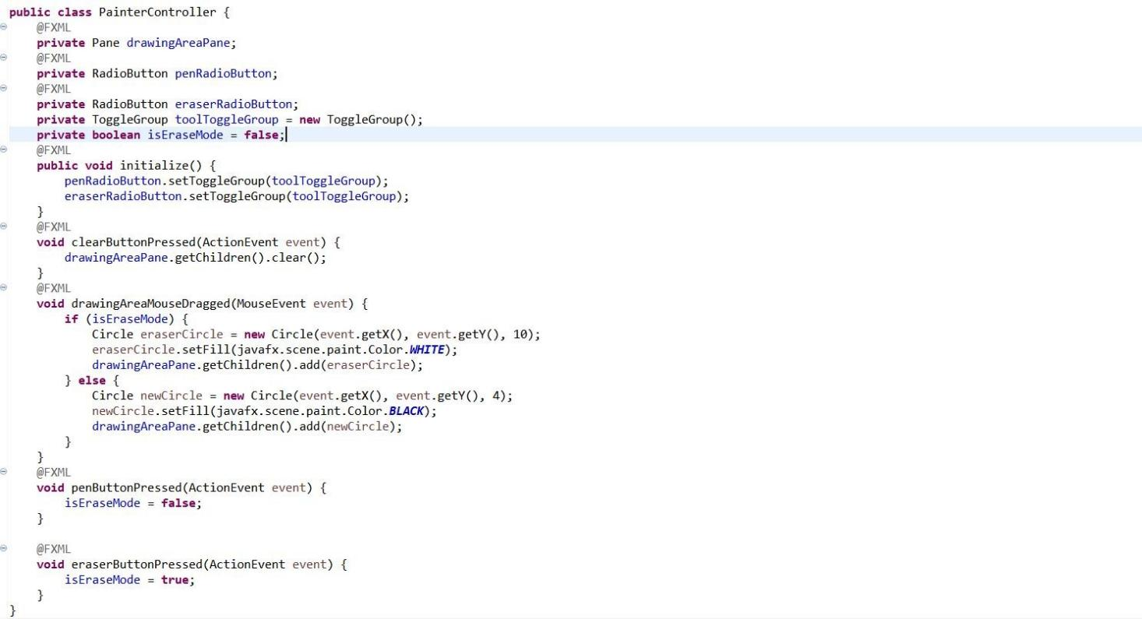

*Figure 4.4: PainterController*

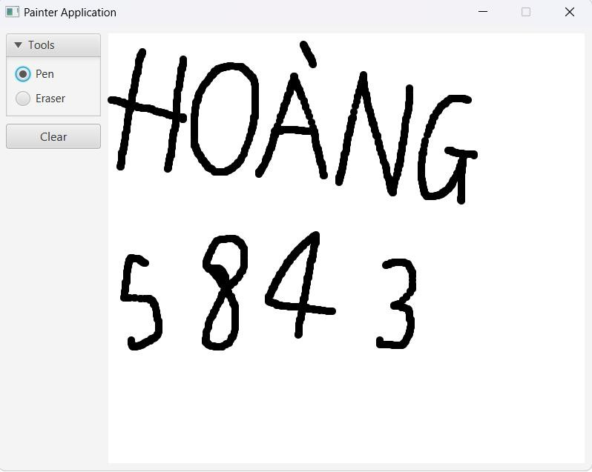

*Figure 4.5: Use Pen*

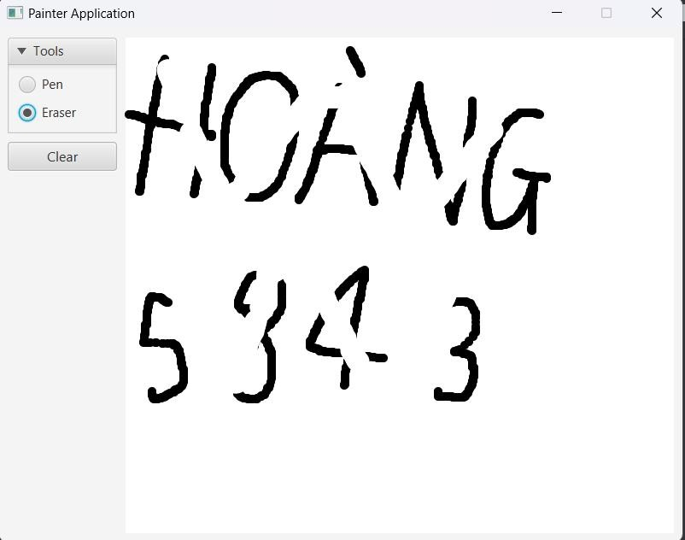

*Figure 4.6: Use Eraser*

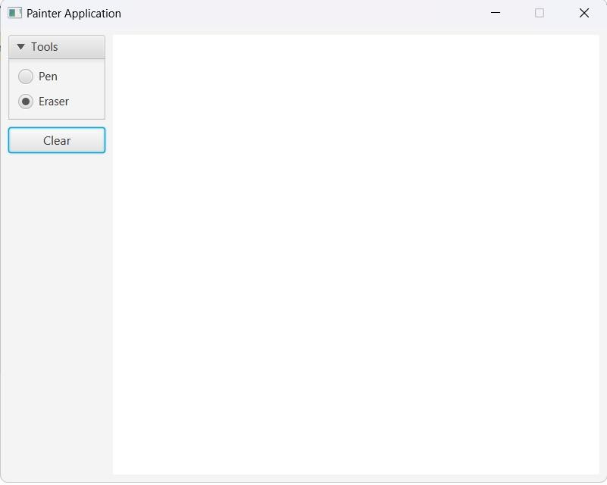

*Figure 4.7: Clear button*

# View Cart Screen

## Create cart.fxml

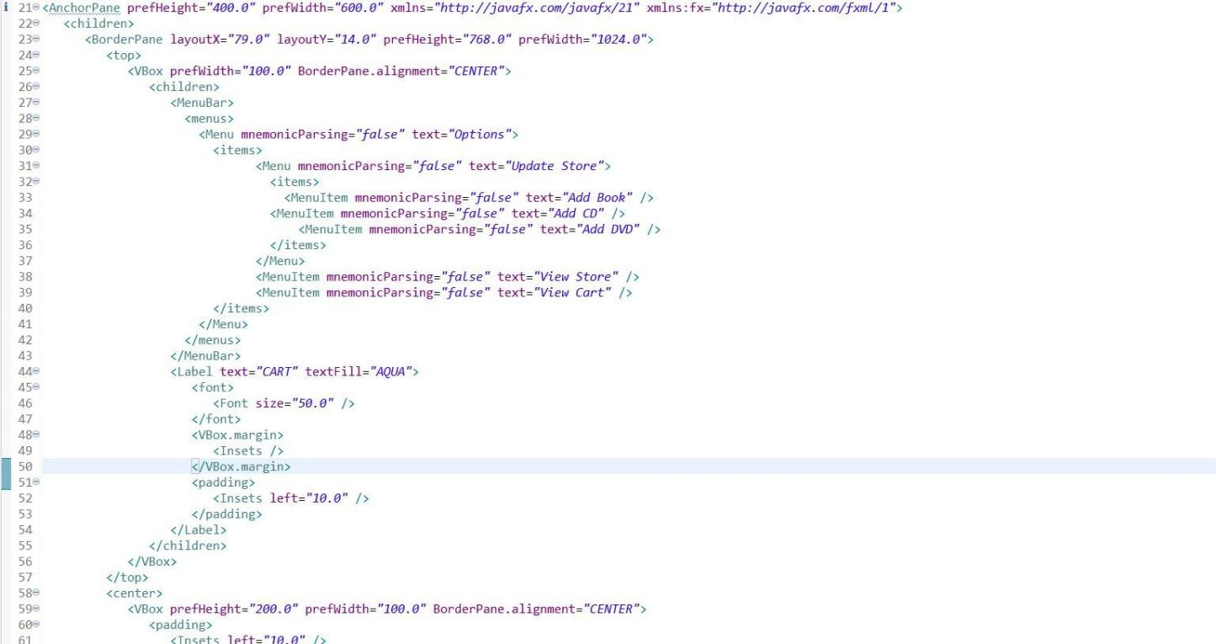

*Figure 5.1: Cart.fxml 1*

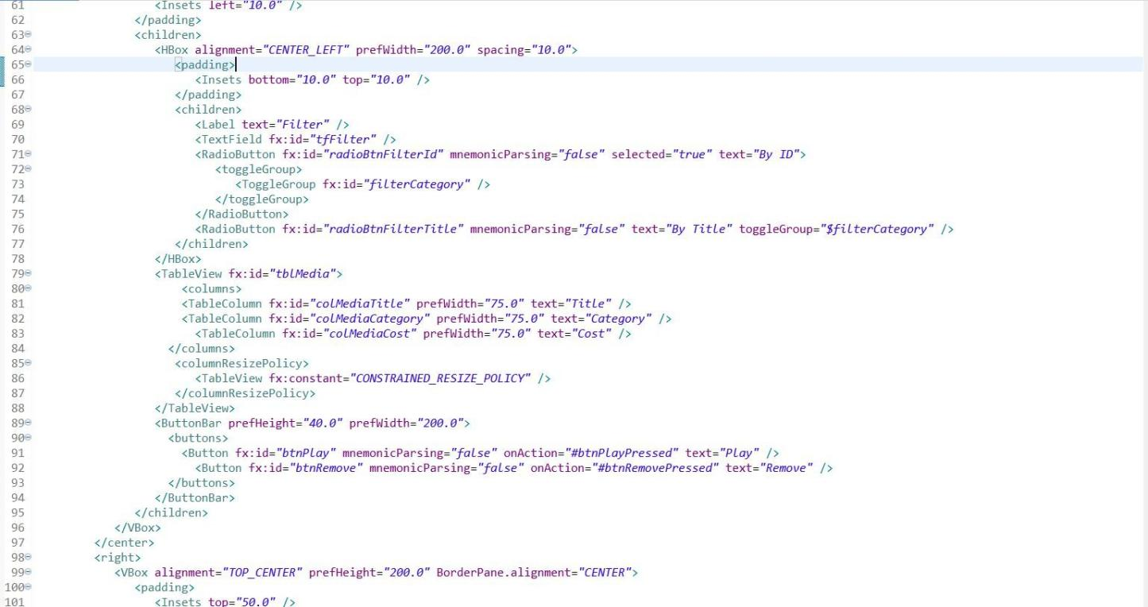

*Figure 5.2: Cart.fxml 2*

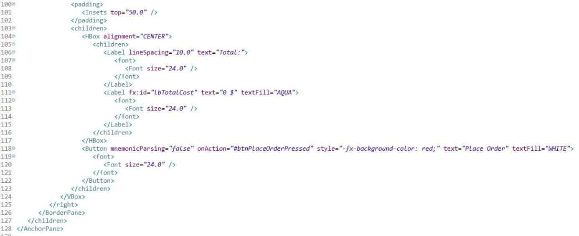

## Create class CartScreen

*Figure 5.3: Cart.fxml 3*

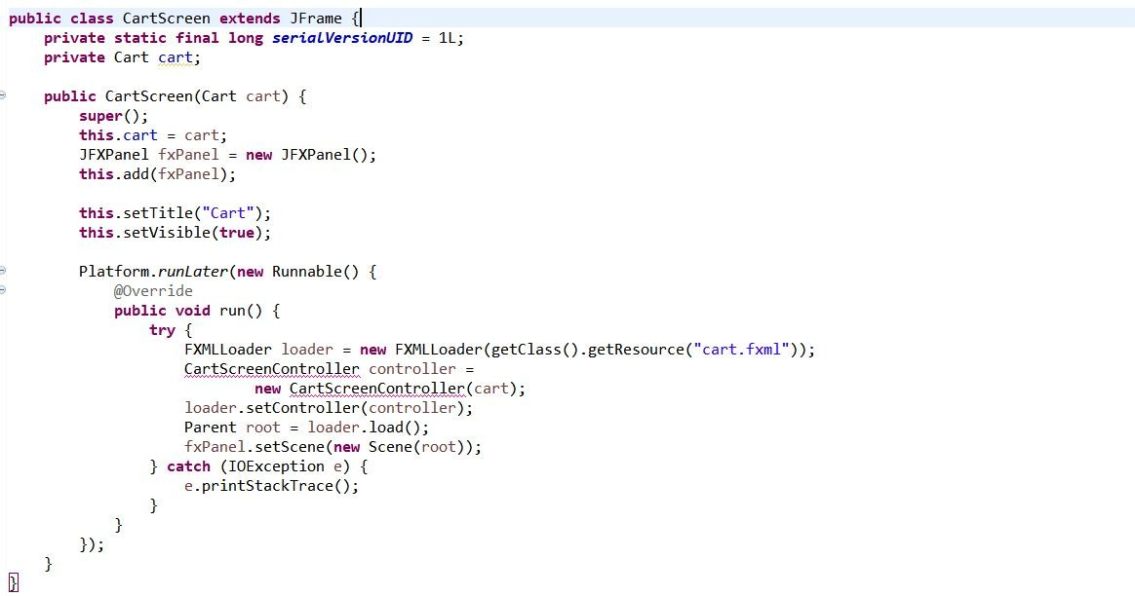

*Figure 5.4: CartScreen class*

## Create class CartScreenController

*Figure 5.5: CartScreenController 1*

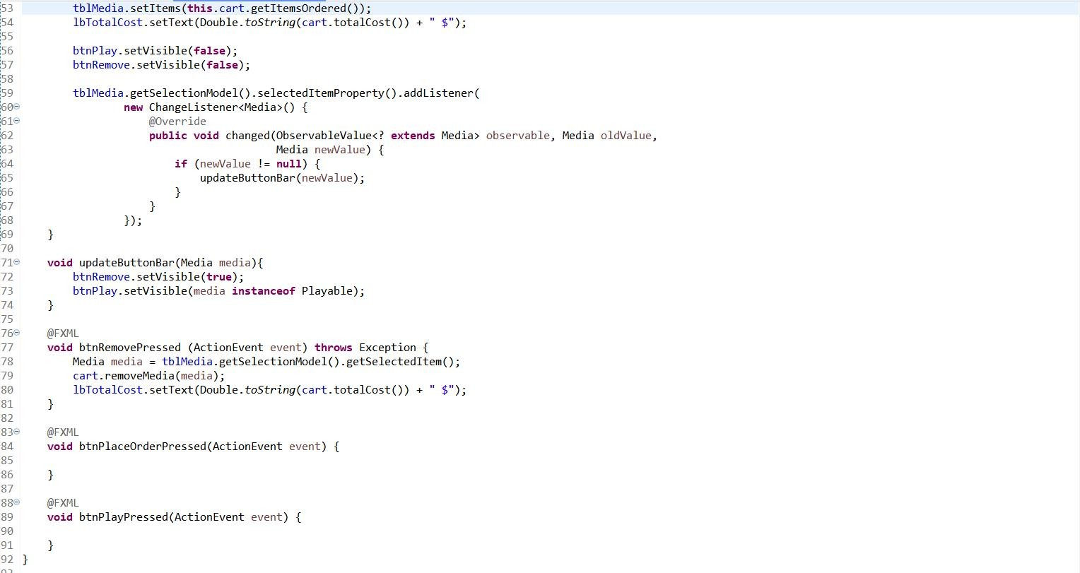

*Figure 5.6: CartScreenController 2*

## Demo

*Figure 5.7: Demo CartScreen*

# Updating buttons based on selected item in TableView – ChangeListener

## Edit class CartScreenController

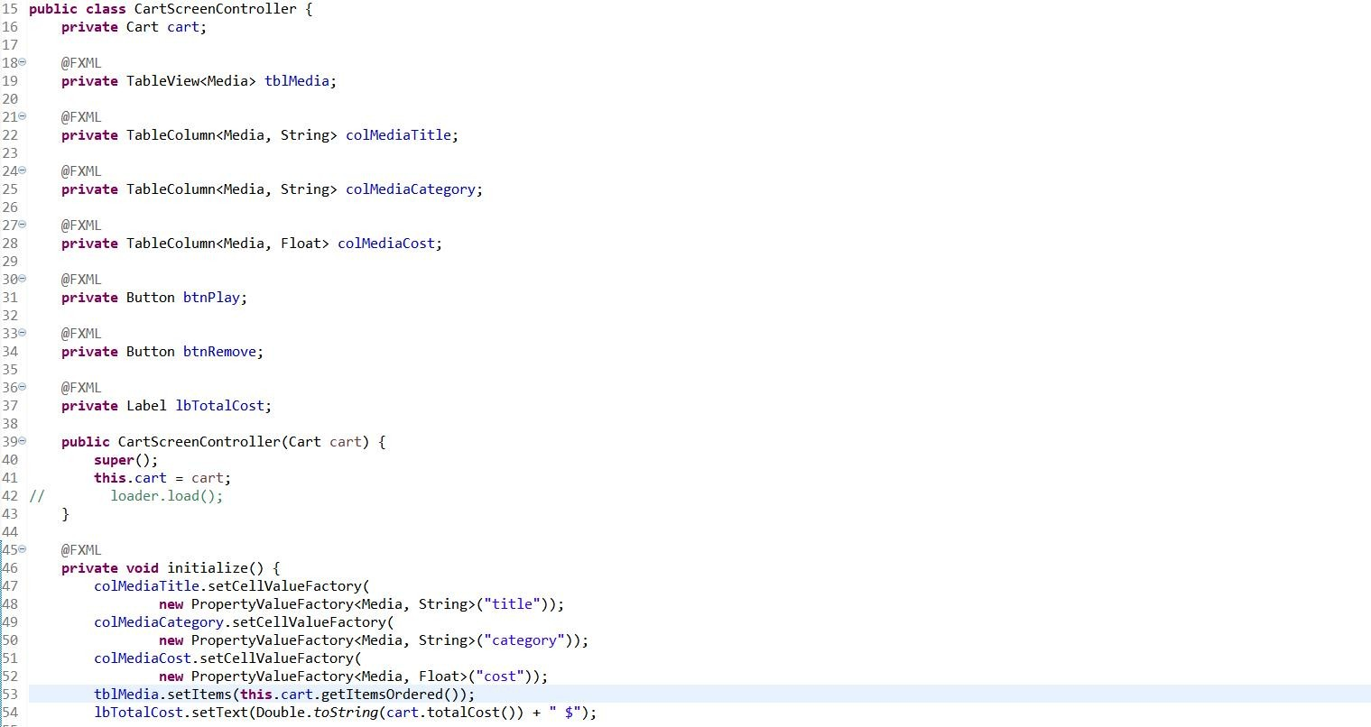



## Demo

*Figure 6.2: CartScreenController 2*

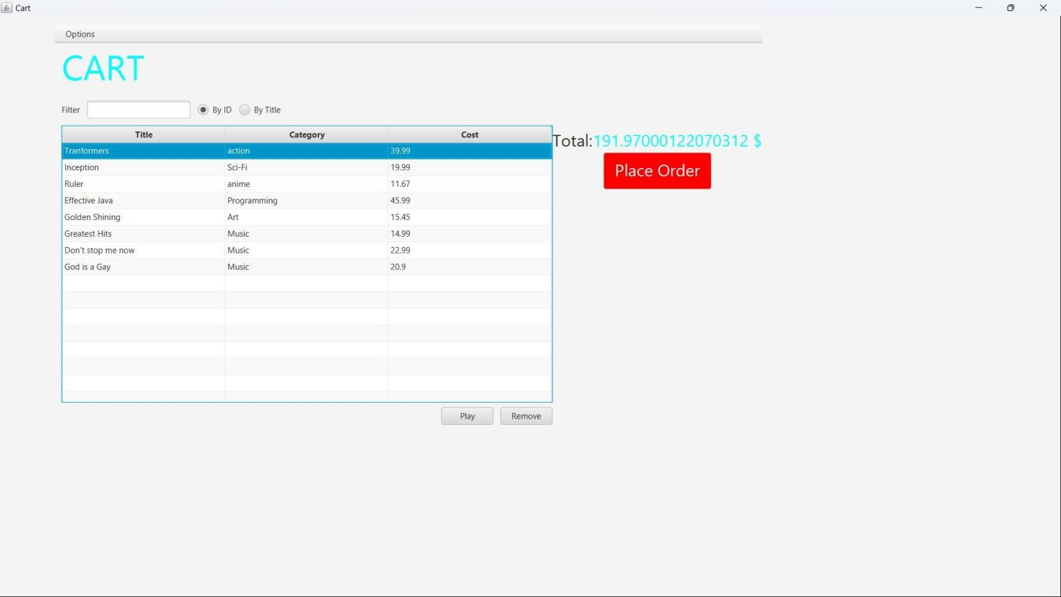

*Figure 6.3: Demo media playable*

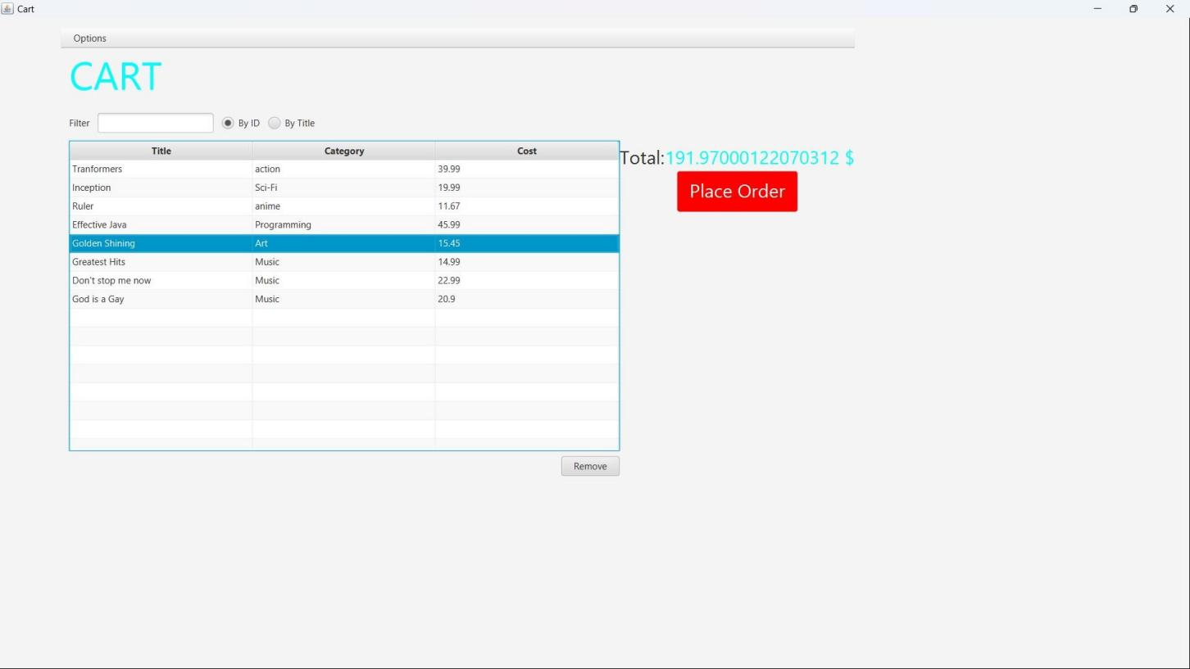

*Figure 6.4: Demo media unplayable*

# Deleting a media

## Code

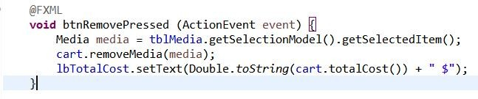

*Figure 7.1: btnRemovePressed Method*

## Demo

*Figure 7.2: button Remove*

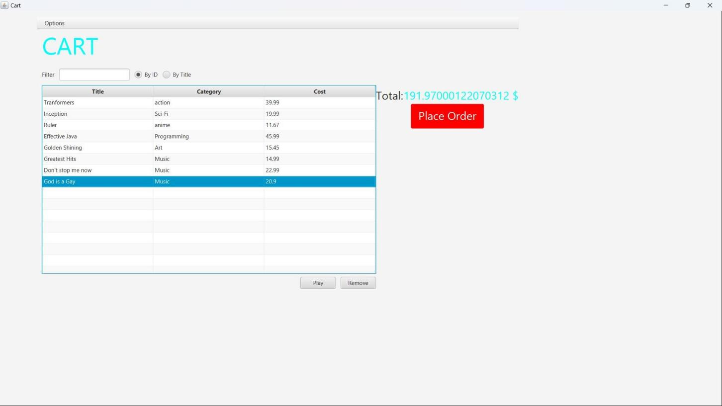

*Figure 7.3: button Remove*

# Complete the Aims GUI application

*Figure 8.1: Store before add book*

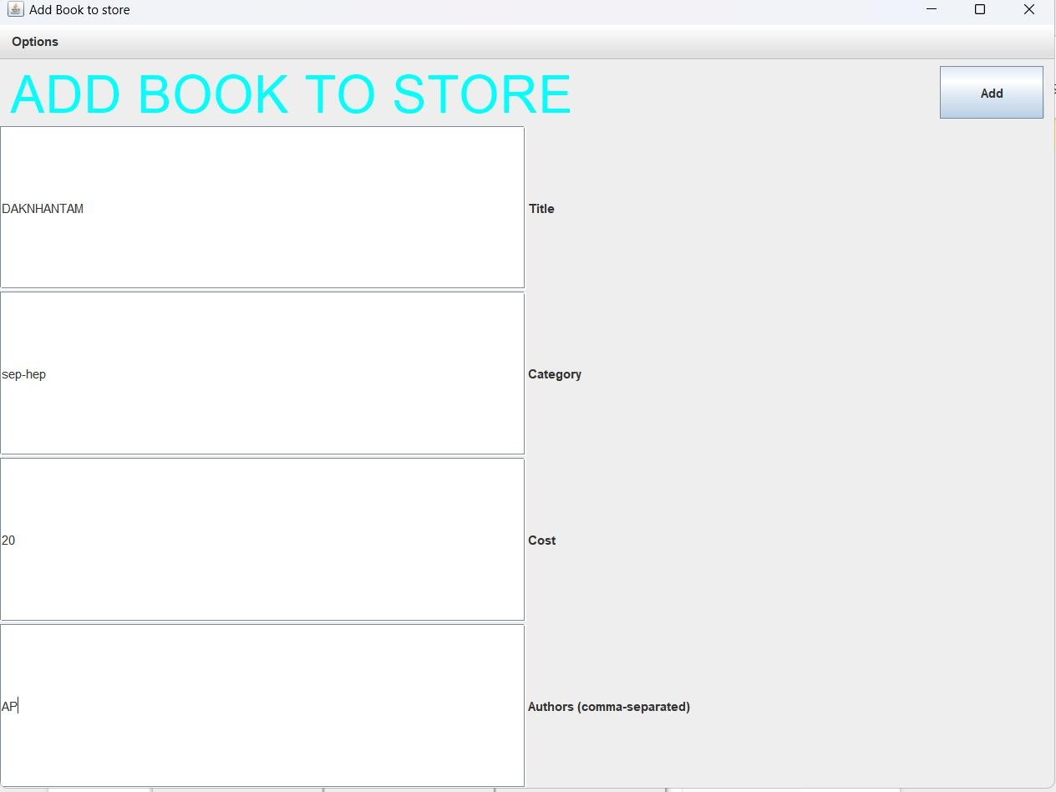

*Figure 8.2: Add book*

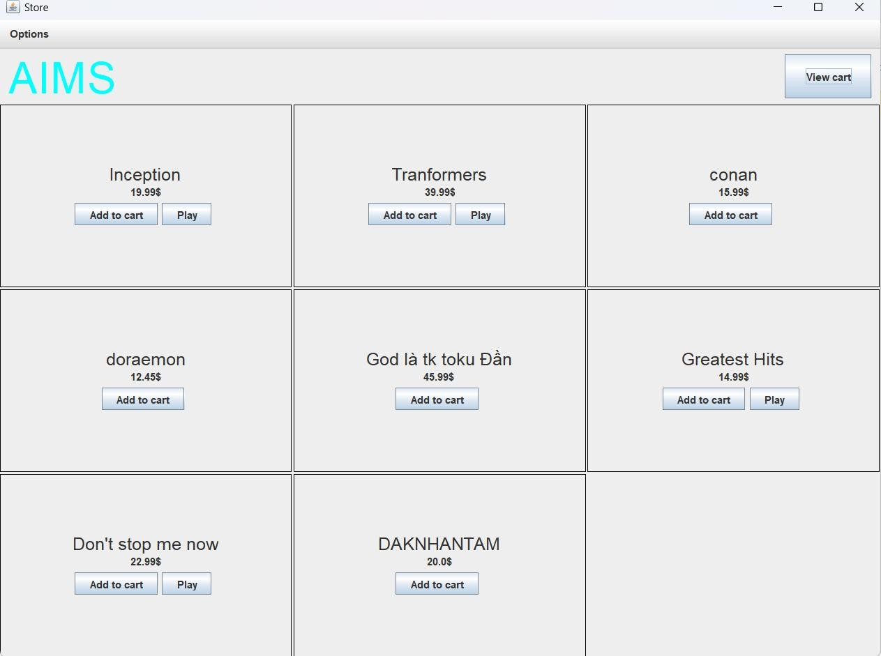

*Figure 8.3: Store after add book*

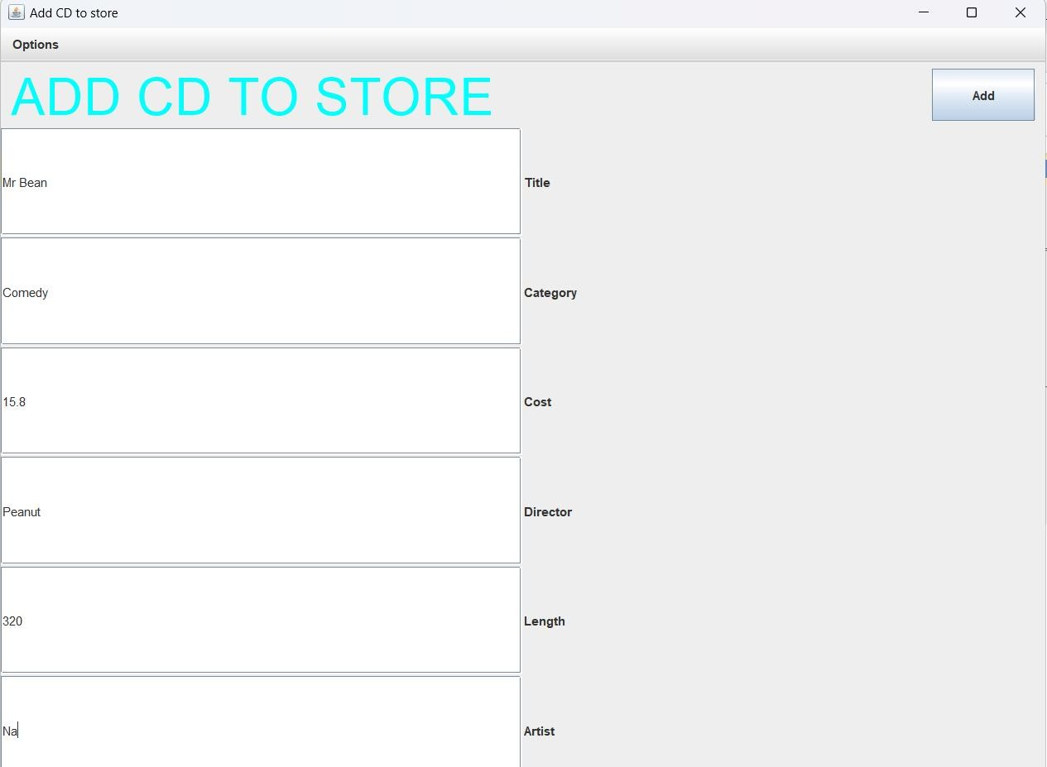

*Figure 8.4: Add CD*

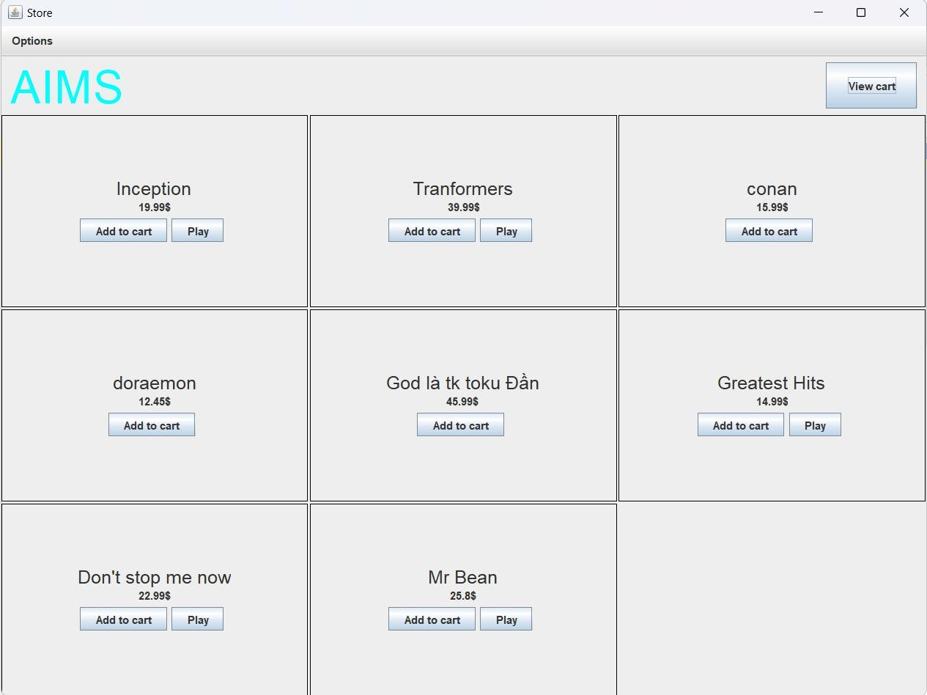

*Figure 8.5: Store after add CD*

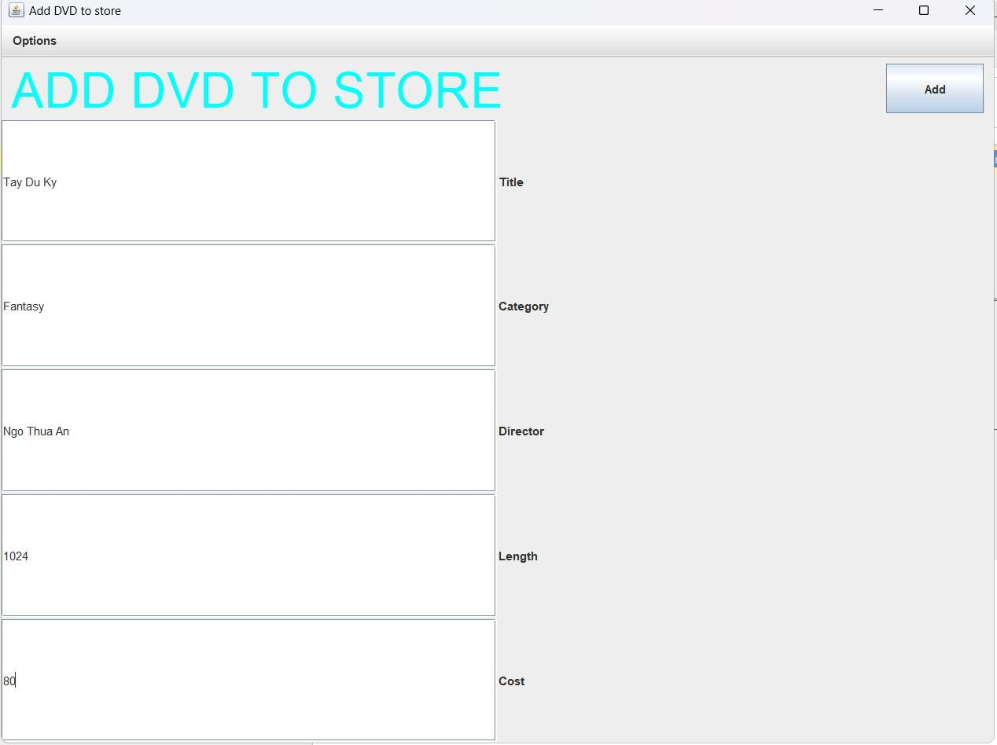

*Figure 8.6 Add DVD*

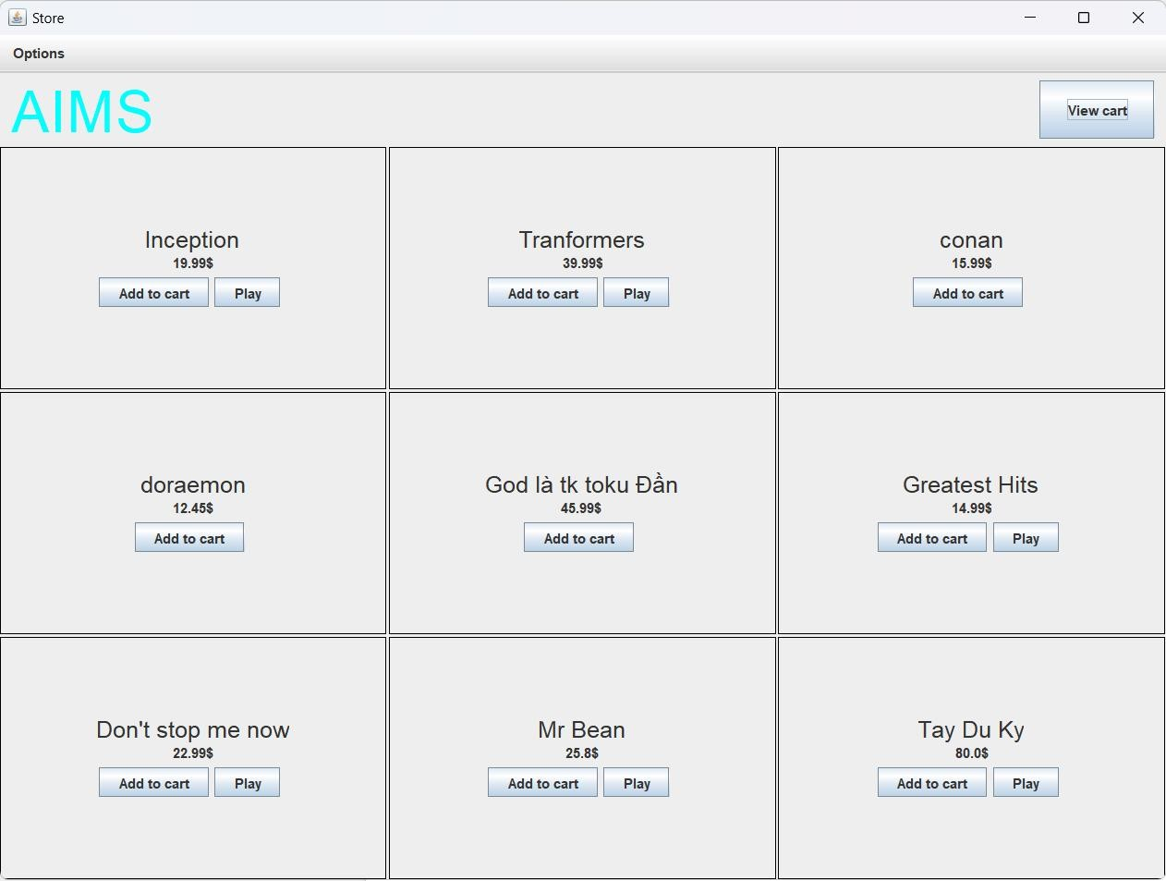

*Figure 8.7: Store after add DVD*

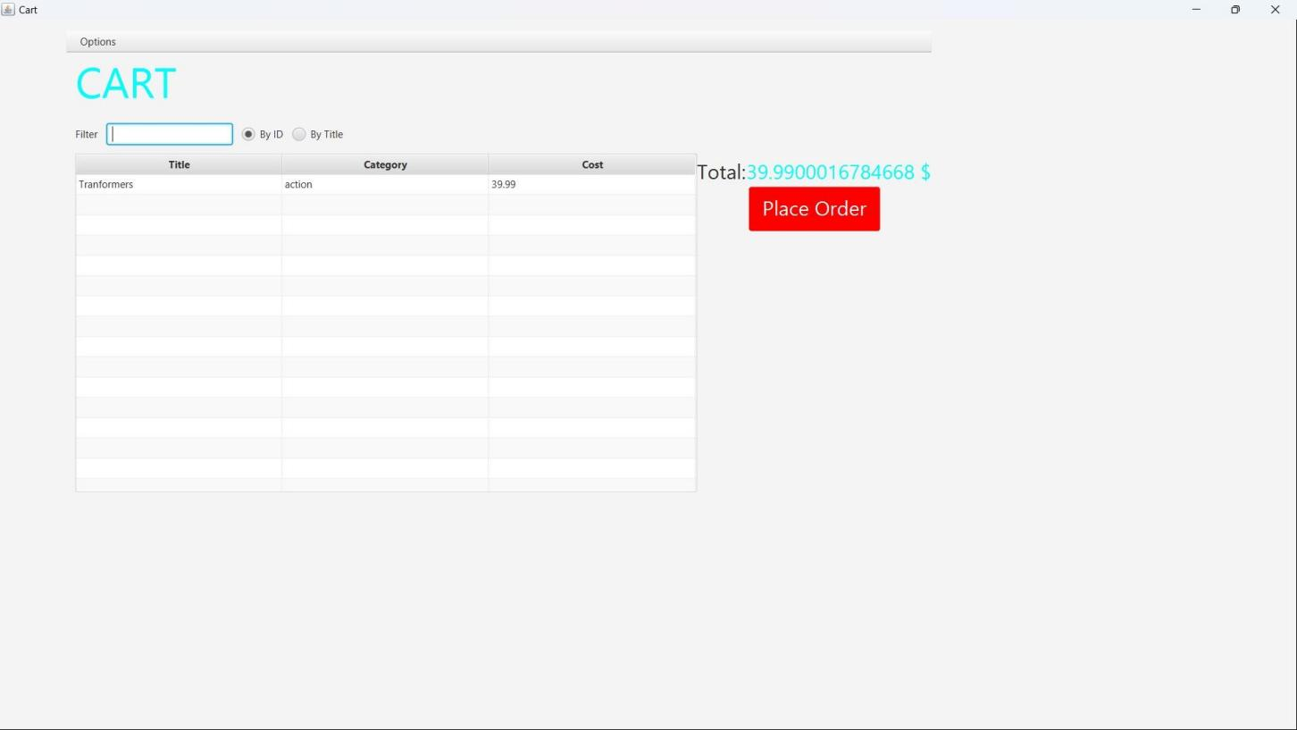

*Figure 8.8: Cart*