BÁO CÁO THỰC HÀNH LAB 3
LẬP TRÌNH HƯỚNG ĐỐI TƯỢNG
Họ và tên: Đặng Huy Hoàng
MSSV: 20225843
Học phần: IT3103
Mã lớp: 744528

- Branch your repository

- Working with method overloading
  - Overloading by differing types of parameter

Phương thức addDigitalVideoDisc(DigitalVideoDisc[] dvdList) cho phép thêm danh sách các đĩa DVD vào giỏ hàng.

Code:

public void addDigitalVideoDisc(DigitalVideoDisc[] dvdList) {
for (DigitalVideoDisc disc : dvdList) {
if (qtyOrdered < MAX_NUMBERS_ORDER) {
itemOrdered[qtyOrdered] = disc;
qtyOrdered++;
System.out.println("The disc has been added: " + disc.getTitle());
} else {
System.out.println("The cart is full! Cannot add: " + disc.getTitle());
break;
}
}
}

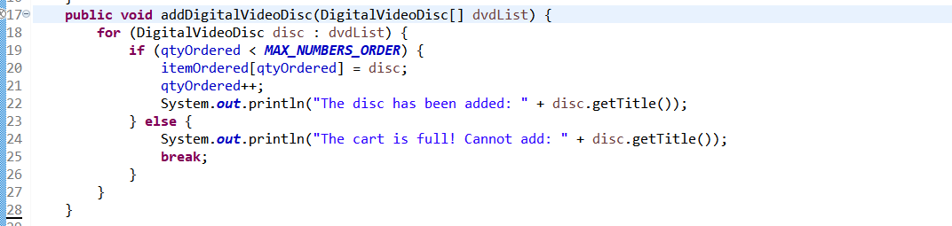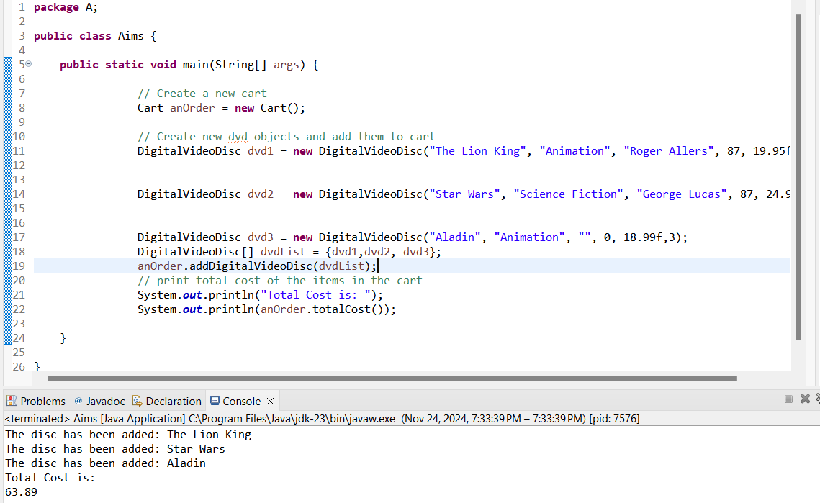

Phương thức addDigitalVideoDisc(DigitalVideoDisc… dvdList) cho phép thêm một danh sách số đĩa bất kỳ các đĩa DVD vào giỏ hàng
Code :

public void addDigitalVideoDisc(DigitalVideoDisc... dvds) {
for (DigitalVideoDisc disc : dvds) {
if (qtyOrdered < MAX_NUMBERS_ORDER) {
itemOrdered[qtyOrdered] = disc;
qtyOrdered++;
System.out.println("The disc has been added: " + disc.getTitle());
} else {
System.out.println("The cart is full! Cannot add: " + disc.getTitle());
break;
}
}
}

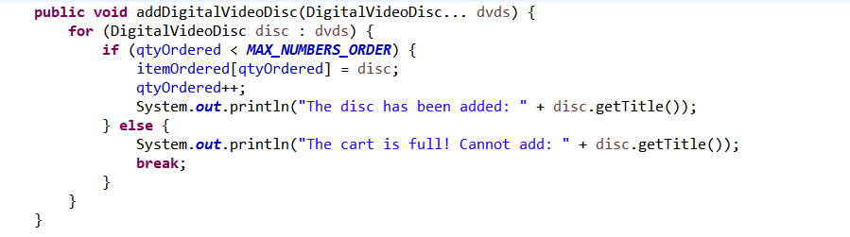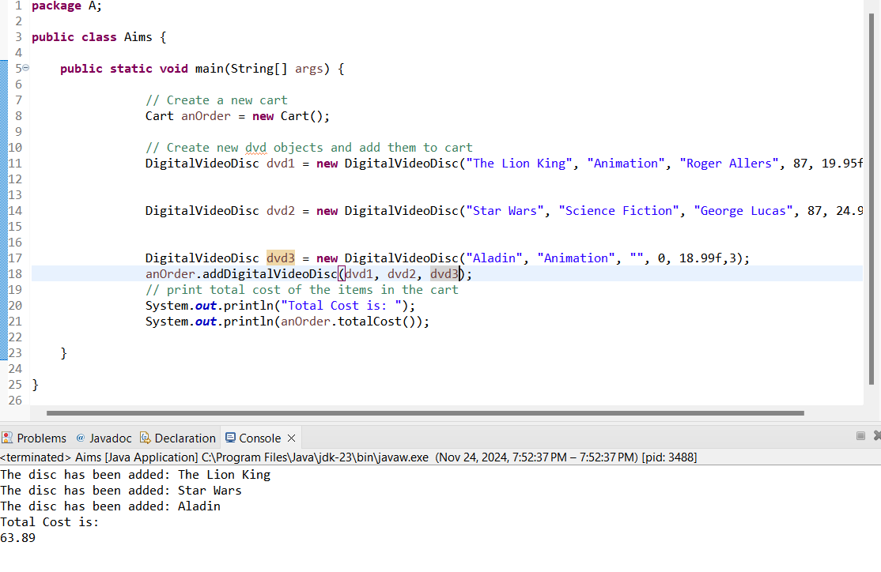
Nhận xét: Cách sử dụng varargs sẽ tốt hơn vì nó cho phép thêm bất kỳ số lượng đĩa DVD nào mà không cần chỉ định mảng một cách rõ ràng, chúng ta có thể sử dụng danh sách tham số, hoặc là sử dụng mảng. Do đó hàm sẽ linh động hơn. Điều này làm cho mã nguồn sạch sẽ hơn và thuận tiện hơn khi gọi phương thức.
2.2. Overloading by differing the number of parameter

Code :
public void addDigitalVideoDisc(DigitalVideoDisc dvd1, DigitalVideoDisc dvd2) {
if (qtyOrdered + 2 <= MAX_NUMBERS_ORDER) {
itemOrdered[qtyOrdered] = dvd1;
qtyOrdered++;
itemOrdered[qtyOrdered] = dvd2;
qtyOrdered++;
System.out.println("The discs have been added: " + dvd1.getTitle() + ", " + dvd2.getTitle());
} else {
System.out.println("The cart does not have enough space to add both discs.");
}
}
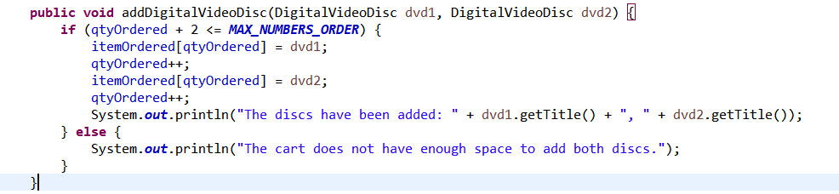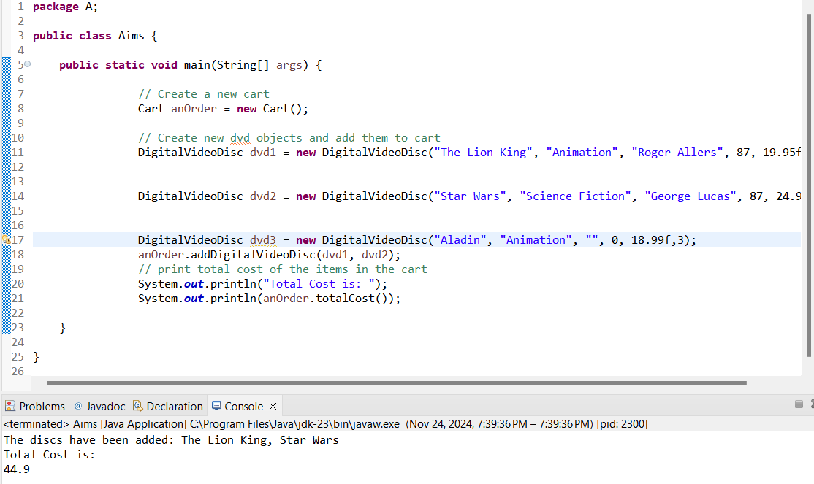

- Passing parameter
Code:
public class TestPassingParameter {

public static void main(String[] args) {
// TODO Auto-generated method stub
DigitalVideoDisc jungleDVD = new DigitalVideoDisc("Jungle");
DigitalVideoDisc cinderellaDVD = new DigitalVideoDisc("Cinderella");
swap(jungleDVD, cinderellaDVD);
System.out.println("jungle dvd title: " + jungleDVD.getTitle());
System.out.println("cinderella dvd title: " + cinderellaDVD.getTitle());
changeTitle(jungleDVD, cinderellaDVD.getTitle());
System.out.println("jungle dvd title: " + jungleDVD.getTitle());
}
public static void swap(Object o1, Object o2) {
Object tmp = o1;
o1 = o2;
o2 = tmp;
}
public static void changeTitle(DigitalVideoDisc dvd, String title) {
String oldTitle = dvd.getTitle();
dvd.setTitle(title);
dvd = new DigitalVideoDisc(oldTitle);
}
}
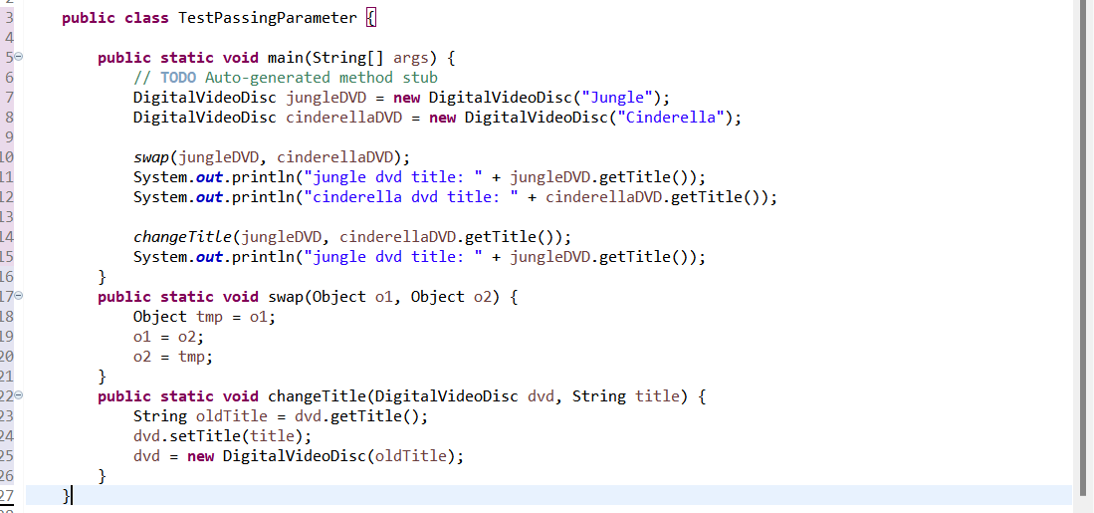
Kết quả :
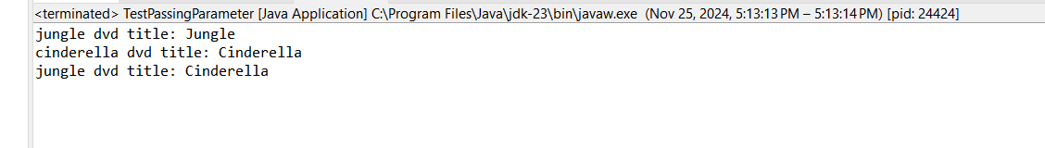
Ta có thể thấy rằng: Hàm swap đã không hoán đổi giá trị hai biến cho nhau.

4.USE DEBUG RUN
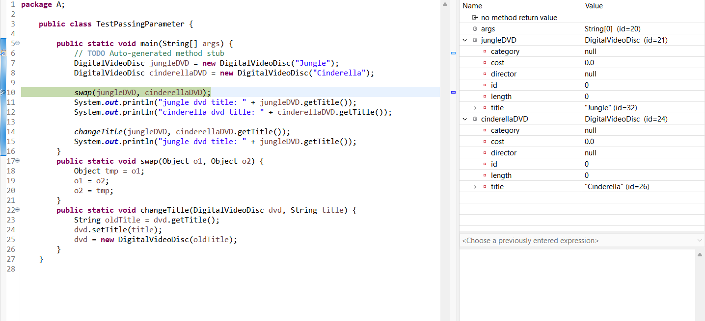
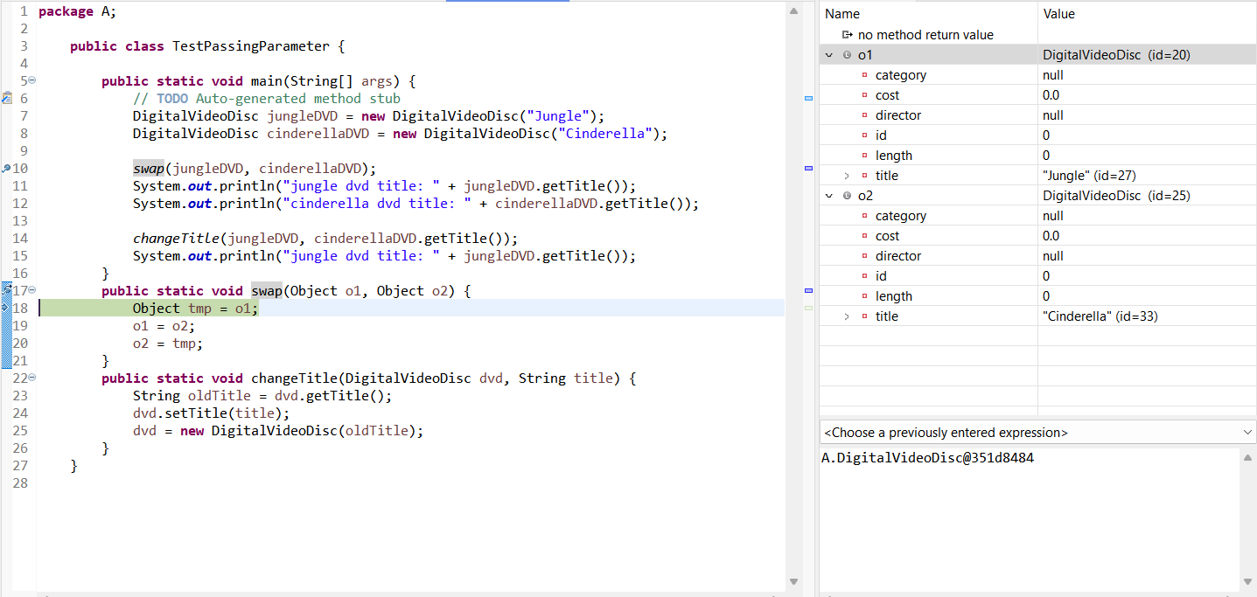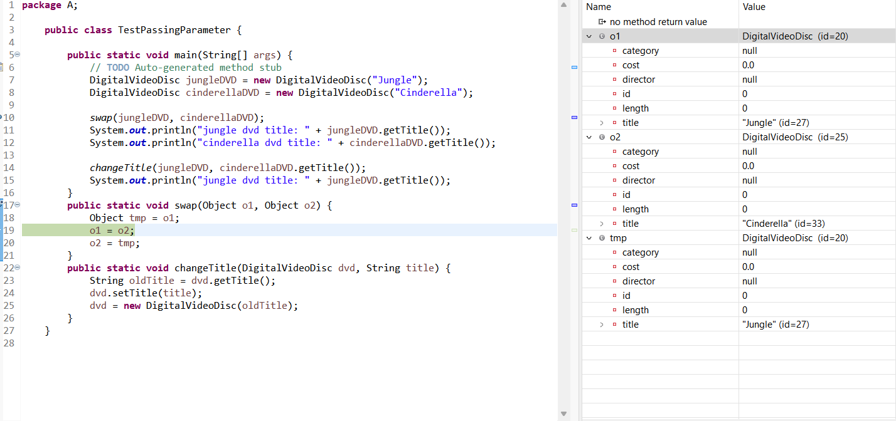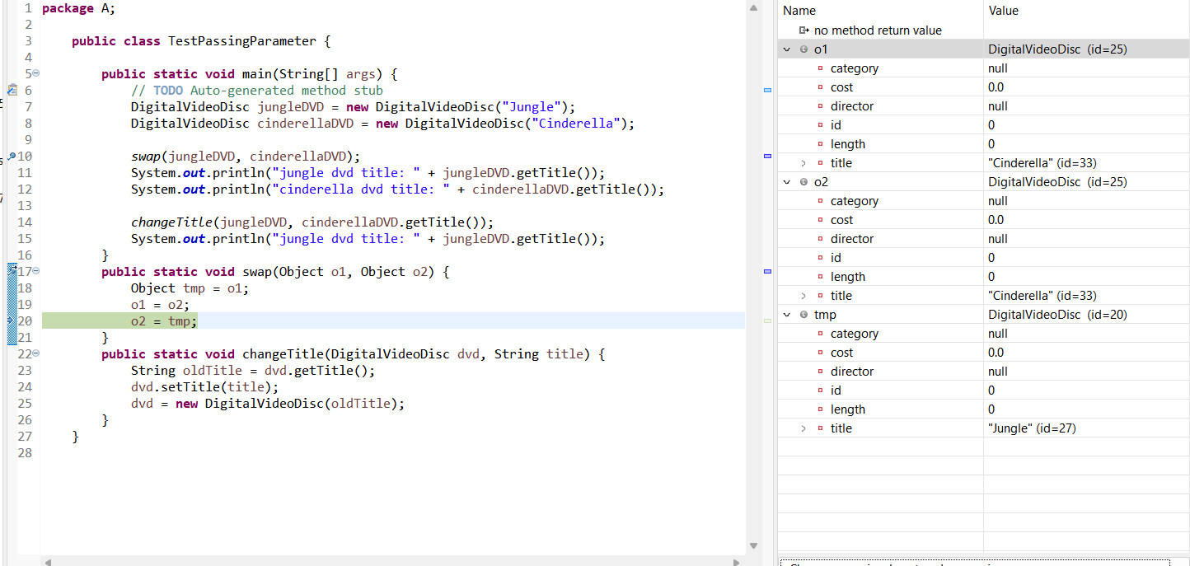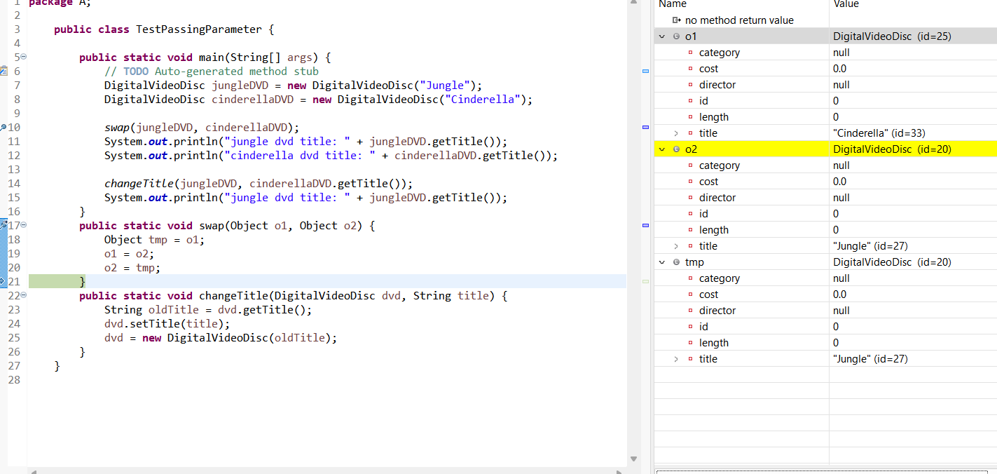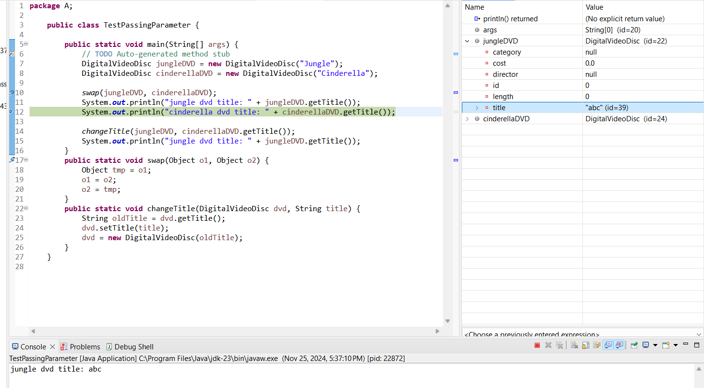

5 . Classifier Member and Instance Member
Code:
public class DigitalVideoDisc {
private String title;
private int length;
private String director;
private String category;
private float cost;
private int id;
public static int nbDigitalVideoDiscs = 0;
public DigitalVideoDisc(String title, String category, String director, int length, float cost) {
this.title = title;
this.category = category;
this.director = director;
this.length = length;
this.cost = cost;
nbDigitalVideoDiscs++;
this.id = nbDigitalVideoDiscs;
}
public DigitalVideoDisc(String title) {
this.title = title;
}
public String getTitle() {
return title;
}
public int getLength() {
return length;
}
public String getDirector() {
return director;
}
public String getCategory() {
return category;
}
public float getCost() {
return cost;
}
public int getId() {
return id;
}
public void setTitle(String titleSet) {
this.title = titleSet;
}

public void setDirector(String directorSet) {
this.director = directorSet;
}

public void setCategory(String categorySet) {
this.category = categorySet;
}

public void setLength(int lengthSet) {
this.length = lengthSet;
}

public void setCost(float costSet) {
this.cost = costSet;
}
public void setid(int idSet) {
this.id = idSet;
}
}
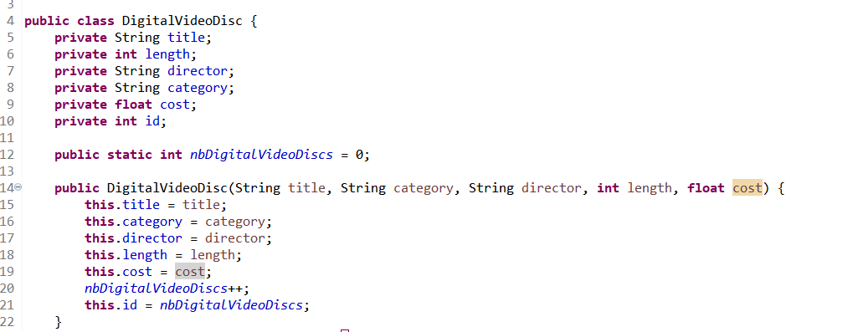
6. Open the Cart class
Code:
public class CartTest {

public static void main(String[] args) {
// Create a new cart
Cart anOrder = new Cart();

// Create new dvd objects and add them to cart
DigitalVideoDisc dvd1 = new DigitalVideoDisc("The Lion King", "Animation", "Roger Allers", 87, 19.95f);

DigitalVideoDisc dvd2 = new DigitalVideoDisc("Star Wars", "Science Fiction", "George Lucas", 87, 24.95f);

DigitalVideoDisc dvd3 = new DigitalVideoDisc("Aladin", "Animation", "", 0, 18.99f);
// Add DVDs to the cart
anOrder.addDigitalVideoDisc(dvd1);
anOrder.addDigitalVideoDisc(dvd2);
anOrder.addDigitalVideoDisc(dvd3);

// Print the cart
anOrder.printCart();

// Search by title
anOrder.searchByTitle("Solomon");
anOrder.searchByTitle("Frozen");

// Search by ID
anOrder.searchById(2);
anOrder.searchById(10);

// Remove a DVD
anOrder.removeDigitalVideoDisc(dvd2);
anOrder.printCart();

}

}
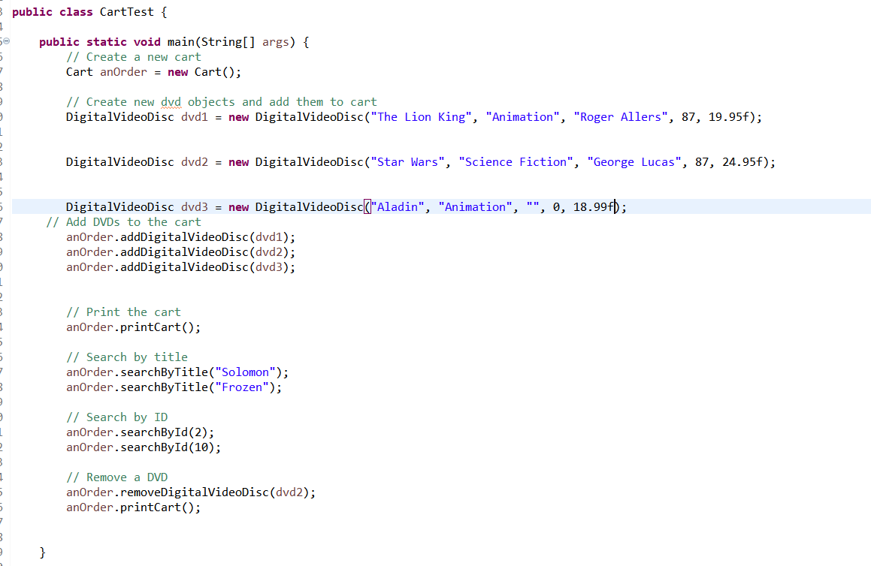

Kết quả :
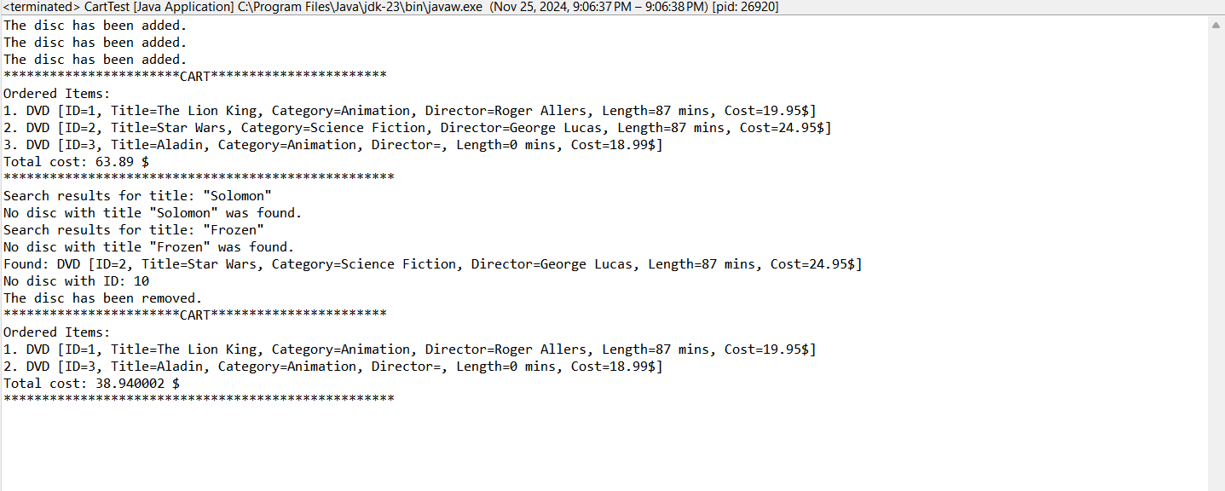

7. Implement the Store class
Code:
public class StoreTest {

public static void main(String[] args) {
// Create a Store instance
Store store = new Store();

// Create some DigitalVideoDisc instances
DigitalVideoDisc dvd1 = new DigitalVideoDisc("Jungle", "Adventure", "John Doe", 120, 15.99f);
DigitalVideoDisc dvd2 = new DigitalVideoDisc("Cinderella", "Animation", "Jane Smith", 90, 12.99f);
DigitalVideoDisc dvd3 = new DigitalVideoDisc("Avengers", "Action", "Joe Russo", 180, 19.99f);

// Test adding DVDs to the store
System.out.println("Adding DVDs to the store...");
store.addDVD(dvd1);
store.addDVD(dvd2);
store.addDVD(dvd3);

// Attempt to add a duplicate DVD
System.out.println("\nAttempting to add a duplicate DVD...");
store.addDVD(dvd1);

// Display the DVDs in the store
System.out.println("\nStore contents after adding DVDs:");
System.out.println(store);

// Test removing a DVD from the store
System.out.println("Removing DVD 'Cinderella' from the store...");
store.removeDVD(dvd2);

// Display the DVDs in the store after removal
System.out.println("\nStore contents after removing 'Cinderella':");
System.out.println(store);

// Attempt to remove a DVD not in the store
System.out.println("Attempting to remove a DVD not in the store...");
DigitalVideoDisc nonExistentDVD = new DigitalVideoDisc("Frozen", "Animation", "Chris Buck", 90, 13.99f);
store.removeDVD(nonExistentDVD);

// Display the final store contents
System.out.println("\nFinal store contents:");
System.out.println(store);
}
}
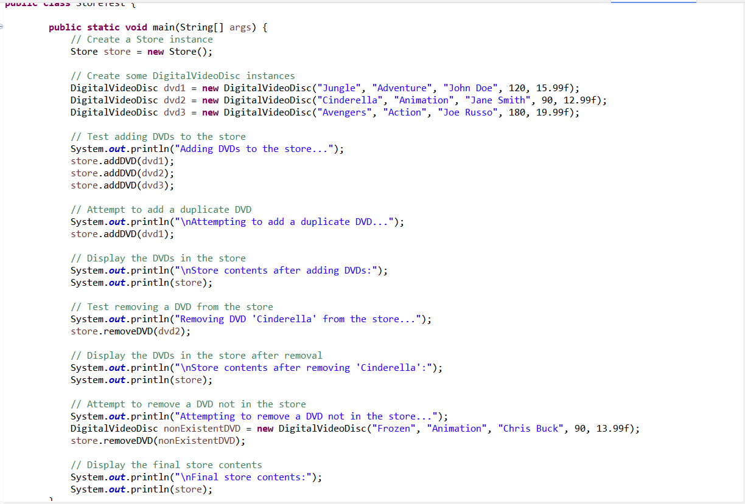
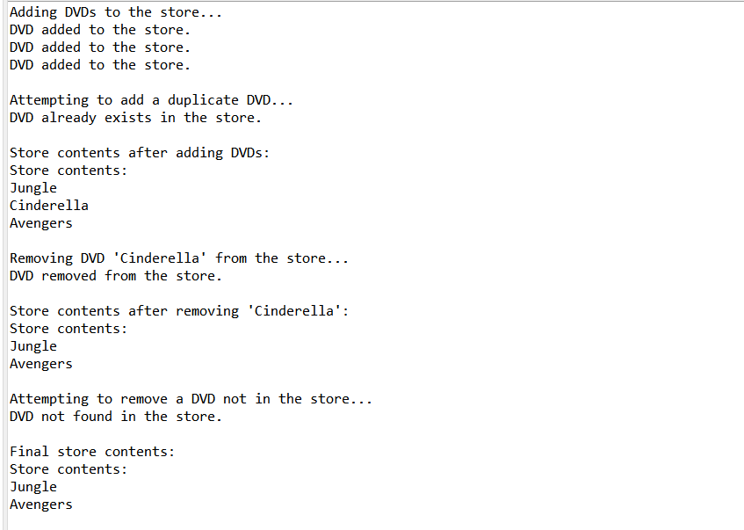
8. Re-organize your projects
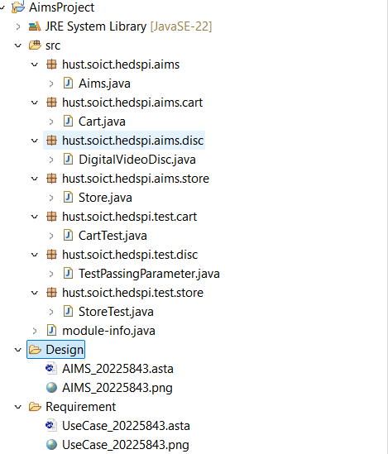

- String, StringBuilder and StringBuffer
9.1 ConcatenationInLoops:
import java.util.Random;

public class ConcatenationInLoops {
public static void main(String[] args) {
Random r = new Random(123);
long start = System.currentTimeMillis();
String s = "";
for (int i = 0; i < 100000; i++)
s += r.nextInt(2);
System.out.println(System.currentTimeMillis() - start);

r = new Random(123);
start = System.currentTimeMillis();
StringBuilder sb = new StringBuilder();
for (int i = 0; i < 100000; i++)
sb.append(r.nextInt(2));
s = sb.toString();
System.out.println(System.currentTimeMillis() - start);
}
}
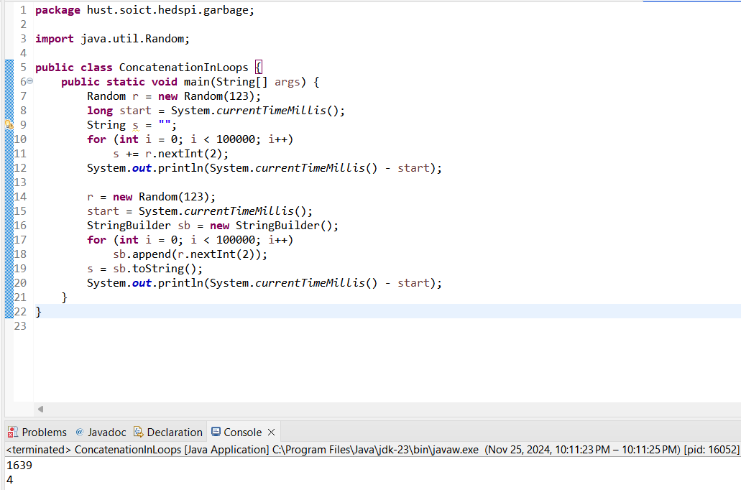
9.2 GarbageCreator khi sử dụng đọc file large_text_file.txt:
import java.io.*;
import java.nio.file.*;

public class GarbageCreator {

public static void main(String[] args) throws IOException{
String filename = "C:\\Users\\LAPTOP\\OneDrive - Hanoi University of Science and Technology\\Desktop\\large.txt";
byte[] inputBytes = { 0 };
long startTime, endTime;

inputBytes = Files.readAllBytes(Paths.get(filename));
startTime = System.currentTimeMillis();
String outputString = "";
for (byte b : inputBytes) {
outputString += (char) b;
}
endTime = System.currentTimeMillis();
System.out.println(endTime - startTime);
}
}
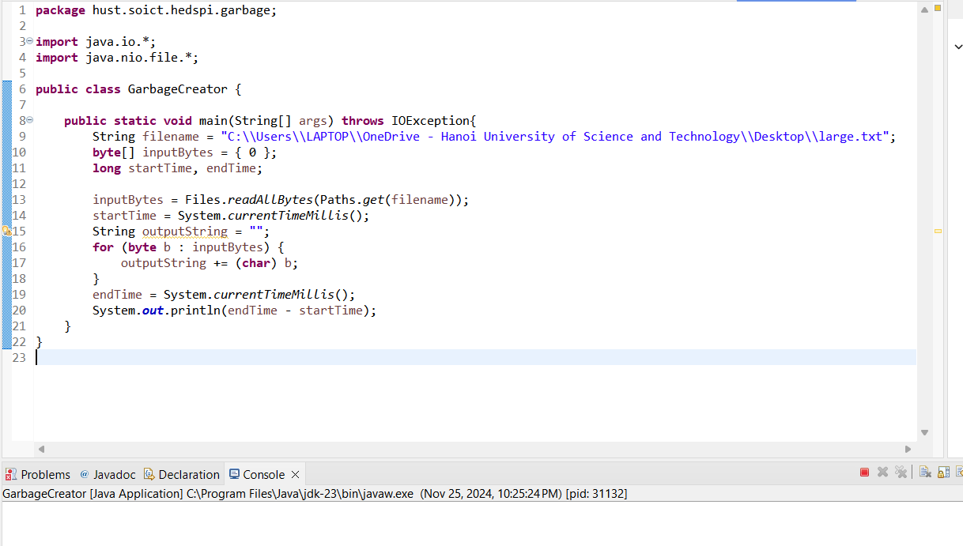
Tốc độ đọc file rất là chậm nên gần như bị đơ.

9.3 NoGarbage khi sử dụng đọc file large_text_file.txt:
import java.io.*;
import java.nio.file.*;

public class NoGarbage {

public static void main(String[] args) throws IOException{
String filename = "C:\\Users\\LAPTOP\\OneDrive - Hanoi University of Science and Technology\\Desktop\\large.txt";
byte[] inputBytes = { 0 };
long startTime, endTime;

inputBytes = Files.readAllBytes(Paths.get(filename));
startTime = System.currentTimeMillis();
StringBuilder outputStringBuilder = new StringBuilder();
for (byte b : inputBytes) {
outputStringBuilder.append((char)b);
}
endTime = System.currentTimeMillis();
System.out.println(endTime - startTime);
}
}
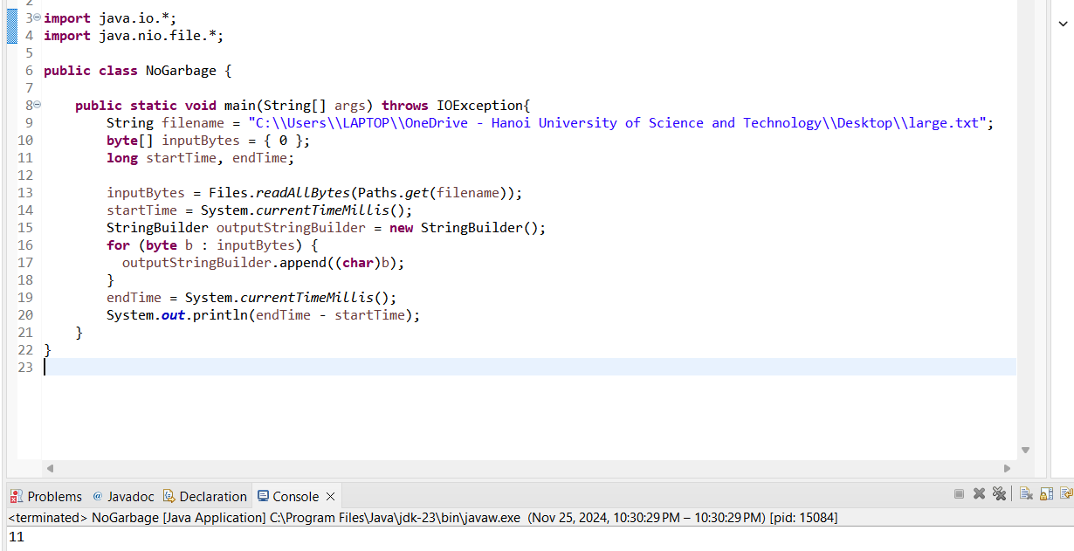
10. Release flow demonstration
Đã tạo trên Github

