1. **Lựa chọn nguồn Ouput 12V/24V Battery thông qua LCD16x2**

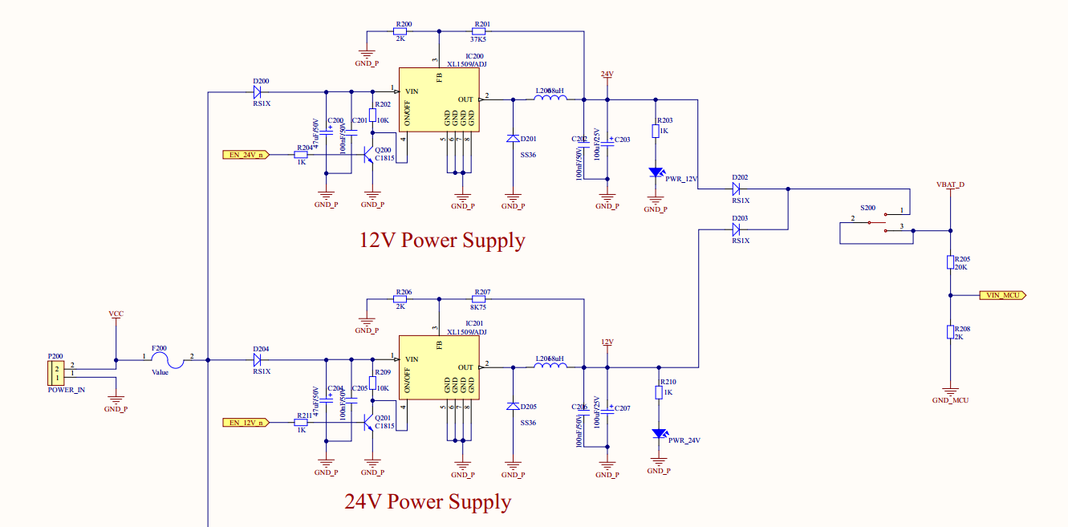

EN_12_n = 1 => Active 12V ouput

EN_12_n = 0 => Deactive 12V ouput

EN_24_n = 1 => Active 24V ouput

EN_24_n = 0 => Deactive 24V ouput

2 signal không thể Active cùng 1 lúc.

ADC voltage sensing kiểm tra ouput voltage đúng hay không (VIN_MCU)

1. **Automation switch signal để nạp code (ST uC, BLE and UWB).**

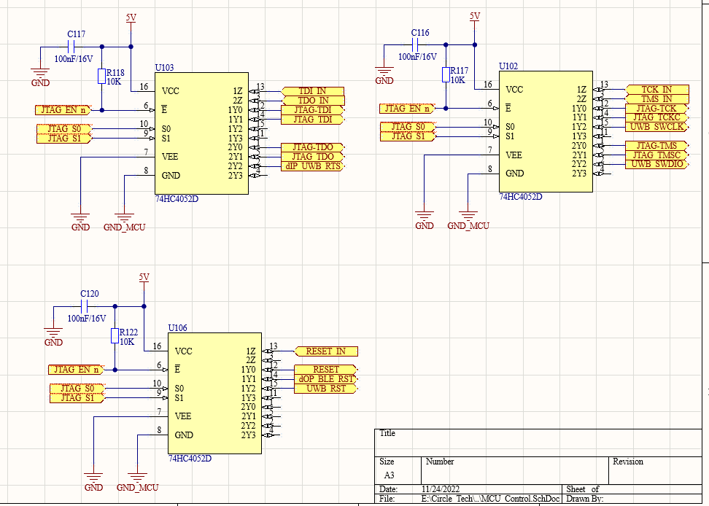 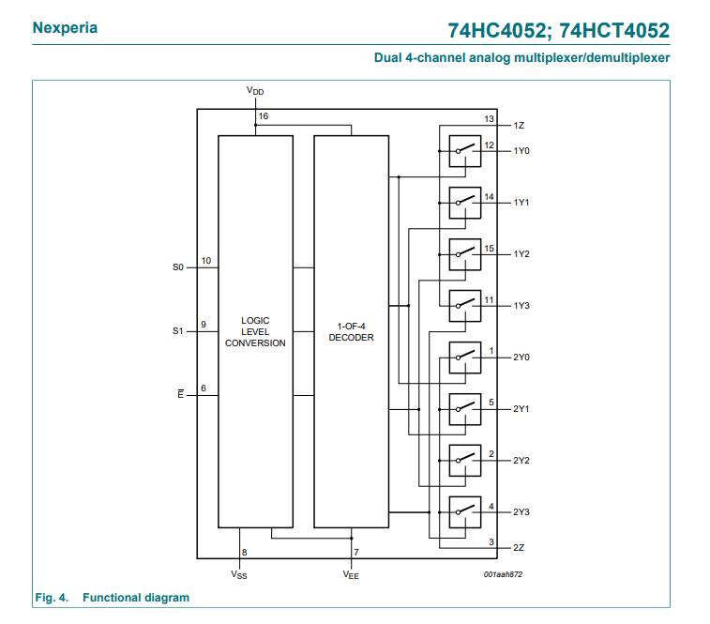

Multiplexer

JTAG_EN_n = 0 => Active Switch

JTAG_S0 = 0 vs JTAG_S1 = 0 => Active ST uC program

JTAG_S0 = 1 vs JTAG_S1 = 0 => Active BLE program

JTAG_S0 = 0 vs JTAG_S1 = 1 => Active UWB program

JTAG_S0 = 1 vs JTAG_S1 = 1 => Not use

1. **Automation reset signal**

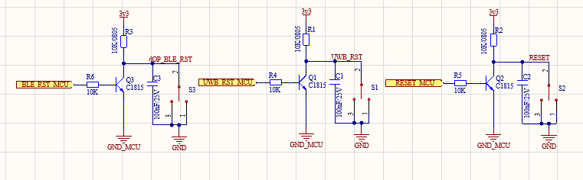

1. **LCD display and button selection**

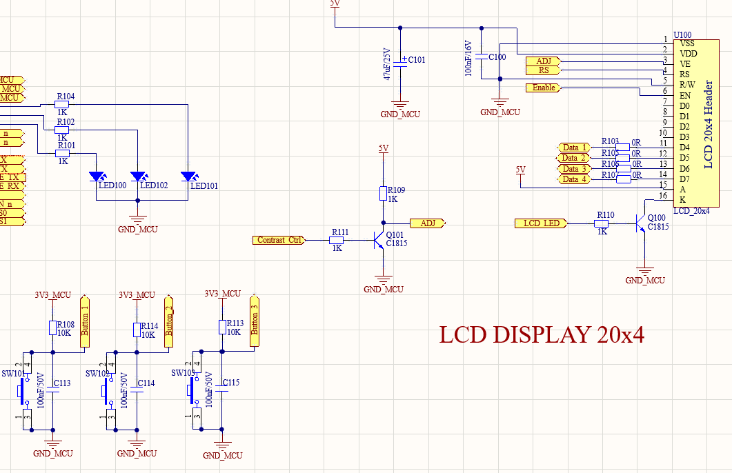

1. **CAN detection and USB interface with computer or uC**

