2 pointers

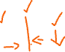

radar



while charAt(head) == chatAt(tail) && (head <= tail):

move head 1 index to right

move tail 1 index to left

noon



javeaj



python



Step not on pets

