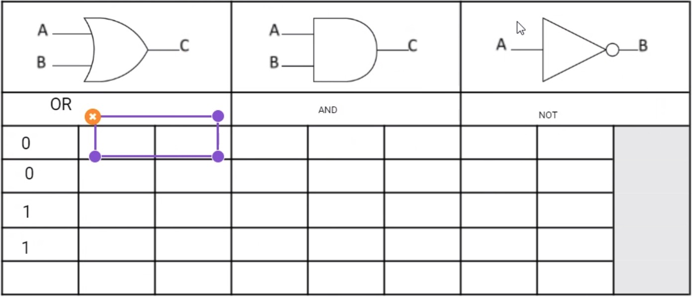

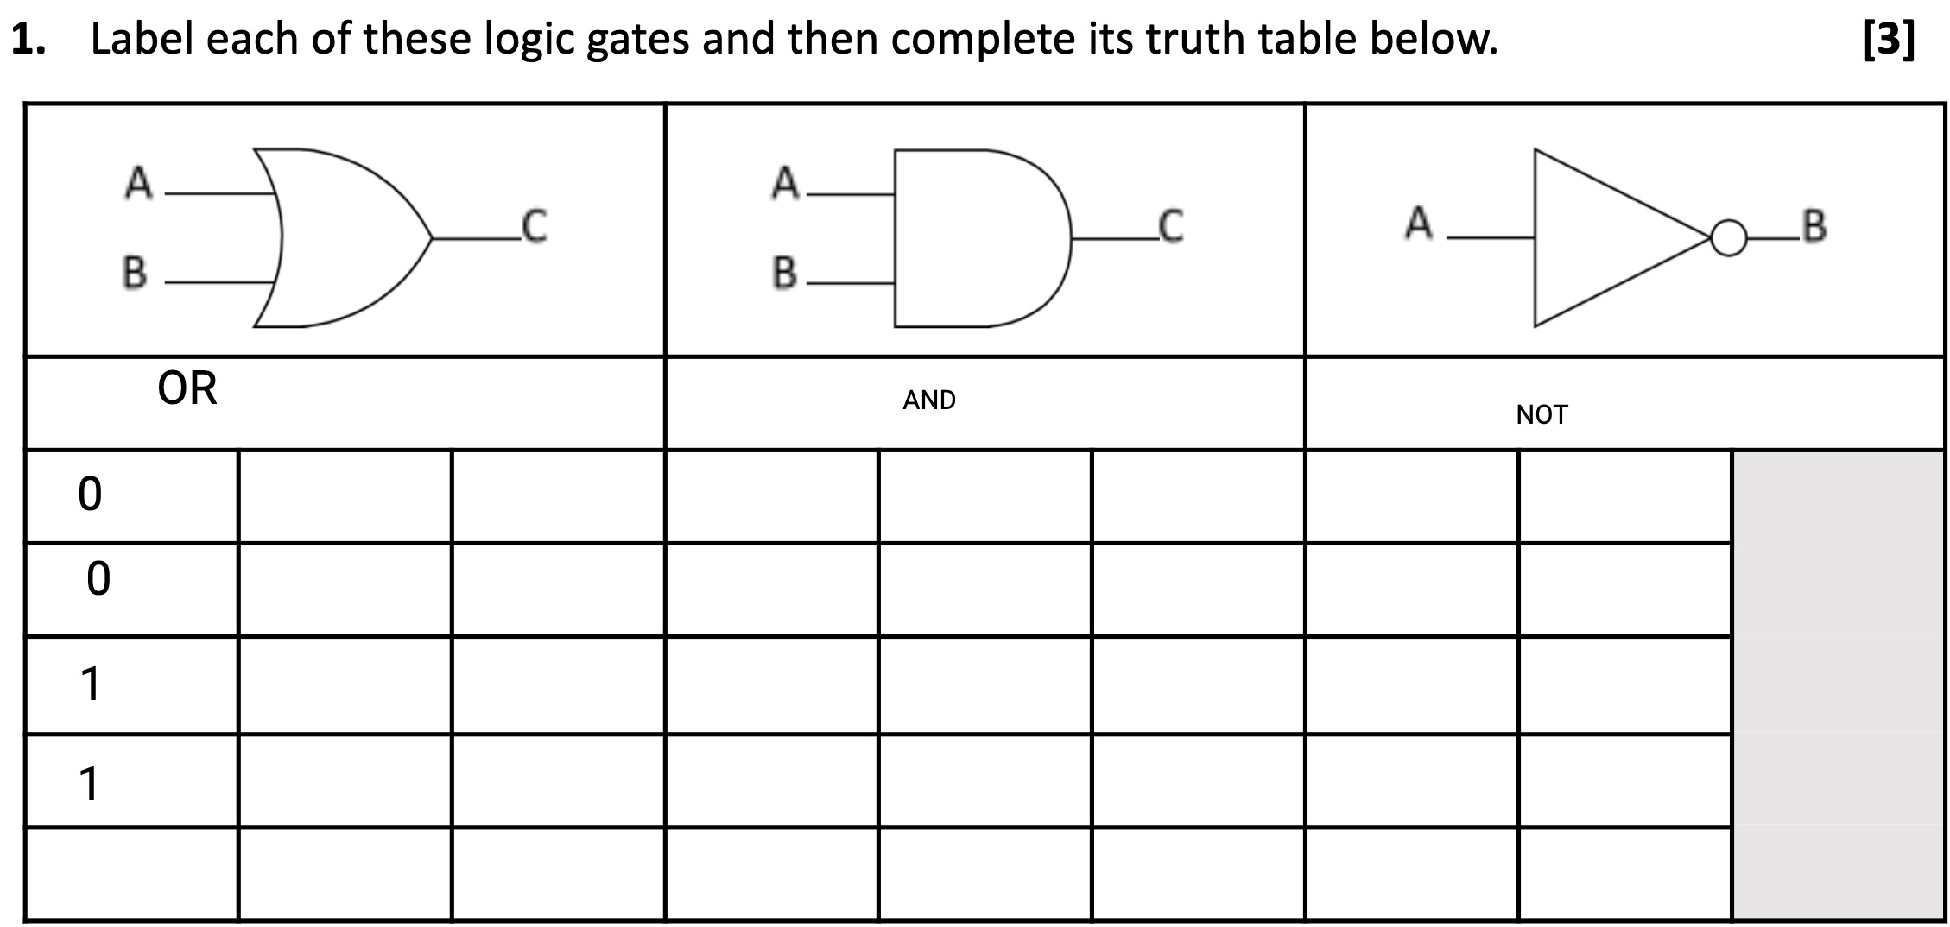

(NOT S AND T) OR (S AND W) OR (NOT T AND W)

