Paradigm: pattern

OOP: Java Class: blueprint / design of an object



Functional programming

Object: instance created from aclass

Properties: thuộc tính



Methods: hành động

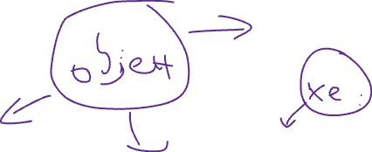

Class vs Object



Thiết kế



Scanner scnr = new Scanner(System.*in*);

Classname object_name = new Classname/constructor

