**Giao diện TLUContact**

1. Quyền admin

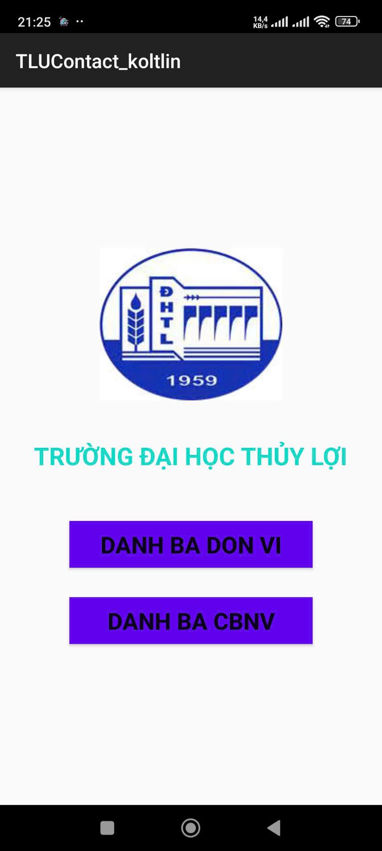

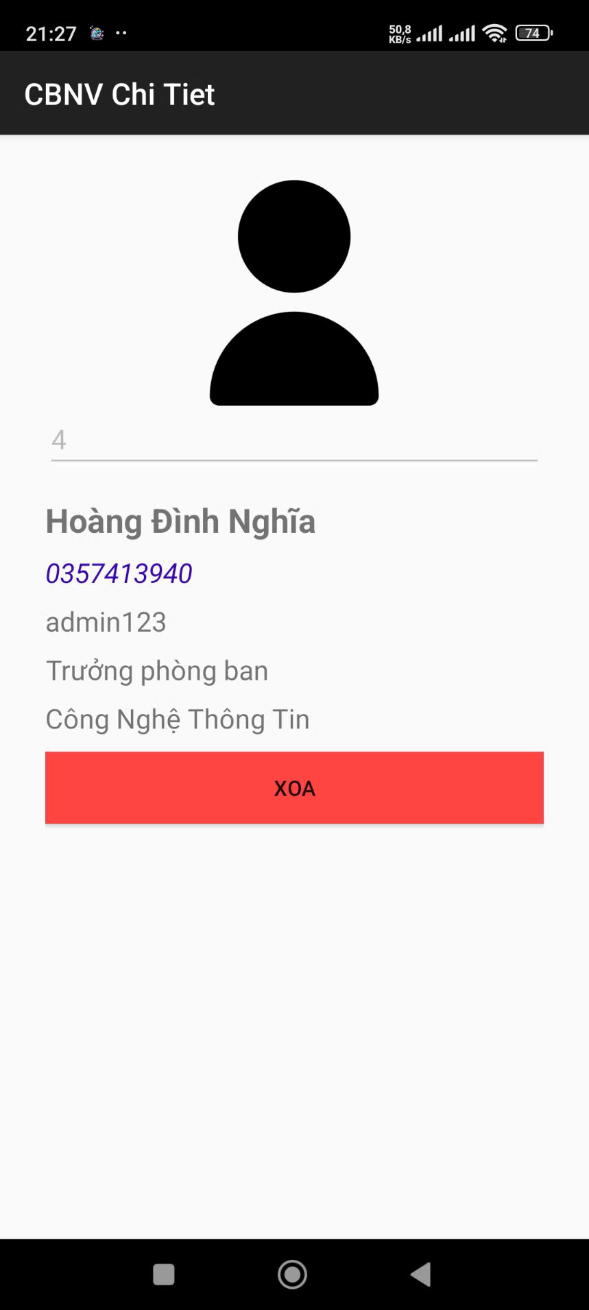

1. Quyền người dùng

