BÁO CÁO THỰC HÀNH LAP 5  
 LẬP TRÌNH HƯỚNG ĐỐI TƯỢNG

Contents

1. Swing components 2

**1.1.** **AWTAccumulator** 2

1.1.1. Create class AWTAccumulator with the source code as below 2

**1.2.** **SwingAccumulator** 4

1.2.1. Create class SwingAccumulator with the source code as below: 4

2. Organizing Swing components with Layout Managers 5

2.1. Swing top-level and secondary-level containers 5

2.2. Using JPanel as secondary-level container to organize components 5

2.2.1. Create class NumberGrid 5

2.2.2. Adding buttons 6

2.2.3. Complete inner class ButtonListener 6

3. Create a graphical user interface for AIMS with Swing 7

3.1. View Store Screen 7

3.1.1. Create the StoreScreen class 7

3.1.2. The NORTH component 7

3.1.3. The CENTER component 8

3.1.4. The MediaStore class 9

3.1.5. Putting it all together 9

3.2. Adding more user interaction 10

4. JavaFX API 10

4.1. Create the FXML file 10

4.1.1. Create and open the FXML file in Scene Builder from Eclipse 10

4.1.2. Building the GUI 10

4.2. Create the controller class 10

4.3. Create the application 11

4.4. Practice exercise 11

5. Setting up the View Cart Screen with ScreenBuilder 11

5.1. Setting up the BorderPane 11

6. Integrating JavaFX into Swing application – The **JFXPanel** class 12

7. View the items in cart – JavaFX’s data-driven UI 12

**8.** Updating buttons based on selected item in **TableView** – **ChangeListener** 13

9. Deleting a media 13

**10.** Filter items in cart – **FilteredList** 14

11. Complete the Aims GUI application 14

12. Check all the previous source codes to catch/handle/delegate runtime exceptions 19

13. Create a class which inherits from **Exception** 19

13.1. Create new class named **PlayerException** 19

13.2. Raise the **PlayerException** in the **play()** method 19

13.3. Update **play()** in the **Playable** interface 19

13.3.4. Update **play()** in **CompactDisc** 19

14. Update the **Aims** class 20

# Swing components

## **AWTAccumulator**

### Create class AWTAccumulator with the source code as below

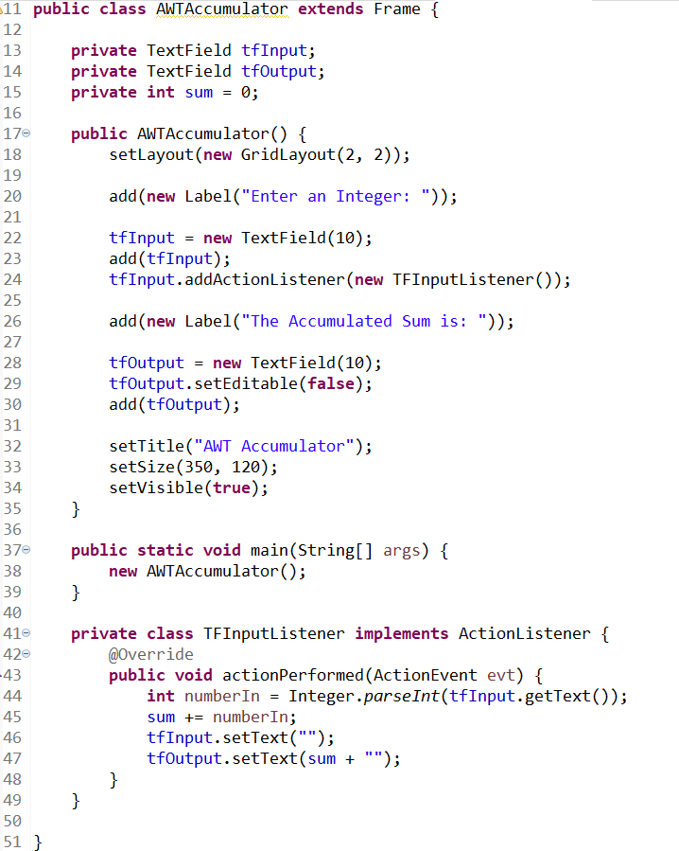

## **SwingAccumulator**

### Create class SwingAccumulator with the source code as below:

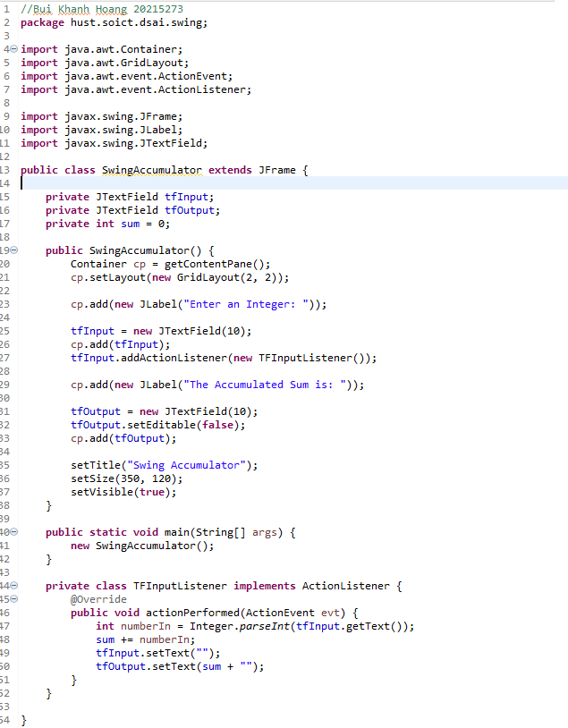

# Organizing Swing components with Layout Managers

## Swing top-level and secondary-level containers

## Using JPanel as secondary-level container to organize components

### Create class NumberGrid

### Adding buttons

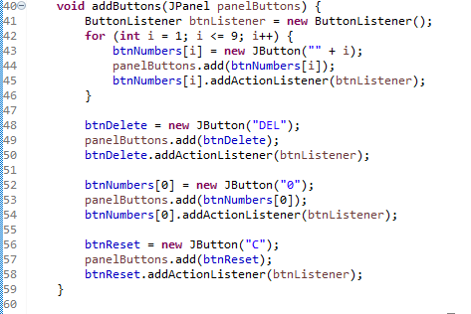

### Complete inner class ButtonListener

* Kết quả:

# Create a graphical user interface for AIMS with Swing

## View Store Screen

### Create the StoreScreen class

### The NORTH component

### The CENTER component

### The MediaStore class

### Putting it all together

## Adding more user interaction

(1 số interaction đã có trong code)

# JavaFX API

## Create the FXML file

### Create and open the FXML file in Scene Builder from Eclipse

### Building the GUI

## Create the controller class

## Create the application

## Practice exercise

# Setting up the View Cart Screen with ScreenBuilder

## Setting up the BorderPane

# Integrating JavaFX into Swing application – The **JFXPanel** class

# View the items in cart – JavaFX’s data-driven UI

# Updating buttons based on selected item in **TableView** – **ChangeListener**

# Deleting a media

* Ban đầu

* Sau khi xóa

# Filter items in cart – **FilteredList**

* By ID



* By title

# Complete the Aims GUI application

* Tạo các class thêm các media vào scence

* Chạy thử

# Check all the previous source codes to catch/handle/delegate runtime exceptions

# Create a class which inherits from **Exception**

## Create new class named **PlayerException**

## Raise the **PlayerException** in the **play()** method

## Update **play()** in the **Playable** interface

## Update **play()** in **CompactDisc**

# Update the **Aims** class



