# 1. Install Xdebug

* Step1: Create HelloWorld.php file in the file: **C:\xampp\htdocs**
* Step2: Using VS code to open HelloWorld.php
* 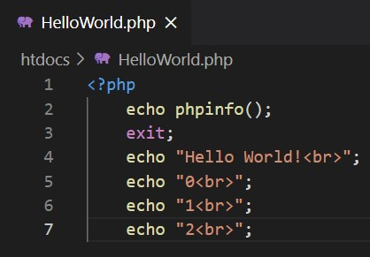Step3:
* Step4: Open link: <http://localhost/HelloWorld.php>

**Copy everthing**.

* Step5: Open link: <http://xdebug.org/wizard>

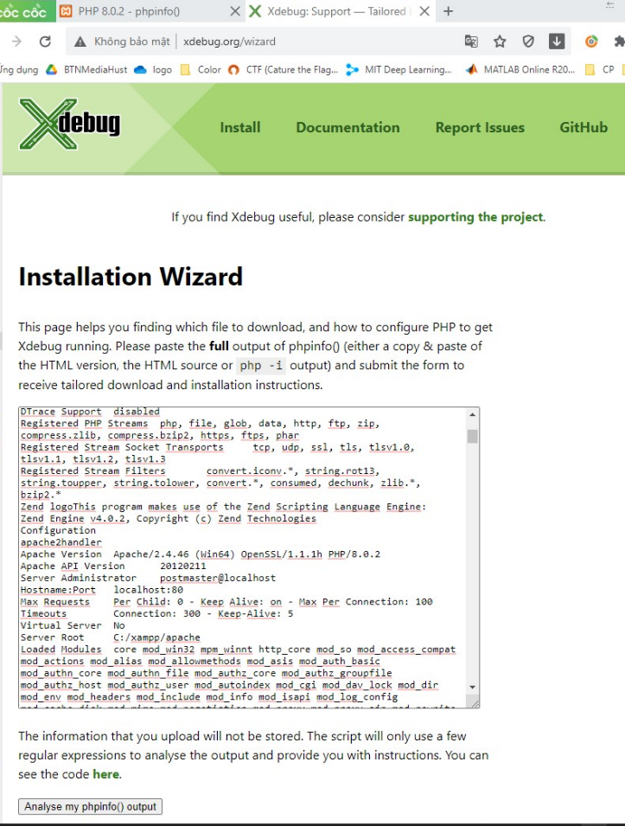**Paste**

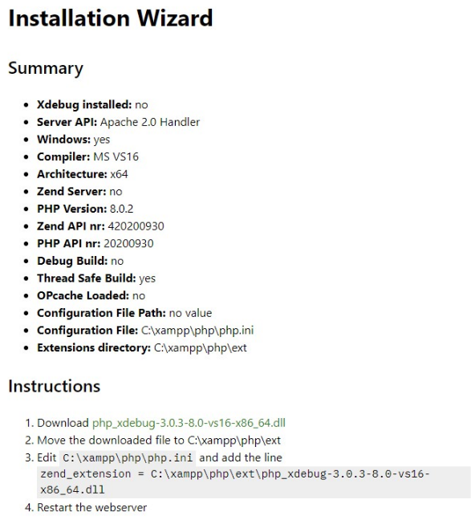

Click **Anlyse my phpinfo() output**

=>

* Step6: Download and do the Instructions

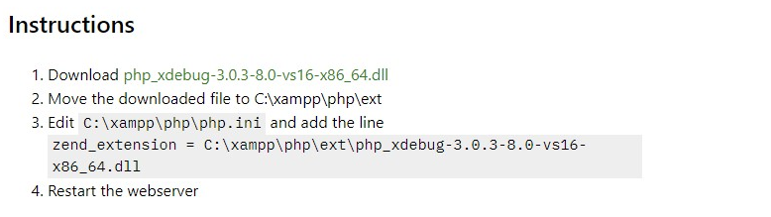

* Step7: Rename this file to **php_xdebug.dll**
* Step8: Open **C:\xampp\php\php.ini**. Add the following text below to the end of this file.

[XDebug]

xdebug.mode = debug

xdebug.start_with_request = yes

xdebug.client_port = 9000

zend_extension="C:\xampp\php\ext\php_xdebug.dll"

* Step9: Restart xampp

# 2. Debug in Visual Studio Code (VS code)

* Step10: Install Extensions: **PHP Debug**

**Then everything’s done.**

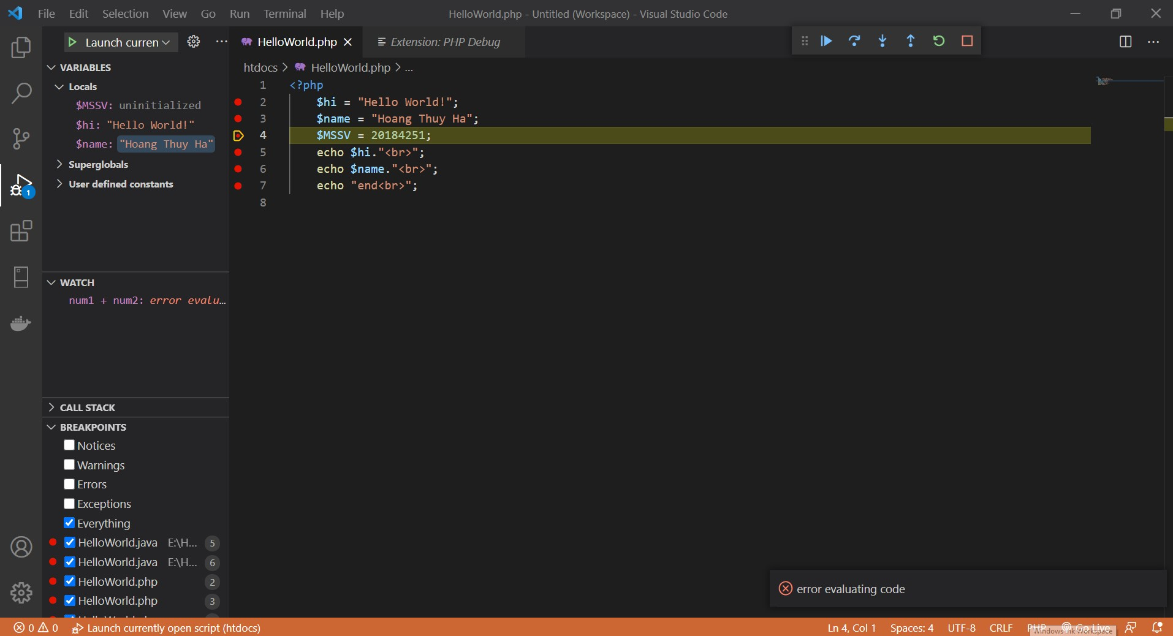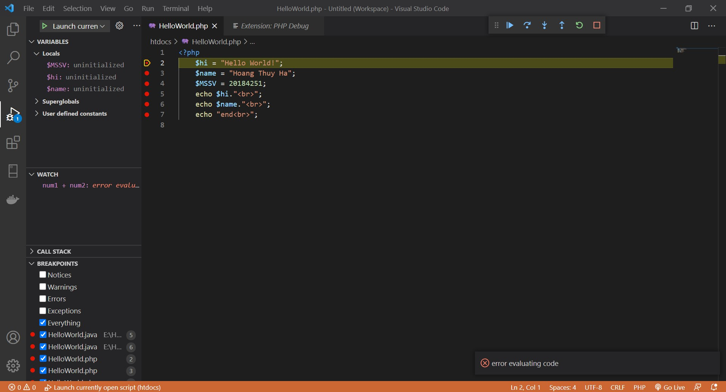

# 3. Source

<https://www.youtube.com/watch?v=LNIvugvmCyQ&t=9s>