# 1. Install XAMPP

* Step1: Download xampp in the link below: <https://www.apachefriends.org/download.html>
* Step2: After getting .exe file, double click to this file and do all the instructions to install xampp.

# 2. Set up XAMPP

* 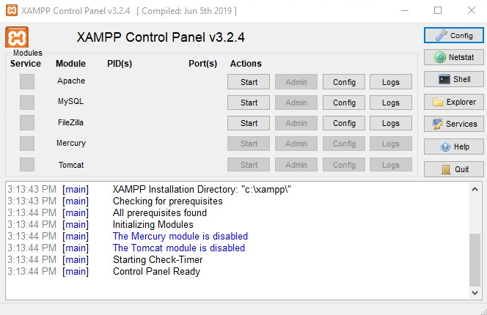Step3: Open xampp, and start Apache and MySQL as figure below:

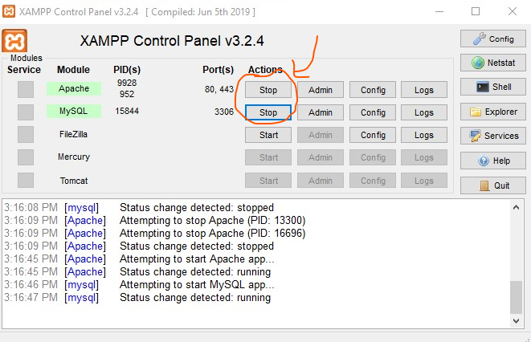

=>

# 3. Set up Enviroment variables

* Step4: Open xampp installation folder (I save it in C:\ ), go to php folder which cantains php.exe. In my case, path: **C:\xampp\php**
* Step5: Add this path to environment variables as below:

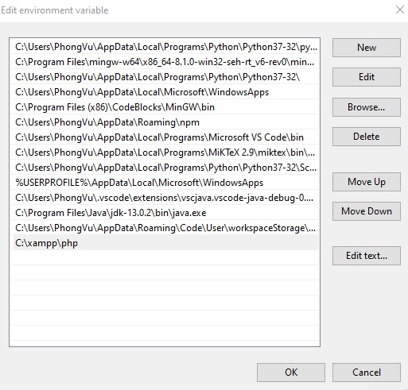

# 4. Install IDE

There are many IDE which is suitable, in my case, I choose Visual Studio Code.

* Step6: Download VS code in the link below:

<https://code.visualstudio.com/>

* Step7: After getting .exe file, double click to this file and do all the instructions to install VS code.
* Step8: Because we use VS code, we need to install Extensions: **PHP Intelephense**

# 5. Hello world!

* After doing all step above, Open xampp installation folder (**C:\**), open path (**C:\xampp\htdocs**).
* Create file “HelloWorld.php”.

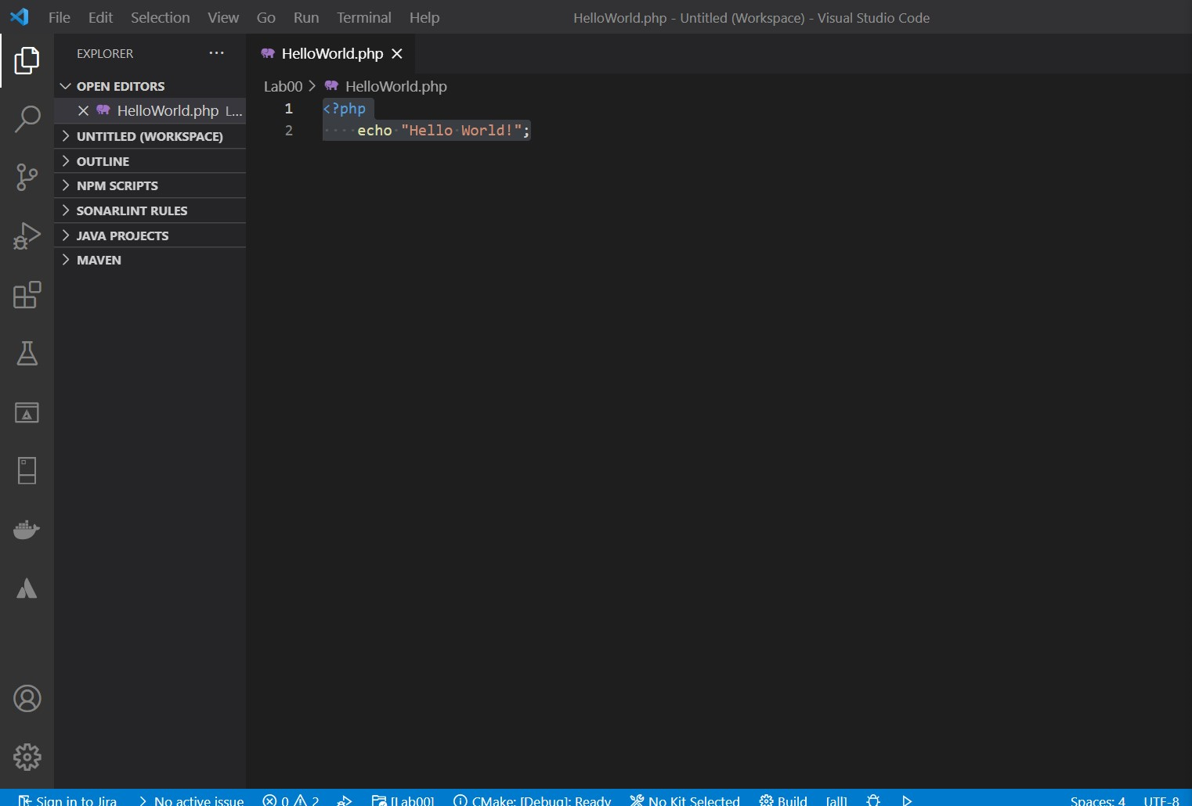

* Open the path:

<http://localhost/HelloWorld.php>

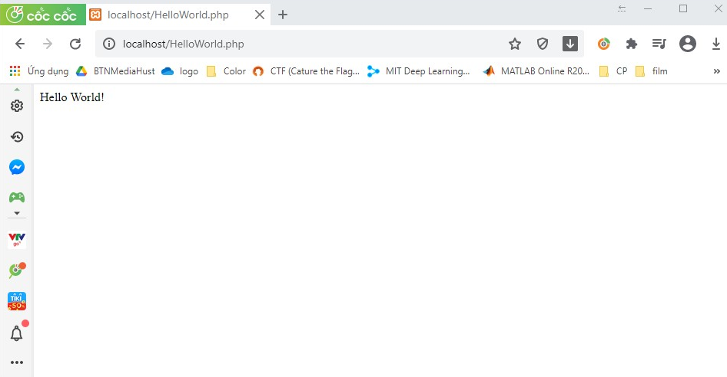

# 6. Source

<https://www.youtube.com/watch?v=2eebptXfEvw&t=9213s>