9.24 ÒFA training

Requirement:

Hi Hai,

The training session today, I think we already go throw almost components of the OFA Framework. You no need to understand all of it, just know the concept and follow the code.

Please do the small exercise below, we will have a review session on this Sunday:

1. Add 3 more field in screen view/edit/create user:
   1. User ID (mandatory)
   2. Role: dropdown. Value should be: “RM”, “RMTL”,”CA”,”BCA” (mandatory)
   3. Function Access Profile. Value should be “RM Profile1”, “RM Profile2”, “RMTL Profile1”, “RMTL Profile2”, “CA Profile1”, “CA Profile2”, “BAC Profile1”, “BCA Profile2” (Mandatory)
   4. Change label “Name” to “Full Name”

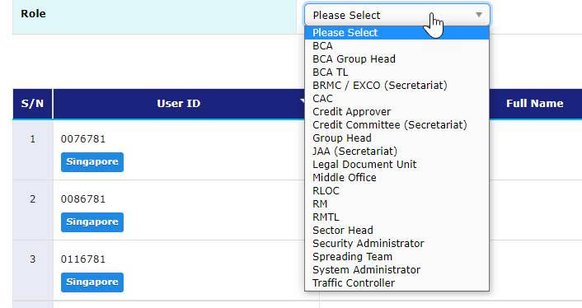

1. In create/edit user screen when user choose role, use ajax to reload the field “Function Access Profile”. Role and Function Access Profile have the relationship 1 to many. 1 role link with many FAP. You will need to create a web controller to receive the request from ajax. Example below:

@GetMapping("/product/list_by_category/{prod_category_id}")  
*public*@ResponseBody  
List<IProduct> getProductsByCategory(@PathVariable("prod_category_id") Long productCategoryId) {  
   *return this*.productBO.getActiveProductsForCategory(productCategoryId);  
}

1. Please implement search function in list screen as below:

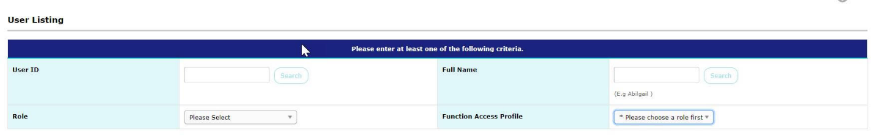

* 1. Need to add all of the search item to the list result (current only have Name, Country), need to add User ID, Role, FAP.
  2. When user click Search by User ID, system only search by user ID, the same for Full Name
  3. When user choose Role, system search by role chosen and the FAP also need to load by that role. Example, choose role RM -> FAP list “RM Profile1”, “RM Profile2”
  4. When user choose FAP, system search by that FAP chosen

If you need more time, please let me know. If you have any issue, don’t be hesitate to ask your Tech Lead (Mr. Toan), he will be happy to help you .

Hướng giải quyết:

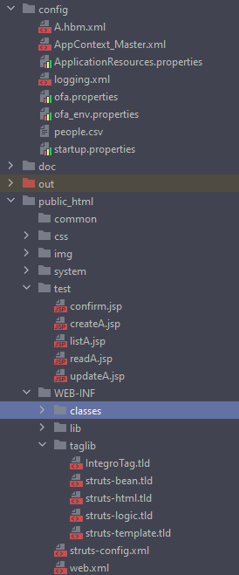

Struts-config

<form-beans type="org.apache.struts.action.ActionFormBean">  
 <form-bean name="AForm" type="com.integrosys.course.ui.test.AForm"></form-bean>  
</form-beans>  
  
<!-- ========== Action Mapping Definitions ============================== -->  
<global-forwards type="org.apache.struts.action.ActionForward">  
 <forward name="error" path="/system/system_error.jsp" redirect="false"/>  
 <forward name="ui_error" path="/system/ui_system_error.jsp" redirect="false"/>  
 <forward name="command_error" path="/system/command_system_error.jsp" redirect="false"/>  
</global-forwards>  
  
<action-mappings type="com.integrosys.base.uiinfra.common.IntegroActionMapping">  
 <action path="/A" type="com.integrosys.course.ui.test.AAction" name="AForm" validate="false" parameter="id">  
 <forward name="list" path="/test/listA.jsp"/>  
 <forward name="read" path="/test/readA.jsp"/>  
 <forward name="create" path="/test/confirm.jsp"/>  
 <forward name="update" path="/test/confirm.jsp"/>  
 <forward name="delete" path="/test/confirm.jsp"/>  
 <forward name="prepare_create" path="/test/createA.jsp"/>  
 <forward name="prepare_update" path="/test/updateA.jsp"/>  
 </action>  
  
</action-mappings>

Thay đổi thêm trường trong DTO

public class OBA {  
 Long id;  
 String name;  
 String country;  
 String role;  
 List<String> rights;

Thêm Aform

public class AForm extends CommonForm implements Serializable {  
 private String name;  
 private String country;  
  
 private Long id;  
 private String role;  
 private List<String> rights;

Theem Amapper

public class AMapper extends AbstractCommonMapper {  
  
 public Object mapFormToOB(CommonForm *cForm*, HashMap *inputs*) throws MapperException {  
 AForm aForm = (AForm) *cForm*;  
  
 OBA aObj = new OBA();  
 aObj.setName(aForm.getName());  
 aObj.setCountry(aForm.getCountry());  
  
 aObj.setId(aForm.getId());  
 aObj.setRole(aForm.getRole());  
  
 aObj.setRights(AProxy.**getRightsFromRole**((aForm.getRole())));  
  
 return aObj;  
 }  
  
 public CommonForm mapOBToForm(CommonForm *cForm*, Object *obj*, HashMap *inputs*) throws MapperException {  
 OBA aObj = (OBA) *obj*;  
 AForm aForm = (AForm) *cForm*;  
  
 aForm.setName(aObj.getName());  
 aForm.setCountry(aObj.getCountry());  
 aForm.setRole(aObj.getRole());  
 aForm.setId(aObj.getId());  
 aForm.setRights(aObj.getRights());  
  
 return aForm;  
 }

Class helper:

public static final String getKeyName() {  
 return "id";  
}  
  
//CRUD Operation  
public static TrxObject add(Object *a*) throws Exception {  
 OBA aObj = (OBA) *a*;  
 return AProxy.**getInstance**().add(aObj);  
}  
  
//CRUD Operation  
public static TrxObject remove(Object *aObj*) throws Exception {  
 DefaultLogger.**debug**(AHelper.class, "id in remove is " + *aObj*);  
 return AProxy.**getInstance**().remove((OBA)*aObj*);  
}  
  
//CRUD Operation  
public static Collection getAll() throws Exception {  
 return AProxy.**getInstance**().getAll();  
}  
  
//CRUD Operation  
public static OBA get(String *name*) throws Exception {  
 DefaultLogger.**debug**(AHelper.class, "id in Get is " + *name*);  
 return AProxy.**getInstance**().get(*name*);  
}  
  
  
//CRUD Operation  
public static TrxObject update(Object *aObj*) throws Exception {  
 DefaultLogger.**debug**(AHelper.class, "id in update is " + *aObj*);  
 return AProxy.**getInstance**().update((OBA) *aObj*);  
}  
  
public static String getCountryName(String *countryID*) {  
 return AProxy.**getCountryName**(*countryID*);  
}  
  
public static Set getRoleList() {return AProxy.**role_accessRight**().keySet(); }

Class Proxy

public class AProxy {  
 HashMap store = new HashMap();  
  
 private static AProxy **aProxy**;  
  
 public static AProxy getInstance() {  
 if (**aProxy** == null)  
 **aProxy** = new AProxy();  
 return **aProxy**;  
 }  
  
 public static final HashMap getCountryList() {  
 HashMap hm = new HashMap();  
 hm.put("HK", "Hong Kong");  
 hm.put("IN", "India");  
 hm.put("SG", "Singapore");  
 hm.put("MY", "Malaysia");  
 return hm;  
 }  
  
 public static final HashMap<String, List<String>> role_accessRight() {  
 HashMap hm = new HashMap();  
 List<String> right1 = new ArrayList<String>(Arrays.**asList**("RM Profile1", "pm3"));  
 List<String> right2= new ArrayList<String>(Arrays.**asList**("RM Profile1", "RM Profile2"));  
 List<String> right3= new ArrayList<String>(Arrays.**asList**("RMTL Profile1" , "RMTL Profile"));  
 List<String> right4= new ArrayList<String>(Arrays.**asList**("RM Profile1", "CA Profile2", "AC Profile1", "BCA Profile2"));  
 hm.put("RM", right1);  
 hm.put("RMTL", right2);  
 hm.put("CA",right3 );  
 hm.put("BCA", right4);  
 return hm;  
 }  
  
 public static List<String>getRightsFromRole(String *key*){  
 return **role_accessRight**().get(*key*);  
 }  
   
 public static String getCountryName(String *countryID*) {  
 return (String)**getCountryList**().get(*countryID*);  
 }   
  
 public TrxObject add(OBA *oba*) throws AException {  
 store.put( Long.**toString**(*oba*.getId()) , *oba*);  
 return **makeTrxObject**(*oba*.hashCode());  
 }  
  
 public TrxObject update(OBA *oba*) throws AException {  
 if (*oba* != null) {  
 DefaultLogger.**debug**(AHelper.class, "OBA name - PUT(from proxy)" + *oba*.getName());  
 store.put( Long.**toString**(*oba*.getId() ), *oba*);  
 return **makeTrxObject**(*oba*.hashCode());  
 } else  
 throw new AException("nothing to update");  
 }  
  
 public OBA get(String *key*) throws AException {  
 DefaultLogger.**debug**(AHelper.class, "OBA id - GET (from Proxy)" + *key*);  
 OBA a = (OBA) store.get(*key*);  
 if (a == null)  
 throw new AException("Key not found");  
 return a;  
 }  
  
 public TrxObject remove(OBA *oba*) throws AException {  
 if ( *oba* != null) {  
 DefaultLogger.**debug**(AHelper.class, "OBA name - REMOVE " + *oba*.getName());  
 store.remove( Long.**toString**(*oba*.getId() ));  
 return **makeTrxObject**(*oba*.hashCode());  
 } else  
 throw new AException("nothing to remove");

public Collection getAll() {  
 Collection c = store.values();  
 ArrayList list = new ArrayList();  
 list.addAll(c);  
 return list;  
 }  
   
 public static TrxObject makeTrxObject(int *a*) {  
 TrxObject trxObj = new TrxObject();  
 trxObj.setID(*a*);  
 trxObj.setDate(new Date());  
 return trxObj;  
 }   
}

DONE:

1. Create/ Edit / Delete
2. Thêm role, fullname + AccessRights\
3. Undone: View + Search functions

Class create, delete, update a cmd

Create

public HashMap doExecute(HashMap *map*) throws CommandProcessingException, CommandValidationException {  
  
 HashMap result = new HashMap();  
 HashMap exceptionMap = new HashMap();  
 HashMap temp = new HashMap();  
  
 DefaultLogger.**log**(CreateACommand.class, 2,"map in create is " + *map* );  
 DefaultLogger.**debug**(CreateACommand.class, "map in create is " + *map*);  
   
 OBA aObj = (OBA)*map*.get("form." + AHelper.**getOBName**());  
 TrxObject trxObj = null;  
 try {  
 trxObj = AHelper.**add**(aObj);  
 } catch (Exception *e*) {  
 DefaultLogger.**error**(this, *e*);  
 }  
  
   
 result.put("request.trxObject", trxObj);  
  
 temp.put(ICommonEventConstant.COMMAND_RESULT_MAP, result);  
 temp.put(ICommonEventConstant.COMMAND_EXCEPTION_MAP, exceptionMap);  
 return temp;

A.hbx.xml

<hibernate-mapping>  
  
 <class entity-name="oba" name="com.integrosys.course.app.test.bus.OBA" table="CUSTOMER" lazy="false">  
 <id name="id">  
 <generator class="sequence">  
 <param name="sequence">CUST_SEQ</param>  
 </generator>  
 </id>  
 <version name="versionTime" column="version_time" type="long"/>  
 <property name="name" column="NAME"/>  
 <property name="country" column="COUNTRY"/>  
 <property name="id" column="ID"/>  
 <property name="role" column="ROLE"/>  
 </class>  
  
</hibernate-mapping>

JSP

<%@ taglib uri="/WEB-INF/struts-bean.tld" prefix="bean" %>  
<%@ taglib uri="/WEB-INF/struts-html.tld" prefix="html" %>  
<%@ taglib uri="/WEB-INF/struts-logic.tld" prefix="logic" %>  
  
<%  
 Collection OBList = (Collection)request.getAttribute("request.OBAList");  
 if (OBList != null && OBList.size() > 0) {  
 pageContext.setAttribute("OBList",OBList);  
 }  
%>

<table width="80%" border="0" align="center" cellpadding="0" cellspacing="0">  
 <tr>  
 <td>  
 <table width="100%" border="0" align="center" cellpadding="0" cellspacing="0">  
 <tr>  
 <td width="64%"><h3>User Details</h3></td>  
 <td width="36%" align="right"><input name="Submit2" type="button" class="btnNormal" value="Add New" onclick="javascript:addUserPage()"/></td>  
 </tr>  
 <tr>  
 <td colspan="2"><hr /></td>  
 </tr>  
 </table>  
 <table width="100%" border="0" cellspacing="0" cellpadding="0" class="tblInput">  
 <thead>  
 <tr>  
 <td width="5%">S/N</td>  
 <td width="5%">Id</td>  
 <td width="15%">Full Name</td>  
 <td width="15%">Role</td>  
 <td width="30%">Access Rights</td>  
 <td width="15%">Country</td>  
 <td width="15%">Action</td>  
 </tr>  
 </thead>  
 <tbody>  
 <logic:present name="OBList">  
 <% int count = 0; %>  
 <logic:iterate id="OB" name="OBList" type="com.integrosys.course.app.test.bus.OBA" scope="page">  
 <tr class="<%=count++%2==0?"even":"odd"%>">  
 <td class="index"><%=count%></td>  
 <td><%=OB.getId()%></td>  
 <td><%=OB.getName()%></td>  
 <td><%=OB.getRole()%></td>  
 <td><%=OB.getRights()%></td>  
 <td><%=AHelper.getCountryName(OB.getCountry()) %></td>  
 <td style="text-align:center"><select name="select3" onChange="JumpOnSelectactive(this, '<%=OB.getId()%>')">  
 <option selected="selected" >Please Select</option>  
 <option value="edit">Edit</option>  
 <option value="view">View</option>  
 <option value="delete">Delete</option>  
 </select>  
 </td>  
 </tr>  
 </logic:iterate>  
 </logic:present>  
 <logic:notPresent name="OBList">  
 <tr class="even">  
 <td colspan="4">There is no user found.</td>  
 </tr>  
 </logic:notPresent>  
 </tbody>  
 </table></td>  
 </tr>  
</table></td>

CreateA

<%  
 HashMap countryListHM = (HashMap)request.getAttribute("countryMap");  
  
 Collection countryList = countryListHM.keySet();  
 Collection countryLabelList = countryListHM.values();  
 if (countryList != null)  
 pageContext.setAttribute("countryList", countryList);  
 if ( countryLabelList != null )  
 pageContext.setAttribute("countryLabelList", countryLabelList);  
  
 HashMap role_accessRight = (HashMap)request.getAttribute("role_accessRight");  
 pageContext.setAttribute("role_accessRight", role_accessRight);  
 Collection roleList = role_accessRight.keySet();  
 Collection rightList = role_accessRight.values();  
 if (countryList != null)  
 pageContext.setAttribute("roleList", roleList);  
 if ( countryLabelList != null )  
 pageContext.setAttribute("rightList", rightList);  
%>

<html:form action="A.do?event=create">

<table width="80%" border="0" align="center" cellpadding="0" cellspacing="0">  
 <tr>  
 <td>  
 <table width="100%" border="0" align="center" cellpadding="0" cellspacing="0">  
 <tr>  
 <td><h3>User Details</h3></td>  
 </tr>  
 <tr>  
 <td><hr /></td>  
 </tr>  
 </table>  
 <table width="100%" border="0" cellspacing="0" cellpadding="0" class="tblInput">  
 <thead>  
 </thead>  
 <tbody>  
 <tr class="odd">  
 <td width="20%" class="fieldname">Id</td>  
 <td width="80%" > <html:text property="id" />  
 <html:errors property="id"/>  
 </td>   
 </tr>  
 <tr class="odd">  
 <td width="20%" class="fieldname">Full Name</td>  
 <td width="80%" > <html:text property="name" />  
 <html:errors property="name"/>  
 </td>  
 </tr>  
  
 <tr class="odd">  
 <td width="20%" class="fieldname">Role</td>  
 <td width="80%" >  
 <html:select property="role" >  
 <option value="">Please Select</option>  
 <html:options name="roleList" labelName="roleList"  
 />  
 </html:select><html:errors property='role'/>  
 </td>  
 </tr>  
  
 <!-- <tr class="odd">  
 <td width="20%" class="fieldname">Access rights: </td>  
 <td width="80%" id="right">  
  
 </td>  
 </tr> --!>  
  
 <tr class="even">  
 <td class="fieldname">Country</td>  
 <td><html:select property="country" >  
 <option value="">Please Select</option>  
 <html:options name="countryList" labelName="countryLabelList" />  
 </html:select><html:errors property="country"/>  
 </td>  
 </tr>  
 </tbody>  
 </table></td>  
 </tr>  
</table>

</html:form>

Giờ muốn SEARCH thì phải hiểu là: chức năng search được lưu trong HASHMA của APROXY

Muốn lấy ra phải tương tác và lọc như một REPO

Bắt đầu:

Tạo ra UI , nút bấm, sự kiện nối sang 1 trang khác

Tiếp: Bổ sung listA.jsp - UI

<!--  
<form>   
<select id="field">  
 <option selected="selected" >Select a search field</option>  
 <option value="1">Full Name</option>  
 <option value="2">Id</option>  
 <option value="3">Country</option>  
 <option value="4">Role</option>  
 <option value="5" selected>Rights to access</option>  
</select>  
<input type="text" placeholder= "enter search key"></input>  
<input type="submit"></input>  
</form>  
-->

Lưu ý file AppContext để tạo và khai báo BEAN

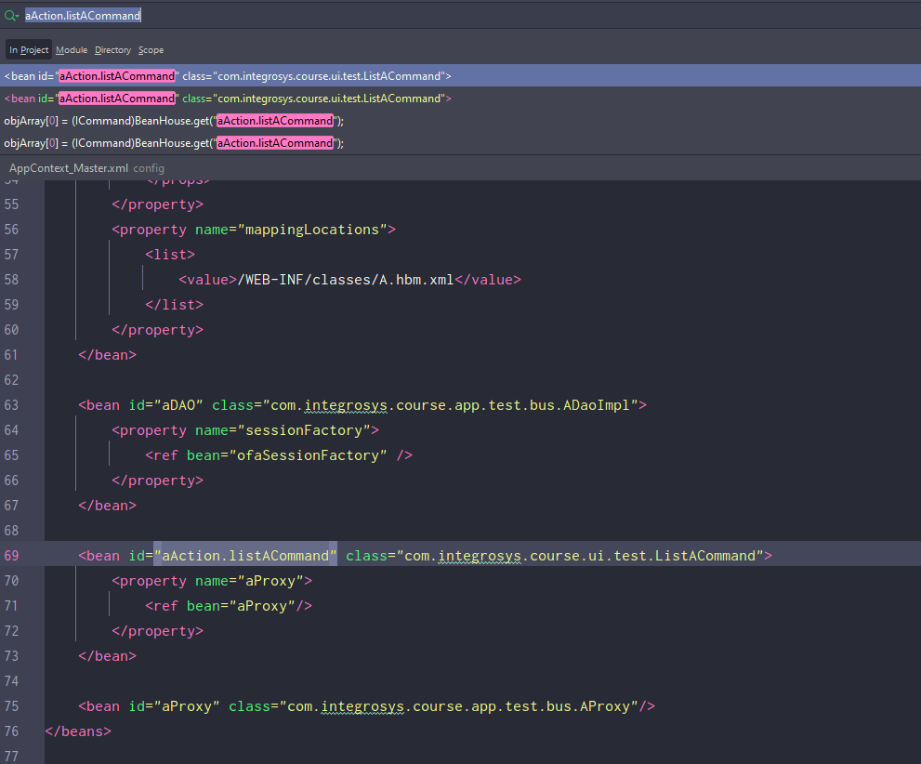

Thấy list a commannd trong aAction ko

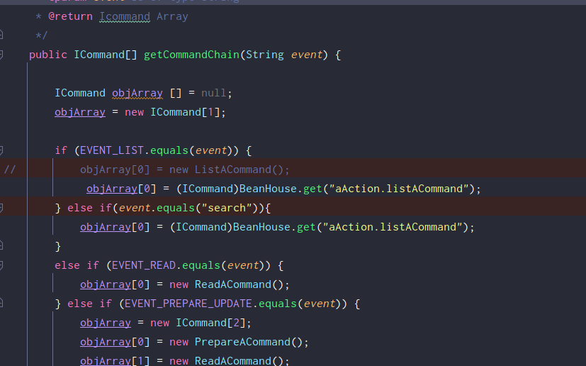

Use PARAMETER in URL

<https://stackoverflow.com/questions/1890438/how-to-get-parameters-from-the-url-with-jsp>