A quick introduction to clean architecture

[](https://medium.freecodecamp.org/@ddcreationstudi?source=post_header_lockup)

[Daniel Deutsch](https://medium.freecodecamp.org/@ddcreationstudi)Follow

Aug 13, 2018



Photo by Rubén García on Unsplash — <https://unsplash.com/photos/R-wQExeiGrc>

In an [open source project](https://github.com/Keep-Current) I started to contribute to, the concept of “clean architecture” was brought to me.

First, it was pretty overwhelming, but after some reading it made sense. I thought it might be helpful for others if I wrote down my thoughts.

**Table of Contents**

* [Visual representations](https://github.com/Createdd/Writing/blob/master/2018/articles/CleanA.md#visual-representations)
* [The concept — presented in bullet points](https://github.com/Createdd/Writing/blob/master/2018/articles/CleanA.md#the-concept---presented-in-bullet-points)
* [Code example](https://github.com/Createdd/Writing/blob/master/2018/articles/CleanA.md#code-example)
* [Resources](https://github.com/Createdd/Writing/blob/master/2018/articles/CleanA.md#resources)

**Visual representations**

I think it’s always good to start with some visualization.

Here are the most common pictures of this concept.

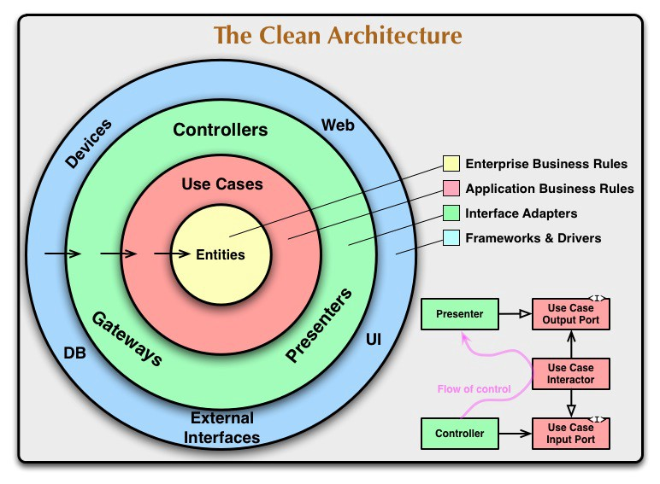

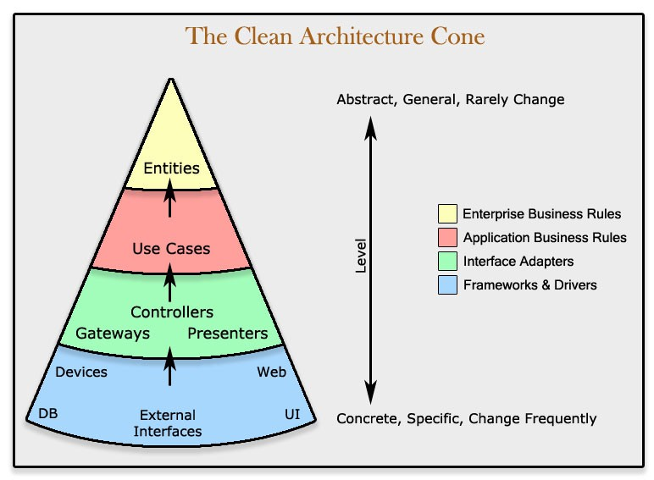

Source and credit: <https://8thlight.com/blog/uncle-bob/2012/08/13/the-clean-architecture.html> .<https://www.codingblocks.net/podcast/clean-architecture-make-your-architecture-scream/>

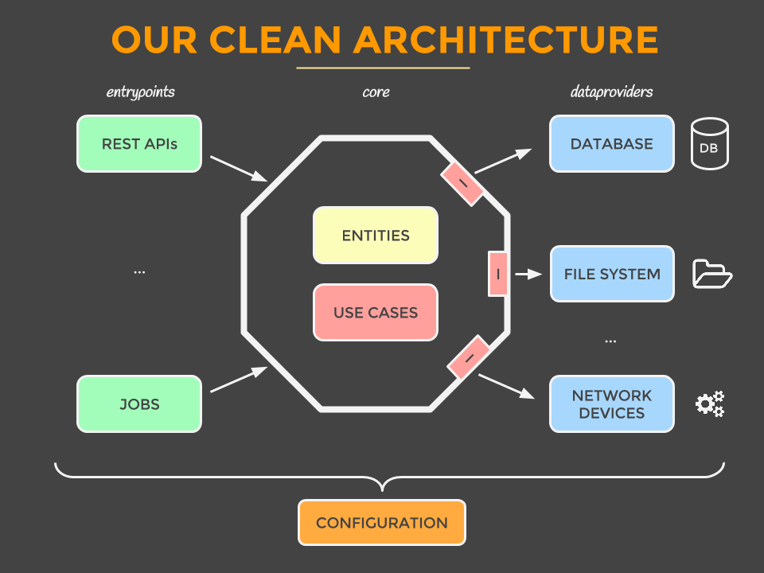

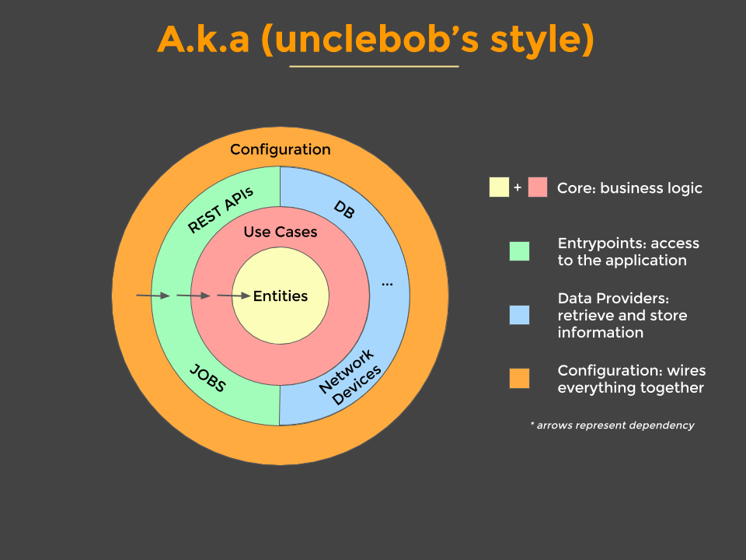

Source and credit: Mattia Battiston, under CC BY 4.0, <https://github.com/mattia-battiston/clean-architecture-example>

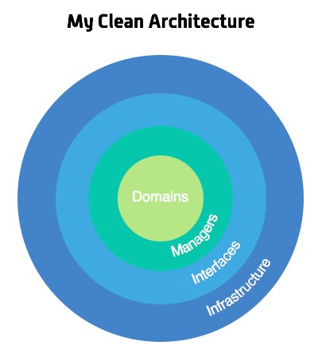

Source and credit: <https://marconijr.com/posts/clean-architecture-practice/>

**The concept — presented in bullet points**

Extended from Source and credit: [Mattia Battiston, under CC BY 4.0](https://github.com/mattia-battiston/clean-architecture-example)

**The value it can provide**

* An effective testing strategy that follows the testing pyramid
* Frameworks are isolated in individual modules. When (not if) we change our mind, we only have to make a change in one place. The app has use cases rather than being tied to a CRUD system
* Screaming architecture a.k.a. it screams its intended usage. When you look at the package structure, you get a feel for what the application does rather than seeing technical details
* All business logic is in a use case, so it’s easy to find and not duplicated anywhere else
* Hard to do the wrong thing because modules enforce compilation dependencies. If you try to use something that you’re not meant to, the app doesn’t compile
* It is always ready to deploy by leaving the wiring up of the object for last. Or by using feature flags, so we get all the benefits of continuous integration
* Multiple works on stories so that different pairs can easily work on the same story at the same time to complete it quicker
* Good monolith with clear use cases that you can split in microservices later on, once you’ve learned more about them

**Entities**

* Represent your domain object
* Apply only logic that is applicable in general to the whole entity (e.g., validating the format of a hostname)
* Plain objects: no frameworks, no annotations

**Use Cases**

* Represent your business actions: it’s what you can do with the application. Expect one use case for each business action
* Pure business logic, plain code (except maybe some utils libraries)
* The use case doesn’t know who triggered it and how the results are going to be presented (for example, could be on a web page, or — returned as JSON, or simply logged, and so on.)
* Throws business exceptions

**Interfaces / Adapters**

* Retrieve and store data from and to a number of sources (database, network devices, file system, 3rd parties, and so on.)
* Define interfaces for the data that they need in order to apply some logic. One or more data providers will implement the interface, but the use case doesn’t know where the data is coming from
* Implement the interfaces defined by the use case
* There are ways to interact with the application, and typically involve a delivery mechanism (for example, REST APIs, scheduled jobs, GUI, other systems)
* Trigger a use case and convert the result to the appropriate format for the delivery mechanism
* the controller for a MVC

**External Interfaces**

* Use whatever framework is most appropriate (they are going to be isolated here anyway)

**Code example**

See the structure on [GitHub](https://github.com/Createdd/web-miner/tree/master/webminer).

First of all, it is important to understand that clean architecture is a bundle of organising principles. So therefore everything is open to personal adjustments as long as core ideas are kept intact. The linked repository is a fork of the original project that brought this architecture design idea to me. Feel free to check out the original project as well, as it reflects further improvements.

The webminer folder is structured into the basic layers:

1. entities
2. use_cases
3. interfaces_adapters
4. external_interfaces

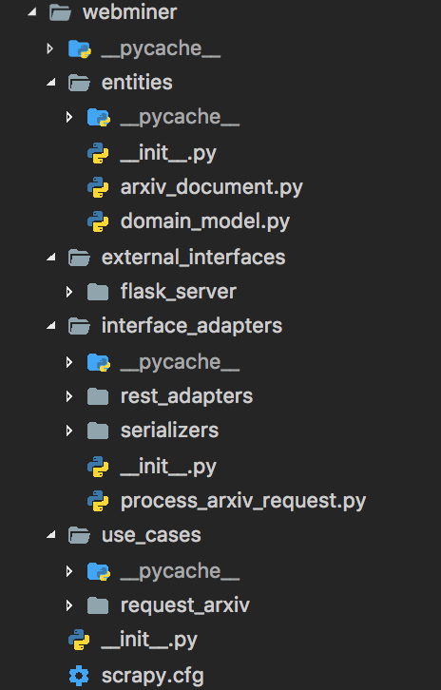

Structure of the webminer folder

It shall reflect the very basic approach for the design pattern.

* Starting from entities, you can see that the core model of this project is the arxiv_document
* The next folder, use_cases shows our use case, namely to request the arxiv page
* After that, we go through the interface_adapters folder that provides adapters for process requests in a REST application or for serializing
* The final and last layer is external_interfaces. This is where we use the flask server to implement the REST functionality

All of those layers are dependent on the core layers but not the other way around.

**One important note: This is not 100% correctly implemented in the repository.**

Why? Because the use cases are actually different. In reality the main use case is to provide the structured data. Another use case is to get the data from the arxiv page.

Did you spot this error in the architecture? If yes, congratulations! Not only did you bring enough curiosity to this article but you likely understand the principles well enough to build your own case and apply the concepts in reality!

Do you agree? If not, why? Thanks for reading my article! Feel free to leave any feedback!

**Resources**

Here are some articles I found helpful in understanding the concept of “clean architecture”:

* <https://8thlight.com/blog/uncle-bob/2012/08/13/the-clean-architecture.html>
* <https://www.codingblocks.net/podcast/clean-architecture-make-your-architecture-scream/>
* <https://github.com/mattia-battiston/clean-architecture-example>
* <https://medium.com/@tiagoflores_23976/how-choose-the-appropriate-ios-architecture-mvc-mvp-mvvm-viper-or-clean-architecture-2d1e9b87d48>
* <https://de.slideshare.net/HimanshuDudhat1/mvp-clean-architecture>
* <https://softwareengineering.stackexchange.com/questions/336677/what-is-the-difference-between-mvp-and-clean-architecture>
* <https://engineering.21buttons.com/clean-architecture-in-django-d326a4ab86a9>
* <https://gist.github.com/ygrenzinger/14812a56b9221c9feca0b3621518635b>
* <https://medium.freecodecamp.org/how-to-write-robust-apps-consistently-with-the-clean-architecture-9bdca93e17b>
* <https://marconijr.com/posts/clean-architecture-practice/>

Daniel is an LL.M. student in business law, working as a software engineer and organizer of tech-related events in Vienna. His current personal learning efforts focus on machine learning.