In this tutorial I’ll guide you how to backup your data and revert to specific commit in github.

There are several ways to fix this bug but I want you to clear your mind by using git as Beginner.

Following all below steps to solve your problems.

# First way

Step 1 : Checkout to master (***git checkout master***).

Step 2 : Create branch *backup* at current HEAD (***git checkout –b backup***).

Step 3 : View all commit (***git log***).

Step 4 : Copy commit ID from commit you want to revert to (reset). Checkout master to that commit ID

(***Git checkout commitID***) – “If you want to Back to master and do nothing (git checkout master)”.

Step 5 : Your cursor HEAD currently locate at your commit ID you checkout to, delete master at where your cursor HEAD is.

(***Git branch –D master***) .Remember delete master use –D.

Now, there are no more master in your current working tree(*remember master not origin/master, clearify what in local, what in reponsitories*).

Step 5 : Create new branch master to point your cusor HEAD and master to this node.(***git checkout –b master***).

Now your tree look like :

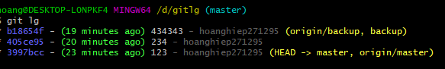

Remember where your **master branch**  are and where your **backup branch** are.

***Main step :***

***git checkout master***

***git push – force origin master***

Step 6 : If you want to make the change from backup branch to fix the bug then merge to master, let do it. Keep in mind where your backup branch node is now.

Make some change and commit from backup branch

***git checkout backup***

***git add .***

***git commit –m ‘from backup’***

Step 7 : Make some change in master branch

***git checkout master***

***git add .***

***git commit –m ‘from backup’***

Step 8 . Finally when your backup branch finish to fix it’s bug and master still moving on.

We need to merge and make master branch is main branch.

***git checkout master***

***git merge backup***

***git lg*** or ***gitk*** to check result.



# Second ways

Second way, much easier

git reset --hard cedc856

git push --force origin master