**RAN INTERFACES**

*Dev: Hoang Hoang*

*Date: 06/18/2023*

# RAN interfaces Overview

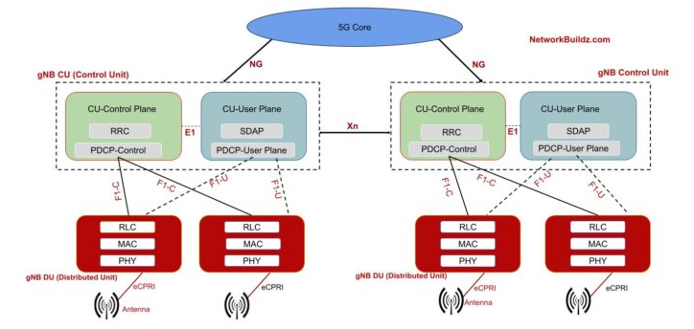

5G is expect to operate in two modes as non -standalone and standalone mode of operation.

For non-stand operation specification defined for S1 and X2 interfaces

For standalone operation Interface between RAN Node as X2/Xn

* Interface between RAN and Core Network as NG
* Interface between RAN nodes X2/Xn
* Interface for Function Split and Open Interface  as F1/E1/eCPRI within RAN Node

# Interface between RAN and Core Network: NG interface

NG interface is specified in standalone operation between the ng-eNB/gNB and the AMF.

**The NG interface supports functions such as session management, mobility management, and security for standalone operation.**

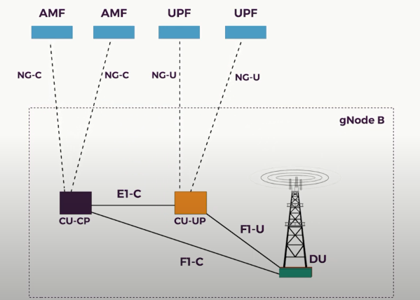

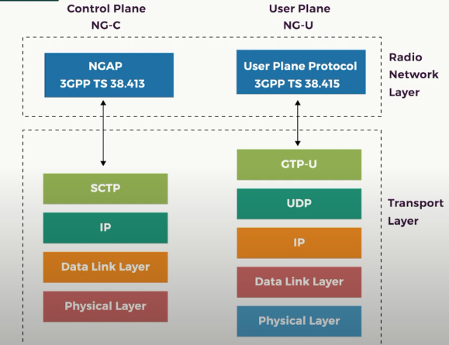

## **NG-C**

* **N2 use NGAP protocol**
* **Use SCTP over IP**
* **Manage the procedures between GNB and AMF**

NGAP responsibilities:

* procedures to establish, maintain and release NG-RAN part of PDU sessions;
* procedures to perform intra-RAT handover and inter-RAT handover;
* the separation of each UE on the protocol level for user specific signalling management;
* the transfer of NAS signalling messages between UE and AMF;
* mechanisms for resource reservation for packet data streams.

## **NG-U**

* **N3 use GTP-U protocol**
* **Use GTP-U over UDP over IP**
* **Manage the procedures between GNB and UPF**

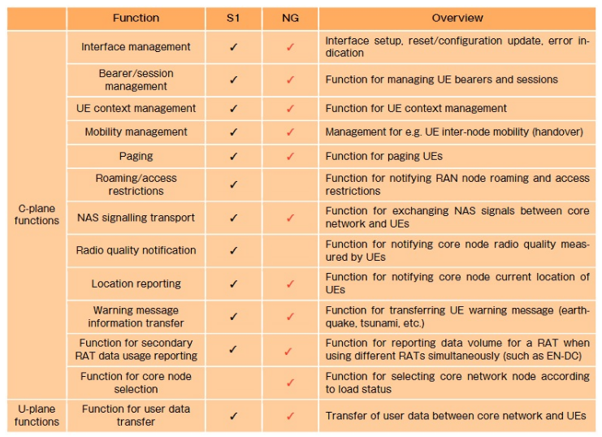

## **Handover procedure/call flow**

1. Procedure

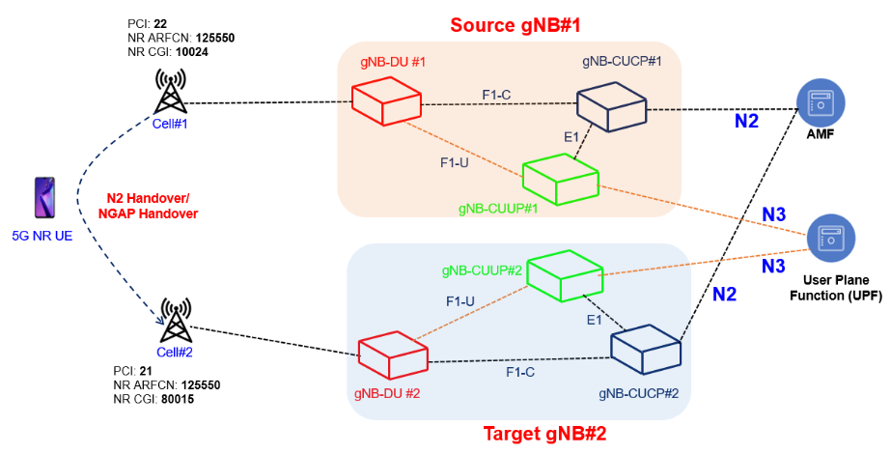

1. Call flow

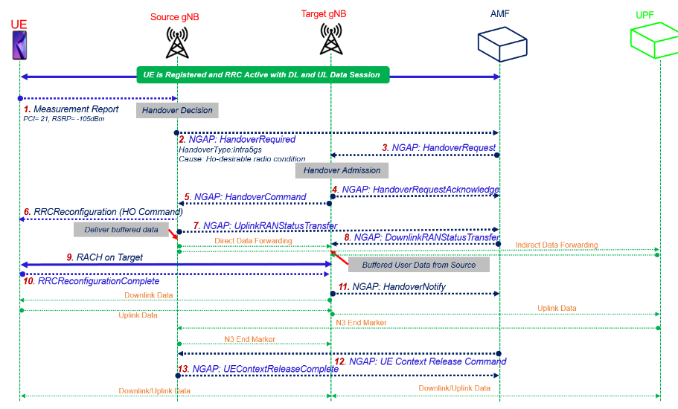

# Interface between Ran nodes

Enable faster handover and better inter-cell operation

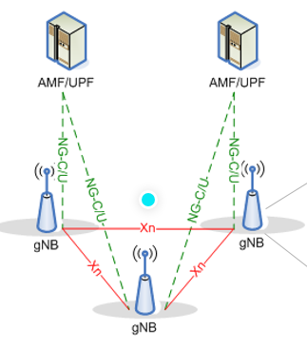

## Xn-Handover Procedure

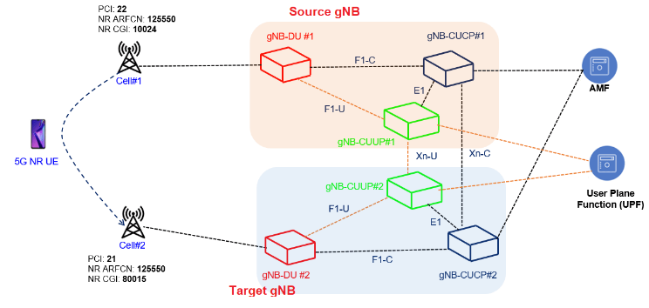

Messaging over Xn interface using **XnAP protocol** and over N2 interface using **NGAP protocol**.

User plane between two gNB is managed using **GTP-U protocol**.

## Xn Handover Call flow

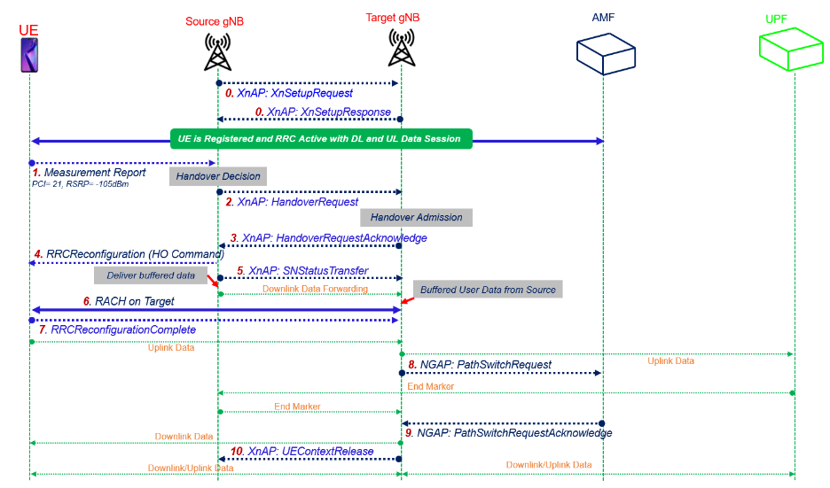

# Interfaces within RAN Nodes

## Functional split and open interfaces (F1, E1)

To address the issue of explosive in-creases of the bandwidth required for the transport between the Central Unit (CU) and Distributed Unit (DU) by the introduction of massive MIMO and extending the frequency bandwidth using Cloud RAN (C-RAN) deployment, the new functional split between CU (gNB-CU) and DU (gNB-DU) within gNB and the corresponding open interface between these nodes were defined.

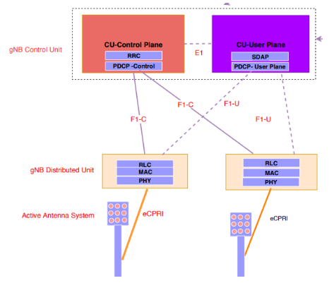

* F1-C: allows signaling between the CU and DU
* F1-U: allows the transfer of application of Data

1. **F1 interface**

**Functions of the F1 interface**

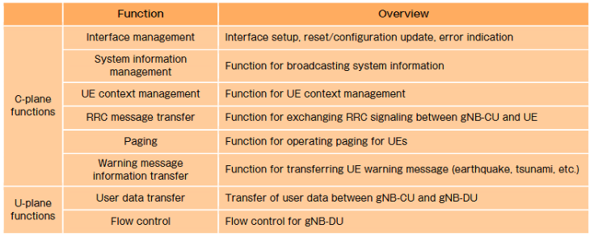

The user plane protocol which runs above the GTP-U layer provides various control mechanisms associated with the transfer of downlink data  
These control mechanisms include flow control, packet loss detection and successful delivery reporting.

The frame formats used by the user plane protocol is referred as

* **PDU Type 0** is sent by the CU
* **PDU Type 1** is sent by the DU.

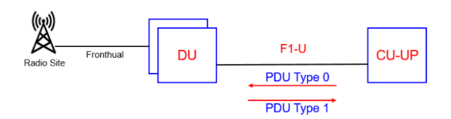

1. **E1 interface**

**Functions of E1 interface**

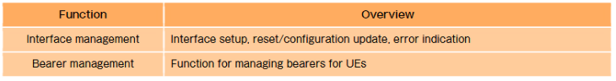

## Handover procedure/call flow

1. Procedure

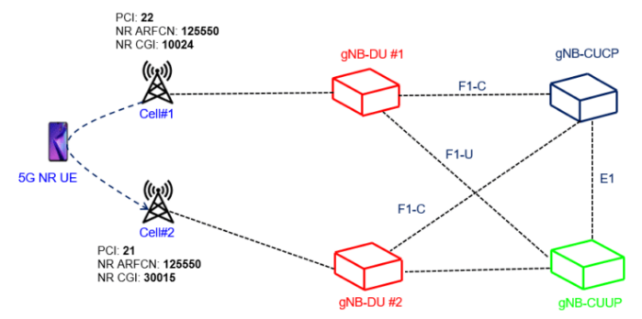

1. Call flow

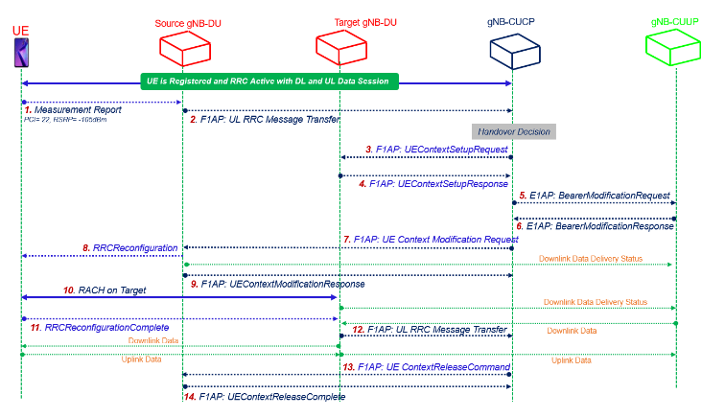

## Interface between PHY and Radio ( eCPRI )

Evolved Common Public Radio Interface.

* **Transport digital baseband samples between the PHY and the radio components in the RAN nodes**
* **This interface is responsible for handling the transmission and reception of the radio signal.**

**Package format**

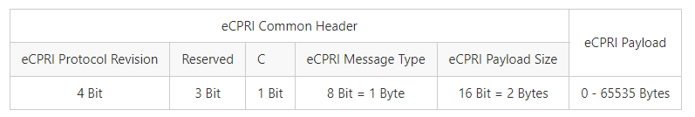

The C field indicates a concatenation.

* If C = 0, then is this the last eCPRI Message inside the eCPRI PDU.
* If C = 1, then another eCPRI Message follows within the same PDU. Between this two messages are padding bits (0-3). The new message starts at a 4-Byte boundary