# Does your heart race for a Fitbit hangover?

## Abstract

## Introduction

Fitbits are popular items of wearable technology, particularly for health-conscious individuals and those trying to become healthier. Fitbit collects many different data points, including steps walked, calories burned as well as heart-rate measurements. Several users (MarathonChris, 2016), including ourselves, have observed that one’s resting heart rate (RHR) measurement is elevated the day after a few alcoholic drinks. While it is well known that the consumption of alcohol increases an individual’s heart rate in the short term (for a few hours during and after), it is not known that there is an increase in the resting heart rate the next day. In the Fitbit community, there have been some suggestions as to the cause. In this report we examine if this observation is accurate via experimentation.

Why would the answer to this question be of interest? As with any questions about health, more knowledge is better. If the answer were that Fitbits algorithm for calculating this is at fault, at least the 23 million active Fitbit users can better understand how it works. On the other hand, suppose this effect is real and measurable in some or all cases. Then further experiments would be required to determine the actual cause, whether it be dehydration, lack of sleep or an indicator of heart problems in certain individuals.

Take for example an individual with heart disease: knowing that the effects of drinking alcohol on their heart are more prolonged than presupposed may help to deter them from having a few drinks, particularly if they are expecting exertion or stress the next day. Another example is a healthy competitive athlete who likes to relax with a few drinks once a week; will their increased heart rate the next day benefit their recovery or reduce the effectiveness of their training?

These and other questions first rely on getting to the answer of the question: does alcohol consumption increase the resting heart rate the next day?

This is the subject of this report and will be covered in the following sections. First we will introduce the existing literature, followed by the details of our pilot study. After that we will lay out the design of our experiment and present the results. Finally we will round up with the conclusions.

## Literature

Usually searching the internet yields myriad of results that have to be carefully sorted and analyzed for truth (or at least an educated guess at the likely truth). In this case however the search of reasons why the RHR is elevated the day after drinking reveals no documents other than some blogs and questions on the fitbit site from MarathonChris. The search reveals plenty of information and understanding of the immediate and long-term effects of alcohol but nothing other than rare blog posts about increased heart rate the next day.

~~Many of the websites reveal the things we do know, such as RHR increasing with age and higher for women. However, the lack of clear results for the impact on the next day means that an experiment is necessary to test if the effect is real or the observations made by Fitbit users are simply some quirk of Fitbits algorithm.~~

## Pilot study

We began the experiment with a pilot study. This study had been conducted in a less than rigorous manor, using no randomization; however the data was suitable to evaluate if the experiment was worth conducting, i.e. if an effect could be measured.

The pilot used a within subject design and a difference in differences (DiD) on the heart rate pre and post treatment, where the treatment was simply a binary variable indicating when the subject drank alcohol the previous day. It did not use any randomization of treatments and as discussed below had a number of issues that needed to be account for. Table 1 presents the regression results from the pilot.

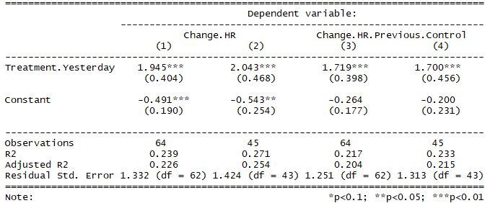

Table 1 Pilot Regressions

The pilot was conducted from the 31st of December 2017 until the 5th of March 2018 and our initial calculations used a DiD of the RHR on subsequent days. The results are shown in regression (1) in table 1. We noticed that the intercept (constant) had a highly statistically significant negative result; implying that when the subject did not drink his RHR was continually decreasing. This obviously was impossible and we realized that this method of taking the DiD included the recovery from treatment as the RHR adjusted back to the original level. Once we realized this we altered the DiD to be the difference between the current days RHR and the previous control day. The results then are seen in regression (3) in table 1. In this regression we no longer see a statistically significant intercept as expected (it is not distinguishable from 0).

There was a second consideration in this pilot which we investigated in regressions (2) and (4). The dates of the pilot were after the end of the fall MIDS term and a seasonal vacation. This was the most sedentary time of year for the subject and the data showed a decline in the subjects RHR as his fitness levels returned to normal. Figure 1 shows this decline.

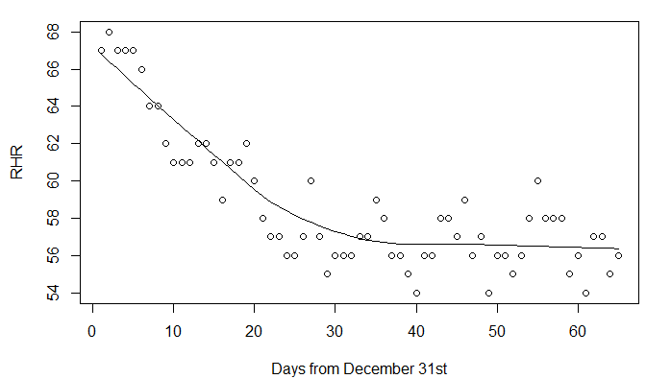

Figure 1 Pilot subjects RHR during the study

Taking this into account in regressions (2) and (4) we used a smaller set of the data. The results changed slightly, with a slight decline in the treatment effect, however it is still highly statistically significant.

Also since the sample size was small we also performed randomization inference on the data. The results were similar with an ATE of 1.71 and a p-value of 8x10-5, indicating that the observed ATE was unlikely to have occurred by chance (again, highly statistically significant).

### Calculating the sample size

To simplify the calculation of the required sample size we used an algorithm on the website www.sample-size.net. From our pilot we calculated an effect size of 1.7, with standard deviation of 1.4. Given that we wanted a high statistical power we chose the probability of type 1 and type 2 errors as 1 in 100 (0.01), we also expected to have about a 1:3 treatment to control measurements. The results estimated a sample size of 82 with 25 treatments. While this may have been sufficient for the project we erred on the side of caution and gathered over twice this recommendation in our experiment.

### Hypotheses

With the results of the pilot in hand we set about to design our experiment in a way to prove or disprove the effect we had observed and to also determine if the effect is true or just something specific to Fitbit. To enable this we layed out the possible results and what we would observe should those results be true.

|  |  |
| --- | --- |
| **Possible effect** | **Results that would be observed** |
| There is no change in RHR measured by Fitbit or manually | Neither Fitbit nor manual methods will record a statistically significant result |
| The RHR changes are specific to Fitbit | The Fitbit measured RHR will have a statistically significant outcome but manual will not |
| The RHR changes are real and observed by both Fitbit and manual measurements | Both manual and Fitbit measurements will show a statistically significant result |
| The effect is real but only for some individuals | We will see that some individuals have a statistically significant result whereas others will not |