NLP-Augmented Multimodal Attention Fusion for Immunotherapy Response Prediction in Non-Small Cell Lung Cancer
Vũ Huy Hoàng^{1,*}
¹Master's student (Student ID 20242052M), School of Information and Communication Technology, Hanoi University of Science and Technology, Hanoi, Vietnam
Correspondence: Hoang.VH242052M@sis.hust.edu.vn; Tel.: +84-327-633-274

Abstract
Predicting response to immune checkpoint inhibitors (ICIs) in non-small cell lung cancer (NSCLC) remains challenging, as established biomarkers such as PD-L1 expression provide only modest discrimination. We extended the Dynamic Attention Multimodal (DyAM) fusion framework, which combines CT radiomics, pathology, genomics, PD-L1, and clinical data via learned per-modality attention, with two contributions: a competitive one-vs-others (OvO) attention mechanism with a smaller parameter count, and a natural language processing (NLP) encoding of 13 numeric clinical variables using a pretrained sentence transformer. In a 247-patient discovery cohort, repeated-seed evaluation (5 seeds × 10-fold, 21 modality combinations) gave three main results. First, fusing sources gave the highest AUCs: four fused sources reached a mean AUC of 0.763 and, with the NLP encoding, 0.786 ± 0.017, against 0.720 for PD-L1 TPS alone. Second, replacing numeric clinical labs by the NLP encoding raised the mean AUC in all six comparisons made (+0.014 to +0.024) with both attention mechanisms. Third, OvO attention, with about a quarter of the trainable parameters, had the higher mean AUC at the primary benchmark (0.771 versus 0.763) and by up to +0.045 in other configurations, most consistently when five or more sources were fused, and with the NLP encoding added the two mechanisms reached 0.785 ± 0.022 (OvO) and 0.786 ± 0.017 (cooperative attention) at the primary benchmark. For progression-free survival, the association of the risk score grew with the number of fused sources, and OvO had a higher log hazard ratio, 12-month time-dependent AUC and C-index than cooperative attention in all eight configurations with five to seven sources; OvO with the NLP encoding gave the highest log hazard ratio (0.495 against 0.416 for cooperative attention at the labs-replaced primary configuration; higher in all 5 seeds). Performance on an order-based hold-out partition was lower (0.703 for OvO+NLP and 0.700 for DyAM+NLP).
Keywords: non-small cell lung cancer; immunotherapy response prediction; multimodal deep learning; attention mechanism; natural language processing; sentence embedding; survival analysis; radiomics

1. Introduction
Lung cancer remains the leading cause of cancer-related mortality worldwide, with non-small cell lung cancer (NSCLC) accounting for approximately 85% of cases [1]. The introduction of immune checkpoint inhibitors (ICIs) targeting the PD-1/PD-L1 axis has transformed treatment for advanced NSCLC, producing durable responses in a subset of patients [2,3]. However, only 20–30% of unselected patients achieve an objective response, and a substantial proportion experience primary or acquired resistance [3,4]. Reliable pre-treatment identification of likely responders remains an unresolved clinical need, as it would allow clinicians to prioritise ICI therapy for patients most likely to benefit and to consider alternative or combination strategies for those unlikely to respond.
PD-L1 tumour proportion score (TPS) and tumour mutational burden (TMB) are the most widely used biomarkers for ICI response prediction, but both have well-documented limitations: PD-L1 expression is spatially heterogeneous and assay-dependent, while TMB alone provides only modest discriminative performance [5–8]. This has motivated growing interest in multimodal approaches that integrate radiomics from CT imaging, pathomics from digitised histology, genomic alterations, and clinical variables into a single predictive model [9–13]. Such approaches are appealing because they can capture complementary aspects of tumour biology and host physiology that no single modality fully represents; however, they introduce new methodological challenges, including how to weight modalities of differing reliability and how to handle missing modalities without discarding patients [14]. The Dynamic Attention Multimodal (DyAM) framework [15] addresses these challenges through a learned, per-patient attention mechanism that adaptively weights each available modality and naturally accommodates missing data via masking, but its original formulation used only a cooperative (softmax/L1-normalised) attention mechanism and represented clinical variables as raw numeric features.
A largely unexplored question in this setting is how structured clinical variables — demographics, laboratory values, performance status — should be represented for fusion with imaging- and molecular-derived features. The conventional approach treats each clinical variable as an independent numeric input, requiring the model to learn inter-variable relationships (e.g., the joint prognostic implication of advanced age, low albumin, and poor performance status) from a relatively small training set. Recent advances in natural language processing (NLP) have shown that pretrained sentence encoders can represent complex, multi-attribute entities as dense embeddings that preserve semantic similarity [16,17], and domain-specific clinical language models have been developed for free-text clinical notes [18]. However, whether converting structured, tabular clinical variables into natural-language sentences and encoding them with a general-purpose sentence transformer can improve multimodal fusion performance — as opposed to encoding free-text clinical narratives — has not, to our knowledge, been systematically evaluated for ICI response prediction.
A second open question concerns the form of the attention mechanism used to combine modalities. Cooperative attention mechanisms, which normalise modality weights to sum to one via softmax or L1 normalisation, implicitly assume that all modalities contribute complementary, additive information. An alternative, competitive formulation — in which each modality's weight is determined relative to the others via a one-vs-others (OvO) comparison — may better capture settings where modalities are partially redundant and the most informative modality should dominate. Whether such a competitive mechanism improves performance, and under what modality configurations, remains untested in the multimodal ICI response prediction literature.
In this study, we extend the DyAM framework with two contributions and evaluate them on a discovery cohort of 247 patients with advanced NSCLC treated with ICIs. First, we introduce an OvO competitive attention variant (AttentionMatrixOvO) and compare it against the original cooperative attention across 21 modality combinations using repeated 10-fold cross-validation (5 seeds × 10-fold), without and with the clinical encoding below. Second, we convert 13 numeric clinical variables into natural-language sentences and encode them with a pretrained sentence transformer (MiniLM-L6-v2), comparing this NLP-based representation against raw numeric encoding, a domain-specific clinical language model (BioClinBERT), and a PCA-compressed variant, evaluated using both binary classification (AUC) and survival analysis (Cox regression, Harrell's C-index, and Kaplan–Meier stratification). Because 247 patients are few for hypothesis tests of differences of the size at stake, we report the direction and magnitude of differences with the number of configurations or partitions favouring each model and interval estimates, and we state where they are of the same order as the variability between partitions. Together, these contributions aim to show that (i) competitive attention can match or exceed cooperative attention in multimodal fusion with fewer parameters, and in which configurations, and (ii) that NLP-based encoding of structured clinical data is a practical, fine-tuning-free alternative to conventional numeric representations for response prediction and survival risk stratification.

2. Materials and Methods

2.1. Study Design and Patient Cohort
This retrospective study used data from the MSK MIND (Multi-Modal Integration of Data) initiative at Memorial Sloan Kettering Cancer Center [15], comprising patients with advanced non-small cell lung cancer (NSCLC) treated with immune checkpoint inhibitor (ICI) therapy between 2017 and 2021. Inclusion criteria were: (i) histologically confirmed stage IIIB/IV NSCLC, (ii) first- or second-line ICI therapy (monotherapy or combination), and (iii) available baseline CT imaging. The study dataset comprised three independent cohorts: a discovery cohort (n = 247) used for model development and 10-fold cross-validation; a radiomics validation cohort (n = 50) and a pathology validation cohort (n = 71), both held out entirely for external evaluation. Patient characteristics are summarised in Table 1.
Table 1. Patient and cohort characteristics. The discovery cohort was used for model development with 10-fold cross-validation; validation cohorts were held out entirely. Validation column reports radiomics-evaluable; pathology-evaluable cohort values, separated by a semicolon. *ICI categories are recorded as independent flags and are not mutually exclusive (patients on combination therapy are counted in more than one row). PR/CR, partial/complete response; SD/PD, stable/progressive disease; PFS, progression-free survival.
Characteristic | Discovery (n = 247) | Validation (rad n=50; path n=71)
Age, years, mean (range) | 66.9 (38–93) | 64.4 (45–86); 68.0 (30–89)
Male sex, n (%) | 113 (45.7%) | 24 (48.0%); 32 (45.1%)
Adenocarcinoma | 184 (74.5%) | 39 (78.0%); 47 (66.2%)
Squamous cell | 36 (14.6%) | 7 (14.0%); 13 (18.3%)
Other / NOS | 27 (10.9%) | 4 (8.0%); 11 (15.5%)
ECOG 0 | 28 (11.3%) | 10 (20.0%); 8 (11.3%)
ECOG 1 | 194 (78.5%) | 39 (78.0%); 58 (81.7%)
ECOG ≥2 | 25 (10.1%) | 1 (2.0%); 5 (7.0%)
Anti-PD-1 therapy* | 197 (79.8%) | not recorded
Anti-PD-L1 therapy* | 50 (20.2%) | not recorded
Combination therapy* | 12 (4.9%) | not recorded
Response (PR/CR), label=0 | 62 (25.1%) | 11 (22.0%); 21 (29.6%)
No response (SD/PD), label=1 | 185 (74.9%) | 39 (78.0%); 50 (70.4%)
PFS events (progression/death), n (%) | 209 (84.6%) | 46 (92.0%); 55 (77.5%)
Median PFS, months (range) | 2.7 (0.1–49.1) | 2.6 (1.0–59.7); 2.7 (0.1–28.4)
CT radiomics available (PC/PL/LN) | 187 (75.7%) | 46/50; —
Pathology IHC available | 105 (42.5%) | —; 52/71
Genomics (NGS) available | 247 (100%) | —
PD-L1 TPS score available | 201 (81.4%) | —
Clinical labs (13 vars) available | 247 (100%) | —

The primary binary endpoint was best overall response to ICI therapy, classified as response (partial or complete response, PR/CR; label = 0) or no response (stable or progressive disease, SD/PD; label = 1). The response-to-no-response ratio in the discovery cohort was approximately 1:2.98, reflecting the known clinical rate of ICI non-response in unselected NSCLC populations [3]. A secondary time-to-event endpoint, progression-free survival (PFS), was defined as time from ICI initiation to disease progression or death from any cause. Patients without a recorded event were censored at the date of last follow-up.
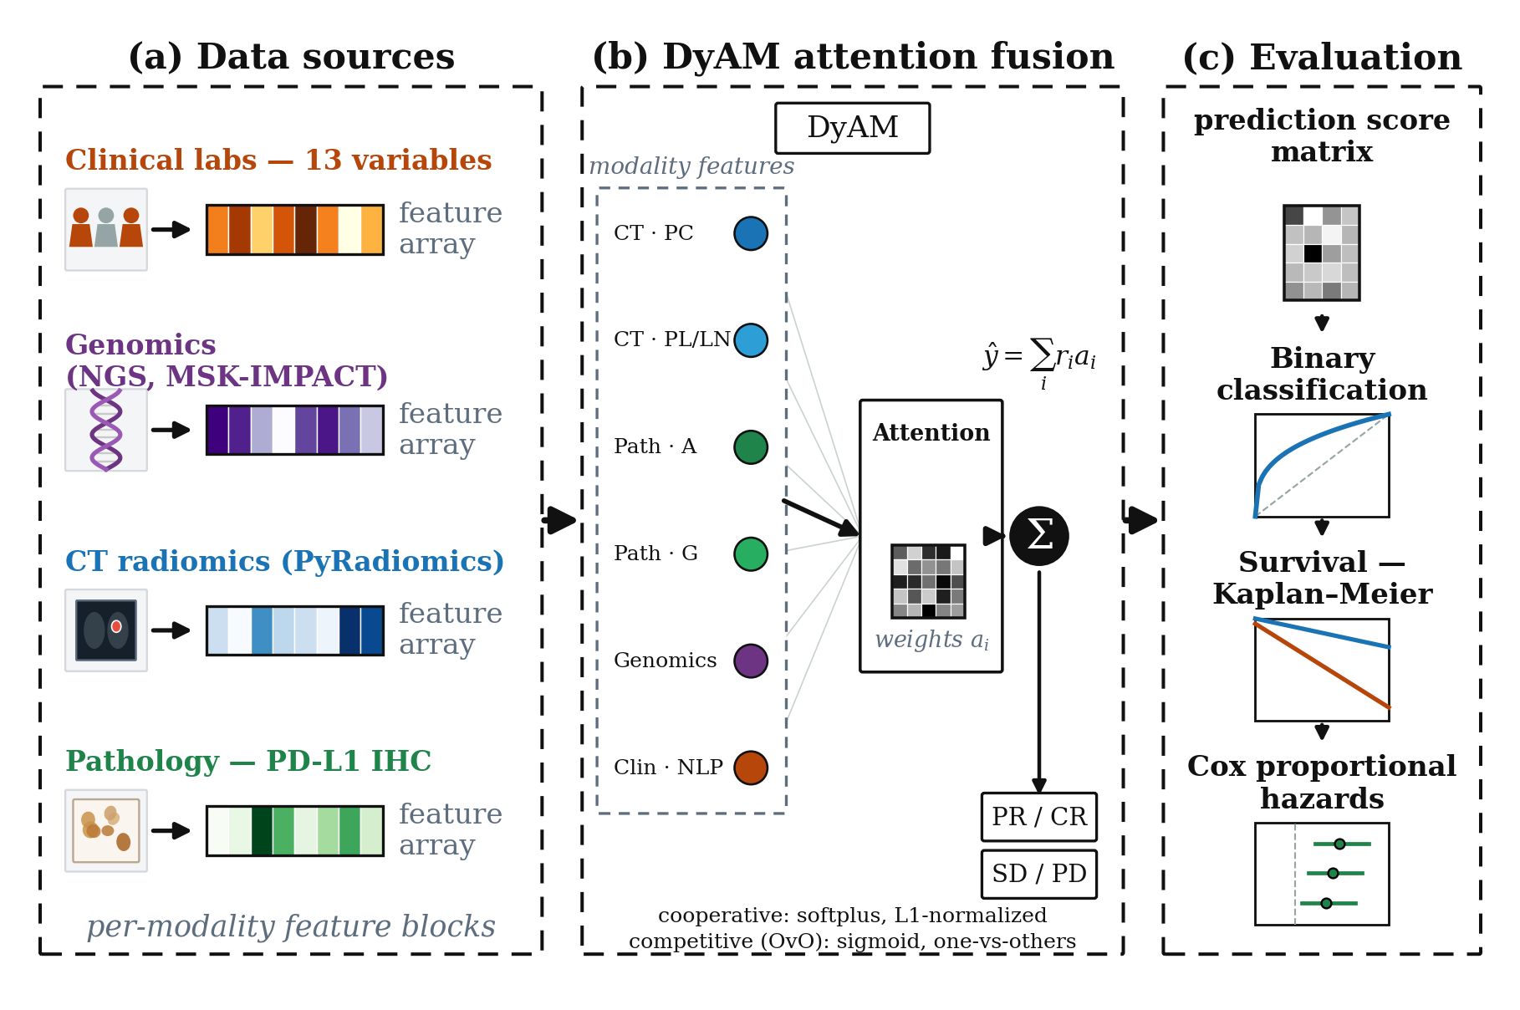
Figure 1. Study overview. (A) The discovery cohort (n = 247) and two validation cohorts (radiomics-evaluable, n = 50; pathology-evaluable, n = 71) provide six data sources: CT radiomics (modelled separately per lesion site: PC, PL, LN), pathology image texture (IHC-A or IHC-G), tumour genomics, PD-L1 TPS, and structured clinical variables, giving up to seven input modalities per model. (B) The DyAM architecture computes a per-modality risk score and combines modalities using either cooperative (AttentionMatrix) or competitive one-vs-others (AttentionMatrixOvO) attention to produce a fused risk prediction ŷ. (C) Models are evaluated on both binary response classification (AUC-ROC with DeLong 95% CI) and survival endpoints (Harrell's C-index, multivariate Cox hazard ratios, and Kaplan–Meier log-rank stratification).

2.2. Data Modalities
Six data sources were assembled for each patient (Table 2). Because CT radiomics is modelled separately per lesion site (PC, PL, LN) and the two pathology feature sets (IHC-A, IHC-G) are used as alternative arms rather than jointly, a single model receives up to seven input modalities. CT radiomics features were extracted from baseline scans using PyRadiomics [19], following the preprocessing of [15], at 1.0 mm isotropic spacing with a window of [−1350, 250] HU, yielding 1,688 features per lesion type. Lesions were categorised by anatomical site: primary tumour (PC), pleural lesion (PL), and lymph node (LN). Up to three lesions per site were included, ranked by volume. Pathology features were derived from PD-L1 immunohistochemistry (IHC) slides: IHC-A comprised 18 pixel-intensity aggregation features (area, mean intensity, percentiles), while IHC-G comprised 150 grey-level co-occurrence matrix (GLCM) texture features across six aggregation levels [15]. Genomic features (11 variables) included tumour mutational burden (TMB) and the status of eight driver mutations and amplifications derived from MSK-IMPACT targeted next-generation sequencing (NGS) [20]. The PD-L1 tumour proportion score (TPS) was obtained from clinical pathology reports (range 0–100%). Clinical laboratory features comprised 13 variables: age, smoking pack-years, Eastern Cooperative Oncology Group (ECOG) performance status, serum albumin, derived neutrophil-to-lymphocyte ratio (dNLR), initial tumour burden, brain and liver metastasis status, line of therapy, combination therapy, primary lung site, prior PD-L1 therapy, and adenocarcinoma histology.
For radiomics modalities, features with an intraclass correlation coefficient (ICC) below 0.15 across test–retest perturbation scans were removed (robustness filter), and features with a z-score exceeding 6 in any patient were flagged as outliers and excluded. All modalities except the NLP embedding (Section 2.3) were standardised with RobustScaler (median centring, IQR scaling). Missing modalities were handled via a binary indicator mask $m ∈ {\left\{0,1\right\}}^{N}$; masked modalities contribute zero attention and zero risk to the fused prediction (Section 2.4).
Table 2. Summary of data modalities used in this study. All feature counts are post-selection (after ICC and outlier filtering for radiomics).
Modality | Source | Features | Clinical meaning
CT Radiomics (PC, PL, LN) | PyRadiomics | ≤1,688 | Tumour shape, size, and texture from baseline CT
Pathology IHC-A | PD-L1 IHC slides | 18 | Pixel-intensity aggregation of PD-L1 expression
Pathology IHC-G | PD-L1 IHC slides | 150 | GLCM texture of PD-L1 signal
Genomics | MSK-IMPACT | 11 | TMB + driver mutation/amplification status
PD-L1 TPS | Pathology report | 1 | Tumour proportion score (0–100%)
Clinical labs | EHR | 13 | Demographics, performance status, labs
NLP embedding (new) | all-MiniLM-L6-v2 | 384 | Sentence embedding of clinical lab text
NLP-PCA16 (new) | PCA of NLP | 16 | PCA-compressed NLP (approx. 94% variance)

2.3. NLP Encoding of Tabular Clinical Features
Standard encoding of clinical variables as a 13-dimensional numeric vector treats each feature independently and loses contextual relationships between variables (e.g., an elderly patient with low albumin and ECOG 2 implies a different prognosis than the same values in isolation). To capture inter-feature context, we converted each patient's clinical profile into an English-language sentence and extracted a dense semantic embedding.
Text prompt construction. For each patient, the 13 clinical variables were formatted into a structured natural-language sentence, for example: “The patient is a 69-year-old. Smoking history in pack-years is 48.0. ECOG performance status is 1.0. Blood albumin concentration is 4.00. Derived neutrophil-to-lymphocyte ratio (dNLR) is 2.40. Initial tumor burden stands at 52.00. The patient is diagnosed with adenocarcinoma at the lung site. Metastatic status: without brain metastasis and without liver metastasis. Currently undergoing therapy line 2, utilizing combination therapy. The patient received prior PD-L1 immunotherapy.” Binary variables were expanded to descriptive phrases to exploit the pretrained vocabulary of the encoder.
Sentence encoder. Prompts were encoded with sentence-transformers/all-MiniLM-L6-v2 [16,17], a 6-layer transformer distilled for semantic sentence similarity and trained on over one billion sentence pairs. Each patient was represented as a 384-dimensional L2-normalised vector. No fine-tuning was performed; the model was applied in zero-shot transfer. We compared this general-purpose encoder against the domain-specific Bio_ClinicalBERT [18]; the domain-specific model performed inferiorly (ΔAUC = −0.012 versus MiniLM-L6-v2 in the IHC-A arm), consistent with its design for masked language modelling rather than sentence-similarity tasks.
Dimensionality reduction. Principal component analysis (PCA) was applied to the 384-dimensional embeddings, retaining the top 16 components (≈94% of variance explained). Both the raw 384-dimensional (NLP raw) and PCA-compressed 16-dimensional (NLP-PCA16) variants were evaluated. Crucially, the NLP modality was passed to the model with the RobustScaler disabled (no_scale=True), as the embeddings are already L2-normalised and scaling would distort the cosine-similarity geometry of the embedding space.
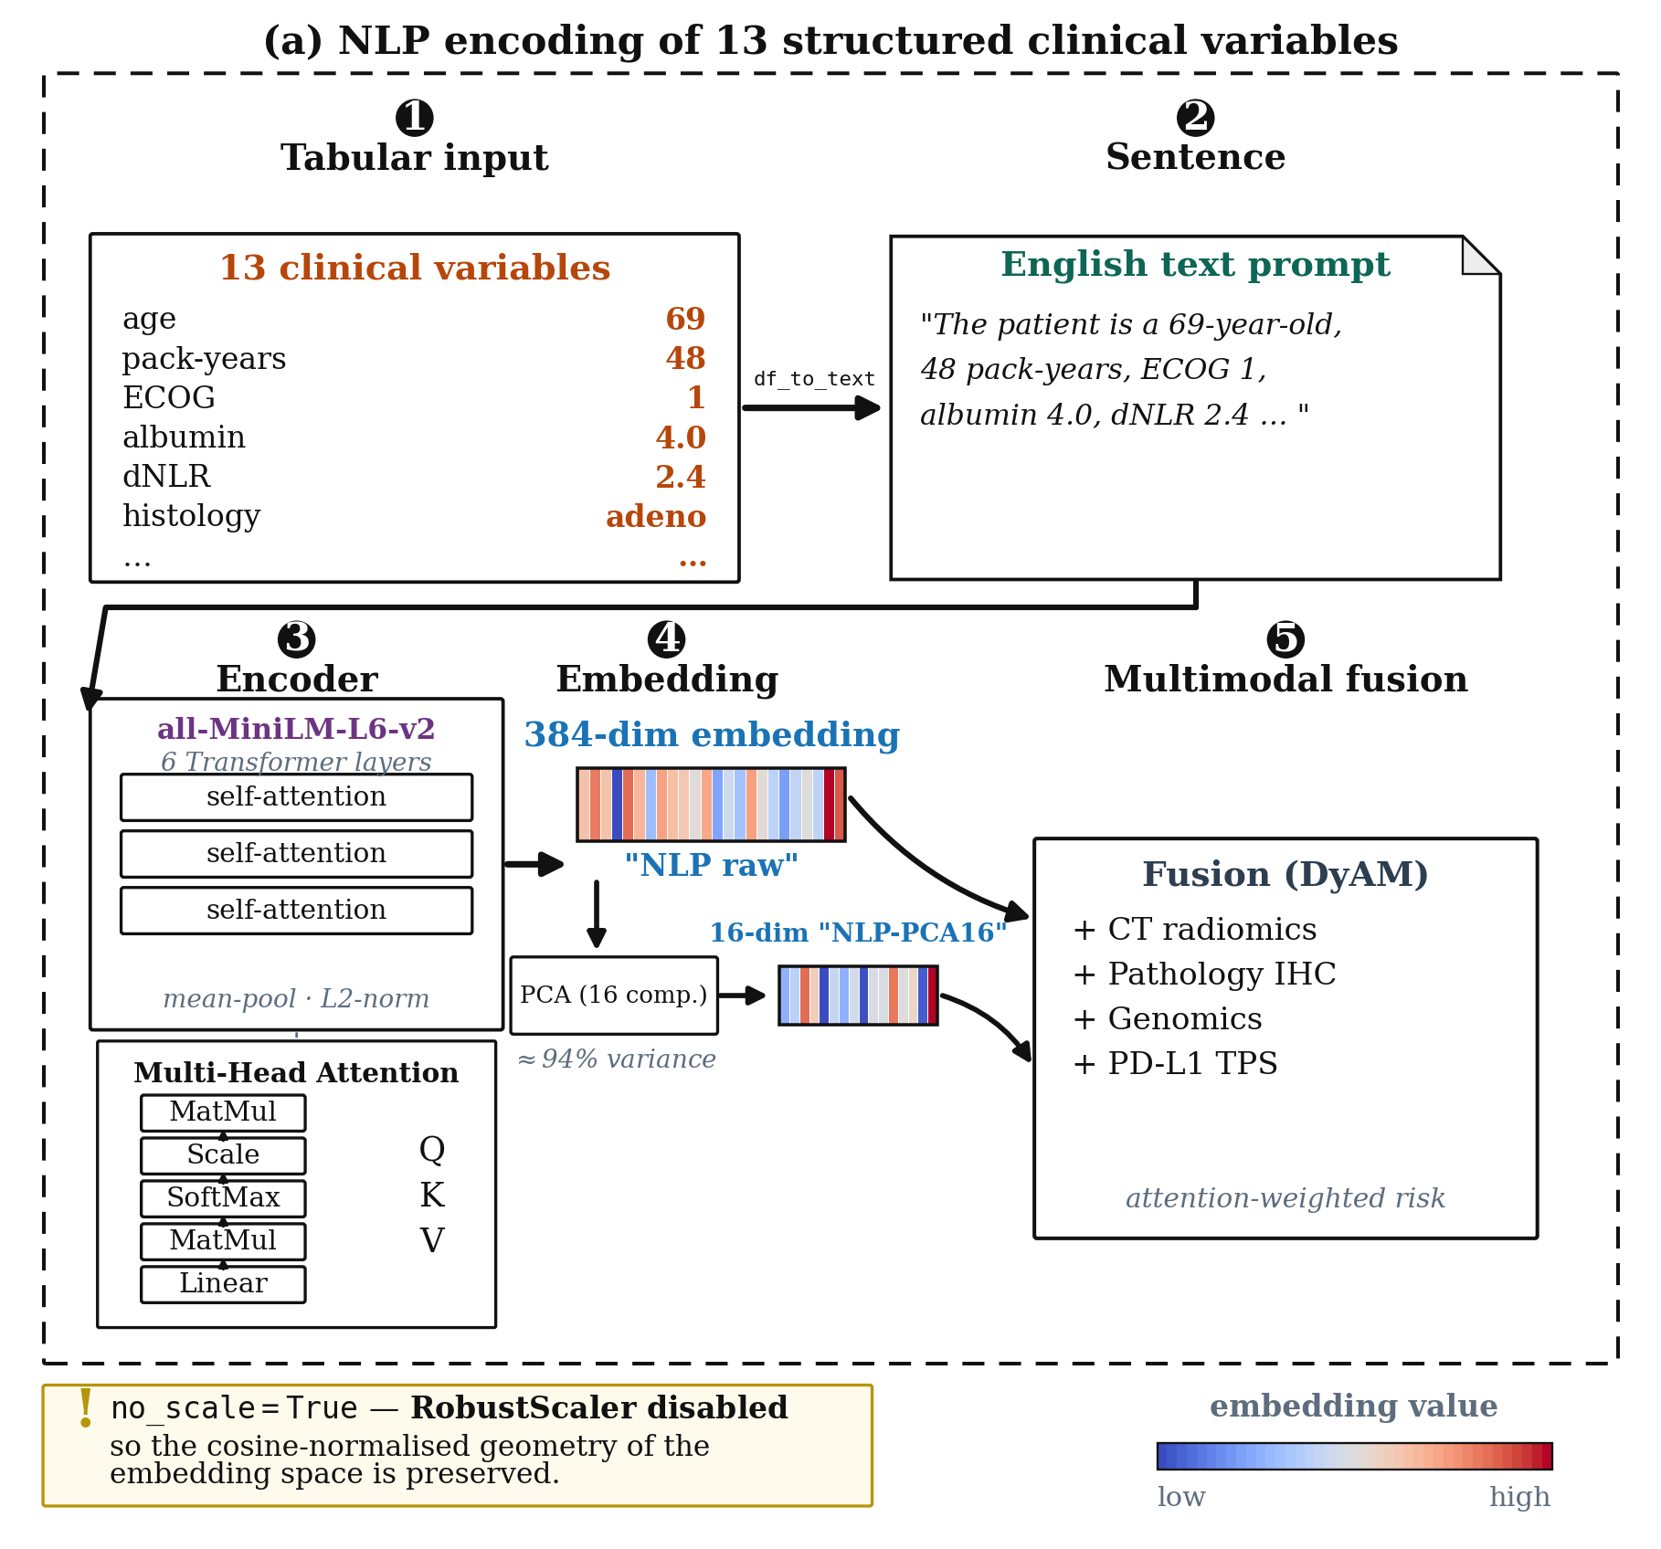
Figure 2. NLP-based encoding of structured clinical features. Thirteen numeric clinical variables per patient are converted into a natural-language sentence describing the patient's clinical profile (example shown), which is then encoded into a 384-dimensional embedding using a pretrained sentence transformer (all-MiniLM-L6-v2). The 384-dimensional embedding (“NLP raw”) is used directly, or further reduced to 16 dimensions via PCA (“NLP-PCA16”, retaining ≈94% of variance) prior to fusion with other modalities. no_scale=True is applied to NLP embeddings to preserve their cosine-normalised geometry.

2.4. Model Architecture
Dynamic Attention Multimodal (DyAM) model. The base model, DyAM [15], fuses $N$ modalities through per-modality risk scores and a learned attention mechanism, in the spirit of attention-based architectures broadly [21]. Let $x_{i} ∈ ℝ^{d_{i}}$ denote the feature vector of modality $i$ after optional RobustScaling. A scalar risk score is computed as:
$r_{i} = \tanh{W_{r,i}^{T} x_{i}}$ (1)
where $W_{r,i} ∈ ℝ^{d_{i}}$ are learnable weights. An attention score is produced by an $N × N$ grid of linear layers with softplus activation, $ℓ_{2}$-normalised by the modality vector norm:
$s_{i} = \frac{\operatorname{softplus}{W_{a,ij}^{T} x_{i}}}{{\left\|x_{i}\right\|}_{2}}$ (2)
Attention weights are obtained by L1 normalisation across modalities:
$a_{i} = \frac{s_{i}}{\sum_{j = 1}^{N}{s_{j}}}$ (3)
OvO competitive attention. We propose an alternative attention mechanism inspired by one-versus-others (OvO) classification [22], in which each modality competes against the mean score of all remaining modalities rather than sharing a fixed budget. The mean score of the $N − 1$ competing modalities is:
$μ_{−i} = \frac{1}{N − 1}\sum_{j ≠ i}{s_{j}}$ (4)
and the OvO attention score is:
${ovo}_{i} = σ\left(s_{i} − μ_{−i}\right), σ(z) = {\left(1 + e^{−z}\right)}^{−1}$ (5)
The sigmoid function yields an independent probability that modality $i$ outperforms the others, rather than a jointly normalised score. After applying the binary missingness mask $m_{i} ∈ \left\{0,1\right\}$, the weights are L1-normalised: $a_{i} = \frac{{ovo}_{i} · m_{i}}{\sum_{j}{{ovo}_{j} · m_{j}}}$.
Fused prediction and training. For both variants, the final risk prediction is:
$\hat{y} = \sum_{i = 1}^{N}{r_{i} · a_{i}}$ (6)
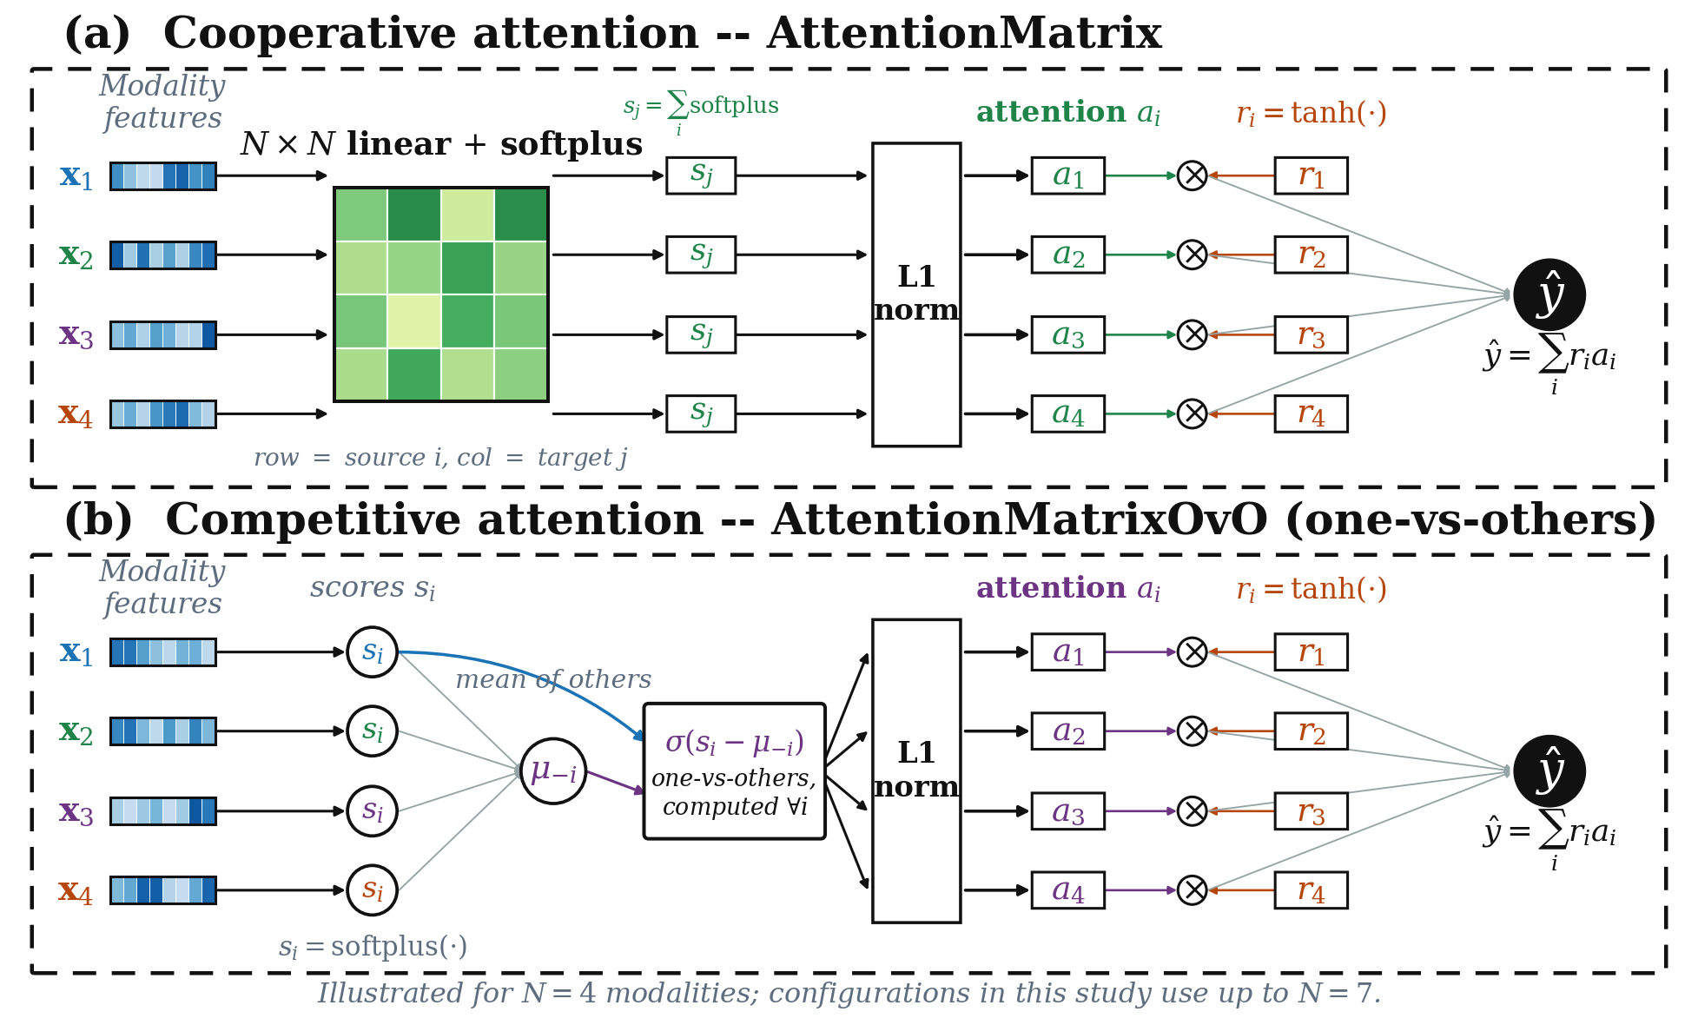
Figure 3. Architecture of the two attention mechanisms. Both variants compute a per-modality risk score $r_{i} = \tanh{W_{r,i}^{T} x_{i}}$ and produce the fused prediction $\hat{y} = \sum_{i}{r_{i} · a_{i}}$; they differ only in how the attention weights $a_{i}$ are obtained. (A) Cooperative attention (AttentionMatrix): an $N × N$ grid of linear layers with softplus activation produces pairwise scores that are column-summed into $s_{j}$ and L1-normalised so that the modalities share a fixed attention budget. (B) Competitive one-vs-others attention (AttentionMatrixOvO): each modality produces a single score $s_{i}$ that is compared against the mean score of the remaining modalities $μ_{−i}$ through a sigmoid, $σ\left(s_{i} − μ_{−i}\right)$, yielding an independent competitive weight before L1 normalisation. Heatmap bars denote modality feature vectors; the diagram is drawn for $N = 4$ modalities for clarity.
The model was trained with binary cross-entropy loss (BCEWithLogitsLoss) with automatic inverse-frequency class weighting to address the ≈1:3 class imbalance, an ℓ2 penalty on the weights (coefficient α = 0.001); the attention-norm penalty was disabled (β = 0). The Adam optimiser was used with a learning rate of 0.01 for 125 epochs. All experiments used 10-fold cross-validation (shuffled, not stratified) on the discovery cohort; predictions were pooled across held-out folds for AUC computation.

2.5. Statistical Analysis and Evaluation
Discriminative performance. Area under the receiver operating characteristic curve (AUC-ROC) was computed on pooled out-of-fold predictions from 10-fold cross-validation. Ninety-five percent confidence intervals (CIs) were estimated using the DeLong structural components method [23]. Differences between models are reported as the difference in mean AUC across repeated partitions (5 seeds × 10-fold), the number of seeds favouring each model, and, where patient-level scores were retained, a 95% patient-level bootstrap interval (5000 resamples) of the difference in ensemble AUC. Because the cohort is small, hypothesis tests were not used to claim that one model is superior; DeLong intervals are reported for single AUC values only. Ensemble scores average, for each patient, the per-partition scores after standardisation within each partition.
Survival analysis. Harrell's concordance index (C-index) [24] was computed from pooled out-of-fold risk scores against PFS, and the survival analyses were repeated for 5 seeds × 10-fold partitions, reporting mean ± s.d. Multivariate Cox proportional hazards regression was fitted with the DyAM risk score as the primary predictor, adjusted for five clinical covariates: age, ECOG performance status, serum albumin, dNLR, and liver metastasis status; hazard ratios are per unit of risk score. Time-dependent AUC (6, 12 and 18 months; cumulative/dynamic estimator [25,26]) was computed for each of the five partitions (scikit-survival 0.28 with numpy 2.5.4 in a separate environment, from the stored out-of-fold risk scores).
Kaplan–Meier survival stratification. Patients were dichotomised at the median risk score, and PFS curves for the two groups were compared with the log-rank test. The log-rank χ² is reported with χ² > 3.84 (p < 0.05) and χ² > 7.88 (p < 0.005) as reference values.
Software. All numerical results in Tables 3–10 were computed in one pinned environment (Linux under WSL2, Ubuntu 22.04; Python 3.8.15, PyTorch 1.8.1 (CPU), scikit-learn 0.24.2, scipy 1.6.3, numpy 1.20.3, pandas 1.2.5, and lifelines 0.26.0 for Kaplan–Meier, Cox regression and the C-index). In this environment the original DyAM code reproduced the single-partition AUC of the original publication at its primary benchmark (0.798) to within one patient pair. The same code and library versions on another operating system gave AUCs that differed in the second or third decimal place, so results were never compared across platforms; the radiomics feature selection used the original procedure, without removal of degenerate columns. The sentence-encoder embeddings (MiniLM-L6-v2 and Bio_ClinicalBERT) were computed once in a separate environment and cached, and time-dependent AUC was computed from the stored out-of-fold risk scores with scikit-survival 0.28 (numpy 2.5.4).

3. Results

3.1. Multimodal Fusion Outperforms Single-Modality Baselines
Within the DyAM framework, models restricted to a single data source achieved repeated-seed (5 seeds × 10-fold) AUC values of 0.616 ± 0.001 (TMB), 0.635 ± 0.021 (pathology IHC-A), 0.672 ± 0.021 (CT radiomics), 0.676 ± 0.013 (genomics), and 0.720 ± 0.012 (PD-L1 TPS) on the discovery cohort. PD-L1 TPS was the strongest individual predictor, consistent with its role as the biomarker in routine clinical use.
Fusing four data sources (CT radiomics, pathology IHC-G, genomics, and PD-L1 TPS) under the same protocol raised the AUC to 0.763 ± 0.022, exceeding the best single source by 0.043 AUC; adding NLP-encoded clinical variables raised it further to 0.786 ± 0.017 (Table 3). Multimodal fusion is therefore the primary driver of predictive performance in this cohort, with no individual source approaching the discrimination of the fused model.

3.2. OvO Competitive Attention Is Comparable to, and in Many-Source Configurations Slightly Higher Than, Cooperative Attention with a Simpler Parameterization
We compared the OvO attention variant with the original cooperative attention across the 21 modality combinations of the primary paper-matched configuration set (Section 3.1), without and with the NLP-clinical encoding of Section 3.3, under the repeated-seed protocol (5 independent random partitions, 5 seeds × 10-fold, patient labels re-shuffled per seed; Table 3). Because a cohort of 247 patients cannot support reliable hypothesis tests of differences of this size, we report the difference in mean AUC and the number of seeds favouring each model, and, where patient-level scores were retained, bootstrap intervals; we do not use significance testing to claim superiority.
At the primary benchmark (Rad+IHC-G+Gen+PDL1, BM1), OvO reached a repeated-seed mean AUC of 0.771 ± 0.021 versus 0.763 ± 0.022 for the cooperative model (ΔAUC = +0.008; OvO higher in four of the five seeds). The largest gains of OvO over the cooperative model were at TMB+PDL1 (+0.045, 0.709 against 0.664), Rad+IHC-A+MutAmp (+0.021), Rad+IHC-A+Gen+PDL1 (+0.019, 0.755 against 0.736), Rad+IHC-A+Gen+TMB+PDL1 (+0.019), Rad+IHC-A+Gen+PDL1+Labs (+0.017) and PDL1+Gen (+0.011), each in all five seeds; the cooperative model was higher at IHC-G+Gen (−0.028) and by smaller margins in radiomics-only and Rad+IHC-A (−0.009 and −0.007).
Adding the NLP-clinical encoding in place of the numeric labs raised the AUC in both configurations that contain labs, for both attention mechanisms: from 0.762 to 0.786 for DyAM and from 0.766 to 0.785 for OvO at BM2, and from 0.731 to 0.745 and from 0.747 to 0.769 in the configuration with IHC-A (Table 3). Relative to BM1, which has the same sources without any clinical variable, the NLP gain was +0.023 for DyAM (0.763 ± 0.022 to 0.786 ± 0.017) and +0.014 for OvO (0.771 ± 0.021 to 0.785 ± 0.022). The highest repeated-seed mean AUCs in Table 3 were 0.786 (DyAM+NLP) and 0.785 (OvO+NLP) at BM2, against 0.771 (OvO) and 0.763 (DyAM) at BM1.
To examine the NLP-containing models beyond the two configurations with labs, we compared DyAM+NLP and OvO+NLP with the NLP encoding added as a further source to the six configurations with k ≥ 5 (Table 4). OvO+NLP had the higher AUC in all five seeds at Rad+IHC-A+Gen (+0.010), Rad+IHC-A+MutAmp (+0.026), Rad+IHC-A+Gen+PDL1 (+0.024) and Rad+IHC-A+Gen+TMB+PDL1 (+0.028); DyAM+NLP was nominally higher at Rad+IHC-G+Gen (−0.004) and at BM1 (−0.001). At BM1 the two ensemble AUCs were 0.799 (DyAM+NLP) and 0.792 (OvO+NLP); the patient-level bootstrap intervals of the ensemble differences were wide and, except for two configurations whose lower bound was close to zero, included zero.
OvO's potential advantage is plausibly one of parameter economy: with the 384-dimensional NLP source added to BM1, the cooperative model has 4,969 trainable parameters against 1,242 for OvO, and the advantage of the simpler model was largest at the largest source counts. We did not test this explanation directly; for example, we did not shrink the cooperative attention matrix to see whether the gap closes. Table 3 gives the repeated-seed AUC of both attention mechanisms, with and without NLP, across all 21 configurations, and Table 4 the comparison of the NLP-containing models in the six configurations with k ≥ 5.
Table 3. Repeated-seed (5 seeds × 10-fold) AUC across all 21 paper-matched modality combinations for cooperative attention (DyAM) and OvO competitive attention, each without and with NLP-clinical encoding. All four columns were produced by the same pipeline. k is the number of fused input sources (CT radiomics contributes one source per lesion site). Bold marks the highest value in each row (among DyAM and OvO where the +NLP entries repeat them). For k = 1 OvO reduces algebraically to the cooperative formulation, hence the identical values. Configurations 8, 11, 18 and 21 are the primary benchmarks BM4, BM3, BM1 and BM2. The NLP encoding replaces the numeric labs, so only configurations 20 and 21 (the two that contain labs) differ between the models with and without NLP; the other configurations contain no clinical source, and their +NLP entries repeat the values without NLP (not in bold).
# | Configuration | k | DyAM | OvO | DyAM+NLP | OvO+NLP
1 | TMB | 1 | 0.616 | 0.616 | 0.616 | 0.616
2 | PDL1 | 1 | 0.720 | 0.720 | 0.720 | 0.720
3 | IHC-A | 1 | 0.635 | 0.635 | 0.635 | 0.635
4 | Gen | 1 | 0.676 | 0.676 | 0.676 | 0.676
5 | Rad | 3 | 0.672 | 0.663 | 0.672 | 0.663
6 | Rad-LU | 4 | 0.650 | 0.641 | 0.650 | 0.641
7 | TMB+PDL1 | 2 | 0.664 | 0.709 | 0.664 | 0.709
8 | PDL1+Gen (BM4) | 2 | 0.707 | 0.718 | 0.707 | 0.718
9 | Rad+IHC-A | 4 | 0.687 | 0.680 | 0.687 | 0.680
10 | Rad+IHC-G | 4 | 0.716 | 0.714 | 0.716 | 0.714
11 | Rad+Gen (BM3) | 4 | 0.713 | 0.710 | 0.713 | 0.710
12 | IHC-A+Gen | 2 | 0.693 | 0.697 | 0.693 | 0.697
13 | IHC-G+Gen | 2 | 0.747 | 0.719 | 0.747 | 0.719
14 | Rad+IHC-A+Gen | 5 | 0.731 | 0.735 | 0.731 | 0.735
15 | Rad+IHC-G+Gen | 5 | 0.749 | 0.748 | 0.749 | 0.748
16 | Rad+IHC-A+MutAmp | 6 | 0.728 | 0.749 | 0.728 | 0.749
17 | Rad+IHC-A+Gen+PDL1 | 6 | 0.736 | 0.755 | 0.736 | 0.755
18 | Rad+IHC-G+Gen+PDL1 (BM1) | 6 | 0.763 | 0.771 | 0.763 | 0.771
19 | Rad+IHC-A+Gen+TMB+PDL1 | 7 | 0.744 | 0.763 | 0.744 | 0.763
20 | Rad+IHC-A+Gen+PDL1+Labs | 7 | 0.731 | 0.747 | 0.745 | 0.769
21 | Rad+IHC-G+Gen+PDL1+Labs (BM2) | 7 | 0.762 | 0.766 | 0.786 | 0.785

Table 4. DyAM+NLP versus OvO+NLP over 5 seeds (5 seeds × 10-fold) on the six configurations fusing five or more sources, with the NLP encoding added as a further source. Per-seed AUC is the mean (s.d.) of the 5 pooled out-of-fold AUCs; the ensemble averages the 5 seeds' standardised scores per patient. Δ is OvO+NLP minus DyAM+NLP; the bracket is the 95% patient-level bootstrap interval (5000 resamples) of the ensemble difference. Wins is the number of seeds in which OvO+NLP had the higher AUC. Same pipeline as Table 3.
Configuration | DyAM+NLP | OvO+NLP | Δ per seed (wins) | Ens. DyAM+NLP | Ens. OvO+NLP | Δ ens. [95% CI]
Rad+IHC-A+Gen | 0.745 (0.012) | 0.756 (0.013) | +0.010 (5/5) | 0.761 | 0.770 | +0.009 [−0.009, +0.026]
Rad+IHC-G+Gen | 0.770 (0.021) | 0.766 (0.016) | −0.004 (1/5) | 0.782 | 0.779 | −0.003 [−0.011, +0.005]
Rad+IHC-A+MutAmp | 0.731 (0.012) | 0.757 (0.013) | +0.026 (5/5) | 0.748 | 0.766 | +0.019 [+0.000, +0.039]
Rad+IHC-A+Gen+PDL1 | 0.745 (0.003) | 0.769 (0.014) | +0.024 (5/5) | 0.761 | 0.779 | +0.018 [+0.001, +0.037]
Rad+IHC-G+Gen+PDL1 (BM1) | 0.786 (0.017) | 0.785 (0.022) | −0.001 (3/5) | 0.799 | 0.792 | −0.007 [−0.021, +0.006]
Rad+IHC-A+Gen+TMB+PDL1 | 0.747 (0.007) | 0.775 (0.015) | +0.028 (5/5) | 0.765 | 0.784 | +0.019 [−0.008, +0.045]

3.3. NLP Encoding Improves AUC over Numeric Clinical Labs
Seven clinical-encoding variants were evaluated under the DyAM architecture in two pathology arms (IHC-A: seven variants; IHC-G: four variants), 5 seeds × 10-fold (Tables 5 and 6; Figure 4). Relative to numeric labs, the NLP raw (384-dimensional) encoding raised the mean AUC by +0.017 in the IHC-A arm (0.749 vs. 0.732) and by +0.020 in the IHC-G arm (0.772 vs. 0.753); the PCA-compressed NLP variant gave +0.013 and +0.015. These differences are of the same order as the partition-to-partition standard deviation (0.012–0.025), so they should be read as a consistent direction of modest size. The same advantage over numeric labs was present in the 21-configuration analysis for both attention mechanisms: in the two seven-source configurations that contain labs (Table 3, rows 20 and 21), replacing labs by the NLP encoding raised the mean AUC from 0.731 to 0.745 and from 0.762 to 0.786 for DyAM, and from 0.747 to 0.769 and from 0.766 to 0.785 for OvO.
Comparison with no clinical information. The comparison with the no-clinical baseline was smaller than the comparison with labs. In the arm analysis above, the NLP raw encoding was above the no-clinical baseline by +0.007 in both arms (IHC-A: 0.749 vs. 0.741; IHC-G: 0.772 vs. 0.765), whereas numeric labs were below it (−0.010 and −0.013). At the primary benchmark of the 21-configuration analysis, NLP was above the configuration without clinical variables by +0.023 for DyAM and +0.014 for OvO. The direction therefore agreed between the two analyses, but the size of the gain over omitting clinical variables (+0.007 to +0.023) is of the same order as the partition-to-partition spread, so we base the main claim on NLP versus numeric labs and regard the benefit of NLP encoding over omitting clinical variables as small and not established in this cohort.
Domain-specific versus general-purpose encoder. Bio_ClinicalBERT [18], PCA-compressed to 16 dimensions, reached 0.732 ± 0.012 in the IHC-A arm, below MiniLM-L6-v2 with the same compression (0.744 ± 0.012; ΔAUC = −0.012, lower in all five partitions) and below the no-clinical baseline (0.741; Supplementary Note S2), consistent with its pretraining objective of masked language modelling on clinical notes rather than semantic sentence similarity.
Combined encoding. Concatenating numeric labs and the NLP encoding as separate sources (8 sources in total) did not improve on the NLP encoding alone (IHC-A: 0.744 for NLP-PCA16 alone vs. 0.736 for labs + NLP-PCA16), and with n/N = 247/8 ≈ 31 the attention weights are poorly determined. NLP encoding is therefore used as a replacement for, rather than an addition to, numeric clinical features.
Table 5. AUC comparison across clinical encoding strategies, IHC-A arm. All models use the DyAM architecture with CT radiomics (PC, PL, LN), pathology IHC-A, genomics, and PD-L1 TPS as base modalities; clinical encoding is the varied factor. Values are mean ± s.d. over 5 independent 10-fold partitions (5 seeds × 10-fold, n = 247). ΔAUC is the difference of means relative to the no-clinical baseline and to numeric labs; the differences are smaller than the seed-to-seed s.d. and are reported as direction and magnitude. n/a, not applicable.
Model | AUC (mean ± s.d.) | Δ vs no clinical | Δ vs labs
No clinical (baseline) | 0.741 ± 0.012 | (ref) | n/a
+ Labs (13-dim numeric) | 0.732 ± 0.014 | −0.010 | n/a
+ NLP raw (384-dim) | 0.749 ± 0.016 | +0.007 | +0.017
+ NLP-PCA16 (16-dim) | 0.744 ± 0.012 | +0.003 | +0.013
+ Labs + NLP (combined) | 0.735 ± 0.016 | −0.007 | +0.003
+ Labs + NLP-PCA16 (combined) | 0.736 ± 0.018 | −0.005 | +0.005
+ BioClinBERT-PCA16 | 0.732 ± 0.012 | −0.009 | +0.001

Table 6. AUC comparison across clinical encoding strategies, IHC-G arm. All models use the DyAM architecture with CT radiomics (PC, PL, LN), pathology IHC-G, genomics, and PD-L1 TPS as base modalities; clinical encoding is the varied factor. Values are mean ± s.d. over 5 independent 10-fold partitions (5 seeds × 10-fold, n = 247). ΔAUC is the difference of means relative to the no-clinical baseline and to numeric labs; the differences are smaller than the seed-to-seed s.d. and are reported as direction and magnitude. n/a, not applicable.
Model | AUC (mean ± s.d.) | Δ vs no clinical | Δ vs labs
No clinical (baseline) | 0.765 ± 0.019 | (ref) | n/a
+ Labs (13-dim numeric) | 0.752 ± 0.020 | −0.013 | n/a
+ NLP raw (384-dim) | 0.772 ± 0.025 | +0.007 | +0.020
+ NLP-PCA16 (16-dim) | 0.768 ± 0.022 | +0.003 | +0.015

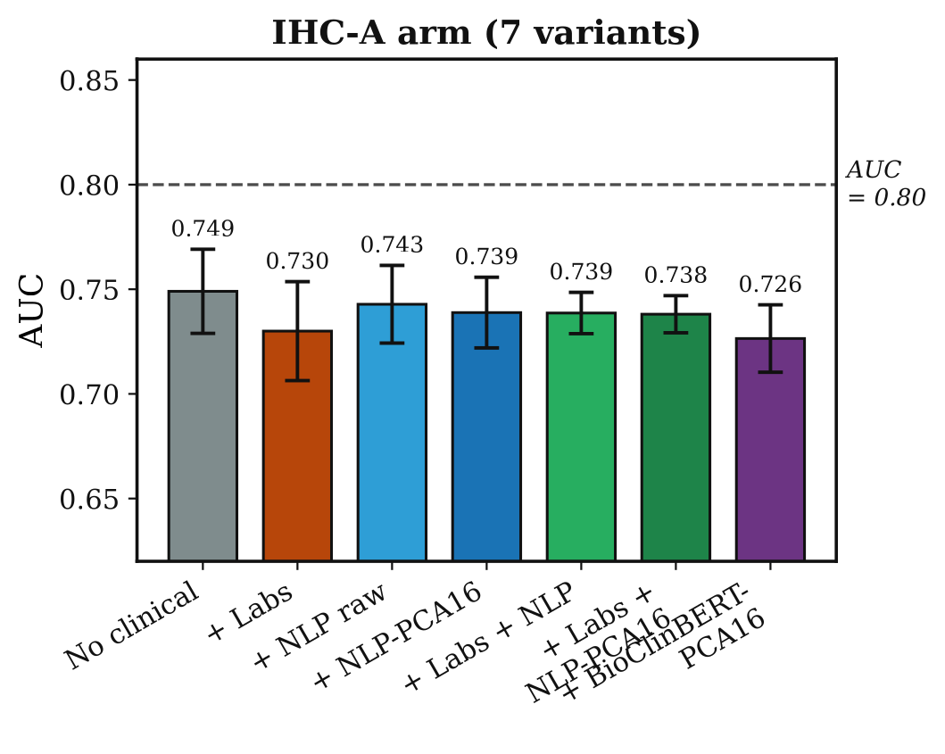
Figure 4A. AUC comparison across clinical encoding strategies, IHC-A arm (7 variants). Bars show the mean AUC over 5 seeds × 10-fold cross-validation (n = 247); error bars denote ±1 standard deviation across the five partitions. The dashed horizontal line at AUC = 0.80 marks the conventional threshold for clinically useful discrimination.
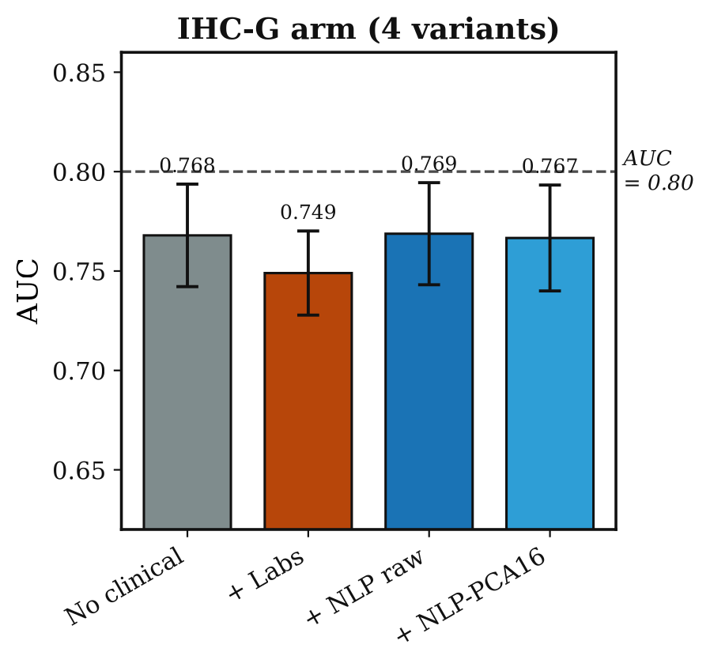
Figure 4B. AUC comparison across clinical encoding strategies, IHC-G arm (4 variants). Same conventions as Figure 4A.

3.4. Survival Analysis: Clinical Encoding Raises the Hazard Ratio of the Risk Score
Under 5 seeds × 10-fold evaluation, the DyAM risk score was strongly associated with progression-free survival in multivariate Cox regression adjusted for age, ECOG performance status, serum albumin, dNLR, and liver metastasis status, in every model variant (hazard ratio per unit of risk score 4.0–4.6; Table 7).
Cox hazard ratios. In both arms the hazard ratio was higher with the NLP encodings than without a clinical encoding: IHC-A, 4.12 (no clinical) vs. 4.13 (labs), 4.52 (NLP raw) and 4.43 (NLP-PCA16); IHC-G, 4.02 vs. 4.54, 4.63 and 4.47. Numeric labs raised the hazard ratio in the IHC-G arm only. The NLP encodings gave the numerically highest hazard ratios (by about 0.1 over labs in IHC-G and 0.4 in IHC-A), but these differences are of the same order as the partition-to-partition spread (0.2–0.6), so the data do not reliably distinguish NLP from numeric labs on this endpoint.
C-index. Harrell's C-index was 0.61–0.62 for all variants and differed by at most 0.006 between encodings in either arm; numeric labs gave the highest value in both arms (IHC-A: 0.614 vs. 0.609 for NLP raw; IHC-G: 0.623 vs. 0.617), and the NLP variants did not exceed the no-clinical baseline in the IHC-A arm (0.608–0.609 vs. 0.608).
Kaplan–Meier stratification. Dichotomising patients at the median risk score gave a log-rank χ² above 3.84 (p < 0.05) in all 55 model–partition combinations (smallest value 7.0) and above 7.88 (p < 0.005) in 53 of them (Table 8). The mean log-rank χ² was higher with clinical encodings than without (IHC-A: 16.9 without vs. 19.5 with labs and 19.3 with NLP raw; IHC-G: 13.6 vs. 14.5 and 15.3), again with no consistent separation between NLP and labs. Kaplan–Meier curves of the primary benchmark models are shown in Figure 5, and the five-partition summary of survival metrics in Figure 6. Time-dependent AUC (Table 7) was 0.63–0.69 at 6, 12 and 18 months for every variant and differed by about 0.03 or less between encodings within an arm; it was not systematically higher with the NLP encodings (IHC-A at 12 months: 0.689 with NLP raw, 0.684 with labs, 0.684 without clinical variables; at 18 months the no-clinical variants were the highest, 0.662 and 0.655).
OvO attention with the NLP encoding at the primary benchmark. We also compared the survival association of the four attention/encoding models at the primary benchmark (Rad+IHC-G+Gen+PDL1; 5 seeds × 10-fold, risk scores standardised, hazard ratio per 1 s.d. adjusted for the same covariates). The hazard ratio rose from 1.53 for cooperative attention (DyAM) to 1.58 for OvO, 1.60 for DyAM with NLP and 1.64 for OvO with NLP (log hazard ratio 0.425, 0.460, 0.468 and 0.495); the log-rank χ² rose from 12.3 to 14.4, 16.3 and 17.9, and the C-index from 0.616 to 0.620, 0.622 and 0.623. Relative to DyAM, OvO with NLP had a higher log hazard ratio in all 5 seeds (+0.070 on average; 95% patient-bootstrap interval 0.013 to 0.106) and a higher C-index in all 5 seeds (+0.006), the latter within the bootstrap interval of zero. OvO with NLP was higher than DyAM with NLP by +0.027 in log hazard ratio (5 of 5 seeds) and by +0.001 in C-index, and the two risk scores were highly correlated (r = 0.99), so the gain relative to DyAM came from the OvO mechanism and the NLP encoding together, about +0.035 and +0.043 each when added alone. The same ordering was obtained in two other software environments (Windows, scikit-learn 1.1.1 and 0.24.2; log hazard ratio difference to DyAM +0.070 and +0.076).
Survival association across the 21 configurations. We repeated this evaluation on all 21 configurations of Table 3 (5 seeds × 10-fold; Tables 9 and 10). The association of the risk score with survival grew with the number of fused sources: for the single-source scores the C-index was 0.567–0.587 and the 12-month time-dependent AUC 0.596–0.661, whereas for the configurations with five to seven sources (14–21) the C-index was 0.588–0.627, the 12-month time-dependent AUC 0.657–0.709 and the log hazard ratio per 1 s.d. 0.362–0.505. In each of these eight configurations the mean log hazard ratio, 12-month time-dependent AUC and C-index of OvO were above those of cooperative attention (for example, at BM1 the log hazard ratio 0.460 against 0.425 and the 12-month time-dependent AUC 0.709 against 0.681; the C-index differences were between +0.001 and +0.016). In the two configurations that contain labs, OvO with the NLP encoding had the highest log hazard ratio (0.495 at BM2 and 0.497 in configuration 20, against 0.416 and 0.411 for DyAM, and 0.468 and 0.450 for DyAM with NLP; higher than DyAM in all 5 seeds in both configurations), and the highest 12-month time-dependent AUC (0.708 and 0.704, against 0.675 and 0.678 for DyAM), with a C-index within 0.01 of DyAM (0.623 against 0.626 at BM2; 0.617 against 0.613 in configuration 20). The Kaplan–Meier log-rank statistic (mean over the 5 seeds) showed the same direction: OvO was above cooperative attention in the six configurations with five to seven sources that do not contain labs (14–19; for example 14.4 against 12.3 at BM1 and 19.9 against 12.1 in configuration 19), and at BM2 (17.6 against 15.2; 17.9 for OvO with NLP), whereas in configuration 20 the cooperative model was higher (20.5 against 14.3; 17.6 for OvO with NLP). For several configurations with fewer sources the two mechanisms were close or OvO was lower (for example TMB+PDL1 and IHC-G+Gen).
Table 7. Survival analysis across model variants. Discovery cohort (n = 247; 209 events, 84.6%; median PFS 2.7 months). Values are mean ± s.d. over 5 independent 10-fold partitions of the DyAM risk score. C-index: Harrell's concordance index. Cox HR: hazard ratio per unit of risk score from multivariate Cox regression adjusted for age, ECOG, albumin, dNLR, and liver metastases. tdAUC: cumulative/dynamic time-dependent AUC at 6, 12 and 18 months (Uno estimator).
Arm | Model | C-index | Cox HR | tdAUC 6 mo | 12 mo | 18 mo
IHC-A | No clinical (baseline) | 0.608 ± 0.007 | 4.12 ± 0.30 | 0.681 ± 0.015 | 0.684 ± 0.028 | 0.662 ± 0.048
IHC-A | + Labs (13-dim numeric) | 0.614 ± 0.007 | 4.13 ± 0.36 | 0.682 ± 0.016 | 0.684 ± 0.017 | 0.633 ± 0.038
IHC-A | + NLP raw (384-dim) | 0.609 ± 0.010 | 4.52 ± 0.21 | 0.679 ± 0.016 | 0.689 ± 0.023 | 0.648 ± 0.043
IHC-A | + NLP-PCA16 (16-dim) | 0.608 ± 0.010 | 4.43 ± 0.27 | 0.678 ± 0.019 | 0.686 ± 0.024 | 0.645 ± 0.043
IHC-A | + Labs + NLP (combined) | 0.609 ± 0.008 | 4.31 ± 0.59 | 0.675 ± 0.012 | 0.672 ± 0.022 | 0.632 ± 0.042
IHC-A | + Labs + NLP-PCA16 (combined) | 0.610 ± 0.008 | 4.35 ± 0.62 | 0.678 ± 0.011 | 0.673 ± 0.020 | 0.631 ± 0.039
IHC-A | + BioClinBERT-PCA16 | 0.614 ± 0.009 | 4.64 ± 0.20 | 0.676 ± 0.016 | 0.690 ± 0.023 | 0.641 ± 0.034
IHC-G | No clinical (baseline) | 0.617 ± 0.007 | 4.02 ± 0.32 | 0.689 ± 0.017 | 0.677 ± 0.020 | 0.655 ± 0.033
IHC-G | + Labs (13-dim numeric) | 0.623 ± 0.006 | 4.54 ± 0.24 | 0.692 ± 0.007 | 0.681 ± 0.016 | 0.634 ± 0.027
IHC-G | + NLP raw (384-dim) | 0.617 ± 0.006 | 4.63 ± 0.39 | 0.693 ± 0.012 | 0.685 ± 0.020 | 0.643 ± 0.032
IHC-G | + NLP-PCA16 (16-dim) | 0.618 ± 0.005 | 4.47 ± 0.30 | 0.691 ± 0.014 | 0.682 ± 0.021 | 0.640 ± 0.032

Table 8. Kaplan–Meier log-rank statistics for survival stratification. Patients were dichotomised at the median risk score. Values are mean ± s.d. of the log-rank χ² over 5 independent partitions, with the smallest of the five values; χ² > 3.84 corresponds to p < 0.05 and χ² > 7.88 to p < 0.005 (1 d.f.).
Model | IHC arm | χ² (mean ± s.d.) | Minimum
No clinical (baseline) | IHC-A | 16.9 ± 5.1 | 10.6
+ Labs (13-dim numeric) | IHC-A | 19.5 ± 5.5 | 13.1
+ NLP raw (384-dim) | IHC-A | 19.3 ± 7.6 | 9.5
+ NLP-PCA16 (16-dim) | IHC-A | 18.4 ± 8.1 | 7.0
+ Labs + NLP (combined) | IHC-A | 15.2 ± 4.3 | 9.0
+ Labs + NLP-PCA16 (combined) | IHC-A | 15.2 ± 4.3 | 8.6
+ BioClinBERT-PCA16 | IHC-A | 21.5 ± 6.3 | 13.7
No clinical (baseline) | IHC-G | 13.6 ± 4.1 | 7.5
+ Labs (13-dim numeric) | IHC-G | 14.5 ± 2.2 | 10.9
+ NLP raw (384-dim) | IHC-G | 15.3 ± 3.1 | 10.9
+ NLP-PCA16 (16-dim) | IHC-G | 13.1 ± 3.4 | 8.9

Table 9. Progression-free survival association of the fused risk score across the 21 configurations: Harrell's C-index and the log hazard ratio per 1 s.d. of the risk score (adjusted for age, ECOG, albumin, dNLR and liver metastases). 5 seeds × 10-fold, each value the mean over the 5 seeds (n = 247; 209 events, median PFS 2.7 months), the same models and partitions as Table 3. As there, the NLP encoding replaces the numeric labs, so only configurations 20 and 21 differ between the models with and without NLP; the D+NLP and O+NLP entries of the other configurations repeat the values without NLP. For k = 1 OvO reduces to the cooperative formulation.
# | Configuration | k | C-index DyAM | C-index OvO | C-index D+NLP | C-index O+NLP | log HR DyAM | log HR OvO | log HR D+NLP | log HR O+NLP
1 | TMB | 1 | 0.567 | 0.567 | 0.567 | 0.567 | 0.308 | 0.308 | 0.308 | 0.308
2 | PDL1 | 1 | 0.587 | 0.587 | 0.587 | 0.587 | 0.307 | 0.307 | 0.307 | 0.307
3 | IHC-A | 1 | 0.568 | 0.568 | 0.568 | 0.568 | 0.254 | 0.254 | 0.254 | 0.254
4 | Gen | 1 | 0.586 | 0.586 | 0.586 | 0.586 | 0.315 | 0.315 | 0.315 | 0.315
5 | Rad | 3 | 0.582 | 0.586 | 0.582 | 0.586 | 0.423 | 0.426 | 0.423 | 0.426
6 | Rad-LU | 4 | 0.569 | 0.570 | 0.569 | 0.570 | 0.357 | 0.358 | 0.357 | 0.358
7 | TMB+PDL1 | 2 | 0.587 | 0.586 | 0.587 | 0.586 | 0.360 | 0.246 | 0.360 | 0.246
8 | PDL1+Gen (BM4) | 2 | 0.597 | 0.602 | 0.597 | 0.602 | 0.360 | 0.369 | 0.360 | 0.369
9 | Rad+IHC-A | 4 | 0.584 | 0.577 | 0.584 | 0.577 | 0.365 | 0.372 | 0.365 | 0.372
10 | Rad+IHC-G | 4 | 0.593 | 0.589 | 0.593 | 0.589 | 0.365 | 0.365 | 0.365 | 0.365
11 | Rad+Gen (BM3) | 4 | 0.602 | 0.599 | 0.602 | 0.599 | 0.410 | 0.414 | 0.410 | 0.414
12 | IHC-A+Gen | 2 | 0.599 | 0.597 | 0.599 | 0.597 | 0.347 | 0.342 | 0.347 | 0.342
13 | IHC-G+Gen | 2 | 0.619 | 0.611 | 0.619 | 0.611 | 0.387 | 0.376 | 0.387 | 0.376
14 | Rad+IHC-A+Gen | 5 | 0.608 | 0.611 | 0.608 | 0.611 | 0.437 | 0.443 | 0.437 | 0.443
15 | Rad+IHC-G+Gen | 5 | 0.614 | 0.617 | 0.614 | 0.617 | 0.419 | 0.429 | 0.419 | 0.429
16 | Rad+IHC-A+MutAmp | 6 | 0.588 | 0.592 | 0.588 | 0.592 | 0.362 | 0.397 | 0.362 | 0.397
17 | Rad+IHC-A+Gen+PDL1 | 6 | 0.610 | 0.612 | 0.610 | 0.612 | 0.440 | 0.458 | 0.440 | 0.458
18 | Rad+IHC-G+Gen+PDL1 (BM1) | 6 | 0.616 | 0.620 | 0.616 | 0.620 | 0.425 | 0.460 | 0.425 | 0.460
19 | Rad+IHC-A+Gen+TMB+PDL1 | 7 | 0.598 | 0.614 | 0.598 | 0.614 | 0.414 | 0.505 | 0.414 | 0.505
20 | Rad+IHC-A+Gen+PDL1+Labs | 7 | 0.613 | 0.618 | 0.606 | 0.617 | 0.411 | 0.446 | 0.450 | 0.497
21 | Rad+IHC-G+Gen+PDL1+Labs (BM2) | 7 | 0.626 | 0.627 | 0.622 | 0.623 | 0.416 | 0.452 | 0.468 | 0.495

Table 10. Kaplan–Meier log-rank statistic (patients dichotomised at the median risk score; χ² > 3.84 corresponds to p < 0.05) and cumulative/dynamic time-dependent AUC at 12 months (Uno estimator) across the 21 configurations. 5 seeds × 10-fold, each value the mean over the 5 seeds (n = 247; 209 events, median PFS 2.7 months), the same models and partitions as Table 3. As there, the NLP encoding replaces the numeric labs, so only configurations 20 and 21 differ between the models with and without NLP; the D+NLP and O+NLP entries of the other configurations repeat the values without NLP. For k = 1 OvO reduces to the cooperative formulation.
# | Configuration | k | Log-rank χ² DyAM | Log-rank χ² OvO | Log-rank χ² D+NLP | Log-rank χ² O+NLP | tdAUC 12 mo DyAM | tdAUC 12 mo OvO | tdAUC 12 mo D+NLP | tdAUC 12 mo O+NLP
1 | TMB | 1 | 8.2 | 8.2 | 8.2 | 8.2 | 0.599 | 0.599 | 0.599 | 0.599
2 | PDL1 | 1 | 12.7 | 12.7 | 12.7 | 12.7 | 0.643 | 0.643 | 0.643 | 0.643
3 | IHC-A | 1 | 4.7 | 4.7 | 4.7 | 4.7 | 0.596 | 0.596 | 0.596 | 0.596
4 | Gen | 1 | 6.8 | 6.8 | 6.8 | 6.8 | 0.661 | 0.661 | 0.661 | 0.661
5 | Rad | 3 | 8.4 | 8.7 | 8.4 | 8.7 | 0.629 | 0.636 | 0.629 | 0.636
6 | Rad-LU | 4 | 5.1 | 5.8 | 5.1 | 5.8 | 0.606 | 0.610 | 0.606 | 0.610
7 | TMB+PDL1 | 2 | 16.6 | 32.3 | 16.6 | 32.3 | 0.661 | 0.617 | 0.661 | 0.617
8 | PDL1+Gen (BM4) | 2 | 23.5 | 22.2 | 23.5 | 22.2 | 0.676 | 0.678 | 0.676 | 0.678
9 | Rad+IHC-A | 4 | 7.4 | 6.8 | 7.4 | 6.8 | 0.623 | 0.610 | 0.623 | 0.610
10 | Rad+IHC-G | 4 | 6.7 | 5.8 | 6.7 | 5.8 | 0.613 | 0.612 | 0.613 | 0.612
11 | Rad+Gen (BM3) | 4 | 13.0 | 13.1 | 13.0 | 13.1 | 0.683 | 0.682 | 0.683 | 0.682
12 | IHC-A+Gen | 2 | 17.8 | 15.9 | 17.8 | 15.9 | 0.653 | 0.654 | 0.653 | 0.654
13 | IHC-G+Gen | 2 | 17.5 | 17.6 | 17.5 | 17.6 | 0.657 | 0.649 | 0.657 | 0.649
14 | Rad+IHC-A+Gen | 5 | 14.1 | 15.6 | 14.1 | 15.6 | 0.683 | 0.686 | 0.683 | 0.686
15 | Rad+IHC-G+Gen | 5 | 10.9 | 11.1 | 10.9 | 11.1 | 0.678 | 0.693 | 0.678 | 0.693
16 | Rad+IHC-A+MutAmp | 6 | 9.7 | 11.0 | 9.7 | 11.0 | 0.657 | 0.678 | 0.657 | 0.678
17 | Rad+IHC-A+Gen+PDL1 | 6 | 13.4 | 14.6 | 13.4 | 14.6 | 0.689 | 0.697 | 0.689 | 0.697
18 | Rad+IHC-G+Gen+PDL1 (BM1) | 6 | 12.3 | 14.4 | 12.3 | 14.4 | 0.681 | 0.709 | 0.681 | 0.709
19 | Rad+IHC-A+Gen+TMB+PDL1 | 7 | 12.1 | 19.9 | 12.1 | 19.9 | 0.674 | 0.703 | 0.674 | 0.703
20 | Rad+IHC-A+Gen+PDL1+Labs | 7 | 20.5 | 14.3 | 18.5 | 17.6 | 0.678 | 0.695 | 0.683 | 0.704
21 | Rad+IHC-G+Gen+PDL1+Labs (BM2) | 7 | 15.2 | 17.6 | 16.3 | 17.9 | 0.675 | 0.699 | 0.685 | 0.708

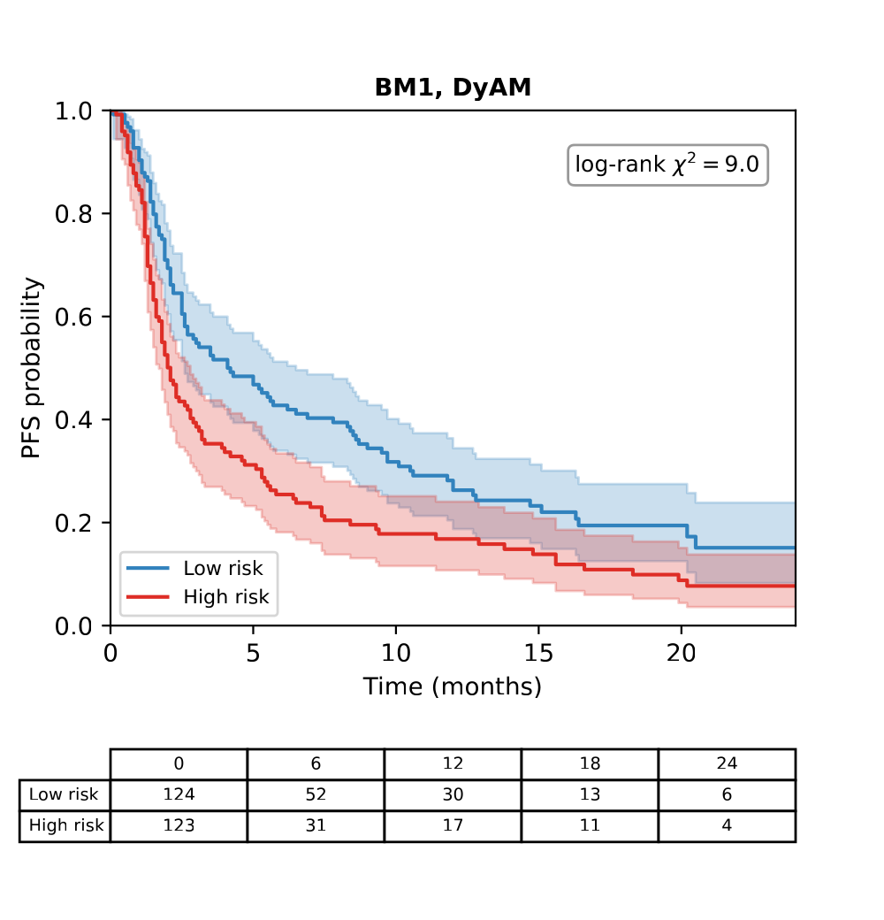
Figure 5A. Kaplan–Meier PFS curves, BM1, DyAM.
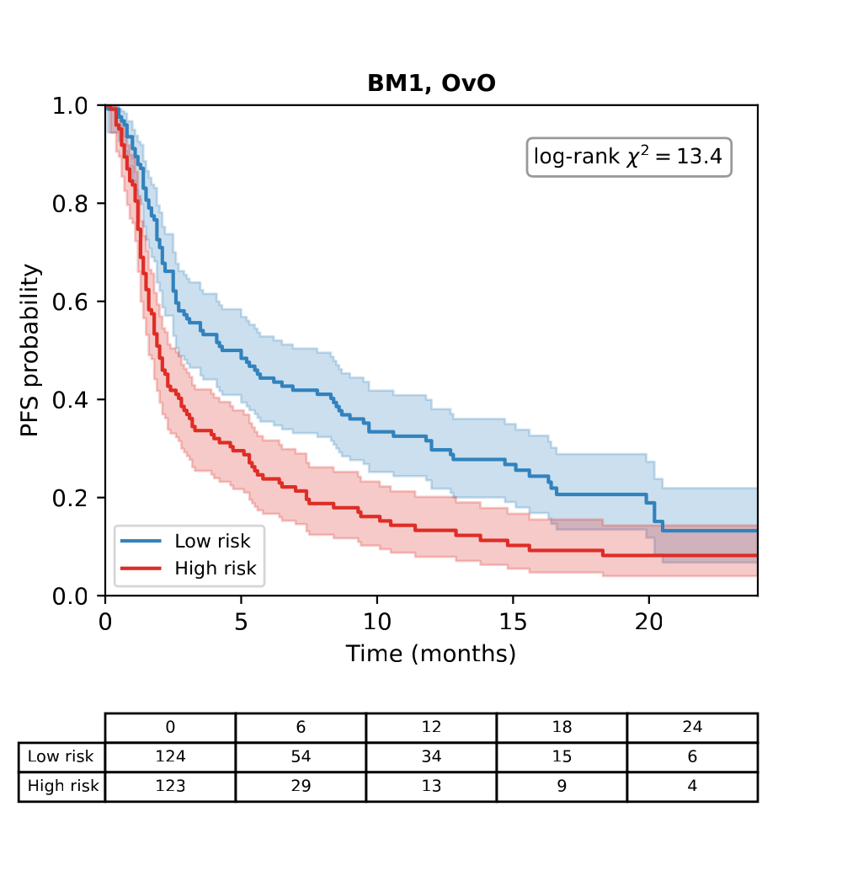
Figure 5B. Kaplan–Meier PFS curves, BM1, OvO.
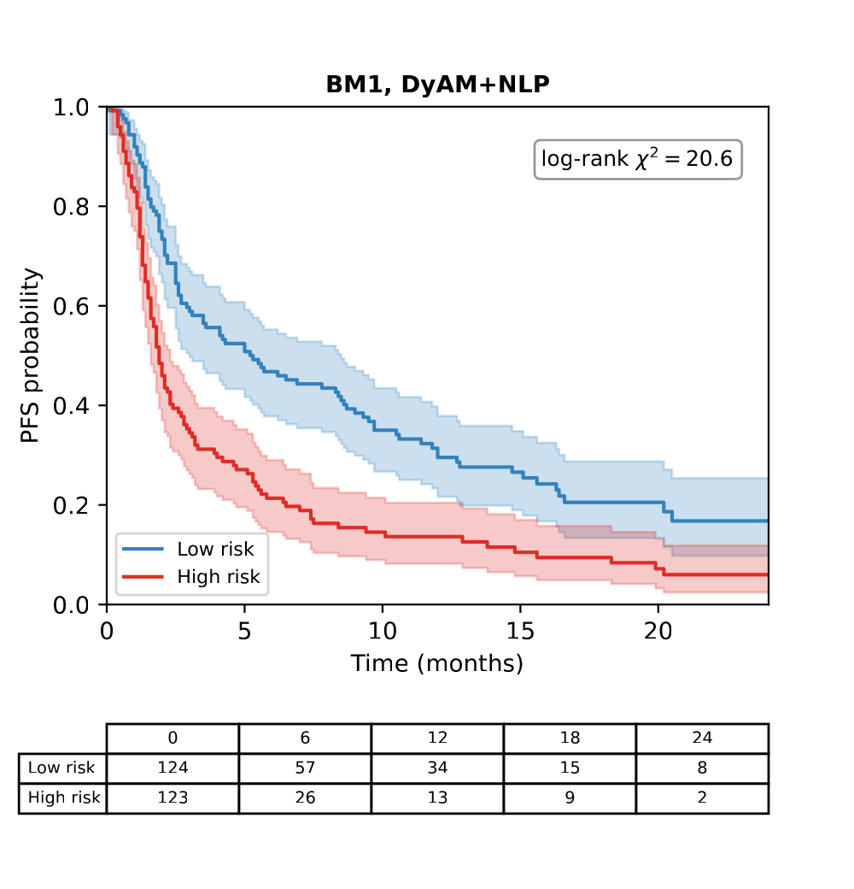
Figure 5C. Kaplan–Meier PFS curves, BM1, DyAM+NLP.
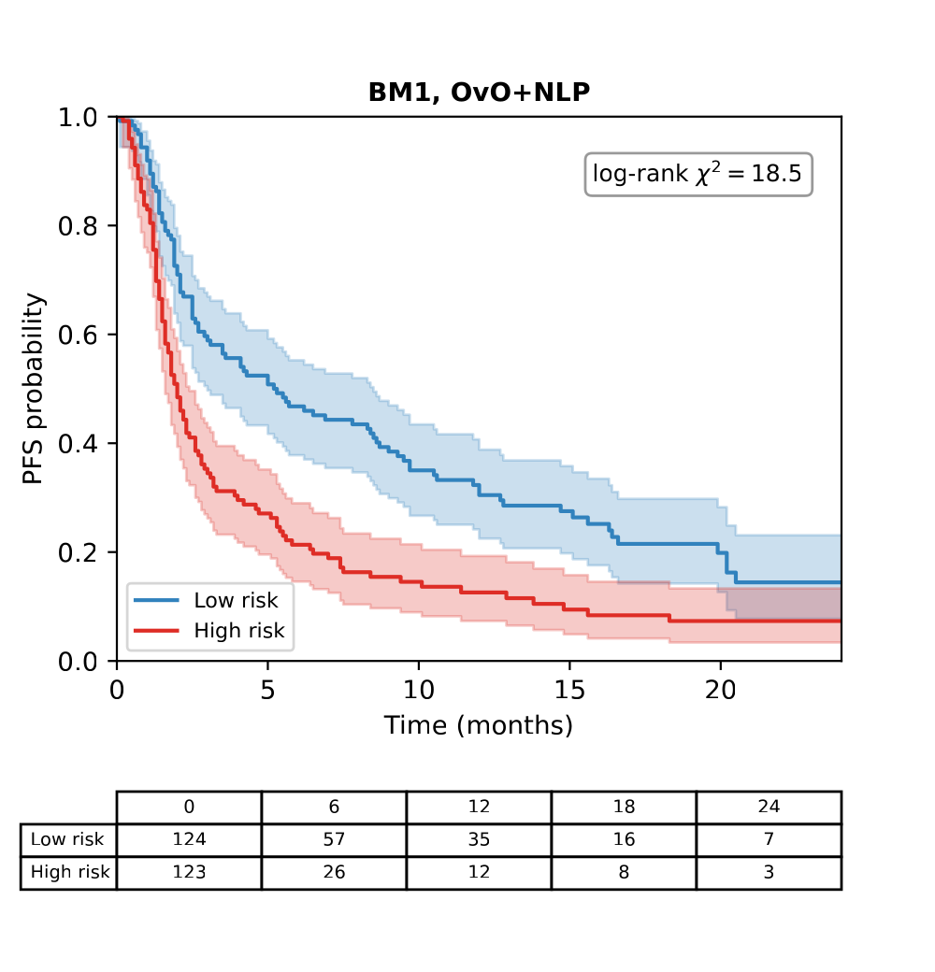
Figure 5D. Kaplan–Meier PFS curves, BM1, OvO+NLP (NLP added to the BM1 sources). Curves are computed from the 5-seed ensemble risk score (the mean over the five seeds of the standardised out-of-fold score) at the primary benchmark BM1 (Rad+IHC-G+Gen+PDL1); the log-rank statistics shown in the panels are those of the ensemble score (mean per-seed values in Table 10). Patients are stratified at the median risk score into high-risk (red) and low-risk (blue) groups, with number-at-risk tables.
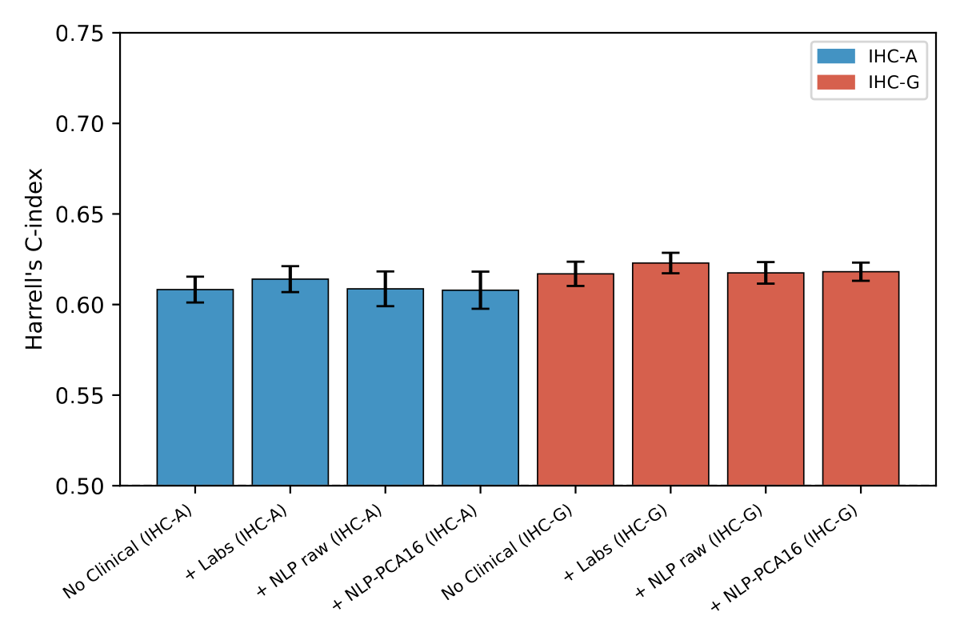
Figure 6A. Harrell's C-index for IHC-A and IHC-G arms.
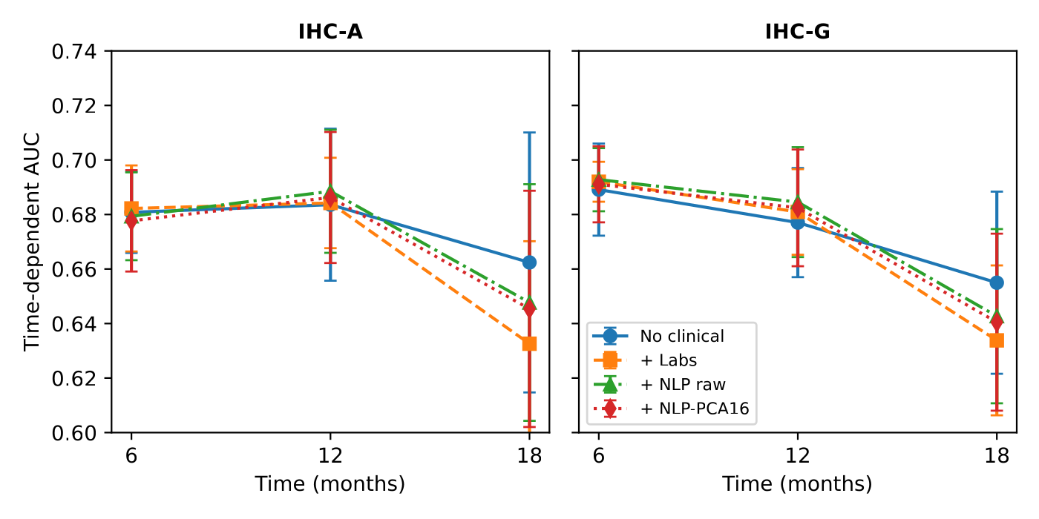
Figure 6B. Time-dependent AUC at 6, 12, and 18 months.
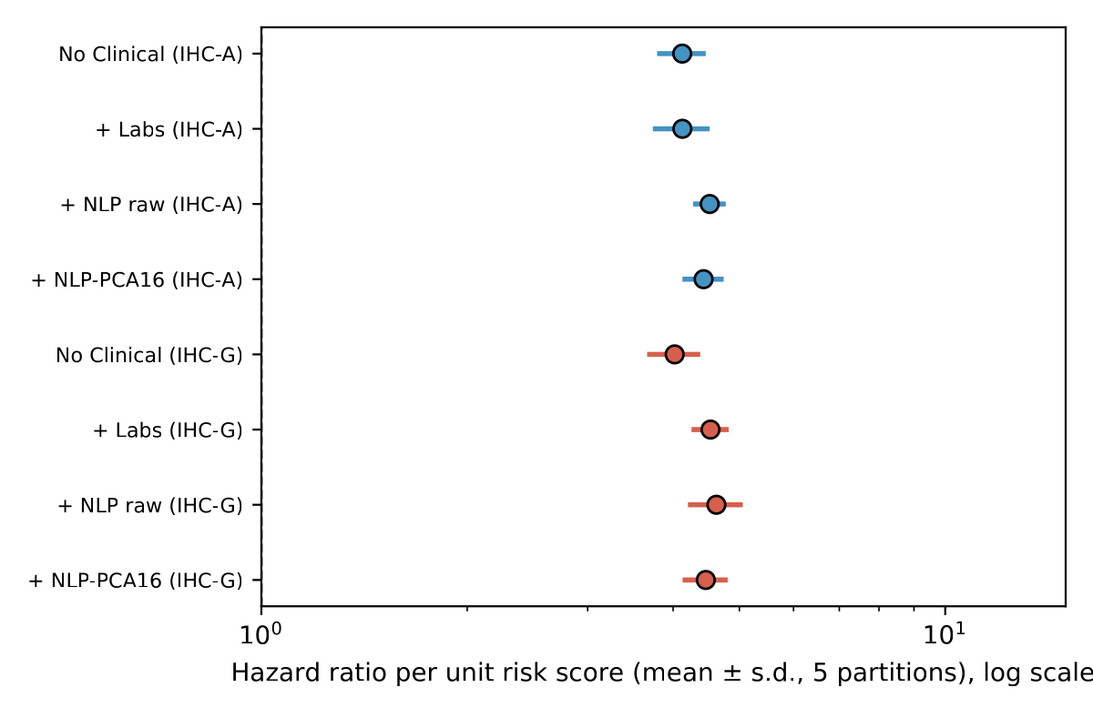
Figure 6C. Multivariate Cox proportional hazards ratio per unit of the fused risk score, adjusted for age, ECOG performance status, albumin, derived neutrophil-to-lymphocyte ratio, and liver metastases.
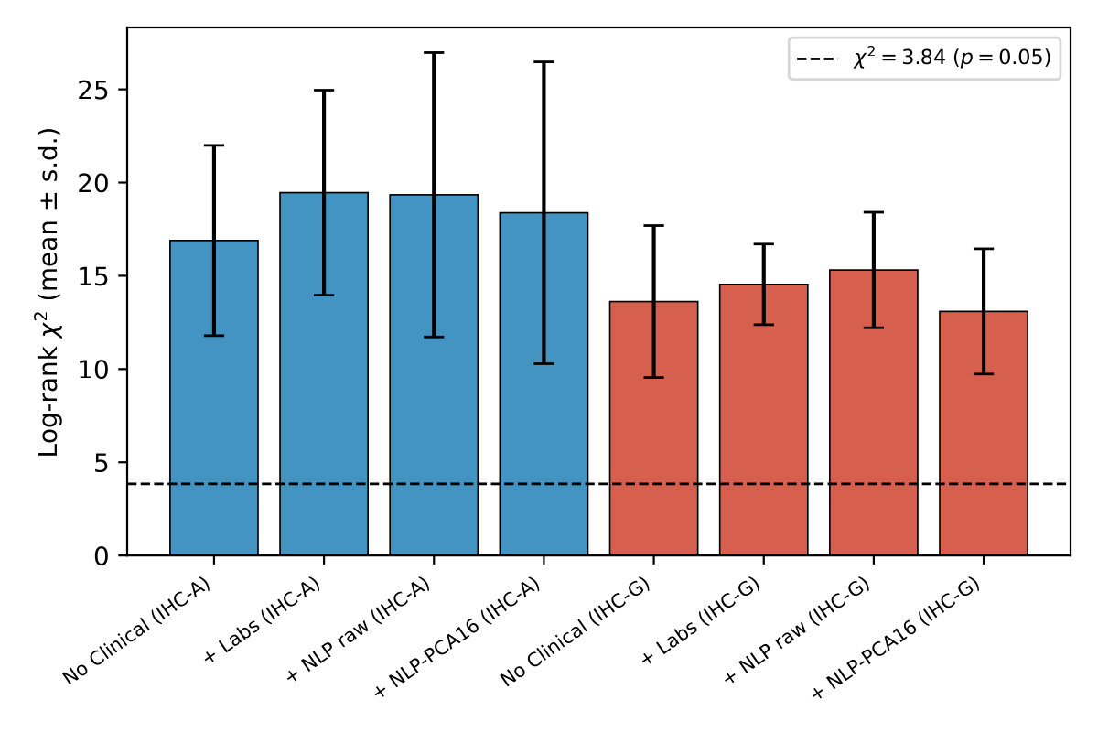
Figure 6D. Log-rank χ² of the dichotomised risk score. Points and bars are mean ± s.d. over 5 independent 10-fold partitions (Tables 8 and 9).

4. Discussion
We extended the DyAM multimodal attention framework with two contributions, a competitive (OvO) attention mechanism with fewer parameters and an NLP-based encoding of tabular clinical features, and evaluated them on response (AUC) and progression-free survival in a 247-patient cohort, with 5 seeds × 10-fold repeated cross-validation over 21 modality combinations. The experiments support four conclusions.
Fusing sources is what moves performance. The best single source was PD-L1 TPS (0.720 ± 0.012), followed by genomics (0.676), CT radiomics (0.672) and TMB (0.616). Fusing four sources raised the mean AUC to 0.763 ± 0.022 and adding the NLP-encoded clinical variables to 0.786 ± 0.017, 0.066 above PD-L1 TPS, the biomarker in routine use, and above the modest discrimination reported for PD-L1 and TMB [8,7]. The ensemble of the five partitions reached 0.799, close to the 0.80 reported for the original framework [15]. The same pattern held for survival: the association of the risk score with progression-free survival rose from a C-index of 0.567–0.587 for a single source to 0.588–0.627 for five to seven sources, and the 12-month time-dependent AUC from 0.596–0.661 to 0.657–0.709. In a leave-one-source-out analysis of OvO+NLP at the primary benchmark (Supplementary Note S4), removing any single source lowered the mean AUC in 4 or 5 of 5 seeds, by 0.013 (NLP-encoded clinical variables) to 0.029 (pathology), so every source contributed. Two endpoints and a leave-one-out analysis therefore point to the same conclusion, that the sources carry complementary information that attention-based fusion can combine.
The NLP encoding of clinical variables is better than numeric labs. This was the most consistent finding of the study. Replacing the 13 numeric laboratory and clinical values by their sentence embedding raised the mean AUC in all six comparisons that were made: +0.017 and +0.020 in the two pathology arms under cooperative attention, +0.014 and +0.024 in the two seven-source configurations under cooperative attention, and +0.022 and +0.019 in the same two configurations under OvO attention, so the benefit appeared with both attention mechanisms and both pathology encodings. A plausible reason is that a sentence embedding represents combinations of variables, for example advanced age together with low albumin and poor performance status, that are not explicit in a 13-dimensional numeric vector and that the attention module would otherwise have to learn from a small training set [16,17]; our data do not test this mechanism. The AUC with the encoding was also above that of the same sources without any clinical variable (+0.023 for DyAM and +0.014 for OvO at the primary benchmark), numeric labs were below that baseline in the arm analysis, and the general-purpose sentence encoder was better than the domain-specific BioClinBERT in all five partitions (Supplementary Note S2), so no clinical fine-tuning was needed. For survival, the NLP encodings gave higher hazard ratios than no clinical encoding in both arms (4.12 to 4.43–4.52 in IHC-A and 4.02 to 4.47–4.63 in IHC-G), and at the primary benchmark the log hazard ratio rose by +0.043 when the NLP encoding alone was added to cooperative attention.
OvO attention is the better fusion mechanism for many sources, with a quarter of the parameters. OvO had the higher mean AUC at the primary benchmark (0.771 against 0.763; four of five seeds) and by +0.019 to +0.021 at Rad+IHC-A+MutAmp, Rad+IHC-A+Gen+PDL1 and Rad+IHC-A+Gen+TMB+PDL1, and by +0.045 at TMB+PDL1, each in all five seeds. With the NLP encoding added as a source, OvO+NLP was above DyAM+NLP in all five seeds at four of the six configurations with five or more sources (+0.010 to +0.028), while using 1,242 trainable parameters against 4,969. A learning-curve analysis is compatible with a parameter-economy explanation: with about 89 training patients OvO+NLP reached 0.707 and DyAM+NLP 0.677, and the gap closed as the training set grew to 222 patients (0.785 and 0.786), with neither curve levelled off, so the smaller model helps most where data are scarcest, which is the situation of most multimodal clinical cohorts; we did not test the explanation by shrinking the cooperative attention matrix. The survival results favoured OvO more clearly than the AUC. In each of the eight configurations with five to seven sources, the mean log hazard ratio, the 12-month time-dependent AUC and the C-index of OvO were above those of cooperative attention. At the primary benchmark OvO with the NLP encoding had a higher log hazard ratio than DyAM in all five seeds (+0.070, patient-bootstrap interval 0.013 to 0.106, which excludes zero) and a higher C-index in all five seeds, and the ordering was reproduced in two other software environments (+0.070 and +0.076). OvO with the NLP encoding also gave the highest log hazard ratio (0.495 and 0.497 against 0.416 and 0.411 for DyAM, higher in all five seeds) and 12-month time-dependent AUC (0.708 and 0.704 against 0.675 and 0.678) in both configurations that contain labs. The cooperative model remained stronger in a few small configurations, such as IHC-G+Gen (−0.028 AUC) and radiomics-only, so the choice of mechanism may depend on the number and kind of sources; the two formulations coincide for a single source.
The approach is practical. Encoding a patient profile takes less than one second on CPU, needs no labelled clinical text, and can be applied to any structured electronic health record field that can be written as a sentence, so it can be transferred to other structured clinical datasets without a fine-tuned clinical language model. An availability vector, which tells the model which sources a patient has, raised the AUC by 0.015–0.017 in the two Gen configurations without PD-L1 but only by −0.003 to +0.008 in the others (Supplementary Note S5), and was not part of the main model.
Performance estimates. A harder evaluation gave lower values: training on the patients with the earliest CT accession numbers and testing on the later 124 (a proxy for time, since calendar dates were not available) gave AUCs of 0.703 (0.587–0.819) for OvO+NLP and 0.700 (0.587–0.812) for DyAM+NLP, with 0.707 and 0.678 at seven sources. The cross-validated AUCs are therefore best read as the performance under the repeated cross-validation protocol rather than the expected performance in new patients. Because about 60 variants were compared on the same 247 patients, the highest figures also include some selection, which we estimate at 0.014–0.031 AUC.
Limitations. First, this was a single-institution retrospective cohort, which may limit generalisability and introduce selection bias. Second, with n = 247 (62 responders) the 95% interval of an AUC is about ± 0.07, and the differences between models, which are 0.02 AUC or smaller at the primary benchmark, are smaller than this cohort can resolve (about 1,200–1,350 patients would be needed to detect 0.02 AUC with 80% power; Supplementary Note S3), so they are described by direction and magnitude. Third, results depended on the numerical environment (in a reproduction check the same code gave 0.798 on Linux and 0.788 on Windows), so all results are from one pinned environment, and the repeated-seed analyses use the same patients in every partition, so they quantify partition variability and not variability across patients. Fourth, the sentence encoder was used without fine-tuning on NSCLC clinical text. Fifth, calendar dates were not available, so temporal validation was approximated by CT accession order and covered two configurations. Finally, PD-L1 TPS was scored with the Sauter method, which may differ from the SP142 or 22C3 assays used elsewhere, so PD-L1-derived features should be interpreted with this in mind.

5. Conclusions
We extended the DyAM multimodal attention framework for ICI response prediction in NSCLC with a competitive (OvO) attention mechanism and an NLP-based encoding of structured clinical variables, and the repeated cross-validation (5 seeds × 10-fold) over 21 modality combinations supports four conclusions. First, fusing sources is what raises performance: four fused sources reached a mean AUC of 0.763 and, with the NLP encoding, 0.786 ± 0.017, against 0.720 for PD-L1 TPS alone, and the association of the risk score with progression-free survival grew with the number of fused sources. Second, the NLP encoding of clinical variables with a general-purpose sentence transformer exceeded numeric labs in all six comparisons (+0.017 and +0.020 AUC in the two pathology arms, +0.014 to +0.024 in the two seven-source configurations), without any fine-tuning on clinical text. Third, OvO attention, with about a quarter of the trainable parameters, had the higher mean AUC at the primary benchmark (0.771 against 0.763) and in most configurations fusing five or more sources, and it had a higher log hazard ratio, 12-month time-dependent AUC and C-index than cooperative attention in all eight configurations with five to seven sources; with the NLP encoding it gave the highest log hazard ratio (0.495 against 0.416, higher in all five seeds). Fourth, the approach is practical, since encoding a patient takes less than one second on CPU and needs no labelled clinical text. An order-based hold-out evaluation gave lower estimates (0.703 for OvO+NLP and 0.700 for DyAM+NLP), so cross-validated AUCs should not be read as expected performance in new patients. Validation in larger, multi-institutional cohorts with calendar dates is needed to confirm these findings and to establish their clinical utility for treatment selection.

Declarations
Author Contributions: Conceptualization, methodology, software, formal analysis, investigation, writing—original draft preparation, and writing—review and editing, V.H.H. The author has read and agreed to the published version of the manuscript.
Data Availability Statement: The code used in this study is available at https://github.com/hoanghuyvu2k/Multimodal-Lung-Cancer. Patient-level data are subject to institutional data-sharing agreements and available upon reasonable request.
Conflicts of Interest: The author declares no conflicts of interest.

References
1. Siegel RL, Giaquinto AN, Jemal A. Cancer Statistics, 2024. CA Cancer J Clin. 2024;74:12–49. doi:10.3322/caac.21820
2. Reck M, Rodríguez-Abreu D, Robinson AG, et al. Pembrolizumab versus Chemotherapy for PD-L1-Positive Non-Small-Cell Lung Cancer. N Engl J Med. 2016;375:1823–1833. doi:10.1056/NEJMoa1606774
3. Borghaei H, Paz-Ares L, Horn L, et al. Nivolumab versus Docetaxel in Advanced Nonsquamous Non-Small-Cell Lung Cancer. N Engl J Med. 2015;373:1627–1639. doi:10.1056/NEJMoa1507643
4. Sharma P, Hu-Lieskovan S, Wargo JA, Ribas A. Primary, Adaptive, and Acquired Resistance to Cancer Immunotherapy. Cell. 2017;168(4):707–723. doi:10.1016/j.cell.2017.01.017
5. Herbst RS, Baas P, Kim DW, et al. Pembrolizumab versus docetaxel for previously treated, PD-L1-positive, advanced non-small-cell lung cancer (KEYNOTE-010). Lancet. 2016;387:1540–1550. doi:10.1016/S0140-6736(15)01281-7
6. Hirsch FR, McElhinny A, Stanforth D, et al. PD-L1 Immunohistochemistry Assays for Lung Cancer: Results from Phase 1 of the Blueprint PD-L1 IHC Assay Comparison Project. J Thorac Oncol. 2017;12(2):208–222. doi:10.1016/j.jtho.2016.11.2228
7. Rizvi NA, Hellmann MD, Snyder A, et al. Mutational landscape determines sensitivity to PD-1 blockade in non-small cell lung cancer. Science. 2015;348:124–128. doi:10.1126/science.aaa1348
8. Lu S, Stein JE, Rimm DL, et al. Comparison of Biomarker Modalities for Predicting Response to PD-1/PD-L1 Checkpoint Blockade: A Systematic Review and Meta-analysis. JAMA Oncol. 2019;5(8):1195–1204. doi:10.1001/jamaoncol.2019.1549
9. Boehm KM, Khosravi P, Vanguri R, Gao J, Shah SP. Harnessing multimodal data integration to advance precision oncology. Nat Rev Cancer. 2022;22(2):114–126. doi:10.1038/s41568-021-00408-3
10. Bodalal Z, Trebeschi S, Nguyen-Kim TDL, et al. Radiogenomics: bridging imaging and genomics. Abdom Radiol. 2019;44:1960–1984. doi:10.1007/s00261-019-02028-w
11. Dercle L, Fronheiser M, Lu L, et al. Identification of Non-Small Cell Lung Cancer Sensitive to Systemic Cancer Therapies Using Radiomics. Clin Cancer Res. 2020;26:2151–2162. doi:10.1158/1078-0432.CCR-19-2942
12. Trebeschi S, Drago SG, Birkbak NJ, et al. Predicting Response to Cancer Immunotherapy Using Noninvasive Radiomic Biomarkers. Ann Oncol. 2019;30:998–1004. doi:10.1093/annonc/mdz108
13. Cheerla A, Gevaert O. Deep Learning with Multimodal Representation for Pancancer Prognosis Prediction. Bioinformatics. 2019;35:i446–i454. doi:10.1093/bioinformatics/btz342
14. Ma M, Ren J, Zhao L, et al. SMIL: Multimodal Learning with Severely Missing Modality. Proc AAAI Conf Artif Intell. 2021;35(3):2302–2310. doi:10.1609/aaai.v35i3.16330
15. Vanguri RS, Luo J, Aukerman AT, et al. Multimodal integration of radiology, pathology and genomics for prediction of response to PD-(L)1 blockade in patients with non-small cell lung cancer. Nat Cancer. 2022;3(10):1151–1164. doi:10.1038/s43018-022-00416-8
16. Reimers N, Gurevych I. Sentence-BERT: Sentence Embeddings using Siamese BERT-Networks. Proc 2019 Conf Empir Methods Nat Lang Process and 9th Int Jt Conf Nat Lang Process (EMNLP-IJCNLP). 2019:3982–3992. doi:10.18653/v1/D19-1410
17. Wang W, Wei F, Dong L, et al. MiniLM: Deep Self-Attention Distillation for Task-Agnostic Compression of Pre-Trained Transformers. Adv Neural Inf Process Syst (NeurIPS). 2020;33:5776–5788. https://arxiv.org/abs/2002.10957
18. Alsentzer E, Murphy JR, Boag W, et al. Publicly Available Clinical BERT Embeddings. Proc 2nd Clinical Nat Lang Process Workshop. 2019:72–78. doi:10.18653/v1/W19-1909
19. van Griethuysen JJM, Fedorov A, Parmar C, et al. Computational Radiomics System to Decode the Radiographic Phenotype. Cancer Res. 2017;77(21):e104–e107. doi:10.1158/0008-5472.CAN-17-0339
20. Cheng DT, Mitchell TN, Zehir A, et al. Memorial Sloan Kettering-Integrated Mutation Profiling of Actionable Cancer Targets (MSK-IMPACT): A Hybridization Capture-Based Next-Generation Sequencing Clinical Assay for Solid Tumor Molecular Oncology. J Mol Diagn. 2015;17(3):251–264. doi:10.1016/j.jmoldx.2014.12.006
21. Vaswani A, Shazeer N, Parmar N, et al. Attention Is All You Need. Adv Neural Inf Process Syst (NeurIPS). 2017;30:5998–6008. https://arxiv.org/abs/1706.03762
22. Rifkin R, Klautau A. In Defense of One-Vs-All Classification. J Mach Learn Res. 2004;5:101–141. https://www.jmlr.org/papers/v5/rifkin04a.html
23. DeLong ER, DeLong DM, Clarke-Pearson DL. Comparing the Areas under Two or More Correlated Receiver Operating Characteristic Curves: A Nonparametric Approach. Biometrics. 1988;44:837–845. doi:10.2307/2531595
24. Harrell FE, Lee KL, Mark DB. Multivariable Prognostic Models: Issues in Developing Models, Evaluating Assumptions and Adequacy, and Measuring and Reducing Errors. Stat Med. 1996;15:361–387. doi:10.1002/(SICI)1097-0258(19960229)15:4<361::AID-SIM168>3.0.CO;2-4
25. Uno H, Cai T, Tian L, Wei LJ. Evaluating Prediction Rules for t-Year Survivors With Censored Regression Models. J Am Stat Assoc. 2007;102(478):527–537. doi:10.1198/016214507000000149
26. Hung H, Chiang CT. Estimation methods for time-dependent AUC models with survival data. Can J Stat. 2010;38(1):8–26. doi:10.1002/cjs.10046
27. Mandrekar JN. Receiver Operating Characteristic Curve in Diagnostic Test Assessment. J Thorac Oncol. 2010;5(9):1315–1316. doi:10.1097/JTO.0b013e3181ec173d

