NLP-Augmented Multimodal Attention Fusion for Immunotherapy Response Prediction in Non-Small Cell Lung Cancer
Vũ Huy Hoàng^{1,*}
¹Master's student (Student ID 20242052M), School of Information and Communication Technology, Hanoi University of Science and Technology, Hanoi, Vietnam
Correspondence: Hoang.VH242052M@sis.hust.edu.vn; Tel.: +84-327-633-274

Abstract
Predicting response to immune checkpoint inhibitors (ICIs) in non-small cell lung cancer (NSCLC) remains challenging, as established biomarkers such as PD-L1 expression provide only modest discrimination. We extended the Dynamic Attention Multimodal (DyAM) fusion framework, which combines CT radiomics, pathology, genomics, PD-L1, and clinical data via learned per-modality attention, with two contributions: a competitive one-vs-others (OvO) attention mechanism with a smaller parameter count, and a natural language processing (NLP) encoding of 13 numeric clinical variables using a pretrained sentence transformer. In a 247-patient discovery cohort, 10-fold cross-validation across 21 modality combinations gave three main results. First, fusing sources gave the highest AUCs: four fused sources reached 0.798, +0.090 above PD-L1 TPS (0.708) alone, and the best model reached 0.824 (95% CI 0.765–0.883). Second, replacing numeric clinical labs by the NLP encoding raised the AUC in all six comparisons made (+0.018 to +0.033) with both attention mechanisms. Third, OvO attention with the NLP encoding gave the highest AUC at the primary benchmark (0.824, against 0.803 for cooperative attention with NLP and 0.783 for the original framework without clinical variables, +0.041) with about a quarter of the trainable parameters. For progression-free survival, the association of the risk score grew with the number of fused sources (C-index 0.56–0.59 for single sources, up to 0.66 with six or seven), and OvO with the NLP encoding gave the highest hazard ratio (6.64 versus 4.63 for cooperative attention), log-rank χ² (23.9 versus 17.6) and 12-month time-dependent AUC (0.733 versus 0.698) in the labs-replaced configuration of BM2.
Keywords: non-small cell lung cancer; immunotherapy response prediction; multimodal deep learning; attention mechanism; natural language processing; sentence embedding; survival analysis; radiomics

1. Introduction
Lung cancer remains the leading cause of cancer-related mortality worldwide, with non-small cell lung cancer (NSCLC) accounting for approximately 85% of cases [1]. The introduction of immune checkpoint inhibitors (ICIs) targeting the PD-1/PD-L1 axis has transformed treatment for advanced NSCLC, producing durable responses in a subset of patients [2,3]. However, only 20–30% of unselected patients achieve an objective response, and a substantial proportion experience primary or acquired resistance [3,4]. Reliable pre-treatment identification of likely responders remains an unresolved clinical need, as it would allow clinicians to prioritise ICI therapy for patients most likely to benefit and to consider alternative or combination strategies for those unlikely to respond.
PD-L1 tumour proportion score (TPS) and tumour mutational burden (TMB) are the most widely used biomarkers for ICI response prediction, but both have well-documented limitations: PD-L1 expression is spatially heterogeneous and assay-dependent, while TMB alone provides only modest discriminative performance [5–8]. This has motivated growing interest in multimodal approaches that integrate radiomics from CT imaging, pathomics from digitised histology, genomic alterations, and clinical variables into a single predictive model [9–13]. Such approaches are appealing because they can capture complementary aspects of tumour biology and host physiology that no single modality fully represents; however, they introduce new methodological challenges, including how to weight modalities of differing reliability and how to handle missing modalities without discarding patients [14]. The Dynamic Attention Multimodal (DyAM) framework [15] addresses these challenges through a learned, per-patient attention mechanism that adaptively weights each available modality and naturally accommodates missing data via masking, but its original formulation used only a cooperative (softmax/L1-normalised) attention mechanism and represented clinical variables as raw numeric features.
A largely unexplored question in this setting is how structured clinical variables — demographics, laboratory values, performance status — should be represented for fusion with imaging- and molecular-derived features. The conventional approach treats each clinical variable as an independent numeric input, requiring the model to learn inter-variable relationships (e.g., the joint prognostic implication of advanced age, low albumin, and poor performance status) from a relatively small training set. Recent advances in natural language processing (NLP) have shown that pretrained sentence encoders can represent complex, multi-attribute entities as dense embeddings that preserve semantic similarity [16,17], and domain-specific clinical language models have been developed for free-text clinical notes [18]. However, whether converting structured, tabular clinical variables into natural-language sentences and encoding them with a general-purpose sentence transformer can improve multimodal fusion performance — as opposed to encoding free-text clinical narratives — has not, to our knowledge, been systematically evaluated for ICI response prediction.
A second open question concerns the form of the attention mechanism used to combine modalities. Cooperative attention mechanisms, which normalise modality weights to sum to one via softmax or L1 normalisation, implicitly assume that all modalities contribute complementary, additive information. An alternative, competitive formulation — in which each modality's weight is determined relative to the others via a one-vs-others (OvO) comparison — may better capture settings where modalities are partially redundant and the most informative modality should dominate. Whether such a competitive mechanism improves performance, and under what modality configurations, remains untested in the multimodal ICI response prediction literature.
In this study, we extend the DyAM framework with two contributions and evaluate them on a discovery cohort of 247 patients with advanced NSCLC treated with ICIs. First, we introduce an OvO competitive attention variant (AttentionMatrixOvO) and compare it against the original cooperative attention across 21 modality combinations using 10-fold cross-validation, without and with the clinical encoding below. Second, we convert 13 numeric clinical variables into natural-language sentences and encode them with a pretrained sentence transformer (MiniLM-L6-v2), comparing this NLP-based representation against raw numeric encoding, a domain-specific clinical language model (BioClinBERT), and a PCA-compressed variant, evaluated using both binary classification (AUC) and survival analysis (Cox regression, Harrell's C-index, and Kaplan–Meier stratification). Because 247 patients are few for hypothesis tests of differences of the size at stake, we report the direction and magnitude of differences with the number of configurations favouring each model and interval estimates, and we state where they are within the confidence intervals. Together, these contributions aim to show that (i) competitive attention can match or exceed cooperative attention in multimodal fusion with fewer parameters, and in which configurations, and (ii) that NLP-based encoding of structured clinical data is a practical, fine-tuning-free alternative to conventional numeric representations for response prediction and survival risk stratification.

2. Materials and Methods

2.1. Study Design and Patient Cohort
This retrospective study used data from the MSK MIND (Multi-Modal Integration of Data) initiative at Memorial Sloan Kettering Cancer Center [15], comprising patients with advanced non-small cell lung cancer (NSCLC) treated with immune checkpoint inhibitor (ICI) therapy between 2017 and 2021. Inclusion criteria were: (i) histologically confirmed stage IIIB/IV NSCLC, (ii) first- or second-line ICI therapy (monotherapy or combination), and (iii) available baseline CT imaging. The study dataset comprised three independent cohorts: a discovery cohort (n = 247) used for model development and 10-fold cross-validation; a radiomics validation cohort (n = 50) and a pathology validation cohort (n = 71), both held out entirely for external evaluation. Patient characteristics are summarised in Table 1.
Table 1. Patient and cohort characteristics. The discovery cohort was used for model development with 10-fold cross-validation; validation cohorts were held out entirely. Validation column reports radiomics-evaluable; pathology-evaluable cohort values, separated by a semicolon. *ICI categories are recorded as independent flags and are not mutually exclusive (patients on combination therapy are counted in more than one row). PR/CR, partial/complete response; SD/PD, stable/progressive disease; PFS, progression-free survival.
Characteristic | Discovery (n = 247) | Validation (rad n=50; path n=71)
Age, years, mean (range) | 66.9 (38–93) | 64.4 (45–86); 68.0 (30–89)
Male sex, n (%) | 113 (45.7%) | 24 (48.0%); 32 (45.1%)
Adenocarcinoma | 184 (74.5%) | 39 (78.0%); 47 (66.2%)
Squamous cell | 36 (14.6%) | 7 (14.0%); 13 (18.3%)
Other / NOS | 27 (10.9%) | 4 (8.0%); 11 (15.5%)
ECOG 0 | 28 (11.3%) | 10 (20.0%); 8 (11.3%)
ECOG 1 | 194 (78.5%) | 39 (78.0%); 58 (81.7%)
ECOG ≥2 | 25 (10.1%) | 1 (2.0%); 5 (7.0%)
Anti-PD-1 therapy* | 197 (79.8%) | not recorded
Anti-PD-L1 therapy* | 50 (20.2%) | not recorded
Combination therapy* | 12 (4.9%) | not recorded
Response (PR/CR), label=0 | 62 (25.1%) | 11 (22.0%); 21 (29.6%)
No response (SD/PD), label=1 | 185 (74.9%) | 39 (78.0%); 50 (70.4%)
PFS events (progression/death), n (%) | 209 (84.6%) | 46 (92.0%); 55 (77.5%)
Median PFS, months (range) | 2.7 (0.1–49.1) | 2.6 (1.0–59.7); 2.7 (0.1–28.4)
CT radiomics available (PC/PL/LN) | 187 (75.7%) | 46/50; —
Pathology IHC available | 105 (42.5%) | —; 52/71
Genomics (NGS) available | 247 (100%) | —
PD-L1 TPS score available | 201 (81.4%) | —
Clinical labs (13 vars) available | 247 (100%) | —

The primary binary endpoint was best overall response to ICI therapy, classified as response (partial or complete response, PR/CR; label = 0) or no response (stable or progressive disease, SD/PD; label = 1). The response-to-no-response ratio in the discovery cohort was approximately 1:2.98, reflecting the known clinical rate of ICI non-response in unselected NSCLC populations [3]. A secondary time-to-event endpoint, progression-free survival (PFS), was defined as time from ICI initiation to disease progression or death from any cause. Patients without a recorded event were censored at the date of last follow-up.
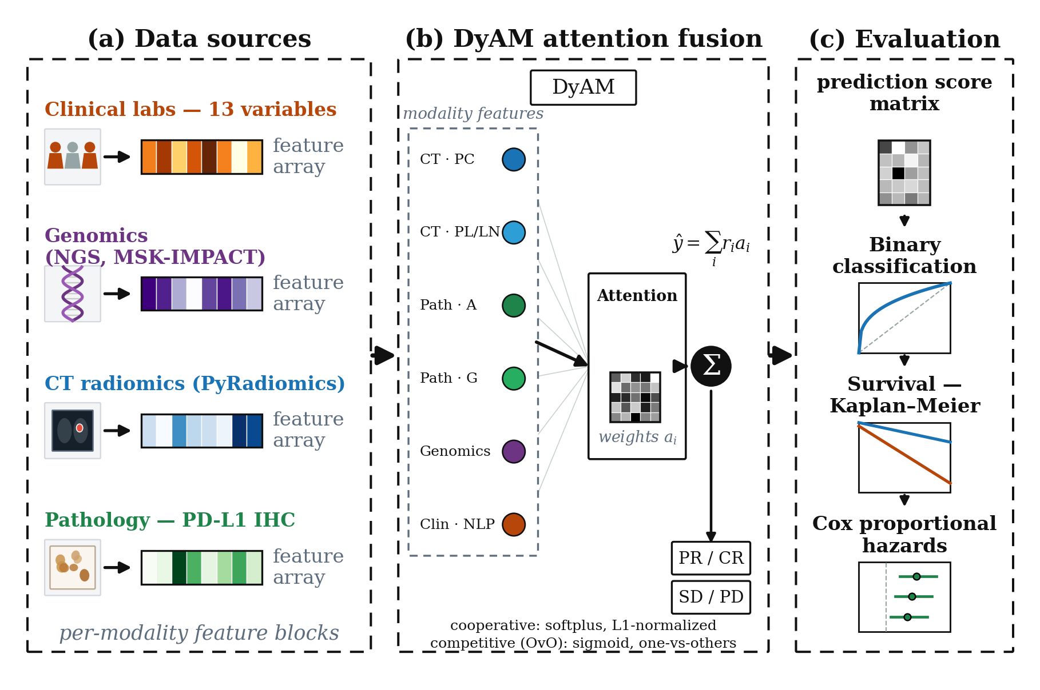
Figure 1. Study overview. (A) The discovery cohort (n = 247) and two validation cohorts (radiomics-evaluable, n = 50; pathology-evaluable, n = 71) provide six data sources: CT radiomics (modelled separately per lesion site: PC, PL, LN), pathology image texture (IHC-A or IHC-G), tumour genomics, PD-L1 TPS, and structured clinical variables, giving up to seven input modalities per model. (B) The DyAM architecture computes a per-modality risk score and combines modalities using either cooperative (AttentionMatrix) or competitive one-vs-others (AttentionMatrixOvO) attention to produce a fused risk prediction ŷ. (C) Models are evaluated on both binary response classification (AUC-ROC with DeLong 95% CI) and survival endpoints (Harrell's C-index, multivariate Cox hazard ratios, and Kaplan–Meier log-rank stratification).

2.2. Data Modalities
Six data sources were assembled for each patient (Table 2). Because CT radiomics is modelled separately per lesion site (PC, PL, LN) and the two pathology feature sets (IHC-A, IHC-G) are used as alternative arms rather than jointly, a single model receives up to seven input modalities. CT radiomics features were extracted from baseline scans using PyRadiomics [19], following the preprocessing of [15], at 1.0 mm isotropic spacing with a window of [−1350, 250] HU, yielding 1,688 features per lesion type. Lesions were categorised by anatomical site: primary tumour (PC), pleural lesion (PL), and lymph node (LN). Up to three lesions per site were included, ranked by volume. Pathology features were derived from PD-L1 immunohistochemistry (IHC) slides: IHC-A comprised 18 pixel-intensity aggregation features (area, mean intensity, percentiles), while IHC-G comprised 150 grey-level co-occurrence matrix (GLCM) texture features across six aggregation levels [15]. Genomic features (11 variables) included tumour mutational burden (TMB) and the status of eight driver mutations and amplifications derived from MSK-IMPACT targeted next-generation sequencing (NGS) [20]. The PD-L1 tumour proportion score (TPS) was obtained from clinical pathology reports (range 0–100%). Clinical laboratory features comprised 13 variables: age, smoking pack-years, Eastern Cooperative Oncology Group (ECOG) performance status, serum albumin, derived neutrophil-to-lymphocyte ratio (dNLR), initial tumour burden, brain and liver metastasis status, line of therapy, combination therapy, primary lung site, prior PD-L1 therapy, and adenocarcinoma histology.
For radiomics modalities, features with an intraclass correlation coefficient (ICC) below 0.15 across test–retest perturbation scans were removed (robustness filter), and features with a z-score exceeding 6 in any patient were flagged as outliers and excluded. All modalities except the NLP embedding (Section 2.3) were standardised with RobustScaler (median centring, IQR scaling). Missing modalities were handled via a binary indicator mask $m ∈ {\left\{0,1\right\}}^{N}$; masked modalities contribute zero attention and zero risk to the fused prediction (Section 2.4).
Table 2. Summary of data modalities used in this study. All feature counts are post-selection (after ICC and outlier filtering for radiomics).
Modality | Source | Features | Clinical meaning
CT Radiomics (PC, PL, LN) | PyRadiomics | ≤1,688 | Tumour shape, size, and texture from baseline CT
Pathology IHC-A | PD-L1 IHC slides | 18 | Pixel-intensity aggregation of PD-L1 expression
Pathology IHC-G | PD-L1 IHC slides | 150 | GLCM texture of PD-L1 signal
Genomics | MSK-IMPACT | 11 | TMB + driver mutation/amplification status
PD-L1 TPS | Pathology report | 1 | Tumour proportion score (0–100%)
Clinical labs | EHR | 13 | Demographics, performance status, labs
NLP embedding (new) | all-MiniLM-L6-v2 | 384 | Sentence embedding of clinical lab text
NLP-PCA16 (new) | PCA of NLP | 16 | PCA-compressed NLP (approx. 94% variance)

2.3. NLP Encoding of Tabular Clinical Features
Standard encoding of clinical variables as a 13-dimensional numeric vector treats each feature independently and loses contextual relationships between variables (e.g., an elderly patient with low albumin and ECOG 2 implies a different prognosis than the same values in isolation). To capture inter-feature context, we converted each patient's clinical profile into an English-language sentence and extracted a dense semantic embedding.
Text prompt construction. For each patient, the 13 clinical variables were formatted into a structured natural-language sentence, for example: “The patient is a 69-year-old. Smoking history in pack-years is 48.0. ECOG performance status is 1.0. Blood albumin concentration is 4.00. Derived neutrophil-to-lymphocyte ratio (dNLR) is 2.40. Initial tumor burden stands at 52.00. The patient is diagnosed with adenocarcinoma at the lung site. Metastatic status: without brain metastasis and without liver metastasis. Currently undergoing therapy line 2, utilizing combination therapy. The patient received prior PD-L1 immunotherapy.” Binary variables were expanded to descriptive phrases to exploit the pretrained vocabulary of the encoder.
Sentence encoder. Prompts were encoded with sentence-transformers/all-MiniLM-L6-v2 [16,17], a 6-layer transformer distilled for semantic sentence similarity and trained on over one billion sentence pairs. Each patient was represented as a 384-dimensional L2-normalised vector. No fine-tuning was performed; the model was applied in zero-shot transfer. We compared this general-purpose encoder against the domain-specific Bio_ClinicalBERT [18]; the domain-specific model performed inferiorly (ΔAUC = −0.012 versus MiniLM-L6-v2 in the IHC-A arm), consistent with its design for masked language modelling rather than sentence-similarity tasks.
Dimensionality reduction. Principal component analysis (PCA) was applied to the 384-dimensional embeddings, retaining the top 16 components (≈94% of variance explained). Both the raw 384-dimensional (NLP raw) and PCA-compressed 16-dimensional (NLP-PCA16) variants were evaluated. Crucially, the NLP modality was passed to the model with the RobustScaler disabled (no_scale=True), as the embeddings are already L2-normalised and scaling would distort the cosine-similarity geometry of the embedding space.
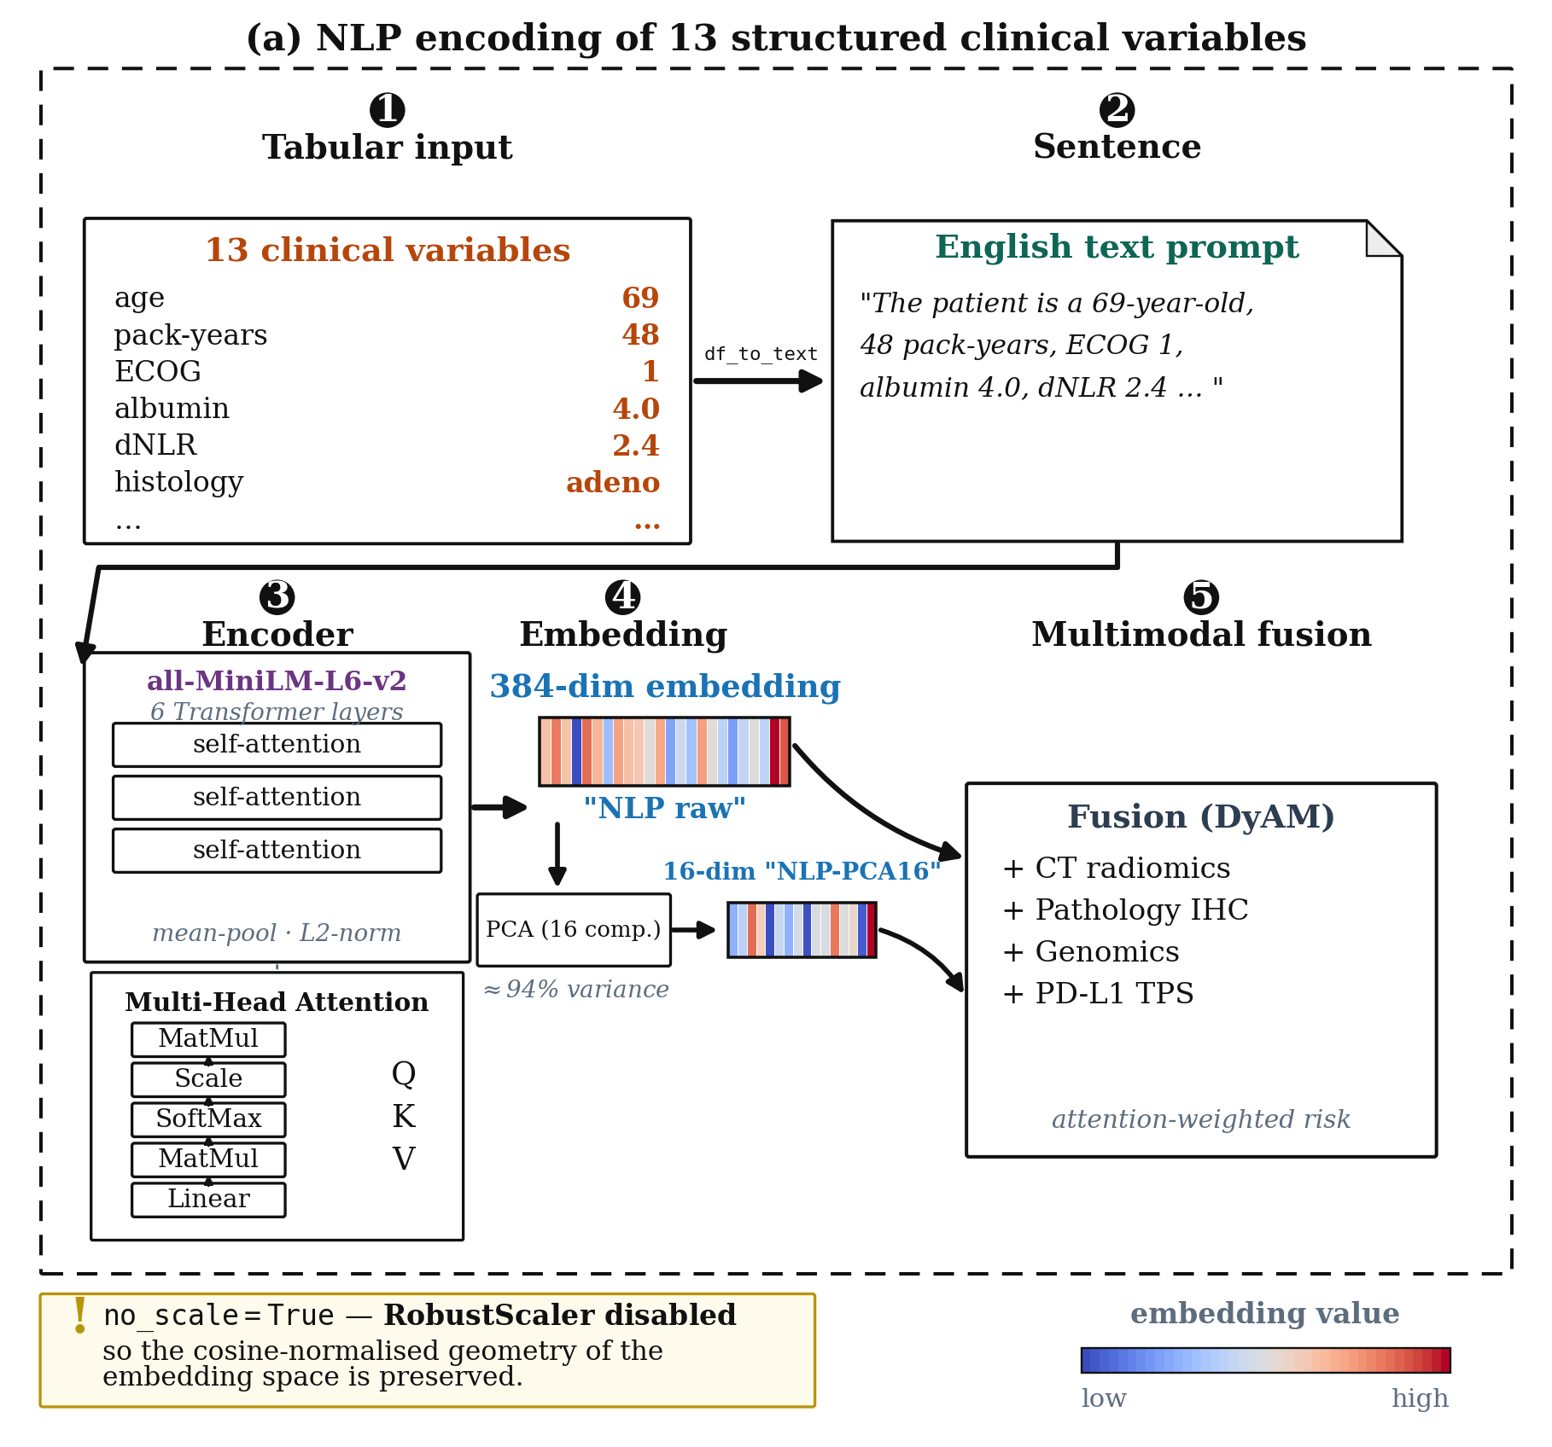
Figure 2. NLP-based encoding of structured clinical features. Thirteen numeric clinical variables per patient are converted into a natural-language sentence describing the patient's clinical profile (example shown), which is then encoded into a 384-dimensional embedding using a pretrained sentence transformer (all-MiniLM-L6-v2). The 384-dimensional embedding (“NLP raw”) is used directly, or further reduced to 16 dimensions via PCA (“NLP-PCA16”, retaining ≈94% of variance) prior to fusion with other modalities. no_scale=True is applied to NLP embeddings to preserve their cosine-normalised geometry.

2.4. Model Architecture
Dynamic Attention Multimodal (DyAM) model. The base model, DyAM [15], fuses $N$ modalities through per-modality risk scores and a learned attention mechanism, in the spirit of attention-based architectures broadly [21]. Let $x_{i} ∈ ℝ^{d_{i}}$ denote the feature vector of modality $i$ after optional RobustScaling. A scalar risk score is computed as:
$r_{i} = \tanh{W_{r,i}^{T} x_{i}}$ (1)
where $W_{r,i} ∈ ℝ^{d_{i}}$ are learnable weights. An attention score is produced by an $N × N$ grid of linear layers with softplus activation, $ℓ_{2}$-normalised by the modality vector norm:
$s_{i} = \frac{\operatorname{softplus}{W_{a,ij}^{T} x_{i}}}{{\left\|x_{i}\right\|}_{2}}$ (2)
Attention weights are obtained by L1 normalisation across modalities:
$a_{i} = \frac{s_{i}}{\sum_{j = 1}^{N}{s_{j}}}$ (3)
OvO competitive attention. We propose an alternative attention mechanism inspired by one-versus-others (OvO) classification [22], in which each modality competes against the mean score of all remaining modalities rather than sharing a fixed budget. The mean score of the $N − 1$ competing modalities is:
$μ_{−i} = \frac{1}{N − 1}\sum_{j ≠ i}{s_{j}}$ (4)
and the OvO attention score is:
${ovo}_{i} = σ\left(s_{i} − μ_{−i}\right), σ(z) = {\left(1 + e^{−z}\right)}^{−1}$ (5)
The sigmoid function yields an independent probability that modality $i$ outperforms the others, rather than a jointly normalised score. After applying the binary missingness mask $m_{i} ∈ \left\{0,1\right\}$, the weights are L1-normalised: $a_{i} = \frac{{ovo}_{i} · m_{i}}{\sum_{j}{{ovo}_{j} · m_{j}}}$.
Fused prediction and training. For both variants, the final risk prediction is:
$\hat{y} = \sum_{i = 1}^{N}{r_{i} · a_{i}}$ (6)
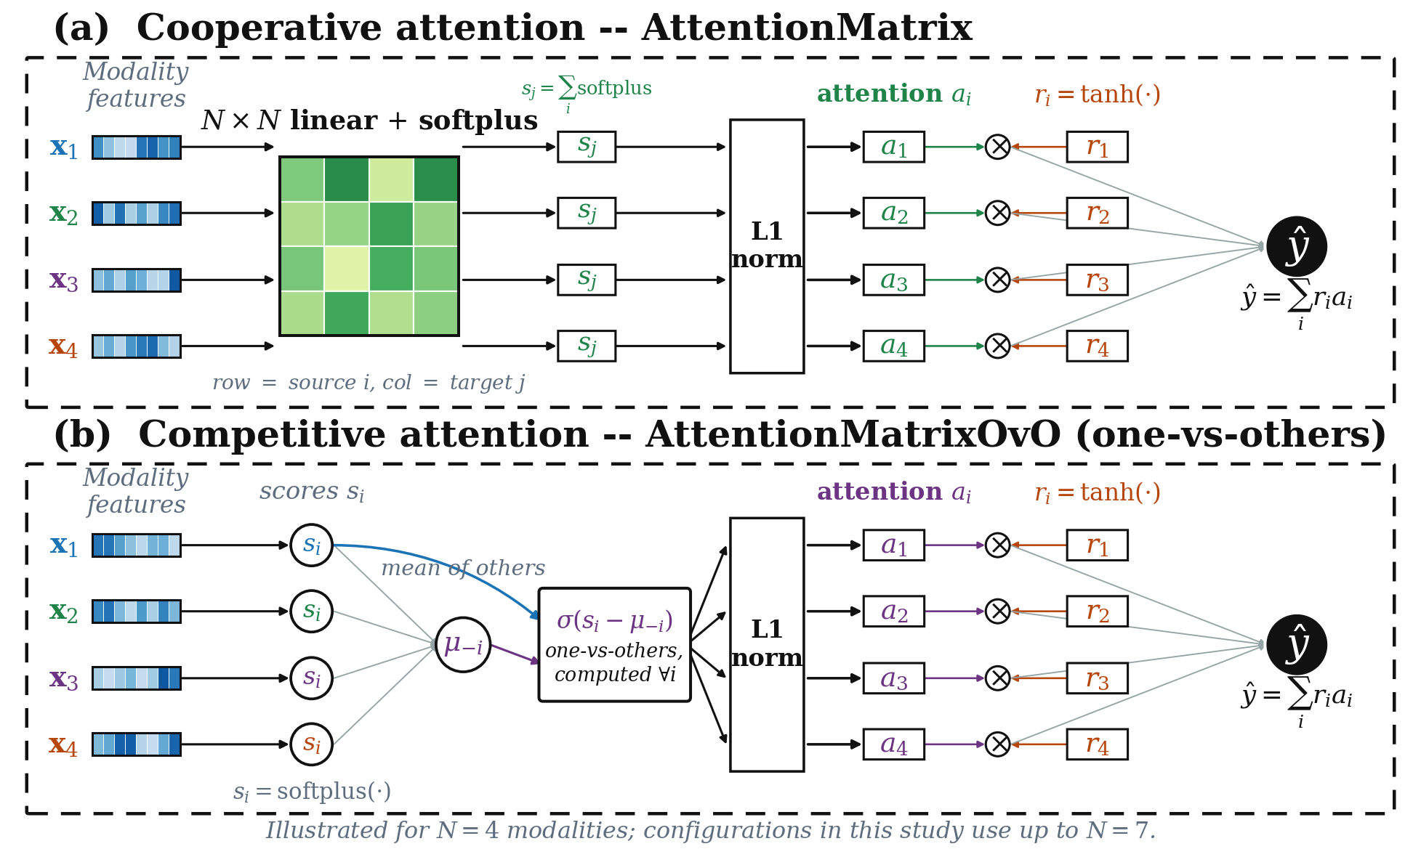
Figure 3. Architecture of the two attention mechanisms. Both variants compute a per-modality risk score $r_{i} = \tanh{W_{r,i}^{T} x_{i}}$ and produce the fused prediction $\hat{y} = \sum_{i}{r_{i} · a_{i}}$; they differ only in how the attention weights $a_{i}$ are obtained. (A) Cooperative attention (AttentionMatrix): an $N × N$ grid of linear layers with softplus activation produces pairwise scores that are column-summed into $s_{j}$ and L1-normalised so that the modalities share a fixed attention budget. (B) Competitive one-vs-others attention (AttentionMatrixOvO): each modality produces a single score $s_{i}$ that is compared against the mean score of the remaining modalities $μ_{−i}$ through a sigmoid, $σ\left(s_{i} − μ_{−i}\right)$, yielding an independent competitive weight before L1 normalisation. Heatmap bars denote modality feature vectors; the diagram is drawn for $N = 4$ modalities for clarity.
The model was trained with binary cross-entropy loss (BCEWithLogitsLoss) with automatic inverse-frequency class weighting to address the ≈1:3 class imbalance, an ℓ2 penalty on the weights (coefficient α = 0.001); the attention-norm penalty was disabled (β = 0). The Adam optimiser was used with a learning rate of 0.01 for 125 epochs. All experiments used 10-fold cross-validation (shuffled, not stratified) on the discovery cohort; predictions were pooled across held-out folds for AUC computation.

2.5. Statistical Analysis and Evaluation
Discriminative performance. Area under the receiver operating characteristic curve (AUC-ROC) was computed on pooled out-of-fold predictions from 10-fold cross-validation. Ninety-five percent confidence intervals (CIs) were estimated using the DeLong structural components method [23]. All results come from a single 10-fold cross-validation partition (seed 42, natural patient order, the protocol of the original publication). Differences between models are reported as the difference in AUC and the number of configurations favouring each model. Because the cohort is small, hypothesis tests were not used to claim that one model is superior; DeLong intervals are reported for single AUC values.
Survival analysis. Harrell's concordance index (C-index) [24] was computed from pooled out-of-fold risk scores against PFS, from the same partition. Multivariate Cox proportional hazards regression was fitted with the DyAM risk score as the primary predictor, adjusted for five clinical covariates: age, ECOG performance status, serum albumin, dNLR, and liver metastasis status; hazard ratios are per unit of risk score. Time-dependent AUC (6, 12 and 18 months; cumulative/dynamic estimator [25,26]) was computed from the same partition (scikit-survival 0.28 with numpy 2.5.4 in a separate environment, from the stored out-of-fold risk scores).
Kaplan–Meier survival stratification. Patients were dichotomised at the median risk score, and PFS curves for the two groups were compared with the log-rank test. The log-rank χ² is reported with χ² > 3.84 (p < 0.05) and χ² > 7.88 (p < 0.005) as reference values.
Software. All numerical results in Tables 3–8 were computed in one pinned environment (Linux under WSL2, Ubuntu 22.04; Python 3.8.15, PyTorch 1.8.1 (CPU), scikit-learn 0.24.2, scipy 1.6.3, numpy 1.20.3, pandas 1.2.5, and lifelines 0.26.0 for Kaplan–Meier, Cox regression and the C-index). In this environment the original DyAM code reproduced the single-partition AUC of the original publication at its primary benchmark (0.798) to within one patient pair. The same code and library versions on another operating system gave AUCs that differed in the second or third decimal place, so results were never compared across platforms; the radiomics feature selection used the original procedure, without removal of degenerate columns. The sentence-encoder embeddings (MiniLM-L6-v2 and Bio_ClinicalBERT) were computed once in a separate environment and cached, and time-dependent AUC was computed from the stored out-of-fold risk scores with scikit-survival 0.28 (numpy 2.5.4).

3. Results
All results are from a single 10-fold cross-validation partition of the 247-patient discovery cohort (natural patient order, the evaluation protocol of the original DyAM publication). Because one partition can favour any model by chance, differences of the size reported below are described by direction and magnitude, and the confidence intervals reflect patient sampling only.

3.1. Multimodal Fusion Outperforms Single-Modality Baselines
Within the DyAM framework, models restricted to a single data source achieved AUC values of 0.615 (TMB), 0.606 (pathology IHC-A), 0.701 (CT radiomics), 0.676 (genomics), and 0.708 (PD-L1 TPS) on the discovery cohort. PD-L1 TPS was the strongest individual predictor among the biomarkers of routine clinical use, although CT radiomics was comparable.
Fusing four data sources (CT radiomics, pathology IHC-A, genomics, and PD-L1 TPS) raised the AUC to 0.798 under the cooperative attention of the original framework, exceeding the best single source by 0.090 AUC; with IHC-G in place of IHC-A the four-source model reached 0.783 (95% CI 0.714–0.853), and adding NLP-encoded clinical variables raised the latter to 0.803 (0.738–0.868) (Table 6). Multimodal fusion is therefore the primary driver of predictive performance in this cohort, with no individual source approaching the discrimination of the fused model.

3.2. NLP Encoding Improves AUC over Numeric Clinical Labs
Seven clinical-encoding variants were evaluated under the DyAM architecture in two pathology arms (IHC-A: seven variants; IHC-G: four variants) (Tables 3 and 4; Figure 4). Relative to numeric labs, the NLP raw (384-dimensional) encoding raised the AUC by +0.018 in the IHC-A arm (0.786 vs. 0.768) and by +0.019 in the IHC-G arm (0.812 vs. 0.792); the PCA-compressed NLP variant gave +0.015 and +0.013. These differences are within the width of the confidence intervals (≈ 0.14), so they should be read as a consistent direction of modest size. The same advantage over numeric labs was present in the 21-configuration analysis for both attention mechanisms: in the two seven-source configurations that contain labs (Table 6, rows 20 and 21), replacing labs by the NLP encoding raised the AUC from 0.753 to 0.772 and from 0.781 to 0.803 for DyAM, and from 0.749 to 0.782 and from 0.794 to 0.824 for OvO.
Comparison with no clinical information. The NLP raw encoding was above the no-clinical baseline by +0.014 in both arms (IHC-A: 0.786 vs. 0.772; IHC-G: 0.812 vs. 0.797), whereas numeric labs were slightly below it (−0.004 and −0.005). At BM2 of the 21-configuration analysis NLP was above BM1 (the configuration without clinical variables) by +0.020 for DyAM and +0.024 for OvO. These gains are small relative to the confidence intervals, so we base the main claim on NLP versus numeric labs and regard the benefit of NLP encoding over omitting clinical variables as small and not established in this cohort.
Domain-specific versus general-purpose encoder. Bio_ClinicalBERT [18], PCA-compressed to 16 dimensions, reached 0.770 in the IHC-A arm, below MiniLM-L6-v2 with the same compression (0.784; ΔAUC = −0.014) and equal to numeric labs (0.768) and slightly below the no-clinical baseline (0.772; Supplementary Note S2), consistent with its pretraining objective of masked language modelling on clinical notes rather than semantic sentence similarity.
Combined encoding. Concatenating numeric labs and the NLP encoding as separate sources (8 sources in total) did not improve on the NLP encoding alone (IHC-A: 0.784 for NLP-PCA16 alone vs. 0.767 for labs + NLP-PCA16), and with n/N = 247/8 ≈ 31 the attention weights are poorly determined. NLP encoding is therefore used as a replacement for, rather than an addition to, numeric clinical features.
Table 3. AUC comparison across clinical encoding strategies — IHC-A arm. All models use the DyAM architecture with CT radiomics (PC, PL, LN), pathology IHC-A, genomics, and PD-L1 TPS as base modalities; clinical encoding is the varied factor. Values are the AUC of a single 10-fold cross-validation partition (n = 247) with the DeLong 95% confidence interval. ΔAUC is the difference relative to the no-clinical baseline and to numeric labs. n/a, not applicable. NLP, natural language processing; PCA, principal component analysis.
Model | AUC [95% CI] | Δ vs no clinical | Δ vs labs
No clinical (baseline) | 0.772 [0.707, 0.838] | (ref) | n/a
+ Labs (13-dim numeric) | 0.768 [0.701, 0.836] | −0.004 | n/a
+ NLP raw (384-dim) | 0.786 [0.725, 0.847] | +0.014 | +0.018
+ NLP-PCA16 (16-dim) | 0.784 [0.722, 0.845] | +0.012 | +0.015
+ Labs + NLP (combined) | 0.758 [0.690, 0.826] | −0.014 | −0.010
+ Labs + NLP-PCA16 (combined) | 0.767 [0.700, 0.834] | −0.005 | −0.001
+ BioClinBERT-PCA16 | 0.769 [0.705, 0.834] | −0.003 | +0.001

Table 4. AUC comparison across clinical encoding strategies — IHC-G arm. All models use the DyAM architecture with CT radiomics (PC, PL, LN), pathology IHC-G, genomics, and PD-L1 TPS as base modalities; clinical encoding is the varied factor. Values are the AUC of a single 10-fold cross-validation partition (n = 247) with the DeLong 95% confidence interval. ΔAUC is the difference relative to the no-clinical baseline and to numeric labs. n/a, not applicable. NLP, natural language processing; PCA, principal component analysis.
Model | AUC [95% CI] | Δ vs no clinical | Δ vs labs
No clinical (baseline) | 0.797 [0.731, 0.863] | (ref) | n/a
+ Labs (13-dim numeric) | 0.792 [0.726, 0.859] | −0.005 | n/a
+ NLP raw (384-dim) | 0.812 [0.753, 0.871] | +0.014 | +0.019
+ NLP-PCA16 (16-dim) | 0.805 [0.745, 0.866] | +0.008 | +0.013

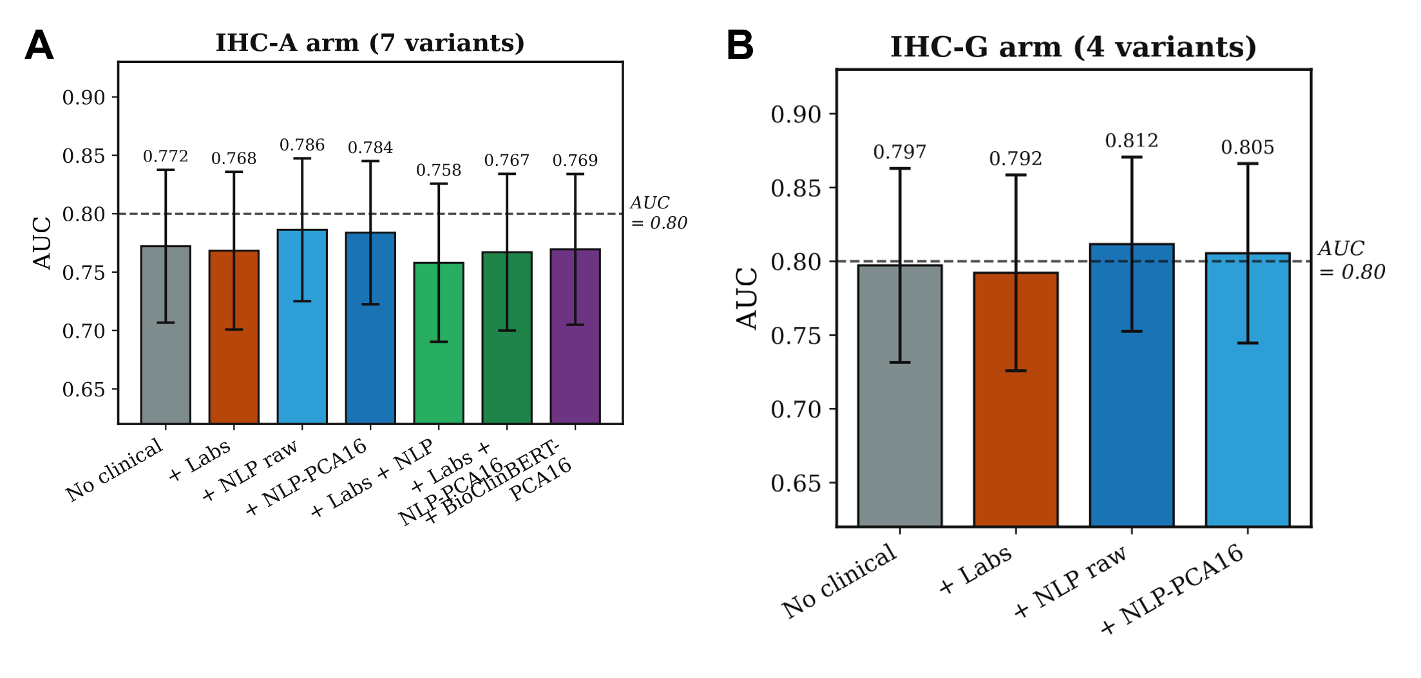
Figure 4. AUC comparison across clinical encoding strategies for (A) the IHC-A arm and (B) the IHC-G arm. Bars show the AUC of a single 10-fold cross-validation partition (n = 247); error bars denote the DeLong 95% confidence interval. The dashed horizontal line at AUC =0.80 marks the conventional threshold for clinically useful discrimination.

3.3. OvO Competitive Attention with NLP Encoding Gives the Highest Fusion AUC with a Simpler Parameterization
We compared the OvO attention variant with the original cooperative attention across the 21 modality combinations of the primary paper-matched configuration set, without and with the NLP-clinical encoding of Section 3.2 (Table 6). Because a cohort of 247 patients cannot support reliable hypothesis tests of differences of this size, we report the difference in AUC and the number of configurations favouring each model; we do not use significance testing to claim superiority.
Without NLP, the largest gains for OvO over the cooperative model were for TMB+PDL1 (ΔAUC = +6.29%, AUC 0.699 vs. 0.636) and PDL1+Gen (+2.27%, 0.716 vs. 0.693; Table 5); the cooperative model was higher for IHC-G+Gen (−3.27%) and Rad+IHC-A+Gen+PDL1 (−3.03%). At the primary benchmark (Rad+IHC-G+Gen+PDL1, BM1), OvO reached an AUC of 0.801 (95% CI 0.735–0.866) versus 0.783 (0.714–0.853) for the cooperative model (ΔAUC = +0.017).
Only the two configurations that contain numeric labs (rows 20 and 21) have an NLP counterpart in Table 6, because the NLP encoding replaces the labs source; the remaining configurations contain no clinical information, so their +NLP entries simply repeat the values without NLP. In the labs-replaced configuration of BM2 (Rad+IHC-G+Gen+PDL1 with NLP), DyAM+NLP reached 0.803 (0.738–0.868) and OvO+NLP 0.824 (0.765–0.883) (Δ = +0.021); the intervals overlap almost completely. Relative to BM1, which has the same sources without any clinical variable, the NLP gain was +0.020 for DyAM and +0.024 for OvO. OvO+NLP reached the highest AUC in this study (0.824), against 0.803 for DyAM+NLP and 0.798 for the cooperative model without NLP (Rad+IHC-A+Gen+PDL1, the primary result of the original publication, which this evaluation reproduced).
OvO's potential advantage is plausibly one of parameter economy: with the 384-dimensional NLP source in the BM2 configuration, the cooperative model has 4,969 trainable parameters against 1,242 for OvO. We did not test this explanation directly; for example, we did not shrink the cooperative attention matrix to see whether the gap closes. Table 5 gives the largest single-configuration differences and Table 6 the AUC of both attention mechanisms, with and without NLP, across all 21 configurations.
Table 5. Largest differences between OvO competitive attention and original cooperative attention among the 21 configurations, from a single 10-fold partition. ΔAUC is computed as OvO minus Original. The upper block lists configurations in which OvO was higher, the lower block those in which the original was higher. Bold denotes the higher AUC for each row. Differences from one partition can favour either model by chance. Gen, genomics; Rad, CT radiomics; IHC-A/G, immunohistochemistry variants; PDL1, PD-L1 TPS score.
Configuration | Orig. | OvO | Δ
TMB+PDL1 | 0.636 | 0.699 | +6.29%
PDL1+Gen | 0.693 | 0.716 | +2.27%
Rad+IHC-G+Gen+PDL1 | 0.783 | 0.801 | +1.71%
Rad+IHC-G+Gen+PDL1+Labs | 0.781 | 0.794 | +1.22%
Rad+IHC-A+Gen+TMB+PDL1 | 0.778 | 0.780 | +0.24%
Rad+IHC-G | 0.713 | 0.702 | −1.10%
Rad-LU | 0.699 | 0.684 | −1.53%
Rad+IHC-A+MutAmp | 0.782 | 0.767 | −1.54%
Rad+IHC-A+Gen+PDL1 | 0.798 | 0.768 | −3.03%
IHC-G+Gen | 0.756 | 0.723 | −3.27%

Table 6. AUC across all 21 paper-matched modality combinations for cooperative attention (DyAM) and OvO competitive attention, each without and with NLP-clinical encoding, from a single 10-fold cross-validation partition (natural patient order, the protocol of the original DyAM publication; n = 247). k is the number of fused input sources (CT radiomics contributes one source per lesion site). For k = 1 OvO reduces algebraically to the cooperative formulation, hence the identical values. Configurations 8, 11, 18 and 21 are the primary benchmarks BM4, BM3, BM1 and BM2. The NLP encoding replaces the numeric labs source, so only the two configurations that contain labs (20 and 21) differ between the models with and without NLP; the other configurations contain no clinical source, and their +NLP values repeat those of the models without NLP (not in bold). Bold marks the highest value in each row.
# | Configuration | k | DyAM | OvO | DyAM+NLP | OvO+NLP
1 | TMB | 1 | 0.615 | 0.615 | 0.615 | 0.615
2 | PDL1 | 1 | 0.708 | 0.708 | 0.708 | 0.708
3 | IHC-A | 1 | 0.606 | 0.606 | 0.606 | 0.606
4 | Gen | 1 | 0.676 | 0.676 | 0.676 | 0.676
5 | Rad | 3 | 0.701 | 0.700 | 0.701 | 0.700
6 | Rad-LU | 4 | 0.699 | 0.684 | 0.699 | 0.684
7 | TMB+PDL1 | 2 | 0.636 | 0.699 | 0.636 | 0.699
8 | PDL1+Gen (BM4) | 2 | 0.693 | 0.716 | 0.693 | 0.716
9 | Rad+IHC-A | 4 | 0.681 | 0.672 | 0.681 | 0.672
10 | Rad+IHC-G | 4 | 0.713 | 0.702 | 0.713 | 0.702
11 | Rad+Gen (BM3) | 4 | 0.759 | 0.755 | 0.759 | 0.755
12 | IHC-A+Gen | 2 | 0.715 | 0.716 | 0.715 | 0.716
13 | IHC-G+Gen | 2 | 0.756 | 0.723 | 0.756 | 0.723
14 | Rad+IHC-A+Gen | 5 | 0.754 | 0.748 | 0.754 | 0.748
15 | Rad+IHC-G+Gen | 5 | 0.782 | 0.774 | 0.782 | 0.774
16 | Rad+IHC-A+MutAmp | 6 | 0.782 | 0.767 | 0.782 | 0.767
17 | Rad+IHC-A+Gen+PDL1 | 6 | 0.798 | 0.768 | 0.798 | 0.768
18 | Rad+IHC-G+Gen+PDL1 (BM1) | 6 | 0.783 | 0.801 | 0.783 | 0.801
19 | Rad+IHC-A+Gen+TMB+PDL1 | 7 | 0.778 | 0.780 | 0.778 | 0.780
20 | Rad+IHC-A+Gen+PDL1+Labs | 7 | 0.753 | 0.749 | 0.772 | 0.782
21 | Rad+IHC-G+Gen+PDL1+Labs (BM2) | 7 | 0.781 | 0.794 | 0.803 | 0.824

3.4. Survival Analysis Across the 21 Configurations
For every one of the 21 configurations of Table 6 we evaluated the association of the out-of-fold risk score with progression-free survival (PFS) in the same single partition, with the same models (DyAM and OvO, and their +NLP versions in the two configurations that contain labs): Harrell's C-index and the multivariate Cox hazard ratio, adjusted for age, ECOG performance status, serum albumin, dNLR and liver metastasis status (Table 7), the log-rank χ² at the median risk score and the time-dependent AUC (Table 8, Figure 6; the 6- and 18-month values are in the Supplementary Tables).
Survival association grows with the number of fused sources. Single-source scores had a C-index of 0.56–0.59 and a 12-month time-dependent AUC of 0.58–0.66 (TMB, PD-L1, IHC-A, genomics), and the log-rank χ² was 1.9 for IHC-A and 6.1–16.8 for the other three. With six or seven fused sources the C-index was 0.59–0.66, the 12-month time-dependent AUC 0.69–0.77, the hazard ratio per unit of risk score 4.4–8.6, and the log-rank χ² 12.1–33.0, all above the p < 0.005 threshold of 7.88. The strongest association among all configurations was obtained by cooperative attention at Rad+IHC-A+Gen+PDL1 (configuration 17; C-index 0.655, hazard ratio 8.59, χ² = 33.0, 12-month time-dependent AUC 0.774), the configuration in which the cooperative model also had its highest AUC.
OvO attention with the NLP encoding at the primary benchmarks. At BM1 (Rad+IHC-G+Gen+PDL1, configuration 18), OvO had a higher hazard ratio (5.83 against 5.27) and log-rank χ² (20.3 against 17.4) than cooperative attention, and OvO with the NLP encoding reached the highest values of the four models in the labs-replaced configuration of BM2 (configuration 21: hazard ratio 6.64 against 4.63, 5.17 and 6.13 for DyAM, DyAM+NLP and OvO; χ² = 23.9 against 17.6, 19.2 and 20.9), with a 12-month time-dependent AUC of 0.733 against 0.698, 0.702 and 0.709 and an 18-month value of 0.690 against 0.650 for DyAM+NLP. In configuration 20 (IHC-A in place of IHC-G) the same ordering held for the hazard ratio (6.60 for OvO with NLP, against 4.70, 5.80 and 5.44). The C-index did not follow this order (0.633 for OvO with NLP and 0.646 for DyAM at BM1), so the higher hazard ratio reflects stronger separation of the risk groups rather than better ranking of patients. Across the other configurations the survival metrics of the two attention mechanisms were close, each being higher in some rows (Tables 7 and 8); OvO had the higher hazard ratio at, for example, PDL1+Gen (configuration 8: 3.01 against 2.70), Rad+Gen (5.00 against 4.74), TMB+PDL1 (3.00 against 2.17) and Rad+IHC-A+Gen+TMB+PDL1 (7.04 against 4.88).
Kaplan–Meier curves. Figure 5 shows the curves at BM1 for the four models; the high- and low-risk groups separated in all four (log-rank χ² = 17.4, 20.3, 19.2 and 23.9 for DyAM, OvO, DyAM+NLP and OvO+NLP).
Clinical encodings in the two pathology arms. The comparison of clinical encodings (no clinical information, numeric labs, NLP raw, NLP-PCA16, and Bio_ClinicalBERT) in the IHC-A and IHC-G arms (Supplementary Tables and Figures) gave hazard ratios of 5.0–6.3, C-indices of 0.62–0.64 and log-rank χ² above 17 for every variant, with no consistent ordering of the encodings; numeric labs gave the highest C-index in both arms (IHC-A: 0.631 against 0.623 for NLP raw; IHC-G: 0.644 against 0.627). The NLP encoding therefore matched numeric labs on these survival metrics, and its advantage in this study is on the response endpoint (Section 3.2).
Table 7. Progression-free survival association of the fused risk score across the 21 configurations: Harrell's C-index and the Cox hazard ratio per unit of risk score (adjusted for age, ECOG, albumin, dNLR and liver metastases). Single 10-fold partition (natural patient order, n = 247; 209 events, median PFS 2.7 months), the same models and partition as Table 6. As there, the NLP encoding replaces the numeric labs, so only configurations 20 and 21 differ between the models with and without NLP; the +NLP entries of the other configurations repeat the values without NLP (not in bold). For k = 1 OvO reduces to the cooperative formulation. Bold marks the highest value in each row and metric.
# | Configuration | k | C-index DyAM | C-index OvO | C-index DyAM+NLP | C-index OvO+NLP | Cox HR DyAM | Cox HR OvO | Cox HR DyAM+NLP | Cox HR OvO+NLP
1 | TMB | 1 | 0.566 | 0.566 | 0.566 | 0.566 | 3.67 | 3.67 | 3.67 | 3.67
2 | PDL1 | 1 | 0.580 | 0.580 | 0.580 | 0.580 | 2.15 | 2.15 | 2.15 | 2.15
3 | IHC-A | 1 | 0.555 | 0.555 | 0.555 | 0.555 | 1.93 | 1.93 | 1.93 | 1.93
4 | Gen | 1 | 0.586 | 0.586 | 0.586 | 0.586 | 3.28 | 3.28 | 3.28 | 3.28
5 | Rad | 3 | 0.582 | 0.577 | 0.582 | 0.577 | 2.82 | 2.79 | 2.82 | 2.79
6 | Rad-LU | 4 | 0.566 | 0.569 | 0.566 | 0.569 | 2.91 | 2.99 | 2.91 | 2.99
7 | TMB+PDL1 | 2 | 0.564 | 0.582 | 0.564 | 0.582 | 2.17 | 3.00 | 2.17 | 3.00
8 | PDL1+Gen (BM4) | 2 | 0.589 | 0.602 | 0.589 | 0.602 | 2.70 | 3.01 | 2.70 | 3.01
9 | Rad+IHC-A | 4 | 0.584 | 0.585 | 0.584 | 0.585 | 2.71 | 2.65 | 2.71 | 2.65
10 | Rad+IHC-G | 4 | 0.591 | 0.586 | 0.591 | 0.586 | 2.76 | 2.71 | 2.76 | 2.71
11 | Rad+Gen (BM3) | 4 | 0.605 | 0.609 | 0.605 | 0.609 | 4.74 | 5.00 | 4.74 | 5.00
12 | IHC-A+Gen | 2 | 0.603 | 0.608 | 0.603 | 0.608 | 3.59 | 3.75 | 3.59 | 3.75
13 | IHC-G+Gen | 2 | 0.622 | 0.612 | 0.622 | 0.612 | 4.04 | 3.59 | 4.04 | 3.59
14 | Rad+IHC-A+Gen | 5 | 0.619 | 0.619 | 0.619 | 0.619 | 5.68 | 5.45 | 5.68 | 5.45
15 | Rad+IHC-G+Gen | 5 | 0.630 | 0.628 | 0.630 | 0.628 | 5.42 | 4.83 | 5.42 | 4.83
16 | Rad+IHC-A+MutAmp | 6 | 0.621 | 0.592 | 0.621 | 0.592 | 4.70 | 4.40 | 4.70 | 4.40
17 | Rad+IHC-A+Gen+PDL1 | 6 | 0.655 | 0.620 | 0.655 | 0.620 | 8.59 | 6.29 | 8.59 | 6.29
18 | Rad+IHC-G+Gen+PDL1 (BM1) | 6 | 0.646 | 0.640 | 0.646 | 0.640 | 5.27 | 5.83 | 5.27 | 5.83
19 | Rad+IHC-A+Gen+TMB+PDL1 | 7 | 0.624 | 0.620 | 0.624 | 0.620 | 4.88 | 7.04 | 4.88 | 7.04
20 | Rad+IHC-A+Gen+PDL1+Labs | 7 | 0.625 | 0.619 | 0.621 | 0.621 | 4.70 | 5.44 | 5.80 | 6.60
21 | Rad+IHC-G+Gen+PDL1+Labs (BM2) | 7 | 0.640 | 0.637 | 0.630 | 0.633 | 4.63 | 6.13 | 5.17 | 6.64

Table 8. Kaplan–Meier log-rank statistic (patients dichotomised at the median risk score; χ² > 3.84 corresponds to p < 0.05) and cumulative/dynamic time-dependent AUC at 12 months (Uno estimator) across the 21 configurations. Single 10-fold partition (natural patient order, n = 247; 209 events, median PFS 2.7 months), the same models and partition as Table 6. As there, the NLP encoding replaces the numeric labs, so only configurations 20 and 21 differ between the models with and without NLP; the +NLP entries of the other configurations repeat the values without NLP (not in bold). For k = 1 OvO reduces to the cooperative formulation. Bold marks the highest value in each row and metric. Time-dependent AUC at 6 and 18 months is in the Supplementary Tables.
# | Configuration | k | Log-rank χ² DyAM | Log-rank χ² OvO | Log-rank χ² DyAM+NLP | Log-rank χ² OvO+NLP | tdAUC 12 mo DyAM | tdAUC 12 mo OvO | tdAUC 12 mo DyAM+NLP | tdAUC 12 mo OvO+NLP
1 | TMB | 1 | 8.5 | 8.5 | 8.5 | 8.5 | 0.596 | 0.596 | 0.596 | 0.596
2 | PDL1 | 1 | 16.8 | 16.8 | 16.8 | 16.8 | 0.662 | 0.662 | 0.662 | 0.662
3 | IHC-A | 1 | 1.9 | 1.9 | 1.9 | 1.9 | 0.577 | 0.577 | 0.577 | 0.577
4 | Gen | 1 | 6.1 | 6.1 | 6.1 | 6.1 | 0.661 | 0.661 | 0.661 | 0.661
5 | Rad | 3 | 5.0 | 7.3 | 5.0 | 7.3 | 0.651 | 0.646 | 0.651 | 0.646
6 | Rad-LU | 4 | 3.7 | 7.6 | 3.7 | 7.6 | 0.612 | 0.603 | 0.612 | 0.603
7 | TMB+PDL1 | 2 | 11.6 | 20.8 | 11.6 | 20.8 | 0.589 | 0.617 | 0.589 | 0.617
8 | PDL1+Gen (BM4) | 2 | 18.8 | 20.8 | 18.8 | 20.8 | 0.630 | 0.654 | 0.630 | 0.654
9 | Rad+IHC-A | 4 | 11.2 | 13.8 | 11.2 | 13.8 | 0.613 | 0.642 | 0.613 | 0.642
10 | Rad+IHC-G | 4 | 13.9 | 13.3 | 13.9 | 13.3 | 0.636 | 0.623 | 0.636 | 0.623
11 | Rad+Gen (BM3) | 4 | 20.5 | 20.2 | 20.5 | 20.2 | 0.715 | 0.730 | 0.715 | 0.730
12 | IHC-A+Gen | 2 | 20.9 | 16.5 | 20.9 | 16.5 | 0.654 | 0.658 | 0.654 | 0.658
13 | IHC-G+Gen | 2 | 18.7 | 16.0 | 18.7 | 16.0 | 0.644 | 0.618 | 0.644 | 0.618
14 | Rad+IHC-A+Gen | 5 | 16.8 | 17.3 | 16.8 | 17.3 | 0.695 | 0.718 | 0.695 | 0.718
15 | Rad+IHC-G+Gen | 5 | 15.6 | 13.5 | 15.6 | 13.5 | 0.698 | 0.705 | 0.698 | 0.705
16 | Rad+IHC-A+MutAmp | 6 | 20.5 | 12.9 | 20.5 | 12.9 | 0.710 | 0.694 | 0.710 | 0.694
17 | Rad+IHC-A+Gen+PDL1 | 6 | 33.0 | 18.9 | 33.0 | 18.9 | 0.774 | 0.732 | 0.774 | 0.732
18 | Rad+IHC-G+Gen+PDL1 (BM1) | 6 | 17.4 | 20.3 | 17.4 | 20.3 | 0.726 | 0.717 | 0.726 | 0.717
19 | Rad+IHC-A+Gen+TMB+PDL1 | 7 | 21.1 | 21.0 | 21.1 | 21.0 | 0.712 | 0.725 | 0.712 | 0.725
20 | Rad+IHC-A+Gen+PDL1+Labs | 7 | 23.3 | 12.1 | 22.1 | 20.1 | 0.690 | 0.698 | 0.693 | 0.731
21 | Rad+IHC-G+Gen+PDL1+Labs (BM2) | 7 | 17.6 | 20.9 | 19.2 | 23.9 | 0.698 | 0.709 | 0.702 | 0.733

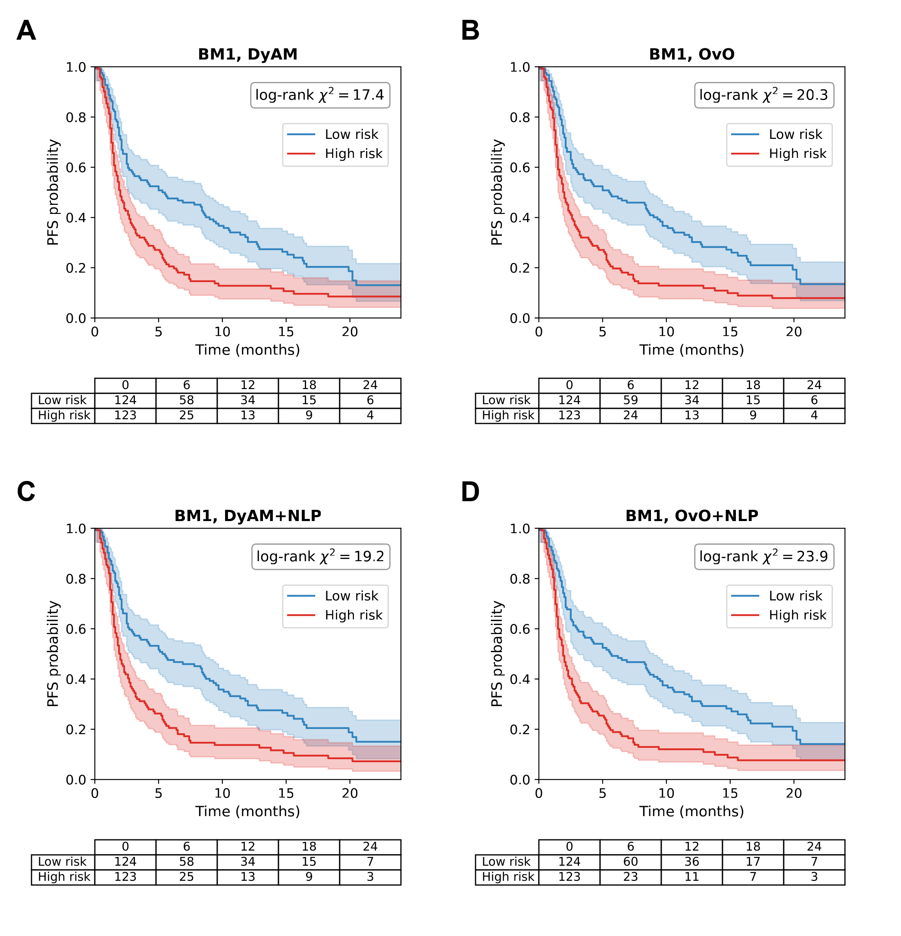
Figure 5. Kaplan–Meier progression-free survival curves at the primary benchmark BM1 (Rad+IHC-G+Gen+PDL1), computed from the out-of-fold risk scores of the single 10-fold partition and stratified at the median risk score into high-risk (red) and low-risk (blue) groups, with number-at-risk tables. The log-rank statistics printed in the panels are those of Table 8 (BM1 rows; for the two +NLP panels the NLP encoding is added to the BM1 sources). (A) DyAM. (B) OvO. (C) DyAM+NLP. (D) OvO+NLP.
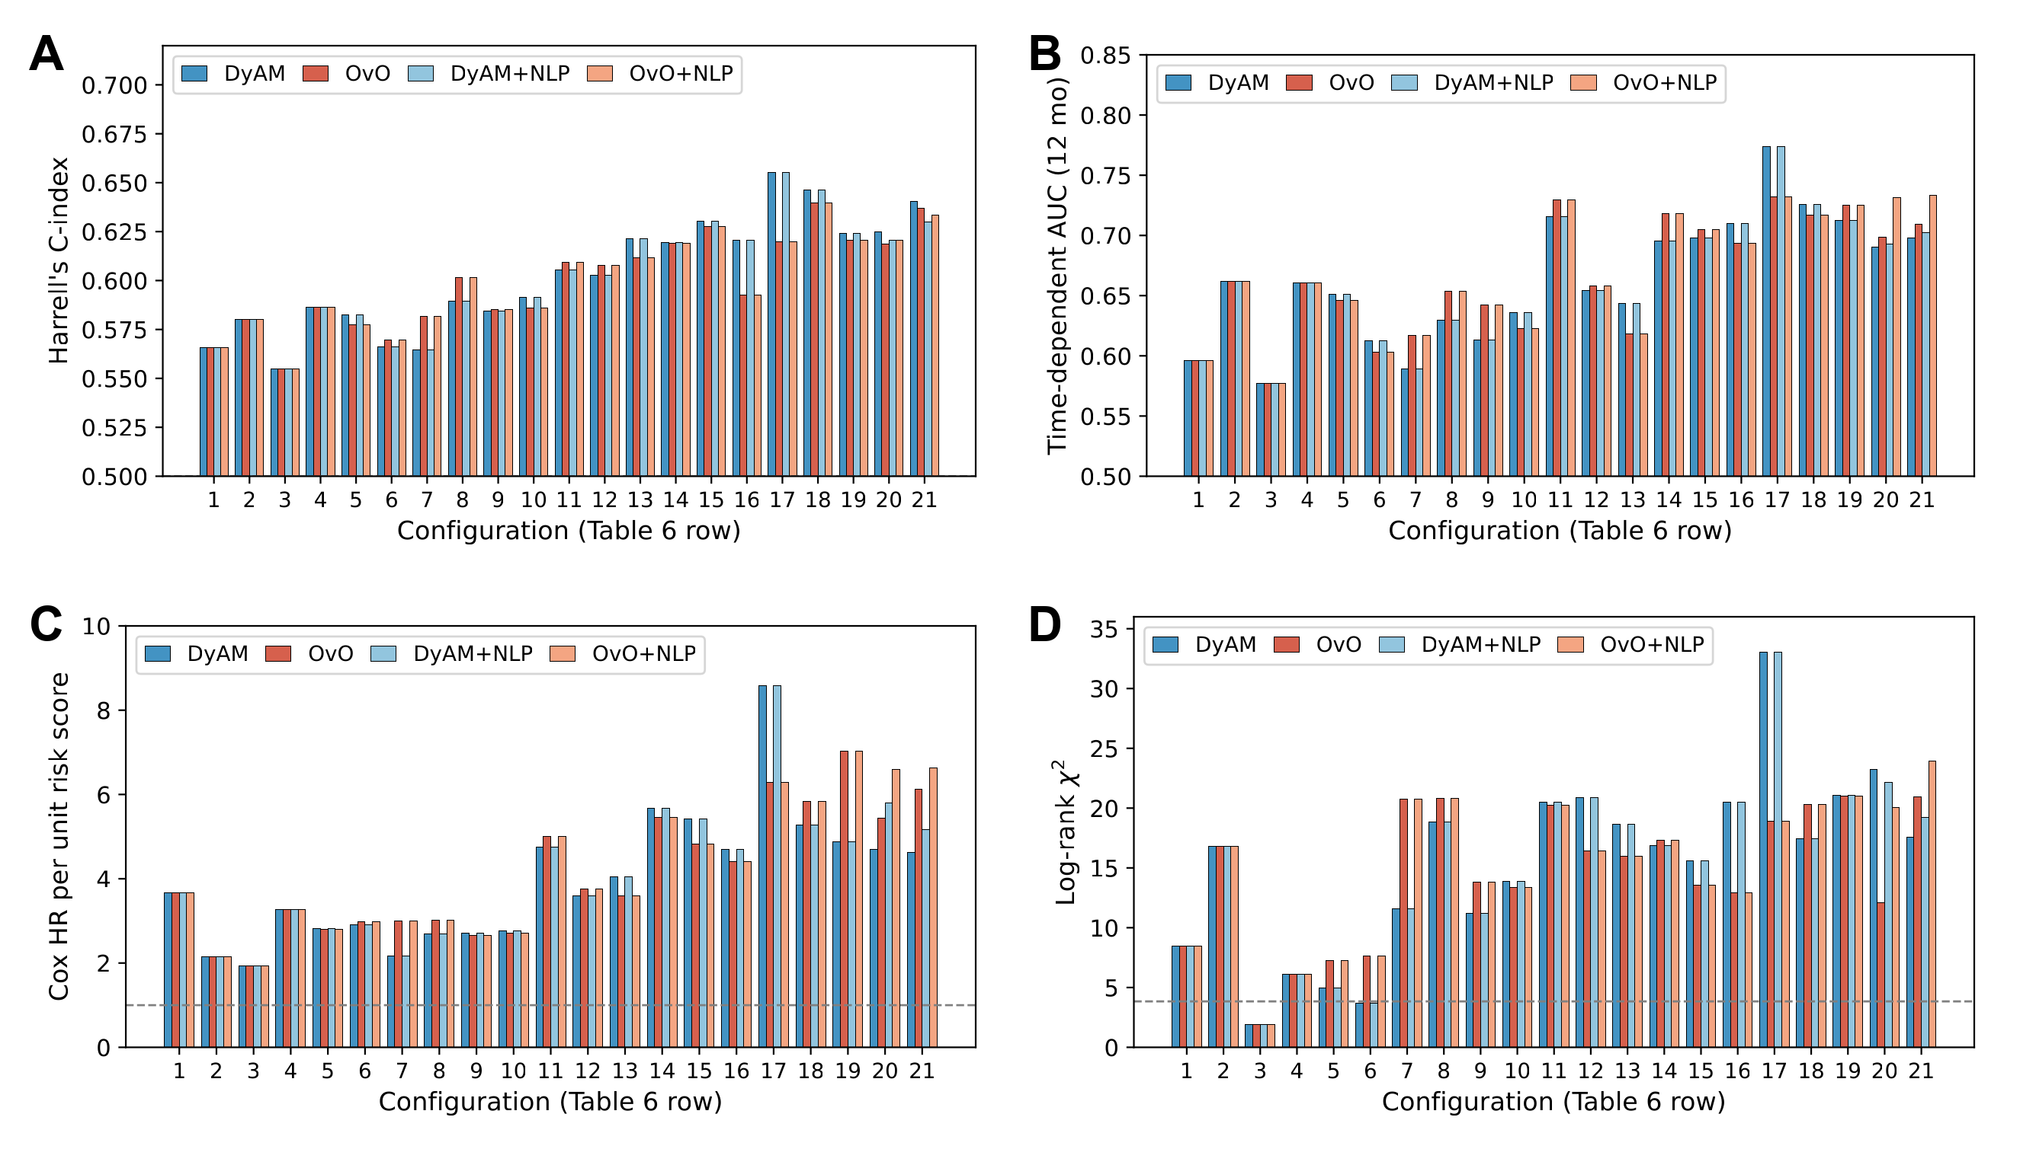
Figure 6. Survival association of the risk score across the 21 configurations (numbered as in Table 6), single 10-fold partition. Bars show DyAM, OvO, and, where they differ (configurations 20 and 21), DyAM+NLP and OvO+NLP; for the other configurations the +NLP bars repeat the values without NLP. (A) Harrell's C-index (dashed line, 0.5). (B) Time-dependent AUC at 12 months. (C) Cox hazard ratio per unit of risk score, adjusted for age, ECOG performance status, albumin, dNLR and liver metastases (dashed line, 1). (D) Log-rank χ² of the dichotomised risk score (dashed line, 3.84).

4. Discussion
We extended the DyAM multimodal attention framework with two contributions, a competitive (OvO) attention mechanism with fewer parameters and an NLP-based encoding of tabular clinical features, and evaluated them on response (AUC) and progression-free survival in a 247-patient cohort using one 10-fold cross-validation partition. The experiments support four conclusions.
Fusing sources is what moves performance. The best single sources reached AUCs of 0.708 (PD-L1 TPS), 0.701 (CT radiomics), 0.676 (genomics) and 0.615 (TMB). Fusing four sources raised the AUC to 0.798 under the cooperative attention of the original framework (+0.090 over PD-L1 TPS), a value that this evaluation reproduced and that matches the 0.80 of the original publication [15], and the best model reached 0.824 (95% CI 0.765–0.883), +0.116 above PD-L1 TPS, the biomarker in routine use, and above the modest discrimination reported for PD-L1 and TMB [8,7]. The same pattern held for survival: the association of the risk score with progression-free survival rose from a C-index of 0.56–0.59 for a single source to 0.59–0.66 for six or seven sources, and the log-rank χ² from 1.9–16.8 to 12.1–33.0. Two endpoints therefore point to the same conclusion, that the sources carry complementary information that attention-based fusion can combine.
The NLP encoding of clinical variables is better than numeric labs. This was the most consistent finding of the study. Replacing the 13 numeric laboratory and clinical values by their sentence embedding raised the AUC in all six comparisons that were made: +0.018 and +0.019 in the two pathology arms under cooperative attention, +0.019 and +0.022 in the two seven-source configurations under cooperative attention, and +0.033 and +0.030 in the same two configurations under OvO attention. That a model that sees the encoded clinical profile in place of the numeric vector gains in every comparison, with both attention mechanisms and both pathology encodings, makes a chance explanation less likely than a systematic benefit. A plausible reason is that a sentence embedding represents combinations of variables, for example advanced age together with low albumin and poor performance status, that are not explicit in a 13-dimensional numeric vector and that the attention module would otherwise have to learn from a small training set [16,17]; our data do not test this mechanism. The AUC with the encoding was also above that of the same sources without any clinical variable (+0.020 for DyAM and +0.024 for OvO at the primary benchmark), and the general-purpose sentence encoder was better than the domain-specific BioClinBERT (Supplementary Note S2), so no clinical fine-tuning was needed.
OvO attention gives the best fusion with a quarter of the parameters. At the primary benchmark OvO improved on cooperative attention by +0.017 without the NLP encoding (0.801 against 0.783) and by +0.021 with it (0.824 against 0.803), and in the two seven-source configurations with labs OvO was above the cooperative model as well (0.782 against 0.772 and 0.824 against 0.803 with NLP). OvO with the NLP encoding gave the highest AUC of all 21 configurations while training 1,242 parameters against 4,969 for the cooperative model. OvO therefore offers the best accuracy of the two mechanisms with a simpler model; the parameter count is a possible explanation, which we did not test by shrinking the cooperative attention matrix. For survival, OvO with the NLP encoding gave the strongest separation of risk groups at BM2 (hazard ratio 6.64 against 4.63 for DyAM, log-rank χ² = 23.9 against 17.6, 12-month time-dependent AUC 0.733 against 0.698), and the hazard ratio was higher for OvO at BM1 (5.83 against 5.27), TMB+PDL1 (3.00 against 2.17) and Rad+IHC-A+Gen+TMB+PDL1 (7.04 against 4.88). The C-index was close for the two mechanisms (0.633 against 0.640 at BM2), so the benefit of OvO lies in the separation of high- and low-risk groups rather than in the ranking of patients. The cooperative model remained the stronger of the two in a few configurations, such as Rad+IHC-A+Gen+PDL1 (0.798 against 0.768), where it also had the strongest survival association of the study (C-index 0.655, hazard ratio 8.59), so the choice between mechanisms may depend on the combination of sources.
The approach is practical. Encoding a patient profile takes less than one second on CPU, needs no labelled clinical text, and can be applied to any structured electronic health record field that can be written as a sentence, so it can be transferred to other structured clinical datasets without a fine-tuned clinical language model.
Clinical encodings and survival. The clinical encodings did not change the survival metrics consistently: hazard ratios were 5.0–6.3, C-indices 0.62–0.64 and log-rank χ² above 17 for every variant. The NLP encoding matched numeric labs on these metrics, so its advantage in this study is on the response endpoint, and we do not claim that it captures prognostic information.
Performance estimates. A harder evaluation gave lower values: training on the patients with the earliest CT accession numbers and testing on the later 124 (a proxy for time, since calendar dates were not available) gave AUCs of 0.703 (0.587–0.819) for OvO+NLP and 0.700 (0.587–0.812) for DyAM+NLP, with 0.707 and 0.678 at seven sources. The cross-validated AUC of 0.824 is therefore best read as the performance under the evaluation protocol of the original framework rather than the expected performance in new patients. Because about 60 variants were compared on the same 247 patients, the highest figures also include some selection, which we estimate at 0.014–0.031 AUC.
Limitations. First, all results come from one 10-fold cross-validation partition of a single-institution retrospective cohort, which limits generalisability; the confidence intervals reflect patient sampling but not the choice of partition. Second, with n = 247 (62 responders) the 95% interval of an AUC is about ± 0.07, and the differences between models, which are 0.02 AUC or smaller, are smaller than this cohort can resolve (about 1,200–1,350 patients would be needed to detect 0.02 AUC with 80% power; Supplementary Note S3), so they are described by direction and magnitude. Third, results depended on the numerical environment (the same code gave 0.798 on Linux and 0.788 on Windows at the primary benchmark), so all results are from one pinned environment. Fourth, the sentence encoder was used without fine-tuning on NSCLC clinical text. Fifth, calendar dates were not available, so temporal validation was approximated by CT accession order and covered two configurations. Finally, PD-L1 TPS was scored with the Sauter method, which may differ from the SP142 or 22C3 assays used elsewhere, so PD-L1-derived features should be interpreted with this in mind.

5. Conclusions
We extended the DyAM multimodal attention framework for ICI response prediction in NSCLC with a competitive (OvO) attention mechanism and an NLP-based encoding of structured clinical variables, and the experiments support four conclusions. First, fusing sources is what raises performance: four fused sources reached an AUC of 0.798 and the best model 0.824 (95% CI 0.765–0.883), against 0.708 for PD-L1 TPS alone, and the association of the risk score with progression-free survival grew with the number of fused sources across the 21 configurations (C-index up to 0.66). Second, the NLP encoding of clinical variables with a general-purpose sentence transformer exceeded numeric labs in all six comparisons (+0.018 and +0.019 in the two pathology arms, +0.019 to +0.033 in the two seven-source configurations), without any fine-tuning on clinical text. Third, OvO attention with the NLP encoding gave the highest AUC at the primary benchmark (0.824 against 0.803 for cooperative attention and 0.783 for the original framework, +0.041) with about a quarter of the trainable parameters, and the strongest separation of risk groups in the labs-replaced configuration of BM2 (hazard ratio 6.64 against 4.63, log-rank χ² = 23.9 against 17.6, 12-month time-dependent AUC 0.733 against 0.698), although the C-index was similar (0.633 against 0.640). Fourth, the approach is practical, since encoding a patient takes less than one second on CPU and needs no labelled clinical text. These results come from a single 10-fold partition, and an order-based hold-out evaluation gave lower estimates (0.703 for OvO+NLP and 0.700 for DyAM+NLP), so the cross-validated AUCs should not be read as expected performance in new patients. Validation in larger, multi-institutional cohorts with calendar dates is needed to confirm these findings and to establish their clinical utility for treatment selection.

Declarations
Author Contributions: Conceptualization, methodology, software, formal analysis, investigation, writing—original draft preparation, and writing—review and editing, V.H.H. The author has read and agreed to the published version of the manuscript.
Data Availability Statement: The code used in this study is available at https://github.com/hoanghuyvu2k/Multimodal-Lung-Cancer. Patient-level data are subject to institutional data-sharing agreements and available upon reasonable request.
Conflicts of Interest: The author declares no conflicts of interest.

References
1. Siegel RL, Giaquinto AN, Jemal A. Cancer Statistics, 2024. CA Cancer J Clin. 2024;74:12–49. doi:10.3322/caac.21820
2. Reck M, Rodríguez-Abreu D, Robinson AG, et al. Pembrolizumab versus Chemotherapy for PD-L1-Positive Non-Small-Cell Lung Cancer. N Engl J Med. 2016;375:1823–1833. doi:10.1056/NEJMoa1606774
3. Borghaei H, Paz-Ares L, Horn L, et al. Nivolumab versus Docetaxel in Advanced Nonsquamous Non-Small-Cell Lung Cancer. N Engl J Med. 2015;373:1627–1639. doi:10.1056/NEJMoa1507643
4. Sharma P, Hu-Lieskovan S, Wargo JA, Ribas A. Primary, Adaptive, and Acquired Resistance to Cancer Immunotherapy. Cell. 2017;168(4):707–723. doi:10.1016/j.cell.2017.01.017
5. Herbst RS, Baas P, Kim DW, et al. Pembrolizumab versus docetaxel for previously treated, PD-L1-positive, advanced non-small-cell lung cancer (KEYNOTE-010). Lancet. 2016;387:1540–1550. doi:10.1016/S0140-6736(15)01281-7
6. Hirsch FR, McElhinny A, Stanforth D, et al. PD-L1 Immunohistochemistry Assays for Lung Cancer: Results from Phase 1 of the Blueprint PD-L1 IHC Assay Comparison Project. J Thorac Oncol. 2017;12(2):208–222. doi:10.1016/j.jtho.2016.11.2228
7. Rizvi NA, Hellmann MD, Snyder A, et al. Mutational landscape determines sensitivity to PD-1 blockade in non-small cell lung cancer. Science. 2015;348:124–128. doi:10.1126/science.aaa1348
8. Lu S, Stein JE, Rimm DL, et al. Comparison of Biomarker Modalities for Predicting Response to PD-1/PD-L1 Checkpoint Blockade: A Systematic Review and Meta-analysis. JAMA Oncol. 2019;5(8):1195–1204. doi:10.1001/jamaoncol.2019.1549
9. Boehm KM, Khosravi P, Vanguri R, Gao J, Shah SP. Harnessing multimodal data integration to advance precision oncology. Nat Rev Cancer. 2022;22(2):114–126. doi:10.1038/s41568-021-00408-3
10. Bodalal Z, Trebeschi S, Nguyen-Kim TDL, et al. Radiogenomics: bridging imaging and genomics. Abdom Radiol. 2019;44:1960–1984. doi:10.1007/s00261-019-02028-w
11. Dercle L, Fronheiser M, Lu L, et al. Identification of Non-Small Cell Lung Cancer Sensitive to Systemic Cancer Therapies Using Radiomics. Clin Cancer Res. 2020;26:2151–2162. doi:10.1158/1078-0432.CCR-19-2942
12. Trebeschi S, Drago SG, Birkbak NJ, et al. Predicting Response to Cancer Immunotherapy Using Noninvasive Radiomic Biomarkers. Ann Oncol. 2019;30:998–1004. doi:10.1093/annonc/mdz108
13. Cheerla A, Gevaert O. Deep Learning with Multimodal Representation for Pancancer Prognosis Prediction. Bioinformatics. 2019;35:i446–i454. doi:10.1093/bioinformatics/btz342
14. Ma M, Ren J, Zhao L, et al. SMIL: Multimodal Learning with Severely Missing Modality. Proc AAAI Conf Artif Intell. 2021;35(3):2302–2310. doi:10.1609/aaai.v35i3.16330
15. Vanguri RS, Luo J, Aukerman AT, et al. Multimodal integration of radiology, pathology and genomics for prediction of response to PD-(L)1 blockade in patients with non-small cell lung cancer. Nat Cancer. 2022;3(10):1151–1164. doi:10.1038/s43018-022-00416-8
16. Reimers N, Gurevych I. Sentence-BERT: Sentence Embeddings using Siamese BERT-Networks. Proc 2019 Conf Empir Methods Nat Lang Process and 9th Int Jt Conf Nat Lang Process (EMNLP-IJCNLP). 2019:3982–3992. doi:10.18653/v1/D19-1410
17. Wang W, Wei F, Dong L, et al. MiniLM: Deep Self-Attention Distillation for Task-Agnostic Compression of Pre-Trained Transformers. Adv Neural Inf Process Syst (NeurIPS). 2020;33:5776–5788. https://arxiv.org/abs/2002.10957
18. Alsentzer E, Murphy JR, Boag W, et al. Publicly Available Clinical BERT Embeddings. Proc 2nd Clinical Nat Lang Process Workshop. 2019:72–78. doi:10.18653/v1/W19-1909
19. van Griethuysen JJM, Fedorov A, Parmar C, et al. Computational Radiomics System to Decode the Radiographic Phenotype. Cancer Res. 2017;77(21):e104–e107. doi:10.1158/0008-5472.CAN-17-0339
20. Cheng DT, Mitchell TN, Zehir A, et al. Memorial Sloan Kettering-Integrated Mutation Profiling of Actionable Cancer Targets (MSK-IMPACT): A Hybridization Capture-Based Next-Generation Sequencing Clinical Assay for Solid Tumor Molecular Oncology. J Mol Diagn. 2015;17(3):251–264. doi:10.1016/j.jmoldx.2014.12.006
21. Vaswani A, Shazeer N, Parmar N, et al. Attention Is All You Need. Adv Neural Inf Process Syst (NeurIPS). 2017;30:5998–6008. https://arxiv.org/abs/1706.03762
22. Rifkin R, Klautau A. In Defense of One-Vs-All Classification. J Mach Learn Res. 2004;5:101–141. https://www.jmlr.org/papers/v5/rifkin04a.html
23. DeLong ER, DeLong DM, Clarke-Pearson DL. Comparing the Areas under Two or More Correlated Receiver Operating Characteristic Curves: A Nonparametric Approach. Biometrics. 1988;44:837–845. doi:10.2307/2531595
24. Harrell FE, Lee KL, Mark DB. Multivariable Prognostic Models: Issues in Developing Models, Evaluating Assumptions and Adequacy, and Measuring and Reducing Errors. Stat Med. 1996;15:361–387. doi:10.1002/(SICI)1097-0258(19960229)15:4<361::AID-SIM168>3.0.CO;2-4
25. Uno H, Cai T, Tian L, Wei LJ. Evaluating Prediction Rules for t-Year Survivors With Censored Regression Models. J Am Stat Assoc. 2007;102(478):527–537. doi:10.1198/016214507000000149
26. Hung H, Chiang CT. Estimation methods for time-dependent AUC models with survival data. Can J Stat. 2010;38(1):8–26. doi:10.1002/cjs.10046

