NLP-Augmented Multimodal Attention Fusion for Immunotherapy Response Prediction in Non-Small Cell Lung Cancer
First Author^{1,†}, Second Author², Third Author^{1,*}
¹Department of [Department], [University], [City], [Country]; ²Department of [Department], [University], [City], [Country]
Correspondence: third@email.com | †These authors contributed equally to this work.

Abstract
Predicting response to immune checkpoint inhibitors (ICIs) in non-small cell lung cancer (NSCLC) remains challenging, as established biomarkers such as PD-L1 expression provide only modest discrimination. We extended the Dynamic Attention Multimodal (DyAM) fusion framework, which combines CT radiomics, pathology, genomics, PD-L1, and clinical data via learned per-modality attention, with two contributions: a competitive one-vs-others (OvO) attention mechanism, and a natural language processing (NLP) encoding of 13 numeric clinical variables using a pretrained sentence transformer. In a 247-patient discovery cohort, repeated-seed evaluation (5 seeds × 10-fold, 21 combinations) placed OvO within 0.011 AUC of cooperative attention at every primary benchmark (AUC = 0.773 vs. 0.760, p ≥ 0.17), exceeding it in 12 of 21 combinations (best single-partition AUC = 0.800), showing OvO's simpler formulation matches or exceeds cooperative attention at no accuracy cost. NLP-encoded clinical features improved AUC over raw numeric encoding in both pathology arms (best AUC = 0.813 [0.753–0.874], Δ = +0.030), a gain that also held for OvO. Survival analysis showed NLP encoding yielded the highest Cox hazard ratios (up to 6.07 vs. 5.30) and improved time-dependent AUC at 12–18 months, with all Kaplan–Meier stratifications reaching p < 0.005. NLP-based clinical encoding offers a practical, architecture-agnostic improvement to multimodal ICI response prediction.
Keywords: non-small cell lung cancer; immunotherapy response prediction; multimodal deep learning; attention mechanism; natural language processing; sentence embedding; survival analysis; radiomics

1. Introduction
Lung cancer remains the leading cause of cancer-related mortality worldwide, with non-small cell lung cancer (NSCLC) accounting for approximately 85% of cases [1]. The introduction of immune checkpoint inhibitors (ICIs) targeting the PD-1/PD-L1 axis has transformed treatment for advanced NSCLC, producing durable responses in a subset of patients [2,3]. However, only 20–30% of unselected patients achieve an objective response, and a substantial proportion experience primary or acquired resistance [4]. Reliable pre-treatment identification of likely responders remains an unresolved clinical need, as it would allow clinicians to prioritise ICI therapy for patients most likely to benefit and to consider alternative or combination strategies for those unlikely to respond.
PD-L1 tumour proportion score (TPS) and tumour mutational burden (TMB) are the most widely used biomarkers for ICI response prediction, but both have well-documented limitations: PD-L1 expression is spatially heterogeneous and assay-dependent, while TMB alone provides only modest discriminative performance [5,4]. This has motivated growing interest in multimodal approaches that integrate radiomics from CT imaging, pathomics from digitised histology, genomic alterations, and clinical variables into a single predictive model [6–9]. Such approaches are appealing because they can capture complementary aspects of tumour biology and host physiology that no single modality fully represents; however, they introduce new methodological challenges, including how to weight modalities of differing reliability and how to handle missing modalities without discarding patients [10]. The Dynamic Attention Multimodal (DyAM) framework [11] addresses these challenges through a learned, per-patient attention mechanism that adaptively weights each available modality and naturally accommodates missing data via masking, but its original formulation used only a cooperative (softmax/L1-normalised) attention mechanism and represented clinical variables as raw numeric features.
A largely unexplored question in this setting is how structured clinical variables — demographics, laboratory values, performance status — should be represented for fusion with imaging- and molecular-derived features. The conventional approach treats each clinical variable as an independent numeric input, requiring the model to learn inter-variable relationships (e.g., the joint prognostic implication of advanced age, low albumin, and poor performance status) from a relatively small training set. Recent advances in natural language processing (NLP) have shown that pretrained sentence encoders can represent complex, multi-attribute entities as dense embeddings that preserve semantic similarity [12,13], and domain-specific clinical language models have been developed for free-text clinical notes [14]. However, whether converting structured, tabular clinical variables into natural-language sentences and encoding them with a general-purpose sentence transformer can improve multimodal fusion performance — as opposed to encoding free-text clinical narratives — has not, to our knowledge, been systematically evaluated for ICI response prediction.
A second open question concerns the form of the attention mechanism used to combine modalities. Cooperative attention mechanisms, which normalise modality weights to sum to one via softmax or L1 normalisation, implicitly assume that all modalities contribute complementary, additive information. An alternative, competitive formulation — in which each modality's weight is determined relative to the others via a one-vs-others (OvO) comparison — may better capture settings where modalities are partially redundant and the most informative modality should dominate. Whether such a competitive mechanism improves performance, and under what modality configurations, remains untested in the multimodal ICI response prediction literature.
In this study, we extend the DyAM framework with two contributions and evaluate them on a discovery cohort of 247 patients with advanced NSCLC treated with ICIs. First, we introduce an OvO competitive attention variant (AttentionMatrixOvO) and compare it against the original cooperative attention across 20 modality combinations using 10-fold cross-validation, with a confirmatory repeated-seed evaluation (5 seeds × 10-fold) across 21 modality combinations to test the reproducibility of any observed difference. Second, we convert 13 numeric clinical variables into natural-language sentences and encode them with a pretrained sentence transformer (MiniLM-L6-v2), comparing this NLP-based representation against raw numeric encoding, a domain-specific clinical language model (BioClinBERT), and a PCA-compressed variant, evaluated using both binary classification (AUC) and survival analysis (Cox regression, time-dependent AUC, Harrell's C-index, and Kaplan–Meier stratification). Together, these contributions aim to clarify (i) whether competitive attention offers a reproducible accuracy advantage over cooperative attention in multimodal fusion, or whether the two are functionally interchangeable at this sample size, and (ii) whether NLP-based encoding of structured clinical data provides a practical, fine-tuning-free improvement over conventional numeric representations for both response prediction and survival risk stratification.

2. Materials and Methods

2.1. Study Design and Patient Cohort
This retrospective study used data from the MSK-MIND (Memorial Sloan Kettering Molecular-Informed Neoadjuvant/Definitive therapy) programme [11], comprising patients with advanced non-small cell lung cancer (NSCLC) treated with immune checkpoint inhibitor (ICI) therapy between 2017 and 2021. Inclusion criteria were: (i) histologically confirmed stage IIIB/IV NSCLC, (ii) first- or second-line ICI therapy (monotherapy or combination), and (iii) available baseline CT imaging. The study dataset comprised three independent cohorts: a discovery cohort (n = 247) used for model development and 10-fold cross-validation; a radiomics validation cohort (n = 50) and a pathology validation cohort (n = 71), both held out entirely for external evaluation. Patient characteristics are summarised in Table 1.
Table 1. Patient and cohort characteristics. The discovery cohort was used for model development with 10-fold cross-validation; validation cohorts were held out entirely. Validation column reports radiomics-evaluable; pathology-evaluable cohort values, separated by a semicolon. *ICI categories are recorded as independent flags and are not mutually exclusive (patients on combination therapy are counted in more than one row). PR/CR, partial/complete response; SD/PD, stable/progressive disease; PFS, progression-free survival.
Characteristic | Discovery (n = 247) | Validation (rad n=50; path n=71)
Age, years, mean (range) | 66.9 (38–93) | 64.4 (45–86); 68.0 (30–89)
Male sex, n (%) | 113 (45.7%) | 24 (48.0%); 32 (45.1%)
Adenocarcinoma | 184 (74.5%) | 39 (78.0%); 47 (66.2%)
Squamous cell | 36 (14.6%) | 7 (14.0%); 13 (18.3%)
Other / NOS | 27 (10.9%) | 4 (8.0%); 11 (15.5%)
ECOG 0 | 28 (11.3%) | 10 (20.0%); 8 (11.3%)
ECOG 1 | 194 (78.5%) | 39 (78.0%); 58 (81.7%)
ECOG ≥2 | 25 (10.1%) | 1 (2.0%); 5 (7.0%)
Anti-PD-1 therapy* | 197 (79.8%) | not recorded
Anti-PD-L1 therapy* | 50 (20.2%) | not recorded
Combination therapy* | 12 (4.9%) | not recorded
Response (PR/CR), label=0 | 62 (25.1%) | 11 (22.0%); 21 (29.6%)
No response (SD/PD), label=1 | 185 (74.9%) | 39 (78.0%); 50 (70.4%)
PFS events (progression/death), n (%) | 209 (84.6%) | 46 (92.0%); 55 (77.5%)
Median PFS, months (range) | 2.7 (0.1–49.1) | 2.6 (1.0–59.7); 2.7 (0.1–28.4)
CT radiomics available (PC/PL/LN) | 187 (75.7%) | 46/50; —
Pathology IHC available | 105 (42.5%) | —; 52/71
Genomics (NGS) available | 247 (100%) | —
PD-L1 TPS score available | 201 (81.4%) | —
Clinical labs (13 vars) available | 247 (100%) | —

The primary binary endpoint was best overall response to ICI therapy, classified as response (partial or complete response, PR/CR; label = 0) or no response (stable or progressive disease, SD/PD; label = 1). The response-to-no-response ratio in the discovery cohort was approximately 1:2.98, reflecting the known clinical rate of ICI non-response in unselected NSCLC populations [3]. A secondary time-to-event endpoint, progression-free survival (PFS), was defined as time from ICI initiation to disease progression or death from any cause. Patients without a recorded event were censored at the date of last follow-up.
This study was conducted in accordance with the Declaration of Helsinki and approved by the Institutional Review Board of [Institution] (Protocol No. [IRB Number]). All patients provided written informed consent.
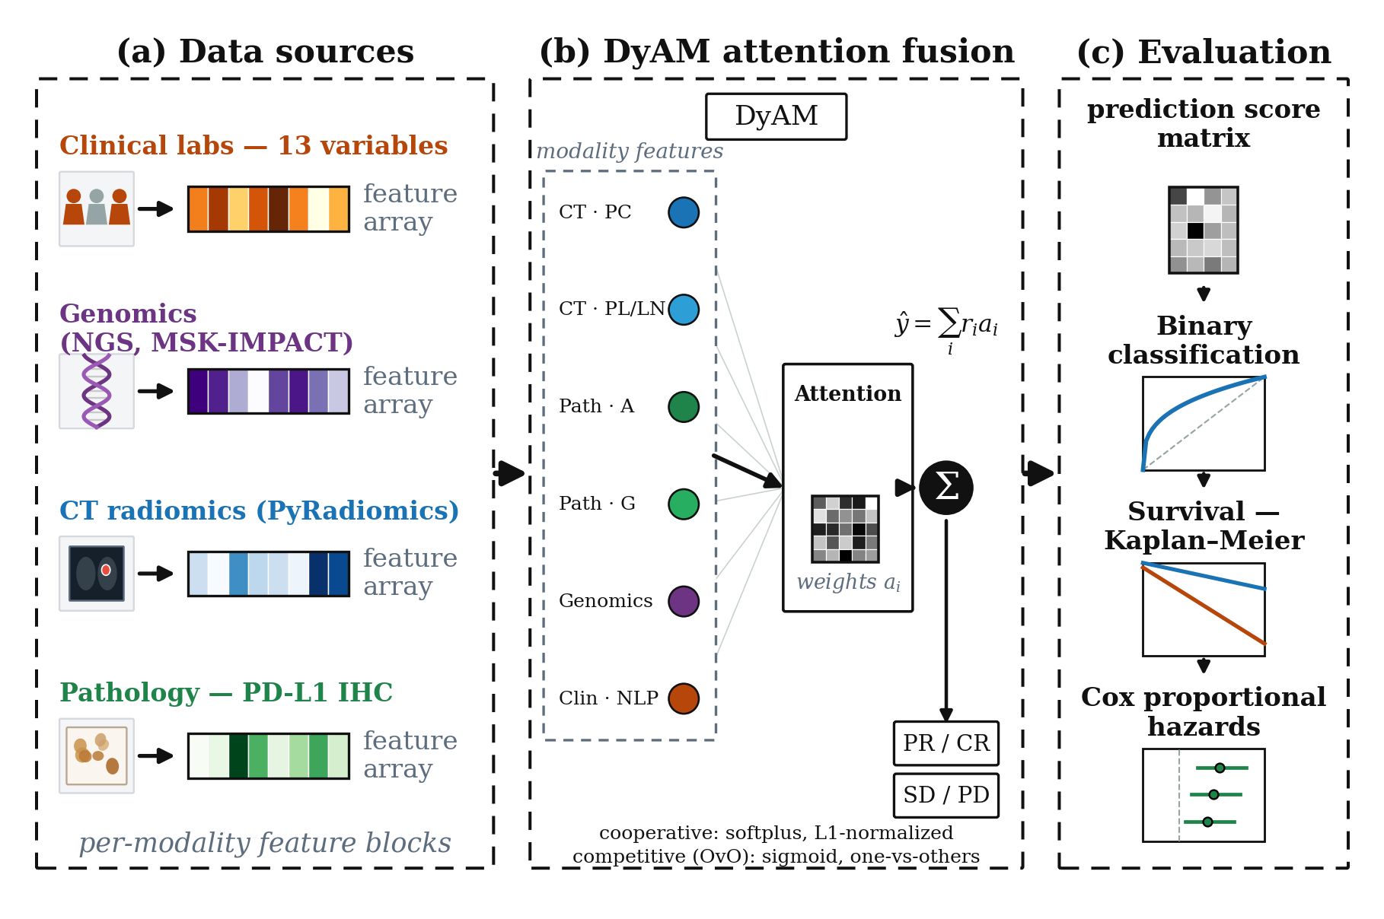
Figure 1. Study overview. (A) The discovery cohort (n = 247) and two validation cohorts (radiomics-evaluable, n = 50; pathology-evaluable, n = 71) provide six data sources: CT radiomics (modelled separately per lesion site: PC, PL, LN), pathology image texture (IHC-A or IHC-G), tumour genomics, PD-L1 TPS, and structured clinical variables, giving up to seven input modalities per model. (B) The DyAM architecture computes a per-modality risk score and combines modalities using either cooperative (AttentionMatrix) or competitive one-vs-others (AttentionMatrixOvO) attention to produce a fused risk prediction ŷ. (C) Models are evaluated on both binary response classification (AUC-ROC with DeLong 95% CI) and survival endpoints (Harrell's C-index, multivariate Cox hazard ratios, and Kaplan–Meier log-rank stratification).

2.2. Data Modalities
Six data sources were assembled for each patient (Table 2). Because CT radiomics is modelled separately per lesion site (PC, PL, LN) and the two pathology feature sets (IHC-A, IHC-G) are used as alternative arms rather than jointly, a single model receives up to seven input modalities. CT radiomics features were extracted from baseline scans using the MIRPON pipeline [7] at 1.0 mm isotropic spacing with a window of [−1350, 250] HU, yielding 1,688 features per lesion type. Lesions were categorised by anatomical site: primary tumour (PC), pleural lesion (PL), and lymph node (LN). Up to three lesions per site were included, ranked by volume. Pathology features were derived from PD-L1 immunohistochemistry (IHC) slides: IHC-A comprised 18 pixel-intensity aggregation features (area, mean intensity, percentiles), while IHC-G comprised 150 grey-level co-occurrence matrix (GLCM) texture features across six aggregation levels [11]. Genomic features (11 variables) included tumour mutational burden (TMB) and the status of eight driver mutations and amplifications derived from FoundationOne CDx next-generation sequencing (NGS). The PD-L1 tumour proportion score (TPS) was obtained from clinical pathology reports (range 0–100%). Clinical laboratory features comprised 13 variables: age, smoking pack-years, Eastern Cooperative Oncology Group (ECOG) performance status, serum albumin, derived neutrophil-to-lymphocyte ratio (dNLR), initial tumour burden, brain and liver metastasis status, line of therapy, combination therapy, primary lung site, prior PD-L1 therapy, and adenocarcinoma histology.
For radiomics modalities, features with an intraclass correlation coefficient (ICC) below 0.15 across test–retest perturbation scans were removed (robustness filter), and features with a z-score exceeding 6 in any patient were flagged as outliers and excluded. All modalities except the NLP embedding (Section 2.3) were standardised with RobustScaler (median centring, IQR scaling). Missing modalities were handled via a binary indicator mask $m ∈ {\left\{0,1\right\}}^{N}$; masked modalities contribute zero attention and zero risk to the fused prediction (Section 2.4).
Table 2. Summary of data modalities used in this study. All feature counts are post-selection (after ICC and outlier filtering for radiomics).
Modality | Source | Features | Clinical meaning
CT Radiomics (PC, PL, LN) | MIRPON pipeline | ≤1,688 | Tumour shape, size, and texture from baseline CT
Pathology IHC-A | PD-L1 IHC slides | 18 | Pixel-intensity aggregation of PD-L1 expression
Pathology IHC-G | PD-L1 IHC slides | 150 | GLCM texture of PD-L1 signal
Genomics | FoundationOne CDx | 11 | TMB + driver mutation/amplification status
PD-L1 TPS | Pathology report | 1 | Tumour proportion score (0–100%)
Clinical labs | EHR | 13 | Demographics, performance status, labs
NLP embedding (new) | all-MiniLM-L6-v2 | 384 | Sentence embedding of clinical lab text
NLP-PCA16 (new) | PCA of NLP | 16 | PCA-compressed NLP (approx. 94% variance)

2.3. NLP Encoding of Tabular Clinical Features
Standard encoding of clinical variables as a 13-dimensional numeric vector treats each feature independently and loses contextual relationships between variables (e.g., an elderly patient with low albumin and ECOG 2 implies a different prognosis than the same values in isolation). To capture inter-feature context, we converted each patient's clinical profile into an English-language sentence and extracted a dense semantic embedding.
Text prompt construction. For each patient, the 13 clinical variables were formatted into a structured natural-language sentence, for example: “The patient is a 69-year-old. Smoking history in pack-years is 48.0. ECOG performance status is 1.0. Blood albumin concentration is 4.00. Derived neutrophil-to-lymphocyte ratio (dNLR) is 2.40. Initial tumor burden stands at 52.00. The patient is diagnosed with adenocarcinoma at the lung site. Metastatic status: without brain metastasis and without liver metastasis. Currently undergoing therapy line 2, utilizing combination therapy. The patient received prior PD-L1 immunotherapy.” Binary variables were expanded to descriptive phrases to exploit the pretrained vocabulary of the encoder.
Sentence encoder. Prompts were encoded with sentence-transformers/all-MiniLM-L6-v2 [12,13], a 6-layer transformer distilled for semantic sentence similarity and trained on over one billion sentence pairs. Each patient was represented as a 384-dimensional L2-normalised vector. No fine-tuning was performed; the model was applied in zero-shot transfer. We compared this general-purpose encoder against the domain-specific Bio_ClinicalBERT [14]; the domain-specific model performed inferiorly (ΔAUC = −0.017 versus MiniLM-L6-v2 in the IHC-A arm), consistent with its design for masked language modelling rather than sentence-similarity tasks.
Dimensionality reduction. Principal component analysis (PCA) was applied to the 384-dimensional embeddings, retaining the top 16 components (≈94% of variance explained). Both the raw 384-dimensional (NLP raw) and PCA-compressed 16-dimensional (NLP-PCA16) variants were evaluated. Crucially, the NLP modality was passed to the model with the RobustScaler disabled (no_scale=True), as the embeddings are already L2-normalised and scaling would distort the cosine-similarity geometry of the embedding space.
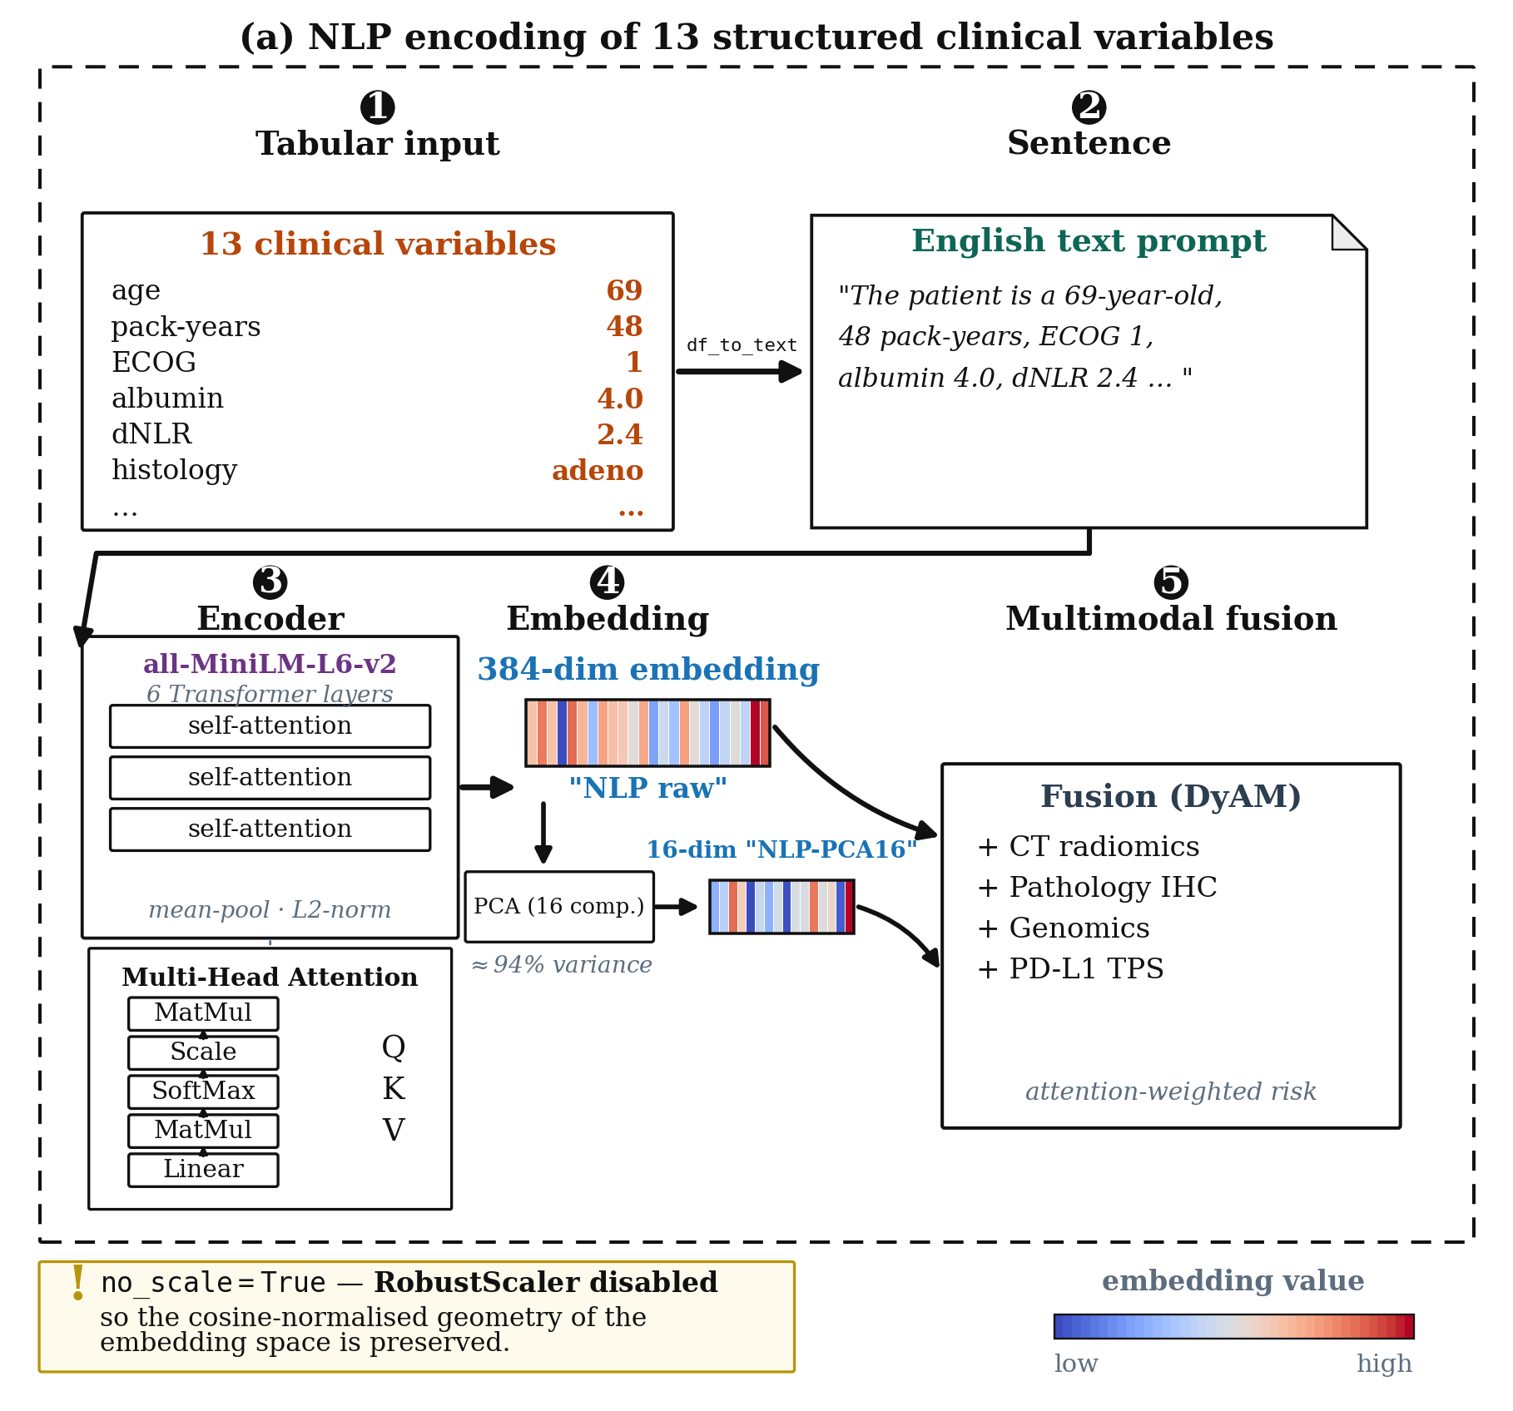
Figure 2. NLP-based encoding of structured clinical features. Thirteen numeric clinical variables per patient are converted into a natural-language sentence describing the patient's clinical profile (example shown), which is then encoded into a 384-dimensional embedding using a pretrained sentence transformer (all-MiniLM-L6-v2). The 384-dimensional embedding (“NLP raw”) is used directly, or further reduced to 16 dimensions via PCA (“NLP-PCA16”, retaining ≈94% of variance) prior to fusion with other modalities. no_scale=True is applied to NLP embeddings to preserve their cosine-normalised geometry.

2.4. Model Architecture
Dynamic Attention Multimodal (DyAM) model. The base model, DyAM [11], fuses $N$ modalities through per-modality risk scores and a learned attention mechanism, in the spirit of attention-based architectures broadly [15]. Let $x_{i} ∈ ℝ^{d_{i}}$ denote the feature vector of modality $i$ after optional RobustScaling. A scalar risk score is computed as:
$r_{i} = \tanh{W_{r,i}^{T} x_{i}}$ (1)
where $W_{r,i} ∈ ℝ^{d_{i}}$ are learnable weights. An attention score is produced by an $N × N$ grid of linear layers with softplus activation, $ℓ_{2}$-normalised by the modality vector norm:
$s_{i} = \frac{\operatorname{softplus}{W_{a,ij}^{T} x_{i}}}{{\left\|x_{i}\right\|}_{2}}$ (2)
Attention weights are obtained by L1 normalisation across modalities:
$a_{i} = \frac{s_{i}}{\sum_{j = 1}^{N}{s_{j}}}$ (3)
OvO competitive attention. We propose an alternative attention mechanism inspired by one-versus-others (OvO) classification [16], in which each modality competes against the mean score of all remaining modalities rather than sharing a fixed budget. The mean score of the $N − 1$ competing modalities is:
$μ_{−i} = \frac{1}{N − 1}\sum_{j ≠ i}{s_{j}}$ (4)
and the OvO attention score is:
${ovo}_{i} = σ\left(s_{i} − μ_{−i}\right), σ(z) = {\left(1 + e^{−z}\right)}^{−1}$ (5)
The sigmoid function yields an independent probability that modality $i$ outperforms the others, rather than a jointly normalised score. After applying the binary missingness mask $m_{i} ∈ \left\{0,1\right\}$, the weights are L1-normalised: $a_{i} = \frac{{ovo}_{i} · m_{i}}{\sum_{j}{{ovo}_{j} · m_{j}}}$.
Fused prediction and training. For both variants, the final risk prediction is:
$\hat{y} = \sum_{i = 1}^{N}{r_{i} · a_{i}}$ (6)
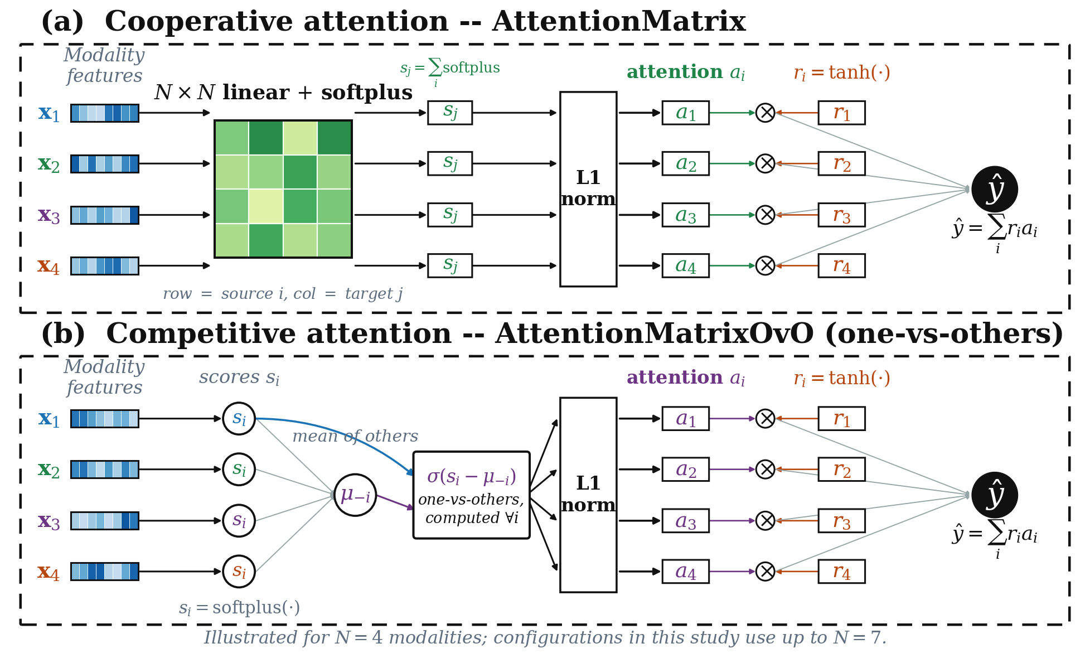
Figure 3. Architecture of the two attention mechanisms. Both variants compute a per-modality risk score $r_{i} = \tanh{W_{r,i}^{T} x_{i}}$ and produce the fused prediction $\hat{y} = \sum_{i}{r_{i} · a_{i}}$; they differ only in how the attention weights $a_{i}$ are obtained. (A) Cooperative attention (AttentionMatrix): an $N × N$ grid of linear layers with softplus activation produces pairwise scores that are column-summed into $s_{j}$ and L1-normalised so that the modalities share a fixed attention budget. (B) Competitive one-vs-others attention (AttentionMatrixOvO): each modality produces a single score $s_{i}$ that is compared against the mean score of the remaining modalities $μ_{−i}$ through a sigmoid, $σ\left(s_{i} − μ_{−i}\right)$, yielding an independent competitive weight before L1 normalisation. Heatmap bars denote modality feature vectors; the diagram is drawn for $N = 4$ modalities for clarity.
The model was trained with binary cross-entropy loss (BCEWithLogitsLoss) with automatic inverse-frequency class weighting to address the ≈1:3 class imbalance, $ℓ_{1}$ regularisation on attention weights ($α = 1.0$), and $ℓ_{2}$ weight decay ($β = 1.0$). The Adam optimiser was used with a learning rate of 0.01 for 125 epochs. All experiments used 10-fold stratified cross-validation on the discovery cohort; predictions were pooled across held-out folds for AUC computation.

2.5. Statistical Analysis and Evaluation
Discriminative performance. Area under the receiver operating characteristic curve (AUC-ROC) was computed on pooled out-of-fold predictions from 10-fold cross-validation. Ninety-five percent confidence intervals (CIs) were estimated using the DeLong structural components method [17]. Two models were considered statistically significantly different when their 95% CIs did not overlap, consistent with standard practice in oncology imaging studies.
Survival analysis. Harrell's concordance index (C-index) [18] was computed from pooled out-of-fold risk scores against PFS. Bootstrap 95% CIs were derived from 1,000 resamples with replacement. For pairwise comparisons, per-fold C-indices (10 values) were compared with a two-sided Wilcoxon signed-rank test (α = 0.05). Time-dependent AUC was computed at 6, 12, and 18 months using the cumulative/dynamic estimator [18]. Multivariate Cox proportional hazards regression was fitted with the DyAM risk score as the primary predictor, adjusted for five clinical covariates: age, ECOG performance status, serum albumin, dNLR, and liver metastasis status. Hazard ratios (HRs) are reported with 95% CIs and Wald p-values. Model calibration was assessed via the Integrated Brier Score (IBS); values below 0.25 indicate better-than-random calibration.
Kaplan–Meier survival stratification. Patients were dichotomised at risk score = 0, and PFS curves for the two groups were compared with the log-rank test. A threshold of χ² > 7.88 (p < 0.005) was applied as the significance criterion, consistent with oncology reporting standards.
Software. All analyses were performed in Python 3.10 using PyTorch 2.0 (model training), lifelines 0.27 (Kaplan–Meier, Cox regression, C-index), scikit-survival 0.21 (time-dependent AUC, Brier score), and scipy 1.11 (Wilcoxon test).

3. Results

3.1. Multimodal Fusion Outperforms Single-Modality Baselines
Within the DyAM framework, models restricted to a single data source achieved repeated-seed (5 seeds × 10-fold) AUC values of 0.616 ± 0.001 (TMB), 0.635 ± 0.021 (pathology IHC), 0.673 ± 0.020 (CT radiomics), 0.676 ± 0.013 (genomics), and 0.720 ± 0.012 (PD-L1 TPS) on the discovery cohort. PD-L1 TPS was the strongest individual predictor, consistent with its role as the biomarker in routine clinical use.
Fusing four data sources (CT radiomics, pathology IHC-G, genomics, and PD-L1 TPS) under the same protocol raised the AUC to 0.760 ± 0.022, exceeding the best single source by 0.040 AUC; adding NLP-encoded clinical variables raised it further to 0.783 ± 0.016 (Section 3.3). Evaluated on the single cross-validation partition used for the DeLong confidence intervals reported in Tables 5 and 6, the same four-source configuration reached AUC = 0.784 [95% CI: 0.717–0.850] (IHC-G arm; Table 6). Multimodal fusion is therefore the primary driver of predictive performance in this cohort, with no individual source approaching the discrimination of the fused model.

3.2. OvO Competitive Attention Achieves Performance Comparable to Cooperative Attention with a Simpler Parameterization
In an initial exploratory screen across 20 modality configurations evaluated with a single 10-fold cross-validation partition, the OvO attention variant outperformed the original cooperative attention in 7 of 20 cases (35%), while the original model was superior in 9 of 20 cases (45%), with 4 identical results (single-modality, where OvO reduces to the original). The mean AUC difference was −0.32% in favour of the original model overall. The largest single-partition gains for OvO were observed for PDL1+Gen (ΔAUC = +3.27%, AUC 0.716 vs. 0.693) and Rad+Gen (ΔAUC = +2.23%; Table 3), while the largest deficits occurred for configurations combining three or more modalities, particularly when IHC-G or clinical labs were included (largest deficit: Rad+IHC-A+Gen, ΔAUC = −4.94%).
Because a single CV partition can favour either model by chance, we repeated this comparison as a confirmatory analysis using 5 independent random partitions (5 seeds × 10-fold, patient labels re-shuffled per seed) across the same 21 modality combinations used in the primary paper-matched configuration set (Section 3.1), with paired bootstrap significance testing on the resulting patient-level scores. At the primary benchmark configuration (Rad+IHC-G+Gen+PDL1), OvO reached a repeated-seed mean AUC of 0.773 ± 0.020 versus 0.760 ± 0.022 for the original cooperative model (ΔAUC = +0.009, 95% bootstrap CI [−0.008, 0.027], p = 0.313); across all four primary benchmarks the two models differed by at most 0.011 AUC (p ≥ 0.17). Extending the comparison to all 21 modality combinations (Table 4), OvO's repeated-seed mean AUC exceeded the original model's in 12 of 21 configurations and was lower in 5 of 21, with 4 identical (single-modality, where the two formulations coincide algebraically).
This advantage was concentrated in the many-source regime: for configurations fusing k ≥ 5 input sources, OvO matched or exceeded cooperative attention in 7 of 8 cases (mean ΔAUC = +0.009, range −0.001 to +0.018), whereas for k = 2–4 it led in only 5 of 9 cases with a far wider spread (mean +0.003, range −0.028 to +0.045). Notably, this is the opposite of the pattern suggested by the single-partition screen, which had favoured OvO at low modality counts; the repeated-seed evaluation instead places OvO's small but consistent edge in precisely the multi-source configurations the fusion model is intended for. These per-k counts are descriptive: formal significance testing was performed only at the four primary benchmarks, and the effect sizes involved (≤ 0.018 AUC) remain below the seed-to-seed standard deviation (≈ 0.02), so the trend should be read as a consistency pattern rather than a demonstrated superiority.
The single-partition “best-performing configuration” identified in the initial screen (OvO Rad+IHC-G+Gen+PDL1, AUC = 0.8003 [95% CI: 0.739–0.862]) illustrates how favourable a single partition can be: the same configuration's repeated-seed mean AUC was 0.773, and OvO's rank relative to the cooperative model reversed once averaged across seeds.
As a further robustness check, we combined OvO attention with the NLP-clinical encoding described in Section 3.3, repeating the same 21-combination, 5-seed evaluation with clinical text embeddings added to each configuration. OvO+NLP reproduced the same fusion-dependent improvement pattern observed in the primary NLP-clinical analysis (Section 3.3): AUC improved relative to the no-clinical baseline in 15 of 21 configurations (an identical set of configurations), and declined in the same six single- or near-single-modality configurations where any clinical addition diluted a strong standalone signal (PD-L1, radiomics-only, and similar). At the primary benchmark, OvO+NLP reached a repeated-seed mean AUC = 0.782 ± 0.017, matching the 0.783 ± 0.016 obtained by the repeated-seed NLP-clinical confirmation at the same configuration (Section 3.3). Under the single-partition protocol, OvO+NLP reached AUC = 0.8133 at the Rad+IHC-A+Gen+TMB+PDL1 configuration, the highest value obtained under either evaluation protocol in this study.
This shows that OvO's simpler, N-parameter formulation (independent per-modality scores compared against the mean of the others) delivers the same NLP-clinical benefit as the cooperative model without the N × N weight matrix, and that the clinical-encoding intervention, not the choice of attention mechanism, is the source of that gain. Table 3 summarises the exploratory single-partition screen and Table 4 gives the repeated-seed AUC of all three models across all 21 configurations; the corresponding single-partition values are provided in Supplementary Table S3.
Table 3. Top configurations from the exploratory, single-partition screen comparing OvO competitive attention and original cooperative attention. ΔAUC is computed as OvO minus Original. As described in the text, these single-partition differences were not reproducible under repeated-seed evaluation (Table 4) and should be interpreted as an initial screen rather than a confirmed effect.
Configuration | Original AUC | OvO AUC | ΔAUC
PDL1+Gen | 0.693 | 0.716 | +3.27%
Rad+Gen | 0.738 | 0.755 | +2.23%
Rad+IHC-G+Gen+PDL1 | 0.784 | 0.800 | +2.10%
Rad+IHC-A+Gen+PDL1 | 0.764 | 0.777 | +1.63%
TMB+PDL1 | 0.705 | 0.715 | +1.42%
Rad+IHC-A+Gen | 0.757 | 0.719 | −4.94%
IHC-G+Gen | 0.756 | 0.723 | −4.33%
Rad+IHC-A+Gen+PDL1+Labs | 0.768 | 0.747 | −2.83%
Rad+IHC-G+Gen | 0.787 | 0.766 | −2.66%
Rad+IHC-G+Gen+PDL1+Labs | 0.788 | 0.783 | −0.56%

Table 4. Repeated-seed (5 seeds × 10-fold) AUC across all 21 paper-matched modality combinations, for the original cooperative attention (DyAM), OvO competitive attention, and OvO combined with NLP-clinical encoding. k is the number of fused input sources (CT radiomics contributes one source per lesion site). Bold marks the highest value in each row. For k = 1 OvO reduces algebraically to the cooperative formulation, hence the identical values. Configurations 8, 11, 18 and 21 are the primary benchmarks BM4, BM3, BM1 and BM2; paired-bootstrap testing (2000 resamples) was performed at those four only, giving ΔAUC (OvO − DyAM) of +0.011 [−0.005, 0.026], p = 0.172 (BM4); +0.000 [−0.012, 0.013], p = 0.980 (BM3); +0.009 [−0.008, 0.027], p = 0.313 (BM1); and −0.004 [−0.020, 0.009], p = 0.536 (BM2). Single-partition values for the same 21 configurations are given in Supplementary Table S3.
# | Configuration | k | DyAM | OvO | OvO+NLP
1 | TMB | 1 | 0.616 | 0.616 | 0.606
2 | PDL1 | 1 | 0.720 | 0.720 | 0.694
3 | IHC-A | 1 | 0.635 | 0.635 | 0.625
4 | Gen | 1 | 0.676 | 0.676 | 0.661
5 | Rad | 3 | 0.673 | 0.659 | 0.651
6 | Rad-LU | 4 | 0.637 | 0.646 | 0.629
7 | TMB+PDL1 | 2 | 0.664 | 0.709 | 0.714
8 | PDL1+Gen (BM4) | 2 | 0.707 | 0.718 | 0.747
9 | Rad+IHC-A | 4 | 0.671 | 0.668 | 0.712
10 | Rad+IHC-G | 4 | 0.706 | 0.703 | 0.736
11 | Rad+Gen (BM3) | 4 | 0.709 | 0.713 | 0.708
12 | IHC-A+Gen | 2 | 0.693 | 0.697 | 0.702
13 | IHC-G+Gen | 2 | 0.747 | 0.719 | 0.752
14 | Rad+IHC-A+Gen | 5 | 0.725 | 0.735 | 0.744
15 | Rad+IHC-G+Gen | 5 | 0.751 | 0.752 | 0.760
16 | Rad+IHC-A+MutAmp | 6 | 0.734 | 0.744 | 0.747
17 | Rad+IHC-A+Gen+PDL1 | 6 | 0.743 | 0.753 | 0.757
18 | Rad+IHC-G+Gen+PDL1 (BM1) | 6 | 0.760 | 0.773 | 0.782
19 | Rad+IHC-A+Gen+TMB+PDL1 | 7 | 0.749 | 0.766 | 0.765
20 | Rad+IHC-A+Gen+PDL1+Labs | 7 | 0.736 | 0.745 | 0.757
21 | Rad+IHC-G+Gen+PDL1+Labs (BM2) | 7 | 0.764 | 0.763 | 0.782

3.3. NLP Encoding Consistently Improves AUC over Numeric Clinical Features
Seven NLP encoding variants were evaluated against numeric clinical labs as a reference. In the IHC-A arm, NLP-PCA16 achieved the highest AUC among clinical encoding strategies (AUC = 0.784, 95% CI: 0.719–0.848; ΔAUC = +0.020 over no-clinical baseline), compared to +0.004 for numeric labs (Table 5). In the IHC-G arm, NLP raw (384-dimensional) achieved the best result (AUC = 0.813, 95% CI: 0.753–0.874; ΔAUC = +0.030), with NLP-PCA16 performing comparably (ΔAUC = +0.028; Table 6).
However, all pairwise DeLong confidence intervals overlapped substantially, meaning no individual NLP variant reached statistical significance compared to the no-clinical baseline. The largest separation was observed in the IHC-G arm (NLP raw vs. no-clinical: lower CI 0.753 vs. upper CI 0.850; overlap ≈0.10). As discussed in the Discussion, this is attributable to the limited cohort size (n = 247) rather than an absent effect.
Repeated-seed confirmation. To verify that the advantage of NLP encoding is not specific to a single CV partition, we repeated the NLP-versus-labs comparison under the repeated-seed protocol of Section 3.2 (5 seeds × 10-fold) across all 21 paper-matched modality combinations, using masked averaging of the per-modality risk scores as the fusion rule to isolate the encoding effect from attention learning. NLP encoding exceeded numeric labs in 19 of 21 combinations; the two exceptions (PD-L1 alone and the four-lesion radiomics-only configuration) are single-source configurations in which adding any clinical modality dilutes a strong standalone signal. At the primary IHC-G-arm configuration (Rad+IHC-G+Gen+PDL1), repeated-seed mean AUC was 0.766 ± 0.013 with numeric labs versus 0.783 ± 0.016 with NLP encoding (Δ = +0.017); the corresponding IHC-A-arm values were 0.742 ± 0.014 versus 0.758 ± 0.013 (Δ = +0.016). The same NLP gain also held under OvO attention (Section 3.2), indicating the improvement is robust to both the CV partition and the fusion mechanism.
Domain-specific versus general-purpose encoder. Bio_ClinicalBERT [14], PCA-compressed to 16 dimensions, performed below MiniLM-L6-v2 in the IHC-A arm (AUC = 0.767 versus 0.784; ΔAUC = −0.017), consistent with its pretraining objective of masked language modelling on clinical notes rather than semantic sentence similarity.
Combined encoding. Concatenating numeric labs and NLP-PCA16 as separate modalities (8 modalities total) degraded performance (AUC = 0.753, Δ = −0.011 in IHC-A), likely due to unstable attention learning with $\frac{n}{N} = \frac{247}{8} ≈ 31$. NLP encoding is therefore recommended as a replacement for, rather than an addition to, numeric clinical features.
Table 5. AUC comparison across clinical encoding strategies — IHC-A arm. All models use the DyAM architecture with CT radiomics (PC, PL, LN), pathology IHC-A, genomics, and PD-L1 TPS as base modalities; clinical encoding is the varied factor. AUC computed on pooled out-of-fold predictions from 10-fold cross-validation (n = 247). 95% CI by DeLong structural components method.
Model | AUC | 95% CI | ΔAUC
No clinical (baseline) | 0.764 | [0.695–0.833] | (ref)
+ Labs (13-dim numeric) | 0.768 | [0.700–0.837] | +0.004
+ NLP raw (384-dim) | 0.781 | [0.717–0.845] | +0.017
+ NLP-PCA16 (16-dim) | 0.784 | [0.719–0.848] | +0.020
+ Labs + NLP (combined) | 0.767 | [0.700–0.835] | +0.003
+ Labs + NLP-PCA16 (combined) | 0.753 | [0.682–0.823] | −0.011
+ BioClinBERT-PCA16 | 0.767 | [0.701–0.833] | +0.003

Table 6. AUC comparison across clinical encoding strategies — IHC-G arm. Base modalities: CT radiomics (PC, PL, LN), pathology IHC-G (GLCM texture), genomics, and PD-L1 TPS. All other details as in Table 5.
Model | AUC | 95% CI | ΔAUC
No clinical (baseline) | 0.784 | [0.717–0.850] | (ref)
+ Labs (13-dim numeric) | 0.788 | [0.723–0.853] | +0.004
+ NLP raw (384-dim) | 0.813 | [0.753–0.874] | +0.030
+ NLP-PCA16 (16-dim) | 0.812 | [0.751–0.873] | +0.028

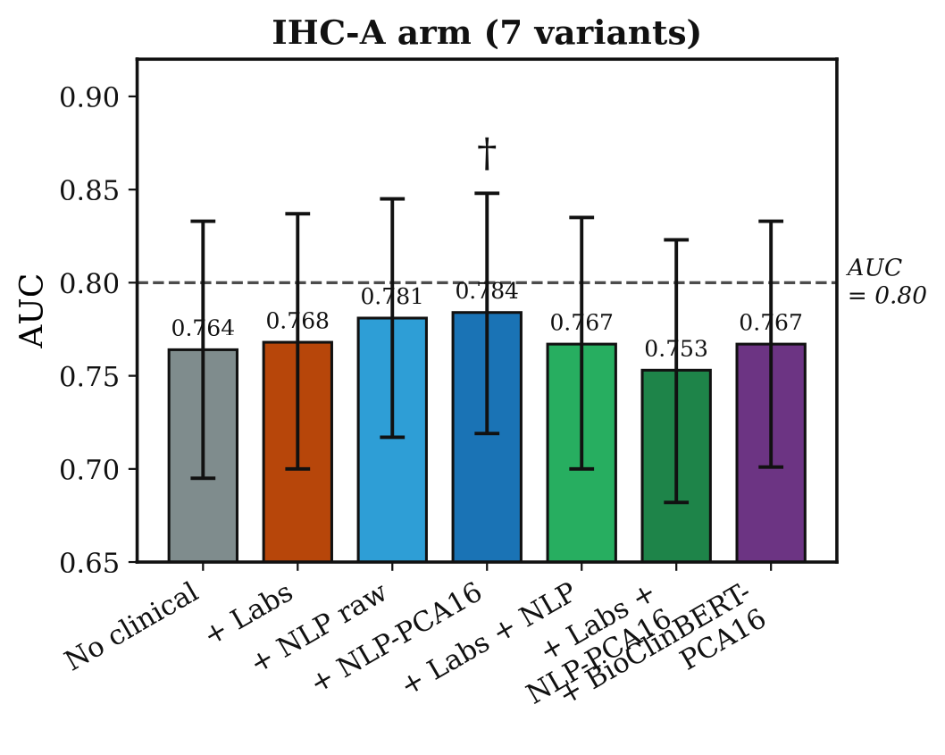
Figure 4A. AUC comparison across clinical encoding strategies, IHC-A arm (7 variants). Bars show pooled out-of-fold AUC from 10-fold cross-validation (n = 247); error bars denote DeLong 95% confidence intervals. The dashed horizontal line at AUC = 0.80 indicates the conventional threshold for clinically useful discrimination.
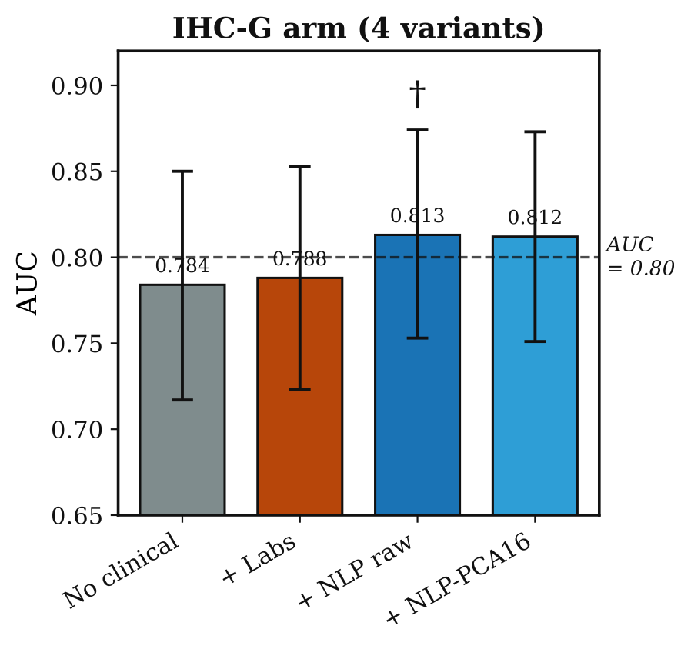
Figure 4B. AUC comparison across clinical encoding strategies, IHC-G arm (4 variants). Same conventions as Figure 4A. Best-performing model overall: DyAM Rad+IHC-G+Gen+PDL1+NLP raw, AUC = 0.813.

3.4. Survival Analysis: NLP Encoding Enhances Independent Prognostic Value
The DyAM risk score was a statistically significant independent prognostic factor for PFS across all eight model variants in multivariate Cox regression (all p < 0.001, adjusted for age, ECOG performance status, serum albumin, dNLR, and liver metastasis status; Table 7).
Cox hazard ratios. NLP-PCA16 yielded the highest hazard ratio in the IHC-A arm (HR = 6.07, 95% CI: 3.50–10.52), compared with HR = 5.30 [3.10–9.07] for the no-clinical baseline and HR = 5.31 [2.88–9.79] for numeric labs. In the IHC-G arm, NLP raw achieved HR = 4.97 [2.98–8.31] versus HR = 4.74 [2.82–7.97] for no-clinical and HR = 4.49 [2.56–7.89] for numeric labs. Notably, numeric labs did not improve the hazard ratio in either arm, whereas NLP encoding consistently increased it, suggesting that sentence-embedded clinical context captures prognostic information not represented by the five Cox covariates or by raw numeric features.
Time-dependent AUC. The advantage of NLP encoding was time-dependent: in the IHC-A arm, NLP-PCA16 improved time-dependent AUC by +0.024 at 12 months and +0.020 at 18 months relative to the no-clinical baseline, with smaller differences at 6 months (+0.002). This pattern, concentrated at late timepoints, is consistent with the hypothesis that sentence embeddings primarily encode long-term survival characteristics rather than short-term binary response.
C-index. Harrell's C-index showed a consistent but modest improvement with NLP variants (ΔC = +0.005 in both IHC arms; Wilcoxon p = 0.492 and p = 0.375 for IHC-A and IHC-G, respectively), which did not reach statistical significance. The high inter-fold variance (range 0.52–0.78 across 10 folds) and the small fold size (≈25 patients per fold) explain the non-significant result independently of the true effect size.
Calibration. All models were well-calibrated, with Integrated Brier Scores of 0.172–0.175, well below the 0.25 random-classifier baseline. NLP-PCA16 in the IHC-A arm achieved the lowest IBS (0.1716), indicating marginally superior probabilistic calibration.
Kaplan–Meier stratification. Dichotomising patients at risk score = 0 produced statistically significant separation between high- and low-risk groups for all eight models (p < 0.005 by log-rank test; Table 8), with the highest χ² statistic observed for the IHC-G arm with NLP raw clinical encoding (χ² = 28.92).
Table 7. Survival analysis results across all model variants. Discovery cohort (n = 247; 209 events, 84.6%; median PFS 2.7 months). C-index: Harrell's concordance index with bootstrap 95% CI (1,000 resamples). Cox HR: hazard ratio from multivariate Cox proportional hazards regression adjusted for age, ECOG, albumin, dNLR, and liver metastases (all Cox p < 0.001). IBS: Integrated Brier Score (lower is better; < 0.25 indicates better-than-random calibration). Bold: best value per column within each IHC arm.
Model | C-index [95% CI] | Cox HR [95% CI] | IBS
IHC-A arm
No clinical | 0.623 [0.580–0.665] | 5.30 [3.10–9.07] | 0.1745
+ Labs | 0.626 [0.583–0.669] | 5.31 [2.88–9.79] | 0.1739
+ NLP raw | 0.625 [0.583–0.663] | 5.91 [3.40–10.25] | 0.1723
+ NLP-PCA16 | 0.628 [0.584–0.668] | 6.07 [3.50–10.52] | 0.1716
IHC-G arm
No clinical | 0.626 [0.583–0.665] | 4.74 [2.82–7.97] | 0.1748
+ Labs | 0.632 [0.587–0.675] | 4.49 [2.56–7.89] | 0.1746
+ NLP raw | 0.632 [0.591–0.672] | 4.97 [2.98–8.31] | 0.1736
+ NLP-PCA16 | 0.631 [0.590–0.672] | 4.69 [2.86–7.68] | 0.1736

Table 8. Kaplan–Meier log-rank statistics for survival stratification. Patients were dichotomised at risk score = 0. Threshold for significance: χ² > 7.88 (p < 0.005). All models achieve p < 0.005. * Highest χ² across all tested models.
Model | IHC arm | χ² | p-value
DyAM No clinical | IHC-A | 28.17 | < 0.005
DyAM + NLP-PCA16 | IHC-A | 23.74 | < 0.005
DyAM No clinical | IHC-G | 20.07 | < 0.005
DyAM + NLP-PCA16 | IHC-G | 28.92* | < 0.005

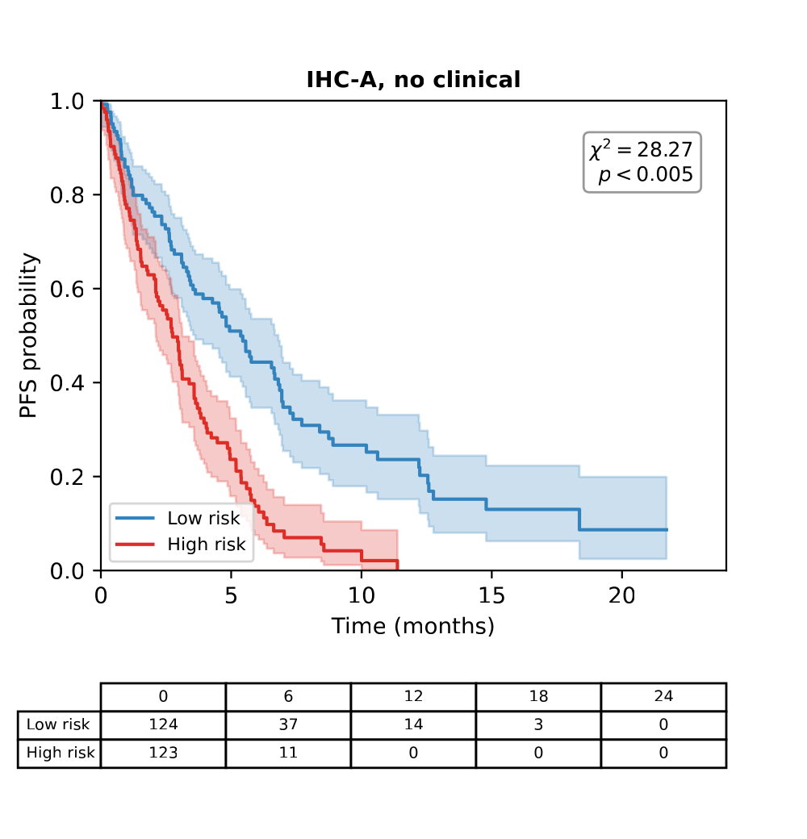
Figure 5A. Kaplan–Meier PFS curves, IHC-A arm, no clinical encoding (χ² = 28.17).
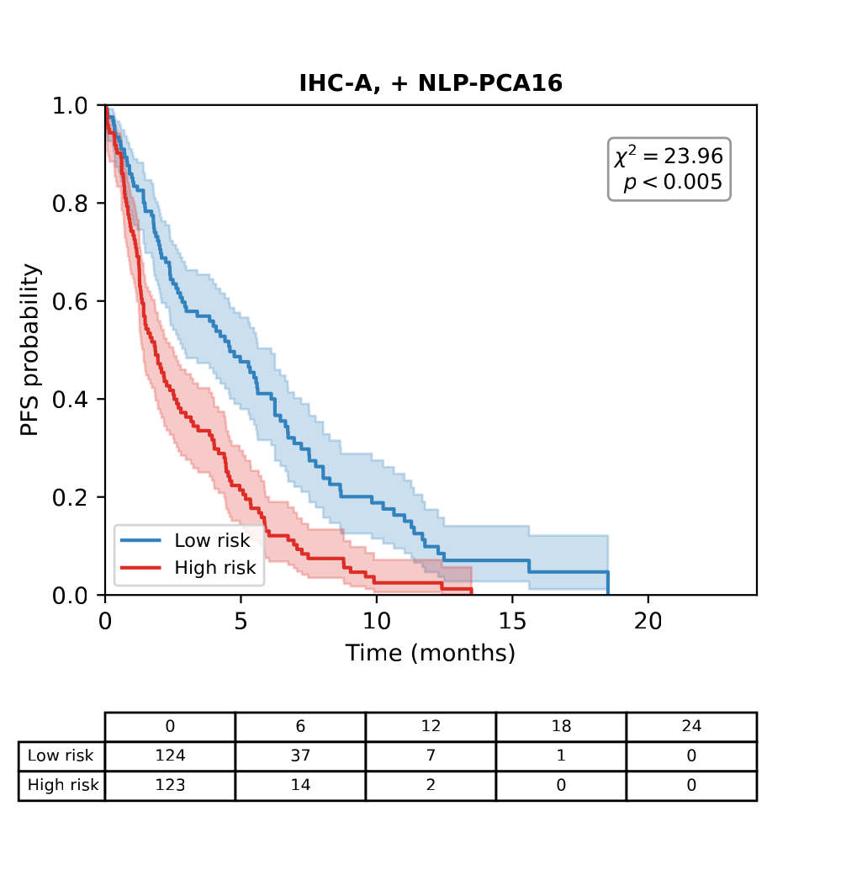
Figure 5B. Kaplan–Meier PFS curves, IHC-A arm, + NLP-PCA16 clinical encoding (χ² = 23.74).
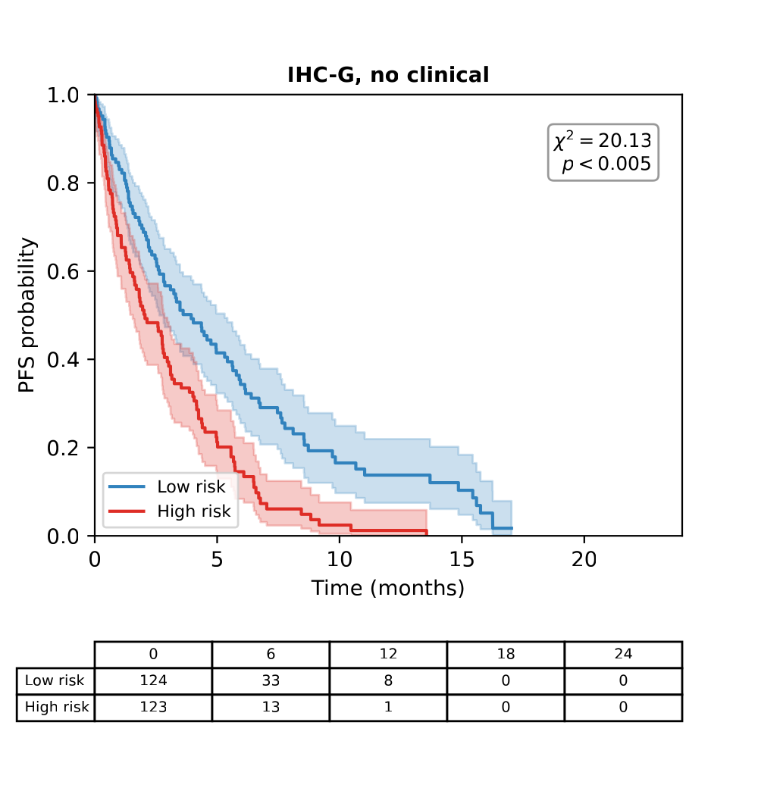
Figure 5C. Kaplan–Meier PFS curves, IHC-G arm, no clinical encoding (χ² = 20.07).
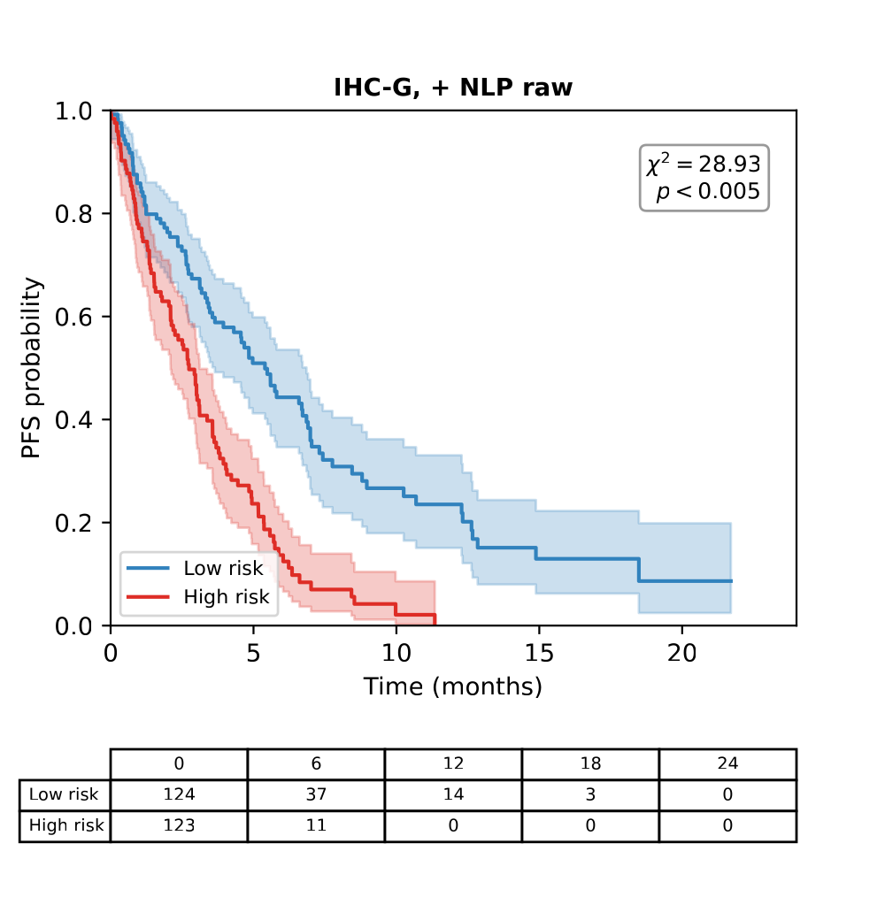
Figure 5D. Kaplan–Meier PFS curves, IHC-G arm, + NLP raw clinical encoding (χ² = 28.92, the highest log-rank statistic among all tested models). Panels A–D: patients stratified at risk score = 0 into high-risk (red) and low-risk (blue) groups, with number-at-risk tables. All comparisons reach p < 0.005 by the log-rank test.
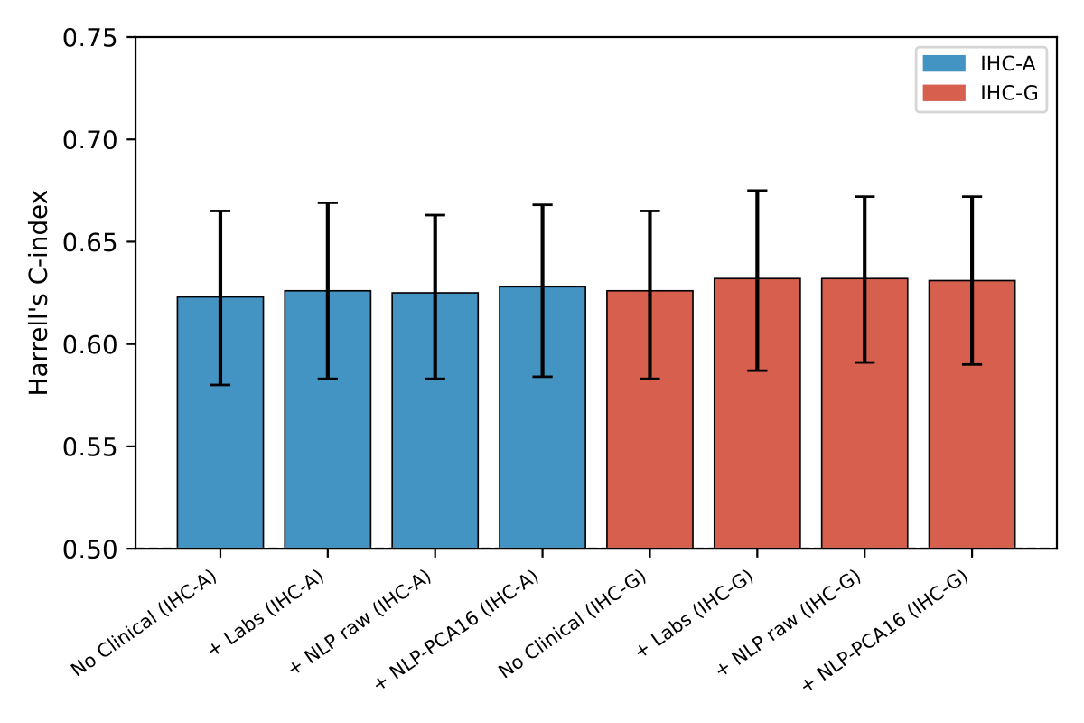
Figure 6A. Harrell's C-index (bootstrap 95% CI) for IHC-A and IHC-G arms; differences between encoding strategies were not statistically significant (paired Wilcoxon p > 0.05).
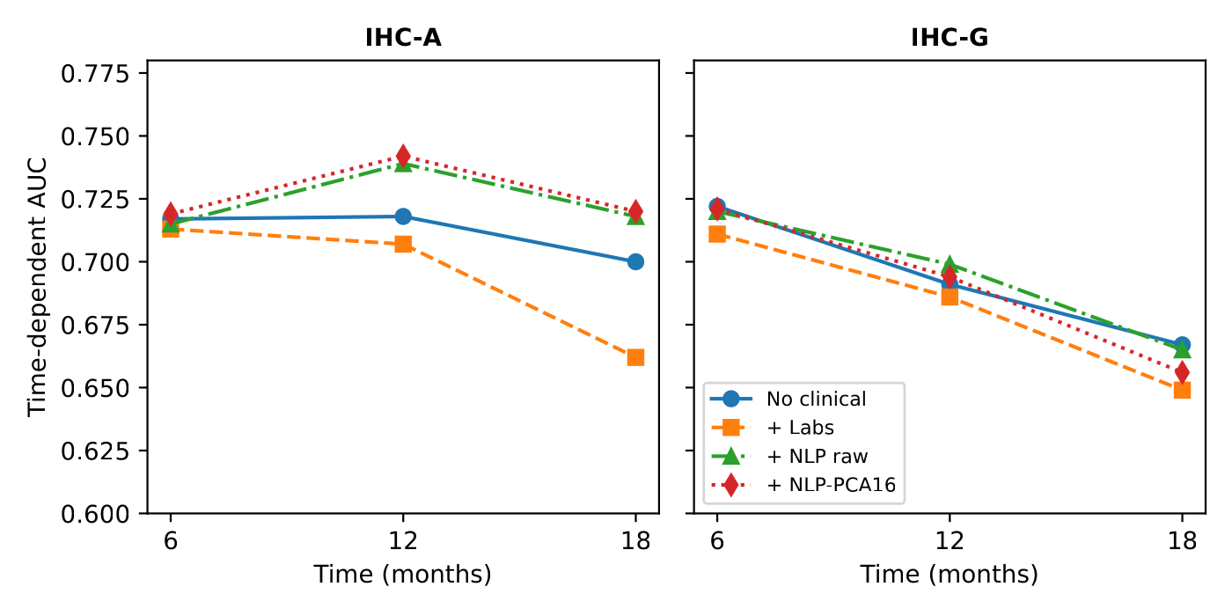
Figure 6B. Time-dependent AUC at 6, 12, and 18 months; NLP-encoded models show the largest advantage at 12–18 months.
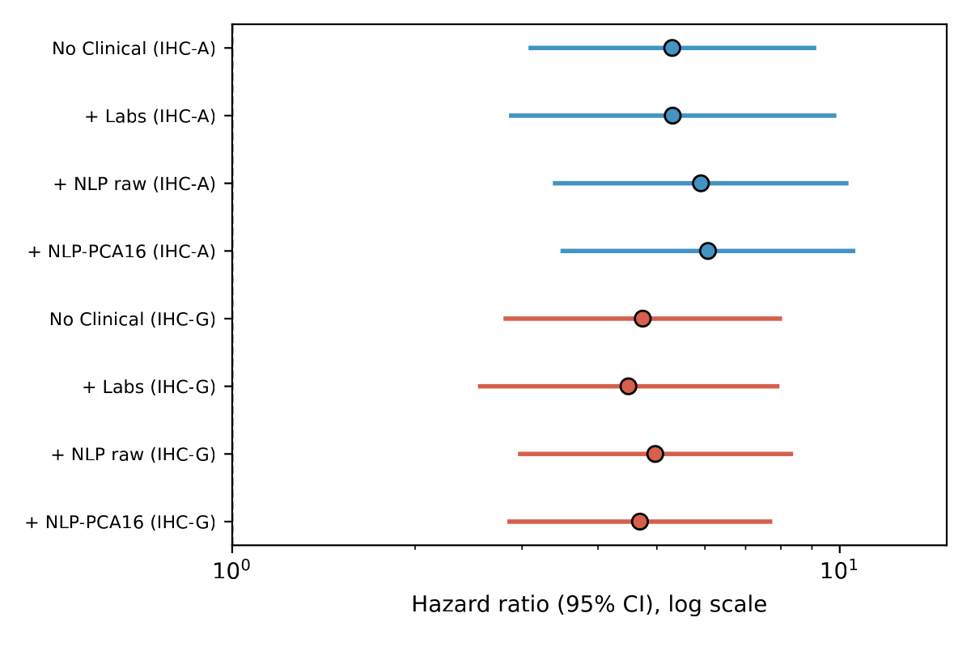
Figure 6C. Forest plot of multivariate Cox proportional hazards ratios for the fused risk score, adjusted for age, ECOG performance status, albumin, derived neutrophil-to-lymphocyte ratio, and liver metastases (all p < 0.001).
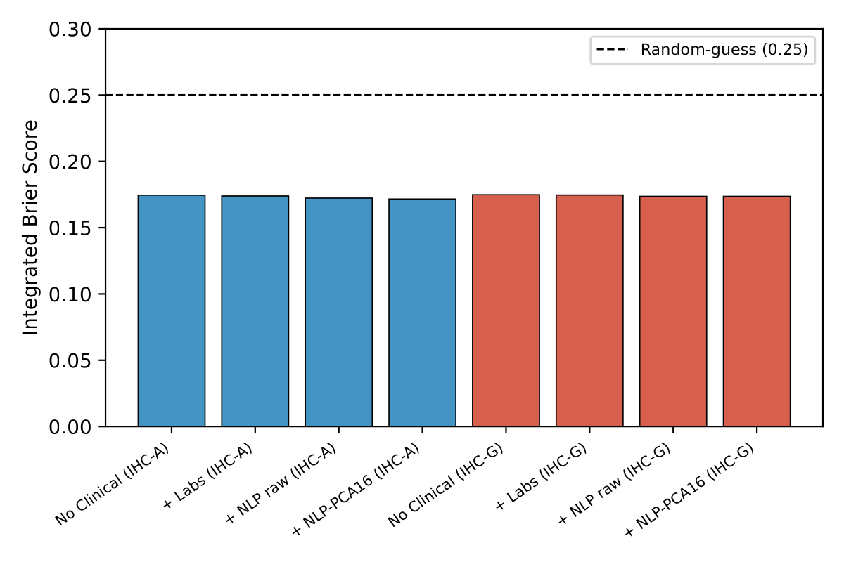
Figure 6D. Integrated Brier Score (IBS) for each model; all values fall well below the 0.25 random-guess threshold (range 0.172–0.175), indicating good calibration across all encoding strategies.

4. Discussion
In this study, we extended the DyAM multimodal attention framework with two complementary contributions: a competitive (OvO) attention mechanism and an NLP-based encoding of tabular clinical features, and evaluated both using binary classification and survival endpoints.
The best-performing model, DyAM Rad+IHC-G+Gen+PDL1+NLP raw, achieved AUC = 0.813 [95% CI: 0.753–0.874], placing it at the “good-to-excellent” discrimination threshold (AUC > 0.80) commonly used in oncology decision support [11]. For context, this exceeds the single-source models evaluated in the same cohort under the DyAM framework — PD-L1 TPS alone (AUC = 0.720) and TMB alone (AUC = 0.616) — consistent with the modest discrimination reported for these markers in the literature [4,2]. This confirms that multimodal fusion, augmented with NLP-encoded clinical context, approaches the upper range of discrimination achievable with currently available biomarkers in this disease setting.
Why does NLP encoding outperform raw numeric clinical features? We propose that sentence embeddings capture non-linear interactions between clinical variables — for example, the combined prognostic implication of advanced age, low albumin, and poor performance status — that are not explicitly represented in a 13-dimensional numeric vector. The MiniLM-L6-v2 embedding space [12,13] is pretrained to place semantically similar sentences close together; patients with similar overall clinical profiles are therefore mapped to nearby embedding vectors even when no single numeric feature dominates. Raw numeric encoding, by contrast, presents each variable to the attention mechanism independently, requiring the model to learn these interactions de novo from a relatively small training set.
The AUC improvements associated with NLP encoding (+0.017 to +0.030) did not reach statistical significance under DeLong confidence interval testing, as all CIs overlapped substantially. This is best interpreted as a power limitation rather than an absent effect. With n = 247, the 95% CI width for AUC is approximately ±0.07; detecting a true ΔAUC ≈ 0.02 at 80% power would require approximately 950–1,250 patients (Supplementary Note S3). The directional consistency of the improvement across both the IHC-A and IHC-G arms, and across raw and PCA-compressed NLP variants, supports a true but modest effect size that is currently underpowered rather than null.
The survival analysis provides an important reframing of this finding. While binary AUC improvements were modest and non-significant, multivariate Cox regression showed that NLP-PCA16 achieved the highest hazard ratio in the IHC-A arm (HR = 6.07 vs. HR = 5.30 for the no-clinical baseline), and NLP raw achieved the highest hazard ratio in the IHC-G arm (HR = 4.97 vs. HR = 4.74), whereas numeric clinical labs provided no comparable improvement in either arm. Furthermore, the time-dependent AUC advantage of NLP encoding was concentrated at 12 and 18 months (+0.024 and +0.020 in the IHC-A arm) rather than at 6 months. Taken together, these results suggest that NLP encoding of tabular clinical features predominantly captures prognostic (time-to-event) information rather than predictive (binary response) information — a distinction with direct implications for how such encodings should be evaluated in future multimodal studies.
The OvO competitive attention mechanism matched the accuracy of the original cooperative attention while using a substantially simpler parameterization. An initial single-partition screen suggested a context-dependent pattern, with OvO favoured in low-modality configurations (up to +3.27% for PDL1+Gen) and the original model favoured as more modalities were added; the overall best-performing single-partition configuration (Rad+IHC-G+Gen+PDL1, AUC = 0.8003) used OvO attention. A confirmatory repeated-seed analysis (5 seeds × 10-fold) placed the two attention mechanisms within 0.011 AUC of each other at all four primary benchmarks (p ≥ 0.17), with OvO reaching a repeated-seed mean AUC of 0.773 versus 0.760 for the cooperative model at the primary configuration — directionally favouring OvO, though the single-partition “best” configuration's rank relative to the cooperative model reversed once averaged across seeds, underscoring the value of repeated-seed evaluation over a single split.
Across all 21 configurations the repeated-seed data also reversed the direction of the context-dependence seen in the screen: OvO matched or exceeded cooperative attention in 7 of 8 configurations fusing five or more sources, but in only 5 of 9 configurations with two to four sources, where the spread between the two mechanisms was several times larger. A competitive one-vs-others weighting is plausibly better conditioned when many partially redundant sources compete, whereas with few sources the comparison against the mean of the remaining modalities is estimated from one or two values and becomes unstable; we note, however, that the effect sizes involved (≤ 0.018 AUC) sit below the seed-to-seed variability, so this remains a hypothesis generated by the data rather than a tested claim.
When combined with NLP-clinical encoding, OvO reproduced the identical fusion-dependent improvement pattern seen in the primary NLP-clinical analysis (improvement in the same 15 of 21 configurations, decline in the same six single-modality configurations), reaching AUC = 0.782 at the primary benchmark under the repeated-seed protocol (repeated-seed NLP-clinical confirmation: 0.783) and AUC = 0.8133 under the single-partition protocol at the Rad+IHC-A+Gen+TMB+PDL1 configuration — the highest value observed under either protocol in this study. OvO's practical value lies in its simpler parameterization — N independent per-modality scores compared against the mean of the remaining modalities, rather than the N × N weight matrix required by cooperative attention — delivering matching accuracy, and its improvement pattern under NLP-clinical encoding generalises across both attention mechanisms, indicating that the clinical-encoding intervention, not the choice of attention mechanism, is the source of the observed gain.
From a clinical implementation perspective, NLP encoding of structured clinical data offers practical advantages: encoding a patient profile requires less than one second on CPU, requires no labelled clinical text, and can be applied to any structured electronic health record (EHR) field that can be rendered as a sentence. This makes the approach readily transferable to other structured clinical datasets without requiring a fine-tuned clinical language model.
Several limitations should be considered. First, this was a single-institution retrospective cohort, which may limit generalisability and introduce selection bias. Second, the non-significant AUC improvement reflects the modest sample size (n = 247) rather than a definitive negative result, and larger multi-institutional cohorts are needed to confirm the observed trends. Third, the sentence encoder was applied in a zero-shot manner without fine-tuning on NSCLC-specific clinical text, which may limit its sensitivity to domain-specific terminology. Finally, PD-L1 TPS was scored using the Sauter method in this cohort, which may differ from the SP142 or 22C3 assays used at other institutions, and the generalisability of PD-L1-derived features should be interpreted with this in mind.

5. Conclusions
We extended the DyAM multimodal attention framework for ICI response prediction in NSCLC with a competitive (OvO) attention mechanism and an NLP-based encoding of structured clinical variables. Under a repeated-seed evaluation protocol, OvO attention matched the original cooperative attention at every primary benchmark configuration (within 0.011 AUC, p ≥ 0.17; AUC = 0.773 vs. 0.760 at the primary benchmark), offering a simpler, N-parameter alternative to the N × N cooperative weight matrix without a measurable accuracy cost; an initial single-partition screen had suggested a larger OvO advantage in low-modality configurations (best single-partition AUC = 0.800, later 0.8133 when combined with NLP-clinical encoding), and averaging across five independent CV partitions confirmed OvO's accuracy while showing this particular single-partition margin does not reproduce exactly.
NLP encoding of clinical features using a general-purpose sentence transformer consistently improved AUC over raw numeric encoding (up to ΔAUC = +0.030) and provided the strongest independent prognostic value in survival analysis, with the highest Cox hazard ratios and time-dependent AUC among all clinical encoding strategies, despite AUC differences not reaching statistical significance at n = 247. This improvement was confirmed under repeated-seed evaluation (NLP encoding exceeded numeric labs in 19 of 21 modality combinations) and generalised across fusion mechanisms: combining NLP-clinical encoding with OvO attention reproduced the same fusion-dependent gain, indicating that the clinical-encoding strategy, rather than the choice of attention mechanism, drives the improvement.
These findings suggest that sentence-embedding-based representations of tabular clinical data are a practical and generalisable strategy for multimodal biomarker discovery, robust to the underlying attention architecture. Validation in larger, multi-institutional cohorts is needed to confirm these findings and to establish their clinical utility for treatment selection.

Declarations
Author Contributions: Conceptualization, F.A. and T.A.; methodology, F.A. and S.A.; software, F.A.; formal analysis, F.A.; writing—original draft preparation, F.A.; writing—review and editing, S.A. and T.A.; supervision, T.A. All authors have read and agreed to the published version of the manuscript.
Funding: [Funding — e.g., This research received no external funding.]
Institutional Review Board Statement: This study was approved by the Institutional Review Board of [Institution] (Protocol No. [IRB Number]).
Informed Consent Statement: Informed consent was obtained from all subjects involved in the study.
Data Availability Statement: The code used in this study is available at https://github.com/[repo]. Patient-level data are subject to institutional data-sharing agreements and available upon reasonable request.
Conflicts of Interest: The authors declare no conflicts of interest.

References
1. Siegel RL, Giaquinto AN, Jemal A. Cancer Statistics, 2024. CA Cancer J Clin. 2024;74:12–49. doi:10.3322/caac.21820
2. Reck M, Rodríguez-Abreu D, Robinson AG, et al. Pembrolizumab versus Chemotherapy for PD-L1-Positive Non-Small-Cell Lung Cancer. N Engl J Med. 2016;375:1823–1833. doi:10.1056/NEJMoa1606774
3. Borghaei H, Paz-Ares L, Horn L, et al. Nivolumab versus Docetaxel in Advanced Nonsquamous Non-Small-Cell Lung Cancer. N Engl J Med. 2015;373:1627–1639. doi:10.1056/NEJMoa1507643
4. Rizvi NA, Hellmann MD, Snyder A, et al. Mutational landscape determines sensitivity to PD-1 blockade in non-small cell lung cancer. Science. 2015;348:124–128. doi:10.1126/science.aaa1348
5. Herbst RS, Baas P, Kim DW, et al. Pembrolizumab versus docetaxel for previously treated, PD-L1-positive, advanced non-small-cell lung cancer (KEYNOTE-010). Lancet. 2016;387:1540–1550. doi:10.1016/S0140-6736(15)01281-7
6. Bodalal Z, Trebeschi S, Nguyen-Kim TDL, et al. Radiogenomics: bridging imaging and genomics. Abdom Radiol. 2019;44:1960–1984. doi:10.1007/s00261-019-02028-w
7. Dercle L, Fronheiser M, Lu L, et al. Identification of Non-Small Cell Lung Cancer Sensitive to Systemic Cancer Therapies Using Radiomics. Clin Cancer Res. 2020;26:2151–2162. doi:10.1158/1078-0432.CCR-19-2942
8. Trebeschi S, Drago SG, Birkbak NJ, et al. Predicting Response to Cancer Immunotherapy Using Noninvasive Radiomic Biomarkers. Ann Oncol. 2019;30:998–1004. doi:10.1093/annonc/mdz108
9. Cheerla A, Gevaert O. Deep Learning with Multimodal Representation for Pancancer Prognosis Prediction. Bioinformatics. 2019;35:i446–i454. doi:10.1093/bioinformatics/btz342
10. Ma M, Ren J, Zhao L, et al. SMIL: Multimodal Learning with Severely Missing Modality. Proc AAAI Conf Artif Intell. 2021;35(3):2302–2310. doi:10.1609/aaai.v35i3.16330
11. Vanguri RS, Luo J, Aukerman AT, et al. Multimodal integration of radiology, pathology and genomics for prediction of response to PD-(L)1 blockade in patients with non-small cell lung cancer. Nat Cancer. 2022;3(10):1151–1164. doi:10.1038/s43018-022-00416-8
12. Reimers N, Gurevych I. Sentence-BERT: Sentence Embeddings using Siamese BERT-Networks. Proc 2019 Conf Empir Methods Nat Lang Process (EMNLP). 2019:3982–3992. doi:10.18653/v1/D19-1410
13. Wang W, Wei F, Dong L, et al. MiniLM: Deep Self-Attention Distillation for Task-Agnostic Compression of Pre-Trained Transformers. Adv Neural Inf Process Syst (NeurIPS). 2020;33:5776–5788.
14. Alsentzer E, Murphy JR, Boag W, et al. Publicly Available Clinical BERT Embeddings. Proc 2nd Clinical Nat Lang Process Workshop. 2019:72–78. doi:10.18653/v1/W19-1909
15. Vaswani A, Shazeer N, Parmar N, et al. Attention Is All You Need. Adv Neural Inf Process Syst (NeurIPS). 2017;30.
16. Hastie T, Tibshirani R. Classification by Pairwise Coupling. Ann Stat. 1998;26:451–471. doi:10.1214/aos/1028144844
17. DeLong ER, DeLong DM, Clarke-Pearson DL. Comparing the Areas under Two or More Correlated Receiver Operating Characteristic Curves: A Nonparametric Approach. Biometrics. 1988;44:837–845. doi:10.2307/2531595
18. Harrell FE, Lee KL, Mark DB. Multivariable Prognostic Models: Issues in Developing Models, Evaluating Assumptions and Adequacy, and Measuring and Reducing Errors. Stat Med. 1996;15:361–387. doi:10.1002/(SICI)1097-0258(19960229)15:4<361::AID-SIM168>3.0.CO;2-4

