User’s guide

# I) Input data:

Go to the URL: <http://archive.ics.uci.edu/ml/datasets.html> for downloading the data set you would like to classify

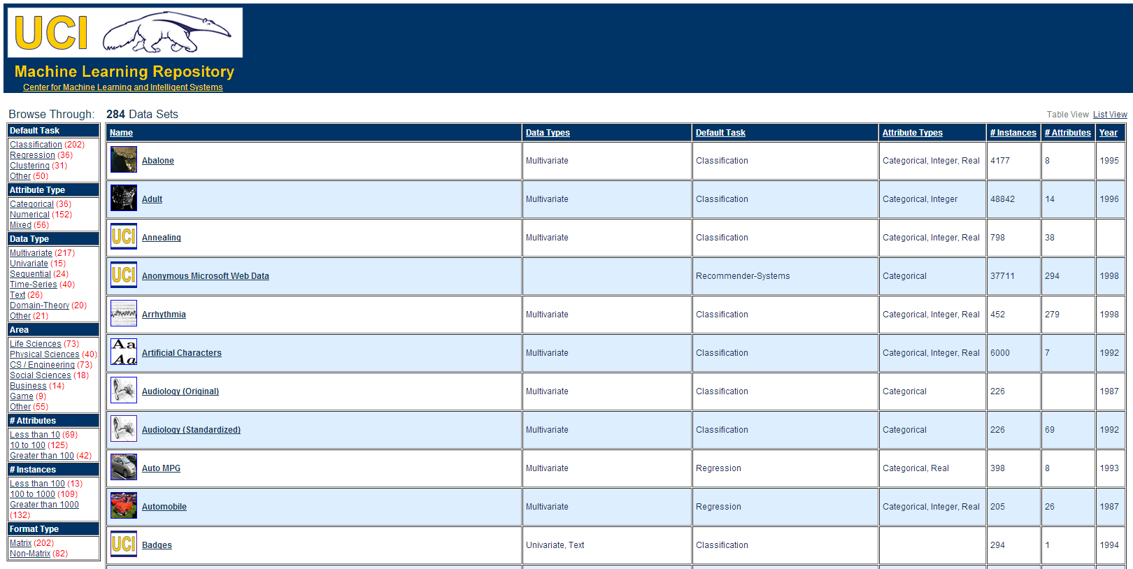

For example, we use Soybean data set, click onto “Data Folder” link for downloading

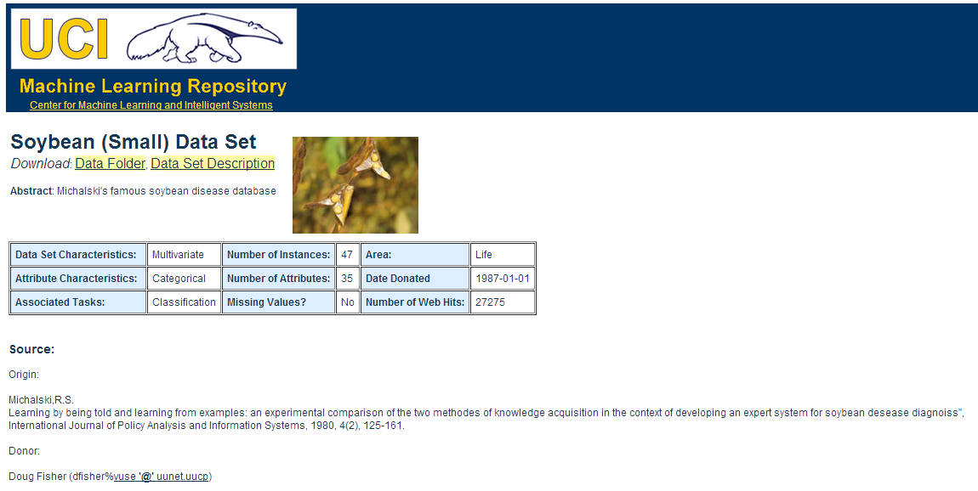

In this folder you will find its data set and together with its specification as below:

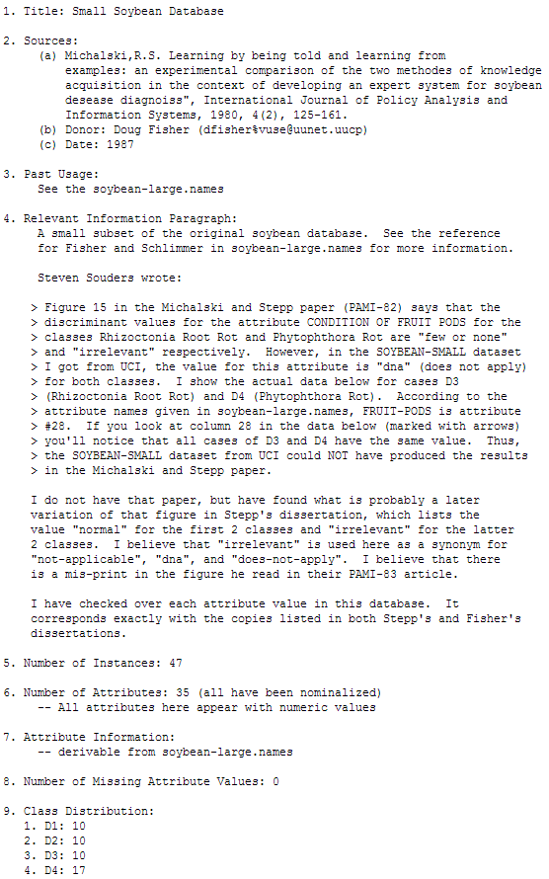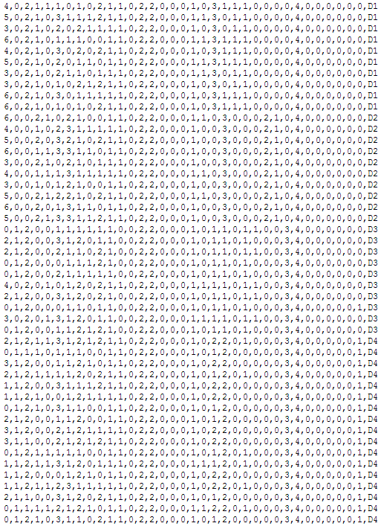

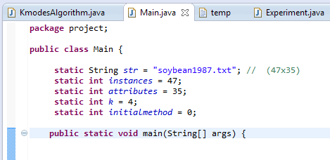You must save the its data in a text file (.txt), after that, you need import the file path in Main.java. Don’t forget declare the number of instances, attributes and number of modes you would like to classify as well.

# II) Run the algorithm:

1. Selecting initial methods:

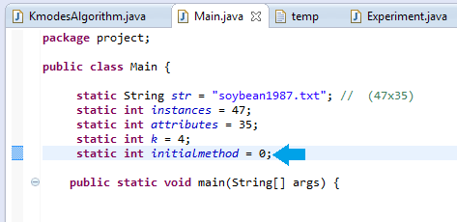For choosing the initial method option we declare as values below:

0: Default random selection initial modes

1: Default random selection initial modes with “Dissimilarity Measures” duplication avoidance

2: 2nd initial method is mentioned in paper

1. Run program:

Press Ctr+F11 for running the application if you use Eclipse IDE:

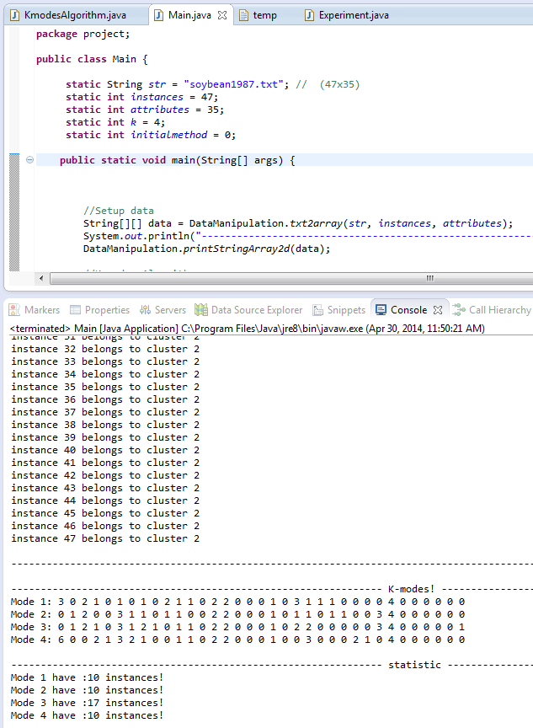

Then the result will appear on the console tab like in the figure x.xx . Otherwise, you could trace what are the operations the program did by scroll up the Console tab

1. Experiment:

To get the experiment the first thing is go to the Experiment class the declare the additional times variable that you want to experiment, in this case we input 100 times then press Ctr+F11 for run the application.

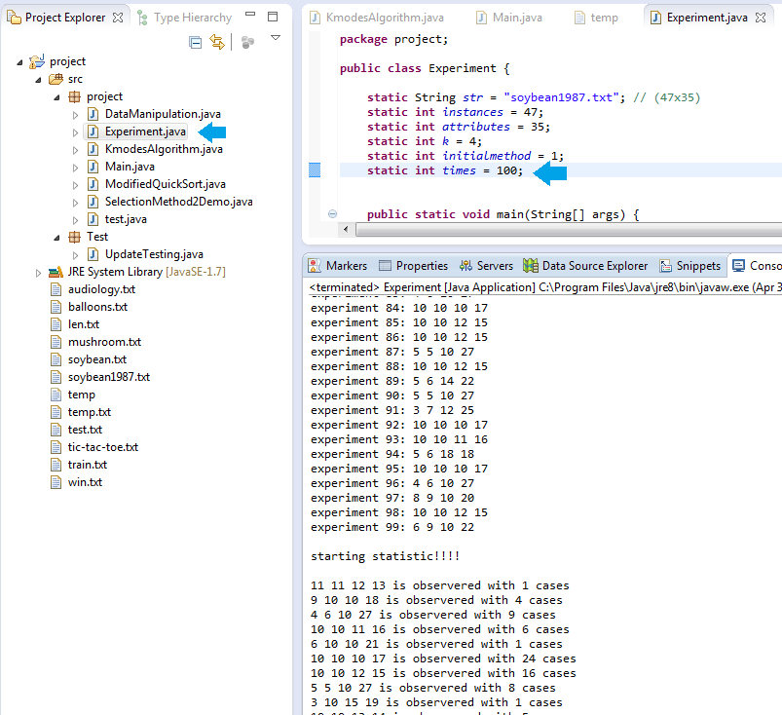

We will get statistic results visually.