Undergraduate Final Year Project Proposal
PROJECT PROPOSAL
2D Game “Knight Vs Monsters”
Nguyen Thanh Nhan
Bachelor of Science with Honours in Computing
GCS18653

Overview
The increasing demand for entertainment along with the development of technology platforms makes game development a very attractive profession for me. From the software field, the game gradually split into a separate industry because of its outstanding development and the ability to bring in huge revenue, accounting for the highest proportion in the information technology industry. For this graduate project, I will develop a game called "Knight Vs Monsters". Project "Knight Vs Monsters" is an action 2D game project. The game will have 2 main levels of gameplay, players can role-play the character and move to destroy the monster, then the character will be transferred to a new screen. To accomplish my project goals, I use Unity cross-platform game creation software.
I use this software because Unity firstly provides a comprehensive system for programmers, from drafting source code, building automation tools to debugging, so it is quite easy to use. Unity's main programming language is C #, which also supports Javascript. Second, Unity also takes advantage of the functions of software libraries such as PhysicX physics simulation engine from Nvidia, OpenGL and Direct3D to render 3D images, OpenAL for sound, very powerful support for programming game. In addition, I also learn more about C # code and unity script API from basic to advanced for this project.
In the project, I also use some open source code such as unity script API and some images that are allowed to use free in the reference below.

Aim
My dream is to become a game developer with Unity cross-platform software. That's why, in this project, I'll accomplish my first goal of creating an action game that runs on PC.

Objectives
3.1. Knowledge of action game programming
3.1.1 Learn the definitions, types and basic programming concepts of the game. [1.0]
3.1.2 Research the structure and characteristics of the elements and components of an action game. [1.0]
3.1.3 Review, experience some action games are created with Unity and use the C # language. [5.0]
3.2. Learn and learn about C #
3.2.1 Find general information about C #. [2.0]
3.2.2 Learn about the basic programming in C # (variable value, command loop, If-esle, operator types). [4.0]
3.2.3 Learn about object oriented programming in C #. [2.0]
3.3 Learn and use software to make games Unity
3.3.1 Carefully study the features and how to use the selected Unity software. [2.0]
3.3.2 Learn the structure of Unity (create project, set up background, create game object, create Sprite). [1.0]
3.3.3 Learn the Unity Scripting API. [4.0]
Architecture design
3.4 Implementation of the example
3.4.1 Building ideas and game flow. [5.0]
3.4.2 Design of game functions. [5.0]
3.4.3 Designing the game interface. [5.0]
3.4.4 Checking and fixing bugs in the game. [5.0]

Legal, Social, Ethical and Professional
Legal:
- C # is the publishing language of the World Wide Web.
- My Unity cross-platform game production software has been licensed to use for free.
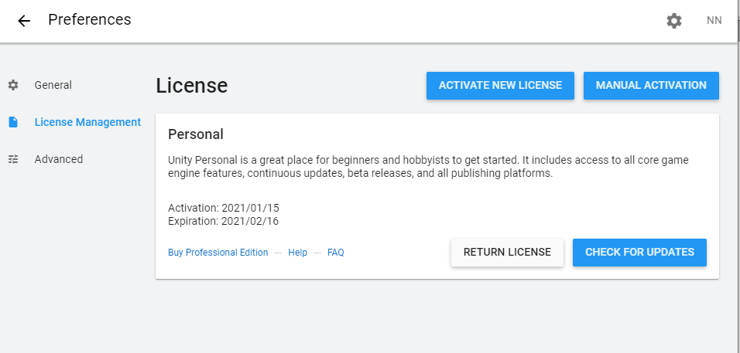
(Technologies, 2021).
- Images that I use in this post are permitted from the website.
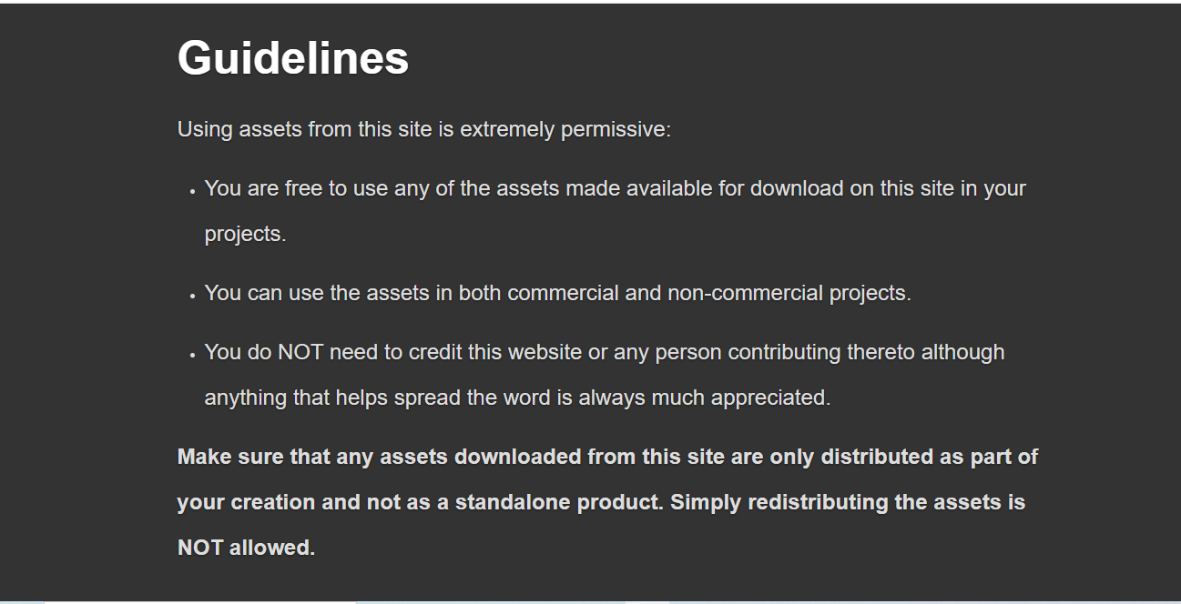
(Guidelines | Dev Assets, 2021).
- Other materials used in my project will come from either free sources or legal copies.
- This project belongs to me and the University of Greenwich.
Society:
- My games are for entertainment and free to use.
- The game will not adversely affect human personality and do not involve social evils.
Morality:
- This project is my own effort, the result of learning and learning.
- There is no plagiarism behaviour in the project.
Professional:
- Ensure that you are knowledgeable and knowledgeable about the Law and that you comply with the Law, in the performance of your professional responsibilities.
- Respect and value alternative perspectives, and seek, accept, and make honest work criticism.
- Used for personal purposes or for the benefit of a third party, confidentiality when permitted by Greenwich University or required by Law (Trustee Board Regulations Schedule 3 v4, 2011).

Planning (see appendix A)
First, I spent 11 days thinking about the topic for my project. Next, I write the proposal and complete it with the guidance of the instructor in about 20 days.
Second, I spent 86 days learning the C # programming language and how to use the Unity cross-platform game software.
Third, after learning programming languages. I proceed to build my game project step by step. In the end, I spent 25 days checking and fixing bugs in the game.
Finally, I wrote a complete report and spent 25 days preparing the project presentation. During these days, I review and re-examine the completed project and prepare my presentation.

Initial References
- Codelearn.io. 2021. Lập Trình Game Với Unity Như Thế Nào (Phần 1). [online] Available at: <https://codelearn.io/sharing/lap-trinh-game-voi-unity-nhu-the-nao-phan-1> [Accessed 3 February 2021].
- Devassets.com. 2021. Guidelines | Dev Assets. [online] Available at: <https://devassets.com/guidelines/> [Accessed 4 February 2021].
- Technologies, U., 2021. Unity - Unity. [online] Unity. Available at: <https://unity.com/> [Accessed 4 February 2021].
- Bcs.org. 2021. [online] Available at: <https://www.bcs.org/media/2211/bcs-code-of-conduct.pdf> [Accessed 4 February 2021].
- Technologies, U., 2021. Unity - Scripting API:. [online] Docs.unity3d.com. Available at: <https://docs.unity3d.com/ScriptReference/> [Accessed 26 February 2021].
- Google Docs. 2021. Turret_ForTutorial_2.png. [online] Available at: <https://drive.google.com/file/d/0B2McEWPOIJDecFVpSjVKcjIwUzQ/view> [Accessed 26 February 2021].
- Google Docs. 2021. Ye_Oldy_Knight_Guy.png. [online] Available at: <https://drive.google.com/file/d/0B2McEWPOIJDeUEl1Y0ZLekQ0dTQ/view> [Accessed 26 February 2021].
- Kenney.nl. 2021. Kenney • Platformer Art: Extended Tileset. [online] Available at: <https://www.kenney.nl/assets/platformer-art-extended-tileset> [Accessed 26 February 2021].

Appendix A - Schedule of Work
