

Software Requirement Specification

Project Code:

Document Code: SRS_V0.1

Record of change

*A - Added M - Modified D - Deleted

|  |  |  |  |  |
| --- | --- | --- | --- | --- |
| Effective Date | Changed Items | A* M, D | Change Description | New Version |
| 04/01/2017 |  |  |  | 0.1 |
|  |  |  |  |  |
|  |  |  |  |  |
|  |  |  |  |  |
|  |  |  |  |  |
|  |  |  |  |  |
|  |  |  |  |  |
|  |  |  |  |  |
|  |  |  |  |  |
|  |  |  |  |  |
|  |  |  |  |  |
|  |  |  |  |  |
|  |  |  |  |  |
|  |  |  |  |  |
|  |  |  |  |  |
|  |  |  |  |  |
|  |  |  |  |  |
|  |  |  |  |  |
|  |  |  |  |  |

SIGNATURE PAGE

**ORIGINATOR:** KienTX2 04/01/2017

Developer

**REVIEWERS:** <Name> <Date>

<Position>

<Name, if it’s needed> <Date>

<Position>

**APPROVAL:** <Name> <Date>

<Position>

TABLE OF CONTENTS

Table of Contents

1. Introdution 5

1.1 Purpose 5

1.2 Scope 5

1.3 Definitions, Acronyms, and Abbreviations 5

1.4 References 5

1.5 Overview 5

2. Overall Description 7

3. Specific Requirements 8

3.1 Functionality 8

3.2 Usability 92

3.3 Reliability 92

3.4 Performance 92

3.5 Supportability 92

3.6 Design Constraints 92

3.7 On-line User Documentation and Help System Requirements 92

3.8 Interfaces 92

3.9 Licensing Requirements 92

3.10 Legal, Copyright, and Other Notices 92

3.11 Applicable Standards 92

4. Supporting Information 93

# Introdution

## **Purpos**e

Documentation for detailed specifications of functional and non-functional requirement for the system of a restaurant. This document is used as a template for design and development the system.

## Scope

The document is intended for Project Manager, Designer, Developer, Tester who will implement and test the software requirements. So it not only provides the ability to read and understand at a high level for those who are not specialized in engineering, but also provide full technical specification for developers and testers.

## Definitions, Acronyms, and Abbreviations

## References

## Overview

|  |  |  |  |  |  |
| --- | --- | --- | --- | --- | --- |
| **Functional Group** | | | **No** | **Functional** | **Note** |
| **System** | | | 1 | Log in |  |
| 2 | Log out |  |
| 3 | Forgot Password |  |
| 4 | Change Password |  |
| 5 | Home Page |  |
| **Product Management** | **Product** | | 6 | Add Product |  |
| 7 | Search Product |  |
| 8 | Update Product |  |
| 9 | Delete Product |  |
| **Product Category** | | 10 | Add Product Category |  |
| 11 | Search Product Category |  |
| 12 | Update Product Category |  |
| 13 | Delete Product Category |  |
| **Employee Management** | | | 14 | Add Employee |  |
| 15 | Search Employee |  |
| 16 | Update Employee Information |  |
| 17 | Delete Employee |  |
| **Promotion Management** | | | 18 | Create Promotion |  |
| 19 | Search Promotion |  |
| 20 | Update Promotion |  |
| **Customer Management** | | | 21 | Add Customer |  |
| 22 | Search Customer Information |  |
| 23 | Update Customer Information |  |
| 24 | Delete Customer |  |
| **Table Management** | | **Table** | 25 | Add Table |  |
| 26 | Search Table |  |
| 27 | Update Table |  |
| 28 | Delete Table |  |
| **Group Table** | 29 | Add Group Table |  |
| 30 | Search Group Table |  |
| 31 | Update Group Table |  |
| 32 | Delete Group Table |  |
| **Material Receipt Management** | | | 33 | Create Material Receipt |  |
| 34 | Search Material Receipt |  |
| 35 | Show Material Receipt Detail |  |
| 36 | Update Material Receipt |  |
| 37 | Delete Material Receipt |  |
| **Bill Management** | | | 38 | Show Bill Detail |  |

# Overall Description

# Specific Requirements

## Functionality

### Log In

|  |  |
| --- | --- |
| Description | Manager login to system. |
| Actor | Manager |
| Pre-condition | Was registered by administrator and correcspones to the role of that account. |
| Post-condition | Login success and display Home page with role of that account. |
| Data Table | Account |
| Usage Frequency | Often | Regular | Low |
| Criticality | High | Normal | Low |
| Denpendencies | N/A |

**Activity Flow**

|  |  |
| --- | --- |
| Actor | System |
| 1. Manager access to application | 2. System display Login Page. |
| 3. Manager input account and password |  |
| 4. Manager Press Button “Đăng nhập” | 5. System display Home Page with functional according to the account |

**Alternative Flow**

* Log in fail: System display notification: “Tài khoản hoặc mật khẩu không đúng”, and manager will try to log in again.
* If manager forgot password, manager can press on button “Quên mật khẩu?” to get back their password.
* System will display screen “Lấy lại mật khẩu” for user to get new password.

**Bussiness Rules**

|  |  |
| --- | --- |
| BR ID | Description |
| BR 1 | Username is invalid, must not contain special character, exp: ~, `, !, @, #, $, %, ^, &, *, (, ), _, -, +, =, :, ;, “, ‘, [, {, ], }, |, \, /, ?, <, >, “,”, “.” . |
| BR 2 | Password must have length from 6 to 30 character and must be contain at least one uppercase character, lowercase character and number and must not include special character : !, @, #.  Password must be transferred to character “*” to privacy. |
| BR 3 | If username and password is incorrect, system will notify error to manager and allow user to log in again |

**Wireframes**

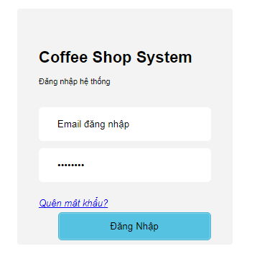

Wireframes 3.1.1 Login

**Wireframes Description**

|  |  |  |  |
| --- | --- | --- | --- |
| No | Control Name | Control Type | Description |
|  | | | |
| 1 | User name textbox | TextBox |  |
| 2 | Password textbox | TextBox |  |
| 3 | “Đăng nhập” button | Button |  |
| 4 | Error Notification | Label |  |
| 5 | “Quên Mật khẩu” | Button |  |

### Log out

|  |  |
| --- | --- |
| Description | Manager log out of system |
| Actor | Manager |
| Pre-condition | Manager was logged in to system |
| Post-condition | Manager log out of system successfully |
| Data Table | N/A |
| Usage Frequency | Often | Regular | Low |
| Criticality | High | Normal | Low |
| Denpendencies | N/A |

**Activity Flow**

|  |  |
| --- | --- |
| Actor | System |
| 1. Manager press button Log out | 2. System display Log In screen |

**Alternative Flow**

N/A

**Bussiness Rules**

|  |  |
| --- | --- |
| BR ID | Description |
|  |  |

**Wireframes**

N/A

**Wireframes Description**

|  |  |  |  |
| --- | --- | --- | --- |
| No | Control Name | Control Type | Description |
|  |  |  |  |
|  |  |  |  |

### Forgot Password

|  |  |
| --- | --- |
| Description | Manager can get new password when they are forget |
| Actor | Manager |
| Pre-condition | Manager press on button “Quên mật khẩu?” and they must remember username |
| Post-condition | Manager get new password from system |
| Data Table | N/A |
| Usage Frequency | Often | Regular | Low |
| Criticality | High | Normal | Low |
| Denpendencies | N/A |

**Activity Flow**

|  |  |
| --- | --- |
| Actor | System |
| 1. Manager press on button “Quên mật khẩu?” | 2. System display field to input username and retrieve password |
| 3. Manager input email or username which registration with administrator |  |
| 4. Manager press on button “Tìm” | 5. System looking for account on system and send an email with new password to manager |

**Alternative Flow**

* Wrong username or email: System will show notification that username or email is not exists in the system and allow manager to input again.

**Bussiness Rules**

|  |  |
| --- | --- |
| BR ID | Description |
| BR 1 | Email must have right format, contain ’@’ |

**Wireframes**

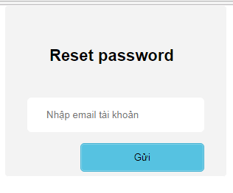

Wireframes 3.1.3 Forgot Password

**Wireframes Description**

|  |  |  |  |
| --- | --- | --- | --- |
| No | Control Name | Control Type | Description |
| 1 | Account, Email Input | Textbox |  |
| 2 | “Tìm” button | Button | System looking for account and send email with new pass |

### Change Password

|  |  |
| --- | --- |
| Description | Manager can change their password |
| Actor | Manager |
| Pre-condition | Manager was logged in to system |
| Post-condition | Manager change their password successfully |
| Data Table | N/A |
| Usage Frequency | Often | Regular | Low |
| Criticality | High | Normal | Low |
| Denpendencies | N/A |

**Activity Flow**

|  |  |
| --- | --- |
| Actor | System |
| 1. Manager press on button “Đổi mật khẩu” | 2. System display dialog “Đổi mật khẩu” |
| 3. Manager input all the fields |  |
| 4. Manager press on button “Thay đổi mật khẩu” | 5. System change password and show notification password changed |

**Alternative Flow**

* Manager don’t input all required fields. System will notify manager “Vui lòng nhập các trường bắt buộc”.
* New Password and Confirm New Password Field not match. System will notify manager “Mật khẩu và Xác nhận mật khẩu không khớp”.
* New Password is the same with Old Password. System will notify manager “Mật khẩu mới không được giống mật khẩu cũ”.
* Password is invalid. System will notify manager “Vui lòng nhập mật khẩu chứa ít nhất một ký tự hoa, thường, số và không có ký tự đặc biệt”.

**Bussiness Rules**

|  |  |
| --- | --- |
| BR ID | Description |
| BR 1 | Password must have length from 6 to 30 character and must be contain at least one uppercase character, lowercase character and number and must not include special character : !, @, #. |
| BR 2 | New Password and Old Password must be the same. |

**Wireframes**

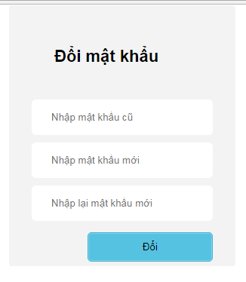

WireFrames 3.1.4 Change Password

**Wireframes Description**

|  |  |  |  |
| --- | --- | --- | --- |
| No | Control Name | Control Type | Description |
| 1 | Old Password | Textbox |  |
| 2 | New Password | Textbox |  |
| 3 | Retype Password | Textbox |  |
| 4 | “Thay đổi mật khẩu” button | Button |  |

### Home Page

|  |  |
| --- | --- |
| Description | Display Home page with the role according to account |
| Actor | Manager |
| Pre-condition | Login Success |
| Post-condition | Display Home Page |
| Data Table | N/A |
| Usage Frequency | Often | Regular | Low |
| Criticality | High | Normal | Low |
| Denpendencies | N/A |

**Activity Flow**

|  |  |
| --- | --- |
| Actor | System |
| 1. Manager access to application | 2. System display Login Page. |
| 3. Manager input account and password |  |
| 4. Manager Press Button “Đăng nhập” | 5. System display Home Page with functional according to the account |

**Alternative Flow**

* Log in fail: Home Page will not display

**Bussiness Rules**

|  |  |
| --- | --- |
| BR ID | Description |
| BR 01 | Home Page will display features according to account |

**Wireframes**

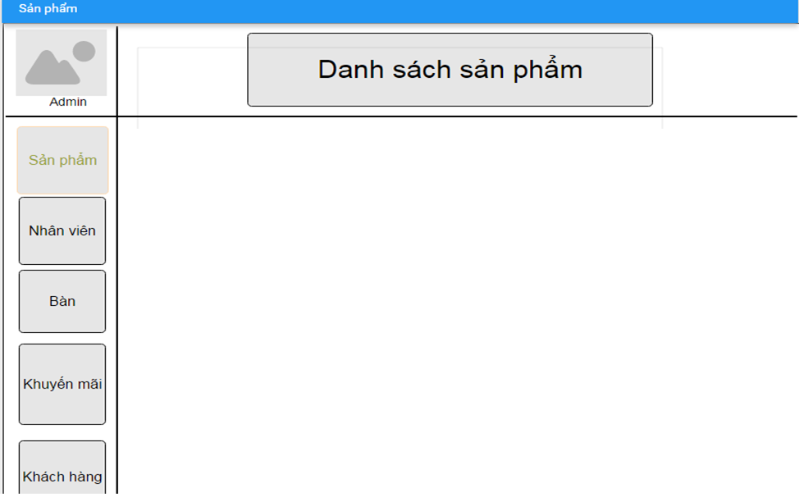

Wireframes 3.1.5 Home Page

**Wireframes Description**

|  |  |  |  |
| --- | --- | --- | --- |
| No | Control Name | Control Type | Description |
|  |  |  |  |
|  |  |  |  |

### Add Product

|  |  |
| --- | --- |
| Description | Manager can add new product for their restaurant |
| Actor | Manager |
| Pre-condition | Manager log in to system and press on button “Thêm sản phẩm” in Product Page |
| Post-condition | New product added to database |
| Data Table | Product |
| Usage Frequency | Often | Regular | Low |
| Criticality | High | Normal | Low |
| Denpendencies | N/A |

**Activity Flow**

|  |  |
| --- | --- |
| Actor | System |
| 1. Manager access to application |  |
| 2. Manager access to Product Feature | 3. System display Product Screen |
| 4. Manager press on button “Thêm Sản Phẩm” | 5. System display Add Product Dialog |
| 6. Manager input all require fields |  |
| 7. Manager press on button “Save” | 8. System save new product to database |
|  | 9. System show dialog to notify successfully |

**Alternative Flow**

* Not input all require field: system will notify manager “Vui lòng nhập các trường bắt buộc”.
* Invalid input: system will notify manager with each field have invalid input.
* Product Name already exists in database: system will notify manager “Sản phẩm đã tồn tại”.

**Bussiness Rules**

|  |  |
| --- | --- |
| BR ID | Description |
| BR 1 | If manager have not input all required fields, system will show error |
| BR 2 | If have invalid field, system will show error below that field. |

**Wireframes**

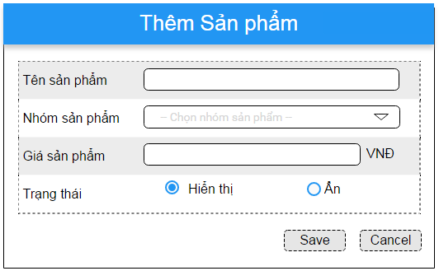

Wireframes 3.1.6 Add Product

**Wireframes Description**

|  |  |  |  |
| --- | --- | --- | --- |
| No | Control Name | Control Type | Description |
|  | | | |
| 1 | “Tên sản phẩm” Label | Label |  |
| 2 | Product Name | Textbox |  |
| 3 | “Nhóm sản phẩm” Label | Label |  |
| 4 | Product Category | Listbox |  |
| 5 | “Gía sản phẩm” Label | Label |  |
| 6 | Price | Textbox |  |
| 7 | “Trạng thái” Label | Label |  |
| 8 | Status | ComboBox |  |
| 9 | “Save” Button | Button |  |
| 10 | “Cancel” Button | Button |  |

### Search Product

|  |  |
| --- | --- |
| Description | Manager list products they want to show |
| Actor | Manager |
| Pre-condition | Manager login to system, and access to Product Feature |
| Post-condition | System show list product by filter |
| Data Table | Product |
| Usage Frequency | Often | Regular | Low |
| Criticality | High | Normal | Low |
| Denpendencies | N/A |

**Activity Flow**

|  |  |
| --- | --- |
| Actor | System |
| 1. Manager access to application |  |
| 2. Manager access to Product Feature | 3. System display Product Screen |
| 4. Manager input to filter fields (not require) |  |
| 5. Manager press on button “Áp dụng” | 6. System search on database by filter fields |
|  | 7. System show products on list view |

**Alternative Flow**

* Not found product: System will show message under header of the list view.

**Bussiness Rules**

N/A

**Wireframes**

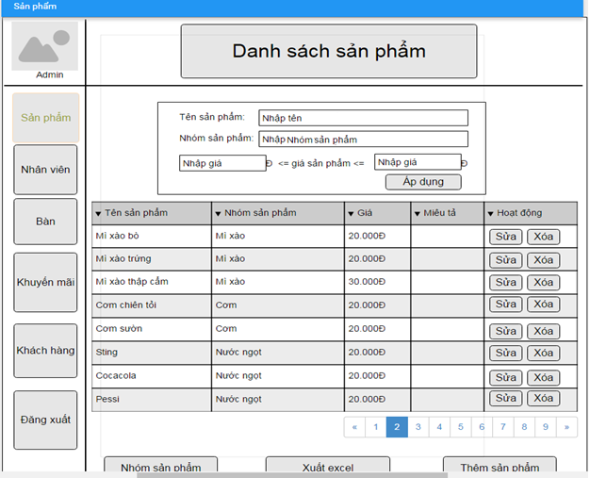

Wireframes 3.1.7 Search Product

**Wireframes Description**

|  |  |  |  |
| --- | --- | --- | --- |
| No | Control Name | Control Type | Description |
|  | | | |
| 1 | “Tên sản phẩm” Label | Label |  |
| 2 | Product Name | Textbox |  |
| 3 | “Nhóm sản phẩm” Label | Label |  |
| 4 | Product Category | Textbox |  |
| 5 | “Gía sản phẩm” Label | Label |  |
| 6 | Min Price | Textbox |  |
| 7 | Max Price | Textbox |  |
| 8 | “Áp dụng” button | Button | Perform search |
| 9 | Product Table | Table |  |
| 10 | “Nhóm sản phẩm” button | Button | Move to search product category |
| 11 | “Xuất Excel” button | Button | Export list product to excel file |
| 12 | “Thêm sản phẩm” button | Button | Move to add product screen |

### Update Product

|  |  |
| --- | --- |
| Description | Manager update information of a product |
| Actor | Manager |
| Pre-condition | Manager login to system, access to Product Feature, search product and press on button “Sửa” beside product in product list |
| Post-condition | Product information will be update |
| Data Table | Product |
| Usage Frequency | Often | Regular | Low |
| Criticality | High | Normal | Low |
| Denpendencies | N/A |

**Activity Flow**

|  |  |
| --- | --- |
| Actor | System |
| 1. Manager press button “Sửa” beside product item in product list | 2. System display dialog Update Product Information |
| 3. Manager input fields |  |
| 4. Manager press on button “Save” | 5. System update product to database |
|  | 6. System show notification that product successfully updated |

**Alternative Flow**

* Not input all require field: system will notify manager “Vui lòng nhập các trường bắt buộc”.
* Invalid input: system will notify manager with each field have invalid input.

**Bussiness Rules**

|  |  |
| --- | --- |
| BR ID | Description |
| BR 1 | If manager have not input all required fields, system will show error |
| BR 2 | If have invalid field, system will show error below that field. |

**Wireframes**

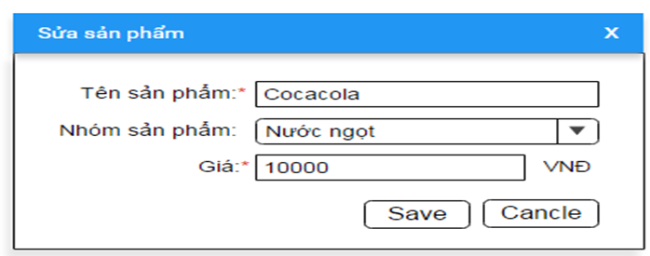

Wireframes 3.1.8 Update Product

**Wireframes Description**

|  |  |  |  |
| --- | --- | --- | --- |
| No | Control Name | Control Type | Description |
|  | | | |
| 1 | “Tên sản phẩm” Label | Label |  |
| 2 | Product name | Textbox |  |
| 3 | “Nhóm sản phẩm” Label | Label |  |
| 4 | Product Category | Listbox |  |
| 5 | “Gía sản phẩm” Label | Label |  |
| 6 | Price | Textbox |  |
| 7 | “Save” Button | Button |  |
| 8 | “Cancel” Button | Button |  |

### Delete Product

|  |  |
| --- | --- |
| Description | Manager want to delete a product from their menu |
| Actor | Manager |
| Pre-condition | Manager login to system, access to Product Feature. search product and click on button “Xóa” beside product item in product list |
| Post-condition | Product is deleted from system |
| Data Table | Product |
| Usage Frequency | Often | Regular | Low |
| Criticality | High | Normal | Low |
| Denpendencies | N/A |

**Activity Flow**

|  |  |
| --- | --- |
| Actor | System |
| 1. Manager press on button “Xóa” beside product item | 2. System show dialog to confirm delete product |
| 3. Manager press on button “Có” | 4. System delete product |
|  | 5. System notify product successfully deleded |

**Alternative Flow**

* Manager press on Button “Không”: System will not delete product.

**Bussiness Rules**

|  |  |
| --- | --- |
| BR ID | Description |
|  |  |

**Wireframes**

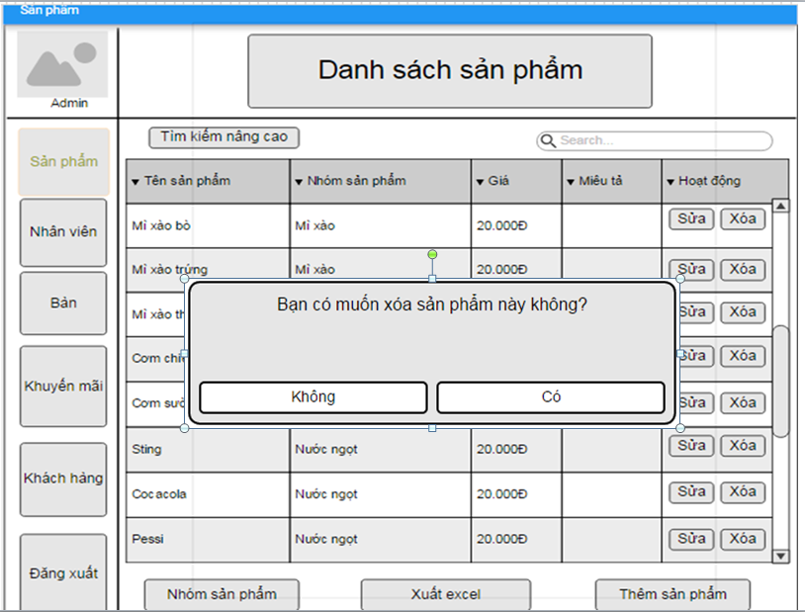

Wireframes 3.1.9 Delete Product

**Wireframes Description**

|  |  |  |  |
| --- | --- | --- | --- |
| No | Control Name | Control Type | Description |
|  | | | |
| 1 | “Có” button | Button |  |
| 2 | “Không” button | Button |  |

### Add Product Category

|  |  |
| --- | --- |
| Description | Manager want to add new Product Category |
| Actor | Manager |
| Pre-condition | Manager login to system, access to Product Feature and press on button “Thêm Nhóm Sản Phẩm” |
| Post-condition | New product category will be add to system |
| Data Table | Product Group |
| Usage Frequency | Often | Regular | Low |
| Criticality | High | Normal | Low |
| Denpendencies | N/A |

**Activity Flow**

|  |  |
| --- | --- |
| Actor | System |
| 1. Manager access to application |  |
| 2. Manager access to Product Page | 3. System display Product Screen |
| 4. Manager press on button “Thêm Nhóm Sản Phẩm” | 5. System display Add Product Category Dialog |
| 6. Manager input product category name |  |
| 7. Manager press on button “Save” | 8. System save new product category to database |
|  | 9. System show dialog to notify successfully |

**Alternative Flow**

* Not input all require field: system will notify manager “Vui lòng nhập các trường bắt buộc”.
* Invalid input: system will notify manager with each field have invalid input.
* Product Category Name already exists in database: system will notify manager “Nhóm sản phẩm đã tồn tại”.

**Bussiness Rules**

|  |  |
| --- | --- |
| BR ID | Description |
| BR 1 | If manager have not input all required fields, system will show error |
| BR 2 | If have invalid field, system will show error below that field. |

**Wireframes**

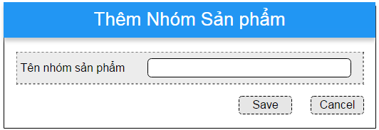

Wireframes 3.1.10 Add Product Category

**Wireframes Description**

|  |  |  |  |
| --- | --- | --- | --- |
| No | Control Name | Control Type | Description |
|  | | | |
| 1 | “Tên nhóm sản phẩm” Label | Label |  |
| 2 | Product category name | Textbox |  |
| 3 | “Save” Button | Button |  |
| 4 | “Cancel” Button | Button |  |

### Search Product Category

|  |  |
| --- | --- |
| Description | Manager search for product category |
| Actor | Manager |
| Pre-condition | Manager log in to system, access to Product Feature |
| Post-condition | System show product category by filter |
| Data Table | Product Group |
| Usage Frequency | Often | Regular | Low |
| Criticality | High | Normal | Low |
| Denpendencies | N/A |

**Activity Flow**

|  |  |
| --- | --- |
| Actor | System |
| 1. Manager access to application |  |
| 2. Manager access to Product Feature | 3. System display Product Screen |
| 4. Manager press on button “Nhóm sản phẩm” | 5. System move to Product Category Page |
| 6. Manager input to filter fields (not require) |  |
| 7. Manager press on icon search | 8. System search on database by filter fields |
|  | 9. System show product categories on list view |

**Alternative Flow**

* Not found product: System will show error message under header of the list view.

**Bussiness Rules**

N/A

**Wireframes**

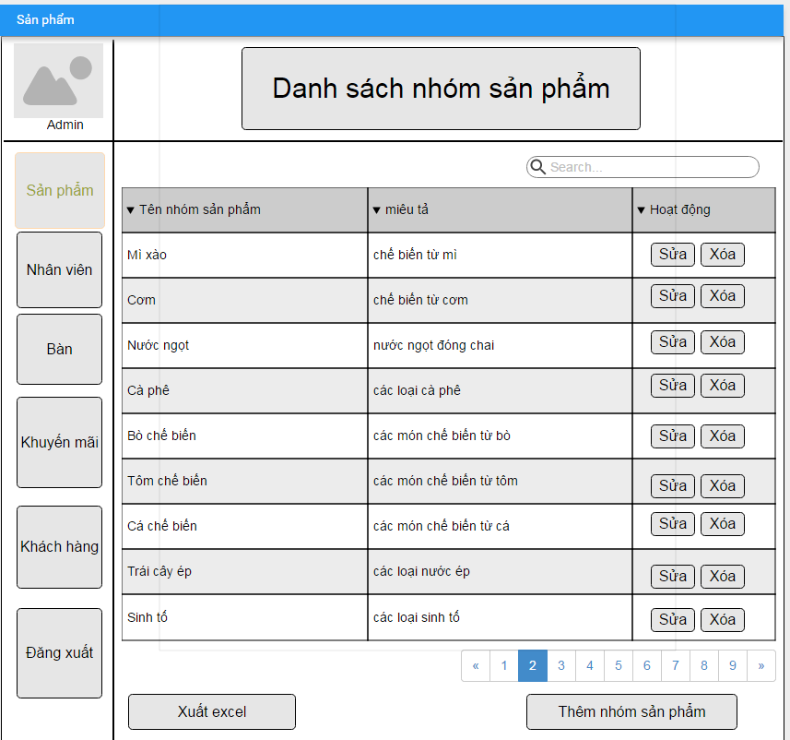

Wireframes 3.1.11 Search Product Category

**Wireframes Description**

|  |  |  |  |
| --- | --- | --- | --- |
| No | Control Name | Control Type | Description |
|  | | | |
| 1 | Product Category Tabel | Table |  |
| 2 | Search field | Textbox |  |
| 3 | Search icon | Button | Perform search |
| 4 | “Sửa” button | Button | Update product information |
| 5 | “Xóa” Button | Button | Delete product |
| 6 | “Thêm Nhóm sản phẩm” button | Button | Display add product category screen |
| 7 | “Xuất Excel” button | Button | Export list product to excel file |

### Update Product Category

|  |  |
| --- | --- |
| Description | Update information of product category |
| Actor | Manager |
| Pre-condition | Manager login to system, access to Product Feature, search product and press on button “Sửa” beside product category in product category list |
| Post-condition | Product category will be update |
| Data Table | Product Group |
| Usage Frequency | Often | Regular | Low |
| Criticality | High | Normal | Low |
| Denpendencies | N/A |

**Activity Flow**

|  |  |
| --- | --- |
| Actor | System |
| 1. Manager press button “Sửa” beside product item in product list | 2. System display dialog Update Product Category Information |
| 3. Manager input fields |  |
| 4. Manager press on button “Save” | 5. System update product category to database |
|  | 6. System show notification that product category successfully updated |

**Alternative Flow**

* Not input all require field: system will notify manager “Vui lòng nhập các trường bắt buộc”.
* Invalid input: system will notify manager with each field have invalid input.

**Bussiness Rules**

|  |  |
| --- | --- |
| BR ID | Description |
| BR 1 | If manager have not input all required fields, system will show error |
| BR 2 | If have invalid field, system will show error below that field. |

**Wireframes**

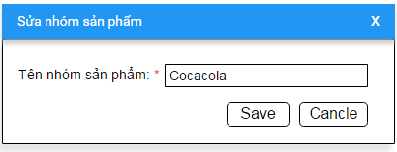

Wireframes 3.1.12 Update Product Category

**Wireframes Description**

|  |  |  |  |
| --- | --- | --- | --- |
| No | Control Name | Control Type | Description |
|  | | | |
| 1 | “Tên nhóm sản phẩm” Label | Label | Required |
| 2 | Product Category name | Textbox |  |
| 3 | “Save” button | Button |  |
| 4 | “Cancel” button | Button |  |

### Delete Product Category

|  |  |
| --- | --- |
| Description | Manager want to delete a product category |
| Actor | Manager |
| Pre-condition | Manager login to system, access to Product Category Page. search product category and click on button “Xóa” beside product item in product category list |
| Post-condition | Product category is deleted from system |
| Data Table | Product Group |
| Usage Frequency | Often | Regular | Low |
| Criticality | High | Normal | Low |
| Denpendencies | N/A |

**Activity Flow**

|  |  |
| --- | --- |
| Actor | System |
| 1. Manager press on button “Xóa” beside product category item | 2. System show dialog to confirm delete product category |
| 3. Manager press on button “Có” | 4. System delete product category |
|  | 5. System notify product category successfully deleded |

**Alternative Flow**

* Manager press on Button “Không”: System will not delete product category.

**Bussiness Rules**

|  |  |
| --- | --- |
| BR ID | Description |
|  |  |

**Wireframes**

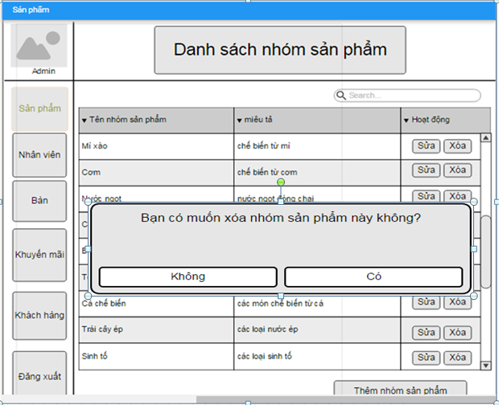

Wireframes 3.1.13 Delete Product Category

**Wireframes Description**

|  |  |  |  |
| --- | --- | --- | --- |
| No | Control Name | Control Type | Description |
|  | | | |
| 1 | “Có” button | Button |  |
| 2 | “Không” button | Button |  |

### Add Employee

|  |  |
| --- | --- |
| Description | Manager add a new employee information of their restaurant |
| Actor | Manager |
| Pre-condition | Manager login to system, access to Employee Feature. Manager press on button “Thêm Nhân Viên” |
| Post-condition | New employee will be added |
| Data Table | Employee |
| Usage Frequency | Often | Regular | Low |
| Criticality | High | Normal | Low |
| Denpendencies | N/A |

**Activity Flow**

|  |  |
| --- | --- |
| Actor | System |
| 1. Manager access to application |  |
| 2. Manager access to Employee Feature | 3. System display Employee Screen |
| 4. Manager press on button “Thêm Nhân Viên” | 5. System display Add New Employee Dialog |
| 6. Manager input all require fields |  |
| 7. Manager press on button “Save” | 8. System save new employee to database |
|  | 9. System show dialog to notify successfully |

**Alternative Flow**

* Not input all require field: system will notify manager “Vui lòng nhập các trường bắt buộc”.
* Invalid input: system will notify manager with each field have invalid input.

**Bussiness Rules**

|  |  |
| --- | --- |
| BR ID | Description |
| BR 1 | If manager have not input all required fields, system will show error |
| BR 2 | If have invalid field, system will show error below that field. |

**Wireframes**

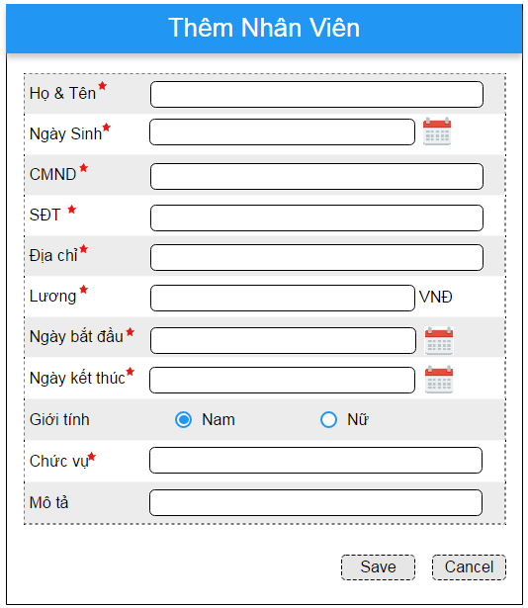

Wireframes 3.1.14 Add Employee

**Wireframes Description**

|  |  |  |  |
| --- | --- | --- | --- |
| No | Control Name | Control Type | Description |
|  | | | |
| 1 | “Họ và tên” Label | Label |  |
| 2 | Employee Name | Textbox |  |
| 3 | “Ngày sinh” Label | Label |  |
| 4 | Birthday | Listbox |  |
| 5 | “CMND” Label | Label |  |
| 6 | Identity Card | Textbox |  |
| 7 | “Số điện thoại” Label | Label |  |
| 8 | Phone number | ComboBox |  |
| 9 | “Địa chỉ” Label | Label |  |
| 10 | Address | Textbox |  |
| 11 | “Lương” Label | Label |  |
| 12 | Salary | Textbox |  |
| 13 | “Ngày bắt đầu” Label | Label |  |
| 14 | Start day | Textbox |  |
| 15 | “Ngày kết thúc” Label | Label |  |
| 16 | End day | Textbox |  |
| 17 | “Giới tính” Label | Label |  |
| 18 | Gender | RadioBox |  |
| 19 | “Chức vụ” Label | Label |  |
| 20 | Position | Textbox |  |
| 21 | “Mô tả” Label | Label |  |
| 22 | Description | Textbox |  |
| 23 | “Save” Button | Button |  |
| 24 | “Cancel” Button | Button |  |

### Search Employee

|  |  |
| --- | --- |
| Description | Manager want to search for employee and see their information |
| Actor | Manager |
| Pre-condition | Manager login to system, access to Employee Feature |
| Post-condition | System display list employee by filter |
| Data Table | Employee |
| Usage Frequency | Often | Regular | Low |
| Criticality | High | Normal | Low |
| Denpendencies | N/A |

**Activity Flow**

|  |  |
| --- | --- |
| Actor | System |
| 1. Manager access to application |  |
| 2. Manager access to Employee Feature | 3. System display Employee Screen |
| 4. Manager input to filter fields (not require) |  |
| 5. Manager press on button “Áp dụng” | 6. System search on database by filter fields |
|  | 7. System show employees on list view |

**Alternative Flow**

* Not found employee: System will show message under header of the list view.

**Bussiness Rules**

N/A

**Wireframes**

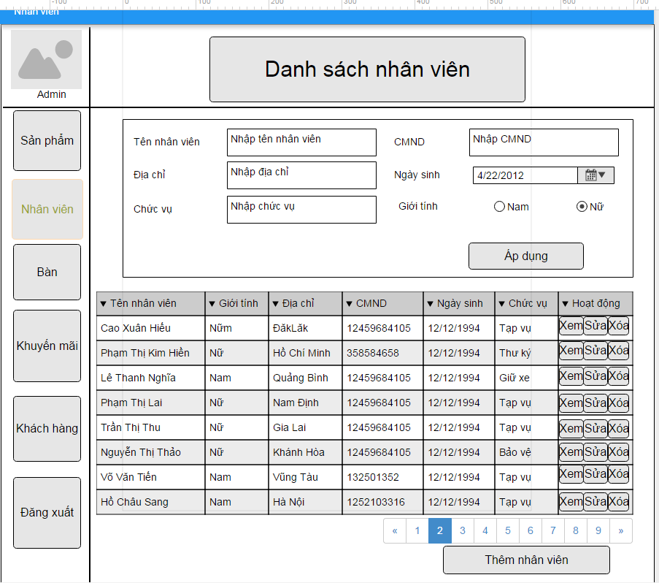

Wireframes 3.1.15 Seach Employee

**Wireframes Description**

|  |  |  |  |
| --- | --- | --- | --- |
| No | Control Name | Control Type | Description |
|  | | | |
| 1 | “Tên nhân viên” Label | Label |  |
| 2 | Name | Textbox |  |
| 3 | “CMND” Label | Label |  |
| 4 | Identity Card | Textbox |  |
| 5 | “Địa chỉ” Label | Label |  |
| 6 | Address | Textbox |  |
| 7 | “Ngày sinh” Label | Label |  |
| 8 | Birthday | Textbox |  |
| 9 | “Chức vụ” Label | Label |  |
| 10 | Position | Textbox |  |
| 11 | “Giới tính” Label | Label |  |
| 12 | Gender | RadioBox |  |
| 13 | “Áp dụng” button | Button |  |
| 14 | Employee Table | Table |  |
| 15 | “Thêm nhân viên” buttton | Button |  |

### Update Employee Information

|  |  |
| --- | --- |
| Description | Manager update information of employee of their restaurant |
| Actor | Manager |
| Pre-condition | Manager login to system, access to Employee Feature, search for employee and press on button “Sửa” beside employee in employee list |
| Post-condition | Employee information updated |
| Data Table | Employee |
| Usage Frequency | Often | Regular | Low |
| Criticality | High | Normal | Low |
| Denpendencies | N/A |

**Activity Flow**

|  |  |
| --- | --- |
| Actor | System |
| 1. Manager press button “Sửa” beside product item in employee list | 2. System display dialog Update Employee Information |
| 3. Manager input fields |  |
| 4. Manager press on button “Save” | 5. System update employee to database |
|  | 6. System show notification that employee successfully updated |

**Alternative Flow**

* Not input all require field: system will notify manager “Vui lòng nhập các trường bắt buộc”.
* Invalid input: system will notify manager with each field have invalid input.

**Bussiness Rules**

|  |  |
| --- | --- |
| BR ID | Description |
| BR 1 | If manager have not input all required fields, system will show error |
| BR 2 | If have invalid field, system will show error below that field. |

**Wireframes**

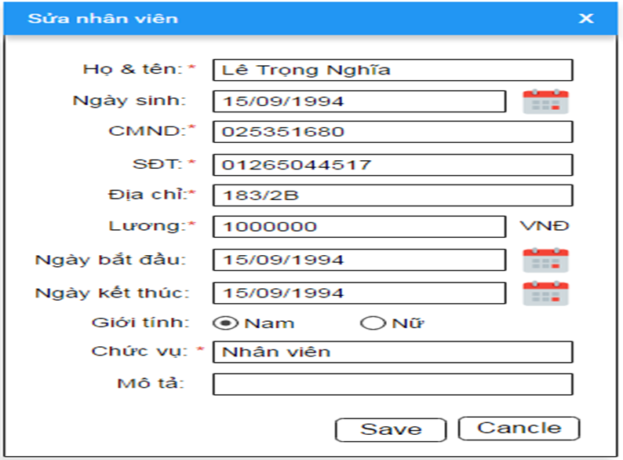

Wireframes 3.1.16 Update Employee Information

**Wireframes Description**

|  |  |  |  |
| --- | --- | --- | --- |
| No | Control Name | Control Type | Description |
|  | | | |
| 1 | “Họ và tên” Label | Label |  |
| 2 | Employee Name | Textbox |  |
| 3 | “Ngày sinh” Label | Label |  |
| 4 | Birthday | Listbox |  |
| 5 | “CMND” Label | Label |  |
| 6 | Identity Card | Textbox |  |
| 7 | “Số điện thoại” Label | Label |  |
| 8 | Phone number | ComboBox |  |
| 9 | “Địa chỉ” Label | Label |  |
| 10 | Address | Textbox |  |
| 11 | “Lương” Label | Label |  |
| 12 | Salary | Textbox |  |
| 13 | “Ngày bắt đầu” Label | Label |  |
| 14 | Start day | Textbox |  |
| 15 | “Ngày kết thúc” Label | Label |  |
| 16 | End day | Textbox |  |
| 17 | “Giới tính” Label | Label |  |
| 18 | Gender | RadioBox |  |
| 19 | “Chức vụ” Label | Label |  |
| 20 | Position | Textbox |  |
| 21 | “Mô tả” Label | Label |  |
| 22 | Description | Textbox |  |
| 23 | “Save” Button | Button |  |
| 24 | “Cancel” Button | Button |  |

### Delete Employee

|  |  |
| --- | --- |
| Description | Manager delete an employee |
| Actor | Manager |
| Pre-condition | Manager login to system, access to Employee Feature, and press on button “Xóa” beside employee row in employee list |
| Post-condition | Employee will be deleted from database |
| Data Table | Employee |
| Usage Frequency | Often | Regular | Low |
| Criticality | High | Normal | Low |
| Denpendencies | N/A |

**Activity Flow**

|  |  |
| --- | --- |
| Actor | System |
| 1. Manager press on button “Xóa” beside employee item | 2. System show dialog to confirm delete |
| 3. Manager press on button “Có” | 4. System delete employee |
|  | 5. System notify employee successfully deleded |

**Alternative Flow**

* Manager press on Button “Không”: System will not delete employee.

**Bussiness Rules**

N/A

**Wireframes**

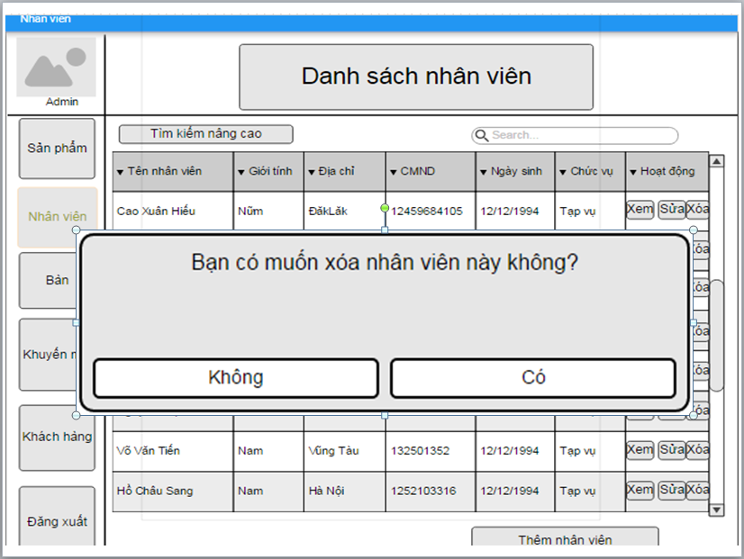

WireFrames 3.1.16 Delete Employee

**Wireframes Description**

|  |  |  |  |
| --- | --- | --- | --- |
| No | Control Name | Control Type | Description |
|  | | | |
| 1 | “Có” button | Button |  |
| 2 | “Không” button | Button |  |

### 3.1.18 Create Promotion

|  |  |
| --- | --- |
| Description | Manager create new promotion for restaurant |
| Actor | Manager |
| Pre-condition | Manager login to system, access to Promotion Feature, and press on button Add |
| Post-condition | New promotion will be created |
| Data Table | Promotion |
| Usage Frequency | Often | Regular | Low |
| Criticality | High | Normal | Low |
| Denpendencies | N/A |

**Activity Flow**

|  |  |
| --- | --- |
| Actor | System |
| 1. Manager access to application |  |
| 2. Manager access to Promotion Feature | 3. System display Promotion Screen |
| 4. Manager press on button “Add” | 5. System display Add New Promotion Dialog |
| 6. Manager input all require fields |  |
| 7. Manager press on button “Thêm chi tiết” | 8. System dislay Add Promotion Detail Dialog |
| 9. Manager press on button “Save” | 10. System save new promotion to database |
|  | 11. System show dialog to notify successfully |

**Alternative Flow**

* Not input all require field: system will notify manager “Vui lòng nhập các trường bắt buộc”.
* Invalid input: system will notify manager with each field have invalid input.
* Manager press on button “Hủy”: promotion will not be save.

**Bussiness Rules**

|  |  |
| --- | --- |
| BR ID | Description |
| BR 1 | If manager have not input all required fields, system will show error |
| BR 2 | If have invalid field, system will show error below that field. |
| BR 3 | Start day must smaller than end date |

**Wireframes**

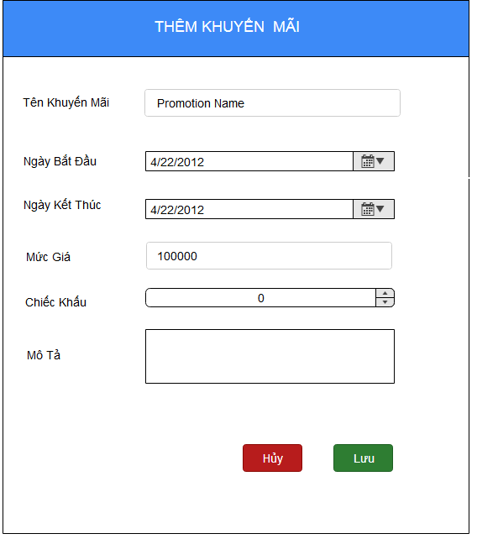

Wireframes 3.1.18.1 Create Promotion

**Wireframes Description**

|  |  |  |  |
| --- | --- | --- | --- |
| No | Control Name | Control Type | Description |
|  | | | |
| 1 | “THÊM KHUYẾN MÃI” Label | Label |  |
| 2 | “Tên khuyến mãi” Label | Label |  |
| 3 | Promotion name | Textbox |  |
| 4 | “Ngày bắt đầu” Label | Label |  |
| 5 | Start date | Datepicker |  |
| 6 | “Ngày kết thúc” Label | Label |  |
| 7 | End date | Datepicker |  |
| 8 | “Mức giá” | Label |  |
| 9 | BasePurchase | Number |  |
| 7 | “Chiết khấu” Label | Label |  |
| 8 | Discount | Number |  |
| 9 | “Lưu” button | Button |  |
| 10 | “Hủy bỏ” button | Button |  |

### 3.1.19 Search Promotion

|  |  |
| --- | --- |
| Description | Manager search for promotion in system |
| Actor | Manager |
| Pre-condition | Manager log in to system, access to Promotion Feature |
| Post-condition | System show promotion to list promotion view |
| Data Table | Promotion |
| Usage Frequency | Often | Regular | Low |
| Criticality | High | Normal | Low |
| Denpendencies | N/A |

**Activity Flow**

|  |  |
| --- | --- |
| Actor | System |
| 1. Manager access to application |  |
| 2. Manager access to Promotion Feature | 3. System display Promotion Screen |
| 4. Manager input to filter fields (not require) |  |
| 5. Manager press on button “Tìm kiếm” | 6. System search on database by filter fields |
|  | 7. System show promotions on list view |

**Alternative Flow**

* Not found promotion: System will show message under header of the list view.

**Bussiness Rules**

N/A

**Wireframes**

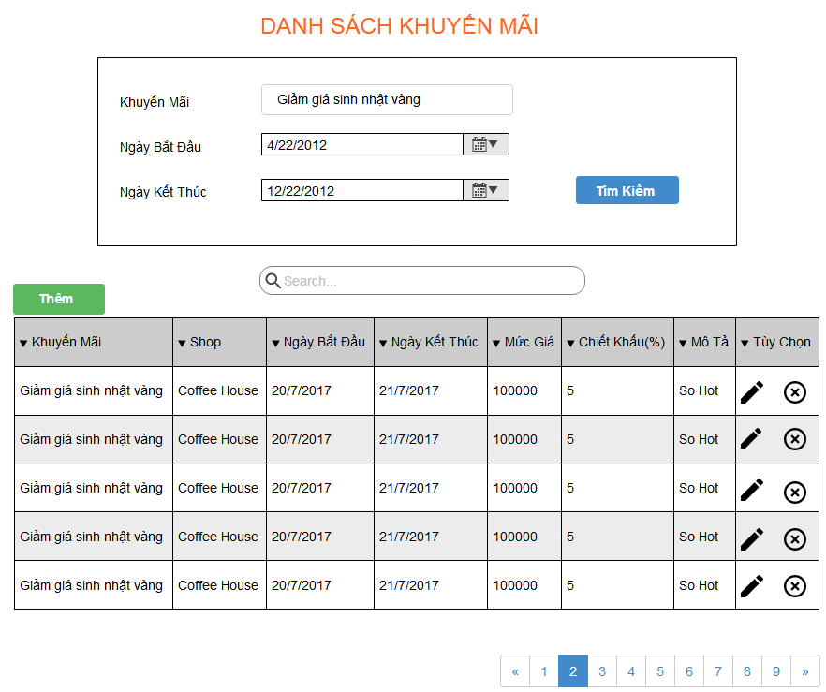

Wireframes 3.1.19 Update Promotion

**Wireframes Description**

|  |  |  |  |
| --- | --- | --- | --- |
| No | Control Name | Control Type | Description |
|  | | | |
| 1 | “DANH SÁCH KHUYẾN MÃI” Label | Label |  |
| 2 | “Tên khuyến mãi” Label | Label |  |
| 3 | Promotion name | Textbox |  |
| 4 | “Ngày bắt đầu” Label | Label |  |
| 5 | Start date | Datepicker |  |
| 6 | “Ngày kết thúc” Button | Label |  |
| 7 | End date | Datepicker |  |
| 8 | “Tìm kiếm” button | Button |  |
| 9 | Promotion table | Table |  |
| 10 | Search | Textbox |  |
| 11 | “Thêm” button | Button |  |

### 3.1.20 Update Promotion

|  |  |
| --- | --- |
| Description | Manager want to update detail of promotion |
| Actor | Manager |
| Pre-condition | Manager login to system, access to Promotion Feature, and press on icon edit beside promotion information in table |
| Post-condition | Promotion details will be updated |
| Data Table | Promotion |
| Usage Frequency | Often | Regular | Low |
| Criticality | High | Normal | Low |
| Denpendencies | N/A |

**Activity Flow**

|  |  |
| --- | --- |
| Actor | System |
| 1. Manager press icon edit beside promotion item in product list | 2. System display dialog Update Promotion Information |
| 3. Manager input fields |  |
| 4. Manager press icon edit beside a product in promotion details | 5. System display dialog Update Promotion detail |
| 6. Manager press on button “Lưu” | 7. System update promotion information to database |
|  | 8. System show notification that promotion successfully updated |

**Alternative Flow**

* Not input all require field: system will notify manager “Vui lòng nhập các trường bắt buộc”.
* Invalid input: system will notify manager with each field have invalid input.

**Bussiness Rules**

|  |  |
| --- | --- |
| BR ID | Description |
| BR 1 | If manager have not input all required fields, system will show error |
| BR 2 | If have invalid field, system will show error below that field. |

**Wireframes**

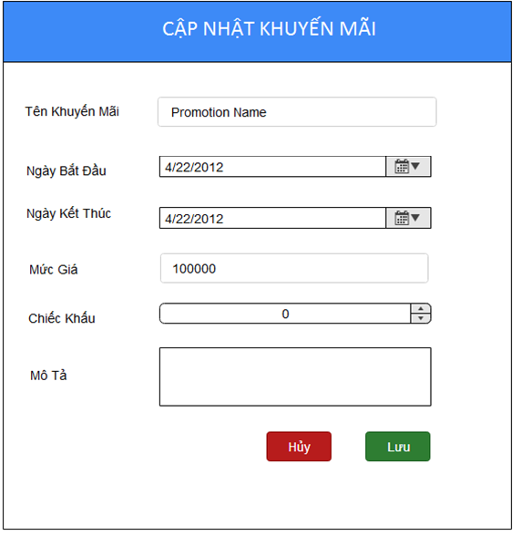

Wireframes 3.1.20 Update Promotion

**Wireframes Description**

|  |  |  |  |
| --- | --- | --- | --- |
| No | Control Name | Control Type | Description |
|  | | | |
| 1 | “CẬP NHẬT KHUYẾN MÃI” Label | Label |  |
| 2 | “Tên khuyến mãi” Label | Label |  |
| 3 | Promotion name | Textbox |  |
| 4 | “Ngày bắt đầu” Label | Label |  |
| 5 | Start date | Datepicker |  |
| 6 | “Ngày kết thúc” Label | Label |  |
| 7 | End date | Datepicker |  |
| 8 | “Mức giá” label | Label |  |
| 9 | BasePurchase | Number |  |
| 10 | “Chiết khấu” Label | Label |  |
| 11 | Discount | Number |  |
| 12 | “Mô tả” | Label |  |
| 13 | Description | TextArea |  |
| 14 | “Lưu” button | Button |  |
| 15 | “Hủy bỏ” button | Button |  |

### 3.1.21 Delete Promotion

|  |  |
| --- | --- |
| Description | Manager want to update detail of promotion |
| Actor | Manager |
| Pre-condition | Manager login to system, access to Promotion Feature, and press on icon delete beside promotion information in table |
| Post-condition | Promotion details will be updated |
| Data Table | Promotion |
| Usage Frequency | Often | Regular | Low |
| Criticality | High | Normal | Low |
| Denpendencies | N/A |

**Activity Flow**

|  |  |
| --- | --- |
| Actor | System |
| 1. Manager press icon delete beside promotion item in product list | 2. System display dialog Delete Promotion |
| 3. Manager press icon “Đồng ý” beside a product in promotion details | 4. System delete promotion information to database |
|  | 5. System show notification that promotion successfully updated |

**Alternative Flow**

* User click “Hủy”

**Bussiness Rules**

**Wireframes**

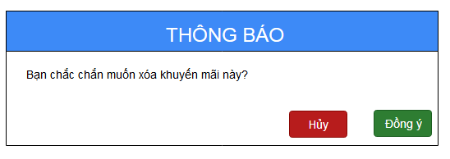

Wireframes 3.1.21 Delete Promotion

**Wireframes Description**

|  |  |  |  |
| --- | --- | --- | --- |
| No | Control Name | Control Type | Description |
|  | | | |
| 1 | “THÔNG BÁO” Label | Label |  |
| 2 | “Xóa khuyến mãi” Label | Label |  |
| 3 | “Đồng ý” button | Button |  |
| 4 | “Hủy” button | Button |  |

### Add Customer

|  |  |
| --- | --- |
| Description | Manager add new customer to system |
| Actor | Manager |
| Pre-condition | Manager login to system, access to Customer Feature, press on button “Thêm Khách Hàng” |
| Post-condition | New customer will be added to database |
| Data Table | Customer |
| Usage Frequency | Often | Regular | Low |
| Criticality | High | Normal | Low |
| Denpendencies | N/A |

**Activity Flow**

|  |  |
| --- | --- |
| Actor | System |
| 1. Manager access to application |  |
| 2. Manager access to Customer Feature | 3. System display Customer Screen |
| 4. Manager press on button “Thêm Khách Hàng” | 5. System display Add New Customer Dialog |
| 6. Manager input all require fields |  |
| 7. Manager press on button “Lưu” | 8. System save new customer to database |
|  | 9. System show dialog to notify successfully |

**Alternative Flow**

* Not input all require field: system will notify manager “Vui lòng nhập các trường bắt buộc”.
* Invalid input: system will notify manager with each field have invalid input.

**Bussiness Rules**

|  |  |
| --- | --- |
| BR ID | Description |
| BR 1 | If manager have not input all required fields, system will show error |
| BR 2 | If have invalid field, system will show error below that field. |

**Wireframes**

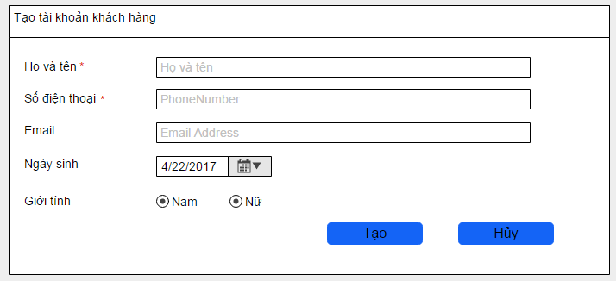

Wireframes 3.1.21 Add Customer

**Wireframes Description**

|  |  |  |  |
| --- | --- | --- | --- |
| No | Control Name | Control Type | Description |
|  | | | |
| 1 | “Họ và tên” Label | Label |  |
| 2 | Employee Name | Textbox |  |
| 3 | “Số điện thoại” Label | Label |  |
| 4 | Phone number | Textbox |  |
| 5 | “Email” Label | Label |  |
| 6 | Email | Textbox |  |
| 7 | “Ngày sinh” Label | Label |  |
| 8 | Birthday | Textbox |  |
| 9 | “Giới tính” Label | Label |  |
| 10 | Gender | Radio Button |  |
| 11 | “Tạo” button | Button |  |
| 12 | “Hủy” button | Button |  |

### Search Customer Information

|  |  |
| --- | --- |
| Description | Manager search for customer information |
| Actor | Manager |
| Pre-condition | Manager login to system, access to Customer Feature |
| Post-condition | System display list customer on table |
| Data Table | Customer |
| Usage Frequency | Often | Regular | Low |
| Criticality | High | Normal | Low |
| Denpendencies | N/A |

**Activity Flow**

|  |  |
| --- | --- |
| Actor | System |
| 1. Manager access to application |  |
| 2. Manager access to Customer Feature | 3. System display Customer Screen |
| 4. Manager input to filter fields (not require) |  |
| 5. Manager press on button “Tìm kiếm” | 6. System search on database by filter fields |
|  | 7. System show customers on list view |

**Alternative Flow**

* Not found customer: System will show message under header of the list view.

**Bussiness Rules**

N/A

**Wireframes**

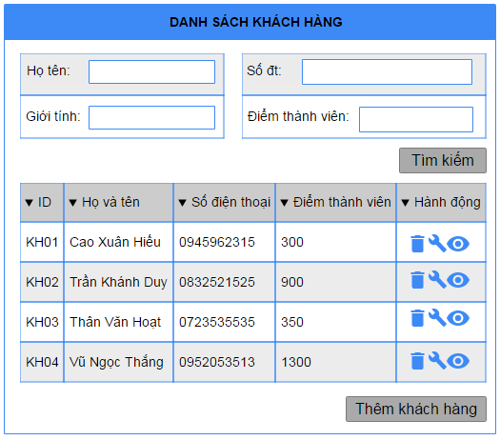

Wireframes 3.1.22 Search Customer

**Wireframes Description**

|  |  |  |  |
| --- | --- | --- | --- |
| No | Control Name | Control Type | Description |
|  | | | |
| 1 | “Họ và tên” Label | Label |  |
| 2 | Customer name | Textbox |  |
| 3 | “Số điện thoại” Label | Label |  |
| 4 | Phone number | Textbox |  |
| 5 | “Giới tính” Label | Label |  |
| 6 | Gender | Textbox |  |
| 7 | “Điểm thành viên” Label | Label |  |
| 8 | Gender | Textbox |  |
| 9 | Customer Table | Table |  |
| 10 | “Hủy” button | Button |  |
| 11 | “Thêm” button | Button |  |

### Update Customer Information

|  |  |
| --- | --- |
| Description | Manager update customer information |
| Actor | Manager |
| Pre-condition | Manager login to system, access to Customer Feature, and press on icon edit beside customer in table |
| Post-condition | Customer information updated |
| Data Table | Customer |
| Usage Frequency | Often | Regular | Low |
| Criticality | High | Normal | Low |
| Denpendencies | N/A |

**Activity Flow**

|  |  |
| --- | --- |
| Actor | System |
| 1. Manager press icon edit beside customer item in product list | 2. System display dialog Update Customer Information |
| 3. Manager input fields |  |
| 4. Manager press on button “Lưu” | 7. System update customer information to database |
|  | 8. System show notification that customer information successfully updated |

**Alternative Flow**

* Not input all require field: system will notify manager “Vui lòng nhập các trường bắt buộc”.
* Invalid input: system will notify manager with each field have invalid input.
* Phone number already exists: system will notify manager that phone number already exists in the system

**Bussiness Rules**

|  |  |
| --- | --- |
| BR ID | Description |
| BR 1 | If manager have not input all required fields, system will show error |
| BR 2 | If have invalid field, system will show error below that field. |

**Wireframes**

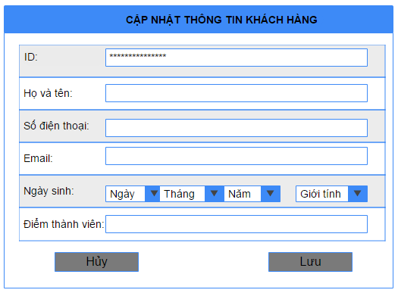

Wireframes 3.1.23 Update Customer Information

**Wireframes Description**

|  |  |  |  |
| --- | --- | --- | --- |
| No | Control Name | Control Type | Description |
|  | | | |
| 1 | “ID” Label | Label |  |
| 2 | Customer id | Textbox | Unable to update |
| 3 | “Họ và tên” Label | Label |  |
| 4 | Customer Name | Textbox |  |
| 5 | “Số điện thoại” Label | Label |  |
| 6 | Phone number | Textbox |  |
| 7 | “Email” Label | Label |  |
| 8 | Email | Textbox |  |
| 9 | “Ngày sinh” Label | Label |  |
| 10 | Product | Combobox |  |
| 11 | “Điểm thành viên” Label | Label |  |
| 12 | Member Point | Textbox |  |
| 13 | “Nam” “Nữ” Label | Label |  |
| 14 | Gender | RadioBox |  |
| 15 | “Lưu” button | Button |  |
| 16 | “Hủy” button | Button |  |

### Delete Customer

|  |  |
| --- | --- |
| Description | Manager delete a customer from database |
| Actor | Manager |
| Pre-condition | Manager login to system, access to Customer Feature, and press on icon delete beside customer in table |
| Post-condition | Customer is deleted from system |
| Data Table | Customer |
| Usage Frequency | Often | Regular | Low |
| Criticality | High | Normal | Low |
| Denpendencies | N/A |

**Activity Flow**

|  |  |
| --- | --- |
| Actor | System |
| 1. Manager press on icon delete beside customer item | 2. System show dialog to confirm delete |
| 3. Manager press on button “Xác nhận” | 4. System delete customer |
|  | 5. System notify customer successfully deleded |

**Alternative Flow**

* Manager press on Button “Không”: System will not delete customer .

**Bussiness Rules**

N/A

**Wireframes**

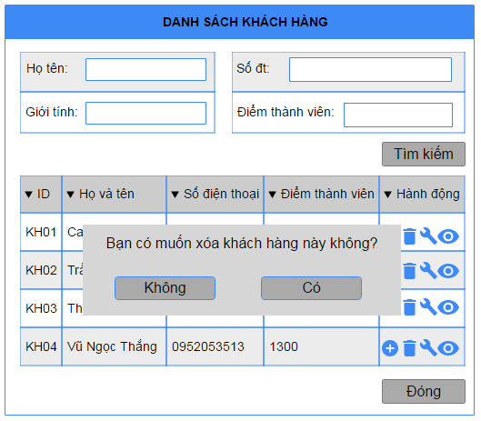

Wireframes 3.1.24 Delete Customer

**Wireframes Description**

|  |  |  |  |
| --- | --- | --- | --- |
| No | Control Name | Control Type | Description |
|  | | | |
| 1 | “Có” button | Button |  |
| 2 | “Không” button | Button |  |

### Add Table

|  |  |
| --- | --- |
| Description | Manager add new table to their shop |
| Actor | Manager |
| Pre-condition | Manager login to system, access to Table Feature, and press on button “Thêm Mới” |
| Post-condition | New table added to datable |
| Data Table | Desk |
| Usage Frequency | Often | Regular | Low |
| Criticality | High | Normal | Low |
| Denpendencies | N/A |

**Activity Flow**

|  |  |
| --- | --- |
| Actor | System |
| 1. Manager access to application |  |
| 2. Manager access to Table Feature | 3. System display Table Screen |
| 4. Manager press on button “Thêm Mới” | 5. System display Add New Table Dialog |
| 6. Manager input all require fields |  |
| 7. Manager press on button “Thêm” | 8. System save new table information to database |
|  | 9. System show dialog to notify successfully |

**Alternative Flow**

* Not input all require field: system will notify manager “Vui lòng nhập các trường bắt buộc”.
* Invalid input: system will notify manager with each field have invalid input

**Bussiness Rules**

|  |  |
| --- | --- |
| BR ID | Description |
| BR 1 | If manager have not input all required fields, system will show error |
| BR 2 | If have invalid field, system will show error below that field. |

**Wireframes**

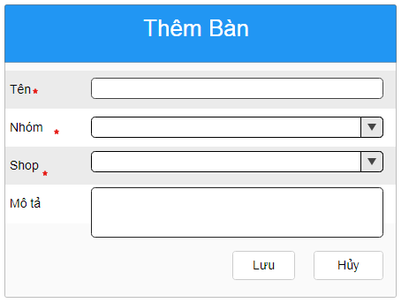

Wireframes 3.1.25 Add Table

**Wireframes Description**

|  |  |  |  |
| --- | --- | --- | --- |
| No | Control Name | Control Type | Description |
|  | | | |
| 1 | “Tên bàn” label | Label |  |
| 2 | TableName textbox | Input |  |
| 3 | “Nhóm” label | Label |  |
| 4 | TableGroupTableID dropdown | Select |  |
| 5 | “Shop” label | Label |  |
| 6 | TableShopID dropdown | Select |  |
| 7 | “Mô tả” label | Label |  |
| 8 | TableDescription textarea | Textarea |  |
| 9 | “Lưu” button | Button |  |
| 10 | “Hủy” button | Button |  |

### Search Table

|  |  |
| --- | --- |
| Description | Search for table information |
| Actor | Manager |
| Pre-condition | Manager login to system, access to Table Feature |
| Post-condition | List table of restaurant show in table |
| Data Table | Desk |
| Usage Frequency | Often | Regular | Low |
| Criticality | High | Normal | Low |
| Denpendencies | N/A |

**Activity Flow**

|  |  |
| --- | --- |
| Actor | System |
| 1. Manager access to application |  |
| 2. Manager access to Table Feature | 3. System display Table Screen |
| 4. Manager input to filter fields (not require) |  |
| 5. Manager press on button “Tìm kiếm” | 6. System search on database by filter fields |
|  | 7. System show tables on list view |

**Alternative Flow**

* Not found table: System will show message under header of the list view.

**Bussiness Rules**

N/A

**Wireframes**

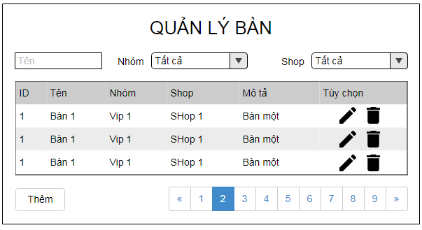

Wireframes 3.1.26 Search Table

**Wireframes Description**

|  |  |  |  |
| --- | --- | --- | --- |
| No | Control Name | Control Type | Description |
|  | | | |
| 1 | TableID | Input hidden | Unable to update |
| 2 | “Tên bàn” label | Label |  |
| 3 | TableName textbox | Input |  |
| 4 | “Nhóm” label | Label |  |
| 5 | TableGroupTableID dropdown | Select |  |
| 6 | “Shop” label | Label |  |
| 7 | TableShopID dropdown | Select |  |
| 8 | “Mô tả” label | Label |  |
| 9 | TableDescription textarea | Textarea |  |
| 10 | “Lưu” button | Button |  |
| 11 | “Hủy” button | Button |  |

### Update Table

|  |  |
| --- | --- |
| Description | Manager update table information |
| Actor | Manager |
| Pre-condition | Manager login to system, access to Table Feature, and press on icon edit beside table in table list |
| Post-condition | Table information updated |
| Data Table | Desk |
| Usage Frequency | Often | Regular | Low |
| Criticality | High | Normal | Low |
| Denpendencies | N/A |

**Activity Flow**

|  |  |
| --- | --- |
| Actor | System |
| 1. Manager press icon edit beside table item in product list | 2. System display dialog Update Table Information |
| 3. Manager input fields |  |
| 4. Manager press on button “Lưu” | 7. System update table information to database |
|  | 8. System show notification that table information successfully updated |

**Alternative Flow**

* Not input all require field: system will notify manager “Vui lòng nhập các trường bắt buộc”.
* Invalid input: system will notify manager with each field have invalid input.
* Phone number already exists: system will notify manager that phone number already exists in the system

**Bussiness Rules**

|  |  |
| --- | --- |
| BR ID | Description |
| BR 1 | If manager have not input all required fields, system will show error |
| BR 2 | If have invalid field, system will show error below that field. |

**Wireframes**

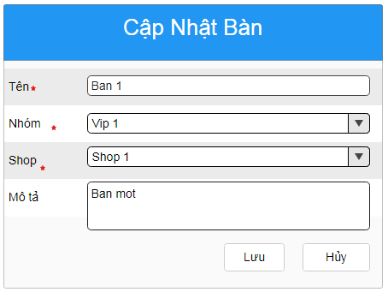

Wireframes 3.1.27 Update Table

**Wireframes Description**

|  |  |  |  |
| --- | --- | --- | --- |
| No | Control Name | Control Type | Description |
|  | | | |
| 1 | TableID | Input hidden | Unable to update |
| 2 | “Tên bàn” label | Label |  |
| 3 | TableName textbox | Input |  |
| 4 | “Nhóm” label | Label |  |
| 5 | TableGroupTableID dropdown | Select |  |
| 6 | “Shop” label | Label |  |
| 7 | TableShopID dropdown | Select |  |
| 8 | “Mô tả” label | Label |  |
| 9 | TableDescription textarea | Textarea |  |
| 10 | “Lưu” button | Button |  |
| 11 | “Hủy” button | Button |  |

### Delete Table

|  |  |
| --- | --- |
| Description | Manager delete a table from system |
| Actor | Manager |
| Pre-condition | Manager login to system, access to Table Feature, and press on icon delete beside table item in table list |
| Post-condition | Customer is deleted from system |
| Data Table | Desk |
| Usage Frequency | Often | Regular | Low |
| Criticality | High | Normal | Low |
| Denpendencies | N/A |

**Activity Flow**

|  |  |
| --- | --- |
| Actor | System |
| 1. Manager press on icon delete beside table item | 2. System show dialog to confirm delete |
| 3. Manager press on button “Đồng ý” | 4. System delete table |
|  | 5. System notify table successfully deleded |

**Alternative Flow**

* Manager press on Button “Hủy”: System will not delete table.

**Bussiness Rules**

N/A

**Wireframes**

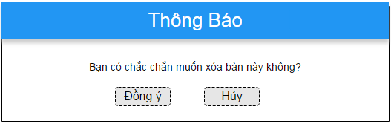

Wireframes 3.1.28 Delete Table

**Wireframes Description**

|  |  |  |  |
| --- | --- | --- | --- |
| No | Control Name | Control Type | Description |
|  | | | |
| 1 | “Đồng ý” button | Button |  |
| 2 | “Hủy” button | Button |  |

### Add Group Table

|  |  |
| --- | --- |
| Description | Manager add new table to their shops |
| Actor | Manager |
| Pre-condition | Manager login to system, access to Group Table Feature, and press on button “Thêm Mới” |
| Post-condition | New group table added to datable |
| Data Table | GroupTable |
| Usage Frequency | Often | Regular | Low |
| Criticality | High | Normal | Low |
| Denpendencies | N/A |

**Activity Flow**

|  |  |
| --- | --- |
| Actor | System |
| 1. Manager access to application |  |
| 2. Manager access to Group Table Feature | 3. System display Group Table Screen |
| 4. Manager press on button “Thêm Mới” | 5. System display Add New Group Table Dialog |
| 6. Manager input all require fields |  |
| 7. Manager press on button “Thêm” | 8. System save new group table information to database |
|  | 9. System show dialog to notify successfully |

**Alternative Flow**

* Not input all require field: system will notify manager “Vui lòng nhập các trường bắt buộc”.
* Invalid input: system will notify manager with each field have invalid input

**Bussiness Rules**

|  |  |
| --- | --- |
| BR ID | Description |
| BR 1 | If manager have not input all required fields, system will show error |
| BR 2 | If have invalid field, system will show error below that field. |

**Wireframes**

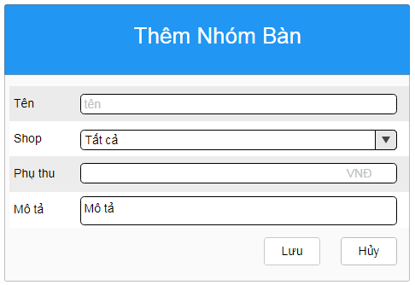

Wireframes 3.1.25 Add Group Table

**Wireframes Description**

|  |  |  |  |
| --- | --- | --- | --- |
| No | Control Name | Control Type | Description |
|  | | | |
| 1 | “Tên nhóm bàn” Label | Label |  |
| 2 | GroupTableName | Input |  |
| 3 | “Phụ thu” Label | Label |  |
| 4 | GroupTableSurcharge | Input |  |
| 5 | “Thêm” button | Button |  |
| 6 | “Hủy” button | Button |  |
| 7 | GroupTableShopID | Select |  |

### Search Group Table

|  |  |
| --- | --- |
| Description | Search for group table information |
| Actor | Manager |
| Pre-condition | Manager login to system, access to Group Table Feature |
| Post-condition | List group table of restaurant show in table |
| Data Table | Group Desk |
| Usage Frequency | Often | Regular | Low |
| Criticality | High | Normal | Low |
| Denpendencies | N/A |

**Activity Flow**

|  |  |
| --- | --- |
| Actor | System |
| 1. Manager access to application |  |
| 2. Manager access to Group Table Feature | 3. System display Group Table Screen |
| 4. Manager input to filter fields (not require) |  |
| 5. Manager press on button “Tìm kiếm” | 6. System search on database by filter fields |
|  | 7. System show group tables on list view |

**Alternative Flow**

* Not found group tables: System will show error message under header of the list view.

**Bussiness Rules**

N/A

**Wireframes**

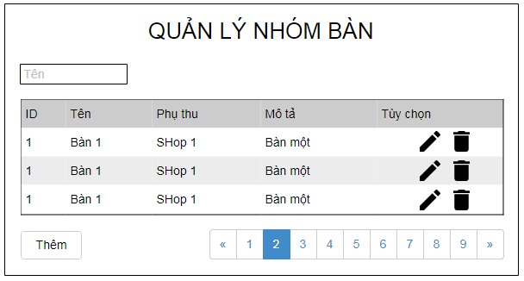

Wireframes 3.1.30 Search Group Table

**Wireframes Description**

|  |  |  |  |
| --- | --- | --- | --- |
| No | Control Name | Control Type | Description |
|  | | | |
| 1 | “QUẢN LÝ NHÓM BÀN” | H3 |  |
| 2 | SearchGroupTableName | Input |  |
| 3 | SearchGroupTable list | Table |  |
| 4 | “Thêm” button | Button |  |

### Update Group Table

|  |  |
| --- | --- |
| Description | Manager update information of group table |
| Actor | Manager |
| Pre-condition | Manager login to system, access to Group Table Feature and press on icon edit beside group table item in list |
| Post-condition | Group table information updated |
| Data Table | Group Desk |
| Usage Frequency | Often | Regular | Low |
| Criticality | High | Normal | Low |
| Denpendencies | N/A |

**Activity Flow**

|  |  |
| --- | --- |
| Actor | System |
| 1. Manager press icon edit beside group table item in product list | 2. System display dialog Update Group Table Information |
| 3. Manager input fields |  |
| 4. Manager press on button “Lưu” | 7. System update group table information to database |
|  | 8. System show notification successfully updated |

**Alternative Flow**

* Not input all require field: system will notify manager “Vui lòng nhập các trường bắt buộc”.
* Invalid input: system will notify manager with each field have invalid input.
* Phone number already exists: system will notify manager that phone number already exists in the system

**Bussiness Rules**

|  |  |
| --- | --- |
| BR ID | Description |
| BR 1 | If manager have not input all required fields, system will show error |
| BR 2 | If have invalid field, system will show error below that field. |

**Wireframes**

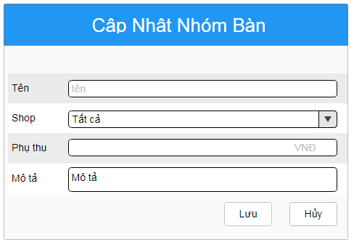

Wireframes 3.1.31 Update Group Table

**Wireframes Description**

|  |  |  |  |
| --- | --- | --- | --- |
| No | Control Name | Control Type | Description |
|  | | | |
| 1 | “Tên nhóm bàn” label | Label |  |
| 2 | GroupTableName textbox | Input |  |
| 3 | “Phụ thu” label | Label |  |
| 4 | GroupTableSurcharge textbox | Input |  |
| 5 | “Lưu” button | Button |  |
| 6 | “Hủy” button | Button |  |
| 7 | GroupTableID input | Input hidden | Unable to update |
| 8 | GroupTableShopID | Select |  |

### Delete Group Table

|  |  |
| --- | --- |
| Description | Manager delete a group table from their system |
| Actor | Manager |
| Pre-condition | Manager login to system, access to Group Table Feature, and press on icon delete beside group table item in list |
| Post-condition | Group table is deleted from system |
| Data Table | Group Table |
| Usage Frequency | Often | Regular | Low |
| Criticality | High | Normal | Low |
| Denpendencies | N/A |

**Activity Flow**

|  |  |
| --- | --- |
| Actor | System |
| 1. Manager press on icon delete beside group table item | 2. System show dialog to confirm delete |
| 3. Manager press on button “Đồng ý” | 4. System delete group table |
|  | 5. System notify group table successfully deleded |

**Alternative Flow**

* Manager press on Button “Hủy”: System will not delete group table.

**Bussiness Rules**

N/A

**Wireframes**

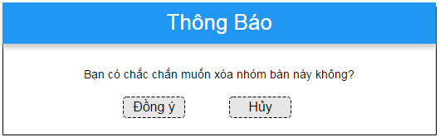

Wireframes 3.1.28 Delete Table

**Wireframes Description**

|  |  |  |  |
| --- | --- | --- | --- |
| No | Control Name | Control Type | Description |
|  | | | |
| 1 | “Đồng ý” button | Button |  |
| 2 | “Hủy” button | Button |  |

### Create Material

|  |  |
| --- | --- |
| Description | Manager create a new Material |
| Actor | Manager |
| Pre-condition | Manager login to system, access to Material Feature, and press on button “Thêm hàng” |
| Post-condition | New Material created |
| Data Table | Material |
| Usage Frequency | Often | Regular | Low |
| Criticality | High | Normal | Low |
| Denpendencies | N/A |

**Activity Flow**

|  |  |
| --- | --- |
| Actor | System |
| 1. Manager access to application |  |
| 2. Manager access to Material Feature | 3. System display Material Screen |
| 4. Manager press on button “Thêm Mới” | 5. System display Add New Material Dialog |
| 6. Manager input all require fields |  |
| 7. Manager press on button “Lưu” | 8. System save new Material information to database |
|  | 9. System show dialog to notify successfully |

**Alternative Flow**

* User leaves required fields empty: system will notify “Vui lòng nhập các trường bắt buộc”.
* Invalid input: system will notify manager with each field have invalid value

**Bussiness Rules**

|  |  |
| --- | --- |
| BR ID | Description |
| BR 1 | If manager have not input all required fields, system will show error |
| BR 2 | If have invalid field, system will show error below that field. |

**Wireframes**

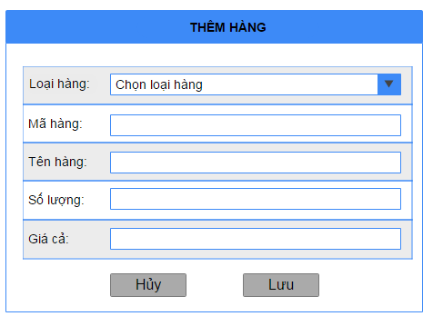

Wireframes 3.1.33 Create Material Receipt

**Wireframes Description**

|  |  |  |  |
| --- | --- | --- | --- |
| No | Control Name | Control Type | Description |
|  | | | |
| 1 | “Loại hàng” Label | Label |  |
| 2 | Material Type | Textbox |  |
| 3 | “Mã hàng” Label | Label |  |
| 4 | Material Id | Textbox |  |
| 5 | “Tên hàng” Label | Label |  |
| 6 | Material Name | TextBox |  |
| 7 | “Số lượng” Label | Label |  |
| 8 | Quantity | TextBox |  |
| 9 | “Giá” Label | Label |  |
| 10 | Price | TextBox |  |
| 11 | “Lưu” button | Button |  |
| 12 | “Hủy” button | Button |  |

### Show Material

|  |  |
| --- | --- |
| Description | Manager search for Material data in system |
| Actor | Manager |
| Pre-condition | Manager login to system, access to Material Feature |
| Post-condition | Show list of Material in shop |
| Data Table | Material |
| Usage Frequency | Often | Regular | Low |
| Criticality | High | Normal | Low |
| Denpendencies | N/A |

**Activity Flow**

|  |  |
| --- | --- |
| Actor | System |
| 1. Manager access to application |  |
| 2. Manager access to Material Feature | 3. System display Material Screen |
| 4. Manager input to filter fields (not require) |  |
| 5. Manager press on button “Search” | 6. System search on database by filter fields |
|  | 7. System show Material on list view |

**Alternative Flow**

* No Material found: System will show message under header of the list view.

**Bussiness Rules**

N/A

**Wireframes**

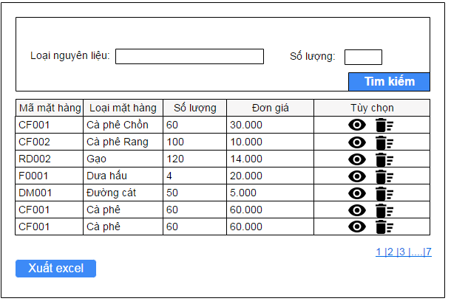

Wireframes 3.1.34 Show Material Receipt

**Wireframes Description**

|  |  |  |  |
| --- | --- | --- | --- |
| No | Control Name | Control Type | Description |
|  | | | |
| 1 | “Loại nguyên liệu” Label | Label |  |
| 2 | Material Type | Textbox |  |
| 3 | “Số lượng” Label | Label |  |
| 4 | Quantity | Textbox |  |
| 5 | Receipt list | Table |  |
| 6 | “Search” button | Button |  |
| 7 | “Xuất Excel” button | Button |  |

### Show Material Detail

|  |  |
| --- | --- |
| Description | Manager want to see detail of Material |
| Actor | Manager |
| Pre-condition | Manager login to system, access to Material Feature, and press on icon View beside the item in table |
| Post-condition | System show dialog detail of Material |
| Data Table | Material |
| Usage Frequency | Often | Regular | Low |
| Criticality | High | Normal | Low |
| Denpendencies | N/A |

**Activity Flow**

|  |  |
| --- | --- |
| Actor | System |
| 1. Manager press icon view beside the item in table | 2. System display dialog detail of Material |

**Alternative Flow**

N/A

**Bussiness Rules**

N/A

**Wireframes**

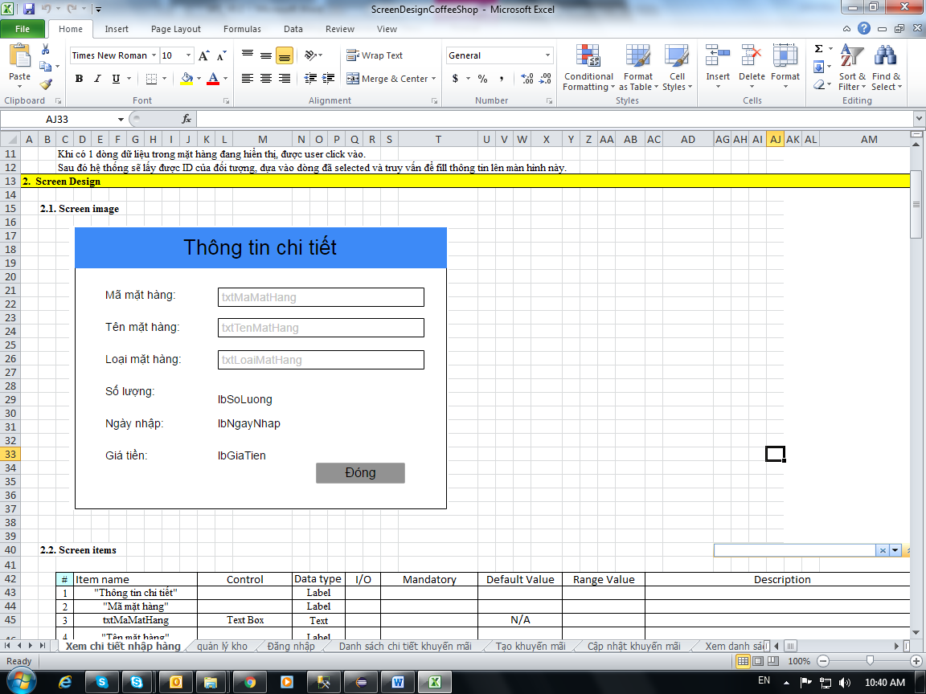

Wireframes 3.1.34 Show Material Receipt Detail

**Wireframes Description**

|  |  |  |  |
| --- | --- | --- | --- |
| No | Control Name | Control Type | Description |
|  | | | |
| 1 | “Mã mặt hàng” Label | Label |  |
| 2 | Material Id | Label |  |
| 3 | “Tên mặt hàng” Label | Label |  |
| 4 | Material Name | Label |  |
| 5 | “Loại mặt hàng” | Label |  |
| 6 | Material Type | Label |  |
| 7 | “Số lượng” | Label |  |
| 8 | Quantity | Label |  |
| 9 | “Ngày nhập” | Label |  |
| 10 | Date | Label |  |
| 11 | “Gía tiền” | Label |  |
| 12 | Price | Label |  |
| 13 | “Đóng” button | Button |  |

### Update Material Detail

|  |  |
| --- | --- |
| Description | Manager update information of Material detail |
| Actor | Manager |
| Pre-condition | Manager login to system, access to Material Feature and press on edit icon beside the item in list |
| Post-condition | Item updated |
| Data Table | Material |
| Usage Frequency | Often | Regular | Low |
| Criticality | High | Normal | Low |
| Denpendencies | N/A |

**Activity Flow**

|  |  |
| --- | --- |
| Actor | System |
| 1. Manager press icon edit item in Material list | 2. System display dialog Update Information |
| 3. Manager input fields |  |
| 4. Manager press on button “Lưu” | 7. System update information to database |
|  | 8. System show notification successfully updated |

**Alternative Flow**

* User leaves required fields empty: system will notify “Vui lòng nhập các trường bắt buộc”.
* Invalid input: system will notify manager with each field have invalid value

**Bussiness Rules**

|  |  |
| --- | --- |
| BR ID | Description |
| BR 1 | If manager have not input all required fields, system will show error |
| BR 2 | If have invalid field, system will show error below that field. |

**Wireframes**

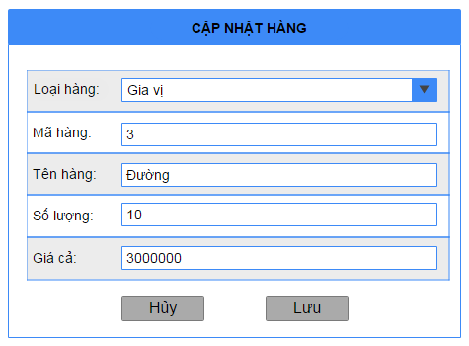

Wireframes 3.1.36 Update Material Receipt

**Wireframes Description**

|  |  |  |  |
| --- | --- | --- | --- |
| No | Control Name | Control Type | Description |
|  | | | |
| 1 | “Loại hàng” Label | Label |  |
| 2 | Material Type | ComboBox |  |
| 3 | “Mã hàng” Label | Label |  |
| 4 | Material Id | Textbox | Unable to update |
| 5 | “Tên hàng” Label | Label |  |
| 6 | Material Name | Textbox |  |
| 7 | “Số lượng” Label | Label |  |
| 8 | Quantity | Textbox |  |
| 9 | “Giá cả” Label | Label |  |
| 10 | Price | Textbox |  |
| 11 | “Lưu” button | Button |  |
| 12 | “Hủy” button | Button |  |

### Delete Material

|  |  |
| --- | --- |
| Description | Manager delete a Material |
| Actor | Manager |
| Pre-condition | Manager login to system, access to Material Feature, and press on icon delete beside item in list |
| Post-condition | Item is deleted from system |
| Data Table | Material |
| Usage Frequency | Often | Regular | Low |
| Criticality | High | Normal | Low |
| Denpendencies | N/A |

**Activity Flow**

|  |  |
| --- | --- |
| Actor | System |
| 1. Manager press on icon delete beside the item | 2. System show dialog to confirm delete |
| 3. Manager press on button “OK” | 4. System delete the item |
|  | 5. System notify successfully deleded |

**Alternative Flow**

* Manager press on Button “Cancel”: System will not delete the item and turn back to previous screen.

**Bussiness Rules**

N/A

**Wireframes**

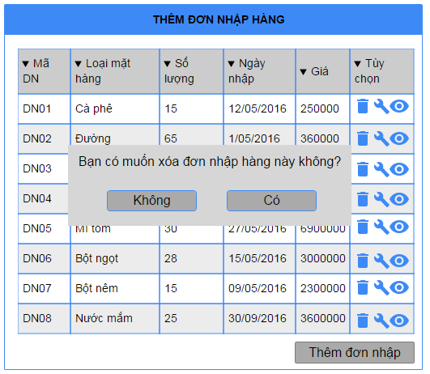

Wireframes 3.1.37 Delete Material Receipt

**Wireframes Description**

|  |  |  |  |
| --- | --- | --- | --- |
| No | Control Name | Control Type | Description |
|  | | | |
| 1 | “OK” button | Button |  |
| 2 | “Cancel” button | Button |  |

### Show Material Category

|  |  |
| --- | --- |
| Description | Manager search for Material categories in data system |
| Actor | Manager |
| Pre-condition | Manager login to system, access to Material Category Feature |
| Post-condition | Show list of Material categories in shop |
| Data Table | MaterialCategory |
| Usage Frequency | Often | Regular | Low |
| Criticality | High | Normal | Low |
| Denpendencies | N/A |

**Activity Flow**

|  |  |
| --- | --- |
| Actor | System |
| 1. Manager access to application |  |
| 2. Manager access to Material Category Feature | 3. System display Material Category Screen |
| 4. Manager input to filter fields (not require) |  |
| 5. Manager press on button “Search” | 6. System search on database by filter fields |
|  | 7. System show items on list view |

**Alternative Flow**

* No items found: System will show message under header of the list view.

**Bussiness Rules**

N/A

**Wireframes**

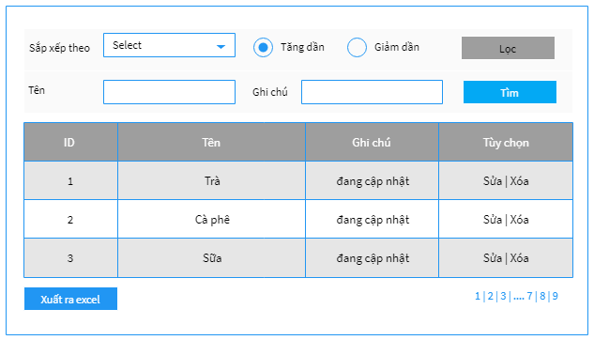

Wireframes 3.1.34 Show Material Category list

**Wireframes Description**

|  |  |  |  |
| --- | --- | --- | --- |
| No | Control Name | Control Type | Description |
|  | | | |
| 1 | “Loại nguyên liệu” Label | Label |  |
| 2 | Material Type | Textbox |  |
| 3 | “Số lượng” Label | Label |  |
| 4 | Quantity | Textbox |  |
| 5 | Receipt list | Table |  |
| 6 | “Search” button | Button |  |
| 7 | “Xuất Excel” button | Button |  |

### Create Material Category

|  |  |
| --- | --- |
| Description | Manager create a new Material category |
| Actor | Manager |
| Pre-condition | Manager login to system, access to Material Category Feature, and press on button “Thêm loại mặt hàng” |
| Post-condition | New Material category created |
| Data Table | MaterialCategory |
| Usage Frequency | Often | Regular | Low |
| Criticality | High | Normal | Low |
| Denpendencies | N/A |

**Activity Flow**

|  |  |
| --- | --- |
| Actor | System |
| 1. Manager access to application |  |
| 2. Manager access to Material Category Feature | 3. System display Material Category Screen |
| 4. Manager press on button “Thêm Mới” | 5. System display Add New Material Category Dialog |
| 6. Manager input all require fields |  |
| 7. Manager press on button “Lưu” | 8. System save information to database |
|  | 9. System show dialog to notify successfully |

**Alternative Flow**

* User leaves required fields empty: system will notify “Vui lòng nhập các trường bắt buộc”.
* Invalid input: system will notify manager with each field have invalid value

**Bussiness Rules**

|  |  |
| --- | --- |
| BR ID | Description |
| BR 1 | If manager have not input all required fields, system will show error |
| BR 2 | If have invalid field, system will show error below that field. |

**Wireframes**

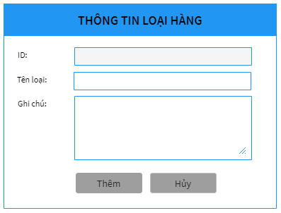

Wireframes 3.1.39 Create Material Category

**Wireframes Description**

|  |  |  |  |
| --- | --- | --- | --- |
| No | Control Name | Control Type | Description |
| 1 | “ID:” Label | Label |  |
| 2 | Material Category ID | Textbox | disabled |
| 3 | “Tên loại” Label | Label |  |
| 4 | Material Category Name | Textbox |  |
| 5 | “Ghi chú” Label | Label |  |
| 6 | Description | Textarea |  |
| 7 | “Lưu” button | Button |  |
| 8 | “Hủy” button | Button |  |

### Update Material Category Detail

|  |  |
| --- | --- |
| Description | Manager update information of Material category detail |
| Actor | Manager |
| Pre-condition | Manager login to system, access to Material Category Feature and press on edit icon beside the item in list |
| Post-condition | Item updated |
| Data Table | MaterialCategory |
| Usage Frequency | Often | Regular | Low |
| Criticality | High | Normal | Low |
| Denpendencies | N/A |

**Activity Flow**

|  |  |
| --- | --- |
| Actor | System |
| 1. Manager press icon edit item in Material category list | 2. System display dialog Update Information |
| 3. Manager input fields |  |
| 4. Manager press on button “Lưu” | 7. System update information to database |
|  | 8. System show notification successfully updated |

**Alternative Flow**

* User leaves required fields empty: system will notify “Vui lòng nhập các trường bắt buộc”.
* Invalid input: system will notify manager with each field have invalid value

**Bussiness Rules**

|  |  |
| --- | --- |
| BR ID | Description |
| BR 1 | If manager have not input all required fields, system will show error |
| BR 2 | If have invalid field, system will show error below that field. |

**Wireframes**



Wireframes 3.1.41 Update Material category

**Wireframes Description**

|  |  |  |  |
| --- | --- | --- | --- |
| No | Control Name | Control Type | Description |
| 1 | “ID:” Label | Label |  |
| 2 | Material Category ID | Textbox | disabled |
| 3 | “Tên loại” Label | Label |  |
| 4 | Material Category Name | Textbox |  |
| 5 | “Ghi chú” Label | Label |  |
| 6 | Description | Textarea |  |
| 7 | “Lưu” button | Button |  |
| 8 | “Hủy” button | Button |  |

### Delete Material Category

|  |  |
| --- | --- |
| Description | Manager delete a Material category |
| Actor | Manager |
| Pre-condition | Manager login to system, access to Material Category Feature, and press on icon delete beside item in list |
| Post-condition | Item is deleted from system |
| Data Table | MaterialCategory |
| Usage Frequency | Often | Regular | Low |
| Criticality | High | Normal | Low |
| Denpendencies | N/A |

**Activity Flow**

|  |  |
| --- | --- |
| Actor | System |
| 1. Manager press on icon delete beside the item | 2. System show dialog to confirm delete |
| 3. Manager press on button “OK” | 4. System delete the item |
|  | 5. System notify successfully deleded |

**Alternative Flow**

* Manager press on Button “Cancel”: System will not delete the item and turn back to previous screen.

**Bussiness Rules**

N/A

**Wireframes**



Wireframes 3.1.37 Material category list

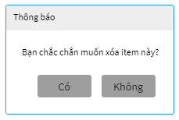

Wireframes 3.1.37 Dialog to confirm delete

**Wireframes Description**

|  |  |  |  |
| --- | --- | --- | --- |
| No | Control Name | Control Type | Description |
|  | | | |
| 1 | “OK” button | Button |  |
| 2 | “Cancel” button | Button |  |

### Show Material Log

|  |  |
| --- | --- |
| Description | Manager search for Material logs in data system |
| Actor | Manager |
| Pre-condition | Manager login to system, access to Material Log Feature |
| Post-condition | Show list of Material logs in shop |
| Data Table | MaterialLog |
| Usage Frequency | Often | Regular | Low |
| Criticality | High | Normal | Low |
| Denpendencies | N/A |

**Activity Flow**

|  |  |
| --- | --- |
| Actor | System |
| 1. Manager access to application |  |
| 2. Manager access to Material Log Feature | 3. System display Material Log Screen |
| 4. Manager input to filter fields (not require) |  |
| 5. Manager press on button “Search” | 6. System search on database by filter fields |
|  | 7. System show items on list view |

**Alternative Flow**

* No items found: System will show message under header of the list view.

**Bussiness Rules**

N/A

**Wireframes**

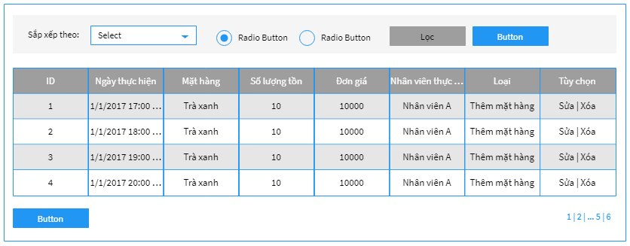

Wireframes 3.1.34 Material log list

**Wireframes Description**

|  |  |  |  |
| --- | --- | --- | --- |
| No | Control Name | Control Type | Description |
| 1 | “Sắp xếp theo” Label | Label |  |
| 2 | Sort By List | Combobox |  |
| 3 | “Tăng dần” Label | Label |  |
| 4 | Increasing Radio | Radio button |  |
| 5 | “Giảm dần” Label | Label |  |
| 6 | Decreasing Radio | Radio button |  |
| 7 | “Lọc” button | Button |  |
| 8 | “Tìm kiếm” button | Button |  |
| 9 | Log list table | Table |  |
| 10 | “Xuất ra Excel” button | Button |  |
| 11 | Pagination | Ul |  |

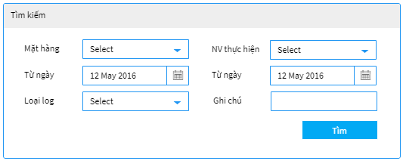

Wireframes 3.1.34 Advance search popup

**Wireframes Description**

|  |  |  |  |
| --- | --- | --- | --- |
| No | Control Name | Control Type | Description |
| 1 | “Mặt hàng” Label | Label |  |
| 2 | Material list | Combobox |  |
| 3 | “NV thực hiện” Label | Label |  |
| 4 | Employee list | Combobox |  |
| 5 | “Từ ngày” label | Label |  |
| 6 | From date | Date |  |
| 7 | “Đến ngày” label | Label |  |
| 8 | To date | Date |  |
| 9 | “Loại log” label | Label |  |
| 10 | Log type list | Combobox |  |
| 11 | “Ghi chú” label | Label |  |
| 12 | Description | Textbox |  |
| 13 | “Tìm” button | Button |  |

### Update Material Log Detail

|  |  |
| --- | --- |
| Description | Manager update information of Material log detail |
| Actor | Manager |
| Pre-condition | Manager login to system, access to Material Log Feature and press on edit icon beside the item in list |
| Post-condition | Item updated |
| Data Table | MaterialCategory |
| Usage Frequency | Often | Regular | Low |
| Criticality | High | Normal | Low |
| Denpendencies | N/A |

**Activity Flow**

|  |  |
| --- | --- |
| Actor | System |
| 1. Manager press icon edit item in Material category list | 2. System display dialog Update Information |
| 3. Manager input fields |  |
| 4. Manager press on button “Lưu” | 7. System update information to database |
|  | 8. System show notification successfully updated |

**Alternative Flow**

* User leaves required fields empty: system will notify “Vui lòng nhập các trường bắt buộc”.
* Invalid input: system will notify manager with each field have invalid value

**Bussiness Rules**

|  |  |
| --- | --- |
| BR ID | Description |
| BR 1 | If manager have not input all required fields, system will show error |
| BR 2 | If have invalid field, system will show error below that field. |

**Wireframes**

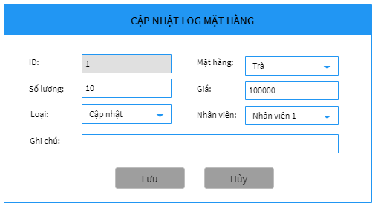

Wireframes 3.1.41 Update Material log

**Wireframes Description**

|  |  |  |  |
| --- | --- | --- | --- |
| No | Control Name | Control Type | Description |
| 1 | “ID:” Label | Label |  |
| 2 | Material Log ID | Textbox | disabled |
| 3 | “Mặt hàng” Label | Label |  |
| 4 | Material ID | Combobox |  |
| 5 | “Số lượng” Label | Label |  |
| 6 | Inventory | Textbox |  |
| 7 | “Giá” Label | Label |  |
| 8 | Unit price | Textbox |  |
| 9 | “Loại” Label | Label |  |
| 10 | Log type | Combobox |  |
| 11 | “Nhân viên” Label | Label |  |
| 12 | Employee ID | Combobox |  |
| 13 | “Ghi chú” Label | Label |  |
| 14 | Description | Textbox |  |
| 15 | “Lưu” button | Button |  |
| 16 | “Hủy” button | Button |  |

### Delete Material Log

|  |  |
| --- | --- |
| Description | Manager delete a Material log |
| Actor | Manager |
| Pre-condition | Manager login to system, access to Material Log Feature, and press on icon delete beside item in list |
| Post-condition | Item is deleted from system |
| Data Table | MaterialLog |
| Usage Frequency | Often | Regular | Low |
| Criticality | High | Normal | Low |
| Denpendencies | N/A |

**Activity Flow**

|  |  |
| --- | --- |
| Actor | System |
| 1. Manager press on icon delete beside the item | 2. System show dialog to confirm delete |
| 3. Manager press on button “OK” | 4. System delete the item |
|  | 5. System notify successfully deleded |

**Alternative Flow**

* Manager press on Button “Cancel”: System will not delete the item and turn back to previous screen.

**Bussiness Rules**

N/A

**Wireframes**



Wireframes 3.1.37 Material log list



Wireframes 3.1.37 Material log confirm delete dialog

**Wireframes Description**

|  |  |  |  |
| --- | --- | --- | --- |
| No | Control Name | Control Type | Description |
| 1 | “OK” button | Button |  |
| 2 | “Cancel” button | Button |  |

### Show Revenue Report

|  |  |
| --- | --- |
| Description | Manager view revenue report |
| Actor | Manager |
| Pre-condition | Manager login to system, access to Revenue Report Feature |
| Post-condition | Show revenue chart of shop |
| Data Table | Order |
| Usage Frequency | Often | Regular | Low |
| Criticality | High | Normal | Low |
| Denpendencies | N/A |

**Activity Flow**

|  |  |
| --- | --- |
| Actor | System |
| 1. Manager access to application |  |
| 2. Manager access to Revenue Report Feature | 3. System display Report Screen |
| 4. Manager input to filter fields (not require) |  |
| 5. Manager press on button “Search” | 6. System search on database by filter fields |
|  | 7. System show chart |

**Alternative Flow**

* N/A

**Bussiness Rules**

N/A

**Wireframes**

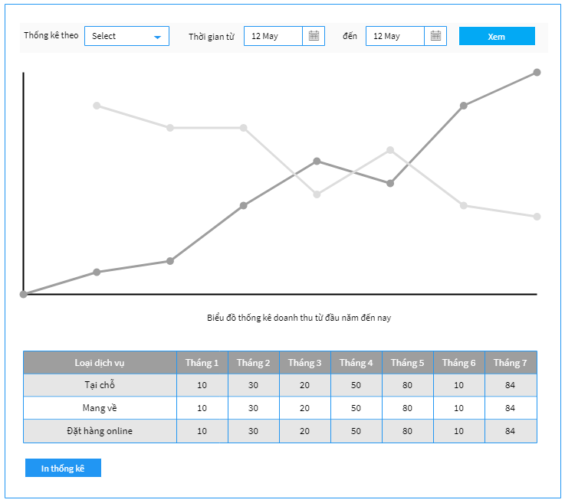

Wireframes 3.1.34 Show Revenue Report

**Wireframes Description**

|  |  |  |  |
| --- | --- | --- | --- |
| No | Control Name | Control Type | Description |
|  | | | |
| 1 | “Thống kê theo” Label | Label |  |
| 2 | By Portion | Combobox |  |
| 3 | “Thời gian từ” Label | Label |  |
| 4 | From date | Date |  |
| 5 | “đến” Label | Label |  |
| 6 | Revenue Chart | Chart/Image |  |
| 7 | “Biểu đồ thống kê doanh thu” Label | Label |  |
| 8 | Revenue table | Table |  |
| 9 | “In thống kê” button | Button |  |

### Show Product Report

|  |  |
| --- | --- |
| Description | Manager view product report |
| Actor | Manager |
| Pre-condition | Manager login to system, access to Product Report Feature |
| Post-condition | Show product chart of shop |
| Data Table | Order |
| Usage Frequency | Often | Regular | Low |
| Criticality | High | Normal | Low |
| Denpendencies | N/A |

**Activity Flow**

|  |  |
| --- | --- |
| Actor | System |
| 1. Manager access to application |  |
| 2. Manager access to Product Report Feature | 3. System display Report Screen |
| 4. Manager input to filter fields (not require) |  |
| 5. Manager press on button “Search” | 6. System search on database by filter fields |
|  | 7. System show chart |

**Alternative Flow**

* N/A

**Bussiness Rules**

N/A

**Wireframes**

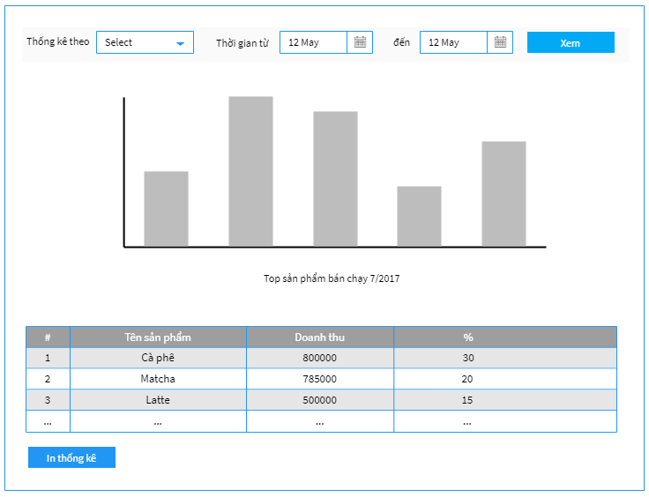

Wireframes 3.1.34 Chart of product

**Wireframes Description**

|  |  |  |  |
| --- | --- | --- | --- |
| No | Control Name | Control Type | Description |
|  | | | |
| 1 | “Thống kê theo” Label | Label |  |
| 2 | By Portion | Combobox |  |
| 3 | “Thời gian từ” Label | Label |  |
| 4 | From date | Date |  |
| 5 | “đến” Label | Label |  |
| 6 | Revenue Chart | Chart/Image |  |
| 7 | “Top sản phẩm” Label | Label |  |
| 8 | Revenue table | Table |  |
| 9 | “In thống kê” button | Button |  |

### Show Bill Detail

|  |  |
| --- | --- |
| Description | Manager see the bill that they sell |
| Actor | Manager |
| Pre-condition | Manager login to system, access to Bill Feature |
| Post-condition | System show bill information |
| Data Table | Orders |
| Usage Frequency | Often | Regular | Low |
| Criticality | High | Normal | Low |
| Denpendencies | N/A |

**Activity Flow**

|  |  |
| --- | --- |
| Actor | System |
| 1. Manager access to application |  |
| 2. Manager access to Bill Feature | 3. System display Bill Management Screen |
| 4. Manager input to filter fields (not require) |  |
| 5. Manager press on button “Tìm kiếm” | 6. System search on database by filter fields |
|  | 7. System show bills on list view |
| 8. Manager press on icon Show on item | 9. System show dialog bill item information |

**Alternative Flow**

* Not found receipt: System will show message under header of the list view.

**Bussiness Rules**

N/A

**Wireframes**

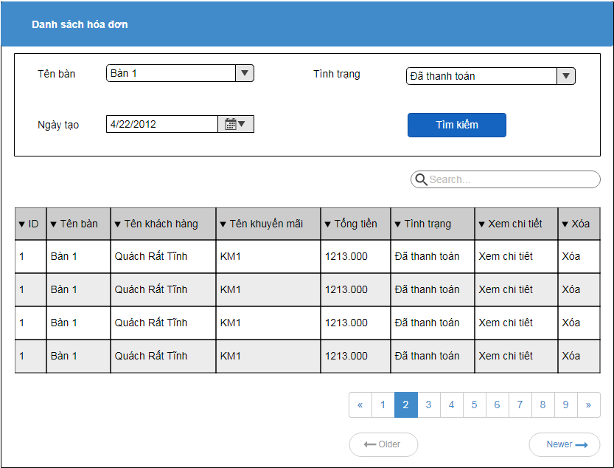

Wireframes 3.1.38.1 Search Bill

Xem chi tiết hóa đơn

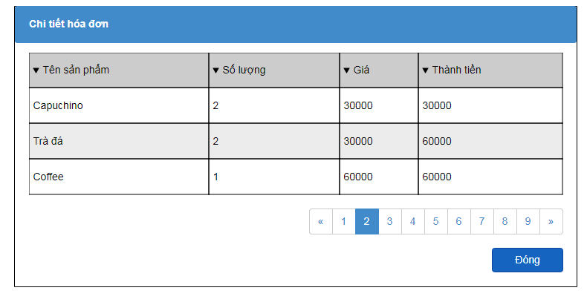

Wireframes 3.1.38 Bill Detail

**Wireframes Description**

|  |  |  |  |
| --- | --- | --- | --- |
| No | Control Name | Control Type | Description |
| 1 | “Danh sách hóa đơn” Label | Label |  |
| 2 | “Tên bàn” Label | Label |  |
| 3 | cbTenban | Combobox |  |
| 4 | “Tình trạng” Label | Label |  |
| 5 | cbTinhtrang | Combobox |  |
| 6 | “Ngày tạo” Label | Label |  |
| 7 | cbNgaytao | Datepicker |  |
| 8 | “Tìm kiếm” button | Button | Advanced search |
| 9 | txtSearch | Textbox | Basic search |
| 10 | Bill table | Table |  |
| 11 | Bill detail table | Table |  |

### 3.1.49 Update Bill Detail

|  |  |
| --- | --- |
| Description | Manager see the bill that they sell |
| Actor | Manager |
| Pre-condition | Manager login to system, access to Bill Feature |
| Post-condition | System show bill information |
| Data Table | Orders |
| Usage Frequency | Often | Regular | Low |
| Criticality | High | Normal | Low |
| Denpendencies | N/A |

**Activity Flow**

|  |  |
| --- | --- |
| Actor | System |
| 1. Manager access to application |  |
| 2. Manager access to Bill Feature | 3. System display Bill Management Screen |
| 4. Manager press on button “Cập nhật”require) |  |
|  | 5. System show bills detail information on popup |
| 6.Manager input fileds and click “Lưu” |  |
|  | 7.System save information |

**Alternative Flow**

* Not found receipt: System will show message under header of the list view.

**Bussiness Rules**

N/A

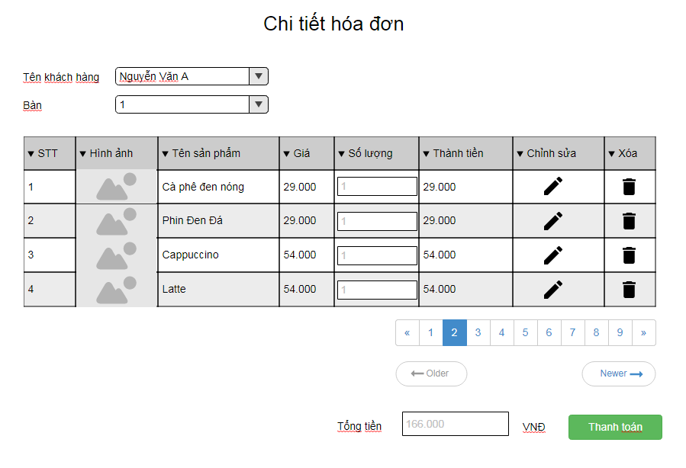

**Wireframes Description**

|  |  |  |  |  |  |  |  |  |
| --- | --- | --- | --- | --- | --- | --- | --- | --- |
| STT | Item name | |  |  |  |  | Control | Description |
| 1 | Tên khách hàng | | | |  |  | Label |  |
| 2 | Textbox Tên khách hàng | | | | | | textbox |  |
| 3 | Bàn |  |  |  |  |  | Label |  |
| 4 | Table danh sách sản phẩm | | | | | | Table |  |
| 5 | Pagination phân trang | | | | |  | button |  |
| 6 | Tổng tiền | |  |  |  |  | Label |  |
| 7 | textbox Tổng tiền | | | |  |  | textbox |  |
| 7 | textbox Số lượng | | | |  |  | textbox |  |
| 8 | Thanh toán | | |  |  |  | button |  |
| 9 | Chỉnh sửa | |  |  |  |  | button |  |
| 10 | Xóa |  |  |  |  |  | button |  |

### 3.1.50 Add Account

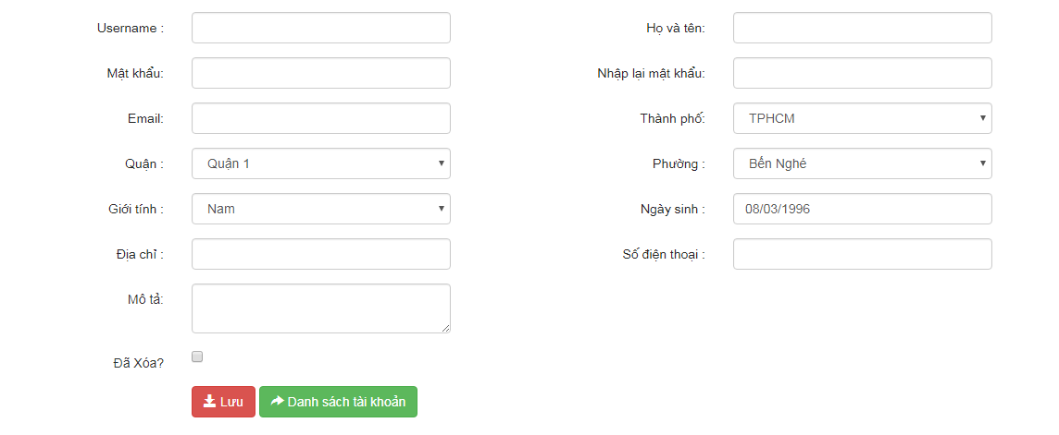

Description:

|  |  |  |  |  |  |  |
| --- | --- | --- | --- | --- | --- | --- |
| # | Item name | Control | Data type | I/O | | Description |
|  | **Màn hình nhập thông tin cho tài khoản mới** | | |  |  |  |
| 1 | Username label | Label | Text | O | | Label cho tên đăng nhập |
| 2 | Full Name label | Label | Text | O | | Label cho họ và tên |
| 3 | Password label | Label | Text | O | | Label cho mật khẩu |
| 4 | ReEnterPassword label | Label | Text | O | | Label cho nhập lại mật khẩu |
| 5 | Email label | Label | Text | O | | Label cho Email |
| 6 | City label | Label | Text | O | | Label cho thành phố |
| 7 | District label | Label | Text | O | | Label cho quận |
| 8 | Ward label | Label | Text | O | | Label cho phường |
| 9 | Sex label | Label | Text | O | | Label cho giới tính |
| 10 | Birthdate label | Label | Text | O | | Label cho ngày sinh |
| 11 | Address label | Label | Text | O | | Label cho địa chỉ |
| 12 | Phone label | Label | Text | O | | Label cho số điện thoại |
| 13 | Description label | Label | Text | O | | Label cho mô tả |
| 14 | IsDelete label | Label | Text | O | | Label cho đã xóa |
| 15 | Username | Textbox | Text | I | | Ô nhập tên đăng nhập |
| 16 | Full Name | Textbox | Text | I | | Ô nhập họ và tên |
| 17 | Password | Textbox | Text | I | | Ô nhập mật khẩu |
| 18 | ReEnterPassword | Textbox | Text | I | | Ô nhập lại mật khẩu |
| 19 | Email | Textbox | Text | I | | Ô nhập email |
| 20 | City | Combobox | Int | I | | Combobox chọn lựa thành phố |
| 21 | District | Combobox | Int | I | | Combobox chọn lựa quận |
| 22 | Ward | Combobox | Int | I | | Combobox chọn lựa phường |
| 23 | Sex | Combobox | Text | I | | Combobox chọn lựa giới tính |
| 24 | Birtdate | Textbox | Datetime | I | | Datepicker lựa chọn ngày sinh |
| 25 | Address | Textbox | Text | I | | Ô nhập địa chỉ |
| 26 | Phone | Textbox | Text | I | | Ô nhập số điện thoại |
| 27 | Description | Textbox | Text | I | | Ô nhập mô tả |
| 28 | IsDelete | Checkbox | Boolean | I | | Checkbox hiển thị xóa hay chưa |
| 29 | Shop label | label | Text | O | | Label cho cửa hàng |
| 30 | Shop | Combobox | Int | I | | Combobox cho cửa hàng |
| 31 | Save | Button |  |  | | Thêm tài khoản vào Database |
| 32 | Return to account listing | Button |  |  | | Quay trở về màn hình list tài khoản |

### Search Account

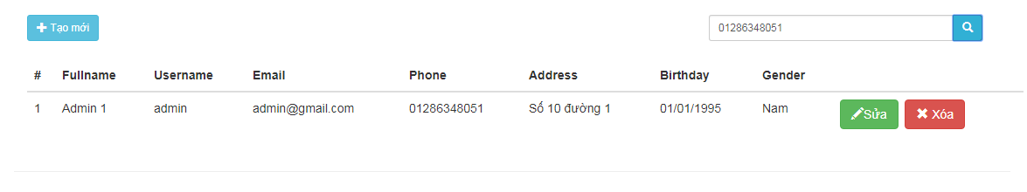

### Update Account

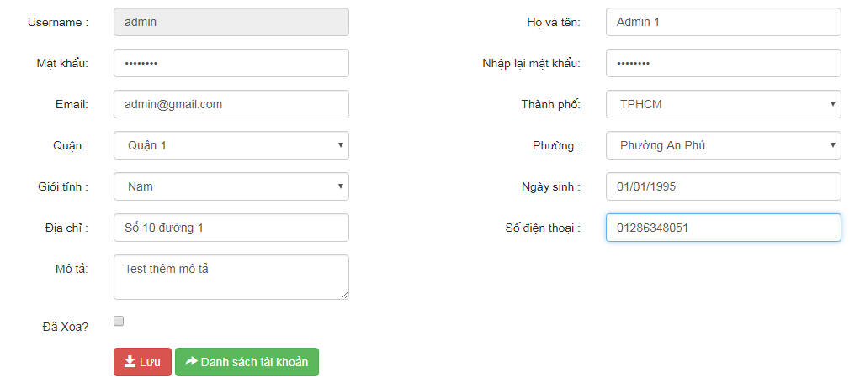

### Delete Account

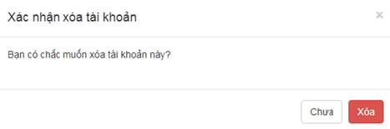

### Add Shop

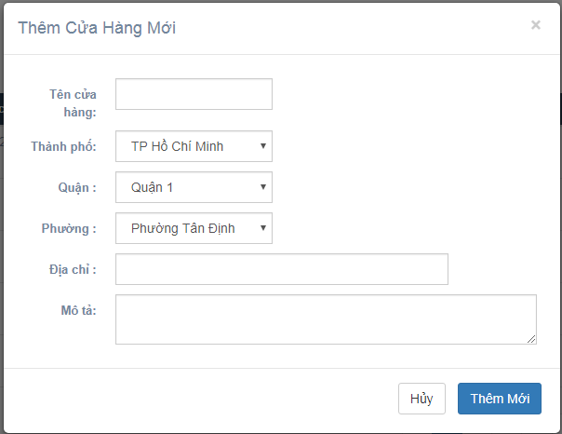

|  |  |  |  |  |  |  |
| --- | --- | --- | --- | --- | --- | --- |
| # | Item name | Control | Data type | I/O | | Description |
|  | **Màn hình nhập thông tin cho tài khoản mới** | | |  |  |  |
| 1 | Name label | Label | Text | O | | Label cho tên cửa hàng |
| 2 | City label | Label | Text | O | | Label cho thành phố |
| 3 | District label | Label | Text | O | | Label cho quận |
| 4 | Ward label | Label | Text | O | | Label cho phường |
| 5 | Address label | Label | Text | O | | Label cho địa chỉ |
| 6 | Description label | Label | Text | O | | Label cho mô tả |
| 7 | Name | Textbox | Text | I | | Ô nhập tên cửa hàng |
| 8 | City | Combobox | Int | I | | Combobox chọn lựa thành phố |
| 9 | District | Combobox | Int | I | | Combobox chọn lựa quận |
| 10 | Ward | Combobox | Int | I | | Combobox chọn lựa phường |
| 11 | Address | Textbox | Text | I | | Ô nhập địa chỉ |
| 12 | Description | Textbox | Text | I | | Ô nhập mô tả |
| 13 | Save | Button |  |  | | Thêm cửa hàng vào Database |
| 14 | Cancel | Button |  |  | | Quay trở về màn hình list cửa hang |

### Search Shop

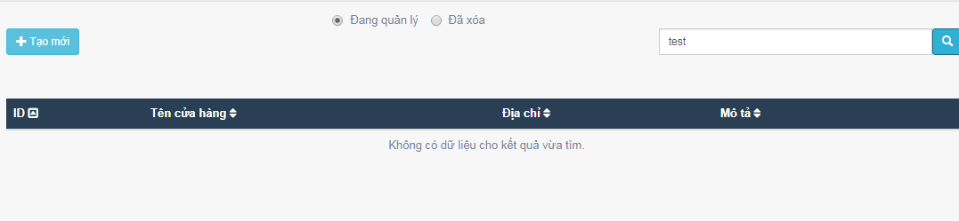

|  |  |  |  |  |  |  |  |  |  |  |  |  |  |
| --- | --- | --- | --- | --- | --- | --- | --- | --- | --- | --- | --- | --- | --- |
| # | Item name | Control | Data type | | I/O | | | Description | | | | | |
|  | **Khung Tìm Kiếm** | | |  | |  |  | |  |  |  |  |  |
| 1 | Name or Des Input | Textbox | Text | | I | | | Nhập tên hoặc mô tả để tìm kiếm cửa hàng ( optional) | | | | | |
| 2 | Search | Button |  | |  | | | Nhấp vào để bắt đầu tìm kiếm cửa hang | | | | | |
|  | **Khung Liệt Kê Danh sách cửa hàng** | | | | | | | | | | | | |
| 3 | ID table heading | TH | Text | | O | | | Table header ID | | | | | |
| 4 | Name table heading | TH | Text | | O | | | Table header Full Name | | | | | |
| 5 | Address column heading | TH | Text | | O | | | Table Header Address | | | | | |
| 6 | Option column heading | TH | Text | | O | | | Table header for Edit ,Delete button | | | | | |
| 7 | ID | TD | Text | | O | | | Ô hiển thị ID cửa hang | | | | | |
| 8 | Name | TD | Text | | O | | | Ô hiển thị tên shop | | | | | |
| 9 | Address | TD | Text | | O | | | Ô hiển thị địa chỉ | | | | | |
| 10 | Edit | Button |  | |  | | | Cập nhật thông tin cửa hàng đang chọn | | | | | |
| 11 | Delete/Recover | Button |  | |  | | | Xóa một cửa hàng đang chọn (Soft Delete) hoặc khôi phục cửa hàng đang chọn | | | | | |

### Update Shop

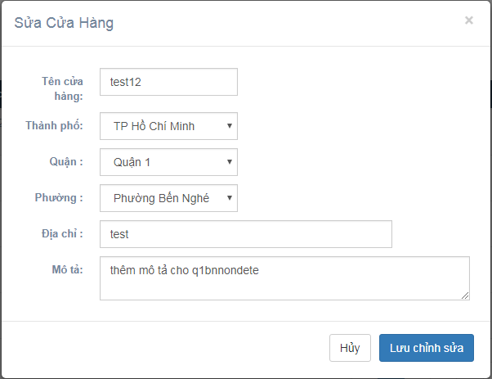

|  |  |  |  |  |  |  |
| --- | --- | --- | --- | --- | --- | --- |
| # | Item name | Control | Data type | I/O | | Description |
|  | **Màn hình nhập thông tin cho tài khoản mới** | | |  |  |  |
| 1 | Name label | Label | Text | O | | Label cho tên cửa hàng |
| 2 | City label | Label | Text | O | | Label cho thành phố |
| 3 | District label | Label | Text | O | | Label cho quận |
| 4 | Ward label | Label | Text | O | | Label cho phường |
| 5 | Address label | Label | Text | O | | Label cho địa chỉ |
| 6 | Description label | Label | Text | O | | Label cho mô tả |
| 7 | Name | Textbox | Text | I | | Ô nhập tên cửa hàng |
| 8 | City | Combobox | Int | I | | Combobox chọn lựa thành phố |
| 9 | District | Combobox | Int | I | | Combobox chọn lựa quận |
| 10 | Ward | Combobox | Int | I | | Combobox chọn lựa phường |
| 11 | Address | Textbox | Text | I | | Ô nhập địa chỉ |
| 12 | Description | Textbox | Text | I | | Ô nhập mô tả |
| 13 | Save | Button |  |  | | Cập nhật thông tin cửa hàng vào Database |
| 14 | Cancel | Button |  |  | | Quay trở về màn hình list cửa hàng |

### Delete Shop

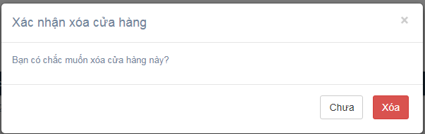

|  |  |  |  |  |  |  |
| --- | --- | --- | --- | --- | --- | --- |
| # | Item name | Control | Data type | I/O | | Description |
|  | **Màn hình nhập thông tin cho tài khoản mới** | | |  |  |  |
| 1 | Modal Title | Label | Text | O | | Tiêu đề cho modal confirm xóa |
| 2 | Modal Content | Label | Text | O | | Content cho modal confirm xóa |
| 3 | No button | Button |  |  | | Nút đóng modal confirm xóa |
| 4 | Yes button | Button |  |  | | Nút xác nhận xóa cửa hàng (soft delete) |
| 5 | (x) button | Button |  |  | | Nút đóng modal confirm xóa |

## Usability

## Reliability

## Performance

## Supportability

## Design Constraints

## On-line User Documentation and Help System Requirements

## Interfaces

## Licensing Requirements

## Legal, Copyright, and Other Notices

## Applicable Standards

## 4. Supporting Information