TITAN: Analytical FMM/M2L Boundary-Integral Poisson-Boltzmann Solves with Sparse Near-Field ILU(0) Preconditioning
Guarded p4 repeatability refresh for external manuscript

Abstract
Boundary-integral Poisson-Boltzmann solvers avoid volumetric grids but require accurate acceleration and robust Krylov preconditioning. We present a guarded fourth-order analytical FMM/M2L path in TITAN that remains an advanced explicit TABI treecode option. The path uses static far-cell refinement, a strict geometric guard, compressed Green-function jets, packed AVX2 direct fallback, and sparse near-field ILU(0). Full prepared proteins were evaluated without atom sampling. Across three repeats per protein, the guarded path was finite, repeatable, and passed sampled direct-operator checks. Grid-based Poisson-Boltzmann remains TITAN's production default.

Methods
The guarded p4 path is selected explicitly and is not the automatic TABI treecode policy. The measured configuration uses Taylor order 4, opening theta 0.6, static tail tolerance 0.002, strict-geometry MAC theta 0.5, compressed degree-9 Green jets, packed AVX2 direct fallback, analytic-singular near integration, and sparse near-field ILU(0) with 64 neighbors.
For panel i, the coupled unknown is u_i = (phi_i, partial_n phi_i)^T. The preconditioner retains 2 x 2 blocks on edges from the FMM near-source graph and applies ILU(0) without fill. Large-system verification uses sampled direct-operator RMS and sampled direct true residuals.

Results
Table 1 reports the repeatability evidence used for the guarded p4 claim. All three rows passed the Z4O gate with zero energy spread across repeats.
Protein | PDB/source | N_atoms | N_panels | E_rxn | Audit max | Direct residual max | Energy spread | p4/deg1 | RSS MB
Barnase | PyDelPhi benchmark | 1700 | 14942 | -21030.83 | 6.383e-05 | 6.383e-05 | 0.000 | 0.450 | 172.6
RNA-binding domain of E. coli Rho factor | 1A63 | 2065 | 17250 | -247716.08 | 2.357e-03 | 2.357e-03 | 0.000 | 0.674 | 369.4
Stichodactyla helianthus neurotoxin I | 1SH1 | 696 | 6673 | -4362.07 | 4.894e-06 | 4.894e-06 | 0.000 | 0.383 | 63.5

Repeatability Summary
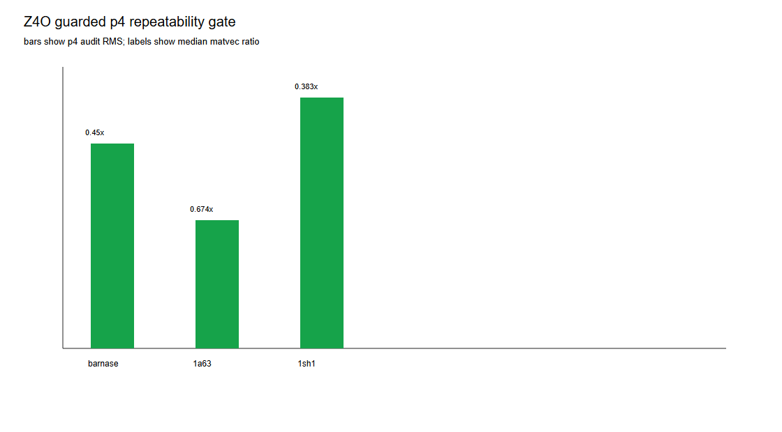
Figure 1. Guarded p4 repeatability across the complete public-protein panel.

Discussion
The guarded p4 path has moved from a diagnostic candidate to a repeatable advanced explicit solver path for the three complete public proteins tested. This does not change default behavior: the grid backend remains TITAN's production Poisson-Boltzmann default and the default TABI treecode engine remains degree-one.

Limitations
Guarded p4 must be requested explicitly; it is not enabled by auto or default policy.
Large-system references use sampled direct-operator verification rather than full direct TABI energy.
Additional public proteins are reported as supplement evidence after passing the same repeatability gate.

Supplementary Public-Protein Expansion
Table S1 reports additional full-protein systems that passed the same guarded p4 repeatability gate. These rows broaden the benchmark panel as supplement evidence while the main claim remains anchored on Table 1.
Protein | PDB | N_atoms | N_panels | E_rxn | Audit max | Direct residual max | Energy spread | p4/deg1
Ubiquitin | 1UBQ | 1231 | 11242 | -4038.46 | 1.468e-05 | 1.468e-05 | 0.000 | 0.499
Villin headpiece subdomain | 1VII | 596 | 5032 | -2355.70 | 5.871e-06 | 5.871e-06 | 0.000 | 0.412
Chymotrypsin inhibitor 2 | 2CI2 | 1076 | 9889 | -4891.15 | 7.983e-06 | 7.983e-06 | 0.000 | 0.547

Supplementary Provenance
Protein | PDB/source | Model | Chain | PDB2PQR | PQR SHA256
Barnase | PyDelPhi benchmark | 1 | A | 3.7.1 | 5a8136a5cc07ab472fcfa0e817d9ecb16d2d705b2bb88ac026ea7fbe16885002
RNA-binding domain of E. coli Rho factor | 1A63 | 1 | A | 3.7.1 | a26d0c3e1fa32fde448a3571a3ab720e4fc8a2bb40d5989f77731ee678681c7a
Stichodactyla helianthus neurotoxin I | 1SH1 | 1 | A | 3.7.1 | c661ed6012607d92bbab2d43b970ae1ec954a16d0694ce60f7037a5cd5c9bd6e

