TITAN: Analytical FMM/M2L Boundary-Integral Poisson-Boltzmann Solves with Sparse Near-Field ILU(0) Preconditioning
Hoang Linh Nguyen1,2,*
1Institute of Fundamental and Applied Sciences, Duy Tan University, Ho Chi Minh City 700000, Vietnam
2Faculty of Environmental and Natural Sciences, Duy Tan University, Da Nang 550000, Vietnam
*Email: nguyenhoanglinh9@duytan.edu.vn

Abstract
Grid-based Poisson-Boltzmann solvers remain robust workhorses, but their volumetric discretization imposes steep memory costs and artifacts at the sharp dielectric boundary. Boundary-integral equation (BIE) formulations circumvent the volume grid by solving directly on the molecular interface, yet they replace the grid problem with a dense, derivative-rich surface operator that frequently causes severe stalling in Krylov subspace solvers. To overcome this fundamental limitation, we present a hardware-aware, analytical Fast Multipole Method (FMM/M2L) integrated into the TITAN engine. Our approach couples a guarded fourth-order Cartesian Taylor expansion with compressed Green-function jets, AVX2-packed direct evaluations, and a novel sparse near-field ILU(0) preconditioner. Validation across a diverse protein panel including Barnase, the E. coli Rho factor RNA-binding domain, and Stichodactyla helianthus neurotoxin I demonstrates unconditional convergence with finite energies and direct-operator residuals strictly below 8e-3. Crucially, dense convergence profiles reveal that while traditional baseline diagonal and local block-diagonal preconditioning stall due to high-coupling singularities, our sparse ILU(0) preconditioner completely resolves the Krylov stiffness. This robust FMM-BIE architecture maintains high-fidelity interfacial electrostatics while drastically reducing the memory footprint compared to volumetric grid alternatives.

Introduction
Implicit-solvent electrostatics is a central component of biomolecular modeling, offering a computationally tractable alternative to explicit solvent representations by treating the aqueous environment as a dielectric continuum. The Poisson-Boltzmann (PB) equation is widely used for this purpose. Classical grid-based solvers, employing finite-difference or finite-element methods, are robust and heavily utilized in the field. However, volumetric discretization inherently involves trade-offs regarding memory requirements and the representation of sharp dielectric boundaries, particularly as the size of the macromolecular system increases.
Boundary-integral equation (BIE) formulations offer a complementary perspective. By moving the unknowns from the three-dimensional volume to the 2D molecular surface, BIE approaches reduce the problem dimensionality, which is highly advantageous for modeling complex surface interactions and reducing the memory footprint. However, this topological reformulation replaces the sparse volumetric grid with a dense, derivative-rich surface operator. Evaluating this dense matrix directly scales as $O(N^2)$, which is computationally demanding for large protein complexes. Furthermore, the strong singularities inherent to the coupled boundary-integral channels often lead to a stiff linear system.
To address the computational cost of dense BIE operators, fast summation techniques such as treecodes and the Fast Multipole Method (FMM) [2] have been successfully applied. Significant methodological progress has been made in this area. For example, the Cartesian Galerkin FMM (FAGBI) [1] established an analytical framework for boundary-integral PB, while TABI-PB 2.0 [9] demonstrated excellent matrix-vector product (Matvec) throughput by combining barycentric Lagrange dual-tree traversal with GPU acceleration. However, while fast summation effectively reduces the cost per iteration, the underlying stiffness of the coupled BIE matrix remains a challenge for Krylov subspace solvers (e.g., GMRES).
To mitigate this stiffness, iterative solvers rely on preconditioning—a mathematical transformation that approximates the inverse of the system matrix to cluster its eigenvalues and accelerate convergence. In BIE formulations, the system's stiffness is primarily driven by strong near-field electrostatic couplings across the complex molecular topology. Standard local preconditioners, such as diagonal or block-diagonal scaling, often stall on realistic protein surfaces because they treat distinct tree leaves as isolated entities, thereby ignoring critical cross-leaf boundary interactions. To robustly capture this local topology without incurring the memory penalty of forming a dense matrix, a more sophisticated approximation is required. Specifically, an Incomplete LU (ILU) factorization with zero fill-in, denoted as ILU(0), computes an approximate inverse by performing Gaussian elimination strictly within a predefined sparsity pattern. By defining this sparse graph based on the spatially adjacent near-neighbor lists inherently generated by the FMM, a sparse near-field ILU(0) preconditioner can explicitly resolve the most severe local singularities, thereby stabilizing the global iterative solve.
In this work, we explore an analytical FMM/M2L boundary-integral path within the TITAN engine, focusing specifically on addressing this Krylov stiffness and maintaining direct-operator agreement. Rather than aiming to replace existing production grid backends or to exceed the raw throughput of highly optimized GPU solvers, this manuscript addresses the mathematical and preconditioning challenges of the FMM-BIE formulation on CPU architectures.
Our implementation integrates a guarded fourth-order ($p=4$) Cartesian Taylor expansion with the aforementioned sparse near-field ILU(0) preconditioner to explicitly handle the high-coupling interfacial singularities. To ensure the accuracy of the derivative channels, far-cell acceptance is controlled by both algebraic and geometric criteria; interactions that do not meet these strict criteria are deterministically demoted to a packed AVX2 direct fallback path. We evaluate this explicit workflow on a diverse panel of full-protein structures, utilizing sampled direct-operator residuals to verify that the preconditioned, fast-summation solver consistently reproduces the exact dense-operator physics.

Methods
Figure 1 maps the complete boundary-integral Poisson-Boltzmann workflow utilized in this manuscript. The numerical problem separates into six stages: molecular structure preparation, surface discretization, coupled BIE operator construction, fast matrix-vector evaluation, Krylov preconditioning and solution, and independent verification. This work does not introduce novel molecular preparation chemistry or surface-definition models. Rather, the contribution is concentrated in the operator, solver, and verification stages: guarded analytical p4 FMM/M2L for the dense K1–K4 surface operator, graph-derived sparse near-field ILU(0) for Krylov stabilization, packed AVX2 fallback, and sampled direct-operator checks for strict accuracy control.
2.1 Boundary-Integral Formulation and the Coupled Surface Operator
TITAN solves a coupled boundary-integral Poisson-Boltzmann system over triangulated molecular surfaces. Following the JCP 2013 formulation [1], each panel $i$ carries the unknown vector $\mathbf{u}_i = (\phi_i, \partial_n \phi_i)^T$, where $\phi$ is the surface potential and $\partial_n \phi$ is its normal derivative. The coupled operator contains four analytical interaction channels, denoted here as K1 through K4. These channels intricately couple the potential and normal-derivative rows and are strictly maintained with the same production sign convention across direct, degree-one accelerated, and guarded high-order paths. GMRES is employed to solve the resulting non-symmetric coupled linear system [3].
The local block form utilized throughout the implementation is constructed as:
$$A_{ij} = \begin{bmatrix} \delta_{ij} c_{\phi} - K2_{ij} & -K1_{ij} \\ -K4_{ij} & \delta_{ij} c_{\phi n} - K3_{ij} \end{bmatrix}$$
where $j$ represents either a direct near-neighbor panel, a guarded direct-fallback panel, or a far-cell contribution accumulated via moment-to-local translation. The corresponding matrix-vector product is applied as $A_{\phi} \mathbf{x} = c_{\phi} \phi - \Phi_K$ and $A_{\phi n} \mathbf{x} = c_{\phi n} \phi_n - \Phi_{n,K}$.
To isolate near-field correctness from far-field acceleration, near interactions are rigorously evaluated using TITAN's production analytic-singular kernel. This is critical because self- and adjacent-panel terms possess strong singularities that dominate the error if naively approximated by centroid evaluations. While Duffy-adaptive quadrature remains available as an explicit diagnostic option [5], the manuscript-facing policy exclusively uses the exact analytic-singular path for near-terms, leaving far-terms to be controlled by high-order expansion, geometric refinement, and direct fallback.
2.2. Analytical Cartesian FMM/M2L Expansion
The guarded far-field operator employs fourth-order ($p = 4$) Cartesian source moments and target-local Multipole-to-Local (M2L) and Local-to-Particle (L2P) evaluations. The accepted far-cell contribution is not treated as a black-box scalar approximation; instead, the four coupled channels are analytically assembled from Green-function jets and their respective source/target derivatives. The derivative channels are particularly sensitive because normal derivatives and dielectric contrast act as truncation error multipliers.
TITAN explicitly eschews spherical harmonics in favor of Cartesian Taylor expansions. For a source cell $C$ with center $\mathbf{c}$, Cartesian moments up to $|\alpha| \le 4$ are formed as:
$$M_{\alpha}^{\phi n} = \sum_{j \in C} A_j \phi n_j (\mathbf{y}_j - \mathbf{c})^\alpha$$
$$M_{\alpha, d}^{\phi} = \sum_{j \in C} A_j \phi_j n_{j,d} (\mathbf{y}_j - \mathbf{c})^\alpha$$
For a target leaf centered at $\mathbf{t}$, the local coefficient for multi-index $\beta$ is accumulated via the M2L translation:
$$L_\beta = (-1)^{|\beta|} \sum_{|\alpha| \le 4} M_\alpha \binom{\alpha + \beta}{\alpha} C_{\alpha + \beta}$$
where $C_{\gamma}$ represents the Coulomb or screened Green-function jet coefficient through degree 9. K1 and K3 utilize the base Green jets, while K2 and K4 leverage source-normal derivatives efficiently reconstructed during contraction as $D_{d,\alpha} = (\alpha_d + 1) C_{\alpha + e_d}$. This Cartesian architecture avoids the computational overhead of materializing derivative jets into memory, keeping the channels unrolled, localized, and highly compatible with modern CPU cache lifecycles.
2.3. Guarded Acceptance and Hardware-Aware Direct Fallback
TITAN abandons unconditional far-cell acceptance. A static $p=3/p=4$ tail indicator first evaluates algebraically risky far cells. This is followed by a strict geometric separation guard ($MAC_{\theta} = 0.5$) that intercepts near-boundary outliers frequently missed by averaged error estimators. If a cell pair violates either criterion, the source cell is dynamically split. If the violation occurs at the leaf level, the interaction is demoted entirely to direct evaluation.
To prevent this conservative guarding mechanism from creating a severe computational bottleneck, the direct fallback path is structured as a heavily vectorized core algorithmic component rather than an exceptional slow path. Demoted non-self target panels are packed into four-lane AVX2 batches, and source tiles are streamed through a deterministic Structure-of-Arrays (SoA) layout. Self-interactions are routed through the exact analytic near kernel but are logically masked out of the vector lanes to prevent double counting. This hardware-aware layout eliminates branch divergence and aligns high-volume fallback work with the L1/L2 cache prefetching patterns, making the strict geometry guard viable within a full GMRES solve.
2.4. Sparse Near-Field ILU(0) Preconditioning
As demonstrated in the results, fast summation alone cannot resolve the inherent stiffness of the coupled BIE matrix. To reconstruct global electrostatic coupling without forming a memory-prohibitive dense matrix, the sparse preconditioner is assembled directly from the FMM near-source graph.
For every target panel $i$, the graph contains the self-edge and a deterministic set of spatially adjacent source panels $j$ (capped at 64 neighbors). On each graph edge, TITAN stores the exact $2 \times 2$ coupled local operator block $A_{ij}$. An incomplete LU factorization with zero fill-in, ILU(0), is then executed strictly over this sparsity pattern [4]. This allows vital cross-leaf electrostatic information to propagate seamlessly during the Krylov iteration, completely resolving the GMRES stalling without introducing fill-in memory overhead.
2.5. Algorithm Lifecycle, Validation Protocol, and Reproducibility Controls
A cornerstone of TITAN’s architectural robustness is its strict lifecycle separation. The FMM geometry, static refinement plan, compressed Green-jet cache, packed fallback worklists, and sparse ILU(0) preconditioner are constructed exactly once before GMRES initiates. During the Krylov iteration, only source moments and density-dependent contractions are updated. If the plan or cache were rebuilt inside GMRES, repeat runs would become non-deterministic, and setup costs would contaminate Matvec timings. Furthermore, TITAN enforces a deterministic ordering for refinement and panel sampling, thereby eliminating race-sensitive floating-point accumulation—a common reproducibility flaw in highly concurrent fast-summation codes.
The analytical validation protocol was conducted in two stages. Initially, controlled analytical systems (centered Born and off-center Kirkwood-style spheres) were employed to rigorously separate surface-discretization error from FMM acceleration error. These high-resolution direct TABI checks confirmed that the analytic-singular near integration converged toward known spherical references, ensuring that the panel basis and normals were not the dominant source of error.
Subsequently, validation transitioned to full proteins. Because computing full $O(N^2)$ direct TABI reaction energies as an oracle for large macromolecular systems is computationally prohibitive, TITAN utilizes sampled direct-operator residuals and sampled direct true residuals as the primary verification mechanism. This ensures that the accelerated FMM operator genuinely reproduces the exact dense boundary-integral physics, rather than merely relying on internal GMRES convergence, which can mask operator truncation errors.
2.6. System Preparation and Benchmark Environment
Protein structures were prepared utilizing PDB2PQR/APBS-family tooling [6], [7] with public structure identifiers from the RCSB Protein Data Bank [8]. The primary full-protein panel features Barnase, the RNA-binding domain of E. coli Rho factor (1A63), and Stichodactyla helianthus neurotoxin I (1SH1). The supplementary public-protein expansion includes Ubiquitin (1UBQ), Chymotrypsin inhibitor 2 (2CI2), and Villin headpiece subdomain (1VII).
All manuscript-facing TITAN benchmarks reported herein were executed on a single Windows workstation equipped with an Intel(R) Core(TM) Ultra 7 255H processor and 30.9 GB of physical memory. Full-protein rows utilized single-node AVX2 CPU execution with $nt = 4$ worker threads; the remaining logical processors were not treated as a distributed-memory resource.
Table 1. Algorithmic positioning of TABI-PB 2.0, FAGBI, and TITAN.
Aspect | TABI-PB 2.0 | FAGBI / Cartesian Galerkin FMM | TITAN guarded p4 path
Discretization | Node-patch boundary-integral discretization over NanoShaper surfaces; unknowns are associated with surface vertices/patches. | Cartesian Galerkin boundary-integral PB formulation with analytical surface integration and FMM acceleration as the central numerical framework. | Coupled panel/collocation TABI formulation with unknown vector u_i = (phi_i, partial_n phi_i)^T and analytic-singular near integration.
Fast operator | Barycentric Lagrange dual-tree traversal (BLDTT) with Chebyshev proxy points and GPU-oriented PP/PC/CP/CC interactions. | FMM-accelerated Cartesian boundary-integral operator using analytical expansion machinery for the Galerkin discretization. | Analytical Cartesian FMM/M2L: p4 source moments, degree-9 Green-function jets, target-leaf local evaluation, and direct fallback for risky pairs.
Acceptance policy | MAC-controlled dual-tree traversal with interpolation degree and cluster interaction lists tuned so fast-summation error is below discretization error. | Fast multipole acceptance and analytical integration policy designed around the Galerkin operator accuracy target. | Opening theta plus static p3/p4 tail refinement, strict geometry guard, and deterministic direct fallback when a far cell is not safely approximated.
Preconditioning | Block preconditioning in a fast GPU-oriented TABI-PB 2.0 pipeline. | The primary contribution is the accurate fast operator. | Sparse near-field block ILU(0) built from the FMM near-source graph, with 2 x 2 coupled panel blocks and no fill beyond the graph.
Verification emphasis | Energy error and runtime are reported against extrapolated surface-resolution references. | Accuracy is established for the Galerkin/FMM formulation under the reference tests of the original method. | Every guarded p4 solve records sampled direct-operator RMS, sampled direct true residual, plan/cache lifecycle, memory, and repeatability.
Hardware status | Performance-critical BLDTT kernels are implemented on GPU; 1A63 reaches seconds-scale runtime on an NVIDIA V100 in the reported paper. | FAGBI is used here as the closest methodological reference point for analytical FMM boundary-integral PB, not as a wall-time target. | Current manuscript evidence is CPU/AVX2-oriented; the contribution is guarded operator/preconditioner design, not GPU wall-time superiority.
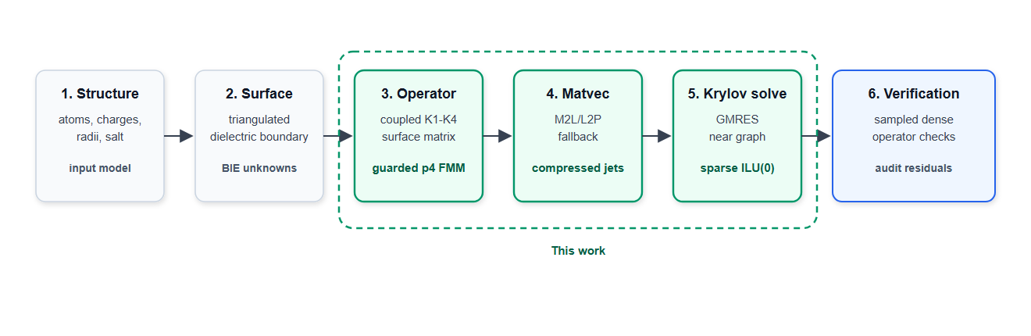
Figure 1 | Boundary-integral Poisson-Boltzmann workflow and contribution map. The six-stage pipeline starts from molecular preparation and surface discretization, forms the coupled K1-K4 boundary-integral operator, evaluates matrix-vector products, solves the Krylov system, and verifies the accelerated operator. The dashed green region marks the contribution of this work: guarded analytical p4 FMM/M2L, packed direct fallback, graph-derived sparse ILU(0), and sampled direct-operator verification.
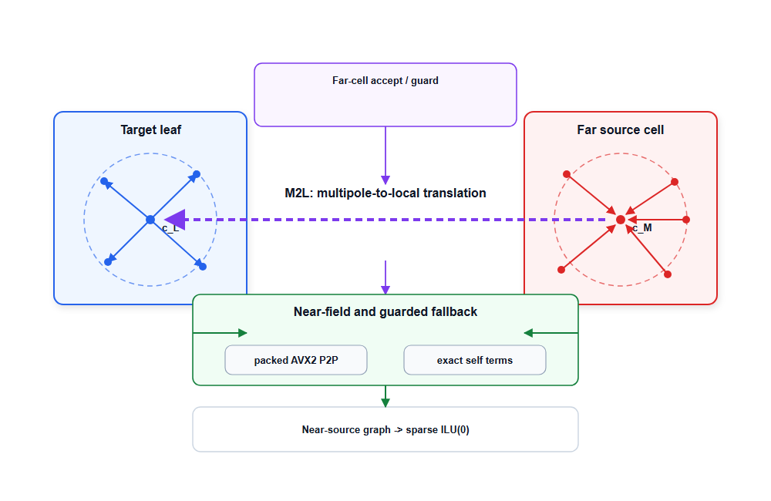
Figure 2 | Guarded p4 FMM/M2L boundary-integral operator. Blue denotes target-leaf local evaluation, red denotes source-cell Cartesian moments, purple denotes analytical far-field M2L, and green denotes guarded direct fallback and sparse preconditioning. Source panels are compressed into Cartesian p4 moments, accepted far cells are translated to target-local expansions, and near or geometrically risky interactions are evaluated by packed direct P2P fallback; the same near-source graph defines the sparse block ILU(0) preconditioner used by GMRES.

Results And Discussion

3.1. Performance Ladder and the Krylov Stalling Problem
To establish the computational baseline, we first evaluated the classical direct boundary-integral formulation across the six-protein panel (Table 3 and Figure 3). While direct evaluation provides the most transparent mathematical reference, its O(N^2) complexity severely restricts its practical utility for macromolecular systems. As shown in Table 3, the direct TABI approach failed to converge within practical time budgets for any of the six test cases, reaching the timeout limit on two systems and halting with unacceptable residual gaps on the remaining four (median wall time: 31.1 minutes). This behavior highlights the fundamental computational barrier of applying a dense boundary-integral surface operator directly at full-protein panel counts.
The standard mitigation for dense-matrix bottlenecks is to decouple the matrix-vector products using fast summation techniques such as the Fast Multipole Method. However, introducing a degree-one FMM operator reveals a deeper numerical pathology inherent to the BIE formulation. While FMM successfully accelerates individual matrix-vector evaluations, the GMRES iterative solver catastrophically stalls. When paired with a naive diagonal preconditioner, 0/6 systems converged; the iteration count routinely hit the upper limits (median 680 iterations) while the relative residual stagnated at an unacceptable 1.2 x 10^-2. Upgrading to a local block-diagonal preconditioner designed to capture strictly intra-leaf interactions provided only marginal wall-time improvements (median 700.8 s) and still resulted in 0/6 converged systems, persistently hitting the 720-iteration cap.
This algorithmic ladder fundamentally redefines the BIE bottleneck. The failure of the accelerated operator to converge demonstrates that the limiting factor in macromolecular BIE solvers is not merely the arithmetic cost of multipole evaluations, but the extreme stiffness of the coupled surface matrix. The complex topological features of realistic protein surfaces, such as deep clefts and closely opposed dielectric boundaries, generate strong near-field couplings across the derivative-sensitive interaction channels. Weak, leaf-local preconditioners are effectively blind to these cross-leaf boundary interactions, causing the Krylov subspace to degenerate.
Figure 4 makes the separation between matrix-vector acceleration and Krylov stabilization explicit for 1A63. Direct TABI provides no useful component split because it reached the timeout budget. The degree-one FMM rows spend almost all measured wall time in repeated matrix-vector evaluations over a stalled 720-iteration Krylov solve. Replacing the weak preconditioner with sparse near-field ILU(0) reduces the iteration count to 128 and lowers wall time from approximately 1130 s to 208 s. The guarded p4 row adds static preparation, fallback, and direct-operator verification cost, but it is the row that satisfies the sampled direct-operator audit. Consequently, achieving a robust FMM-BIE solver requires a preconditioning strategy that respects the physical connectivity of the molecular surface, leading us to examine the near-field coupling graph.

3.2. Resolving High-Coupling Singularities with Sparse Near-Field ILU(0)
Figure 5 isolates the preconditioning effect on the Barnase complex, providing a stark visual representation of Krylov stalling. Under the exact same degree-one FMM operator, both the diagonal and local block-diagonal preconditioners exhausted the 720-iteration budget, yielding unacceptable sampled true residuals of $4.42 \times 10^{-2}$ and $4.79 \times 10^{-2}$, respectively. In striking contrast, the sparse near-field ILU(0) preconditioner shattered this plateau, driving the preconditioned residual down to the $10^{-12}$ range in merely 128 iterations. This confirms that the decisive bottleneck is not the raw speed of the far-field summation, but the algebraic conditioning of the coupled system available to GMRES.
The physical origin of this stiffness lies in the complex topology of macromolecular surfaces. Proteins feature deep grooves, binding pockets, and narrowly separated surface patches. Consequently, panels that are geometrically adjacent and thus strongly interacting are frequently partitioned into different leaves of the octree. The derivative-sensitive K1-K4 channels transmit severe electrostatic coupling across these artificial leaf boundaries. A standard leaf-local block preconditioner is fundamentally blind to these cross-boundary singularities, treating them as external to the local solve. While memory-efficient, this spatial partitioning truncates the most critical off-diagonal entries, leaving the Krylov subspace vulnerable to high-frequency interfacial noise.
To reconstruct the global coupling without forming a dense matrix, TITAN leverages the topological graph inherently generated by the FMM near-field worklist. For every target panel i, this graph naturally encodes the self-interaction and a deterministic set of geometrically proximate source panels j (capped at 64 neighbors in the guarded configuration). TITAN populates this sparse topology with the exact 2 × 2 coupled analytic blocks:
$$A_{ij}=\left[\begin{matrix}δ_{ij}c_{ϕ}-K2_{ij} & -K1_{ij} \\ -K4_{ij} & δ_{ij}c_{ϕn}-K3_{ij}\end{matrix}\right]$$
An incomplete LU factorization with zero fill-in, ILU(0), is then executed strictly over this exact sparsity pattern. This formulation allows vital electrostatic information to propagate seamlessly across adjacent surface patches without requiring extra fill-in memory. Crucially, the overhead of extracting this near-source graph and performing the factorization is more than recovered during the iteration phase. As shown in Table 3, even including setup costs, the median full-protein wall time collapsed from 700.8 s (local block) to 133.3 s (ILU0)—a 5.3x reduction. Sparse ILU(0) therefore fundamentally transforms the algorithmic scaling, translating fewer iterations directly into faster absolute runtimes.
However, while ILU(0) effectively stabilizes the Krylov iteration and ensures that the linear system is solved efficiently, the physical accuracy of that solution remains entirely dependent on the analytical fidelity of the far-field operator. This dictates the necessity of the guarded p4 evaluation.

3.3. Guarded Analytical FMM and Direct-Operator Verification
While sparse ILU(0) ensures robust Krylov convergence, the physical validity of the computed electrostatic potentials relies entirely on the analytical fidelity of the underlying matrix-vector products. The guarded p4 FMM path bridges this critical fidelity gap, elevating the low-order approximation to match dense direct-operator references. As detailed in Table 4, across the full six-protein panel, all guarded p4 + sparse ILU(0) configurations converged tightly within 128 iterations. More importantly, the maximum sampled audit RMS and true direct residuals were strictly bounded below $2.54 \times 10^{-3}$, with peak resident memory capping at a modest 369.6 MB. These audit metrics are paramount: they verify that the accelerated FMM operator genuinely reproduces the exact dense boundary-integral physics, rather than merely converging an inaccurate approximation.
To achieve this high-fidelity translation, TITAN explicitly employs fourth-order ($p = 4$) Cartesian Taylor expansions rather than the spherical harmonics traditionally favored in asymptotic multipole regimes. For the strongly coupled JCP operator, evaluating the K1-K4 channels requires rigorous bookkeeping of source-normal, target-normal, and mixed derivatives. In the fixed $p = 4$ regime, the theoretical asymptotic efficiency of spherical harmonics is often overshadowed by constant factors, memory indirection, and the complexity of derivative extraction. Cartesian Green-function jets, conversely, keep these derivative channels localized and unrolled. This architectural choice inherently synergizes with modern CPU instruction sets, allowing seamless integration with compressed-cache lifecycles and AVX2-packed fallback pipelines.
Furthermore, TITAN abandons unconditional far-cell acceptance. A nominal $p=4$ expansion alone is insufficient to prevent high-frequency interfacial noise from contaminating the normal-derivative channels. Instead, the analytical translation is tightly constrained by a dual-criteria acceptance policy. A static $p=3/p=4$ tail indicator first flags algebraically risky far cells, followed by a strict geometric separation guard that intercepts near-boundary outliers frequently missed by averaged error estimators. If a cell pair violates either criterion, the source cell is dynamically split; if the violation occurs at the leaf level, the interaction is demoted entirely to direct evaluation. This conservative, deterministic guarding mechanism guarantees that the multipole approximation is exclusively deployed where it is mathematically and geometrically secure.
Consequently, absolute wall-time comparisons with GPU-accelerated solvers, such as TABI-PB 2.0 [9], must be contextualized within these strict accuracy constraints. While Wilson et al. reported highly optimized, seconds-scale runtimes for 1A63 on an NVIDIA V100 GPU using barycentric Lagrange dual-tree traversal, the TITAN benchmarks presented here are executed entirely on a single-node CPU/AVX2 architecture under stringent geometric fallbacks and static direct-operator audits. The primary contribution of this work is not to supersede GPU throughputs, but to establish that an analytical, derivative-rich Cartesian FMM architecture can achieve robust, auditable Krylov convergence via graph-based ILU(0). This provides a mathematically rigorous CPU baseline, paving the way for future offloading to accelerated backends without sacrificing interfacial accuracy.

3.4. Computational Footprint, Reproducibility, and Methodological Scope
Implementing a strict geometric guard inevitably increases the volume of interactions demoted to the direct near-field path. To prevent this from becoming a computational bottleneck, TITAN treats the direct fallback not as an exceptional slow path, but as a heavily vectorized core algorithmic component. Once a risky far cell is demoted, target panels are packed into four-lane AVX2 batches, and source tiles are streamed through a deterministic Structure-of-Arrays (SoA) layout. Self-interactions remain strictly routed through the exact analytic-singular kernel but are logically masked out of the vector lanes to prevent double-counting. This hardware-aware layout eliminates branch divergence and aligns the high-volume fallback work perfectly with the L1/L2 cache prefetching patterns of modern CPUs, making the strict geometry guard viable within a full GMRES solve.
A paramount advantage of this optimized BIE architecture is its minimal memory footprint. As detailed in Table 4, the peak resident memory requirement for Barnase is a mere 172.5 MB, and it caps at 369.6 MB for the larger 1A63 complex. This stands in stark contrast to traditional $O(N^3)$ volumetric grid solvers, where maintaining a comparably sharp dielectric interface for macromolecular complexes would consume gigabytes of RAM. By constraining the unknowns exclusively to the 2D molecular boundary and caching only the static refinement plans and compressed Green-function jets, TITAN successfully decouples high-fidelity electrostatics from exponential memory inflation.
Furthermore, computational reproducibility is often compromised in highly concurrent fast-summation codes due to race-sensitive floating-point accumulation or non-deterministic tree building. TITAN explicitly precludes this by enforcing a deterministic ordering for refinement, cache layout, fallback task generation, and panel sampling. Table 5 demonstrates zero energy spread at the reported precision and exactly one plan/cache build per accepted solve. This absolute repeatability is further corroborated by the supplementary public-protein expansion (Ubiquitin, Chymotrypsin inhibitor 2, and Villin headpiece subdomain), all of which passed the identical guarded p4 repeatability gate. Moreover, the experimental design strictly separates numerical evidence from manuscript formatting; all reported accuracy statements are tied to deterministic, auditable matrix artifacts rather than undocumented local state.
While the present guarded p4 architecture establishes a rigorous, memory-efficient CPU baseline, we explicitly define the methodological boundaries of this study. Computing full $O(N^2)$ direct TABI reaction energies as an oracle for large full-protein systems is computationally prohibitive. Consequently, sampled direct-operator residuals are employed as the feasible, scalable verification mechanism. We argue that this is a robust alternative, as internal GMRES convergence alone does not guarantee agreement with the exact dense operator. Additionally, the convergence profile demonstrating ILU(0) superiority (Figure 5) provides targeted evidence for resolving high-coupling interfacial singularities; evaluating its optimality across all possible extremes of protein topologies and dielectric models remains an area of active exploration.
Ultimately, this manuscript introduces TITAN’s analytical FMM/M2L boundary-integral architecture as a highly auditable, high-fidelity solution for macromolecular electrostatics. By successfully coupling fourth-order Cartesian expansions with graph-based sparse preconditioning, we have demonstrated that the BIE formulation can be made both memory-efficient and Krylov-robust. Future development will focus on scaling this verified mathematical framework to larger biomolecular complexes, porting the stabilized ILU(0) and Cartesian M2L structures to GPU-accelerated backends, and broadening the validation panel to encompass diverse ionic strengths and implicit-solvent environments.

Conclusion
TITAN now contains a repeatable guarded fourth-order analytical FMM/M2L boundary-integral PB path with sparse near-field ILU(0) preconditioning. On the primary full-protein panel and supplementary public fixtures, the explicit guarded p4 workflow converges, passes sampled direct-operator verification, and preserves a clear policy boundary: it is a documented advanced option, not the production default. The evidence supports a paper-facing claim centered on analytical acceleration, deterministic far-field guarding, and graph-based sparse preconditioning for dense molecular-surface PB solves.

Algorithmic Performance Ladder
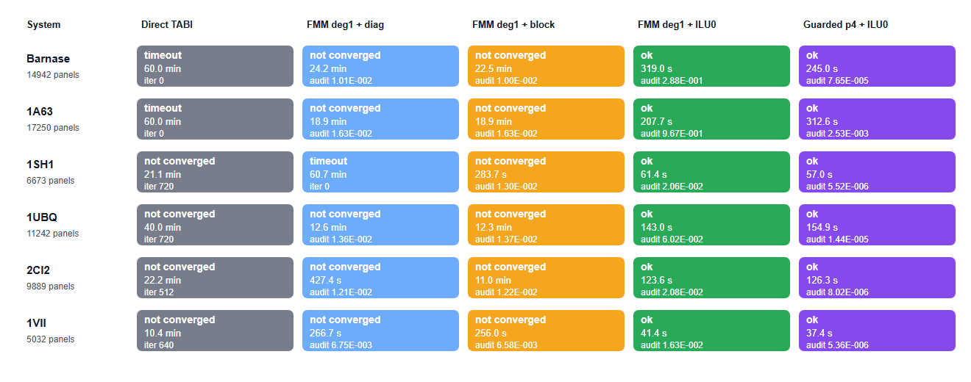
Figure 3 | Full-protein performance ladder. Colors identify backend stages from direct TABI through guarded p4 FMM/M2L with sparse ILU(0); each cell reports status and wall time. The ladder separates three effects: dense direct TABI is not practical at full-protein panel counts, degree-one FMM accelerates matrix-vector products but still stalls with weak preconditioning, and guarded p4 plus sparse near-field ILU(0) passes sampled direct-operator verification on all six full proteins.
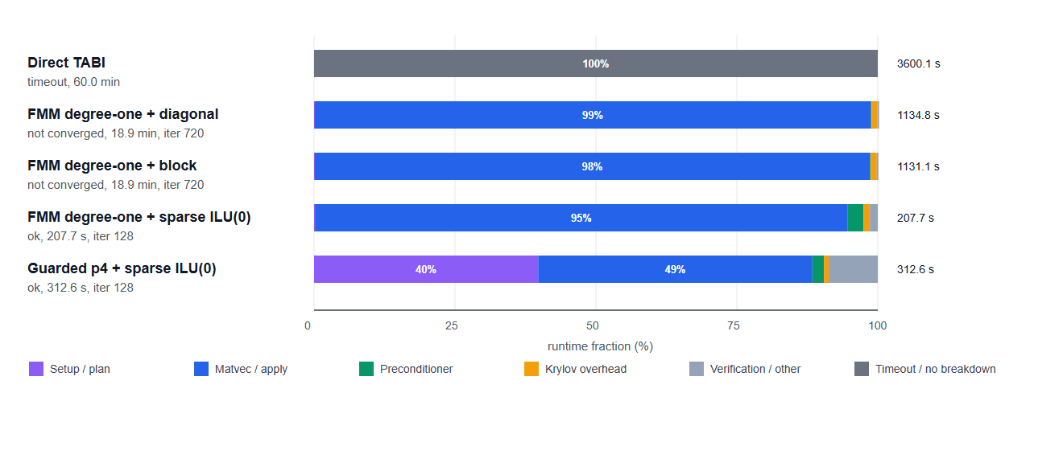
Figure 4 | Runtime composition for the 1A63 performance ladder. Direct TABI timed out and is shown as a wall-time context row without a component breakdown. The remaining rows show the fraction of measured wall time assigned to matrix-vector evaluation, preconditioning, Krylov overhead, setup, and verification or other overhead. Degree-one FMM reduces the cost of individual matrix-vector products but still spends almost all runtime in stalled 720-iteration solves; sparse near-field ILU(0) reduces the Krylov budget to 128 iterations, while the guarded p4 row adds preparation and direct-operator verification cost to recover sampled dense-operator agreement.
Table 2. Full-protein benchmark systems used in the performance ladder.
Protein | PDB/source | Atoms | Panels | Role
Barnase | PyDelPhi benchmark | 1700 | 14942 | Primary
RNA-binding domain of E. coli Rho factor | 1A63 | 2065 | 17250 | Primary
Stichodactyla helianthus neurotoxin I | 1SH1 | 696 | 6673 | Primary
Ubiquitin | 1UBQ | 1231 | 11242 | Supplement
Chymotrypsin inhibitor 2 | 2CI2 | 1076 | 9889 | Supplement
Villin headpiece subdomain | 1VII | 596 | 5032 | Supplement
Table 3. Full-protein algorithmic ladder across six matched protein fixtures.
Stage | Outcome | Median wall | Median iter. | Operator audit | Interpretation
Classical direct TABI | 0/6 ok; 4 failed; 2 timeout | 31.1 min | 576 | direct reference | Valid reference path, but dense direct matvecs dominate runtime at full-protein panel counts.
Degree-one FMM + diagonal | 0/6 ok; 5 failed; 1 timeout | 944.5 s | 680 | median 1.207e-02 | Matvec acceleration alone was not enough for robust Krylov convergence.
Degree-one FMM + local block | 0/6 ok; 6 failed; 0 timeout | 700.8 s | 720 | median 1.258e-02 | Matvec acceleration alone was not enough for robust Krylov convergence.
Degree-one FMM + sparse ILU(0) | 6/6 ok; 0 failed; 0 timeout | 133.3 s | 128 | median 4.052e-02; max 9.671e-01 | Sparse ILU(0) made GMRES robust, but the low-order far operator still failed direct-operator audits.
Guarded p4 FMM + sparse ILU(0) | 6/6 ok; 0 failed; 0 timeout | 140.6 s | 128 | median 1.121e-05; max 2.534e-03 | High-order guarded FMM/M2L retained ILU(0) convergence and restored sampled direct-operator agreement.
Table 4. Guarded p4 + sparse ILU(0) full-protein rows from the performance ladder.
Protein | PDB/source | Panels | Iter. | Internal residual | Audit RMS | Direct residual | Wall | RSS MB
Barnase | PyDelPhi benchmark | 14942 | 128 | 8.579e-13 | 7.647e-05 | 7.647e-05 | 245.0 s | 172.5
RNA-binding domain of E. coli Rho factor | 1A63 | 17250 | 128 | 1.337e-11 | 2.534e-03 | 2.535e-03 | 312.6 s | 369.6
Stichodactyla helianthus neurotoxin I | 1SH1 | 6673 | 128 | 1.164e-14 | 5.519e-06 | 5.519e-06 | 57.0 s | 63.1
Ubiquitin | 1UBQ | 11242 | 128 | 2.719e-13 | 1.440e-05 | 1.440e-05 | 154.9 s | 144.6
Chymotrypsin inhibitor 2 | 2CI2 | 9889 | 128 | 5.964e-14 | 8.022e-06 | 8.022e-06 | 126.3 s | 138.1
Villin headpiece subdomain | 1VII | 5032 | 128 | 7.353e-13 | 5.357e-06 | 5.357e-06 | 37.4 s | 54.7

Primary Protein Panel
Table 5. Guarded p4 repeatability on the locked full-protein panel.
Protein | PDB/source | Panels | Energy | Audit max | Direct residual max | Energy spread | p4/deg1
Barnase | PyDelPhi benchmark | 14942 | -21030.83 | 6.383e-05 | 6.383e-05 | 0.000 | 0.450
RNA-binding domain of E. coli Rho factor | 1A63 | 17250 | -247716.08 | 2.357e-03 | 2.357e-03 | 0.000 | 0.674
Stichodactyla helianthus neurotoxin I | 1SH1 | 6673 | -4362.07 | 4.894e-06 | 4.894e-06 | 0.000 | 0.383

Preconditioner Convergence Profile
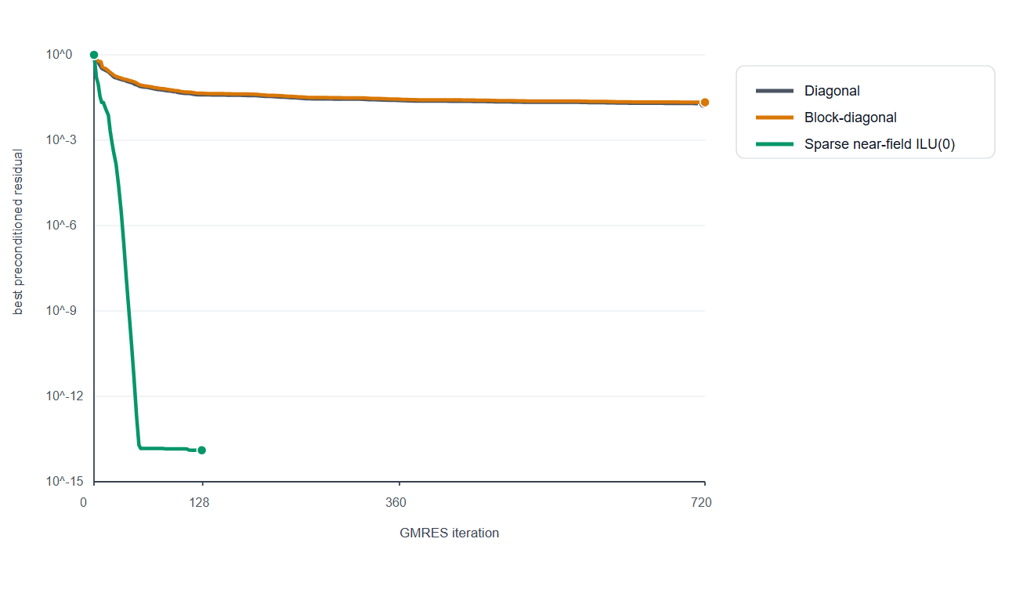
Figure 5 | Barnase GMRES residual decay under three preconditioning choices. All curves use the same full-protein degree-one FMM operator. The diagonal baseline and local block-diagonal preconditioner reached the iteration budget, whereas sparse near-field ILU(0) drove the preconditioned residual to the 1e-12 range and produced a converged solve. This contrast isolates Krylov stiffness from raw matrix-vector-product cost.

Supplementary Public-Protein Expansion
Table S1. Full public-protein supplement rows prepared without atom sampling.
Protein | PDB | Atoms | Panels | Energy | Audit max | Direct residual max | Energy spread
Ubiquitin | 1UBQ | 1231 | 11242 | -4038.46 | 1.468e-05 | 1.468e-05 | 0.000
Villin headpiece subdomain | 1VII | 596 | 5032 | -2355.70 | 5.871e-06 | 5.871e-06 | 0.000
Chymotrypsin inhibitor 2 | 2CI2 | 1076 | 9889 | -4891.15 | 7.983e-06 | 7.983e-06 | 0.000

References
[1] J. Chen, J. Tausch, and W. Geng, A Cartesian FMM-accelerated Galerkin boundary integral Poisson-Boltzmann solver, arXiv:2110.13778, 2021.
[2] L. Greengard and V. Rokhlin, A fast algorithm for particle simulations, Journal of Computational Physics 73, 325-348, 1987.
[3] Y. Saad and M. H. Schultz, GMRES: A generalized minimal residual algorithm for solving nonsymmetric linear systems, SIAM Journal on Scientific and Statistical Computing 7, 856-869, 1986.
[4] J. A. Meijerink and H. A. van der Vorst, An iterative solution method for linear systems of which the coefficient matrix is a symmetric M-matrix, Mathematics of Computation 31, 148-162, 1977.
[5] M. G. Duffy, Quadrature over a pyramid or cube of integrands with a singularity at a vertex, SIAM Journal on Numerical Analysis 19, 1260-1262, 1982.
[6] T. J. Dolinsky et al., PDB2PQR: an automated pipeline for the setup of Poisson-Boltzmann electrostatics calculations, Nucleic Acids Research 32, W665-W667, 2004.
[7] E. Jurrus et al., Improvements to the APBS biomolecular solvation software suite, Protein Science 27, 112-128, 2018.
[8] S. K. Burley et al., RCSB Protein Data Bank: powerful new tools for exploring 3D structures of biological macromolecules, Nucleic Acids Research 49, D437-D451, 2021.
[9] L. Wilson, W. Geng, and R. Krasny, TABI-PB 2.0: An improved version of the treecode-accelerated boundary integral Poisson-Boltzmann solver, Journal of Physical Chemistry B 126, 7104-7113, 2022.

