Stabilizing Boundary-Integral Poisson-Boltzmann Solvers via Guarded Cartesian FMM and Sparse Near-Field ILU(0) Preconditioning
My Na O^{1,2}, Hoang Linh Nguyen^{3,4,*}
¹Faculty of Applied Science, Ho Chi Minh City University of Technology (HCMUT), 268 Ly Thuong Kiet, Dien Hong Ward, Ho Chi Minh City 700000, Vietnam
²Vietnam National University, Ho Chi Minh City 700000, Vietnam
³Institute of Fundamental and Applied Sciences, Duy Tan University, Ho Chi Minh City 700000, Vietnam
⁴School of Engineering and Technology, Duy Tan University, Da Nang 550000, Vietnam
*Email: nguyenhoanglinh9@duytan.edu.vn

Abstract
Grid-based Poisson-Boltzmann solvers are widely used, but volumetric discretization can impose memory constraints and approximate sharp dielectric interfaces. Boundary-integral equation (BIE) formulations offer a mathematically rigorous alternative by solving directly on the molecular surface. However, this dimensionality reduction introduces dense, derivative-rich operators that often cause Krylov subspace solvers to stall. To stabilize these solvers, we present a CPU-oriented architecture within the TITAN engine that couples a guarded fourth-order Cartesian Fast Multipole Method (FMM) with a sparse near-field ILU(0) preconditioner. By leveraging the inherently generated FMM near-source graph, the preconditioner explicitly resolves strong local electrostatic couplings. Concurrently, the guarded FMM employs strict geometric separation checks, deterministically routing risky interactions to a vectorized direct fallback path to preserve numerical fidelity. Evaluated on a diverse protein panel, this combined approach consistently resolves the Krylov stalling associated with standard local acceleration. Sampled direct-operator audits indicate that this implementation effectively controls far-field truncation errors—particularly within the highly sensitive normal-derivative channels—providing a stable, memory-efficient, and auditable baseline for boundary-integral biomolecular electrostatics.

Introduction
Implicit-solvent electrostatics is a standard approximation in biomolecular modeling[1, 2]. It replaces explicit solvent molecules with a dielectric continuum and treats ionic screening through the Poisson-Boltzmann (PB) model[3-5]. Classical grid-based solvers, employing finite-difference or finite-element methods, are robust and heavily utilized in the field[6]. However, volumetric discretization inherently involves trade-offs regarding memory requirements and the representation of sharp dielectric boundaries[3, 7] particularly as the size of the macromolecular system increases[8].
Boundary-integral equation (BIE) formulations provide an alternative discretization for continuum electrostatics[1]. By moving the unknowns from the three-dimensional volume to the 2D molecular surface, BIE approaches reduce the problem dimensionality, which is highly advantageous for modeling complex surface interactions and reducing the memory footprint. However, this topological reformulation replaces the sparse volumetric grid with a dense, derivative-rich surface operator. Evaluating this dense matrix directly scales as O(N²), which is computationally demanding for large protein complexes. Furthermore, the strong singularities inherent to the coupled boundary-integral channels often lead to a stiff linear system[9, 10].
To alleviate the computational bottleneck of dense BIE operators, fast summation techniques such as treecodes and the Fast Multipole Method (FMM)[11, 12] have been successfully deployed. The field has seen substantial methodological progress, encompassing the original treecode-accelerated boundary integral (TABI) formulation[13], dedicated preconditioning studies for TABI[14], the Cartesian Galerkin FMM approach in FAGBI[15], and the highly optimized, GPU-accelerated TABI-PB 2.0 implementation[16]. While these milestones definitively establish the feasibility of rapid matrix-vector evaluations, they also reveal a deeper numerical challenge: simply accelerating the operator does not resolve the inherent stiffness of the coupled BIE matrix[14, 17]. Consequently, the critical issue addressed in this work is how to effectively pair fast summation throughput with a preconditioner robust enough to stabilize these derivative-rich molecular-surface operators during Krylov iteration. To contextualize the specific contributions of this work within the current landscape of fast BIE solvers, Table 1 outlines the core architectural and algorithmic distinctions between TITAN, FAGBI, and TABI-PB 2.0.
To mitigate this stiffness, iterative solvers rely on preconditioning which is a mathematical transformation that approximates the inverse of the system matrix to cluster its eigenvalues and accelerate convergence[18]. In BIE formulations, the system's stiffness is primarily driven by strong near-field electrostatic couplings across the complex molecular topology[17, 19]. Standard local preconditioners, such as diagonal or block-diagonal scaling, often stall on realistic protein surfaces because they treat distinct tree leaves as isolated entities, thereby ignoring critical cross-leaf boundary interactions. To robustly capture this local topology without incurring the memory penalty of forming a dense matrix, a more sophisticated approximation is required. Specifically, an Incomplete LU (ILU) factorization with zero fill-in, denoted as ILU(0), computes an approximate inverse by performing Gaussian elimination strictly within a predefined sparsity pattern. By defining this sparse graph based on the spatially adjacent near-neighbor lists inherently generated by the FMM, a sparse near-field ILU(0) preconditioner can explicitly resolve the most severe local singularities, thereby stabilizing the global iterative solve.
In this work, we explore an analytical FMM/M2L boundary-integral path within the TITAN engine—a modular and comprehensive computational framework designed for biomolecular modeling. Specifically, we focus on addressing the aforementioned Krylov stiffness while strictly maintaining direct-operator agreement. Rather than aiming to replace existing production grid backends or to exceed the raw throughput of highly optimized GPU solvers, this manuscript addresses the fundamental mathematical and preconditioning challenges of the FMM-BIE formulation on CPU architectures.
Our implementation integrates a guarded fourth-order (p = 4) Cartesian Taylor expansion with the aforementioned sparse near-field ILU(0) preconditioner to explicitly handle the high-coupling interfacial singularities. To ensure the accuracy of the derivative channels, far-cell acceptance is controlled by both algebraic and geometric criteria; interactions that do not meet these strict criteria are deterministically demoted to a packed AVX2 direct fallback path. We evaluate this explicit workflow on a diverse panel of full-protein structures, utilizing sampled direct-operator residuals to verify that the preconditioned, fast-summation solver consistently reproduces the exact dense-operator physics.

Methods
Figure 1 illustrates the complete boundary-integral Poisson-Boltzmann workflow implemented in this work. The numerical pipeline comprises six distinct stages: molecular structure preparation, surface discretization, coupled BIE operator construction, fast matrix-vector evaluation, Krylov preconditioning and solution, and independent verification. Rather than introducing novel molecular preparation chemistry or surface-definition models, this work focuses strictly on advancing the computational backend specifically the operator, solver, and verification stages. Our core contributions include a guarded fourth-order (p = 4) Cartesian FMM/M2L approach for the dense K1–K4 surface operator, a graph-derived sparse near-field ILU(0) preconditioner to stabilize the Krylov solve, a packed AVX2 direct fallback mechanism for rejected far-field interactions, and rigorous sampled direct-operator audits.

2.1. Boundary-Integral Formulation and Coupled Surface Operator
TITAN solves a coupled boundary-integral Poisson-Boltzmann system on triangulated molecular surfaces. Following the TABI boundary-integral formulation[13] and established boundary-integral PB methodologies[1], each surface panel i carries the unknown vector $u_{i}={\left(ϕ_{i},∂_{n}ϕ_{i}\right)}^{T}$, where $ϕ$ is the surface potential and $∂_{n}ϕ_{i}$ is its normal derivative. The governing operator consists of four analytical interaction channels, denoted as K1 through K4, which intricately couple the potential and normal-derivative rows. To maintain consistency, the identical sign convention is strictly applied across the direct, degree-one accelerated, and guarded high-order evaluation paths. The resulting non-symmetric coupled linear system is solved using GMRES[9], adopting standard terminology for Krylov subspace methods and preconditioning[18, 20].
The local block matrix form utilized throughout the implementation is constructed as follows:
$$A_{ij}=\left[\begin{matrix}δ_{ij}c_{ϕ}-K2_{ij} & -K1_{ij} \\ -K4_{ij} & δ_{ij}c_{ϕn}-K3_{ij}\end{matrix}\right]$$
Here j denotes a direct near-neighbor panel, a guarded direct-fallback panel, or a far-cell contribution accumulated by moment-to-local translation. The row and column order is $(ϕ,∂_{n}ϕ)$. Thus $K_{2}$multiplies $ϕ$in the potential row, $K_{1}$multiplies $∂_{n}ϕ$in the potential row, $K_{4}$multiplies $ϕ$in the normal-derivative row, and $K_{3}$multiplies $∂_{n}ϕ$in the normal-derivative row. The matrix-vector product is applied as $A_{ϕ}x=c_{ϕ}ϕ-Φ_{K}$ and ${ A}_{ϕn}x=c_{ϕn}ϕ_{n}-Φ_{n,K}$.
To ensure high fidelity, near-field interactions are rigorously evaluated using TITAN's analytic-singular kernel. This prevents strongly singular self- and adjacent-panel terms from being inaccurately approximated by centroid-only far-field formulas, a critical separation since improperly treated near terms would otherwise dominate the local truncation error. While Duffy-adaptive quadrature is retained as an explicit diagnostic option [17], the standard policy for results presented in this manuscript exclusively employs the analytic-singular path for near terms. Conversely, far-field interactions are strictly governed by high-order analytical expansion, geometric acceptance criteria, and deterministic direct fallback.

2.2. Analytical Cartesian FMM/M2L Expansion
The guarded far-field operator evaluates distant interactions using fourth-order (p = 4) Cartesian source moments and target-local multipole-to-local (M2L) translations. Accepted far-cell contributions are assembled channel-by-channel using Green-function jets alongside the requisite source and target derivatives. These derivative channels require careful handling, as normal derivatives and dielectric contrasts can rapidly amplify far-field truncation errors.
TITAN exclusively employs Cartesian Taylor expansions rather than spherical harmonics. This implementation choice prioritizes explicit derivative bookkeeping, cache-efficient local contractions, and the direct reuse of Green-function jet coefficients across all four interaction channels (K1–K4). For a source cell C centered at c, the Cartesian moments up to order |α| ≤ 4 are accumulated as:
Mαϕn=j∈C​Ajϕnjyj-cα
Mα,dϕ=j∈C​Ajϕjnj,dyj-cα
For a target leaf centered at t, the local coefficient for multi-index β is accumulated via the M2L translation:
Lβ=α≤p​MαCα+β(t-c)
Where
$$C_{γ}​(r)=\frac{{(-1)}^{\left|α\right|}}{α!β!}D^{α+β}βG(r)$$
Here the multi-index α + β labels the Coulomb or screened Green-function jet coefficients up to degree 9. For p = 4, base potential and target-normal channels require jets through degree 8, while source-normal derivative reconstruction in K2 and K4 requires one additional derivative order; therefore the compressed Green-jet cache is built through degree 9. The K1 and K3 channels utilize the base Green jets directly, whereas the K2 and K4 channels dynamically reconstruct the source-normal derivative terms from adjacent jet coefficients during the contraction phase. This unified data organization circumvents the need to materialize all derivative jets separately, ensuring that channel contractions remain tightly localized in memory.

2.3. Guarded Acceptance and Hardware-Aware Direct Fallback
The guarded path does not blindly accept far-cell interactions based solely on a nominal expansion order. Instead, a static p3/p4 tail indicator first flags algebraically risky far cells. Subsequently, a strict geometric separation guard (MAC_{θ} = 0.5) rejects cell pairs that remain too close to the target region. If a cell pair violates either criterion, the source cell is split. If this violation persists down to the leaf level, the interaction is demoted and evaluated directly rather than through M2L approximation.
This direct fallback path is implemented as a highly optimized, high-volume kernel rather than an exceptional slow path. Demoted non-self target panels are packed into four-lane AVX2 batches, and the corresponding source tiles are streamed using a deterministic Structure-of-Arrays (SoA) layout. Self-interactions are handled exclusively by the analytic-singular near kernel and are strictly masked out of the vector lanes to prevent double counting. This design minimizes branch divergence and ensures that fallback evaluations remain fully compatible with CPU cache hierarchies.

2.4. Sparse Near-Field ILU(0) Preconditioning
As demonstrated by the performance benchmarks in Section 3, accelerating the matrix-vector products alone is insufficient to eliminate Krylov stalling. Consequently, TITAN constructs a sparse preconditioner derived directly from the FMM near-source graph, eschewing both isolated tree-leaf approximations and dense matrix formulations.
For each target panel i, this graph encodes the self-edge along with a deterministic set of spatially adjacent source panels j, capped at 64 neighbors in the reported configuration. On each edge of this graph, TITAN stores a directly evaluated 2 × 2 coupled local operator block, A_{ij}. An Incomplete LU factorization with zero fill-in, ILU(0)[21], is then executed strictly within this predefined sparsity pattern. The resulting preconditioner successfully captures critical cross-leaf near-field couplings without introducing fill-in beyond the defined graph. (Section 3.5 and the Supplementary Information provide a detailed comparison of neighbor caps at 32, 64, and 128; cap 64 is adopted as the standard protocol value rather than an absolute optimum).

2.5. Algorithm Lifecycle, Validation Protocol, and Reproducibility Controls
TITAN strictly decouples the setup phase from the Krylov iteration loop. The FMM geometry, static refinement plan, compressed Green-jet cache, packed fallback worklists, and sparse ILU(0) preconditioner are fully constructed before GMRES execution begins. During the GMRES iterations, only the source moments and density-dependent contractions are dynamically updated. This separation effectively removes setup overhead from the repeated matrix-vector timings and prevents structural changes to the evaluation plan during the iterative solve.
During development, analytical checks using centered Born and off-center Kirkwood-style spheres were utilized to isolate surface-discretization errors from FMM acceleration errors. These foundational checks validated the analytic-singular near integration, panel basis, and normal conventions prior to testing on full-protein systems.
For the full-protein panel, computing a full O(N²) dense direct reaction-energy oracle is computationally prohibitive. Instead, the reported verification relies on two sampled dense-reference metrics. The sampled audit RMS quantifies the root-mean-square discrepancy between the accelerated and dense direct operator rows on randomly sampled target panels. The sampled direct true residual measures the residual of the final solution evaluated on these same dense direct rows, using identical normalization. The manuscript's guarded p = 4 ladder utilized 512 sampled target panels per protein, while the p-order coverage sweep employed an independent 1024-row audit to stress-test fallback accounting. These metrics rigorously test the agreement with dense direct evaluations and are reported independently of internal GMRES residuals. This sampled direct-operator gate is applied in conjunction with the 10⁻⁶ Krylov stopping tolerance, as internal GMRES convergence alone cannot guarantee physical agreement with the dense direct operator.

2.6. System Preparation and Benchmark Environment
Protein structures were prepared with PDB2PQR/APBS-family tooling[22-24] and public structure identifiers from the RCSB Protein Data Bank[25]. The primary full-protein panel includes Barnase (1BRS chain A[26]), the RNA-binding domain of E. coli Rho factor (1A63[27]), and Stichodactyla helianthus neurotoxin I (1SH1[28]). The supplementary public-protein expansion includes Ubiquitin (1UBQ[29]), Chymotrypsin inhibitor 2 (2CI2[30]), and Villin headpiece subdomain (1VII[31]).
All reported TITAN benchmarks were executed on a single Windows workstation with an Intel(R) Core(TM) Ultra 7 255H processor and 30.9 GB of physical memory. Full-protein rows used single-node AVX2 CPU execution with 4 worker threads. The remaining logical processors were not treated as a distributed-memory resource. To guarantee rigorous verification and facilitate future comparisons, Table 2 summarizes the key physicochemical parameters, algorithmic configurations, and hardware specifications applied universally across these benchmark rows to ensure transparent reproducibility.

Results and Discussion

3.1. Performance Ladder and the Krylov Stalling Problem
We first evaluated the algorithmic ladder across the six-protein panel (Table 3 and Figure 3). Direct dense TABI is useful as a conceptual baseline, but its O(N^2) matrix-vector cost limited its practical use at the tested full-protein panel counts. In this benchmark, the direct configuration did not complete a passing solve for any of the six cases: two systems reached the timeout limit and four halted with residual gaps. The median wall time for this row was 31.1 min. Here, Direct TABI denotes direct summation of the dense JCP panel-panel boundary-integral operator, not a grid PB solve and not a treecode/FMM approximation.
Degree-one FMM reduced the cost of individual matrix-vector evaluations but did not by itself produce accepted solves under the benchmark criteria. With a diagonal preconditioner, 0/6 systems passed the convergence criterion; the median iteration count was 680. With leaf-local block preconditioning, 0/6 systems passed and the median iteration count reached the 720-iteration budget. These results indicate that the bottleneck is not only the cost of applying the dense operator, but also the conditioning of the coupled surface system.
This ladder separates two numerical issues. Fast summation addresses the cost of applying the dense operator, but weak preconditioning leaves the coupled surface system stiff. The protein surfaces contain grooves, pockets, and closely opposed patches that create strong near-field interactions across artificial tree-leaf boundaries. When those couplings are absent from the preconditioner, GMRES can stagnate even though each matrix-vector product is accelerated.
Figure 4 shows the same separation for 1A63. In this figure, convergence denotes an internal GMRES true residual below 10^-6; manuscript-facing rows additionally require sampled direct-operator residuals below 8 x 10^-3. The direct TABI row reached the timeout budget and is shown only as a wall-time context row. The degree-one FMM rows spent most measured time in repeated matrix-vector products over stalled Krylov solves. Replacing the weak preconditioner with sparse near-field ILU(0) reduced the iteration count to 128 and reduced wall time from approximately 1130 s to 208 s. The guarded p = 4 row adds static preparation, fallback, and audit cost, but it is the row that passed the sampled direct-operator audit.

3.2. Resolving High-Coupling Singularities with Sparse Near-Field ILU(0)
Figure 5 isolates the preconditioning effect on Barnase. With the same degree-one FMM operator, the diagonal and local block-diagonal preconditioners reached the 720-iteration budget and produced sampled true residuals of 4.42e-02 and 4.79e-02, respectively. The sparse near-field ILU(0) preconditioner reached the 1e-12 preconditioned-residual range in 128 iterations. This comparison indicates that the observed bottleneck is not only far-field matrix-vector cost but also algebraic conditioning of the coupled surface system.
The likely source of this stiffness is the topology of macromolecular surfaces. Surface patches that are physically close can be separated into different octree leaves. The derivative-sensitive K1-K4 channels then transmit strong off-diagonal couplings across those leaf boundaries. A strictly leaf-local preconditioner omits these couplings and therefore leaves the Krylov solve exposed to high-frequency interfacial error modes.
TITAN reconstructs a sparse approximation to this local connectivity from the FMM near-field worklist. For each target panel i, the graph records the self-edge and a capped deterministic set of nearby source panels j. The stored edge values are the directly evaluated 2 x 2 coupled analytic blocks defined in Section 2.1, restricted to this sparse graph.
$$A_{ij}=\left[\begin{matrix}δ_{ij}c_{ϕ}-K2_{ij} & -K1_{ij} \\ -K4_{ij} & δ_{ij}c_{ϕn}-K3_{ij}\end{matrix}\right]$$
ILU(0) is then applied on the graph without adding fill beyond the prescribed sparsity pattern. In the reported ladder, this graph-based preconditioner reduced median full-protein wall time from 700.8 s for the local block row to 133.3 s for the degree-one FMM + sparse ILU(0) row. However, Table 4 also shows that Krylov convergence alone is not sufficient: the degree-one FMM + sparse ILU(0) row passed convergence but failed the sampled direct-operator audit. This motivates the guarded p4 operator.
The role of ILU(0) in this manuscript is therefore specific: it stabilizes the Krylov solve for the tested systems under the stated stopping criteria. The physical accuracy of the final solution remains controlled by the accuracy of the fast operator and by the direct-operator audit.

3.3. Guarded Analytical FMM and Direct-Operator Verification
The guarded p4 path addresses the operator-accuracy issue exposed by the degree-one FMM + sparse ILU(0) row. Across the six-protein panel, all guarded p4 + sparse ILU(0) rows reached the GMRES stopping criterion at 128 reported iterations. The largest sampled audit RMS in Table 5 was 2.534e-03 for 1A63, and the largest reported resident set size was 369.6 MB. These metrics indicate that the high-order guarded path retained the Krylov benefit of near-field ILU(0) while improving sampled agreement with dense direct evaluations.
The p4 Cartesian representation was selected because the coupled K1-K4 operator requires explicit source-normal, target-normal, and mixed-derivative bookkeeping. In this fixed-order regime, Cartesian Green-function jets keep the derivative channels local and unrolled. This does not imply that Cartesian expansions are generally superior to spherical harmonics; it states the implementation rationale for this CPU-oriented derivative-rich operator.
A nominal p4 expansion is not used without additional checks. The p3/p4 tail indicator identifies cell pairs with potentially large truncation error, and the geometric separation guard rejects pairs that are too close for the expansion to be trusted. Rejected leaf-level pairs are demoted to direct evaluation. This policy reduces the risk that far-field truncation error contaminates the normal-derivative channels, at the cost of additional direct fallback work.
Wall-time comparisons with GPU-accelerated solvers such as TABI-PB 2.0 [9] must therefore be interpreted cautiously. TABI-PB 2.0 reports a GPU-oriented barycentric Lagrange dual-tree traversal pipeline, while the TITAN results here are single-node CPU/AVX2 measurements with guarded fallback and sampled direct-operator audits. The contribution claimed here is not GPU throughput superiority. It is the combination of guarded Cartesian FMM/M2L, graph-derived near-field ILU(0), and auditable CPU execution.

3.4. Computational Footprint, Reproducibility, and Methodological Scope
To accommodate the increased workload resulting from the geometric separation guard, the direct fallback path was implemented as a vectorized AVX2 kernel. By packing demoted interactions and streaming source data, this approach helps maintain computational throughput even when a substantial fraction of near-field pairs is rejected by the FMM criteria.
Consequently, the memory footprint remains well within the capacity of standard workstations. As detailed in Table 5, peak resident memory ranged from 54.7 MB (1VII) to 369.6 MB (1A63). This efficiency is primarily driven by the inherent nature of the boundary-integral formulation, further aided by a constrained caching strategy for the compressed Green-function jets, fallback worklists, and sparse ILU(0) factors.
To provide broader context, we compared these metrics against the classical grid-based solver APBS[23] (Figure S1). Because boundary-integral and finite-difference methods employ fundamentally different discrete operators and interface definitions, direct energy comparisons are not intended as absolute correctness benchmarks. However, the comparison illustrates the architectural trade-offs: refining the APBS finite-difference grid (from d225 to d257) required up to ~3.5 GB of memory, whereas the TITAN boundary-integral approach maintained a footprint under 151 MB for the same small proteins. While CPU wall times were comparable for these specific systems, the BIE formulation significantly reduces the memory overhead associated with explicitly capturing sharp dielectric boundaries.
The accuracy of the fast BIE operator was further validated against full O(N²) dense direct evaluations for smaller systems (Table S5). In these calibration cases, the guarded p = 4 operator matched dense direct reaction energies closely, confirming the reliability of the sampled direct-operator audit protocol used for the larger proteins. Additionally, a preliminary surface-density check on 1VII (Table S6) showed that the solver maintains stable Krylov convergence and consistent audit residuals when the mesh is refined (from 5,032 to 8,507 panels), suggesting numerical robustness independent of specific panel alignments, provided the system remains within the available memory envelope.
Finally, the implementation ensures bitwise reproducibility within the tested hardware environment through deterministic setup and fixed traversal orders, yielding zero energy spread across multiple executions (Table 6 and S1). We acknowledge that the current evaluation focuses on a specific single-node CPU architecture and a defined protein panel, relying on sampled audits for the largest systems. Nevertheless, within this defined scope, the integration of graph-derived ILU(0) and guarded Cartesian FMM provides a stable, auditable baseline that effectively resolves the observed Krylov stalling. This robust foundational architecture naturally paves the way for future extensions, including full hierarchical scaling and adaptation to heterogeneous hardware accelerators.

3.5. Sensitivity Analysis and Algorithmic Stability
To assess the stability of the reported configuration, we evaluated the solver’s sensitivity to critical algorithmic parameters (Table 7 and Tables S2-S4).
First, testing the ILU(0) near-field neighbor cap (32, 64, and 128) indicated that a cap of 64 provides a reasonable balance between preconditioner setup cost and GMRES iteration reduction (Figure S2). Lower caps resulted in mild iteration growth, while higher caps increased the memory footprint without significantly improving convergence.
Second, variations of the FMM expansion order (p) and geometric opening angle (θ) supported the selection of p = 4 and θ =0.6. Lower-order expansions (p ≤ 3) did not fully satisfy the 10⁻⁶ sampled direct-operator audit. This was particularly evident in the derivative-sensitive K4 channel, which requires higher-order terms to adequately capture complex near-field gradients. Conversely, higher orders (p ≥ 5) increased cache pressure and computational cost without offering meaningful physical improvements. The geometric separation guard, together with the deterministic direct fallback mechanism, helped manage far-field truncation errors effectively within the p = 4 setup.
Finally, a surface-density check on 1VII (refined from 5,032 to 8,507 panels) showed that the guarded operator maintains stable Krylov convergence and audit agreement. This suggests that the current implementation can accommodate moderate mesh variations within the targeted memory envelope, confirming its numerical stability independent of specific grid alignments..

Conclusion
Boundary-integral Poisson-Boltzmann formulations offer the advantage of avoiding volumetric grid discretization while explicitly representing dielectric interfaces. However, they inherently introduce dense, derivative-rich surface operators that often present substantial challenges for Krylov subspace solvers. In this work, we presented a CPU-oriented implementation within the TITAN engine aimed at addressing these specific numerical difficulties. By combining a guarded fourth-order Cartesian FMM/M2L operator with a sparse, graph-derived near-field ILU(0) preconditioner, the observed GMRES stalling typically associated with lower-fidelity acceleration was resolved for the tested panel.
A key aspect of this implementation is that it does not rely solely on nominal order-based acceptance. Instead, it incorporates explicit algebraic and geometric guards. Near-field configurations and high-aspect interactions that fail to meet these criteria are routed to a vectorized AVX2 direct-fallback kernel. Rigorous sampled direct-operator audits indicated that this hybrid approach helps control truncation errors—particularly within the highly sensitive normal-derivative channels—while successfully avoiding the prohibitive cost of full O(N²) dense matrix evaluations.
As a comprehensive computational engine for biomolecular modeling, TITAN is designed to support a variety of modular numerical backends. By operating within a memory footprint compatible with single-node workstations, the specific guarded FMM and ILU(0) preconditioner modules introduced here offer a deterministic and auditable baseline for boundary-integral electrostatics. While the current findings are based on a specific set of test cases and Cartesian expansions, they establish a stable foundation for ongoing development. Future work will seek to extend this architecture to full hierarchical scaling and accelerated hardware backends, with the ultimate goal of improving the accessibility and performance of high-fidelity implicit solvent modeling.

Code and Data Availability
The TITAN source code corresponding to this manuscript has been prepared for release under the MIT License as the tagged release fagbi-submission-v0.1 at https://github.com/hoanglinh221191/TITAN. The persistent Zenodo DOI will be inserted after deposition of the tagged release and before journal submission. The archived release will include source code, build instructions, benchmark manifests, input metadata, scripts, figures, APBS input files, APBS logs, APBS grid-size settings used for Supplementary Figure S1, and reference outputs for Tables 3-6 and Supplementary Tables S1-S6. Public protein structures are identified by their RCSB PDB accession codes; derived surface metadata, run manifests, and tabulated outputs corresponding to the manuscript tables are included in the release manifest.

ASSOCIATED CONTENT
Supporting Information: The Supporting Information contains Table S1, Supplementary public-protein rows prepared from complete atom sets; Table S2, Aggregated theta, guard, and tail sensitivity; Table S3, Per-fixture sensitivity rows; Table S4, ILU neighbor-cap sensitivity sweep; Table S5, Small-system dense direct calibration on analytic and mini public-protein systems; Table S6, Minimal 1VII surface-density stress check under the guarded p4 protocol; Figure S1, APBS grid-solver context rows; Figure S2, ILU neighbor-cap sensitivity under the guarded p4 protocol.
Author Contributions
M.N.O, H.L.N conceived the experiments. M.N.O conducted experiments. H.L.N and M.N.O analyzed the results. All authors wrote and reviewed the manuscript.
Conflicts of interest
There are no conflicts of interest to declare.

Acknowledgements
This research is funded by Vietnam National Foundation for Science and Technology Development (NAFOSTED) under grant number 103.01-2025.110.

Tables and Figures
Table 1: Algorithmic positioning of TABI-PB 2.0, FAGBI, and TITAN.
Aspect | TABI-PB 2.0 | FAGBI (Cartesian Galerkin FMM) | TITAN (guarded p = 4 path)
Discretization | Node-patch BIE (NanoShaper) | Galerkin BIE | Coupled panel/collocation BIE (Analytic-singular near terms)
Fast operator | Barycentric Lagrange Treecode | Adaptive Cartesian FMM | Guarded Cartesian p = 4 FMM/M2L
Preconditioning | Block-diagonal | Block-diagonal | Graph-derived sparse near-field ILU(0)
Acceptance Policy | Standard MAC | FMM analytical bounds | Strict geometry guard (θ= 0.5) + p₄ tail + direct fallback
Hardware Focus | GPU-oriented throughput | Galerkin mathematical accuracy | CPU/AVX2

Table 2: Core physicochemical parameters, algorithmic settings, and hardware environment.
Category | Parameter | Value/Protocol
Electrostatics | Dielectric constants & Solvent | solute epsilon = 1; solvent epsilon = 80, 0.15 M salt, 298.15 K
Preparation | Force field & Radius floor | AMBER99SB via PDB2PQR 3.7.1, 0.60 Å radius floor
Discretization | Surface definition & Integration | van der Waals (vdW), centroid collocation, analytic-singular near field
Linear Solver | GMRES & Preconditioner | Restart 128, tolerance 10⁻⁶, Sparse near-field ILU(0) (cap 64)
Fast Operator | Guarded Cartesian FMM | Taylor p = 4, MAC_{θ} = 0.6, strict geometry guard θ = 0.5
Environment | Hardware & Parallelism | Intel Core Ultra 7 255H, 30.9 GB RAM, 4 CPU threads (AVX2)

Table 3: Full-protein benchmark systems used in the performance ladder.
Protein | PDB/source | Atoms | Panels | Role
Barnase | 1BRS | 1700 | 14942 | Primary
RNA-binding domain of E. coli Rho factor | 1A63 | 2065 | 17250 | Primary
Stichodactyla helianthus neurotoxin I | 1SH1 | 696 | 6673 | Primary
Ubiquitin | 1UBQ | 1231 | 11242 | Supp.
Chymotrypsin inhibitor 2 | 2CI2 | 1076 | 9889 | Supp.
Villin headpiece subdomain | 1VII | 596 | 5032 | Supp.

Table 4: Full-protein algorithmic ladder across six matched protein fixtures.
Stage | Outcome | Median wall | Median iter. | Operator audit | Interpretation
Classical direct TABI | 0/6 ok; 4 failed; 2 timeout | 31.1 min | 576 | no passing solve under budget | Dense baseline; no passing full-protein solve under the benchmark budget.
Degree-one FMM + diagonal | 0/6 ok; 5 failed; 1 timeout | 944.5 s | 680 | median 1.207e-02 | FMM matvec acceleration did not prevent Krylov stall with diagonal preconditioning.
Degree-one FMM + local block | 0/6 ok; 6 failed; 0 timeout | 700.8 s | 720 | median 1.258e-02 | Leaf-local block coupling remained insufficient for the tested systems.
Degree-one FMM + sparse ILU(0) | 6/6 ok; 0 failed; 0 timeout | 133.3 s | 128 | median 4.052e-02; max 9.671e-01 | GMRES converged, but the low-order far operator failed sampled audits.
Guarded p4 FMM + sparse ILU(0) | 6/6 ok; 0 failed; 0 timeout | 140.6 s | 128 | median 1.121e-05; max 2.534e-03 | Converged and passed sampled direct-operator audit.

Table 5: Guarded p4 + sparse ILU(0) full-protein rows from the performance ladder.
Protein | PDB/source | Panels | Iter. | Internal residual | Audit RMS | Sampled direct residual | Wall | RSS MB
Barnase | 1BRS | 14942 | 128 | 8.579e-13 | 7.647e-05 | 7.647e-05 | 245.0 s | 172.5
RNA-binding domain of E. coli Rho factor | 1A63 | 17250 | 128 | 1.337e-11 | 2.534e-03 | 2.535e-03 | 312.6 s | 369.6
Stichodactyla helianthus neurotoxin I | 1SH1 | 6673 | 128 | 1.164e-14 | 5.519e-06 | 5.519e-06 | 57.0 s | 63.1
Ubiquitin | 1UBQ | 11242 | 128 | 2.719e-13 | 1.440e-05 | 1.440e-05 | 154.9 s | 144.6
Chymotrypsin inhibitor 2 | 2CI2 | 9889 | 128 | 5.964e-14 | 8.022e-06 | 8.022e-06 | 126.3 s | 138.1
Villin headpiece subdomain | 1VII | 5032 | 128 | 7.353e-13 | 5.357e-06 | 5.357e-06 | 37.4 s | 54.7

Table 6: Guarded p4 repeatability on the primary full-protein panel.
Protein | PDB/source | Panels | Energy | Audit max | Sampled residual max | Energy spread
Barnase | 1BRS | 14942 | -21030.83 | 6.383e-05 | 6.383e-05 | 0.000
RNA-binding domain of E. coli Rho factor | 1A63 | 17250 | -247716.08 | 2.357e-03 | 2.357e-03 | 0.000
Stichodactyla helianthus neurotoxin I | 1SH1 | 6673 | -4362.07 | 4.894e-06 | 4.894e-06 | 0.000

Table 7: Summary of algorithmic sensitivity analysis and optimal parameter selection. N/A stands for not applicable.
Parameter | Tested range | Selected value | Primary Observation
ILU(0) Near-field cap | 32, 64, 128 | 64
  Balances setup cost and iteration reduction; higher caps increased memory without significant convergence gains.
FMM expansion order (p) | 3, 4, 5 | 4 | p ≤ 3 did not fully satisfy K4 channel accuracy; p ≥ 5 increased cache pressure without meaningful physical benefit.
MAC opening angle (θ) | 0.5, 0.6, 0.7 | 0.6 | Working alongside the direct fallback, helped manage far-field truncation errors effectively.
Surface Mesh Density | 1VII: 5,032 – 8,507 panels | N/A | Maintained stable Krylov convergence and audit agreement within the targeted memory envelope.

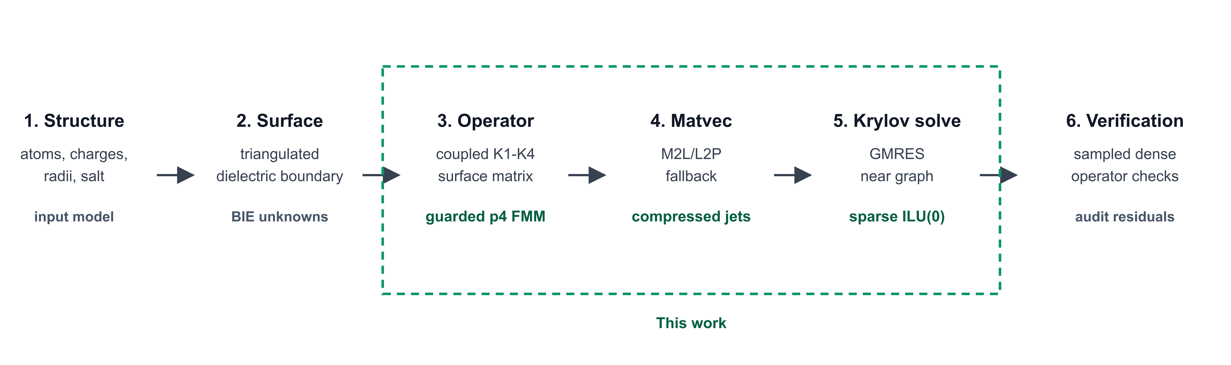
Figure 1: Boundary-integral Poisson-Boltzmann workflow and contribution map. The six-stage pipeline starts from molecular preparation and surface discretization, forms the coupled K1-K4 boundary-integral operator, evaluates matrix-vector products, solves the Krylov system, and verifies the accelerated operator. The highlighted region marks the contribution of this work: guarded Cartesian p4 FMM/M2L, packed direct fallback, graph-derived sparse ILU(0), and sampled direct-operator verification.
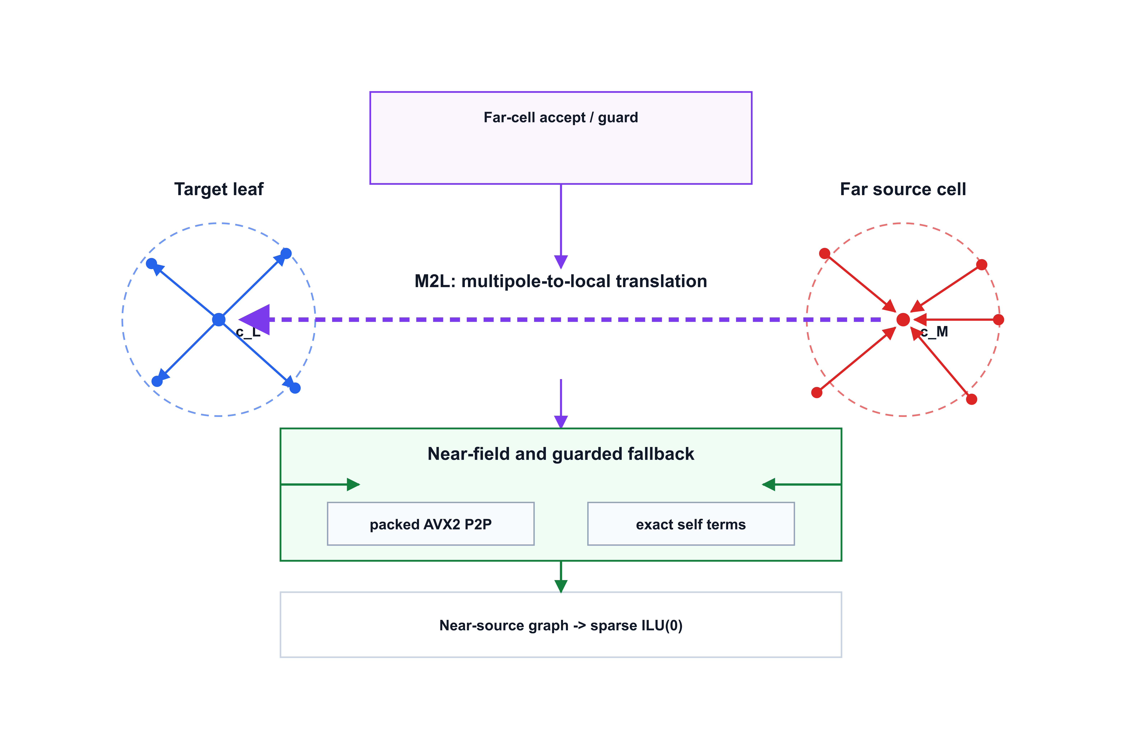
Figure 2: Guarded p4 FMM/M2L boundary-integral operator. Source panels are compressed into Cartesian p4 moments, accepted far cells are translated to target-local expansions, and near or geometrically risky interactions are evaluated by packed direct fallback. The same near-source graph defines the sparse block ILU(0) preconditioner used by GMRES.

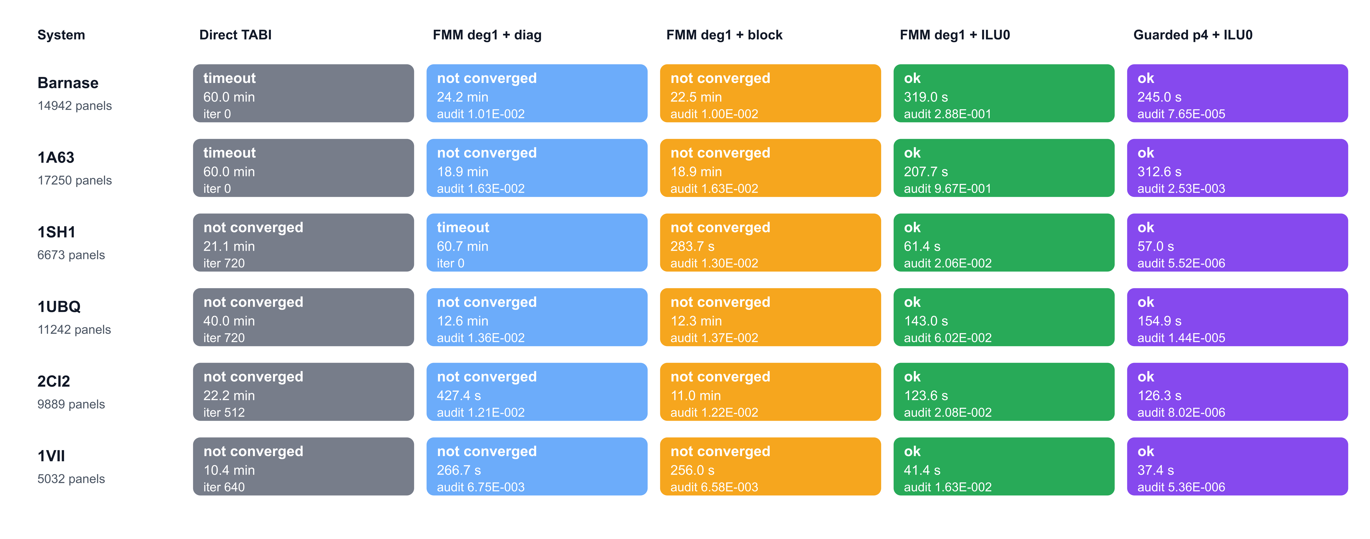
Figure 3: Full-protein performance ladder. Colors identify backend stages from direct TABI through guarded p4 FMM/M2L with sparse ILU(0); each cell reports status and wall time. The ladder separates three effects: direct dense TABI is not practical at the tested full-protein panel counts, degree-one FMM accelerates matrix-vector products but still stalls with weak preconditioning, and guarded p4 plus sparse near-field ILU(0) passes sampled direct-operator verification on all six full proteins.
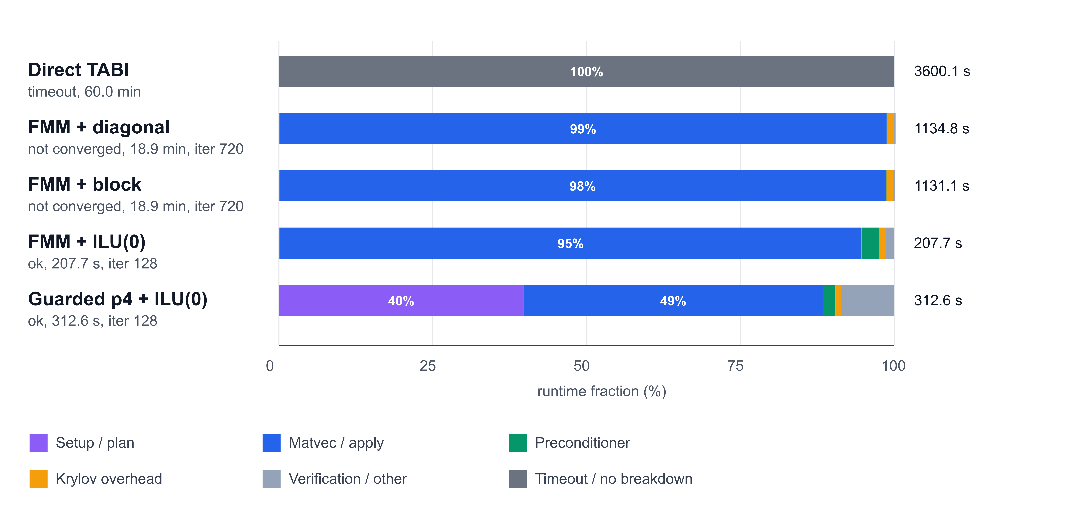
Figure 4: Runtime composition for the 1A63 performance ladder. Direct TABI reached the timeout budget and is shown as a wall-time context row without component breakdown. The remaining rows show the fraction of measured wall time assigned to matrix-vector evaluation, preconditioning, Krylov overhead, setup, and verification or other overhead. Degree-one FMM reduces the cost of individual matrix-vector products but still spends most runtime in stalled 720-iteration solves; sparse near-field ILU(0) reduces the Krylov budget to 128 iterations, while the guarded p4 row adds preparation and direct-operator verification cost to recover sampled dense-operator agreement. Convergence in this figure denotes internal GMRES true residual below 10^-6; paper-facing acceptance additionally requires sampled direct-operator residual below 8 x 10^-3.
Figure 5: Barnase GMRES residual decay under three preconditioning choices. All curves use the same full-protein degree-one FMM operator. The diagonal and local block-diagonal preconditioners reached the iteration budget, whereas sparse near-field ILU(0) drove the preconditioned residual to the 1e-12 range and produced a converged solve. This contrast isolates Krylov stiffness from raw matrix-vector-product cost.
Figure 6: Guarded p-order trade-off across the six-protein panel. A: sampled direct-operator audit RMS. B: total wall time. C: peak resident set size. D: accepted far M2L pairs and direct-fallback panel pairs. Points and bars show mean +/- standard deviation across the six proteins. The p2 rows pass the audit by demoting essentially all far work to direct fallback. The reported p4 policy is retained because it passes the audit while preserving far-field compression in the current panel; no general p-order optimum is implied.

References
[1] A. Juffer, E.F.F. Botta, B.A.M. van Keulen, A. van der Ploeg, H.J.C. Berendsen, The electric potential of a macromolecule in a solvent: A fundamental approach, Journal of Computational Physics, 97 (1991) 144–171.
[2] M. Brieg, J. Setzler, S. Albert, W. Wenzel, Generalized Born implicit solvent models for small molecule hydration free energies, Physical Chemistry Chemical Physics, 19 (2017) 1677–1685.
[3] A. Nicholls, B. Honig, A rapid finite difference algorithm, utilizing successive over‐relaxation to solve the Poisson–Boltzmann equation, Journal of Computational Chemistry, 12 (2004) 435–445.
[4] B. Honig, A. Nicholls, Classical Electrostatics in Biology and Chemistry, Science, 268 (1995) 1144–1149.
[5] Y.C. Zhou, B. Lu, A.A. Gorfe, Continuum electromechanical modeling of protein-membrane interactions, Physical Review E, 82 (2010).
[6] D.D. Nguyen, B. Wang, G.W. Wei, Accurate, robust, and reliable calculations of Poisson–Boltzmann binding energies, Journal of Computational Chemistry, 38 (2017) 941–948.
[7] Z. Liu, S. Gui, B. Lu, L. Zhang, An Unfitted Finite Element Poisson–Boltzmann Solver with Automatic Resolving of Curved Molecular Surface, The Journal of Physical Chemistry B, 128 (2024) 6463–6475.
[8] Q. Cai, M.-J. Hsieh, J. Wang, R. Luo, Performance of Nonlinear Finite-Difference Poisson−Boltzmann Solvers, Journal of Chemical Theory and Computation, 6 (2009) 203–211.
[9] Y. Saad, M.H. Schultz, GMRES: A Generalized Minimal Residual Algorithm for Solving Nonsymmetric Linear Systems, SIAM Journal on Scientific and Statistical Computing, 7 (1986) 856–869.
[10] R.L. Muddle, M. Mihajlović, M. Heil, An efficient preconditioner for monolithically-coupled large-displacement fluid–structure interaction problems with pseudo-solid mesh updates, Journal of Computational Physics, 231 (2012) 7315–7334.
[11] L. Greengard, V. Rokhlin, A fast algorithm for particle simulations, Journal of Computational Physics, 73 (1987) 325–348.
[12] J. Barnes, P. Hut, A hierarchical O(N log N) force-calculation algorithm, Nature, 324 (1986) 446–449.
[13] W. Geng, R. Krasny, A treecode-accelerated boundary integral Poisson–Boltzmann solver for electrostatics of solvated biomolecules, Journal of Computational Physics, 247 (2013) 62–78.
[14] J. Chen, W. Geng, On preconditioning the treecode-accelerated boundary integral (TABI) Poisson–Boltzmann solver, Journal of Computational Physics, 373 (2018) 750–762.
[15] J. Chen, J. Tausch, W. Geng, A Cartesian FMM-accelerated Galerkin boundary integral Poisson-Boltzmann solver, Journal of Computational Physics, 478 (2023).
[16] L. Wilson, W. Geng, R. Krasny, TABI-PB 2.0: An Improved Version of the Treecode-Accelerated Boundary Integral Poisson-Boltzmann Solver, The Journal of Physical Chemistry B, 126 (2022) 7104–7113.
[17] M.D. Altman, J.P. Bardhan, J.K. White, B. Tidor, Accurate solution of multi‐region continuum biomolecule electrostatic problems using the linearized Poisson–Boltzmann equation with curved boundary elements, Journal of Computational Chemistry, 30 (2008) 132–153.
[18] Y. Saad, Iterative Methods for Sparse Linear Systems, 2003.
[19] C.D. Cooper, J.P. Bardhan, L.A. Barba, A biomolecular electrostatics solver using Python, GPUs and boundary elements that can handle solvent-filled cavities and Stern layers, Computer Physics Communications, 185 (2014) 720–729.
[20] M. Benzi, Preconditioning Techniques for Large Linear Systems: A Survey, Journal of Computational Physics, 182 (2002) 418–477.
[21] J.A. Meijerink, H.A. van der Vorst, An Iterative Solution Method for Linear Systems of Which the Coefficient Matrix is a Symmetric M-Matrix, Mathematics of Computation, 31 (1977).
[22] T.J. Dolinsky, J.E. Nielsen, J.A. McCammon, N.A. Baker, PDB2PQR: an automated pipeline for the setup of Poisson-Boltzmann electrostatics calculations, Nucleic Acids Research, 32 (2004) W665–W667.
[23] E. Jurrus, D. Engel, K. Star, K. Monson, J. Brandi, L.E. Felberg, D.H. Brookes, L. Wilson, J. Chen, K. Liles, M. Chun, P. Li, D.W. Gohara, T. Dolinsky, R. Konecny, D.R. Koes, J.E. Nielsen, T. Head‐Gordon, W. Geng, R. Krasny, G.W. Wei, M.J. Holst, J.A. McCammon, N.A. Baker, Improvements to the APBS biomolecular solvation software suite, Protein Science, 27 (2017) 112–128.
[24] N.A. Baker, D. Sept, S. Joseph, M.J. Holst, J.A. McCammon, Electrostatics of nanosystems: Application to microtubules and the ribosome, Proceedings of the National Academy of Sciences, 98 (2001) 10037–10041.
[25] S.K. Burley, C. Bhikadiya, C. Bi, S. Bittrich, L. Chen, G.V. Crichlow, C.H. Christie, K. Dalenberg, L. Di Costanzo, J.M. Duarte, S. Dutta, Z. Feng, S. Ganesan, D.S. Goodsell, S. Ghosh, R.K. Green, V. Guranović, D. Guzenko, B.P. Hudson, Catherine L. Lawson, Y. Liang, R. Lowe, H. Namkoong, E. Peisach, I. Persikova, C. Randle, A. Rose, Y. Rose, A. Sali, J. Segura, M. Sekharan, C. Shao, Y.-P. Tao, M. Voigt, John D. Westbrook, J.Y. Young, C. Zardecki, M. Zhuravleva, RCSB Protein Data Bank: powerful new tools for exploring 3D structures of biological macromolecules for basic and applied research and education in fundamental biology, biomedicine, biotechnology, bioengineering and energy sciences, Nucleic Acids Research, 49 (2021) D437–D451.
[26] A.M. Buckle, G. Schreiber, A.R. Fersht, Protein-protein recognition: Crystal structural analysis of a barnase-barstar complex at 2.0-.ANG. resolution, Biochemistry, 33 (2002) 8878–8889.
[27] D.M. Briercheck, T.C. Wood, T.J. Allison, J.P. Richardson, G.S. Rule, The NMR structure of the RNA binding domain of E.coli rho factor suggests possible RNA–protein interactions, Nature Structural Biology, 5 (1998) 393–399.
[28] R.H. Fogh, W.R. Kem, R.S. Norton, Solution structure of neurotoxin I from the sea anemone Stichodactyla helianthus. A nuclear magnetic resonance, distance geometry, and restrained molecular dynamics study, Journal of Biological Chemistry, 265 (1990) 13016–13028.
[29] S. Vijay-kumar, C.E. Bugg, W.J. Cook, Structure of ubiquitin refined at 1.8 Å resolution, Journal of Molecular Biology, 194 (1987) 531–544.
[30] C.A. McPhalen, M.N.G. James, Crystal and molecular structure of the serine proteinase inhibitor CI-2 from barley seeds, Biochemistry, 26 (2002) 261–269.
[31] C.J. McKnight, P.T. Matsudaira, P.S. Kim, NMR structure of the 35-residue villin headpiece subdomain, Nature Structural Biology, 4 (1997) 180–184.

