Supplementary Information for Stabilizing Boundary-Integral Poisson-Boltzmann Solvers via Guarded Cartesian FMM and Sparse Near-Field ILU(0) Preconditioning
My Na O^{1,2}, Hoang Linh Nguyen^{3,4,*}
¹Faculty of Applied Science, Ho Chi Minh City University of Technology (HCMUT), 268 Ly Thuong Kiet, Dien Hong Ward, Ho Chi Minh City 700000, Vietnam
²Vietnam National University, Ho Chi Minh City 700000, Vietnam
³Institute of Fundamental and Applied Sciences, Duy Tan University, Ho Chi Minh City 700000, Vietnam
⁴School of Engineering and Technology, Duy Tan University, Da Nang 550000, Vietnam
*Email: nguyenhoanglinh9@duytan.edu.vn

Table S1: Supplementary public-protein rows prepared from complete atom sets.
Protein | PDB | Atoms | Panels | Energy | Sampled audit max | Sampled direct true residual max | Energy spread
Ubiquitin | 1UBQ | 1231 | 11242 | -4038.46 | 1.468e-05 | 1.468e-05 | 0
Villin headpiece subdomain | 1VII | 596 | 5032 | -2355.7 | 5.871e-06 | 5.871e-06 | 0
Chymotrypsin inhibitor 2 | 2CI2 | 1076 | 9889 | -4891.15 | 7.983e-06 | 7.983e-06 | 0

Table S2: Aggregated theta, guard, and tail sensitivity.
Axis | Row | Value | Status | Sampled audit max | Sampled direct true residual max | Median wall (s) | Max RSS (MB) | Interpretation
baseline | baseline guarded p4 | theta 0.6; tail on; guard theta 0.5; ILU cap 64 | 6/6 ok | 0.003 | 0.003 | 133 | 369.3 | Reference configuration used in the main text.
geometry_guard | geometry guard off | off | 6/6 ok | 0.052 | 0.052 | 143.4 | 259.3 | Measured guard-off sensitivity; 1A63 exceeds the sampled direct-operator audit gate.
geometry_guard | geometry guard on | strict-geometry-mac | 6/6 ok | 0.003 | 0.003 | 128.7 | 369.4 | Guarded configuration; all six rows pass the sampled gate in this protocol.
opening_theta | theta 0.4 | 0.4 | 6/6 ok | 0.003 | 0.003 | 142.9 | 379.5 | Measured theta row; all tested theta values pass the sampled gate in this protocol.
opening_theta | theta 0.5 | 0.5 | 6/6 ok | 0.003 | 0.003 | 135.8 | 370.1 | Measured theta row; all tested theta values pass the sampled gate in this protocol.
opening_theta | theta 0.6 | 0.6 | 6/6 ok | 0.003 | 0.003 | 128.4 | 370.1 | Measured theta row; all tested theta values pass the sampled gate in this protocol.
opening_theta | theta 0.7 | 0.7 | 6/6 ok | 0.003 | 0.003 | 126.2 | 369.8 | Measured theta row; all tested theta values pass the sampled gate in this protocol.
tail_indicator | tail indicator off | off | validator stop | NA | NA | NA | NA | Guarded validator stops this policy before solving; no numerical residuals are produced.
tail_indicator | tail indicator on | operator-tail-static | 6/6 ok | 0.003 | 0.003 | 126.1 | 369.7 | Tail-refined configuration; all six rows pass.

Table S3: Per-fixture sensitivity rows.
Fixture | Axis | Row | Value | Status | Failure class | Sampled audit RMS | Sampled direct true residual | True residual | Iter. | Wall (s) | RSS (MB)
1A63 | baseline | baseline guarded p4 | theta 0.6; tail on; guard theta 0.5; ILU cap 64 | ok | pass | 0.003 | 0.003 | 1.337e-11 | 128 | 282.8 | 369.3
1SH1 | baseline | baseline guarded p4 | theta 0.6; tail on; guard theta 0.5; ILU cap 64 | ok | pass | 5.519e-06 | 5.519e-06 | 1.164e-14 | 128 | 56.2 | 63.3
1UBQ | baseline | baseline guarded p4 | theta 0.6; tail on; guard theta 0.5; ILU cap 64 | ok | pass | 1.440e-05 | 1.440e-05 | 2.719e-13 | 128 | 152.5 | 144.1
1VII | baseline | baseline guarded p4 | theta 0.6; tail on; guard theta 0.5; ILU cap 64 | ok | pass | 5.357e-06 | 5.357e-06 | 7.353e-13 | 128 | 46.3 | 54.8
2CI2 | baseline | baseline guarded p4 | theta 0.6; tail on; guard theta 0.5; ILU cap 64 | ok | pass | 8.022e-06 | 8.022e-06 | 5.964e-14 | 128 | 113.4 | 137.9
PyDelPhi benchmark | baseline | baseline guarded p4 | theta 0.6; tail on; guard theta 0.5; ILU cap 64 | ok | pass | 7.647e-05 | 7.647e-05 | 8.579e-13 | 128 | 235.3 | 172.5
1A63 | opening_theta | theta 0.4 | 0.4 | ok | pass | 0.003 | 0.003 | 2.356e-11 | 128 | 286.5 | 379.5
1SH1 | opening_theta | theta 0.4 | 0.4 | ok | pass | 5.508e-06 | 5.508e-06 | 1.790e-14 | 128 | 64.2 | 63.7
1UBQ | opening_theta | theta 0.4 | 0.4 | ok | pass | 1.423e-05 | 1.423e-05 | 2.027e-13 | 128 | 166.4 | 144.1
1VII | opening_theta | theta 0.4 | 0.4 | ok | pass | 5.338e-06 | 5.338e-06 | 1.105e-12 | 128 | 49.6 | 53.1
2CI2 | opening_theta | theta 0.4 | 0.4 | ok | pass | 7.955e-06 | 7.955e-06 | 7.952e-14 | 128 | 119.5 | 138.4
PyDelPhi benchmark | opening_theta | theta 0.4 | 0.4 | ok | pass | 7.625e-05 | 7.625e-05 | 8.127e-13 | 128 | 290 | 172.4
1A63 | opening_theta | theta 0.5 | 0.5 | ok | pass | 0.003 | 0.003 | 1.337e-11 | 128 | 280.7 | 370.1
1SH1 | opening_theta | theta 0.5 | 0.5 | ok | pass | 5.519e-06 | 5.519e-06 | 1.164e-14 | 128 | 62.1 | 63.2
1UBQ | opening_theta | theta 0.5 | 0.5 | ok | pass | 1.440e-05 | 1.440e-05 | 2.719e-13 | 128 | 153 | 144.8
1VII | opening_theta | theta 0.5 | 0.5 | ok | pass | 5.357e-06 | 5.357e-06 | 7.353e-13 | 128 | 47.9 | 54.3
2CI2 | opening_theta | theta 0.5 | 0.5 | ok | pass | 8.022e-06 | 8.022e-06 | 5.964e-14 | 128 | 118.5 | 139
PyDelPhi benchmark | opening_theta | theta 0.5 | 0.5 | ok | pass | 7.647e-05 | 7.647e-05 | 8.579e-13 | 128 | 213 | 172.5
1A63 | opening_theta | theta 0.6 | 0.6 | ok | pass | 0.003 | 0.003 | 1.337e-11 | 128 | 265.7 | 370.1
1SH1 | opening_theta | theta 0.6 | 0.6 | ok | pass | 5.519e-06 | 5.519e-06 | 1.164e-14 | 128 | 59.4 | 63.2
1UBQ | opening_theta | theta 0.6 | 0.6 | ok | pass | 1.440e-05 | 1.440e-05 | 2.719e-13 | 128 | 145.4 | 145.3
1VII | opening_theta | theta 0.6 | 0.6 | ok | pass | 5.357e-06 | 5.357e-06 | 7.353e-13 | 128 | 46.6 | 54.8
2CI2 | opening_theta | theta 0.6 | 0.6 | ok | pass | 8.022e-06 | 8.022e-06 | 5.964e-14 | 128 | 111.5 | 138.1
PyDelPhi benchmark | opening_theta | theta 0.6 | 0.6 | ok | pass | 7.647e-05 | 7.647e-05 | 8.579e-13 | 128 | 207.4 | 172.4
1A63 | opening_theta | theta 0.7 | 0.7 | ok | pass | 0.003 | 0.003 | 1.489e-11 | 128 | 253.8 | 369.8
1SH1 | opening_theta | theta 0.7 | 0.7 | ok | pass | 5.519e-06 | 5.519e-06 | 1.164e-14 | 128 | 57.9 | 63.1
1UBQ | opening_theta | theta 0.7 | 0.7 | ok | pass | 1.440e-05 | 1.440e-05 | 2.719e-13 | 128 | 141.1 | 144.2
1VII | opening_theta | theta 0.7 | 0.7 | ok | pass | 5.357e-06 | 5.357e-06 | 7.353e-13 | 128 | 45.8 | 53.8
2CI2 | opening_theta | theta 0.7 | 0.7 | ok | pass | 8.022e-06 | 8.022e-06 | 5.964e-14 | 128 | 111.3 | 136.5
PyDelPhi benchmark | opening_theta | theta 0.7 | 0.7 | ok | pass | 7.647e-05 | 7.647e-05 | 8.579e-13 | 128 | 199.2 | 172.7
1A63 | geometry_guard | geometry guard off | off | ok | operator_accuracy_gap | 0.052 | 0.052 | 7.783e-12 | 128 | 274.4 | 259.3
1SH1 | geometry_guard | geometry guard off | off | ok | pass | 1.405e-04 | 1.405e-04 | 1.176e-14 | 128 | 68.9 | 62
1UBQ | geometry_guard | geometry guard off | off | ok | pass | 2.090e-04 | 2.090e-04 | 1.771e-13 | 128 | 157.1 | 128.7
1VII | geometry_guard | geometry guard off | off | ok | pass | 5.800e-05 | 5.800e-05 | 2.227e-13 | 128 | 57.5 | 53.7
2CI2 | geometry_guard | geometry guard off | off | ok | pass | 1.501e-04 | 1.501e-04 | 6.696e-14 | 128 | 129.7 | 119.5
PyDelPhi benchmark | geometry_guard | geometry guard off | off | ok | pass | 0.002 | 0.002 | 4.320e-12 | 128 | 218.1 | 153.1
1A63 | geometry_guard | geometry guard on | strict-geometry-mac | ok | pass | 0.003 | 0.003 | 1.337e-11 | 128 | 291.8 | 369.4
1SH1 | geometry_guard | geometry guard on | strict-geometry-mac | ok | pass | 5.519e-06 | 5.519e-06 | 1.164e-14 | 128 | 61.3 | 63.3
1UBQ | geometry_guard | geometry guard on | strict-geometry-mac | ok | pass | 1.440e-05 | 1.440e-05 | 2.719e-13 | 128 | 144 | 145.7
1VII | geometry_guard | geometry guard on | strict-geometry-mac | ok | pass | 5.357e-06 | 5.357e-06 | 7.353e-13 | 128 | 47 | 54.7
2CI2 | geometry_guard | geometry guard on | strict-geometry-mac | ok | pass | 8.022e-06 | 8.022e-06 | 5.964e-14 | 128 | 113.4 | 139.7
PyDelPhi benchmark | geometry_guard | geometry guard on | strict-geometry-mac | ok | pass | 7.647e-05 | 7.647e-05 | 8.579e-13 | 128 | 199.8 | 172.4
1A63 | tail_indicator | tail indicator off | off | validator stop | policy boundary | NA | NA | NA | 0 | 0.1 | 2.6
1SH1 | tail_indicator | tail indicator off | off | validator stop | policy boundary | NA | NA | NA | 0 | 0.2 | 2.6
1UBQ | tail_indicator | tail indicator off | off | validator stop | policy boundary | NA | NA | NA | 0 | 0.2 | 2.6
1VII | tail_indicator | tail indicator off | off | validator stop | policy boundary | NA | NA | NA | 0 | 0.2 | 2.6
2CI2 | tail_indicator | tail indicator off | off | validator stop | policy boundary | NA | NA | NA | 0 | 0.2 | 2.6
PyDelPhi benchmark | tail_indicator | tail indicator off | off | validator stop | policy boundary | NA | NA | NA | 0 | 0.2 | 2.6
1A63 | tail_indicator | tail indicator on | operator-tail-static | ok | pass | 0.003 | 0.003 | 1.337e-11 | 128 | 263.4 | 369.7
1SH1 | tail_indicator | tail indicator on | operator-tail-static | ok | pass | 5.519e-06 | 5.519e-06 | 1.164e-14 | 128 | 60.4 | 63.2
1UBQ | tail_indicator | tail indicator on | operator-tail-static | ok | pass | 1.440e-05 | 1.440e-05 | 2.719e-13 | 128 | 136.3 | 144.2
1VII | tail_indicator | tail indicator on | operator-tail-static | ok | pass | 5.357e-06 | 5.357e-06 | 7.353e-13 | 128 | 46.4 | 54.7
2CI2 | tail_indicator | tail indicator on | operator-tail-static | ok | pass | 8.022e-06 | 8.022e-06 | 5.964e-14 | 128 | 115.8 | 139.6
PyDelPhi benchmark | tail_indicator | tail indicator on | operator-tail-static | ok | pass | 7.647e-05 | 7.647e-05 | 8.579e-13 | 128 | 199.8 | 172.5

Table S4: ILU neighbor-cap sensitivity sweep.
Cap | Status | Sampled audit max | Sampled direct true residual max | Mean matvec (s) | Mean wall (s) | Mean RSS (MB) | Median nnz blocks | Interpretation
32 | 3/3 ok | 0.003 | 0.003 | 0.593 +/- 0.347 | 175.3 +/- 150.2 | 187.9 +/- 149.5 | 5e+05 | All rows pass; memory-lean graph, but not the lowest mean matrix-vector time in this sweep.
64 | 3/3 ok | 0.003 | 0.003 | 0.491 +/- 0.263 | 164.5 +/- 133.3 | 203.4 +/- 155.6 | 1e+06 | All rows pass; mean matrix-vector time is lowest in this subset, supporting cap 64 as the reported protocol value.
128 | 3/3 ok | 0.003 | 0.003 | 0.616 +/- 0.384 | 168.8 +/- 121.8 | 235.6 +/- 167.4 | 2e+06 | All rows pass; larger graph and RSS without a consistent accuracy advantage in this sweep.

Table S5: Small-system dense direct calibration on analytic and mini public-protein systems.
Case | Panels | Surface request | Dense direct energy | Guarded p4 energy | |Delta E| | Sampled direct residual | Direct wall (s) | p4 wall (s)
1UBQ mini | 2992 | 8 | -3511.08 | -3511.08 | 0.00063 | 7.02e-07 | 47.70 | 17.77
1UBQ mini | 2992 | 12 | -3511.08 | -3511.08 | 0.00063 | 7.02e-07 | 53.97 | 20.93
1VII mini | 2534 | 8 | -3810.76 | -3810.76 | 0.000162 | 1.27e-06 | 24.92 | 6.90
1VII mini | 2534 | 12 | -3810.76 | -3810.76 | 0.000162 | 1.27e-06 | 32.32 | 11.02
1VII mini (larger subset) | 3656 | 8 | -4835.65 | -4835.65 | 0.000321 | 1.01e-06 | 37.34 | 12.39
2CI2 mini | 3030 | 8 | -2242.83 | -2242.83 | 0.000144 | 1.23e-06 | 60.58 | 16.55
2CI2 mini | 3030 | 12 | -2242.83 | -2242.83 | 0.000144 | 1.23e-06 | 49.92 | 15.90
Off-center Kirkwood sphere | 48 | 8 | -79.6048 | -79.6048 | 0 | 6.83e-16 | 0.13 | 0.14
Centered sphere | 48 | 8 | -242.928 | -242.928 | 0 | 1.35e-15 | 0.18 | 0.14
Note for Table S5: energies are displayed rounded to the reported precision; |Delta E| was computed from the unrounded dense-direct and guarded-p4 outputs. The larger 1VII-mini subset provides an additional dense-direct calibration row at 3656 panels.

Table S6: Minimal 1VII surface-density stress check under the guarded p4 protocol.
Protein | Surface request | Panels | Energy (kJ/mol) | Audit RMS | Sampled direct residual | Iterations | Wall (s) | RSS (MB) | Outcome
1VII | 8 | 5032 | -2355.70 | 5.36e-06 | 5.36e-06 | 128 | 23.67 | 58.65 | Pass; manuscript-facing mesh
1VII | 16 | 8507 | -3871.56 | 7.87e-06 | 7.87e-06 | 128 | 138.13 | 137.46 | Pass; refined stress-check mesh
1VII | 81 | not written | not solved | not solved | not solved | not solved | 829.12 | 154.75 | Cache budget exceeded: required 845,572,040 bytes vs 256 MB budget
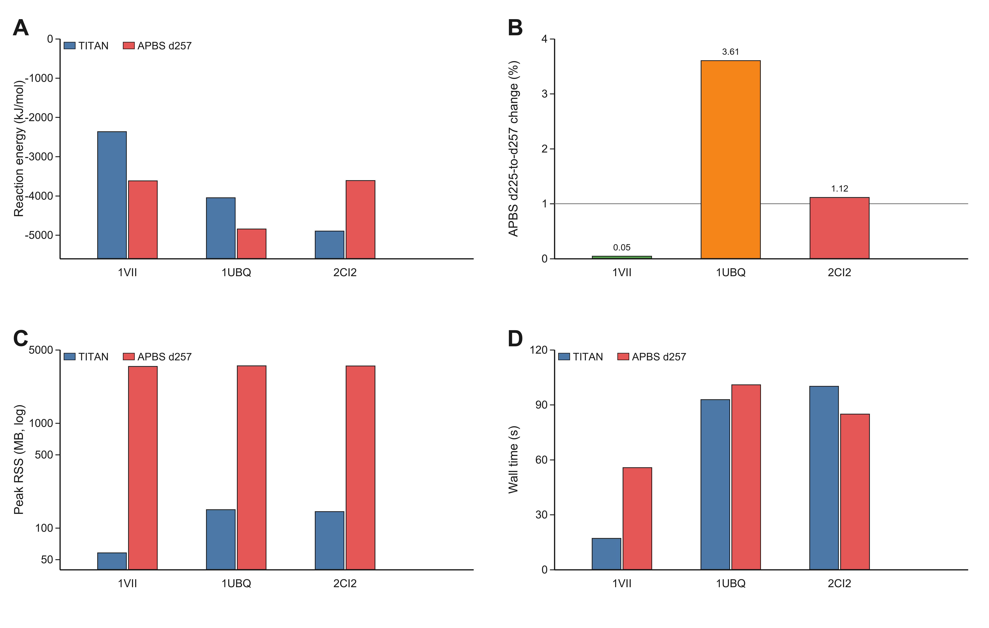
Note for Table S6: the surface request 81 row exceeded the compressed Green-jet cache budget during setup and is therefore treated as a memory-scaling limit, not as a failed numerical solve. No mesh-convergence order is inferred from this two-level stress check.

Figure S1. APBS grid-solver context rows. APBS grid-solver context rows. A, reaction energy from TITAN guarded p4 and the finest APBS grid in the sweep. B, relative APBS energy change when refining the finite-difference grid from d225 to d257. C, peak resident memory for the matched TITAN guarded p4 rows and the finest APBS grid. D, wall time for the same rows. The comparison quantifies grid sensitivity and resource context, not dense-operator error, because the boundary-integral and finite-difference solvers use different discretizations and interface definitions.

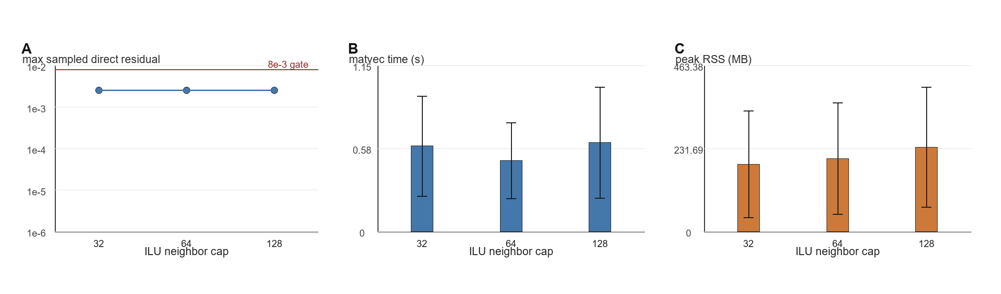

Figure S2. ILU neighbor-cap sensitivity under the guarded p4 protocol. ILU neighbor-cap sensitivity under the guarded p4 protocol. A, maximum sampled direct residual across Barnase, 1A63, and 1SH1, with the 8 x 10^-3 verification gate shown as a reference line. B, mean GMRES matrix-vector time. C, mean process peak RSS. Points show means and error bars show sample standard deviation across the three proteins.

