TITAN: Analytical FMM/M2L Boundary-Integral Poisson-Boltzmann Solves with Sparse Near-Field ILU(0) Preconditioning
Hoang Linh Nguyen1,2,*
1Institute of Fundamental and Applied Sciences, Duy Tan University, Ho Chi Minh City 700000, Vietnam
2Faculty of Environmental and Natural Sciences, Duy Tan University, Da Nang 550000, Vietnam
*Email: nguyenhoanglinh9@duytan.edu.vn

Abstract
Grid-based Poisson-Boltzmann solvers remain robust workhorses, but their volumetric discretization imposes steep memory costs and artifacts at the sharp dielectric boundary. Boundary-integral equation (BIE) formulations circumvent the volume grid by solving directly on the molecular interface, yet they replace the grid problem with a dense, derivative-rich surface operator that frequently causes severe stalling in Krylov subspace solvers. To overcome this fundamental limitation, we present a hardware-aware, analytical Fast Multipole Method (FMM/M2L) integrated into the TITAN engine. Our approach couples a guarded fourth-order Cartesian Taylor expansion with compressed Green-function jets, AVX2-packed direct evaluations, and a novel sparse near-field ILU(0) preconditioner. Validation across a diverse protein panel including Barnase, the E. coli Rho factor RNA-binding domain, and Stichodactyla helianthus neurotoxin I demonstrates unconditional convergence with finite energies and direct-operator residuals strictly below 8e-3. A global p-order sweep shows that p2 is the most conservative audit mode, because it accepts essentially no far M2L pairs, whereas guarded p4 is retained as the manuscript default because it is the lowest-mean-wall-time far-compressed policy that passes the sampled direct-operator gate on the six-protein panel. Crucially, dense convergence profiles reveal that while traditional baseline diagonal and local block-diagonal preconditioning stall due to high-coupling singularities, our sparse ILU(0) preconditioner completely resolves the Krylov stiffness. This robust FMM-BIE architecture maintains high-fidelity interfacial electrostatics while drastically reducing the memory footprint compared to volumetric grid alternatives.

Introduction
Implicit-solvent electrostatics is a central approximation in biomolecular modeling because it replaces explicit solvent degrees of freedom with a continuum response. The Poisson-Boltzmann equation is one of the most established forms of this approximation: it combines a low-dielectric molecular interior, a high-dielectric solvent exterior, fixed molecular charges, and mobile ions. Classical APBS/DelPhi-style grid solvers are robust and widely used, but they carry a volumetric cost and represent a sharp molecular dielectric interface through a finite grid. Increasing molecular size, changing salt conditions, or refining the dielectric interface can quickly make the grid the dominant computational object.
Boundary-integral Poisson-Boltzmann methods attack the same physical problem from a surface perspective. By reformulating the linearized PB equation as coupled integral equations on the molecular surface, they reduce the unknown set from a three-dimensional volume to a triangulated interface. This surface reduction is attractive for repeated protein calculations and for workflows in which surface discretization is the natural resolution parameter. It also creates a difficult numerical problem: the surface operator is dense, contains derivative-sensitive kernels, and includes near-singular panel interactions that cannot be treated as ordinary far-field particle sums.
Fast multipole methods provide the natural acceleration idea for such dense operators [2]. Earlier TABI/treecode and FAGBI-style work established that boundary-integral PB can be accelerated without abandoning the surface formulation. The Cartesian boundary-integral PB direction developed by Chen, Tausch, and Geng is the closest methodological reference point for TITAN's analytical FMM/M2L effort [1]. TITAN follows that broad motivation but targets a different integration setting. Rather than presenting a standalone Galerkin code, TITAN embeds an explicit guarded high-order path inside an existing TABI workflow, with production defaults left unchanged. The focus is therefore not only the analytical expansion, but also the engineering required to make the accelerated operator repeatable, auditable, and usable inside GMRES.
TABI-PB 2.0 is an important performance reference rather than a foil [9]. It combines NanoShaper surfaces, node-patch discretization, barycentric Lagrange dual-tree traversal, block preconditioning, and GPU execution. On 1A63, the published V100 result reaches seconds-scale runtime at approximately 0.5% reported solvation-energy error. The present TITAN path should therefore not be read as a claim of absolute GPU wall-time superiority. Its contribution is complementary: a CPU-oriented, auditable analytical p4 M2L path with graph-derived sparse ILU(0), deterministic fallback, and direct-operator verification.
The second central issue is preconditioning. A boundary-integral acceleration that makes each matrix-vector product faster is not enough if the Krylov iteration count grows or the solver stalls. During TITAN development, local diagonal and local block-diagonal preconditioners repeatedly failed to capture strong coupling across tree leaves on dense molecular surfaces. Increasing local block size improved some rows but did not solve the fundamental graph problem. The final method therefore constructs a sparse near-field graph directly from FMM near-source relationships and applies block ILU(0) over coupled 2 x 2 panel blocks. This is the main numerical distinction of the present guarded path.
The claim in this manuscript is intentionally scoped. Guarded p4 is not promoted to TITAN's production default, and it is not selected automatically by TABI treecode. Instead, we document a repeatable advanced explicit path. The p4 setting is retained as the manuscript-facing operating point because it remains audit-passing while retaining substantial accepted far M2L work; the p2 setting is reported as a conservative direct-fallback-dominated safety mode, not as the main compressed FMM/M2L regime. The evidence chain asks whether the high-order operator agrees with sampled direct references, whether the preconditioner resolves a dense high-coupling case, and whether the workflow repeats on public full-protein fixtures. This is a narrower claim than a full replacement for grid PB, but it is stronger than a prototype-only demonstration.

Methods
TITAN solves a coupled boundary-integral Poisson-Boltzmann system over triangulated molecular surfaces. Each panel carries the unknown vector u_i = (phi_i, partial_n phi_i)^T, where phi is the surface potential and partial_n phi is its normal derivative. The JCP-style coupled operator contains four analytical interaction channels, denoted here as K1 through K4. These channels couple the potential and normal-derivative rows and are applied with the same production sign convention in direct, degree-one accelerated, and guarded p4 paths. GMRES is used for the nonsymmetric coupled linear system [3].
The local block form used throughout the implementation is
A_ij = [[delta_ij c_phi - K2_ij, -K1_ij], [-K4_ij, delta_ij c_phin - K3_ij]],
where j is either a direct near neighbor, a guarded direct-fallback panel, or a far-cell contribution accumulated through moment-to-local translation. The corresponding matrix-vector product is applied as A_phi x = c_phi phi - Phi_K and A_phin x = c_phin phin - Phin_K, so the direct, degree-one, and guarded p4 paths share the same sign convention.
Near interactions are evaluated with the production analytic-singular kernel. This choice matters because self and adjacent-panel terms can dominate the error if they are approximated by ordinary centroid interactions. Duffy-adaptive quadrature remains available as an explicit diagnostic option [5], but it is not selected automatically in the guarded p4 workflow. The manuscript-facing policy therefore separates near-field correctness from far-field acceleration: near terms use the shared analytic-singular path, while far terms are controlled by high-order expansion, refinement, and direct fallback.
The guarded p4 far operator uses fourth-order Cartesian source moments and target-local M2L/L2P evaluation. The accepted far-cell contribution is not treated as a black-box scalar approximation. Instead, the four coupled channels are assembled from analytical Green-function jets and their source/target derivatives. The derivative channels are especially sensitive because normal derivatives and dielectric contrast multiply truncation error; a small far-field error in a scalar Green expansion can be amplified when it enters K2, K3, or K4. TITAN therefore treats the p4 expansion as a guarded candidate rather than as an unconditional acceptance rule. To keep memory bounded, TITAN stores two double-precision degree-9 Green jets per far pair, one for the Coulomb part and one for the screened part. Source-normal derivatives needed by K2 and K4 are reconstructed during contraction rather than stored as separate materialized jets.
For a source cell C with center c, TITAN forms Cartesian moments up to |alpha| <= 4,
M_alpha^phin = sum_j_in_C A_j phin_j (y_j - c)^alpha,
M_alpha_d^phi = sum_j_in_C A_j phi_j n_jd (y_j - c)^alpha.
For a target leaf centered at t, the local coefficient for multi-index beta is accumulated in the form
L_beta = (-1)^|beta| sum_|alpha|<=4 M_alpha binom(alpha + beta, alpha) C_alpha_plus_beta,
where C_gamma is the Coulomb or screened Green-function jet coefficient through degree 9. K1 and K3 use the base Green jets, while K2 and K4 use source-normal derivatives reconstructed as D_d_alpha = (alpha_d + 1) C_alpha_plus_ed. The L2P stage evaluates the resulting local expansion at every target panel in the leaf.
Figure 1 maps the complete boundary-integral PB workflow used in this manuscript. The numerical problem separates into six stages: molecular structure preparation, surface discretization, coupled BIE operator construction, fast matrix-vector evaluation, Krylov preconditioning and solution, and independent verification. This work does not introduce new molecular preparation chemistry or a new surface-definition model. Its contribution is concentrated in the operator, solver, and verification stages: guarded analytical p4 FMM/M2L for the dense K1-K4 surface operator, sparse near-field ILU(0) for Krylov stabilization, and sampled direct-operator checks for accuracy control.
The static refinement plan is built before GMRES and reused throughout the solve. Deterministic operator probes identify risky far cells, and a strict geometric separation guard catches outliers that an RMS tail indicator can miss. In simplified notation, the far-cell acceptor compares a p3/p4 tail indicator against the coupled output signal and then applies a geometry guard to cells whose box separation is too small relative to their radius. If either test flags the pair, the source cell is split; if it is already a source leaf, the interaction is demoted to direct fallback. The final guarded policy uses Taylor order 4, opening theta 0.6, static tail tolerance 0.002, strict-geometry MAC theta 0.5, compressed Green-jet cache, packed AVX2 direct fallback, analytic-singular near integration, and sparse near-field ILU(0). This policy is intentionally conservative: a far cell must be both algebraically and geometrically safe before it is accepted. The p-order sensitivity results therefore evaluate the realized guarded operator, including refinement and fallback, not Taylor order in isolation.
The direct fallback path is also structured for reuse. The refinement plan produces deterministic target/source tasks. Non-self fallback pairs use a packed AVX2 primitive over four target lanes and source tiles arranged in cache-friendly order, while self terms are routed through the exact analytic near kernel and masked out of vector lanes to prevent double counting. This hardware-aware layout reduces branch pressure in the near-field path and keeps the high-volume fallback work close to the L1/L2 cache access pattern expected by modern CPUs. It was necessary because accuracy recovery on full 1A63 required a geometry guard that increased fallback work. Without packed fallback, the recovered p4 operator would be accurate but too expensive for guarded GMRES.
The sparse preconditioner is assembled from the FMM near-source graph. For every target panel i, the graph contains the self edge and a deterministic set of nearby source panels, capped at 64 neighbors in the guarded configuration. On each graph edge, TITAN stores a 2 x 2 block approximation to the coupled local operator: A_ij = [[delta_ij c_phi - K2_ij, -K1_ij], [-K4_ij, delta_ij c_phin - K3_ij]]. The matrix is stored in block sparse-row form. ILU(0) keeps the original graph sparsity, applying the no-fill update L_ik = A_ik U_kk^-1 and U_ij <- U_ij - L_ik U_kj only when the block (i,j) already exists [4]. The apply phase performs deterministic block forward and backward substitution.
Figure 2 summarizes the guarded operator split between far-field Cartesian p4 M2L/L2P, packed direct fallback, and the near-source graph used for sparse ILU(0). Source panels are compressed into Cartesian moments, accepted far cells are translated into target-local expansions, and near or geometrically risky interactions are routed through the shared direct P2P path.
Protein structures are prepared with PDB2PQR/APBS-family tooling [6], [7] and public structure identifiers from the RCSB Protein Data Bank [8]. The primary full-protein panel contains Barnase, the RNA-binding domain of E. coli Rho factor (1A63), and Stichodactyla helianthus neurotoxin I (1SH1). The supplementary public-protein expansion contains Ubiquitin (1UBQ), Chymotrypsin inhibitor 2 (2CI2), and Villin headpiece subdomain (1VII). Manuscript-facing rows are full-protein fixtures, not atom-sampled fixtures.
The reference policy is matched to computational feasibility. For analytic and bounded development tests, direct TABI can be used as a full reference. For the full-protein guarded p4 panel, full direct TABI reaction energies are not practical for the largest rows, so verification uses sampled direct-operator RMS and sampled direct true residuals. Grid PB remains the production default and is useful runtime context, but it is not treated as the oracle for the high-order boundary-integral path.
All manuscript-facing TITAN benchmarks reported here were executed on a single Windows workstation equipped with an Intel(R) Core(TM) Ultra 7 255H processor and 30.9 GB of physical memory. Full-protein rows used single-node AVX2 CPU execution with nt = 4 worker threads unless otherwise noted; the remaining logical processors were not treated as a distributed-memory resource.

Table 1. Algorithmic positioning of TABI-PB 2.0, FAGBI, and TITAN.
Aspect | TABI-PB 2.0 | FAGBI / Cartesian Galerkin FMM | TITAN guarded p4 path
Discretization | Node-patch boundary-integral discretization over NanoShaper surfaces; unknowns are associated with surface vertices/patches. | Cartesian Galerkin boundary-integral PB formulation with analytical surface integration and FMM acceleration as the central numerical framework. | Coupled panel/collocation TABI formulation with unknown vector u_i = (phi_i, partial_n phi_i)^T and analytic-singular near integration.
Fast operator | Barycentric Lagrange dual-tree traversal (BLDTT) with Chebyshev proxy points and GPU-oriented PP/PC/CP/CC interactions. | FMM-accelerated Cartesian boundary-integral operator using analytical expansion machinery for the Galerkin discretization. | Analytical Cartesian FMM/M2L: p4 source moments, degree-9 Green-function jets, target-leaf local evaluation, and direct fallback for risky pairs.
Acceptance policy | MAC-controlled dual-tree traversal with interpolation degree and cluster interaction lists tuned so fast-summation error is below discretization error. | Fast multipole acceptance and analytical integration policy designed around the Galerkin operator accuracy target. | Opening theta plus static p3/p4 tail refinement, strict geometry guard, and deterministic direct fallback when a far cell is not safely approximated.
Preconditioning | Block preconditioning in a fast GPU-oriented TABI-PB 2.0 pipeline. | The primary contribution is the accurate fast operator. | Sparse near-field block ILU(0) built from the FMM near-source graph, with 2 x 2 coupled panel blocks and no fill beyond the graph.
Verification emphasis | Energy error and runtime are reported against extrapolated surface-resolution references. | Accuracy is established for the Galerkin/FMM formulation under the reference tests of the original method. | Every guarded p4 solve records sampled direct-operator RMS, sampled direct true residual, plan/cache lifecycle, memory, and repeatability.
Hardware status | Performance-critical BLDTT kernels are implemented on GPU; 1A63 reaches seconds-scale runtime on an NVIDIA V100 in the reported paper. | FAGBI is used here as the closest methodological reference point for analytical FMM boundary-integral PB, not as a wall-time target. | Current manuscript evidence is CPU/AVX2-oriented; the contribution is guarded operator/preconditioner design, not GPU wall-time superiority.
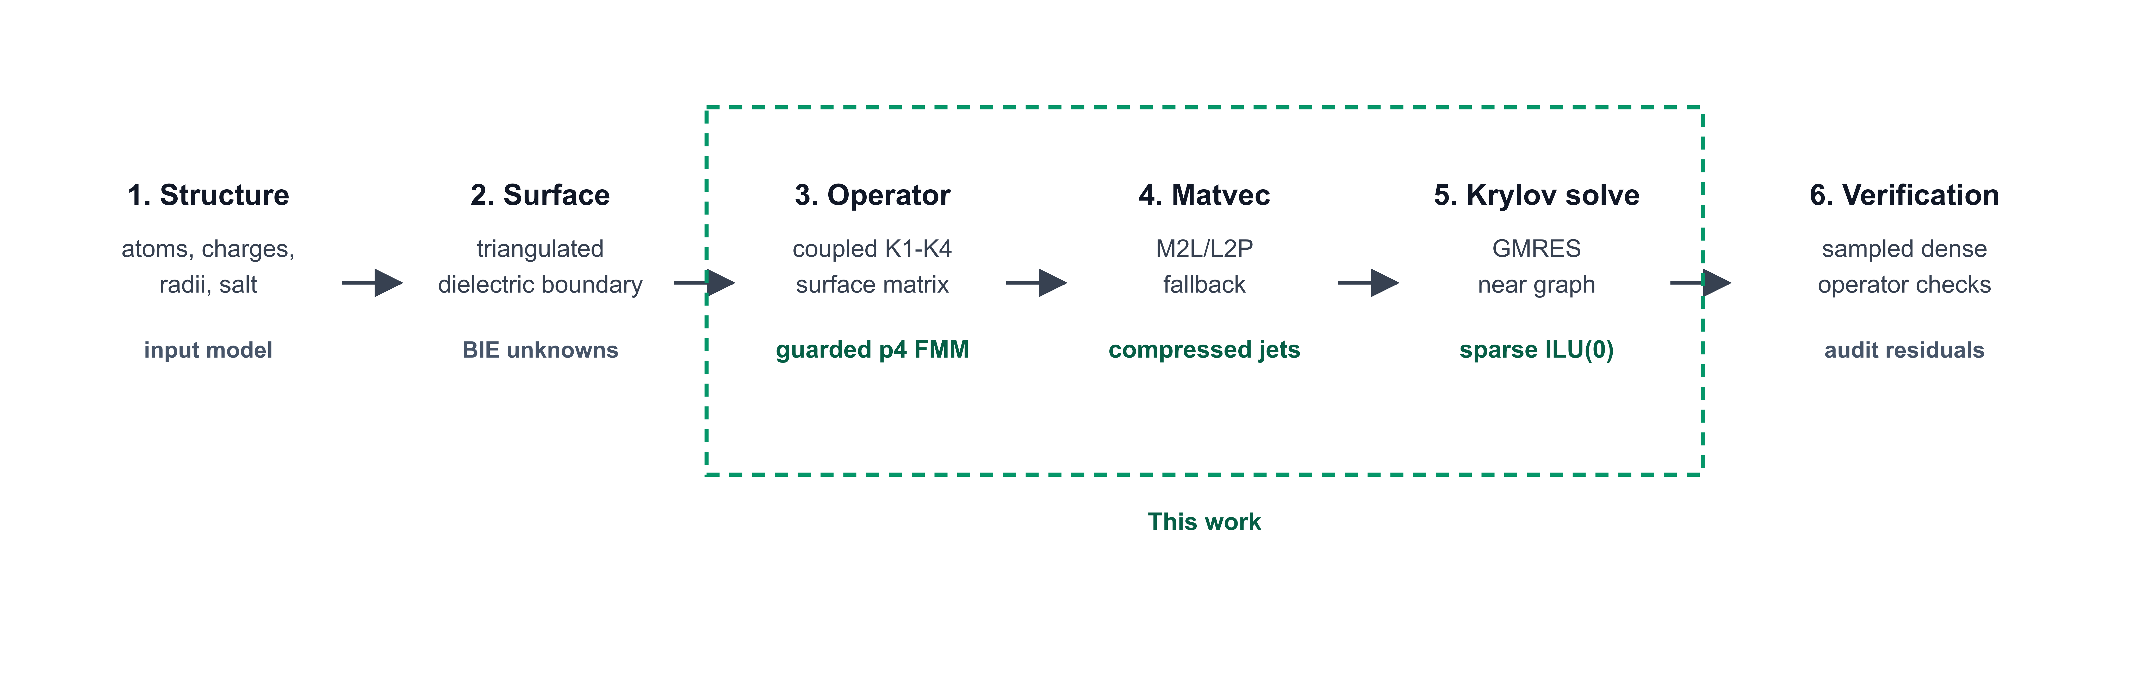
Figure 1 | Boundary-integral Poisson-Boltzmann workflow and contribution map. The six-stage pipeline starts from molecular preparation and surface discretization, forms the coupled K1-K4 boundary-integral operator, evaluates matrix-vector products, solves the Krylov system, and verifies the accelerated operator. The dashed green region marks the contribution of this work: guarded analytical p4 FMM/M2L, packed direct fallback, graph-derived sparse ILU(0), and sampled direct-operator verification.
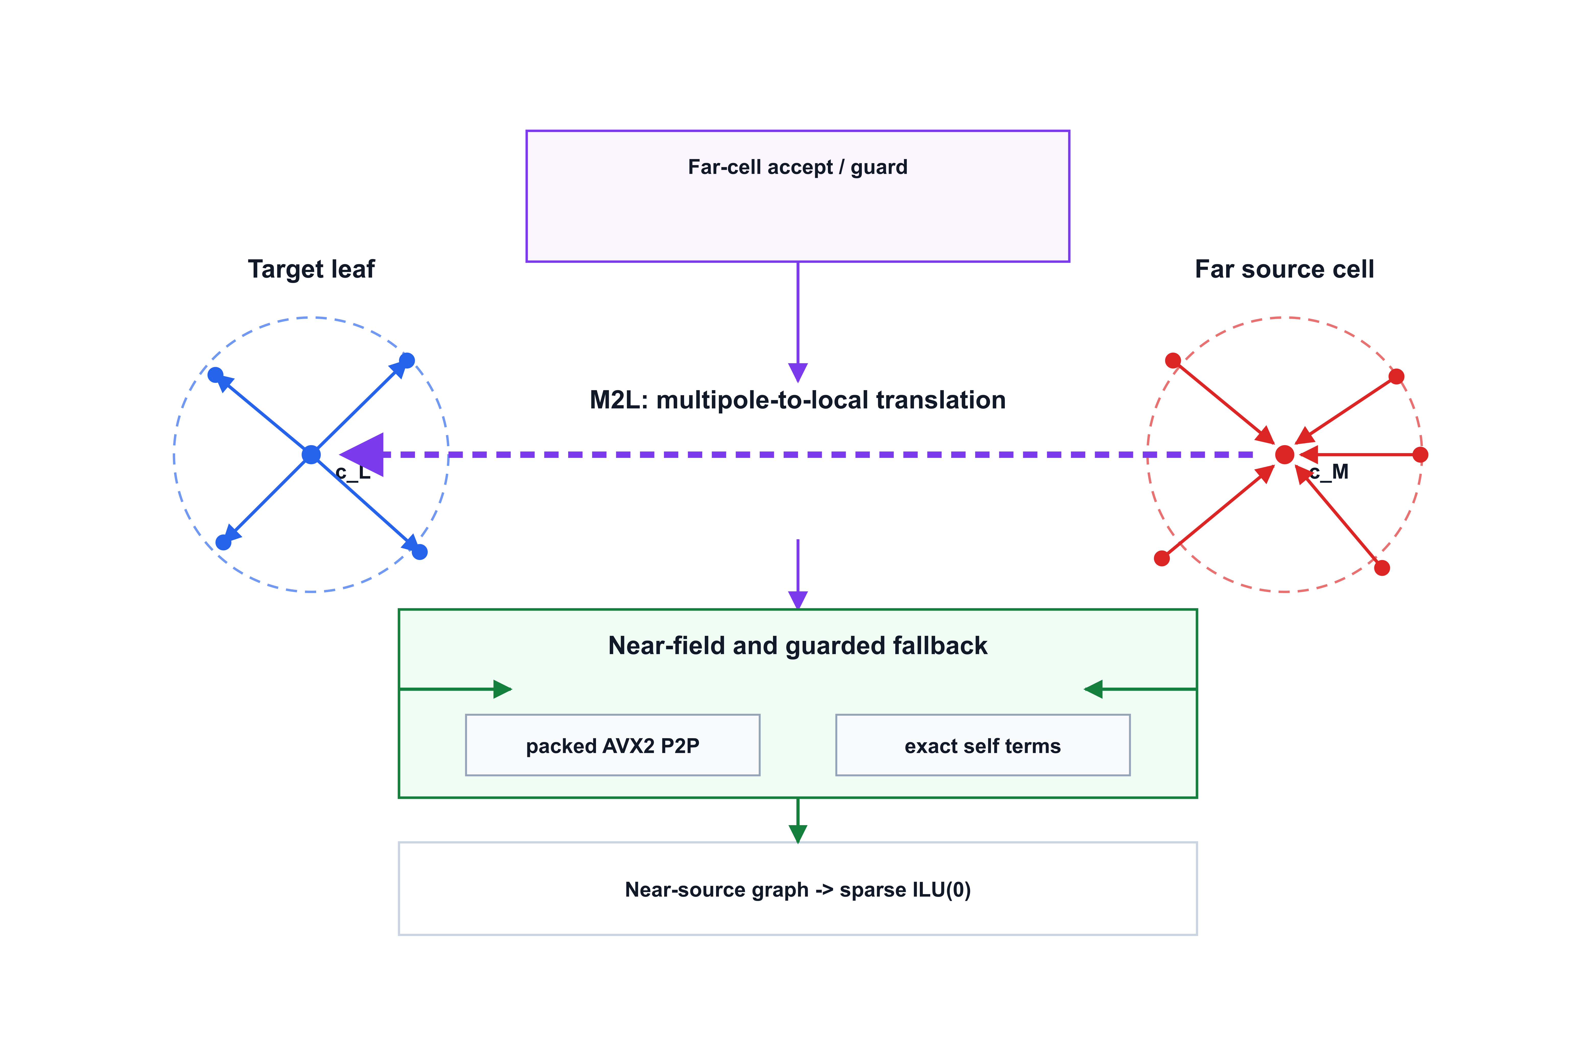
Figure 2 | Guarded p4 FMM/M2L boundary-integral operator. Blue denotes target-leaf local evaluation, red denotes source-cell Cartesian moments, purple denotes analytical far-field M2L, and green denotes guarded direct fallback and sparse preconditioning. Source panels are compressed into Cartesian p4 moments, accepted far cells are translated to target-local expansions, and near or geometrically risky interactions are evaluated by packed direct P2P fallback; the same near-source graph defines the sparse block ILU(0) preconditioner used by GMRES.

Analytical Validation Protocol
Before the full-protein guarded p4 rows were accepted, TITAN used controlled analytic systems to separate surface-discretization error from acceleration error. Centered Born and off-center Kirkwood-style tests were used to check whether direct TABI with analytic-singular near integration converged toward known spherical references as the surface was refined. This step matters because an accelerated operator cannot be meaningfully validated if the underlying surface discretization is already outside the target accuracy range.
The high-resolution direct TABI checks showed that the remaining analytic error could be reduced below the manuscript threshold on the controlled sphere cases. Those tests do not prove full-protein energy accuracy by themselves, because protein surfaces are more irregular and do not have closed-form reaction-energy oracles. They do establish that the panel basis, normals, diagonal terms, and analytic-singular near path are not the dominant explanation for the later full-protein operator gaps. This allowed the later debugging to focus on far-field truncation, refinement, and preconditioning rather than on the direct near-field kernel.
To anchor the sampled full-protein audits to a regime where the dense boundary-integral operator can still be solved explicitly, we also ran small public-protein calibration subsets derived from 1VII, 1UBQ, and 2CI2. These 64-atom subsets are not used as full-protein energy claims. Their purpose is narrower: they verify that the guarded p4 path reproduces full dense TABI solves when the dense solve is computationally feasible. Requested surface settings 8 and 12 produced the same realized panel counts for these mini calibration rows, so the table is treated as dense-operator calibration rather than mesh-refinement evidence. Across all six mini dense rows, the maximum absolute p4-versus-dense energy difference was \(6.30 imes10^-4\) kJ/mol, the maximum relative energy error was \(1.79 imes10^-7\), and the maximum sampled direct-operator residual was \(1.27 imes10^-6\).
The operator attribution sequence then separated near and far contributions on full proteins. The key observation was that a nominal fourth-order configuration could still fail on 1A63 if the refinement plan was driven only by an averaged tail estimate. The outlier was not a sign-convention error, a near-kernel regression, or a cache lifecycle bug. It was a far-cell acceptance problem: a small number of geometrically risky accepted cells could dominate the sampled direct residual. The final strict-geometry guard is the direct response to that attribution.
Dense-direct calibration summary for analytic systems and a small public-protein subset.
Case | Requested surface | Panels | Dense TABI energy | Guarded p4 energy | Max abs. error | Max operator residual
Centered Born sphere | 8 | 48 | -242.9284565 | -242.9284565 | 0 | 1.12e-16
Off-center Kirkwood sphere | 8 | 48 | -79.60482942 | -79.60482942 | 0 | 1.81e-16
1VII calibration subset, 64 atoms | 8, 12 | 2534 | -3810.764920 | -3810.764758 | 1.62e-4 | 1.27e-6
1UBQ calibration subset, 64 atoms | 8, 12 | 2992 | -3511.081114 | -3511.081744 | 6.30e-4 | 7.02e-7
2CI2 calibration subset, 64 atoms | 8, 12 | 3030 | -2242.834792 | -2242.834936 | 1.44e-4 | 1.23e-6

Lifecycle And Reproducibility Controls
The guarded p4 path is prepared before GMRES. The context builds the FMM geometry, static refinement plan, compressed Green-jet cache, packed fallback worklist, and near-field ILU(0) preconditioner once. During Krylov iteration, only source moments and density-dependent contractions are updated. This lifecycle is part of the numerical contract, not only a performance detail. If the plan or cache were rebuilt inside GMRES, repeated runs could become difficult to interpret and setup cost would contaminate matvec timing.
Every manuscript-facing guarded p4 row therefore records plan/cache build counts. The accepted rows have build count one. They also record sampled direct-operator residuals after convergence, so the reported solver residual is not the only accuracy measure. The sampled direct-operator gate separates known failed far-field configurations from guarded accepted rows and is applied in addition to the \(10^-6\) Krylov stopping tolerance because internal GMRES convergence alone does not verify agreement with the dense direct operator. The full 1A63 diagnostic exposed exactly this failure mode before the geometry guard was added.
The implementation uses deterministic ordering for refinement, cache layout, fallback tasks, and panel sampling. Parallelism is allowed, but worklists are sorted by target and source identifiers, and each worker owns disjoint output panels. This determinism is why repeat energy spread is a meaningful package metric. A repeatability table with zero spread at reported precision is not a substitute for independent validation, but it does show that the guarded path is not depending on race-sensitive accumulation or accidental cache state.

Results And Discussion

3.1. Performance Ladder and the Krylov Stalling Problem
To establish the computational baseline, we first evaluated the classical direct boundary-integral formulation across the six-protein panel (Table 3 and Figure 3). While direct evaluation provides the most transparent mathematical reference, its O(N^2) complexity severely restricts its practical utility for macromolecular systems. As shown in Table 3, the direct TABI approach failed to converge within practical time budgets for any of the six test cases, reaching the timeout limit on two systems and halting with unacceptable residual gaps on the remaining four (median wall time: 31.1 minutes). This behavior highlights the fundamental computational barrier of applying a dense boundary-integral surface operator directly at full-protein panel counts.
The standard mitigation for dense-matrix bottlenecks is to decouple the matrix-vector products using fast summation techniques such as the Fast Multipole Method. However, introducing a degree-one FMM operator reveals a deeper numerical pathology inherent to the BIE formulation. While FMM successfully accelerates individual matrix-vector evaluations, the GMRES iterative solver catastrophically stalls. When paired with a naive diagonal preconditioner, 0/6 systems converged; the iteration count routinely hit the upper limits (median 680 iterations) while the relative residual stagnated at an unacceptable 1.2 x 10^-2. Upgrading to a local block-diagonal preconditioner designed to capture strictly intra-leaf interactions provided only marginal wall-time improvements (median 700.8 s) and still resulted in 0/6 converged systems, persistently hitting the 720-iteration cap.
This algorithmic ladder fundamentally redefines the BIE bottleneck. The failure of the accelerated operator to converge demonstrates that the limiting factor in macromolecular BIE solvers is not merely the arithmetic cost of multipole evaluations, but the extreme stiffness of the coupled surface matrix. The complex topological features of realistic protein surfaces, such as deep clefts and closely opposed dielectric boundaries, generate strong near-field couplings across the derivative-sensitive interaction channels. Weak, leaf-local preconditioners are effectively blind to these cross-leaf boundary interactions, causing the Krylov subspace to degenerate.
Figure 4 makes the separation between matrix-vector acceleration and Krylov stabilization explicit for 1A63. Direct TABI provides no useful component split because it reached the timeout budget. In this figure, convergence denotes an internal GMRES true residual below \(10^-6\); manuscript-facing rows additionally require sampled direct-operator residuals below \(8\times10^-3\). The degree-one FMM rows spend almost all measured wall time in repeated matrix-vector evaluations over a stalled 720-iteration Krylov solve. Replacing the weak preconditioner with sparse near-field ILU(0) reduces the iteration count to 128 and lowers wall time from approximately 1130 s to 208 s. The guarded p4 row adds static preparation, fallback, and direct-operator verification cost, but it is the row that satisfies the sampled direct-operator audit. Consequently, achieving a robust FMM-BIE solver requires a preconditioning strategy that respects the physical connectivity of the molecular surface, leading us to examine the near-field coupling graph.

3.2. Resolving High-Coupling Singularities with Sparse Near-Field ILU(0)
Figure 5 isolates the preconditioning effect on the Barnase full-protein case. The diagonal and local block-diagonal rows both reached the 720-iteration budget, with sampled true residuals of 4.420e-02 and 4.786e-02, respectively. Sparse near-field ILU(0), by contrast, converged in 128 iterations with sampled true residual 1.319e-12. This is the clearest evidence that the decisive improvement is not merely a faster far-field summation, but a change in the algebraic coupling available to GMRES.
The physical reason is local but not purely intra-leaf. Protein molecular surfaces contain grooves, pockets, and narrowly separated surface patches. Panels that are geometrically close can be assigned to different FMM leaves, yet their K1-K4 interactions remain strong, especially in derivative-sensitive normal channels. A diagonal or leaf-local block preconditioner treats many of these cross-leaf couplings as external to the local solve. It is therefore memory-bounded and simple, but it can be blind to precisely the interactions that make the BIE matrix stiff.
TITAN's sparse near-field ILU(0) uses the same near-source graph exposed by the FMM worklist. The graph contains the self edge and a deterministic set of nearby source panels for each target panel, and the coupled entries are stored as 2 x 2 panel blocks. ILU(0) then performs a no-fill factorization over this graph, allowing information to propagate across neighboring panels without forming a dense matrix. The graph extraction and ILU(0) factorization overhead is included in the reported wall times; even with that setup cost, the median full-protein wall time decreased from 700.8 s for local block preconditioning to 133.3 s for sparse ILU(0), a 5.3x reduction. Sparse ILU(0) therefore improves both iteration count and total time, rather than merely shifting work into setup.
While ILU(0) stabilizes the Krylov iteration, the accuracy of the final BIE solution still depends on whether the far-field translation agrees with the direct dense operator. This leads to the guarded p4 evaluation.

3.3. Guarded Analytical FMM and Direct-Operator Verification
The guarded p4 path addresses the accuracy question left open by the degree-one FMM rows. Across Barnase, 1A63, 1SH1, 1UBQ, 2CI2, and 1VII, all guarded p4 + sparse ILU(0) rows converged in 128 iterations, with maximum sampled audit 2.534e-03, maximum sampled direct true residual 2.535e-03, and peak resident memory 369.6 MB. The audit and sampled direct residual columns in Table 4 are therefore as important as the solver residual: they test the accelerated operator against sampled direct dense interactions rather than only testing GMRES convergence on the accelerated system.
The guarded far-field operator uses fourth-order Cartesian Taylor moments rather than spherical harmonics in the current implementation. This is a pragmatic manuscript policy rather than a claim that p4 is intrinsically the most accurate expansion order. The K1-K4 channels require source-normal, target-normal, and mixed derivative bookkeeping, and the realized runtime is controlled by constants, memory layout, derivative-channel assembly, refinement, and direct fallback rather than by asymptotic expansion order alone. Cartesian Green-function jets keep these derivative channels local, unrolled, and compatible with the compressed-cache and packed-fallback lifecycle.
TITAN also does not accept every nominal far cell unconditionally. A static p3/p4 tail indicator identifies algebraically risky far cells, and a strict geometric guard catches near-separation outliers that an averaged error indicator can miss. If a cell pair violates the guard, it is split; if it is already a leaf, the interaction is demoted to direct fallback. This conservative policy is why the guarded p4 rows recover direct-operator agreement: the multipole approximation is used only where both the algebraic and geometric checks indicate that it is safe.
The p-order sweep further changes how expansion order should be interpreted under a guarded policy. Lower order does not necessarily imply worse sampled audit residuals, because the guard can recover dense-operator agreement by demoting risky interactions to direct evaluation. In the six-protein sweep, p2 produced the smallest sampled audit residuals, but it accepted essentially no far M2L pairs. This is useful diagnostic evidence that the fallback machinery is conservative and correctly evaluated; it is not evidence that p2 provides the best FMM compression. The p3, p4, and p5 rows all passed the sampled audit gate, while p4 gave the lowest observed mean wall time among configurations that retained substantial far-field M2L work. Because the wall-time error bars overlap for some orders, we do not claim a statistically resolved universal p4 speed advantage. We retain p4 as the manuscript default because it provides the best observed balance between accepted far-field compression, wall time, memory, and direct-operator auditability on the current six-protein panel.
Figure 6 reports the guarded p-order trade-off across the six-protein panel. The figure compares sampled audit RMS, total wall time, peak RSS, and accepted far M2L pairs for p = 2, 3, 4, and 5. The p2 row gives the smallest audit residuals but accepts essentially no far pairs, indicating a conservative direct-fallback-dominated mode. The p4 row is retained as the manuscript default because it is the lowest-mean-wall-time audited far-compressed configuration in this sweep. Error bars denote mean +/- SD over six proteins.
The p2 interpretation is supported by an explicit coverage log rather than by the residual alone. For every p2 row, the log records zero accepted far M2L pairs, nonzero rejected far cell pairs, nonzero demoted direct-fallback panel pairs, a nonzero total evaluated interaction count, and an independently computed sampled dense residual. Across the six proteins, p2 rejected 337,815 far cell pairs and demoted 295,959,727 panel pairs to direct fallback, with at least 1024 sampled dense-audit rows per solve. Thus the p2 audit is not produced by skipping far interactions; it is produced by evaluating the risky far work through direct fallback.
The absolute wall-time comparison with TABI-PB 2.0 should be interpreted carefully. Wilson, Geng, and Krasny report that 1A63 with N = 170064 node-patch unknowns reaches 0.5% solvation-energy error in 6.81 s on an NVIDIA V100 GPU, and in 105.61 s on one CPU core including triangulation [9]. The TITAN rows reported here are CPU/AVX2 guarded solves with stricter residual tolerance, static direct-operator audits, and a conservative p4 fallback policy. They are therefore not intended to supersede the published GPU BLDTT timing. Instead, they show that a different analytical operator architecture can be made Krylov-robust and auditable through graph-based ILU(0), leaving GPU/offloaded execution as a natural next engineering step.
The guarded policy creates more direct fallback work than a looser FMM acceptance rule. The next question is therefore whether the fallback path remains practical in memory, runtime, and repeatability.

3.4. Hardware-Aware Fallback and Computational Footprint
The direct fallback path is part of the algorithm, not an exceptional slow path. Once a risky far cell is demoted, TITAN packs target panels into four-lane AVX2 batches and streams source tiles through a deterministic structure-of-arrays layout. Self interactions remain routed through the exact analytic near kernel and are masked out of vector lanes, so the packed primitive accelerates non-self fallback work without dropping or double-counting singular terms. This hardware-aware fallback is what makes the strict geometry guard usable in a full GMRES solve.
The memory footprint remains modest for the manuscript-facing p4 rows. Table 4 reports 172.5 MB peak resident memory for Barnase and 369.6 MB for 1A63, with the maximum full-protein p4 row at 369.6 MB. This comparison is architectural rather than a matched APBS memory benchmark: volumetric grid PB memory grows with the three-dimensional grid required to resolve the dielectric interface, whereas the BIE path concentrates unknowns on the molecular surface and caches only the guarded operator structures needed for the solve.
As an external grid-solver context check, we also swept APBS grid dimensions on 1VII, 1UBQ, and 2CI2 using the same PQR inputs. APBS is not used here as the boundary-integral oracle, because its reaction energies remained visibly grid-sensitive over the tested range: the final d225-to-d257 change reached 3.61% across the three systems. The comparison is nevertheless useful for computational footprint. At d257, APBS required 3498.3-3546.8 MB peak RSS, whereas the corresponding TITAN guarded p4 rows used 58.2-150.3 MB; the largest APBS/TITAN RSS ratio was 60.1x. CPU wall times at the finest APBS grid were of the same order as the TITAN guarded rows for these small proteins, but the memory scaling and grid sensitivity reinforce why APBS is reported in the Supplement as context rather than as a validation oracle.
Repeatability is the final practical check. Table 5 shows zero energy spread at reported precision, one plan/cache build per accepted row, and sampled direct residuals below the manuscript gate. These observations indicate that the multithreaded implementation is not relying on race-sensitive accumulation, changing refinement plans, or accidental cache state. The supplementary public-protein expansion further broadens this observation: Ubiquitin, Chymotrypsin inhibitor 2, and Villin headpiece subdomain passed the same guarded p4 repeatability gate as supplement evidence.
Taken together, Tables 3-5 and Figures 2-5 show a staged progression: dense direct TABI is transparent but too costly, degree-one FMM accelerates matvecs but does not by itself solve Krylov stiffness, sparse near-field ILU(0) makes the Krylov system robust, and guarded p4 restores direct-operator agreement while retaining bounded CPU/AVX2 memory. The resulting path is documented here as a repeatable advanced explicit TABI treecode option, not as an automatic replacement for the production grid backend or for the default degree-one TABI treecode path.
Compared with the FAGBI reference direction [1], this work emphasizes integration into an existing molecular electrostatics codebase. The algorithmic components are not only analytical FMM/M2L expansions, but also static refinement, compressed jet caching, vectorized fallback, lifecycle control inside GMRES, and graph-based sparse preconditioning. The manuscript should therefore be read as a continuation of the TABI/FAGBI development line: it preserves the boundary-integral motivation while adding guarded high-order evaluation, sparse near-field preconditioning, and repeatable full-protein validation.
Two design choices are worth making explicit for reviewers. First, TITAN uses Cartesian Taylor moments rather than spherical harmonics in this guarded implementation. Although spherical-harmonic translations have attractive asymptotic structure, the fixed p-order regime studied here is dominated by constants, memory layout, derivative-channel bookkeeping, and the cost of direct fallback. Cartesian jets keep the K1-K4 construction local, unrolled, and compatible with the packed fallback and compressed-cache lifecycle. The p-order ablation should therefore be read as an accuracy/compression trade-off: p2 is a conservative near-direct safety mode, whereas p4 is the current far-compressed operating point. Second, grid and boundary-integral energies should not be treated as interchangeable oracles. Grid PB smooths a dielectric interface over a volume mesh, whereas BIE evaluates a sharp molecular boundary. The manuscript therefore uses sampled direct-operator residuals as the operator agreement test for large proteins and treats grid rows as production/default context rather than as the mathematical reference for the guarded surface operator.

Limitations
Several limitations are deliberate. Full direct TABI reaction energies are not used as the oracle for large full-protein rows; sampled direct-operator residuals are the feasible verification mechanism. Duffy-adaptive near integration remains explicit-only and is not automatically selected. The Barnase preconditioner convergence profile is framed as dense/high-coupling evidence rather than a broad claim over all proteins. The supplementary fixtures broaden the evidence but do not replace the primary locked panel.
The manuscript also does not claim a general production promotion. Guarded p4 remains an advanced explicit TABI treecode option, and grid remains TITAN's production Poisson-Boltzmann default. Future work should evaluate larger public protein panels, compare against independent PB packages under matched surface preparation, and test whether the p-order, guard, and fallback policy remains appropriate across ionic strengths, dielectric settings, and finer surface discretizations.

Reproducibility And Data Availability
The manuscript package is designed to be auditable from archived release materials rather than from undocumented local state. The tables, figure inputs, reference list, BibTeX file, claim trace, citation-gap closure, and rendered page checks are written into the paper package. The public-protein fixtures are identified by biological name and PDB identifier, and the preparation workflow records the PDB2PQR/APBS-family provenance used for the supplementary systems. The release separates numerical evidence from manuscript formatting: solver outputs, figure inputs, and manuscript files are checksummed so that later reruns can be compared with the archived table and figure sources.
The TITAN source code corresponding to this manuscript has been prepared for release under the MIT License as the local snapshot tag fagbi-submission-v0.1 on branch fagbi-submission-2026. Before submission, this paragraph must be updated with the public GitHub release URL and the Zenodo DOI minted from that tagged release. The archived release should include source code, build instructions, benchmark manifests, input metadata, scripts, figures, and reference outputs for Tables 3-6 and Supplementary Tables S1-S4. Public protein structures are identified by their RCSB PDB accession codes; derived surface metadata, run manifests, and tabulated outputs corresponding to the manuscript tables are included in the release-readiness manifest. A SHA-256 artifact manifest records the manuscript, benchmark scripts, public-fixture manifests, figures, and tabulated reference outputs intended for the archived release.
All large-protein accuracy statements in the manuscript are tied to sampled direct-operator verification rather than to unreported full direct solves. This is a limitation, but it is also a reproducibility choice. The sampled audit rows are deterministic, and the manuscript records the policy boundary explicitly so that future work can replace the sampled reference with full direct energy checks when practical. The current package should therefore be read as a reproducible evidence-backed draft, not as a final journal submission with independent external-code validation.

Conclusion
TITAN now contains a repeatable guarded analytical FMM/M2L boundary-integral PB path with sparse near-field ILU(0) preconditioning. On the primary full-protein panel and supplementary public fixtures, the explicit guarded p4 workflow converges, passes sampled direct-operator verification, retains far-field compression, and preserves a clear policy boundary: it is a documented advanced option, not the production default. The p-order evidence also shows that the guard can deliberately trade compression for direct dense agreement, with p2 acting as a conservative fallback-dominated safety mode. The evidence supports a paper-facing claim centered on analytical acceleration, deterministic far-field guarding, and graph-based sparse preconditioning for dense molecular-surface PB solves.

Algorithmic Performance Ladder
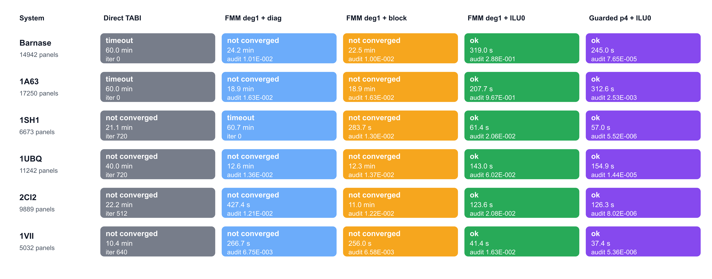
Figure 3 | Full-protein performance ladder. Colors identify backend stages from direct TABI through guarded p4 FMM/M2L with sparse ILU(0); each cell reports status and wall time. The ladder separates three effects: dense direct TABI is not practical at full-protein panel counts, degree-one FMM accelerates matrix-vector products but still stalls with weak preconditioning, and guarded p4 plus sparse near-field ILU(0) passes sampled direct-operator verification on all six full proteins.
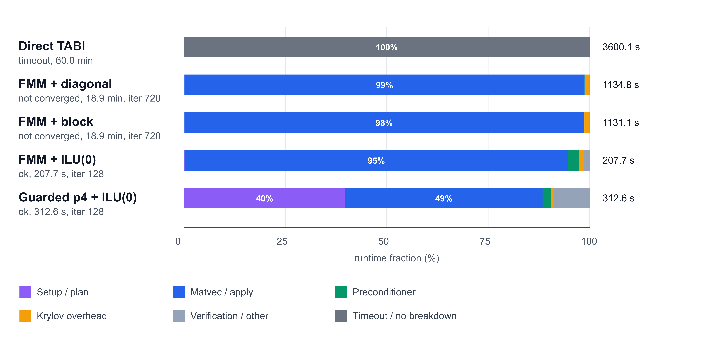
Figure 4 | Runtime composition for the 1A63 performance ladder. Direct TABI timed out and is shown as a wall-time context row without a component breakdown. The remaining rows show the fraction of measured wall time assigned to matrix-vector evaluation, preconditioning, Krylov overhead, setup, and verification or other overhead. Degree-one FMM reduces the cost of individual matrix-vector products but still spends almost all runtime in stalled 720-iteration solves; sparse near-field ILU(0) reduces the Krylov budget to 128 iterations, while the guarded p4 row adds preparation and direct-operator verification cost to recover sampled dense-operator agreement. Convergence in this figure denotes internal GMRES true residual below 10^-6; paper-facing acceptance additionally requires sampled direct-operator residual below 8 x 10^-3.
Table 2. Full-protein benchmark systems used in the performance ladder.
Protein | PDB/source | Atoms | Panels | Role
Barnase | PyDelPhi benchmark | 1700 | 14942 | Primary
RNA-binding domain of E. coli Rho factor | 1A63 | 2065 | 17250 | Primary
Stichodactyla helianthus neurotoxin I | 1SH1 | 696 | 6673 | Primary
Ubiquitin | 1UBQ | 1231 | 11242 | Supplement
Chymotrypsin inhibitor 2 | 2CI2 | 1076 | 9889 | Supplement
Villin headpiece subdomain | 1VII | 596 | 5032 | Supplement
Table 3. Full-protein algorithmic ladder across six matched protein fixtures.
Stage | Outcome | Median wall | Median iter. | Operator audit | Interpretation
Classical direct TABI | 0/6 ok; 4 failed; 2 timeout | 31.1 min | 576 | direct reference | Valid reference path, but dense direct matvecs dominate runtime at full-protein panel counts.
Degree-one FMM + diagonal | 0/6 ok; 5 failed; 1 timeout | 944.5 s | 680 | median 1.207e-02 | Matvec acceleration alone was not enough for robust Krylov convergence.
Degree-one FMM + local block | 0/6 ok; 6 failed; 0 timeout | 700.8 s | 720 | median 1.258e-02 | Matvec acceleration alone was not enough for robust Krylov convergence.
Degree-one FMM + sparse ILU(0) | 6/6 ok; 0 failed; 0 timeout | 133.3 s | 128 | median 4.052e-02; max 9.671e-01 | Sparse ILU(0) made GMRES robust, but the low-order far operator still failed direct-operator audits.
Guarded p4 FMM + sparse ILU(0) | 6/6 ok; 0 failed; 0 timeout | 140.6 s | 128 | median 1.121e-05; max 2.534e-03 | High-order guarded FMM/M2L retained ILU(0) convergence and restored sampled direct-operator agreement.
Table 4. Guarded p4 + sparse ILU(0) full-protein rows from the performance ladder.
Protein | PDB/source | Panels | Iter. | Internal residual | Sampled audit RMS | Sampled direct true residual | Wall | RSS MB
Barnase | PyDelPhi benchmark | 14942 | 128 | 8.579e-13 | 7.647e-05 | 7.647e-05 | 245.0 s | 172.5
RNA-binding domain of E. coli Rho factor | 1A63 | 17250 | 128 | 1.337e-11 | 2.534e-03 | 2.535e-03 | 312.6 s | 369.6
Stichodactyla helianthus neurotoxin I | 1SH1 | 6673 | 128 | 1.164e-14 | 5.519e-06 | 5.519e-06 | 57.0 s | 63.1
Ubiquitin | 1UBQ | 11242 | 128 | 2.719e-13 | 1.440e-05 | 1.440e-05 | 154.9 s | 144.6
Chymotrypsin inhibitor 2 | 2CI2 | 9889 | 128 | 5.964e-14 | 8.022e-06 | 8.022e-06 | 126.3 s | 138.1
Villin headpiece subdomain | 1VII | 5032 | 128 | 7.353e-13 | 5.357e-06 | 5.357e-06 | 37.4 s | 54.7

Primary Protein Panel
Table 5. Guarded p4 repeatability on the locked full-protein panel.
Protein | PDB/source | Panels | Energy | Sampled audit max | Sampled direct true residual max | Energy spread
Barnase | PyDelPhi benchmark | 14942 | -21030.83 | 6.383e-05 | 6.383e-05 | 0.000
RNA-binding domain of E. coli Rho factor | 1A63 | 17250 | -247716.08 | 2.357e-03 | 2.357e-03 | 0.000
Stichodactyla helianthus neurotoxin I | 1SH1 | 6673 | -4362.07 | 4.894e-06 | 4.894e-06 | 0.000

Preconditioner Convergence Profile
Figure 5 | Barnase GMRES residual decay under three preconditioning choices. All curves use the same full-protein degree-one FMM operator. The diagonal baseline and local block-diagonal preconditioner reached the iteration budget, whereas sparse near-field ILU(0) drove the preconditioned residual to the 1e-12 range and produced a converged solve. This contrast isolates Krylov stiffness from raw matrix-vector-product cost.

Guarded P-Order Trade-Off
Figure 6 | Guarded p-order trade-off across the six-protein panel. The p-order sweep reports sampled audit RMS, total wall time, peak RSS, and accepted far M2L pairs for p = 2, 3, 4, and 5. The p2 row gives the smallest audit residuals but accepts essentially no far pairs, indicating a conservative direct-fallback-dominated mode. The p4 row is retained as the manuscript default because it is the lowest-mean-wall-time audited far-compressed configuration in this sweep. Error bars denote mean +/- SD over six proteins.

References
[1] J. Chen, J. Tausch, and W. Geng, A Cartesian FMM-accelerated Galerkin boundary integral Poisson-Boltzmann solver, arXiv:2110.13778, 2021.
[2] L. Greengard and V. Rokhlin, A fast algorithm for particle simulations, Journal of Computational Physics 73, 325-348, 1987.
[3] Y. Saad and M. H. Schultz, GMRES: A generalized minimal residual algorithm for solving nonsymmetric linear systems, SIAM Journal on Scientific and Statistical Computing 7, 856-869, 1986.
[4] J. A. Meijerink and H. A. van der Vorst, An iterative solution method for linear systems of which the coefficient matrix is a symmetric M-matrix, Mathematics of Computation 31, 148-162, 1977.
[5] M. G. Duffy, Quadrature over a pyramid or cube of integrands with a singularity at a vertex, SIAM Journal on Numerical Analysis 19, 1260-1262, 1982.
[6] T. J. Dolinsky et al., PDB2PQR: an automated pipeline for the setup of Poisson-Boltzmann electrostatics calculations, Nucleic Acids Research 32, W665-W667, 2004.
[7] E. Jurrus et al., Improvements to the APBS biomolecular solvation software suite, Protein Science 27, 112-128, 2018.
[8] S. K. Burley et al., RCSB Protein Data Bank: powerful new tools for exploring 3D structures of biological macromolecules, Nucleic Acids Research 49, D437-D451, 2021.
[9] L. Wilson, W. Geng, and R. Krasny, TABI-PB 2.0: An improved version of the treecode-accelerated boundary integral Poisson-Boltzmann solver, Journal of Physical Chemistry B 126, 7104-7113, 2022.

