TITAN: Guarded Cartesian FMM/M2L Boundary-Integral Poisson-Boltzmann Solves with Sparse Near-Field ILU(0) Preconditioning
Hoang Linh Nguyen1,2,*
1Institute of Fundamental and Applied Sciences, Duy Tan University, Ho Chi Minh City 700000, Vietnam
2Faculty of Environmental and Natural Sciences, Duy Tan University, Da Nang 550000, Vietnam
*Email: nguyenhoanglinh9@duytan.edu.vn

Abstract
Grid-based Poisson-Boltzmann solvers are robust and widely used, but volumetric discretization can impose substantial memory costs and can blur sharp dielectric interfaces. Boundary-integral equation (BIE) formulations avoid a volume grid by solving on the molecular surface, but this reduction in dimensionality introduces a dense, derivative-rich operator that can be difficult for Krylov solvers. We present a CPU-oriented implementation in the TITAN engine that combines guarded fourth-order Cartesian FMM/M2L evaluation with a sparse near-field ILU(0) preconditioner built from the FMM near-source graph. The preconditioner stores exact 2 x 2 coupled local blocks on a capped spatial-neighbor graph, while the guarded operator uses algebraic and geometric acceptance checks with deterministic direct fallback for risky interactions. On the six-protein panel reported here, weakly preconditioned degree-one FMM configurations did not meet the convergence criterion, whereas the near-field ILU(0) rows converged in 128 iterations across all fixtures. The reported guarded p4 + sparse ILU(0) path retained this convergence and passed sampled direct-operator audits, with a maximum sampled residual of 2.534e-3 and peak resident memory of 369.6 MB. Additional p-order and neighbor-cap sweeps show that the reported p4/cap-64 setting is a reproducible operating point with a favorable balance of sampled accuracy, far-field compression, wall time, and memory on the tested cases; no general optimality claim is made.

Introduction
Implicit-solvent electrostatics is a standard approximation in biomolecular modeling. It replaces explicit solvent molecules with a dielectric continuum and treats ionic screening through the Poisson-Boltzmann (PB) model. Grid-based finite-difference and finite-element PB solvers remain practical and widely used, but they require volumetric discretization. As molecular size and geometric complexity increase, this volume representation can increase memory use and can make it difficult to represent the dielectric interface at the desired surface resolution.
Boundary-integral equation (BIE) formulations provide an alternative discretization. They move the unknowns from the three-dimensional volume to the molecular surface and therefore reduce the number of geometric degrees of freedom. The cost of this reduction is that the surface operator is dense and contains derivative-sensitive interaction channels. Direct evaluation of the dense matrix-vector product scales as O(N^2), where N is the number of surface panels. In addition, the coupled potential and normal-derivative unknowns can produce linear systems that are difficult for GMRES when near-field surface interactions are not represented effectively in the preconditioner.
Fast summation methods address the arithmetic cost of dense BIE matrix-vector products. Treecodes and the Fast Multipole Method (FMM) [2] have been used successfully in boundary-integral PB solvers. Relevant prior work includes the TABI formulation [10], preconditioning studies for TABI [11], the Cartesian Galerkin FMM approach in FAGBI [1], and the GPU-oriented TABI-PB 2.0 implementation [9]. These methods establish that fast operator evaluation is feasible. The remaining issue studied here is how to combine fast evaluation with a preconditioner that is strong enough for derivative-rich molecular-surface operators.
This work focuses on that preconditioning problem. Standard diagonal or strictly leaf-local block preconditioners are inexpensive, but they omit many strong cross-leaf near-field couplings created by molecular grooves, pockets, and closely opposed surface patches. ILU(0) provides a way to approximate local elimination without introducing fill outside a prescribed sparsity pattern. In TITAN, the sparsity pattern is derived from the same FMM near-source graph that identifies spatially adjacent panels. This graph-based construction lets the preconditioner retain local electrostatic connectivity without forming the full dense matrix.
We therefore evaluate an analytical FMM/M2L boundary-integral path in TITAN with a narrow scope: Krylov stabilization, guarded far-field evaluation, and direct-operator auditability on CPU hardware. The goal is not to replace production grid solvers or to claim wall-time superiority over GPU implementations. The goal is to establish whether a guarded Cartesian FMM/M2L operator and a sparse near-field ILU(0) preconditioner can produce reproducible, audited solves for representative protein surfaces.
The reported implementation uses a fourth-order Cartesian Taylor expansion (p = 4), compressed Green-function jets, deterministic direct fallback for rejected far interactions, and packed AVX2 direct evaluation for demoted work. Accuracy is assessed with sampled direct-operator residuals rather than only internal GMRES residuals. This distinction is important because a Krylov solve can converge relative to an approximate operator while still disagreeing with the dense boundary-integral operator that the fast method is intended to approximate. The Results section also reports p-order, opening-angle, guard, and ILU neighbor-cap sensitivity tests to make the selected p4/cap-64 protocol easier to interpret.

Methods
Figure 1 summarizes the boundary-integral Poisson-Boltzmann workflow used in this manuscript. The numerical pipeline has six stages: molecular structure preparation, surface discretization, coupled BIE operator construction, fast matrix-vector evaluation, Krylov preconditioning and solution, and independent verification. This work does not introduce new molecular preparation chemistry or a new surface-definition model. The contribution is concentrated in the operator, solver, and verification stages: guarded Cartesian p4 FMM/M2L for the dense K1-K4 surface operator, graph-derived sparse near-field ILU(0) for Krylov stabilization, packed AVX2 fallback for rejected interactions, and sampled direct-operator checks.

2.1. Boundary-Integral Formulation and Coupled Surface Operator
TITAN solves a coupled boundary-integral Poisson-Boltzmann system on triangulated molecular surfaces. Following the TABI boundary-integral formulation [10], each panel i carries the unknown vector u_i = (phi_i, partial_n phi_i)^T, where phi is the surface potential and partial_n phi is its normal derivative. The operator contains four analytical interaction channels, denoted K1 through K4, that couple the potential and normal-derivative rows. The same sign convention is used across the direct, degree-one accelerated, and guarded high-order paths. GMRES is used to solve the resulting nonsymmetric coupled linear system [3].
The local block form used throughout the implementation is:
$$A_{ij}=\left[\begin{matrix}δ_{ij}c_{ϕ}−K2_{ij} & −K1_{ij} \\ −K4_{ij} & δ_{ij}c_{ϕn}−K3_{ij}\end{matrix}\right]$$
Here j denotes a direct near-neighbor panel, a guarded direct-fallback panel, or a far-cell contribution accumulated by moment-to-local translation. The matrix-vector product is applied as A_phi x = c_phi phi - Phi_K and A_phi_n x = c_phi_n phi_n - Phi_n,K.
Near interactions are evaluated with TITAN's analytic-singular kernel so that self- and adjacent-panel terms are not approximated by centroid-only far-field formulas. This separation is important because near terms dominate the local truncation error when singular kernels are treated incorrectly. Duffy-adaptive quadrature remains available as a diagnostic option [5], but the manuscript-facing near-term policy uses the analytic-singular path; far terms are controlled by high-order expansion, geometric acceptance, and direct fallback.

2.2. Analytical Cartesian FMM/M2L Expansion
The guarded far-field operator uses fourth-order (p = 4) Cartesian source moments and target-local M2L/L2P evaluation. Accepted far-cell contributions are assembled channel by channel from Green-function jets and the required source and target derivatives. The derivative channels receive particular attention because normal derivatives and dielectric contrast can amplify far-field truncation errors.
TITAN uses Cartesian Taylor expansions rather than spherical harmonics. This is an implementation choice aimed at explicit derivative bookkeeping, cache-local contractions, and direct reuse of Green-function jet coefficients in the K1-K4 channels. For a source cell C with center c, Cartesian moments up to |alpha| <= 4 are formed as:
Mαϕn=j∈C​Ajϕnjyj−cα
Mα,dϕ=j∈C​Ajϕjnj,dyj−cα
For a target leaf centered at t, the local coefficient for multi-index beta is accumulated via the M2L translation:
Lβ=−1βα≤4​Mαα+βαCα+β
Here C_gamma denotes the Coulomb or screened Green-function jet coefficient through degree 9. K1 and K3 use base Green jets, while K2 and K4 use source-normal derivatives reconstructed during contraction as D_{d,alpha} = (alpha_d + 1) C_{alpha + e_d}. This organization avoids materializing all derivative jets separately and keeps the channel contractions localized in memory.

2.3. Guarded Acceptance and Hardware-Aware Direct Fallback
The guarded path does not accept far cells solely from a nominal expansion order. A static p3/p4 tail indicator first identifies algebraically risky far cells. A geometric separation guard with MAC_theta = 0.5 then rejects cell pairs that remain too close to the target region. If a cell pair violates either criterion, the source cell is split. If the violation occurs at the leaf level, the interaction is evaluated directly rather than through M2L.
The direct fallback path is implemented as a regular high-volume kernel, not as an exceptional slow path. Demoted non-self target panels are packed into four-lane AVX2 batches, and source tiles are streamed through a deterministic Structure-of-Arrays layout. Self-interactions remain assigned to the analytic near kernel and are masked out of the vector lanes to avoid double counting. This layout reduces branch divergence and keeps fallback work compatible with CPU cache behavior.

2.4. Sparse Near-Field ILU(0) Preconditioning
The benchmark ladder in Section 3 shows that fast matrix-vector products alone did not remove the observed GMRES stalls. TITAN therefore constructs a sparse preconditioner from the FMM near-source graph rather than from isolated tree leaves or a dense matrix approximation.
For each target panel i, the graph contains the self-edge and a deterministic set of spatially adjacent source panels j, capped at 64 neighbors in the reported guarded configuration. On each graph edge, TITAN stores the exact 2 x 2 coupled local operator block A_ij. ILU(0) factorization [4] is then performed strictly on this sparsity pattern. The resulting preconditioner preserves selected cross-leaf near-field couplings while avoiding fill-in beyond the graph. Section 3.5 and the Supplement compare caps 32, 64, and 128 on the primary cap-sweep subset; cap 64 is used as the reported protocol value rather than as a claimed optimum.

2.5. Algorithm Lifecycle, Validation Protocol, and Reproducibility Controls
TITAN separates setup from Krylov iteration. The FMM geometry, static refinement plan, compressed Green-jet cache, packed fallback worklists, and sparse ILU(0) preconditioner are constructed once before GMRES begins. During GMRES, only source moments and density-dependent contractions are updated. This separation keeps setup cost out of repeated matrix-vector timings and avoids plan changes during the iterative solve.
Development-time analytical checks used centered Born and off-center Kirkwood-style spheres to separate surface-discretization error from FMM acceleration error. These checks were used to verify the analytic-singular near integration, panel basis, and normal conventions before full-protein tests were considered.
For the full-protein panel, full O(N^2) dense direct reaction-energy oracles were not computed. Instead, the reported verification uses two sampled dense-reference quantities. The sampled audit RMS is the root-mean-square discrepancy between accelerated and dense direct operator rows on sampled target panels. The sampled direct true residual is the residual of the final solution evaluated on the same sampled dense direct rows with the same normalization; the two values can therefore be numerically close when the accelerated-row discrepancy dominates the sampled residual. The manuscript-facing guarded p4 ladder used 512 sampled target panels per protein. The p-order coverage sweep used a separate 1024-row sampled audit to stress-test fallback accounting; these two audit sizes are reported separately and were not pooled. These metrics test agreement with dense direct evaluations on audited panels and are reported separately from internal GMRES residuals. The sampled direct-operator gate separates known failed far-field configurations from guarded accepted rows and is applied in addition to the 10^-6 Krylov stopping tolerance because internal GMRES convergence alone does not verify agreement with the dense direct operator.

As a dense-direct calibration for these sampled full-protein audits, we also solved three 64-atom public-protein subsets derived from 1VII, 1UBQ, and 2CI2 with both full dense TABI and guarded p4. The requested surface settings 8 and 12 produced the same realized panel counts for these mini calibration rows, so this check is treated as dense-operator calibration rather than mesh-refinement evidence. Across all six mini dense rows, the maximum absolute p4-versus-dense energy difference was 6.30e-4 kJ/mol, the maximum relative energy error was 1.79e-7, and the maximum sampled direct-operator residual was 1.27e-6.

Dense-direct calibration summary for analytic systems and small public-protein subsets.
Case | Requested surface | Panels | Dense TABI energy | Guarded p4 energy | Max abs. error | Max operator residual
Centered Born sphere | 8 | 48 | -242.9284565 | -242.9284565 | 0 | 1.12e-16
Off-center Kirkwood sphere | 8 | 48 | -79.60482942 | -79.60482942 | 0 | 1.81e-16
1VII calibration subset, 64 atoms | 8, 12 | 2534 | -3810.764920 | -3810.764758 | 1.62e-4 | 1.27e-6
1UBQ calibration subset, 64 atoms | 8, 12 | 2992 | -3511.081114 | -3511.081744 | 6.30e-4 | 7.02e-7
2CI2 calibration subset, 64 atoms | 8, 12 | 3030 | -2242.834792 | -2242.834936 | 1.44e-4 | 1.23e-6

2.6. System Preparation and Benchmark Environment
Protein structures were prepared with PDB2PQR/APBS-family tooling [6], [7] and public structure identifiers from the RCSB Protein Data Bank [8]. The primary full-protein panel includes Barnase, the RNA-binding domain of E. coli Rho factor (1A63), and Stichodactyla helianthus neurotoxin I (1SH1). The supplementary public-protein expansion includes Ubiquitin (1UBQ), Chymotrypsin inhibitor 2 (2CI2), and Villin headpiece subdomain (1VII).
All reported TITAN benchmarks were executed on a single Windows workstation with an Intel(R) Core(TM) Ultra 7 255H processor and 30.9 GB of physical memory. Full-protein rows used single-node AVX2 CPU execution with nt = 4 worker threads. The remaining logical processors were not treated as a distributed-memory resource.
Table M1. Reproducibility parameters for the manuscript-facing TITAN benchmarks.
Category | Parameter | Value used in the reported rows | Evidence and notes
Electrostatics | Dielectric constants | solute epsilon = 1; solvent epsilon = 80 | arg.in: -pbe-int-diel=1, -pbe-ext-diel=80
Electrostatics | Ionic strength and temperature | 0.15 M salt, 298.15 K | arg.in: -pbe-salt=0.15, -pbe-temp=298.15
Electrostatics | Screening parameter | kappa = 0.12746 A^-1 in TABI profile at 0.15 M | Reported as kappa_inv_A in pbe_tabi_profile.csv
Molecular preparation | Charge/radius model | AMBER/PDB2PQR charges and radii; TITAN force-field tag AMBER99SB | PQR provenance plus -ff=AMBER99SB runtime option
Molecular preparation | PDB2PQR preparation | PDB2PQR 3.7.1, AMBER, pH 7.0, chain retained, PROPKA titration-state method | Fixture manifests record command and SHA256 checksums
Molecular preparation | Radius floor | 0.6000 A post-processing floor for zero-radius PDB2PQR atoms | Recorded as postprocess-radius-floor=0.6000A
Surface | Boundary surface | van der Waals molecular surface | arg.in: -pbe-surface=vdw
Surface | Panel generation | TABI sphere-patch triangular surface, surface-points request = 8 | Actual panel counts reported per protein in the system table
Surface | Collocation/discretization | centroid panel collocation with analytic-singular near integration | profile: discretization=centroid, near_integration=analytic_singular
Linear solver | Operator | JCP2013 coupled two-row TABI boundary-integral system | profile: bie_system=linear_pb_2x2
Linear solver | Direct TABI reference meaning | direct summation of the dense panel-panel boundary-integral operator | No grid or FMM acceleration in direct TABI rows
Linear solver | GMRES controls | relative tolerance 1e-6, dphi 1e-6, restart 128, max iterations 720 | arg.in: -pbe-rms, -pbe-dphi, -pbe-tabi-gmres-restart, -pbe-max-iter
Preconditioning | Guarded p4 preconditioner | sparse near-field ILU(0), neighbor cap 64, drop tolerance 0 | arg.in: -pbe-tabi-precond=fmm-nearfield-ilu0
Verification | Direct-operator audit | 512 sampled targets; audit RMS and sampled direct true residual gate <= 8e-3 | arg.in: -pbe-tabi-matvec-audit=sampled-detail
Guarded p4 | Far-field policy | Taylor order 4, theta 0.6, static tail tolerance 0.002, strict geometry guard theta 0.5 | Locked guarded p4 policy manifest
Implementation | Build and precision | native MinGW build, AVX2 CPU path, double precision | Build command used in gates: mingw32-make PROFILE=native TARGET=titan.exe
Implementation | Threads | 4 TITAN worker threads | arg.in: -nt=4
Benchmark environment | Hardware | Intel Core Ultra 7 255H workstation, 30.9 GB RAM, Windows | Reported benchmark environment
Benchmark environment | Thread pinning and power mode | OS scheduler default; no explicit thread pinning or power-mode lock recorded | Limitation for external timing reproduction
Benchmark environment | Timer and RSS | wall-clock process time; peak RSS from process working-set telemetry | PowerShell runner records wall_seconds and peak_working_set_mb
Table 1. Algorithmic positioning of TABI-PB 2.0, FAGBI, and TITAN.
Aspect | TABI-PB 2.0 | FAGBI / Cartesian Galerkin FMM | TITAN guarded p4 path
Discretization | Node-patch BIE on NanoShaper surfaces; surface-vertex/patch unknowns. | Galerkin BIE PB with analytical integration and Cartesian FMM acceleration. | Coupled panel/collocation BIE with u_i=(phi_i, partial_n phi_i)^T; analytic-singular near terms.
Fast operator | Barycentric Lagrange dual-tree traversal; GPU-oriented PP/PC/CP/CC kernels. | Cartesian FMM-accelerated Galerkin operator with adaptive order and Duffy treatment. | Guarded Cartesian FMM/M2L: p4 moments, degree-9 jets, local evaluation, direct fallback.
Acceptance policy | MAC-controlled dual-tree traversal with interpolation degree and cluster lists tuned for accuracy. | FMM acceptance and analytical integration policy designed for Galerkin accuracy targets. | Opening theta plus p3/p4 tail refinement, geometric guard, and direct fallback.
Preconditioning | Block preconditioning in a GPU-oriented TABI-PB 2.0 pipeline. | Block-diagonal preconditioning in the Galerkin/FMM solver. | Near-field graph ILU(0) with exact 2 x 2 local blocks; no fill beyond graph.
Verification emphasis | Energy error and runtime against extrapolated surface-resolution references. | Accuracy established under the reference tests of the published method. | Sampled direct-operator RMS, sampled true residual, lifecycle, memory, and repeatability diagnostics.
Hardware status | Performance-critical BLDTT kernels implemented on GPU; V100 results reported for 1A63. | Used here as the closest analytical FMM-BIE reference, not as a wall-time target. | CPU/AVX2 evidence; contribution is guarded operator/preconditioner design, not GPU throughput.
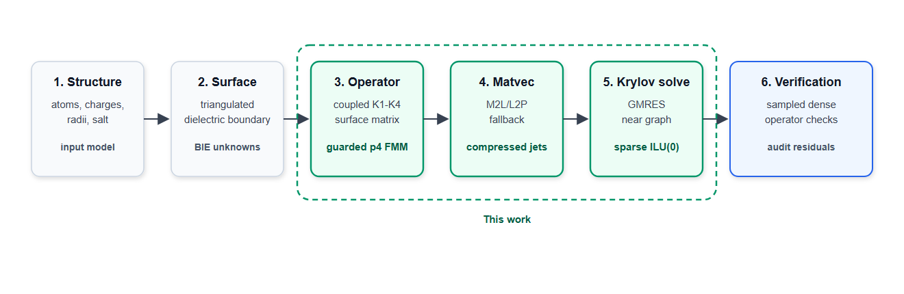
Figure 1 | Boundary-integral Poisson-Boltzmann workflow and contribution map. The six-stage pipeline starts from molecular preparation and surface discretization, forms the coupled K1-K4 boundary-integral operator, evaluates matrix-vector products, solves the Krylov system, and verifies the accelerated operator. The highlighted region marks the contribution of this work: guarded Cartesian p4 FMM/M2L, packed direct fallback, graph-derived sparse ILU(0), and sampled direct-operator verification.
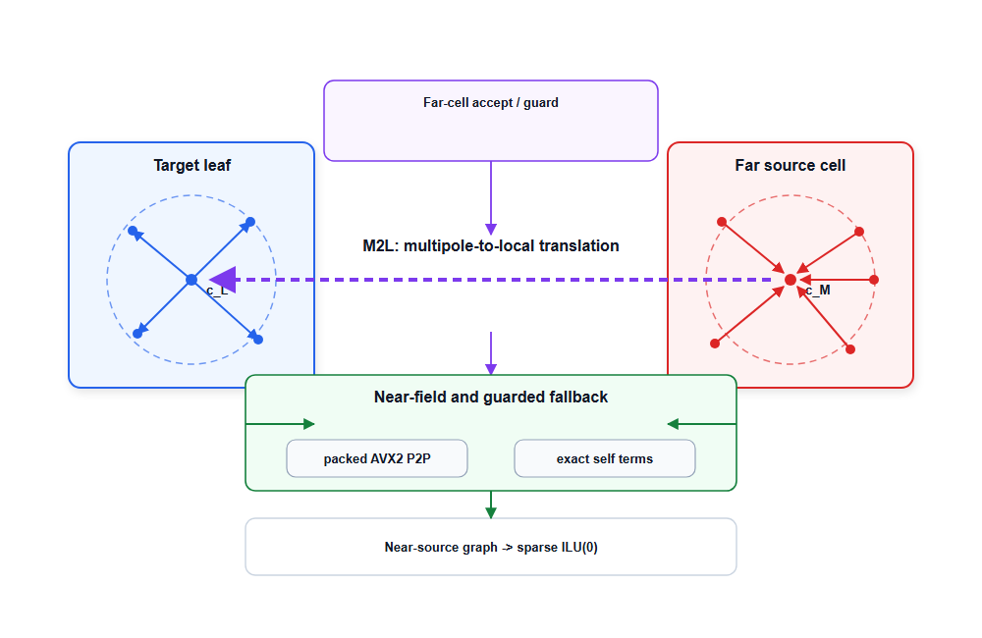
Figure 2 | Guarded p4 FMM/M2L boundary-integral operator. Source panels are compressed into Cartesian p4 moments, accepted far cells are translated to target-local expansions, and near or geometrically risky interactions are evaluated by packed direct fallback. The same near-source graph defines the sparse block ILU(0) preconditioner used by GMRES.

Results and Discussion

3.1. Performance Ladder and the Krylov Stalling Problem
We first evaluated the algorithmic ladder across the six-protein panel (Table 3 and Figure 3). Direct dense TABI is useful as a conceptual baseline, but its O(N^2) matrix-vector cost limited its practical use at the tested full-protein panel counts. In this benchmark, the direct configuration did not complete a passing solve for any of the six cases: two systems reached the timeout limit and four halted with residual gaps. The median wall time for this row was 31.1 min. Here, Direct TABI denotes direct summation of the dense JCP panel-panel boundary-integral operator, not a grid PB solve and not a treecode/FMM approximation.
Degree-one FMM reduced the cost of individual matrix-vector evaluations but did not by itself produce robust solves. With a diagonal preconditioner, 0/6 systems passed the convergence criterion; the median iteration count was 680 and the median sampled operator audit was 1.207e-02. Replacing the diagonal preconditioner with a strictly local block preconditioner reduced median wall time to 700.8 s but still resulted in 0/6 passing cases and a median iteration count at the 720-iteration cap.
This ladder separates two numerical issues. Fast summation addresses the cost of applying the dense operator, but weak preconditioning leaves the coupled surface system stiff. The protein surfaces contain grooves, pockets, and closely opposed patches that create strong near-field interactions across artificial tree-leaf boundaries. When those couplings are absent from the preconditioner, GMRES can stagnate even though each matrix-vector product is accelerated.
Figure 4 shows the same separation for 1A63. In this figure, convergence denotes an internal GMRES true residual below 10^-6; manuscript-facing rows additionally require sampled direct-operator residuals below 8 x 10^-3. The direct TABI row reached the timeout budget and is shown only as a wall-time context row. The degree-one FMM rows spent most measured time in repeated matrix-vector products over stalled Krylov solves. Replacing the weak preconditioner with sparse near-field ILU(0) reduced the iteration count to 128 and reduced wall time from approximately 1130 s to 208 s. The guarded p4 row adds static preparation, fallback, and audit cost, but it is the row that passed the sampled direct-operator audit.

3.2. Resolving High-Coupling Singularities with Sparse Near-Field ILU(0)
Figure 5 isolates the preconditioning effect on Barnase. With the same degree-one FMM operator, the diagonal and local block-diagonal preconditioners reached the 720-iteration budget and produced sampled true residuals of 4.42e-02 and 4.79e-02, respectively. The sparse near-field ILU(0) preconditioner reached the 1e-12 preconditioned-residual range in 128 iterations. This comparison indicates that the observed bottleneck is not only far-field matrix-vector cost but also algebraic conditioning of the coupled surface system.
The likely source of this stiffness is the topology of macromolecular surfaces. Surface patches that are physically close can be separated into different octree leaves. The derivative-sensitive K1-K4 channels then transmit strong off-diagonal couplings across those leaf boundaries. A strictly leaf-local preconditioner omits these couplings and therefore leaves the Krylov solve exposed to high-frequency interfacial error modes.
TITAN reconstructs a sparse approximation to this local connectivity from the FMM near-field worklist. For each target panel i, the graph records the self-edge and a capped deterministic set of nearby source panels j. The stored edge values are the exact 2 x 2 coupled analytic blocks defined in Section 2.1, restricted to this sparse graph.
$$A_{ij}=\left[\begin{matrix}δ_{ij}c_{ϕ}-K2_{ij} & -K1_{ij} \\ -K4_{ij} & δ_{ij}c_{ϕn}-K3_{ij}\end{matrix}\right]$$
ILU(0) is then applied on the graph without adding fill beyond the prescribed sparsity pattern. In the reported ladder, this graph-based preconditioner reduced median full-protein wall time from 700.8 s for the local block row to 133.3 s for the degree-one FMM + sparse ILU(0) row. However, Table 3 also shows that Krylov convergence alone is not sufficient: the degree-one FMM + sparse ILU(0) row passed convergence but failed the sampled direct-operator audit. This motivates the guarded p4 operator.
The role of ILU(0) in this manuscript is therefore specific: it stabilizes the Krylov solve for the tested systems under the stated stopping criteria. The physical accuracy of the final solution remains controlled by the accuracy of the fast operator and by the direct-operator audit.

3.3. Guarded Analytical FMM and Direct-Operator Verification
The guarded p4 path addresses the operator-accuracy issue exposed by the degree-one FMM + sparse ILU(0) row. Across the six-protein panel, all guarded p4 + sparse ILU(0) configurations converged in 128 iterations. The largest sampled audit RMS in Table 4 was 2.534e-03 for 1A63, and the largest reported resident set size was 369.6 MB. These metrics show that the high-order guarded path retained the Krylov benefits of near-field ILU(0) while improving sampled agreement with dense direct evaluations.

The sampled-audit policy is anchored by a separate dense-direct mini-protein calibration: for 1VII, 1UBQ, and 2CI2 64-atom subsets, guarded p4 reproduced full dense TABI energies with maximum absolute error 6.30e-4 kJ/mol and maximum sampled direct-operator residual 1.27e-6.
The p4 Cartesian representation was selected because the coupled K1-K4 operator requires explicit source-normal, target-normal, and mixed-derivative bookkeeping. In this fixed-order regime, Cartesian Green-function jets keep the derivative channels local and unrolled. This does not imply that Cartesian expansions are generally superior to spherical harmonics; it states the implementation rationale for this CPU-oriented derivative-rich operator.
A nominal p4 expansion is not used without additional checks. The p3/p4 tail indicator identifies cell pairs with potentially large truncation error, and the geometric separation guard rejects pairs that are too close for the expansion to be trusted. Rejected leaf-level pairs are demoted to direct evaluation. This policy reduces the risk that far-field truncation error contaminates the normal-derivative channels, at the cost of additional direct fallback work.
Wall-time comparisons with GPU-accelerated solvers such as TABI-PB 2.0 [9] must therefore be interpreted cautiously. TABI-PB 2.0 reports a GPU-oriented barycentric Lagrange dual-tree traversal pipeline, while the TITAN results here are single-node CPU/AVX2 measurements with guarded fallback and sampled direct-operator audits. The contribution claimed here is not GPU throughput superiority. It is the combination of guarded Cartesian FMM/M2L, graph-derived near-field ILU(0), and auditable CPU execution.

3.4. Computational Footprint, Reproducibility, and Methodological Scope
The geometric guard increases the number of interactions evaluated by the direct path. TITAN therefore implements fallback evaluation as a vectorized kernel. Demoted non-self target panels are packed into four-lane AVX2 batches, and source tiles are streamed through a deterministic Structure-of-Arrays layout. Self-interactions remain assigned to the analytic-singular near kernel and are masked out of the vector lanes. This design makes guarded fallback a planned part of the operator rather than an exceptional branch.
The reported memory footprint is also bounded by the surface formulation and by the limited cached state. In Table 4, peak resident memory ranges from 54.7 MB for 1VII to 369.6 MB for 1A63. These values reflect the tested CPU implementation, the panel counts in Table 2, the cached FMM plans, the compressed Green-function jets, fallback worklists, and the sparse ILU(0) factors.
Reproducibility is handled by deterministic setup and traversal order. The refinement plan, cache layout, fallback worklist, and panel sampling order are fixed before GMRES begins. Table 5 reports zero energy spread at the displayed precision for the locked primary panel, and Table S1 reports the same displayed precision for the supplementary public-protein rows. These results support repeatability under the reported configuration, not universal reproducibility across compilers, hardware, or altered parameter settings.
The present evidence has explicit limits. The benchmark is CPU/AVX2-only, uses six protein fixtures, and relies on sampled direct-operator audits for full-protein verification rather than full dense O(N^2) reaction-energy oracles. Section 3.5 and the Supplement add p-order, opening-angle, guard, tail-policy, and ILU neighbor-cap sensitivity checks, but they do not replace a full dense small-system oracle, surface-density scaling, or a larger public-protein validation set. The reported settings should therefore be read as reproducible protocol choices for the tested cases, not as universal parameter optima.
Within these limits, the results support a focused methodological conclusion: for the tested molecular surfaces, near-field graph ILU(0) removed the observed Krylov stalls, while guarded Cartesian FMM/M2L restored sampled agreement with dense direct evaluations. The architecture provides a reproducible CPU baseline that can be extended to broader validation sets and accelerated backends.

3.5. Ablation and Sensitivity
The ablation evidence is intended to make the reported protocol interpretable rather than to search the full parameter space. It asks five practical questions: whether fast matrix-vector evaluation alone removes the bottleneck, whether near-field ILU(0) is inexpensive enough to justify its setup cost, whether the geometric guard is needed for sampled direct-operator agreement, how the Taylor order changes the balance between compression and fallback, and how the ILU neighbor cap affects cost and memory.
The performance ladder in Table 3 provides the first separation. Direct dense TABI is runtime-limited at the tested panel counts. Degree-one FMM reduces the cost of each matrix-vector product, but weak diagonal or leaf-local preconditioners still produce Krylov stalls. Sparse near-field ILU(0) removes this stall, while the guarded high-order path restores sampled agreement with the dense direct operator. In the 1A63 guarded p4 profile, ILU(0) setup accounts for 5.15 s and preconditioner application accounts for 6.37 s over the solve, compared with 151.9 s for p4 matrix-vector application and 312.6 s total wall time. This cost split supports the use of the graph factorization in the tested CPU workflow, while leaving larger-panel scaling as a separate question.
The guard ablation separates internal convergence from operator agreement. In the six-protein guard-on/guard-off runs, removing the strict geometric guard still allowed internal GMRES convergence, but it caused full 1A63 to fail direct-operator verification: the sampled audit RMS was 5.18e-2 and the sampled direct true residual was 5.20e-2. Restoring the strict geometric guard at theta = 0.5 reduced the corresponding 1A63 audit to 2.53e-3. This result supports retaining the geometric guard as part of the accuracy contract for the reported p4 path.
Opening-angle sensitivity was evaluated over theta = 0.4, 0.5, 0.6, and 0.7. All four settings passed the sampled direct-operator gate on the six-protein panel, and the median wall time decreased modestly from 142.9 s at theta = 0.4 to 126.2 s at theta = 0.7. The manuscript retains theta = 0.6 because it was the locked validation setting used in the repeatability gates. This result is read narrowly: within the tested range, the strict guard dominated the sampled accuracy behavior; no global theta optimum is inferred.
Table 6. Compact ablation and sensitivity summary for the reported p4/cap-64 protocol.
Axis | Evidence | Main observation | Boundary
Direct/FMM/ILU ladder | Six-protein ladder in Table 3 | Low-order FMM reduces matvec cost but does not remove Krylov stalls with weak preconditioners; near-field ILU(0) stabilizes the tested solves. | Not an exhaustive preconditioner comparison.
ILU(0) cost split | 1A63 profile: 5.15 s setup, 6.37 s total application, 151.9 s p4 matvec, 312.6 s wall | The ILU(0) overhead is small relative to the measured solve cost in this CPU workflow. | Larger-panel setup and factor-memory scaling remain open.
Geometry guard | Six-protein guard-on/guard-off runs | Guard-off keeps GMRES convergence but fails 1A63 sampled audit (5.18e-2); guard-on reduces the 1A63 audit to 2.53e-3. | Evidence supports the guard for this panel, not all geometries.
Opening theta | theta = 0.4, 0.5, 0.6, 0.7 | All four settings pass; median wall time ranges from 142.9 s to 126.2 s. | theta = 0.6 is the locked protocol value, not a global optimum.
Expansion order | p2/p3/p4/p5 rows on six proteins | All tested orders pass under the guard. p2 is fallback-dominated; p4 preserves far-field compression and gives the lowest observed mean wall time among far-compressed rows. | Additional meshes and systems are needed before recommending a general p order.
ILU neighbor cap | Caps 32, 64, 128 on Barnase, 1A63, 1SH1 | All caps pass. Cap 64 gives the lowest mean matvec time with moderate graph size and memory in this subset. | A larger cap sweep is needed before claiming cap optimality.
Tail indicator | Tail-on rows pass; tail-off rows stop at the guarded validator | Tail refinement is part of the validated workflow. | A deliberately relaxed tail-off numerical run would be needed to isolate the tail term alone.
The p-order sweep was run under the guarded policy on the six-protein panel. Orders p2, p3, p4, and p5 all passed the sampled audit gate, but they did so with different work decompositions. The p2 rows are conservative: they produce very small sampled residuals while accepting no far M2L pairs, so most risky far work is demoted to direct fallback. The reported p4 row is retained because it remains audit-passing while preserving substantial far-field compression and the lowest observed mean wall time among the far-compressed configurations in this panel. This is a protocol choice, not evidence that p4 is the best order in all regimes.
The p2 coverage logs rule out a simple skipped-work explanation. Across the six proteins, p2 accepted zero far M2L pairs, rejected 337,815 far cell pairs, and demoted 295,959,727 panel pairs to direct fallback. Every p2 solve also reports a nonzero total evaluated interaction count and at least 1024 independently sampled dense-audit rows in the separate p-order coverage protocol. The p2 audit therefore reflects conservative direct evaluation of risky interactions, not omission of far-field work.
The ILU neighbor-cap sweep was run on Barnase, 1A63, and 1SH1 under the guarded p4 protocol. Caps 32, 64, and 128 all passed the sampled direct-operator gate. Cap 32 was the most memory-lean row in mean RSS, cap 128 used the largest graph and memory, and cap 64 gave the lowest mean matrix-vector time in this three-protein sweep. The manuscript therefore uses cap 64 as a balanced protocol value for the reported runs, not as an accuracy-only optimum.
Taken together, the ablations support the selected p4/cap-64 guarded workflow for the current benchmark panel while keeping the stronger questions--larger protein sets, mesh-density scaling, and full dense small-system oracles--outside the present claim.

Conclusion
TITAN contains a guarded fourth-order Cartesian FMM/M2L boundary-integral PB path with sparse near-field ILU(0) preconditioning. On the reported primary and supplementary protein fixtures, the guarded p4 workflow converged under the stated criteria, passed sampled direct-operator verification, and kept resident memory below 370 MB. The p-order and neighbor-cap sweeps support the reported p4/cap-64 setting as a reproducible operating point for the tested panel, while leaving broader optimality and scaling questions open. The supported claim is deliberately bounded: the method combines analytical fast evaluation, deterministic far-field guarding, and graph-based sparse preconditioning to make the tested dense molecular-surface PB solves Krylov-robust and auditable on CPU hardware.

Code and Data Availability
The TITAN source code corresponding to this manuscript has been prepared for release under the MIT License as the local snapshot tag fagbi-submission-v0.1 on branch fagbi-submission-2026. Before submission, this paragraph must be updated with the public GitHub release URL and the Zenodo DOI minted from that tagged release. The archived release should include source code, build instructions, benchmark manifests, input metadata, scripts, figures, and reference outputs for Tables 3-6 and Supplementary Tables S1-S4. Public protein structures are identified by their RCSB PDB accession codes; derived surface metadata, run manifests, and tabulated outputs corresponding to the manuscript tables are included in the release-readiness manifest. A SHA-256 artifact manifest records the manuscript, benchmark scripts, public-fixture manifests, figures, and tabulated reference outputs intended for the archived release.

Algorithmic Performance Ladder
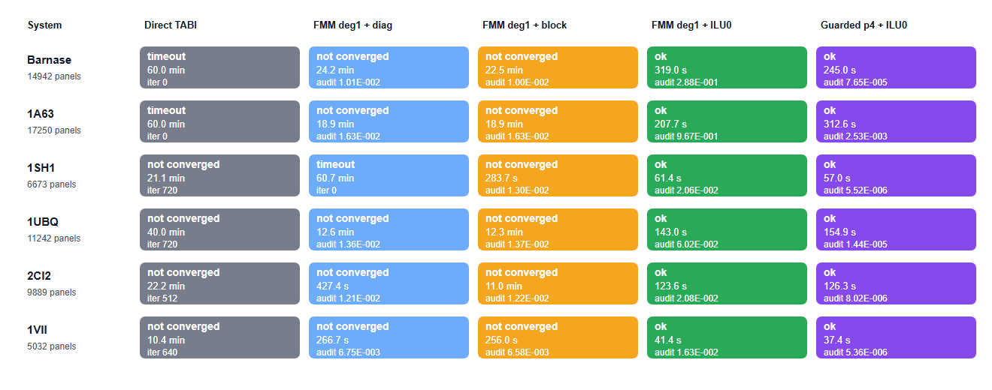
Figure 3 | Full-protein performance ladder. Colors identify backend stages from direct TABI through guarded p4 FMM/M2L with sparse ILU(0); each cell reports status and wall time. The ladder separates three effects: direct dense TABI is not practical at the tested full-protein panel counts, degree-one FMM accelerates matrix-vector products but still stalls with weak preconditioning, and guarded p4 plus sparse near-field ILU(0) passes sampled direct-operator verification on all six full proteins.
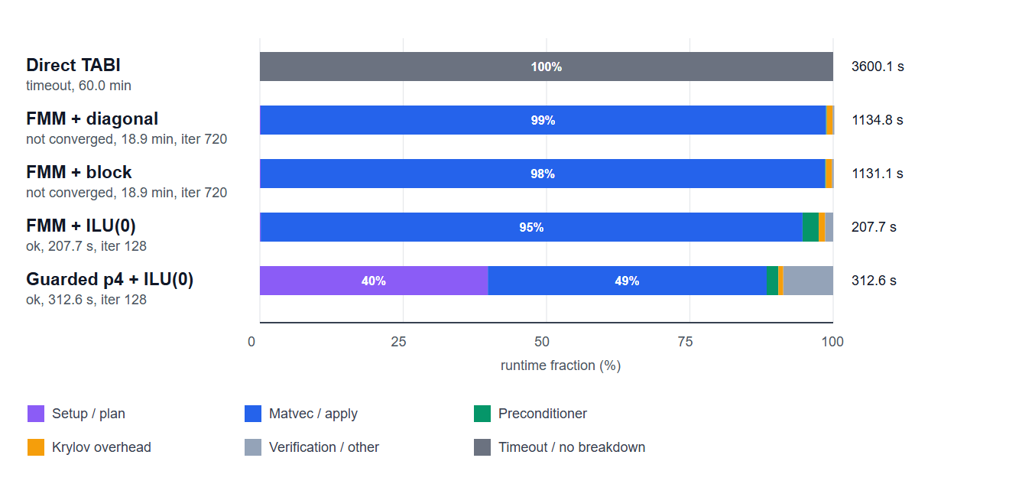
Figure 4 | Runtime composition for the 1A63 performance ladder. Direct TABI reached the timeout budget and is shown as a wall-time context row without component breakdown. The remaining rows show the fraction of measured wall time assigned to matrix-vector evaluation, preconditioning, Krylov overhead, setup, and verification or other overhead. Degree-one FMM reduces the cost of individual matrix-vector products but still spends most runtime in stalled 720-iteration solves; sparse near-field ILU(0) reduces the Krylov budget to 128 iterations, while the guarded p4 row adds preparation and direct-operator verification cost to recover sampled dense-operator agreement. Convergence in this figure denotes internal GMRES true residual below 10^-6; paper-facing acceptance additionally requires sampled direct-operator residual below 8 x 10^-3.
Table 2. Full-protein benchmark systems used in the performance ladder.
Protein | PDB/source | Atoms | Panels | Role
Barnase | PyDelPhi benchmark | 1700 | 14942 | Primary
RNA-binding domain of E. coli Rho factor | 1A63 | 2065 | 17250 | Primary
Stichodactyla helianthus neurotoxin I | 1SH1 | 696 | 6673 | Primary
Ubiquitin | 1UBQ | 1231 | 11242 | Supplement
Chymotrypsin inhibitor 2 | 2CI2 | 1076 | 9889 | Supplement
Villin headpiece subdomain | 1VII | 596 | 5032 | Supplement
Table 3. Full-protein algorithmic ladder across six matched protein fixtures.
Stage | Outcome | Median wall | Median iter. | Operator audit | Interpretation
Classical direct TABI | 0/6 ok; 4 failed; 2 timeout | 31.1 min | 576 | no passing solve under budget | Dense baseline; no passing full-protein solve under the benchmark budget.
Degree-one FMM + diagonal | 0/6 ok; 5 failed; 1 timeout | 944.5 s | 680 | median 1.207e-02 | FMM matvec acceleration did not prevent Krylov stall with diagonal preconditioning.
Degree-one FMM + local block | 0/6 ok; 6 failed; 0 timeout | 700.8 s | 720 | median 1.258e-02 | Leaf-local block coupling remained insufficient for the tested systems.
Degree-one FMM + sparse ILU(0) | 6/6 ok; 0 failed; 0 timeout | 133.3 s | 128 | median 4.052e-02; max 9.671e-01 | GMRES converged, but the low-order far operator failed sampled audits.
Guarded p4 FMM + sparse ILU(0) | 6/6 ok; 0 failed; 0 timeout | 140.6 s | 128 | median 1.121e-05; max 2.534e-03 | Converged and passed sampled direct-operator audit.
Table 4. Guarded p4 + sparse ILU(0) full-protein rows from the performance ladder.
Protein | PDB/source | Panels | Iter. | Internal residual | Sampled audit RMS | Sampled direct true residual | Wall | RSS MB
Barnase | PyDelPhi benchmark | 14942 | 128 | 8.579e-13 | 7.647e-05 | 7.647e-05 | 245.0 s | 172.5
RNA-binding domain of E. coli Rho factor | 1A63 | 17250 | 128 | 1.337e-11 | 2.534e-03 | 2.535e-03 | 312.6 s | 369.6
Stichodactyla helianthus neurotoxin I | 1SH1 | 6673 | 128 | 1.164e-14 | 5.519e-06 | 5.519e-06 | 57.0 s | 63.1
Ubiquitin | 1UBQ | 11242 | 128 | 2.719e-13 | 1.440e-05 | 1.440e-05 | 154.9 s | 144.6
Chymotrypsin inhibitor 2 | 2CI2 | 9889 | 128 | 5.964e-14 | 8.022e-06 | 8.022e-06 | 126.3 s | 138.1
Villin headpiece subdomain | 1VII | 5032 | 128 | 7.353e-13 | 5.357e-06 | 5.357e-06 | 37.4 s | 54.7

Primary Protein Panel
Table 5. Guarded p4 repeatability on the locked full-protein panel.
Protein | PDB/source | Panels | Energy | Sampled audit max | Sampled direct true residual max | Energy spread
Barnase | PyDelPhi benchmark | 14942 | -21030.83 | 6.383e-05 | 6.383e-05 | 0.000
RNA-binding domain of E. coli Rho factor | 1A63 | 17250 | -247716.08 | 2.357e-03 | 2.357e-03 | 0.000
Stichodactyla helianthus neurotoxin I | 1SH1 | 6673 | -4362.07 | 4.894e-06 | 4.894e-06 | 0.000

Preconditioner Convergence Profile
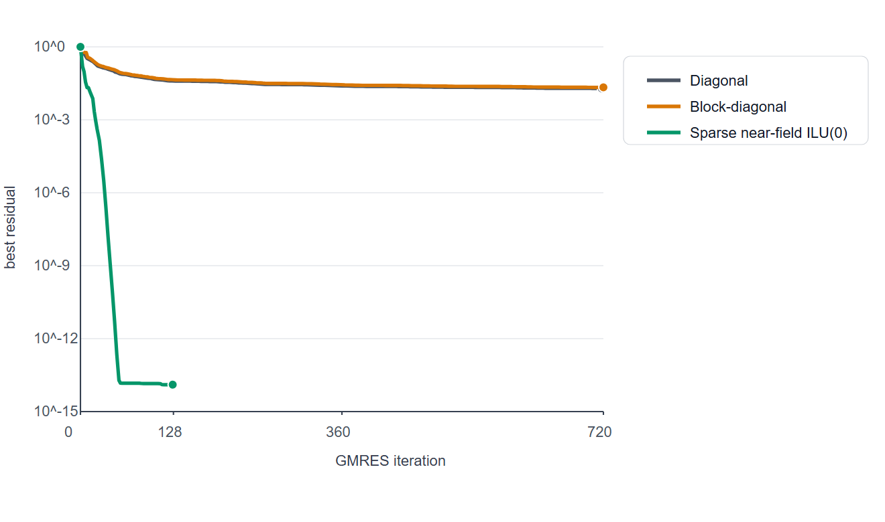
Figure 5 | Barnase GMRES residual decay under three preconditioning choices. All curves use the same full-protein degree-one FMM operator. The diagonal and local block-diagonal preconditioners reached the iteration budget, whereas sparse near-field ILU(0) drove the preconditioned residual to the 1e-12 range and produced a converged solve. This contrast isolates Krylov stiffness from raw matrix-vector-product cost.
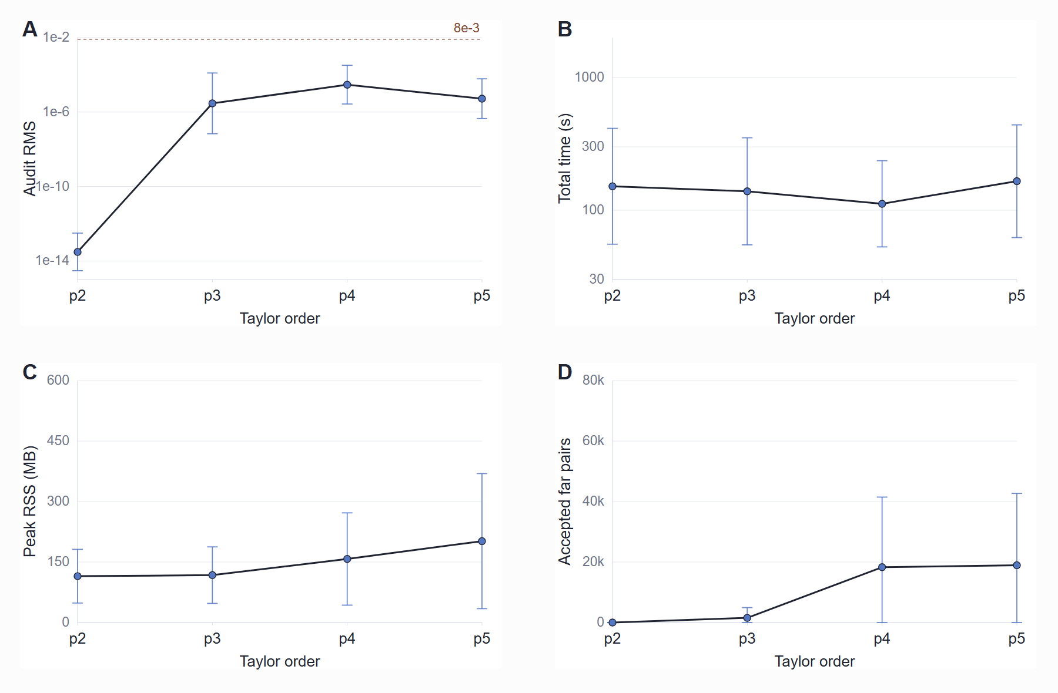
Figure 6 | Guarded p-order trade-off across the six-protein panel. A, sampled direct-operator audit RMS. B, total wall time. C, peak resident set size. D, accepted far M2L pairs and direct-fallback panel pairs. Points and bars show mean +/- s.d. across the six proteins. The p2 rows pass the audit by demoting essentially all far work to direct fallback. The reported p4 policy is retained because it passes the audit while preserving far-field compression in the current panel; no general p-order optimum is implied.

References
[1] J. Chen, J. Tausch, and W. Geng, A Cartesian FMM-accelerated Galerkin boundary integral Poisson-Boltzmann solver, Journal of Computational Physics 478, 111981, 2023.
[2] L. Greengard and V. Rokhlin, A fast algorithm for particle simulations, Journal of Computational Physics 73, 325-348, 1987.
[3] Y. Saad and M. H. Schultz, GMRES: A generalized minimal residual algorithm for solving nonsymmetric linear systems, SIAM Journal on Scientific and Statistical Computing 7, 856-869, 1986.
[4] J. A. Meijerink and H. A. van der Vorst, An iterative solution method for linear systems of which the coefficient matrix is a symmetric M-matrix, Mathematics of Computation 31, 148-162, 1977.
[5] M. G. Duffy, Quadrature over a pyramid or cube of integrands with a singularity at a vertex, SIAM Journal on Numerical Analysis 19, 1260-1262, 1982.
[6] T. J. Dolinsky et al., PDB2PQR: an automated pipeline for the setup of Poisson-Boltzmann electrostatics calculations, Nucleic Acids Research 32, W665-W667, 2004.
[7] E. Jurrus et al., Improvements to the APBS biomolecular solvation software suite, Protein Science 27, 112-128, 2018.
[8] S. K. Burley et al., RCSB Protein Data Bank: powerful new tools for exploring 3D structures of biological macromolecules, Nucleic Acids Research 49, D437-D451, 2021.
[9] L. Wilson, W. Geng, and R. Krasny, TABI-PB 2.0: An improved version of the treecode-accelerated boundary integral Poisson-Boltzmann solver, Journal of Physical Chemistry B 126, 7104-7113, 2022.
[10] W. Geng and R. Krasny, A treecode-accelerated boundary integral Poisson-Boltzmann solver for electrostatics of solvated biomolecules, Journal of Computational Physics 247, 62-78, 2013.
[11] J. Chen and W. Geng, On preconditioning the treecode-accelerated boundary integral (TABI) Poisson-Boltzmann solver, Journal of Computational Physics 373, 750-762, 2018.

