VIBE: Virtual Intact Block Extraction for Topology-Aware PBC Correction
A manuscript-ready method note for TITAN pbctopo
Draft status: algorithm description and implementation manuscript scaffold. Benchmark claims are intentionally deferred until the external PDB/XTC test drive is mounted.

Abstract
Periodic boundary condition artifacts can fragment molecular assemblies, obscure chain continuity, and distort downstream interaction analyses. We describe VIBE (Virtual Intact Block Extraction), implemented in TITAN as pbctopo, a topology-aware reconstruction strategy that searches for intact molecular placements using virtual cut-plane candidates, component offset graphs, continuity constraints, and anchor-based scoring. The method is designed for multi-chain protein systems and coarse-grained MARTINI trajectories while keeping conservative fallback behavior when a frame cannot be certified. This manuscript scaffold documents the algorithm, public configuration surface, implementation boundaries, and validation plan without making benchmark claims that require the currently unmounted external PDB/XTC test drive.
Contribution summary: VIBE is presented as an independent pbctopo algorithm in TITAN. FixBox (-pbcn) and pbci are described only as separate TITAN baseline or fallback paths, not as VIBE extensions.

1. Motivation
Many MD trajectories store atoms inside a primary periodic image even when the chemically meaningful assembly spans an image boundary. Simple minimum image wrapping can restore distances for pair calculations, but it may not recover an intact block suitable for output PDBs, contact maps, radius of gyration calculations, or multi-chain topology analyses. VIBE targets this gap: it searches for an atom placement that is simultaneously compact, topology-consistent, continuity-preserving, and guarded against hard clashes.
The method is intentionally conservative. It does not declare a corrected frame merely because a virtual split looks plausible. Candidate placements must pass local topology checks, owner-contact split guards, continuity constraints, anchor graph scoring, and clash rejection. If this certification fails, TITAN records the failure and can fall back to the existing pbci path.

2. Method Overview
VIBE operates per frame but carries warm-state information forward from previous accepted frames. For each frame, TITAN extracts receptor and ligand atoms, builds a local topology graph, identifies heavy-atom projection subsets, derives continuity and anchor pairs, and then searches candidate placements through two complementary mechanisms.
The first mechanism is virtual-box search. Candidate cut planes are generated from density and gap structure along the periodic axes, evaluated cheaply on a projected subset, and then verified against the full atom set. The second mechanism is component-offset graph search. Local topology splits atoms into connected components; small component counts use exact search, intermediate counts can merge chain-local raw components before graph solving, and large counts use a bounded beam search. The selected mode is controlled by the exact component limit and beam width exposed through the pbctopo CLI/config.
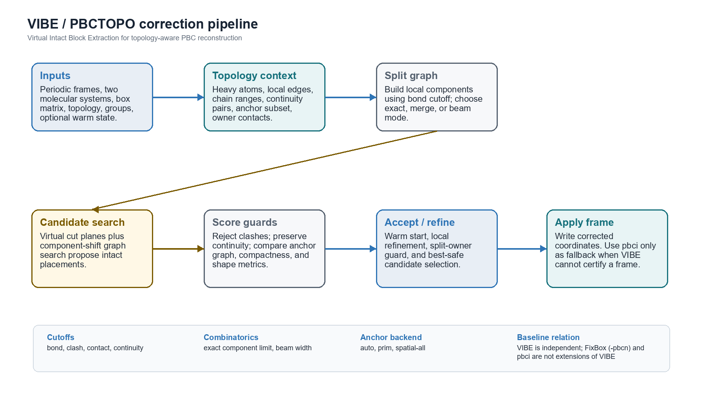
Figure 1. Schematic of the VIBE/pbctopo frame-correction pipeline.

Algorithm 1. VIBE / PBCTOPO
Input: frames F, receptor system R, ligand system L, periodic box B,
topology T, runtime cutoffs C, exact_limit E, beam_width W
Output: corrected coordinates for each frame, plus diagnostics
Build static topology context from R, L, and T
Identify heavy atoms, continuity pairs, anchors, chain ranges
Initialize warm_state from the previous accepted frame, if available
for each frame f in F:
atoms <- append receptor and ligand atoms for frame f
local_edges <- topology graph using C.bond_cutoff
components <- connected_components(local_edges)
owner_contacts <- contacts(atoms, C.contact_cutoff)
candidate_set <- empty
if warm_state has a previous virtual-box candidate:
score it first and keep it if safe
projection <- heavy-atom projection plus local-edge subset
seeds <- virtual cut-plane density seeds along x, y, z
for each seed in seeds:
coarse <- evaluate virtual-box placement on projection
if coarse is promising:
candidate_set.add(verify on full atoms)
mode <- choose_component_mode(count(components), E)
if mode == exact:
graph_candidate <- exact component-offset graph search
else if mode == merge:
graph_candidate <- chain-aware merged-component graph search
else:
graph_candidate <- beam component search with width W
candidate_set.add(graph_candidate)
for each candidate in candidate_set:
reject if hard clash under C.clash_cutoff
reject if continuity graph fails under C.continuity_cutoff
reject if anchor graph is disconnected or worse than incumbent
score compactness, split-owner safety, shape, and shift norm
best <- best safe candidate
if best is valid:
apply best to frame f
update warm_state
else:
apply pbci fallback for frame f and record fallback diagnostic
Note. The pbci step is a fallback/baseline path, not part of the VIBE search model. FixBox (-pbcn) is likewise a separate TITAN tool option.

3. Scoring and Rejection Criteria
Candidate scoring is multi-stage. A placement first has to avoid ultra-clash conditions under the clash cutoff. It then has to preserve continuity graph metrics under the continuity cutoff and keep anchor relationships connected under the selected anchor backend. Surviving candidates are compared using shift norm, compactness, bounding-box and gyration-derived shape statistics, owner-pair split safety, and whether the candidate improves or remains close to the current incumbent. This layered design is deliberate: the algorithm prefers a certified safe placement over a geometrically attractive but topologically suspicious placement.

Runtime Parameters Exposed Through CLI/Config
Parameter | Default | MARTINI default | Algorithmic role
bond cutoff | 2.15 | 5.5 | Builds the local topology graph used to split atoms into connected components.
clash cutoff | 1.05 | 3.5 | Rejects placements that create hard overlaps; also sets the legacy hard-clash guard.
contact cutoff | 4.5 | 8.0 | Defines owner/contact relationships used by split guards and scoring context.
continuity cutoff | 20.0 | 20.0 | Bounds continuity graph checks across frames and candidate placements.
exact component limit | 6 | 6 | Controls when VIBE uses exact component-offset search instead of large-mode paths.
beam width | 12 | 12 | Controls retained states in large-component beam search.
anchor backend | auto | auto | Chooses anchor scoring backend: auto, prim, or spatial-all.
Table 1. Public VIBE control surface after the pbctopo refactor.

4. Implementation Surface in TITAN
The public command is -pbctopo. The refactor introduces a pbctopo module boundary under src/pbctopo for runtime configuration and logging while keeping Multi_MOL::solve_pbc_pbctopo as the stable public adapter. Runtime cutoffs are resolved after force-field defaults are selected, so MARTINI defaults remain intact unless a user explicitly overrides them. The same configuration fields are documented in CLI help and exported through the TITAN schema surface.
Current refactor boundary: Configuration and logging are already isolated in src/pbctopo. The next low-risk extractions should be geometry helpers, topology-context builders, scoring, component search, and virtual-box evaluation.

5. Validation Plan
- Parser and schema contract: invalid cutoffs, invalid beam/exact limits, and invalid anchor backend fail closed.
- Smoke behavior: existing PBC/nocal smoke remains unchanged when VIBE options are absent.
- Frame-level diagnostics: pbctopo_debug.log should record resolved cutoffs, anchor backend, exact limit, beam width, component modes, and fallback counts.
- Regression windows: rerun dimer and tetramer pbctopo windows once the external D:\Data_MD drive is mounted.
- Publication metrics: report frame success rate, pbci fallback count, component graph usage, runtime, and geometry sanity checks before making benchmark claims.

6. Limitations and Manuscript Notes
This draft should be treated as a methods manuscript scaffold rather than a final results paper. It describes the algorithm and implementation state, but it deliberately avoids new quantitative claims because the PDB/XTC validation drive is not currently mounted. Once the drive is available, the existing dimer and tetramer windows can supply method validation tables and representative corrected structures.
Terminology should stay strict in the final manuscript: VIBE is the pbctopo algorithm, FixBox is the separate -pbcn option, and pbci is an in-house TITAN PBC path used here only as a baseline or fallback reference.

Acknowledgments and Disclosure Draft
This manuscript scaffold was generated with AI-assisted drafting from the local TITAN source tree. All algorithmic claims should be reviewed against the source code and rerun logs before submission. No external benchmark data were analyzed in this scaffold.

